**Editorial: In Honor of Gregory B. McKenna’s Contributions to the Field of Polymer Science**

Reiner Zorn

Forschungszentrum Jülich GmbH, Jülich Centre for Neutron Science (JCNS-1) and Institute for Biological Information Processing (IBI-8), 52425 Jülich, Germany

The present collection of articles gives an impressive overview of diverse aspects in the field of polymer physics to which Dr. Gregory B. McKenna contributed enormously with his work. The articles range from fundamental research to studies of applied materials. The applications discussed are as different as future engineering technologies and medicine. Before giving an synopsis of the issue, first we briefly review Dr. McKenna's background and accomplishments.

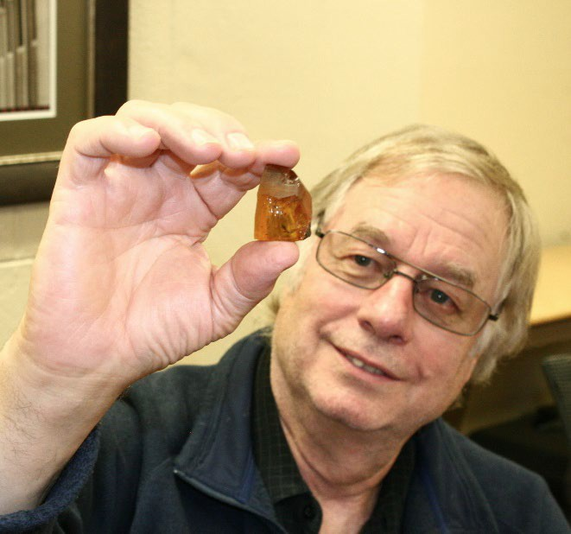

Dr. McKenna inspecting a piece of amber.

Gregory B. McKenna attended the U.S. Air Force Academy from which he received his Bachelor’s degree in Engineering Mechanics in 1970. As part of his active duty he attended MIT where he earned a Masters Degree in the area of composite materials before being stationed at Hill Air Force Base in Ogden Utah, where he served as a Test Evaluation Engineer until 1975 when he left the Air Force at the rank of Captain. While in Utah, he also obtained a Ph.D. in Materials Science and Engineering at the University of Utah, graduating in 1976. Dr. McKenna was honored with a National Research Council Postdoc at the then National Bureau of Standards (NBS) and accepted a permanent position at NBS (now the National Institute of Standards and Technology, NIST) in 1977. He was the head of the Structure and Mechanics Group in the Polymers Division at NIST from August 1992 until July 1999 when he moved to Texas Tech University as Professor in the Department of Chemical Engineering and John R. Bradford Endowed Chair in Engineering. In 2005 he became a Paul Whitfield Horn Distinguished Professor at TTU. In 2021 he moved to the Department of Chemical and Biomolecular Engineering at North Carolina State University. Dr. McKenna has earned a reputation as a pioneering researcher in multiple areas of polymers and materials physics and engineering, including physics of glasses, solid mechanics and nonlinear viscoelasticity of polymers, thermodynamics and mechanics of elastomers and gels, and molecular rheology. He has over 260 publications that have been cited over 20,000 times. Dr. McKenna is a Fellow of the American Physical Society, the Society of Plastics Engineers, the Society of Engineering Science, the North American Thermal Analysis Society (NATAS), The American Institute of Chemical Engineers, the American Association for the Advancement of Science (AAAS), and the Society of Rheology. He is the recipient of multiple awards including the International Award from the Society of Plastics Engineers, the Mettler-Toledo Award of NATAS, and the Bingham Medal of the Society of Rheology. He has served as Chairman of the Polymer Physics Division of the APS, President of the Society of Engineering Science, and President of the Society of Rheology.

In this special issue, Dr. McKenna himself contributes a trendsetting article1 which presents three current directions in polymer physics: the question of the divergence of relaxation time at a finite temperature (in which amber plays a key role), dynamic heterogeneity, and the dynamics of circular macromolecules. While there is evidence of a clear answer for the first question and there is significant progress concerning the second, for the last topic many unanswered questions remain. In another article by Lopez et al.13 mixing rules for the glass transition temperatures are scrutinized. As well as having an immediate relevance for the estimation of *T*g of blends, this study allows an insight on the origin of *T*g from the theoretical concept of configurational entropy. The work of Song et al.16 indicates a relaxation process different from ⍺ and β relaxation responsible for deep-glass ageing, but some care may have to be taken due to concerns raised in ref. 10.

Other articles in this volume, although not being explicitly fundamental studies, include very fundamental and general concepts as the mathematically elegant description of weak gels formed by cartilage components by fractional calculus in the article by Ferenc Horkay and Jack Douglas2 or the application of the Ozawa-Avrami model for the crystallization kinetics of materials for additive manufacturing by Alexis Thézé et al.3. Finally, Bernard Lotz4 makes a strong point for the fundamental relevance of *crystalline* polymers, a sometimes-neglected topic in polymer physics.

Also in the application-oriented contributions current trends are addressed. Complex co-polymers designed for detergent formulations are shown by Nakatani et al.11 to exhibit a new rheological scaling, a “time-hydrophobe superposition”. The question of unifying ion conductivity and stability in membranes and how to solve it by an aligned microstructure is tackled by Pitia et al.5. Methods to produce microfibers for battery application by means of polymer precursors are presented by Gabriel Gonzalez et al.6. Polymers with high intrinsic microporosity for gas-separation membranes are studied by a combination of dynamical methods by Kolmangadi et al.12. Yucheng Wang et al.7 use a similar technique as used in ref. 4 for surface decoration here as a preparative tool to obtain highly oriented crystalline polymer layers. Materials of less technological but more cross-disciplinary relevance, namely ambers, are studied by Kong et al.17 with respect to their polymeric network structure.

There are several articles dealing with the development and improvement of experimental technologies. Lesser et al.14 describe the design of a novel dilatometer, a technique to which also Greg McKenna contributed a large part. An important contribution to rheological metrology is the random-frequency sweep method described by Montgomery Shaw8. A recurring novel theme is flash DSC which is used to study otherwise inaccessible phenomena as a glassy polymer layer at a nanoparticle surface (Sakib et al.9) or possible below-Tg features (Pallaka et al.10). Some studies, as those of Jin et al.18 and Pallaka et al.10 also address with diligence possible mistakes and artifacts in current experimental procedures contributing to the improvement of future such studies.

Most of the authors of this volume are close collaborators of Greg McKenna. Speaking for myself, Greg strongly influenced the way I am ‘doing science.’ I presume this is true also for many of the scientists presenting their work here. So apart from the direct contribution by his scientific studies and publications also Greg’s contribution through collaborations, mentorship, and friendship must not be underestimated. I think I can speak for all the authors here in thanking Greg for this very personal contribution.

**References**

1. Gregory B. McKenna, Dongjie Chen, Satish Chandra Hari Mangalara, Dejie Kong, and Sourya Banik: Some Open Challenges in Polymer Physics, this issue

2. Ferenc Horkay and Jack F. Douglas: Cartilage Polymers: From Viscoelastic Solutions to Weak Gels, this issue

3. Alexis Thézé, Alain Guinault, Gilles Régnier, Sébastien Richard, and Bruno Macquaire: Fused filament fabrication process window for good interlayer bonding: Application to highly filled polymers in metallic powder, this issue

4. Bernard Lotz: The structural language of crystalline polymers, this issue

5. Emmanuel Pitia, Saurabh Batra, Mukerrem Cakmak, Montgomery Shaw, and R. A. Weiss: A continuous process for manufacturing proton exchange membranes featuring z-direction-aligned, proton-conducting particles or polymers, this issue

6. Gabriel Gonzalez, Md Toukir Hasan, Daniel Ramirez, Jason Parsons, Mataz Alcoutlabi: Synthesis of SnO2/TiO2 micro belt-fibers from polymer composite precursors and their applications in Li-ion batteries, this issue

7. Yucheng Wang, Kaichen Gu, Jason X. Liu, Anishkumar Soman, Tingyi Gu, Craig B. Arnold, Richard A. Register, Yueh-Lin Loo, Rodney D. Priestley: Epitaxially Crystallized Polyethylene Exhibiting Near-Equilibrium Melting Temperatures, this issue

8. Montgomery Shaw: Polymer melt rheology: Advantages of frequency sweeps using randomly selected frequencies, this issue

9. Nazam Sakib, Yung Koh, Sindee Simon: The Absolute Heat Capacity of Polymer Grafted Nanoparticles using Fast Scanning Calorimetry, this issue

10. Madhusudhanreddy Pallaka, Rozana Bari, Sindee Simon: Origin of the Broad Endothermic Peak Observed at Low Temperatures for Polystyrene and Metals in Flash Differential Scanning Calorimetry, this issue

11. Alan Nakatani, Lyndsay Leal, Kathleen Michels, Nikhil Fernandes, Jennifer Koenig, Wenshiue Young, Catheryn Jackson: Hydrophobe Size and Concentration Dependent Rheology of Hydrophobically Modified Alkali Soluble Emulsion (HASE) Polymer Solutions at Various pH Conditions, this issue

12. Mohamed A. Kolmangadi, Paulina Szymoniak, Reiner Zorn, Martin Böhning, Marcell Wolf, Michaela Zamponi, Andreas Schönhals: Molecular mobility in high-performance polynorbornenes: A combined broadband dielectric, advanced calorimetry, and neutron scattering investigation, this issue

13. Evelyn Lopez, Yung Koh, John A. Zapata-Hincapie, Sindee L. Simon: The Composition-Dependent Glass Transition Temperature and its Dependence on Configurational Entropy, this issue

14. Alan Lesser, Brendan Ondra, David Brewer, Amy Brewer: Design and Development of a Bi-Fluidic, Confining-Fluid, Pressurizable Dilatometer, this issue

16. Hosup Song, Grigori Medvedev, James Caruthers: Structural relaxation of an epoxy resin at temperatures well below Tg, this issue

17. Dejie Kong, Yan Meng, Gregory B. McKenna: Quantitative Determination of the Molecular Weight between Cross-links for Different Ambers: Viscoelastic Measurements of the Rubbery Plateau, this issue

18. Shuang Jin, Gregory B. McKenna: Anomalous Structural Recovery in a Polymer Glass: Data Revisited in Light of Temperature Variability in Vacuum Oven-based Experiments, this issue