**Anti-isostructural phase transition and twinning in CrAs at low temperatures and high pressures**

Andrzej Grzechnik 1,2,*, Vladimir Dmitriev 3, Michael Hanfland 3, Tobias Geise 2, Hend Shahed 4,2, Karen Friese 4,2

1 Jülich Centre for Neutron Science-4 (JCNS-4), Forschungszentrum Jülich, 52425, Germany

2 Institute of Crystallography, RWTH Aachen University, Aachen, 52066, Germany

3 European Synchrotron Radiation Facility, Grenoble, 38000, France

4 Jülich Centre for Neutron Science-2 and Peter Grünberg Institute-4 (JCNS-2/PGI-4), Forschungszentrum Jülich, 52425, Germany

Corresponding author: [a.grzechnik@fz-juelich.de](mailto:a.grzechnik@fz-juelich.de)

**Abstract**

Chromium arsenide CrAs (*Pnma*, *Z* = 4) is studied with synchrotron single-crystal diffraction in diamond anvil cells at high-pressures and low temperatures to examine its structural evolution across the boundary (*T*N) between the antiferromagnetic (*AF*) and paramagnetic (*PM*) states. Compressing CrAs across *T*N at low temperatures is equivalent to warming up the material from the *AF* to *PM* phases at atmospheric pressure. The phase transition at different conditions is determined from the abrupt changes of the lattice parameters, unit-cell volumes, axial ratios, and interatomic distances. Although, the space group symmetry does not change at *T*N, the transition is associated with the formation of twin domains. All experimental observations are rationalized with the concept of an *anti-isostructural* phase transition, in which both orthorhombic phases have the same space group symmetry, but different distortions of the parent hexagonal structure of the NiAs type (*P*63/*mmc*, *Z* = 2). The magneto-structural phase transformation in CrAs is the first example of the *anti-isostructural* phase transition, in which twinning, as a signature of lost higher rotational symmetry, has been detected.

**Keywords:** synchrotron single-crystal diffraction, high pressure, anti-isostructural phase transitions

**Introduction**

Transition-metal pnictides show unconventional properties due to the complex interplay between the structural, electronic, magnetic, and superconducting properties [1,2]. These properties can be suppressed or triggered by the application of a physical or chemical pressure [3,4]. Detailed studies of the crystal structures observed in these compounds and of the phase transitions between them can lead to a better understanding of the role of the structural mechanisms controlling the stability of the unconventional states.

At ambient conditions, chromium arsenide (CrAs) has the MnP-type structure (*Pnma*, *Z* = 4) that is a variant of the NiAs-type structure (*P*63/*mmc*, *Z* = 2) [5]. The parent NiAs-type structure can be described as a hexagonal close packing (*hcp*) of large As atoms, in which the smaller Ni atoms occupy the octahedral voids. Distorted [CrAs6] octahedra share faces and form columns parallel to the *a* axis. Neighbouring columns are connected via common edges. Distorted [AsCr6] trigonal prisms share edges to form a three-dimensional framework.

The relation between the parent NiAs and CrAs structures can be explained with the group–subgroup relation *P*63/*mmc*  *Cmcm*  *Pnma* [5]. In such a sequence of structural phase transformations, three twin domains related by the three-fold rotation axis along the *a*-axis of the lower symmetrical *Pnma* structure, which is lost in the symmetry reduction [6], are likely to be formed. The lattice parameters in the ortho-hexagonal setting (*Cmcm*, Z = 4) are *a*’ = *a*hex, *b*’ = √3*a*hex and *c*’ = *c*hex while the relationship between the orthorhombic and hexagonal cell vectors is ’= *a*hex, ’= hex + 2hex and ’= hex. In space group *Pnma*, the lattice parameters are *a*ortho= *c*hex, *b*ortho = *a*hex and *c*ortho=√3*a*hex as the relationship between the cell vectors is ortho= -hex, ortho= hex and ortho=hex + 2hex [7].

At *T*N = 267 K and ambient pressure, CrAs undergoes a first-order phase transition from the room-temperature paramagnetic (*PM*) phase to a low-temperature antiferromagnetically ordered (*AF*) phase, which is characterized by an incommensurate magnetic order [8]. Below and above *T*N, CrAs has the same space group symmetry *Pnma*, *Z* = 4. However, this transition is associated with abrupt changes in the unit-cell parameters *a*/*a* ≈ -0.4%, *b*/*b* ≈ +3.5% and *c*/*c* ≈ -0.8% as well as in the unit-cell volume V/V ≈ +2.25% [7]. The *c*/*b* axial ratio discontinuously changes at the transition from *c*/*b* > √3 to *c*/*b* < √3. Accompanying this isosymmetric transformation is the development of a microstructure with three twin domains related by a three-fold rotation axis.

No phase transition is observed in CrAs up to about 9.5 GPa at room temperature [7]. The *c*/*b* ratio increases with pressure away from the ideal value of √3. On compression, *T*N decreases and the magnetic transition is completely suppressed above a critical pressure of *p*c ≈ 0.7 GPa due to the stabilization of the lower-volume paramagnetic phase with pressure [4,9,10]. The observed hysteresis of the transition at all pressures indicates that it is of first order up to its suppression [10]. Above about 0.3 GPa [3,4,9,11], CrAs exhibits a dome-like-shaped superconducting phase region with a maximum *T*c ≈ 2.2 K at about 1.0 GPa. The superconducting phase is suppressed at about 4.4 GPa [10]. Between the onset of superconductivity at 0.3 GPa and the suppression of the magnetic order at 0.7 GPa, a two-phase region with competing magnetic and superconducting properties is observed [12,13].

Up to now, the crystal structure of CrAs has not been thoroughly investigated as a function of both temperature and pressure. The aim of this work is to examine the structural evolution of this material across the boundary between the two isosymmetric states at high pressures and low temperatures using synchrotron single-crystal diffraction in diamond anvil cells. The results are rationalized with symmetry-based considerations and interpreted on the basis of the concept of *anti-isostructural* phase transitions.

**Experimental**

The crystals studied here were from the same batch prepared previously by Eich *et al*. [7], who followed the synthesis procedure reported by Wu *et al*. [11].

Synchrotron single-crystal diffraction was performed on the ID15B beamline at the European Synchrotron Radiation Facility (Grenoble, France) using the EIGER2 X 9M CdTe flat panel detector ( = 0.409976 Å). Three different samples (each about 0.05*0.04*0.02 mm3 in size) were loaded separately in membrane-driven diamond anvil cells with helium as a pressure transmitting medium and a ruby ball. The selected crystals were essentially composed of one single domain. In each of them, the primary twin indexed more than 95% of the observed reflections. The cells were mounted in a custom-built cryostat that could be used down to 10 K. The pressures were determined using the ruby luminescence method [14]. The data were integrated with the *CrysAlisPRO* software [15] and refined with the program Jana2020 [16]. The refined parameters included the scale factor, atomic coordinates, isotropic displacement parameters, and an isotropic extinction correction.

Further details of the crystal structure investigations may be obtained from the joint CCDC/FIZ Karlsruhe online deposition service <https://www.ccdc.cam.ac.uk/structures/> by quoting the deposition number CSD-2241098.

**Results and Discussion**

The single-crystal diffraction data were collected in diamond anvil cells upon compression at 200 K and 50 K across the boundary between the two structural/magnetic states of CrAs [4,10]. In addition, one data set was measured at 0.79 GPa and 10 K, i.e., close to the superconducting phase (**Tables 1-3**). For all the data, the extinction rules of the observed diffraction patterns agree with space groups *Pnma* or *Pn*21*a*. All the structural refinements were performed in space group *Pnma* since lowering symmetry to any of its subgroups did not improve the results for all the data sets.

The structural phase transitions in CrAs are clearly visible at about 0.3 GPa and 200 K as well as at 0.8 GPa and 50 K from the abrupt changes of the lattice parameters and unit-cell volumes (**Figure 1**). The relative changes of the lattice parameters and unit-cell volumes at the phase transition are:

~0.3 GPa and 200 K: *a*/*a* ≈ +0.5%, *b*/*b* ≈ -5%, c/c ≈ +1%, *V*/*V* ≈ -4%.

~0.8 GPa and 50 K: *a*/*a* ≈ +1%, *b*/*b* ≈ -6%, *c*/*c* ≈ +1%, V/V ≈ -4%.

The estimated errors of the relative changes do not exceed 10% of the given values.

At pressures above the transformation at 200 K (**Figure 1**), the lattice parameters and unit-cell volumes are close to those on compression at room temperature [7]. Due to a limited number of data points, the *P-V* data at different temperatures are fitted with a second-order Birch-Murnaghan equation of state. Since the zero-pressure volume V0 for the *PM* phase cannot be well determined from the EoS fit, a modified second-order Birch–Murnaghan EoS in terms of (*P* − *P*tr), where *P*tr = 0.46 GPa and *P*tr = 0.96 GPa are the first data points for the paramagnetic phase at 200 K and 50 K, respectively, was used. As a result, the bulk modulus Btr = 80(3) GPa and the unit-cell volume *V*tr = 118.8(1) Å3 at 200 K as well as Btr = 126(12) GPa and *V*tr = 116.3(1) Å3 at 50 K are obtained. The corresponding experimental values of the unit-cell volumes are *V*tr = 119.0(1) Å3 and *V*tr = 116.3(2) Å3, respectively. The *P-V* data for the *AF* phase at 50 K are also fitted with the second-order Birch-Murnaghan equation of state. The bulk modulus and unit-cell volume at zero pressure are B0 = 34(5) GPa and *V*0 = 123.2(2) Å3, respectively. The experimental value is *V*0 = 122.988(4) Å3.

The *c*/*b* ratios at 200 K and 50 K exhibit discontinuities at the phase transitions and change from *c*/*b* < √3 to *c*/*b* > √3 (**Figure 2**). When they cross the ideal value of √3 corresponding to the ortho-hexagonal setting during the phase transitions, the formation of a twin domain structure with a pseudo-threefold axis as a twinning element is observed. Above the transformations at both temperatures, the primary twin indexed only about 75.0% of the reflections, while the second and third twin components indexed the remaining ones. The domain structure does not change with further pressure increase (the integrated reflections, which were indexed only by the primary twin component, were used in the refinement of all the data above the phase transitions). Similar observations were previously made on the twinning at *T*N upon cooling the material at atmospheric pressure [7]. The pressure-temperature conditions for the transitions inferred from the anomalies in the lattice parameters and unit-cell volumes as well as from the discontinuities in the interatomic distances (**Figures 3** & **4**) are in excellent agreement with those that can be extracted from the pressure dependence of *T*N in the magnetic phase diagram [4,9,10].

Since the MnP-type structure (*Pnma*, *Z* = 4) is a distorted variant of the NiAs-type structure (*P*63/*mmc*, *Z* = 2) [5], it is then worth analysing whether the pseudo-symmetry of the orthorhombic CrAs structure in *Pnma* with respect to the hexagonal aristotype is pressure dependent. For this purpose, we used the program PSEUDO [17] that determines displacements of the atoms in the structure with respect to an idealized structure, the symmetry of which corresponds to one of the minimal supergroups *G* of the space group *H*. The additional symmetry elements of the supergroup *G* are applied to the atoms of the structure in space group *H* and new virtual atomic positions are generated that fulfil the Wyckoff compatibility conditions. The maximum distance between the original and the virtual atoms is then used as a measure of pseudo-symmetry. The smaller the distance, the higher the pseudo-symmetry. Here, the analysis involved two steps (1) *Pnma* → *Cmcm* and (2) *Cmcm* → *P*63/*mmc*. The displacements of both Cr and As atoms from the *C*-centring (step 1) are comparable (0.25-0.35 Å) (**Figure 5**) and occur predominantly along the *z* and *x* directions, respectively (**Figure 6**). In the structure in space group *Cmcm*, the Cr atoms are at the ideal pseudo-hexagonal positions at all pressures, i.e., the displacements of these atoms during the transformation *Cmcm* → *P*63/*mmc* at 200 K and 50 K are zero (step 2) (**Figure 5**). In other words, these atoms occupy a non-characteristic orbit of space group *Cmcm*. The same is true for the As atoms in the *AF* phase and it is only in the high-pressure *PM* phase that the As atoms show a deviation from the hexagonal symmetry entirely due to their displacements along the *y* axis (**Figure 7**). The phase transitions at about 0.3 GPa and 200 K as well as at 0.8 GPa and 50 K are clearly visible from the discontinuities in the displacements. Our results indicate, that the *PM* phase (*c*/*b* > √3) is more distorted with respect to the ideal hexagonal structure than the *AF* one (*c*/*b* < √3).

The discontinuous changes of the lattice parameters as well as the development of twinning related to the abrupt axial-ratio change between *c*/*b* < √3 and *c*/*b* > √3 could be explained within the concept of an *anti-isostructural* phase transition [18-20], in which both orthorhombic phases have the same space group symmetry, but different distortions of the parent hexagonal structure, i.e., they have different axial ratios *c*/*b* < √3 and *c*/*b* > √3. The symmetry-based consideration allows disclosing two mechanisms of such a transition. The first is a formation of the orthorhombic MnP-type structure from the hexagonal NiAs-type one. The transformation is only hypothetic in CrAs [7,21]. On the macroscopic level, this antiferrodistortive transition should be classified as improper ferroelastic, i.e., it is accompanied by the onset of an elastic lattice distortion [20]. The distortion due to the spontaneous strain would vanish when *c*/*b* = √3 and the high-symmetry phase might occur at certain conditions (although it has not been directly observed in CrAs). The pseudo-hexagonal phase of CrAs would then be present while the material crosses *T*N. Consequently, the formation of the distinct orthorhombic phases, when the axial ratio passes the ideal ortho-hexagonal value *c*/*b* ≈ √3, is associated with twinning according to the *P*63/*mmc* → *Cmcm* → *Pnma* group–subgroup relationships. A pseudo-threefold axis would then be present in the structure at *T*N. It would act as the twinning element during the subsequent loss of pseudo-symmetry [6].

The microscopic atomistic mechanism is of the displacive type and consists of antiparallel shifts of hexagonal atom planes. The relevant displacements represent the classical reverse Burgers mechanism transforming the *hcp* structure to the body-centred cubic (*bcc*) one [18,20]. The *primary* displacive order parameter spans irreducible representation at the surface point M of the hexagonal Brillouin zone (). It induces spontaneous strains (*e*1 = *exx - eyy*, *e*2 = *exy*), which distort the ideal hexagonal lattice to an orthorhombic one with *b’*/*a’* ≠ √3. In the transformation *hcp* → *bcc*, the spontaneous strain *eij* becomes a second *primary* order parameter [18,20], induced and controlled by the *primary* symmetry-breaking order parameter. The two-component elastic *primary* order parameter spans the irreducible representation of space group *P*63/*mmc* at the Brillouin zone centre (-point). It reduces the symmetry of the parent structure from *P*63/*mmc* to the equitranslational *Cmcm* one (*t* = 3). Accordingly, the transformation should be classified as proper ferroelastic. The corresponding orthorhombic structure in *Cmcm* has already been considered as an intermediate phase in the earlier model of the NiAs-type to MnP-type structure transformation [5].

The order parameters have different parities and free energies. They contain only even-degree terms relating to the displacive order parameter but both even- and odd-degree elastic contribution terms in . The thermodynamic consequences [20] are (*i*) the possibility of a continuous *P*63/*mmc* → *Pnma* phase transition or (*ii*) the existence of two stable isosymmetric phases characterised by opposite signs of the elastic order parameter, i.e., opposite signs of the spontaneous orthorhombic strains. Both symmetry-based conclusions (*i*) and (*ii*) are supported by the experimental evidence: (*a*) the second-order phase transition *P*63/*mmc* → *Pnma* in chromium phosphide CrP [22] and (*b*) two stable isosymmetric phases with *c*/*b* < √3 and *c*/*b* > √3 in the discontinuous *anti-isostructural* transformation in CrAs discussed here.

**Conclusions**

The synchrotron single-crystal diffraction data show that the effect of compression on the crystal structure of CrAs at temperatures below 267 K is equivalent to warming up the antiferromagnetic phase across *T*N at atmospheric pressure. They also confirm that the magnetic and the structural transitions do not decouple while varying pressure-temperature conditions [4,9,10]. To our knowledge, the magneto-structural phase transformation in CrAs is the first reported example of an *anti-isostructural* phase transition [18,20], in which the twinning has been detected. It would be worth investigating whether similar phase transitions are observed in other transition-metal pnictides, especially in those undergoing isosymmetric transformations coupled with the onset of magnetic ordering.

**Acknowledgements**

We thank Andreas Eich for discussions and Thomas Wolf for the samples. We also acknowledge Gaston Garbarino for his assistance with our measurements at ID15B. This work was supported by the Bundesministerium für Bildung und Forschung (the grant No. 05K19PA2 and the grant for the Palestinian German Science Bridge).

**References**

[1] D. Johrendt, C. Hieke, T. Stürzer, Transition Metal Pnictides, in: Comprehensive Inorganic Chemistry II (volume 2) (2013) 111-135, <https://doi.org/10.1016/B978-0-08-097774-4.00205-9>

# [2] [A. Nigro](https://pubmed.ncbi.nlm.nih.gov/?term=Nigro%20A%5BAuthor%5D), G. [Cuono](https://pubmed.ncbi.nlm.nih.gov/?term=Cuono%20G%5BAuthor%5D), [P. Marra](https://pubmed.ncbi.nlm.nih.gov/?term=Marra%20P%5BAuthor%5D), [A. Leo](https://pubmed.ncbi.nlm.nih.gov/?term=Leo%20A%5BAuthor%5D), [G. Grimaldi](https://pubmed.ncbi.nlm.nih.gov/?term=Grimaldi%20G%5BAuthor%5D), [Z. Liu](https://pubmed.ncbi.nlm.nih.gov/?term=Liu%20Z%5BAuthor%5D), [Z. Mi](https://pubmed.ncbi.nlm.nih.gov/?term=Mi%20Z%5BAuthor%5D), [W. Wu](https://pubmed.ncbi.nlm.nih.gov/?term=Wu%20W%5BAuthor%5D), [G. Liu](https://pubmed.ncbi.nlm.nih.gov/?term=Liu%20G%5BAuthor%5D), [C. Autieri](https://pubmed.ncbi.nlm.nih.gov/?term=Autieri%20C%5BAuthor%5D), [J. Luo](https://pubmed.ncbi.nlm.nih.gov/?term=Luo%20J%5BAuthor%5D), and [C. Noce](https://pubmed.ncbi.nlm.nih.gov/?term=Noce%20C%5BAuthor%5D), Dimensionality of the Superconductivity in the Transition Metal Pnictide WP, Materials 15 (2022) 1027, <https://doi.org/10.3390/ma15031027>

# [3] W. Wu, J.G. Cheng, K. Matsubayashi, P.P. Kong, F.K. Lin, C.Q. Jin, N.L. Wang, Y. Uwatoko, J.L. Luo, Superconductivity in the vicinity of antiferromagnetic order in CrAs, Nat. Commun. 5 (2014) 5508, https://doi.org/10.1038/ncomms6508

# [4] H. Kotegawa, K. Matsushima, S. Nakahara, H. Tou, J. Kaneyoshi, T. Nishiwaki, E. Matsuoka, H. Sugawara, H. Harima, Superconductivity and magnetic fluctuations developing in the vicinity of strong first-order magnetic transition in CrAs, J. Phys.: Condens. Matter 29 (2017) 234002, https://doi.org/10.1088/1361-648X/aa6e7d

# [5] W. Tremel, R. Hoffmann, J. Silvestre, Transitions between NiAs and MnP type phases: an electronically driven distortion of triangular (36) nets, J. Am. Chem. Soc. 108 (1986) 5174-5187, <https://doi.org/10.1021/ja00277a023>

[6] K. Friese, A. Grzechnik, **Twinning and pseudosymmetry under high pressure**, Z. Kristallogr. 229 (2014) 158-168, https://doi.org/[10.1515/zkri-2013-1662](http://dx.doi.org/10.1515/zkri-2013-1662)

## [7] A. Eich, A. Grzechnik, C. Paulmann, T. Müller, Y. Su, T. Wolf, K. Friese, Comparison of the temperature- and pressure-dependent behavior of the [crystal structure](https://journals.iucr.org/https:/dictionary.iucr.org/Crystal_structure) of CrAs, Acta Cryst. B 77 (2021) 594–604, <https://doi.org/10.1107/S2052520621005655>

[8] H. Watanabe, N. Kazama, Y. Yamaguchi, M. Ohashi, Magnetic structure of CrAs and Mn-substituted CrAs, J. Appl. Phys. 40 (1969) 1128–1129, https://doi.org/10.1063/1.1657559

# [9] Y. Shen, Q. Wang, Y. Hao, B. Pan, Y. Feng, Q. Huang, L.W. Harriger, J.B. Leao, Y. Zhao, R.M. Chisnell, J.W. Lynn, H. Cao, J. Hu, J. Zhao, Structural and Magnetic Phase Diagram of CrAs and its Relationship with Pressure-induced Superconductivity, Phys. Rev. B 93 (2016) 060503(R), https://doi.org/10.1103/PhysRevB.93.060503

### [10] M. Matsuda, F.K. Lin, R. Yu, J.-G. Cheng, W. Wu, J.P. Sun, J.H. Zhang, P.J. Sun, K. Matsubayashi, T. Miyake, T. Kato, J.-Q. Yan, M.B. Stone, Q. Si, J.L. Luo, Y. Uwatoko, Evolution of Magnetic Double Helix and Quantum Criticality near a Dome of Superconductivity in CrAs, Phys. Rev. X 8 (2018) 031017, https://doi.org/10.1103/PhysRevX.8.031017

# [11] W. Wu, X.D. Zhang, Z.H. Yin, P. Zheng, N.L. Wang, J.L. Luo, Low temperature properties of pnictide CrAs single crystal, Sci. China Phys. Mech. Astron. 53 (2010) 1207-1211, https://doi.org/10.1007/s11433-010-4006-1

### [12] L. Keller, J.S. White, M. Frontzek, P. Babkevich, M.A. Susner, Z.C. Sims, A.S. Sefat, H.M. Runnow, Ch. Ruegg, Pressure dependence of the magnetic order in CrAs: A neutron diffraction investigation, Phys. Rev. B 91 (2015) 020409(R), https://doi.org/10.1103/PhysRevB.91.020409

# [13] R. Khasanov, Z. Guguchia, I. Eremin, H. Luetkens, A. Amato, P.K. Biswas, Ch. Ruegg, M.A. Susner, A.S. Sefat, N.D. Zhigadlo, E. Morenzoni, Pressure-induced electronic phase separation of magnetism and superconductivity in CrAs, Sci. Rep. 5 (2015) 13788, https://doi.org/10.1038/srep13788

[14] G.Y. Shen, Y.B. Wang, A. [Dewaele, C.](https://www.webofscience.com/wos/author/record/7532356) [Wu, D.E.](https://www.webofscience.com/wos/author/record/14594947) [Fratanduono, J.](https://www.webofscience.com/wos/author/record/29599482) [Eggert, S.](https://www.webofscience.com/wos/author/record/28460828) [Klotz, K.F.](https://www.webofscience.com/wos/author/record/2126452) [Dziubek, P.](https://www.webofscience.com/wos/author/record/1553656) [Loubeyre, O.V.](https://www.webofscience.com/wos/author/record/25616978) [Fat'yanov, P.D.](https://www.webofscience.com/wos/author/record/29357100) [Asimow, T.](https://www.webofscience.com/wos/author/record/18782946) [Mashimo, R.M.M.](https://www.webofscience.com/wos/author/record/25844804) [Wentzcovitch, J.](https://www.webofscience.com/wos/author/record/17777536) [Bass, Y.](https://www.webofscience.com/wos/author/record/18918667) [Bi, D.W.](https://www.webofscience.com/wos/author/record/5072108) [He, K.V.](https://www.webofscience.com/wos/author/record/22552934) [Khishchenko, K.](https://www.webofscience.com/wos/author/record/696863) [Leinenweber, B.S.](https://www.webofscience.com/wos/author/record/10796339) [Li, T.](https://www.webofscience.com/wos/author/record/15184856) [Sakai, T](https://www.webofscience.com/wos/author/record/27143879). [Tsuchiya, K.](https://www.webofscience.com/wos/author/record/2147833) [Shimizu, D.](https://www.webofscience.com/wos/author/record/28253906) [Yamazaki, M.](https://www.webofscience.com/wos/author/record/31449710) Mezouar, Toward an international practical pressure scale:620  
A proposal for an IPPS ruby gauge (IPPS-Ruby2020), High Pressure Research 40 (2020), 299-314, https://doi.org/10.1080/08957959.2020.1791107

[15] Rigaku Oxford Diffraction (2022). CrysAlis PRO. Rigaku Oxford Diffraction, Yarnton, England.

# [16] V. Petříček, M. Dušek, L. Palatinus, Crystallographic Computing System JANA2006: General features, Z. Kristallogr. 229 (2014) 345-352, <https://doi.org/10.1515/zkri-2014-1737>

[17] C. Capillas, E.S. Tasci, G. de la Flor, D. Orobengoa, J.M. Perez-Mato, M.I. Aroyo, A new computer tool at the Bilbao Crystallographic Server to detect and characterize pseudosymmetry, Z. Kristallogr. 226 (2011), 186-196, https://doi.org/[10.1524/zkri.2011.1321](http://dx.doi.org/10.1524/zkri.2011.1321)

[18] P. Toledano, V. Dmitriev, Reconstructive Phase Transitions in Crystals and Quasicrystals, World Scientific Publishing Co. Pte. Ltd., Singapore (1996), <https://doi.org/10.1142/2848>

### [19] V.P. Dmitriev, D. Chernyshov, Y.E. Filinchuk, V.F. Degtyareva, Anti-isostructural phases and anomalous thermoelasticity in In-based alloys: Synchrotron x-ray diffraction experiments and unified phenomenological model, Phys. Rev. B 75 (2007) 024111, https://doi.org/10.1103/PhysRevB.75.024111

[20] V. Dmitriev, Discontinuous Phase Transitions in Condensed Matter, World Scientific Publishing Co. Pte. Ltd., Singapore (2023), <https://doi.org/10.1142/q0381>

[21] K. Selte, A. Kjekshus, On Phase Transitions between the MnP and NiAs Type Structures, Acta Chem. Scand. 27 (1973) 3195–3206, https://doi.org/10.3891/acta.chem.scand.27-3195

[22] K. Selte, H. Hjersing, A. Kjekshus, A.F. Andresen, P. Fischer, Magnetic Structures and Properties of CrP(1-x)As(x), Acta Chem. Scand. 29a (1975) 695–698, https://doi.org/10.3891/acta.chem.scand.29a-0695

**Table 1** Experimental data at 10 K and 0.79 GPa.

-------------------------------------------------------------------

*Crystal data*

Space group *Pnma*

*Z* 4

*a* (Å) 5.6324(4)

*b* (Å) 3.3566(5)

*c* (Å) 6.191(5)

*V*(Å3) 117.0(1)

❒ (g cm-3) 7.202

❍ (mm-1) 8.086

Giso 0.12(2)

*Data collection*

No. measured refl. 92

No. observed refl. a 207

Range of *hkl* -8 ≤ *h* ≤ 8

-4 ≤ *k* ≤ 4

-3 ≤ *l* ≤ 2

R(int)obs/all b 5.33/5.33

*Refinement*

Robs/all 3.69/3.69

*w*Robs/all 5.09/5.09

GoFobs/all 3.97/3.90

No. parameters 8

-------------------------------------------------------------------

a The criterion for observed reflections is |*F*obs| > 3.

b All agreement factors are given in %; weighing scheme 1/[2(*F*obs)+(0.01*F*obs)2].

**Table 2** Refined structural parameters at 10 K and 0.79 GPa.

------------------------------------------------------------------------------------------------------

Atom Site *x* *y* *z* Uiso

------------------------------------------------------------------------------------------------------

Cr *4c* 0.4924(3) 0.25 0.3026(8) 0.0059(6)

As *4c* 0.8032(2) 0.25 0.5722(5) 0.0059(6)

------------------------------------------------------------------------------------------------------

**Table 3** Selected interatomic distances (Å) at 10 K and 0.79 GPa.

------------------------------------------------------------------------------------------------------

Cr-Cr (2x) 3.357(1) As-As (2x) 3.574(4) Cr-As 2.554(6)

(2x) 2.966(7) (4x) 3.572(6) (2x) 2.487(2)

(2x) 2.891(3) (2x) 3.357(1) (2x) 2.486(4)

(2x) 2.921(2) 2.418(5)

------------------------------------------------------------------------------------------------------

**Figure captions**

**Figure 1** Pressure dependence of lattice parameters and unit-cell volumes. Full black and red symbols indicate the data at 50 K and 200 K, respectively. Open symbols stand for the data at room temperature. Estimated standard deviation of the present data are shown when larger than the size of the symbols.

**Figure 2** Pressure dependence of the *c*/*b* axial ratio. Full black and red symbols indicate the data at 50 K and 200 K, respectively. Open symbols stand for the data at room temperature.

**Figure 3** Pressure dependence of the Cr-As interatomic distances at 50 K (solid symbols) and 200 K (open symbols). Estimated standard deviation are shown when larger than the size of the symbols. Lines are guide for the eye.

**Figure 4** Pressure dependence of the Cr-Cr and As-As interatomic distances at 50 K (solid symbols) and 200 K (open symbols). Estimated standard deviation are smaller than the size of the symbols. Lines are guide for the eye.

**Figure 5** Pressure dependence of the absolute displacements of the atoms with respect to the idealized structures in the minimal supergroup of the space group at 200 K (circles) and 50 K (squares). Full symbols stand for the displacements during the *Pnma* → *Cmcm* transformation. Open symbols represent the displacements during the *Cmcm* → *P*63/*mmc* transformation. Lines are guide for the eye.

**Figure 6** Relative displacements of the Cr (squares) and As (circles) atoms along the *z* and *x* directions, respectively, during the *Pnma* → *Cmcm* transformation. Full and open symbols stand for the data at 50 K and 200 K, respectively. Lines are guide for the eye.

**Figure 7** Relative displacements of the As atom along the *y* direction during the *Cmcm* → *P*63/*mmc* transformation. Full and open symbols stand for the data at 50 K and 200 K, respectively. Lines are guide for the eye.

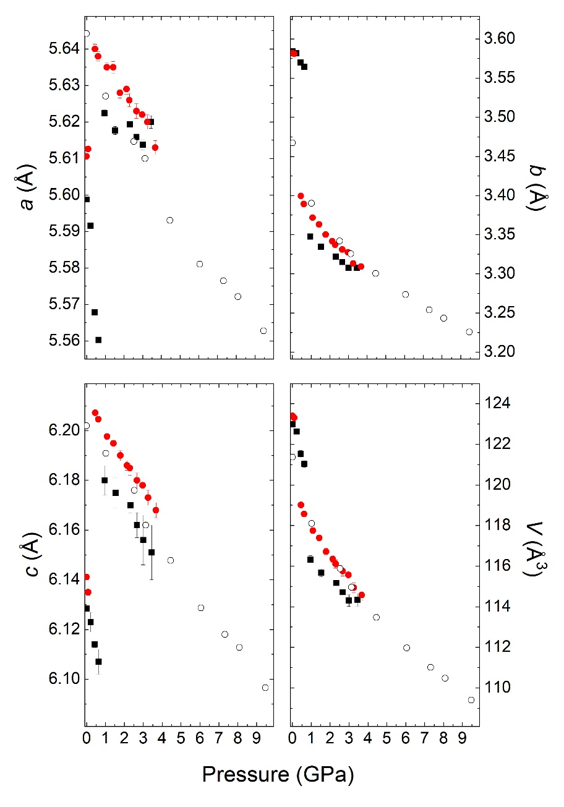

Figure 1.

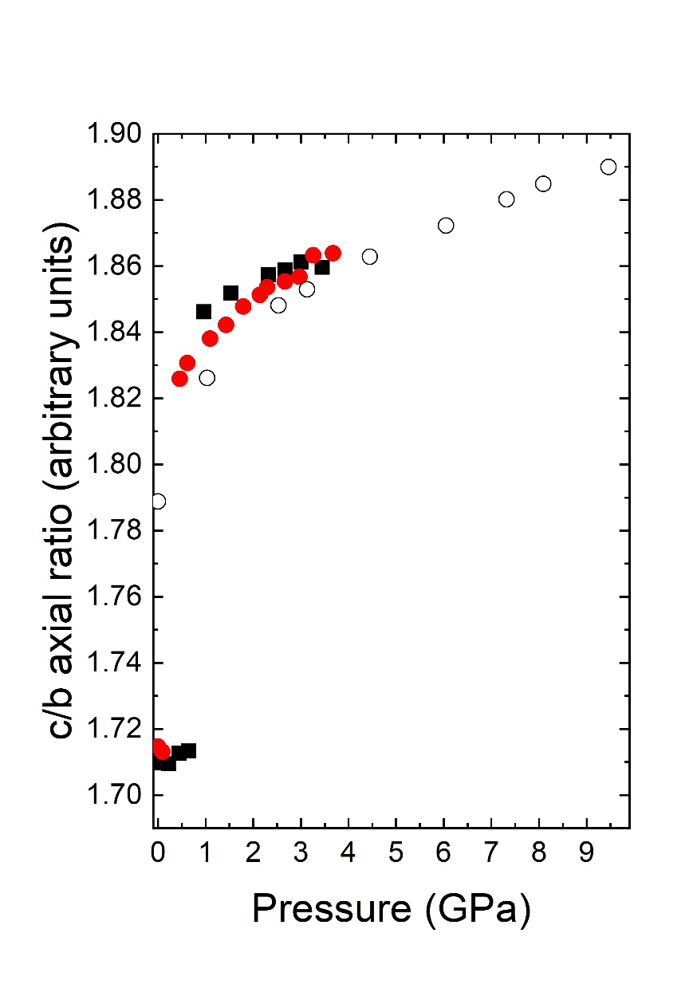

Figure 2.

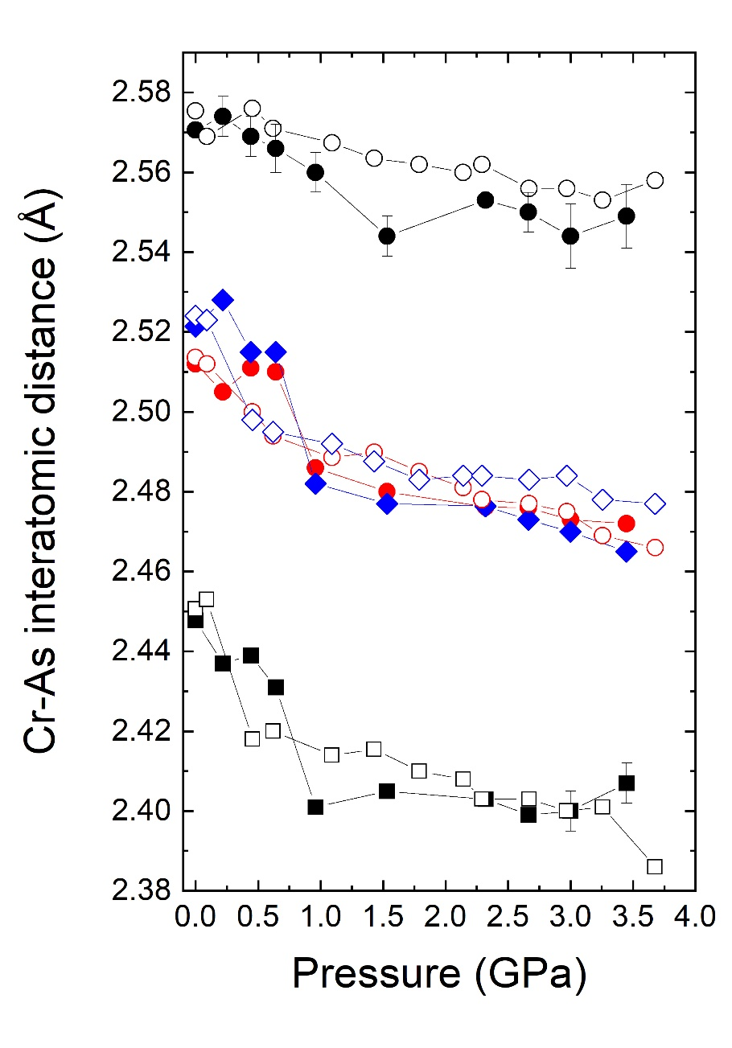

Figure 3.

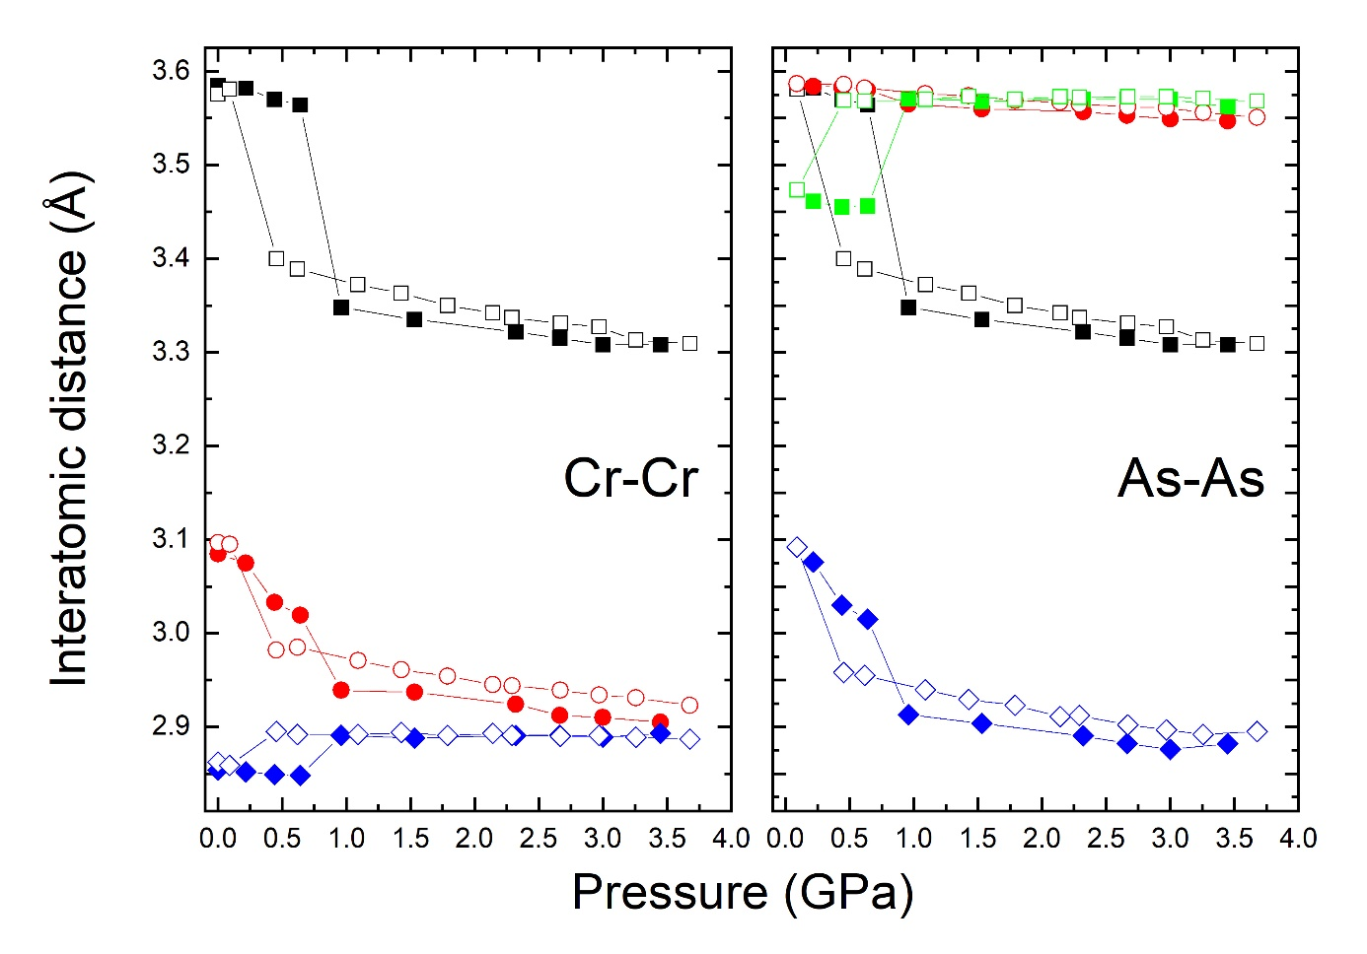

Figure 4.

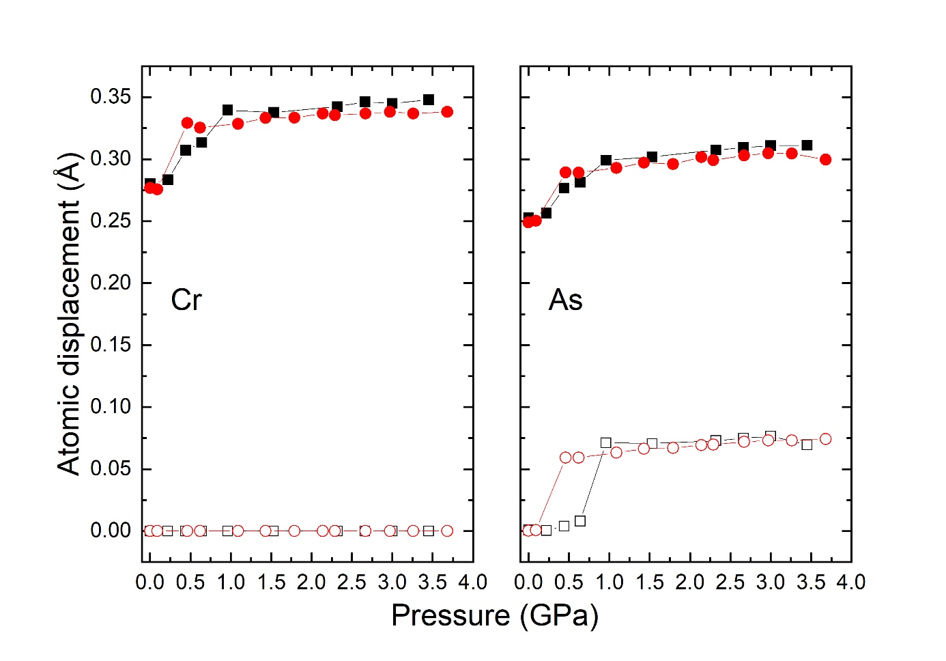

Figure 5.

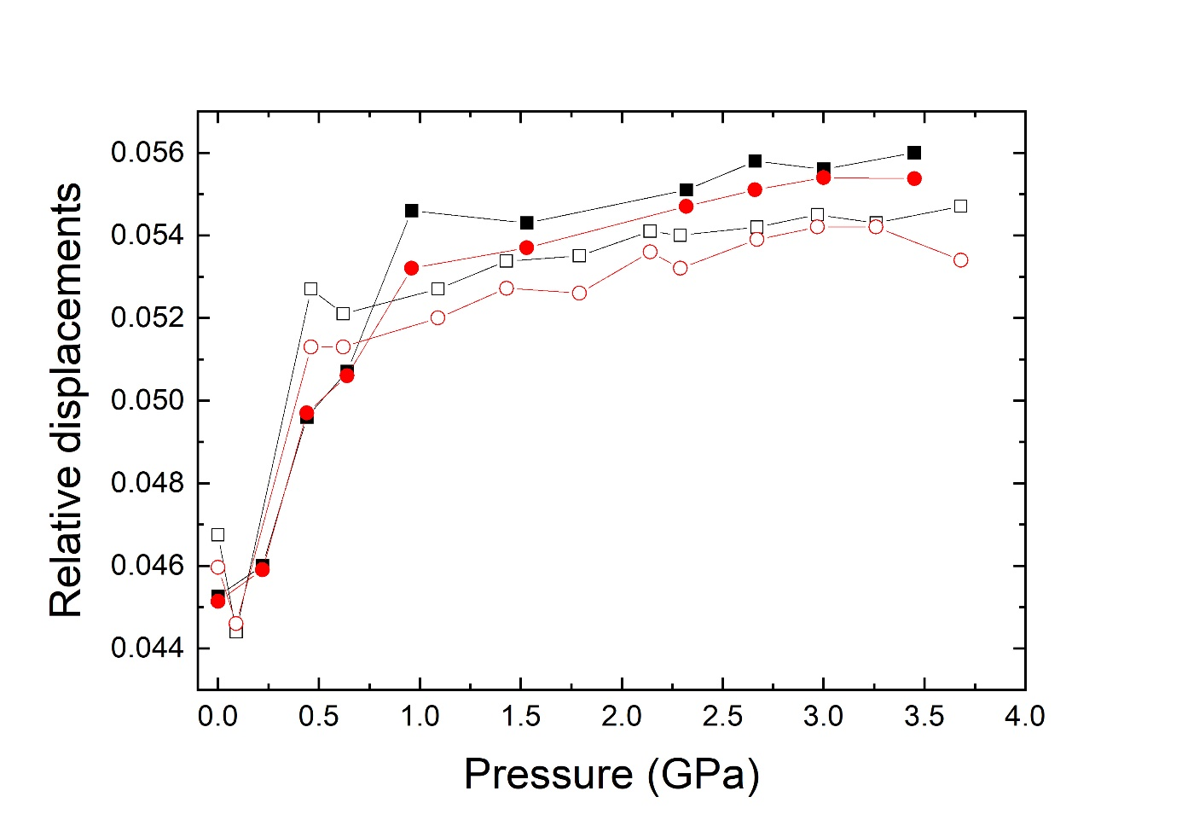

Figure 6.

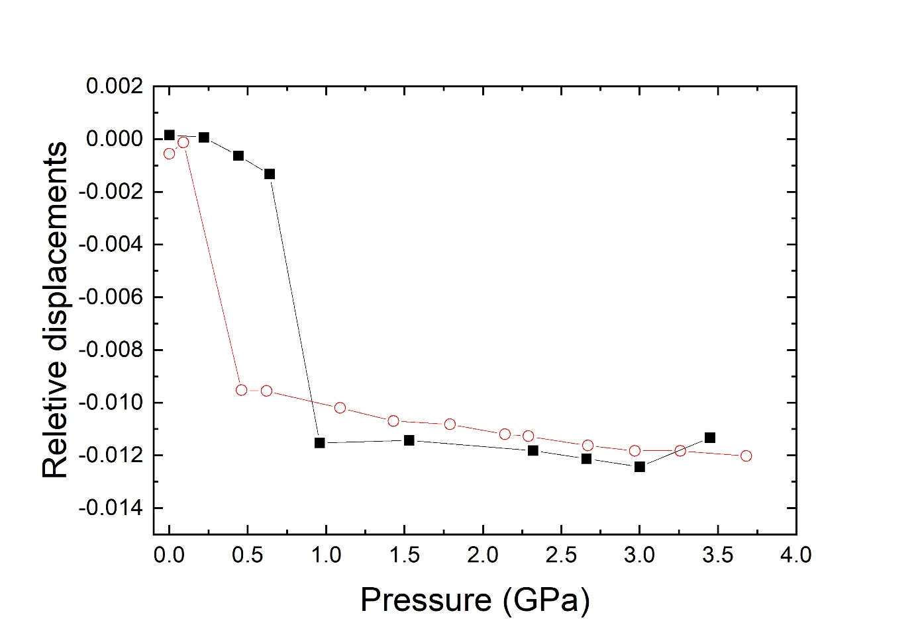

Figure 7.