Progress in Research and Development of Solid Oxide Cells, Stacks and Systems at Forschungszentrum Jülich

F. Kunza, R. Petersa, D. Schäfera, S. Zhanga, N. Krusea, L. G. J. de Haarta, V. Vibhua, R.-A. Eichela,b, N. H. Menzlerc, C. Lenserc, D. Naumenkod, T. Kadyke, N. Margaritisf, and S.-M. Groß-Barsnickf

a Forschungszentrum Jülich GmbH, Institute of Energy and Climate Research – Fundamental Electrochemistry (IEK-9), 52428 Jülich, Germany

b RWTH Aachen University, Institute of Physical Chemistry, Templergraben 55,   
52074 Aachen, Germany

c Forschungszentrum Jülich GmbH, Institute of Energy and Climate Research – Materials Synthesis and Processing (IEK-1), 52428 Jülich, Germany

d Forschungszentrum Jülich GmbH, Institute of Energy and Climate Research – Microstructure and Properties (IEK-2), 52428 Jülich, Germany

e Forschungszentrum Jülich GmbH, Institute of Energy and Climate Research – Theory and Computation of Energy Materials (IEK-13), 52428 Jülich, Germany

f Forschungszentrum Jülich GmbH, Central Institute of Engineering, Electronics and Analytics – Engineering and Technology (ZEA-1), 52428 Jülich, Germany

Forschungszentrum Jülich has been involved in the research and development of SOCs for more than 30 years. In this work, selected highlights on material, cell, stack and system development are presented, whereas improving performance and understanding degradation phenomena were in the focus. On cell level, operation in steam, co-electrolysis as well as pure CO2 electrolysis mode was researched. A hierarchical degradation model framework was developed that relates changes at the level of electrode particles to changes in electrode structure, resulting materials properties and overall lifetime-performance. On stack level, progress in clarification and optimization of performance and lifetime relevant processes was made. The role of contaminants, foremost silicon species and sulfur dioxide in feed gases, was investigated to support technical applications. On system level, an rSOC system with an output power of 10 kW in fuel cell mode and an input power of 40 kW in electrolysis mode was developed.

Introduction

The defossilization of the energy, mobility and industry sectors requires the transfer of sustainable, carbon-neutral technologies and processes into application. Along with the development of a global hydrogen economy, technologies that generate, store, distribute and use hydrogen and its derivatives are particularly relevant. Considerable potential in this sense is offered by the solid oxide cell (SOC), which can be operated as a fuel cell (SOFC), an electrolysis cell (SOEC) and a reversible cell (rSOC). Forschungszentrum Jülich has been involved in the research and development of SOCs for more than 30 years. In addition to material and cell development, the stack and system development and understanding degradation effects are among the main topics today.

In the area of the development and investigation of cells and materials, the performance of the SOC in the fuel cell mode as well as in the electrolysis mode was in the focus. In addition to operation in steam and co-electrolysis modes, operation in pure CO2 electrolysis was also investigated. On single cell level the degradation behavior in the different modes of electrolysis operation was investigated (1-5). Different alternative materials were examined both on the fuel side (f.i. Ni-GDC (4-5), (La,Sr)MnO3 (6), Sr2Fe2‑xMox‑yMyO6‑δ (7)) and on the air side (f.i. La2‑xSrxNi0.8Co0.2O4+δ (3)) as well. A hierarchical degradation model framework was developed that relates changes at the level of electrode particles to changes in electrode structure, resulting materials properties and overall lifetime-performance. Model-based diagnostic allows the extraction of model parameters from experimental data, model verification as well as identification and quantification of different degradation mechanisms.

With a focus on the SOC stack, progress was made both in the area of actual stack development and in the area of clarification and optimization of performance and lifetime relevant processes. The role of contaminants, foremost silicon species and sulfur dioxide in the feed gases, was investigated to support technical applications. Headway was also made in applying advanced measuring technology like fibre-optic sensors for temperature measurements in air channels. Degradation processes were investigated both experimentally and simulatively in fuel cell as well as in steam and co-electrolysis operation. On the one hand, machine learning approaches were pursued to analyze degradational patterns in SOC stacks, utilizing a specifically consolidated and curated set of long-term experiments and EIS measurements. On the other hand, a multiphysical stack model was developed that allows the relevant physical processes within the stack to be analyzed individually and coupled and thus to optimize the overall operation of the stack.

Recently, an rSOC system with a nominal output power of 10 kW in fuel cell mode and input power of 40 kW in electrolysis mode was developed. Four SOC sub-stacks, separated and surrounded by a total of five heating plates plus an air preheater at one end and a fuel preheater at the other end, form the Integrated Module of the system; each stack has 20 layers with an active cell area of 19 cm x19 cm. A compact and optimized design could be realized, which achieves a system efficiency of 63.3 % and 71.1 % with respect to the lower heating value in fuel cell mode and electrolysis mode, respectively. The system has already been tested in stationary operation modes. Current developments focus on the operating strategy, in particular on the temperature control of the stack in fuel cell mode and during the transient operation of the system.

Results and Discussion

Electrode Development

The conventional Ni-cermet fuel electrode (Ni / 8 mol% yttria stabilized zirconia (8YSZ)) exhibits several issues during long-term SOEC operation of which the Ni agglomeration is most detrimental. Therefore, to avoid such issues, Ni-free electrodes are considered, like La0.6Sr0.4MnO3 (LSM) based perovskite oxides as fuel electrode (6). LSM is a purely electronic conductor and is well known as oxygen electrode for SOCs. Under reducing atmosphere, the LSM perovskite phase transforms into a Ruddlesden-Popper (RP) (La0.6Sr0.4)2MnO4±δ phase and MnOx. Single cells were prepared by screen printing the LSM electrodes on an 8YSZ electrolyte foil. Next to a pure LSM layer, also composite layers of the LSM with 8YSZ and with Gd0.2Ce0.8O2 (GDC) were prepared. On the air side the conventional two-layer LSM+8YSZ//LSM electrode was screen printed. XRD analysis of the reduced LSM powder showed the pure RP (La0.6Sr0.4)2MnO4±δ phase along with nano-sized MnOx-particles, that were exsolved out and distributed on the surface of RP LSM (6).

Figure 1 shows the current-voltage characteristics of the single cells with the three different LSM-based fuel electrodes under steam electrolysis conditions with a 50 % N2 + 50 % H2O feed gas mixture. A comparable good cell performance is observed for both the pure LSM and the LSM+GDC composite fuel electrode containing single cells. However, a lower performance is observed for the LSM+YSZ composite fuel electrode containing single cell. A detailed analysis of the recorded impedance spectra and post-test examination of the samples is being conducted in order to give more insight in this difference in performance of the three LSM-based electrodes.

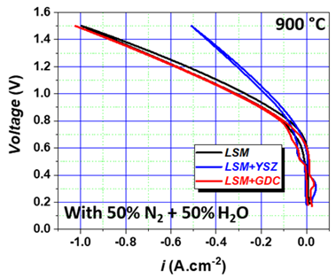

Figure 1. Current-voltage characteristics of single cells containing different fuel electrodes: LSM, LSM+GDC, and LSM+YSZ. The characteristics were recorded at 900 °C. The feed gas mixture consisted of 50 % N2 and 50 % H2O.

Electrode-Electrolyte Interfaces

State-of-the-art air-electrode materials like LSC(F) are known to react with YSZ electrolyte material to form electrically insulating SrZrO3 (SZO) (8). It was recently shown that even a very thin interdiffusion layer at the interface of GDC and YSZ is enough to prevent SZO formation (8). Thus, the authors recently developed such a thin interdiffusion zone by applying a screen-printed Pr-doped ceria (PCO) layer on YSZ. The large chemical expansion of PCO in air leads to the disintegration of the PCO microstructure during cooling, since the contraction mismatch with regards to the YSZ leads to critical stresses. Nevertheless, there remains an interdiffusion zone and a very thin layer of PCO on the YSZ support, which gives rise to the functionality expected from a barrier layer. Impedance analysis shows an exponential dependence of electrode polarization and sintering temperature, i.e. the extend of the interdiffusion zone. For example, sintering the PCO layer at 1400 °C leads to a decrease of the electrode ASR of more than 2 orders of magnitude compared to PCO layers sintered at 1300 °C magnitude (9). These results prove the hypothesis that for the minimization of the foreign phase formation between YSZ-GDC-LSC(F), a thin interdiffusion layer between YSZ and the ceria is necessary.

Hierarchical Degradation Model Framework

The main contribution to irreversible performance losses stems from microstructural and compositional changes in the fuel electrode. However, the detailed nature and interplay of the degradation mechanisms involved, like sintering of catalyst particles, Ostwald ripening, catalyst migration, and catalyst poisoning, are not yet fully understood (9-11). The authors’ modeling work on the cell level focuses on the development of a hierarchical model that links the microstructural evolution to changes of materials properties and, ultimately, to the loss of performance during operation of the cell. In the modeling framework depicted in Figure 2, a particle population balance approach (12) relates changes at the level of electrode particles due to sintering, poisoning, dissolution, or Ostwald ripening to the evolution of the particle radius distribution (PRD). Percolation theory (13) is used to link these structural changes to effective materials properties, i.e., electronic and ionic conductivities and catalytic activity. A macro homogeneous model (14) uses these effective properties to calculate the rates of transport and reactive processes, ultimately determining the electrode performance. Properly parameterized, this hierarchical model allows analyzing the coupling between changes in local microstructure, materials properties, local reaction conditions, and electrochemical performance. A dynamic diagnostic model for the electrochemical impedance allows a comparison with experimental EIS spectra, which can be used for extraction of part of the model parameters, model verification as well as identification and quantification of different degradation mechanisms. With these capabilities, the hierarchical modeling framework provides guidance for materials development and cell fabrication.

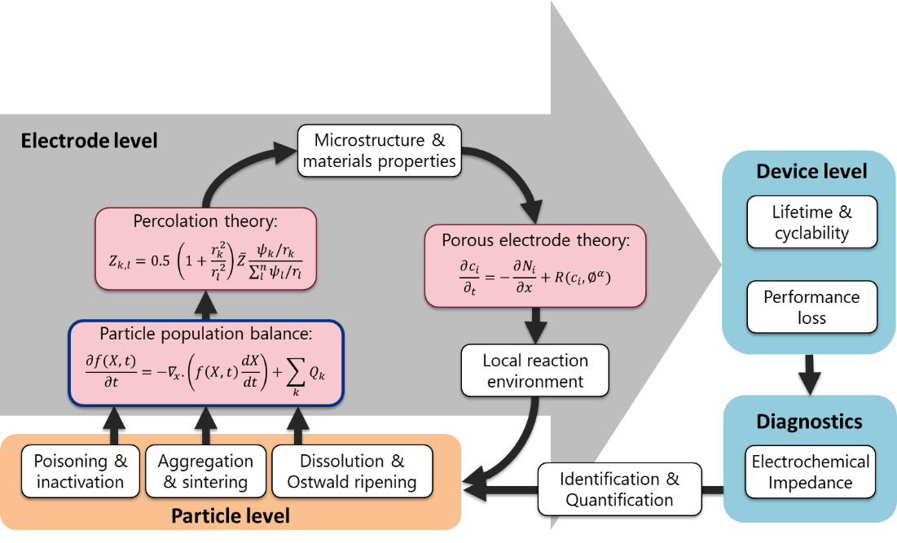

Figure 2. Hierarchical model framework for prediction and analysis of degradation in solid oxide cells. It combines particle level, electrode level, device level and diagnostics.

Stack Characterization and Degradation Analysis

One prominent branch of stack testing and characterization at the Forschungszentrum Jülich is the co-electrolysis mode. Current state-of-the-art fuel electrode supported cells can maintain high current densities of 1.5 A cm-2 in the F10 design stacks, but various degradation effects are now in the investigative focus, e.g. poisoning effects due to chromium, silicon and sulfur. The authors’ findings confirm previous investigations in so far that the co-electrolysis process is very susceptible to sulfur dioxide poisoning. Over long periods of operation with clean feed gases, a mostly complete recovery was observed. However, any carbon dioxide feed needs to ensure SO2 concentrations in the low ppb range. The poisoning impacts mainly the charge-transfer process in the fuel electrode as is known with H2S poisoning in fuel-cell mode operation, and likely a transport or solid-state-diffusion process in the fuel electrode, but not the high frequency series resistance. In standby/OCV conditions (i.e. without polarization) with co-electrolysis feed gases, some continued degradation and changes of the electrode processes was observed after removal of SO2 from the feed. Harmful silicon impurities can be introduced by balance of plant components like gas preheaters (15) and were successfully localized in the functional layer of cells after steam electrolysis operation. Steam generators can transport a number of species into the gas phase when operation in unstable regimes (15) and their role is under investigation as well.

Instrumentational improvements are being developed to better monitor cell temperature distributions in the stack during operation. To introduce novel temperature sensing techniques for SOC stacks, a five-layer F10 stack was modified to retrofit an optical fiber comprised an array of seven regenerated fiber Bragg grating (RFBG) sensors. The RFBG sensors demonstrated excellent high temperature resilience up to 800 °C. The non-conductive nature and chemical inertness of silica allowed a safe employment of optical fiber sensors in the SOC stack. The compact size and multiplex capability of this sensor provided a new avenue to study the temperature distribution directly inside the SOC stack, which was in practice hardly accessible with conventional thermocouples. The newly employed technique revealed a different temperature distribution inside the air channel of one stack layer than what the thermocouples suggested.

Reducing operation temperatures for SOC stacks is always an important investigative field. The oxidation resistance of steel components in stacks, such as interconnects is known to be good for majority of the service conditions at temperatures of 700 to 800 °C. However, when the stack is to be operated at lower temperatures, i.e. below 600 °C the steel oxidation rate can increase and Fe-rich oxide formation can occur depending on a number of parameters including the water vapor content in the service atmosphere, exact steel chemical composition, its microstructure and surface finish. This was demonstrated in a recent study of components produced from Crofer 22 APU after a stack operation at 500 °C (16). The major issue is slow Cr diffusion in the alloy grains, which may require using fine grained steel and/or specific surface treatments to obtain protective chromia base scale formation.

Data Analysis

In the field of data analysis and evaluation the authors pursued to contribute to data-driven degradation analysis for SOC stacks and to utilize the vast set of long-term stack experiments conducted at FZJ. However, electrochemical impedance spectroscopy (EIS) data from recent years exhibit varying instabilities and undesirable attributes that would adversely affect pattern recognition processes. Therefore, and to address the automatic feature extraction for a considerable amount of EIS data, the authors developed a python-based data curation pipeline. Leveraging these and sequential data from test rigs, both from historical and future experiments, the authors develop models for SOC stack lifetime and failure analysis.

Post-Test Characterization

An in-depth post-test characterization was performed on an SOFC stack that had run for 93,000 hours (and been at operation temperature for 100,000 hours) (17). The major findings were (18):

* Formation of a Cr, Mn, Co and Cu containing foreign phase on top of the contact layer adjacent to the manganese oxide Cr retention layer. It is concluded that the Mn-oxide reacts during long-term operation with elements from the LCC12 layer.
* Concerning the LSCF air electrode, Cr-rich phases could be identified in all three regions: i) on top of the layer adjacent to the contact layer, ii) at the border to the GDC barrier layer and iii) within the bulk air-electrode structure.
* At the interface between the LSCF and the GDC other foreign phases containing mostly Co, Cr and Sr have been formed. Also, here additional Raman-spectroscopy reveals the formation of Sr-chromate.

In conclusion the additional post-test evaluation of the long-term operated SOFC stack shows some expected interactions but also some unexpected ones. The interplay between all these layers (electrolyte, barrier, air-electrode, contacting, Cr-retention layer and native oxide scale) over time and temperature are complex and multilayered and they happen on different time scales and during different time periods of operation.

Repair Joining of Stacks

After the first promising preliminary tests with sandwiched samples made of Crofer22APU and state-of-the-art glass sealant of Forschungszentrum Jülich reported in (19), upscaling of the novel procedure on leaking SOFC stacks was carried out. One stack in F10-design and two stacks of H20-design were repair joined at 930 °C. The stack F1004-37 has shown very low leakage rates with good electrochemical behavior after the reparation step. This finding was confirmed with one of the two stacks in H20-design, unfortunately the third reproduction did not improve the leakage values at all. Further tests on stacks under realistic conditions are necessary to evaluate this method.

Recycling

The authors started to generate recycling or re-using strategies for SOC systems (20). The basic idea is to dismantle the stacks and separate at least three fractions: i) metal parts (mostly interconnects, frames, top and base plates; Ni mesh), ii) ceramic parts (the cell) and iii) miscellaneous (sealing, coatings).

The philosophy is to separate the air-side materials (electrode and possibly the contact layer) from the rest of the cell. This is done by leaching the LSC(F) with acids from the remaining ceramic fractions. Choosing the right acid, it’s concentration, the contact time and temperature and stirring leads to a complete dissolution of the air-side materials from the barrier / electrolyte / fuel electrode / support part. Especially if the Ni in the support and fuel electrode are re-oxidized, the separation is close to ideal. The dissolved fraction can be used to recover either raw materials or precursors of the air-side materials. Most critical and valuable here are lanthanum and cobalt.

The rest of the cell is then coarsely crushed, milled and re-used as raw material for a new fuel-electrode support. First tests with 0, 25 and 50% recycled amount show promising results with respect to castability, drying and sintering and final microstructure (21).

Stack Modelling and Simulation

To complement stack experiments and data evaluation, a three-dimensional time-dependent model that predicts the degradation due to chromium poisoning in the SOFC stack was developed using OpenFOAM. The model can reveal the spatial distribution of surface coverage of Cr2O3 and SrCrO4 on LSCF. Quantitative analysis of degradation owing to chromium poisoning can be achieved by the model and voltage degradation can be simulated over 100 kh. In addition, the model considers the influence of protective coatings. According to the simulation, it is found that with atmospheric plasma-spraying (APS) protective coating, the contribution of chromium poisoning to overall degradation in the SOFC stack is almost negligible.

Another focus of modelling activities is to elucidate the degradation of Ni-YSZ electrodes within the typical operating temperatures ranging between 700-800 °C which seriously harms the performance of SOCs. The evolution of microstructure in SOC electrodes involves complex physical and chemical processes. Notably, the redistribution of Ni and YSZ materials is a significant change that occurs during the lifetime of SOCs, which can greatly affect the percolation of the solid matrix and pores in the electrodes. To study the evolution of the microstructure of Ni/YSZ, the phase field method (PFM) has been introduced, which enables the study of Ni particle redistribution. An open-source computational fluid dynamics (CFD) package, openFuelCell2, is developed based on OpenFOAM, which shows the ability to describe the detailed physical transport phenomena, including electrochemistry on the triple-phase-boundaries (TPBs), charge transfer, species diffusion, and heat and mass transfer, etc. A workflow on how to couple the PFM and CFD is provided. Figure 3 shows the simulation results of the Ni agglomeration and the redistribution of TPBs. It can be seen that smaller Ni particles gradually vanish while the larger ones grow. Meanwhile, the number of active TPBs decreases.

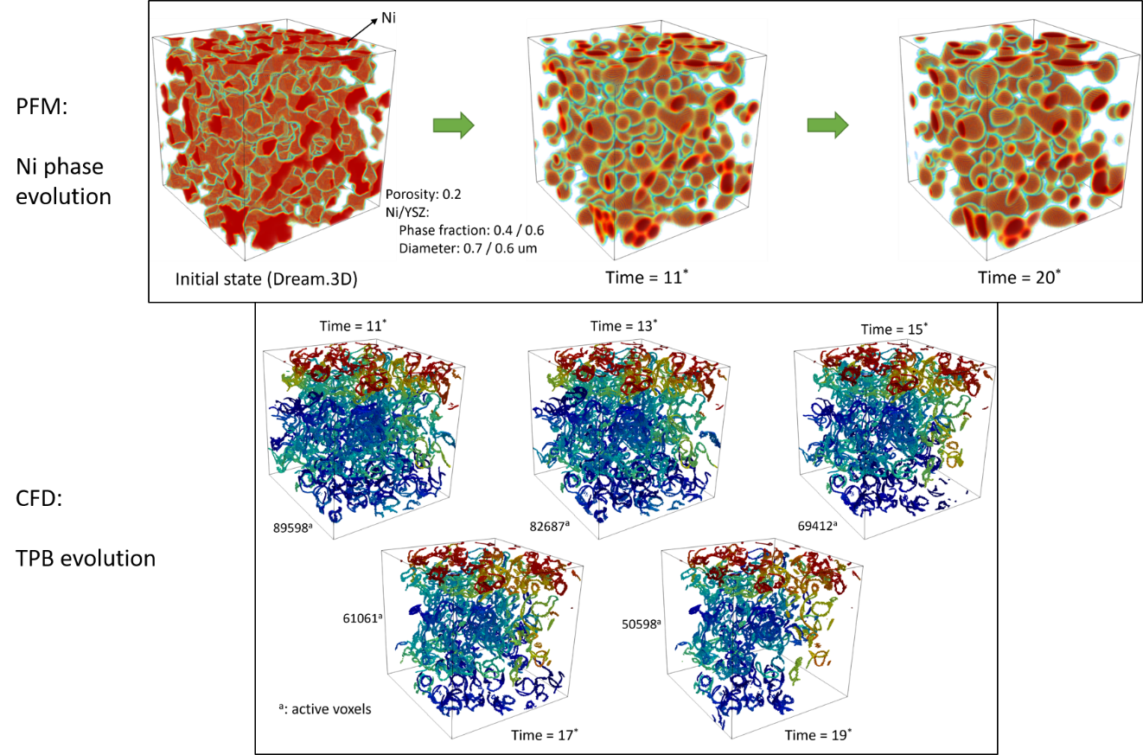

Figure 3. Simulation results from phase field method (PFM) and computational fluid dynamics (CFD), which represents the Ni agglomeration and its effects on the redistribution of triple-phase-boundaries (TPBs).

rSOC System Development

Driven by the positive experiences during the operation of the 5/15 kW rSOC system (22), it was scaled to the 10/40 kW class (23). The stack of the new system consists of four 20-layer sub-stacks in the planar-type window frame design (Mark H20). A total of four cells measuring 10 cm × 10 cm with an active area of 81 cm² for each of the four cells are installed in a layer of the stack.

Figure 4 shows the assembled rSOC system.

The basic system structure was adopted from the previous system, whereby the performance of the stack and the balance of plant (BoP) components must be adjusted to higher power class. After completion, system operation began. Within the scope of these tests, a maximum efficiency of 63.3 % in fuel cell mode and 71.1 % in electrolysis mode was achieved, each based on the lower heating value of hydrogen. To further improve the system efficiency in electrolysis mode, a steam generator with heat recovery from the product stream leaving the system was developed. Here also a prototype was built and tested. The test reveals that the system efficiency in electrolysis mode can be increased by about 4 percentage points (24).

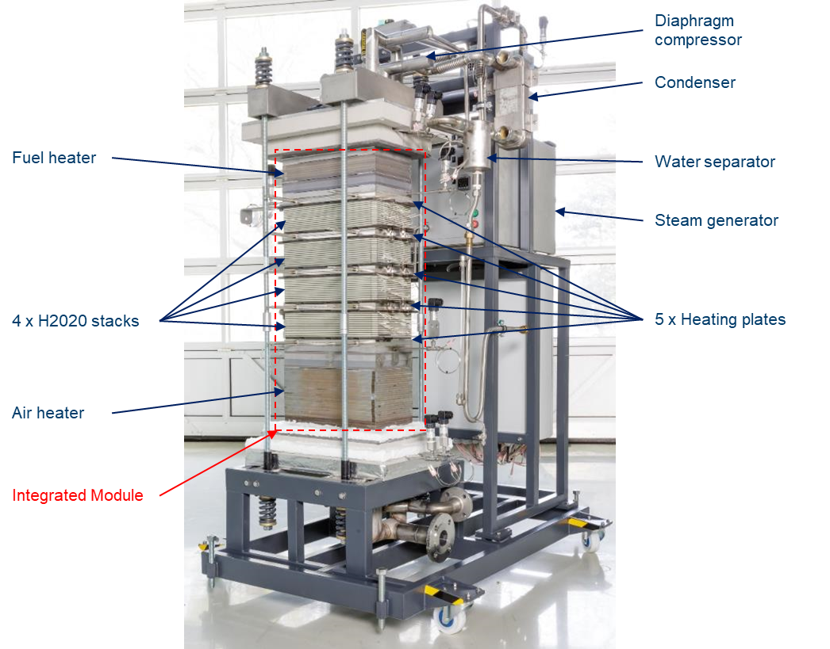

Figure 4. Assembled rSOC core system. The integrated module represents the core of the system, which consists of four SOC sub-stacks, separated and surrounded by a total of five heating plates plus an air preheater at one end and a fuel preheater at the other end.

Temperature Control for SOFC

Different controller topologies for fuel cell operation of the rSOC system were designed and experimentally evaluated. The first controller design uses a PID controller to control a weighted average temperature of the integrated stack module. In the experiments, the controller showed a stable and robust behavior. A limitation of this controller is given by the significant dependency of the maximum temperature on operating conditions like current density. The second design incorporates an Artificial Neuronal Network (ANN) for predicting the optimal average temperature to achieve a constant maximum stack temperature independent from operating point. When applying this controller to the rSOC system a stable behavior as well as a reduced dependency of the maximum stack temperature on operating conditions could be reached.

Acknowledgments

The authors wish to thank all contributing staff members of Forschungszentrum Jülich for their continuing excellent work and the Helmholtz Society, the German Federal Ministry of Education and Research as well as the Federal Ministry for Economic Affairs and Climate Action for financing the SOC research and development at Forschungszentrum Jülich.

References

1. S. E. Wolf, V. Vibhu, E. Tröster, I. C. Vinke, R.‑A. Eichel, and L. G. J. de Haart, *Energies* **15**(15), 5449 (2022).
2. S. E. Wolf, L. Dittrich, M. Nohl, T. Duyster, I. C. Vinke, R.‑A. Eichel, and L. G. J. de Haart, *J. Electrochem. Soc.* **169**, 034531 (2022).
3. I. D. Unachukwu, V. Vibhu, I. C. Vinke, R.‑A. Eichel, L. G. J. de Haart, *Energies* **15**(6), 2136 (2022).
4. I. D. Unachukwu, V. Vibhu, I. C. Vinke, R.‑A. Eichel, and L. G. J. de Haart, *J. Power Sources* **556**, 232436 (2023).
5. I. D. Unachukwu, V. Vibhu, I.C. Vinke, R.‑A. Eichel, and L.G.J. de Haart, *J. of CO2 Utilization* **69**, 102423 (2023).
6. V. Vibhu, I.C. Vinke, R.‑A. Eichel, L.G.J. de Haart, *ECS Trans.* This issue (2023).
7. S. E. Wolf, V. Vibhu, C.L. Coll Torrado, N. Eyckeler, I.C. Vinke, R.‑A. Eichel, and L.G.J. de Haart, *ECS Trans.* This issue (2023).
8. J. Szász, F. Wankmüller, V. Wilde, H. Störmer, D. Gerthsen, N. H. Menzler, and E. Ivers-Tiffée, *J. Electrochem. Soc.* **165** (10), F898-F906 (2018).
9. C. Lenser, A. Schwiers, D. Ramler, and N. H. Menzler, *ECS Trans.* This issue (2023).
10. R. Knibbe, A. Hauch, J. Hjelm, S. D. Ebbesen, and M. Mogensen, *Green* **1** (2011).
11. M. B. Mogensen, M. Chen, H. L. Frandsen, C. Graves, A. Hauch, P. V. Hendriksen, T. Jacobsen, S. H. Jensen, T. L. Skafte, and X. Sun. *Fuel Cells,* **21**(5), 10 (2020).
12. P. Urchaga, T. Kadyk, S. G. Rinaldo, A. O. Pistonio, J. Hu, W. Lee, C. Richards, M.H. Eikerling, and C. Rice, *Electrochimica Acta*, **176,** 1500–1510 (2015).
13. D. Chen, Z. Lin, H. Zhu, and R. J. Kee, *J. Power Sources,* **191,** 240–252 (2009).
14. A. A. Kulikovsky, *Electrochimica Acta*, **54,** 6686–6695 (2009).
15. D. Schäfer, L. Queda, V. Nischwitz, Q. Fang, and L. Blum, *Processes* **10**(3), 598 (2022).
16. C. Lenser, J. Zurek, D. Naumenko, C. A Thieu, J. W. Son, U. de Haart, Q. Fang, L. Blum, and N. H. Menzler, *J. Power Sources* 474, 228671 (2020).
17. N. H. Menzler, D. Sebold, Y. J. Sohn, and S. Zischke, *J. Power Sources* 478, 228770 (2020).
18. C. Dellen, S. Tardif, R. R. P. P. R. Purohit, J.-S. Micha, O. Guillon, and N. H. Menzler, *ECS Trans.* This issue (2023).
19. S. M. Gross-Barsnick, J. Malzbender, Q. Fang. *ECS Trans.* **103**, 1859 (2021).
20. S. Sarner, A. Schreiber, N. H. Menzler, and O. Guillon, *Advanced Energy Materials* 12, 2201805 (1-19) (2022).
21. S. Sarner, N. H. Menzler, A. Hilgers, and O. Guillon, *ECS Trans.* This issue (2023).
22. R. Peters, M. Frank, W. Tiedemann, I. Hoven, R. Deja, N. Kruse, Q. Fang, L. Blum and R. Peters, *J. Electrochem. Soc.* (2021).
23. R. Peters, W. Tiedemann, I. Hoven, R. Deja, N. Kruse, Q. Fang, L. Blum and R. Peters, *ECS Trans.* **103**, 289 (2021).
24. N. Kruse, W. Tiedemann, I. Hoven, R. Deja, R. Peters, L. Blum and R. Peters, *ECS Trans.* **103**, 555 (2021).