Prompt gamma rays from fast neutron induced reactions on cerium and chlorine

Niklas Ophoven1,2*, Zeljko Ilic1,3, Eric Mauerhofer1, Tsitohaina H. Randriamalala1,Egor Vezhlev1, Christian Stieghorst4, Zsolt Révay4, Thomas Brückel1,3, Jan Jolie2, Erik Strub2

1Jülich Centre for Neutron Science, Forschungszentrum Jülich GmbH, 52425 Jülich, Germany

2Mathematisch-Naturwissenschaftliche Fakultät, Universität zu Köln, 50923 Köln, Germany

3Lehrstuhl Für Experimentalphysik IVc, RWTH Aachen University, 52056 Aachen, Germany

4Heinz Maier-Leibnitz Zentrum (MLZ), Technische Universität München, Lichtenbergstraße 1, 85748 Garching, Germany

Abstract

Prompt gamma rays of cerium and chlorine were investigated with the FaNGaS (Fast Neutron-induced Gamma-ray Spectrometry) instrument operated at the Heinz Maier-Leibnitz Zentrum (MLZ) in Garching. The gamma radiation was emitted from (n,n’), (n,p) and (n,α) reactions induced by the irradiation of a cerium(III) chloride (CeCl3) sample with a beam of fission neutrons. Additionally, a polyvinylchloride (PVC, (C2H3Cl)n) sample was irradiated to verify possible interferences between gamma lines of cerium and chlorine. We identified 87 prompt gamma lines of cerium and chlorine. From these, we assigned 58 lines to the (n,n’) reaction in cerium (one for 136Ce, 41 for 140Ce and 16 for 142Ce), 23 to the (n,n’) reaction in chlorine (15 for 35Cl and 8 for 37Cl), 5 lines to the 35Cl(n,p)35S reaction and 1 line to the 35Cl(n,α)32P reaction. We present relative intensities and fast-neutron spectrum-averaged partial cross sections of the aforementioned gamma lines and compare them with available literature data. Identification of new lines and discussion of possible errors adds important value to the literature data found to be consistent with our results. In addition, for a counting time of 12 hours we estimate the detection limits for cerium and chlorine as 1 and 2 mg, respectively.

Keywords

Inelastic scattering · Cerium · Chlorine · Fast neutron · Cross section · Gamma ray

Introduction

The advantages of using fast neutrons in non-destructive elemental analysis were demonstrated already several decades ago [1-5]. The FaNGaS (Fast Neutron-induced Gamma-ray Spectrometry) instrument [6-12], installed at Heinz Maier-Leibnitz Zentrum (MLZ) in 2014 and upgraded in 2020, advances this technique in neutron analytics and is available for a broad community of industry and research. At the FRM II (Forschungs-Neutronenquelle Heinz Maier-Leibnitz), the fast neutrons are produced using a highly-enriched uranium (93% 235U) converter in the heavy water moderator. Passing through beamtube SR10, the beam enters the experimental room of the MEDAPP (Medical Application) instrument via a set of filters and collimators [13]. The electromechanically-cooled high-purity germanium (HPGe) detector is placed perpendicularly to the neutron beam. It is surrounded by a complex shielding against neutrons and gamma rays to reduce the spectral background. For the use of the FaNGaS instrument in nuclear analytical chemistry we are (i) continuously improving the instrument to further improve the peak-to-background ratio and (ii) building up a comprehensive data catalogue of (n,n’γ) reactions containing relative intensities and partial gamma-ray production cross sections for all natural elements. This catalogue is intended to update and extend the ”Atlas of Gamma-rays from the Inelastic Scattering of Reactor Fast Neutrons”, by Demidov et al. in 1978 [14], which is the only existing database for this reaction type [15-17]. However, while a database [18] exists based on [14] and a reasonable agreement compared to data evaluated from work at FRM II is generally observed, we also showed the need for a meticulous validation and reevaluation of the data in our former publications [6-12]. Furthermore, the measurements performed at FRM II provide a valuable contribution to the nuclear data community with new gamma-ray data from an alternative fission source with an average incident neutron energy closer to that one expected from a fission spectrum and much higher than in Demidov´s work.

In the present work, we provide the results from the measurement of prompt gamma rays induced by (n,n’) inelastic scattering and (n,p) and (n,α) reactions on cerium and chlorine. The measurements were performed with an upgraded version of the FaNGaS instrument as described in [12]. In order to check if the cerium(III) chloride (CeCl3) sample is free of water and to exclude interferences between chlorine and cerium we also report on the measurement of a polyvinylchloride (PVC, (C2H3Cl)n) sample. Relative gamma-ray intensities and fast-neutron spectrum-averaged partial gamma-ray production cross sections are presented including comparisons with available literature data. In addition, we also give elemental detection limits for cerium and chlorine.

Experimental

Prompt gamma radiation induced by fast neutrons on a CeCl3 powder sample (mass: 2.66 g, Ce: 1.51 g, Cl: 1.15 g) and on a PVC foil (mass: 0.15 g, Cl: 0.08 g, C: 0.06 g, H: 0.01 g) was investigated with the FaNGaS instrument described in [12]. The CeCl3 powder was filled into a small PTFE (Polytetrafluorethylene) bag. The maximum thickness of the sample was estimated to be 5 mm. The thickness of the PVC foil was 0.2 mm. The samples were attached to a thin PTFE rod as the sample holder, and the samples were tilted by an angle of 45° with respect to the beam direction. They were completely irradiated by the fast neutrons with a flux at sample position of (1.13 ± 0.04) × 108 cm-2 s-1 and an average neutron energy of 2.30 MeV. The irradiation time was 3.4 h for CeCl3 and 17 h for PVC, and the live times were 2.7 and 15.4 h, respectively, meaning 20% and 10% deadtimes, respectively. The measurement was performed at a sample-to-detector distance of 67 cm and at an angle of 90° to the beam direction. The acquired spectra were analyzed with the HYPERMET-PC software [19] and they are shown in Figs. 1 and 2. Prompt gamma rays emitted from the (n,n’) inelastic scattering as well as (n,p) and (n,α) reactions of fast neutrons were identified using the NuDat 3.0 database [20] and associated nuclear data from various evaluations for all nuclides relevant to this work [21-27]. Presence of gamma rays from (n,γ) reactions and possible interferences were checked with the prompt gamma neutron activation analysis (PGNAA) database [28].

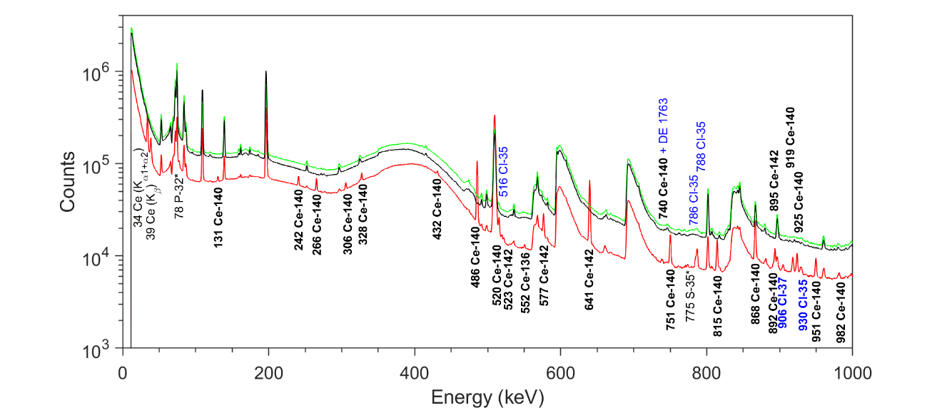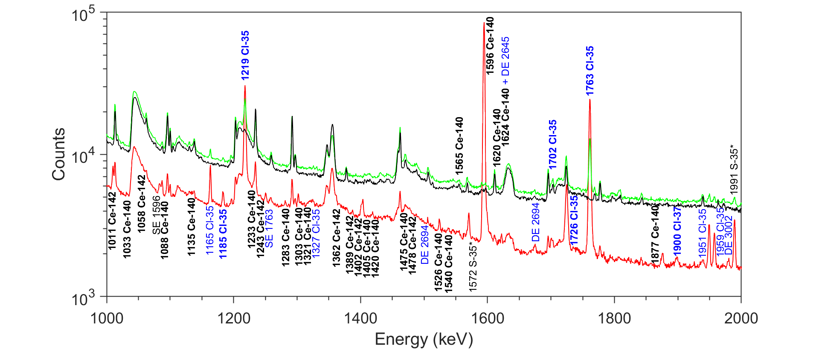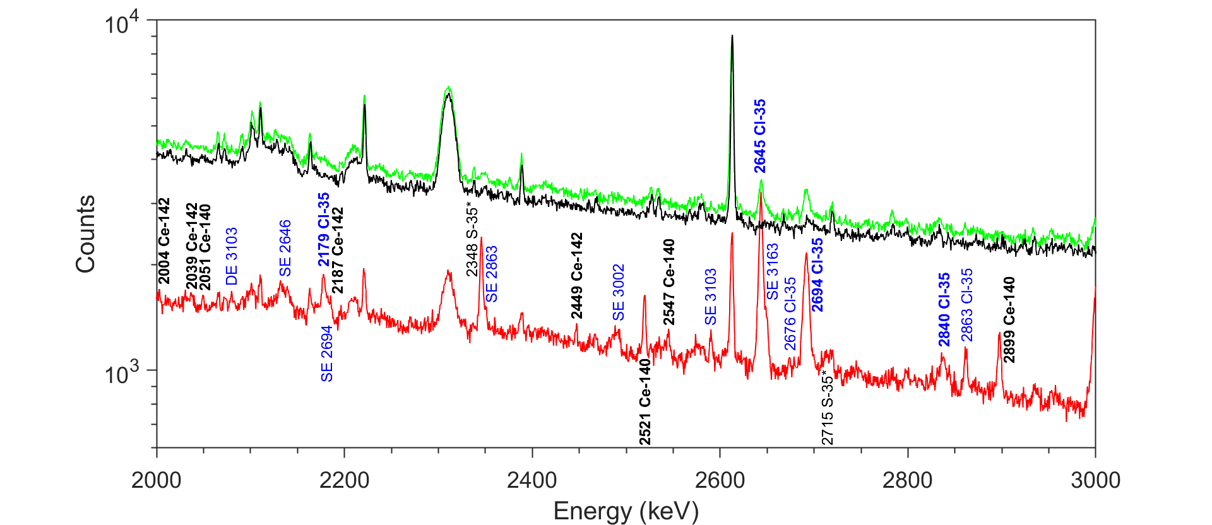

**Fig. 1** Gamma-ray spectra in the energy range 0-3000 keV acquired during 55,478 s counting live time for the PVC sample (green), 9,743 s for the CeCl3 sample (red) and during 51,506 s for the beam background (black). Prompt gamma rays induced by (n,p) reactions (S-35) and (n,α) reactions (P-32) on Cl-35 are written in black with an asterisk. Other lines marked in black but without an asterisk represent X-rays from cerium. Prompt gamma rays issued from (n,n’) inelastic scattering of fast neutrons on cerium are written in black and bold. They are written in bold blue for the case of chlorine. Lines in light blue are capture gamma rays from Cl-35. Abbreviations SE and DE indicate single and double escape peaks, respectively*.* The origin of prominent lines attributed to the beam background is discussed within our former publications [7,9]

**Fig. 2** Gamma-ray spectra in the energy range 3000-8000 keV acquired during 55,478 s counting live time for the PVC sample (green), 9,743 s for the CeCl3 sample (red) and during 51,506 s for the beam background (black). Prompt gamma rays issued from (n,n’) inelastic scattering of fast neutrons on cerium are written in black and bold. They are written in bold blue for the case of chlorine. Lines in light blue are capture gamma rays from Cl-35. Abbreviations SE and DE indicate single and double escape peaks, respectively*.* The prompt line of C-12 was observed in the PVC measurement.The origin of prominent lines attributed to the beam background is discussed within our former publications [7,9]

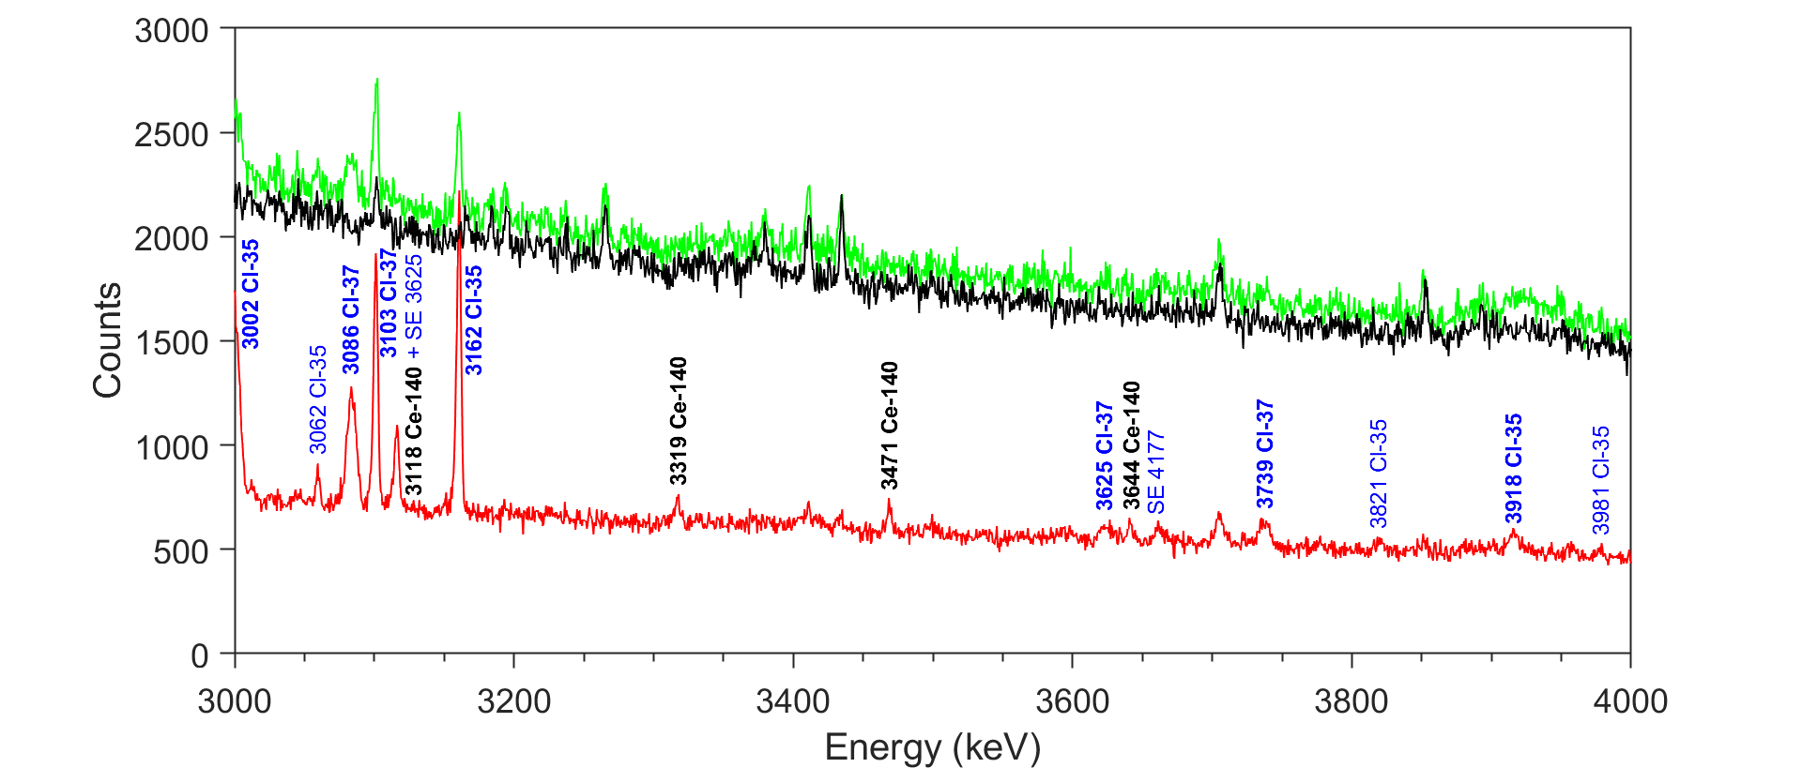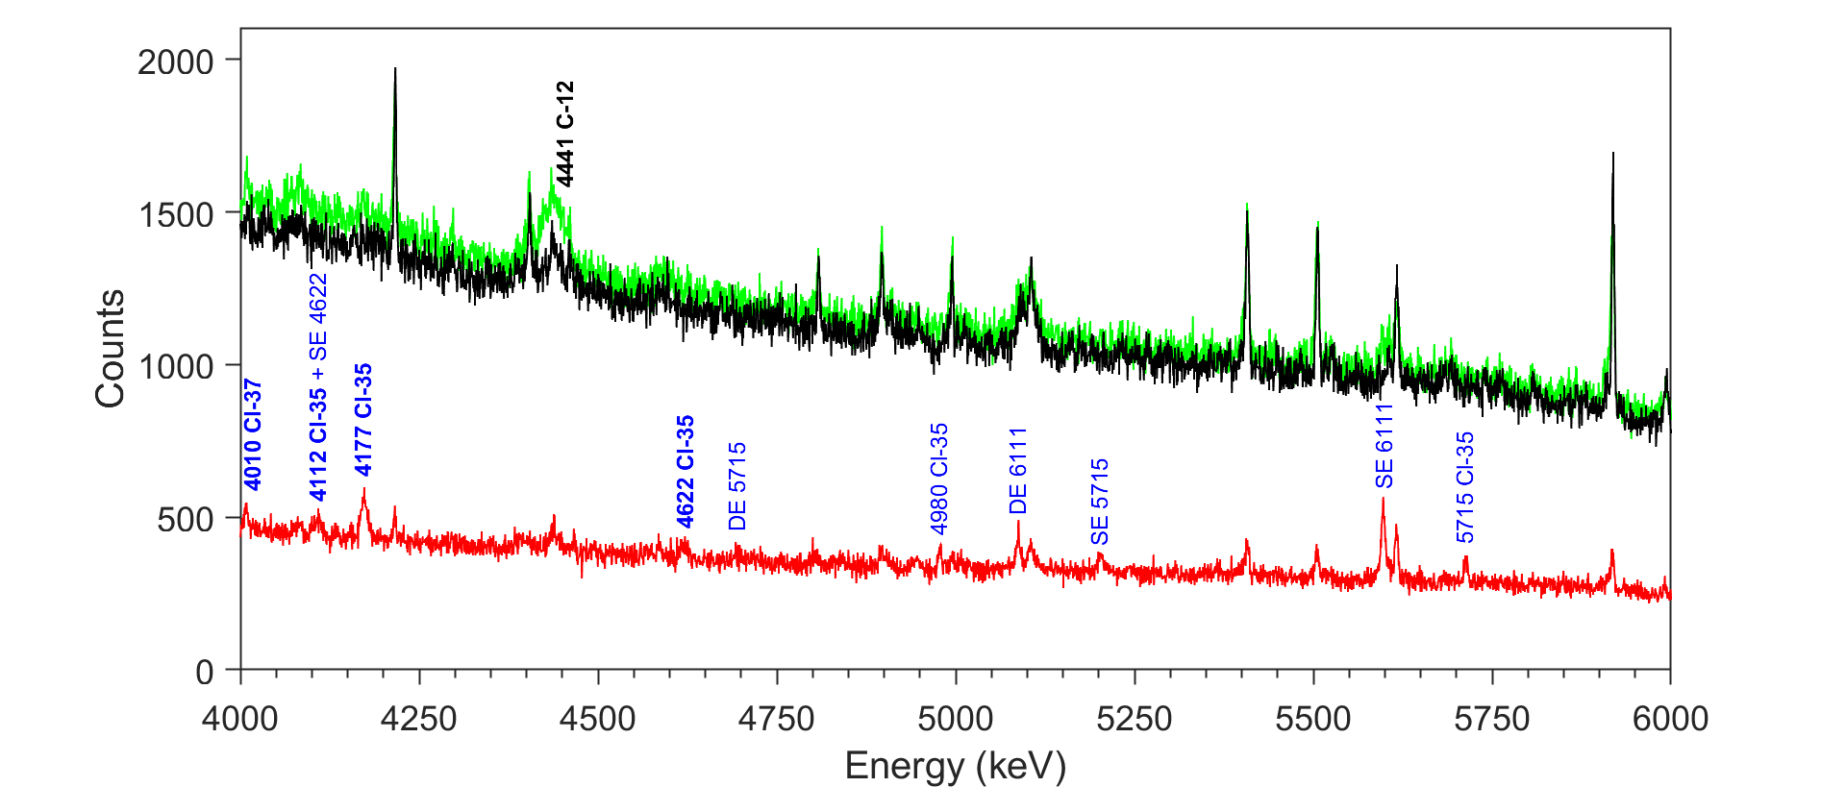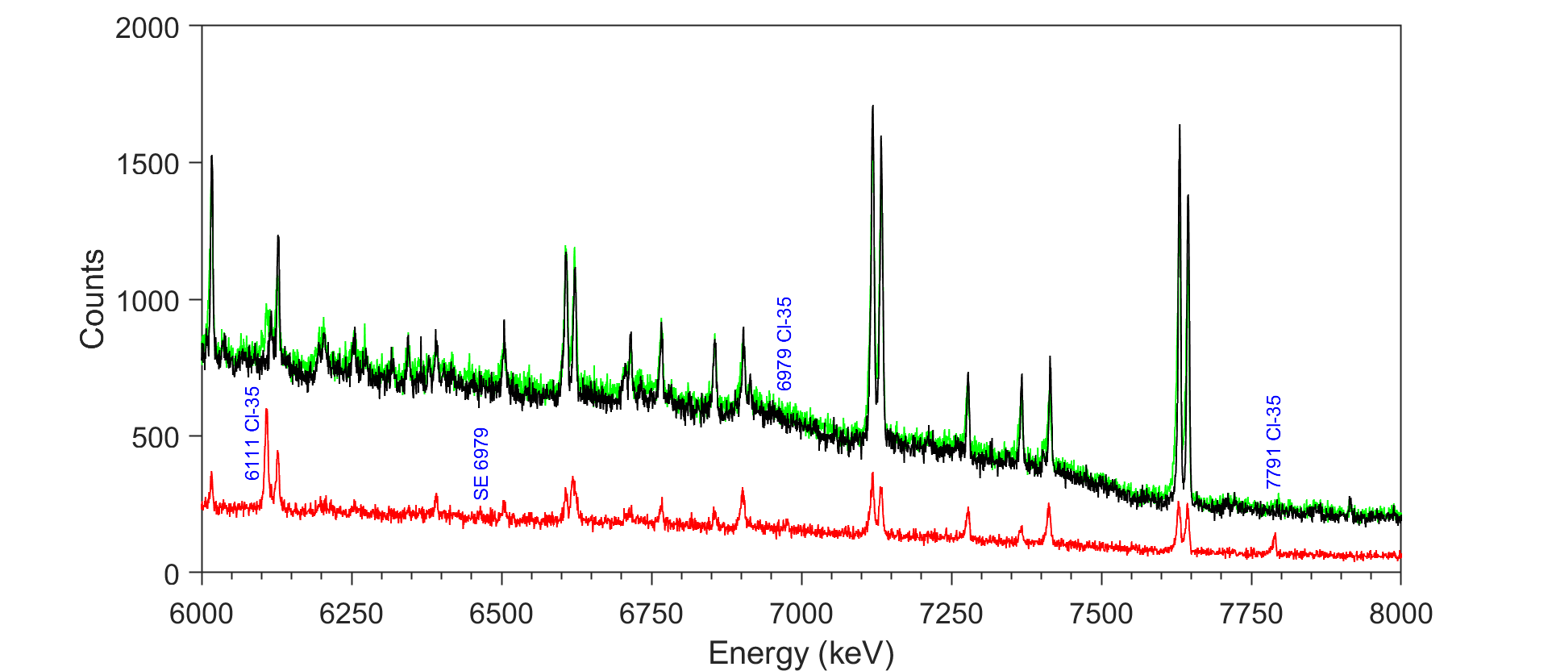

As a certain fraction of neutrons scatters towards the spectrometer, we have observed an increase of the count rate of the background lines. For the CeCl3 sample, we found a mean factor of 1.42 ± 0.30, while for the PVC sample 1.03 ± 0.10. In the case of CeCl3 this scattering factor was used to correct for the interfering background lines, whereas it could be neglected for PVC. Correction for interferences arising from a single or double escape peak (denoted as SE and DE, respectively) is discussed in the following section.

Method

Inelastic neutron scattering reactions have threshold energies typically above 100 keV. This is mostly true also for (n,p) and (n,α) reactions with the exception of a few light nuclides for which no thresholds are observed [29-30]. The net peak area *PE*γ of a prompt gamma ray emitted from the aforementioned reactions can be described by the following relationship [9-12]:

|  |  |
| --- | --- |
|  | (1) |

where *m* (g) is the mass of the considered element, *M* is the molar mass (g mol-1), *N*A the Avogadro constant (6.022 × 10-23 mol-1), *h* the isotopic abundance, *εEγ* the full-energy-peak (FEP) efficiency, *<σE*γ(90°)*>* the fast-neutron spectrum-averaged partial gamma-ray production cross section (cm2) for an angle of 90° between neutron beam and detector, *<Φ*fast*>* the integral fast neutron flux (cm-2 s-1), *t*c the counting live time (s), *f*n the neutron self-shielding factor and *fE*γ the gamma-ray self-absorption factor. The PVC sample is thin enough to neglect the self-attenuation factors, i.e. *f*n ~ 1 and *fE*γ ~ 1. The neutron self-shielding of the CeCl3 sample was investigated by numerical simulation using the Monte Carlo N-Particle (MCNP, version 6.1) [31,32] code. The Lib80x library [33] with ENDF/B-VIII.0 data was used [34]. The irradiation of a CeCl3 slab of 5 mm thickness, tilted by an angle of 45° and having a mass equal to the one of our measurement, was simulated with a neutron-energy distribution identical to our experiment. The neutron self-shielding factor is determined as the ratio of the average fast neutron flux within the sample (F4 tally) to the incident fast neutron flux on the sample (F2 tally). The value of *f*n = 1.01 indicates that the neutron self-shielding can be neglected.

The gamma-ray self-absorption factor *fE*γ for the CeCl3 sample can be analytically calculated as [28,35]:

|  |  |
| --- | --- |
|  | (2) |

where *l*= 0.71 cm is the effective thickness of the sample, *μ/ρ* (cm2 g-1) denotes the mass attenuation coefficient (cm2 g-1) and **   g cm-3 is the density of the sample. The total value of *μ/ρ* including coherent scattering was taken from the NIST (National Institute of Standards and Technology) photon cross sections database XCOM [36,37]. The *fE*γvalues were determined with Eq. (2) for various discrete energies between 100 and 5000 keV. The dependence of the gamma-ray self-absorption factors *f*Eγon the gamma-ray energy *E*γis shown in Fig. 3. The data points were fitted with the following semi-empirical function:

|  |  |
| --- | --- |
|  | (3) |

with *a*0= -1.1265 ± 0.0546, *a*1= 0.1368 ± 0.0142, *a*2= 0.0014 ± 0.0002, *a*3= 1.9425 ± 0.0449, *a*4= 0.0118 ± 0.0003 and *E*γ in units of keV.

For the correction of SE and DE interferences the energy deposited by high-energy gammas in the HPGe detector was simulated using the F8 tally of the MCNP code [31,32]. Based on the technical drawing provided by the manufacturer (ORTEC®), a realistic detector model was implemented in the simulation. The gamma source was defined as a parallel photon beam of several discrete energies between 1.3 and 8.0 MeV. The ratios between net counts of SEs and FEPs and between net counts of DEs and FEPs were deduced from the simulated spectrum. The dependence of the logarithmic value of the ratios on the gamma energy is shown in Fig. 4 and was approximated with Eq. (4):

|  |  |
| --- | --- |
|  | (4) |

with *b*0= 0.7737 ± 0.0385, *b*1= (-6.3758 ±0.3493) · 103, *b*2= (7.3210 ± 0.8957) · 106 , *b*3= (-6.2095 ± 0.6781) · 109 for SE correction and *b*0= 0.4463 ± 0.0432, *b*1= (-6.3979 ± 0.3912) · 103, *b*2= (7.4241 ± 1.0031) · 106, *b*3= (-6.1875 ± 0.7594) · 109 for DE correction with *E*γ in units of keV. The calculated values are in good agreement with the experimental ones (see Fig. 4).

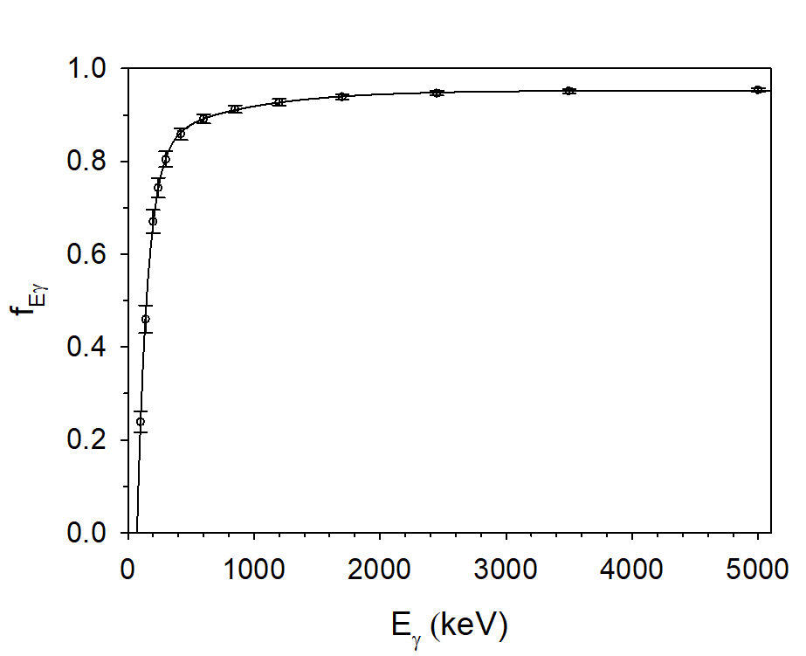

**Fig. 3** Dependence of the gamma-ray self-absorption factor *fE*γ on the gamma energy *E*γ. The solid line represents the fit of the data taken from NIST XCOM [36,37] with Eq. (3)

Prompt gamma rays of chlorine

**Fig. 4** Determined correction curves for single (left) and double (right) escape peak interferences. Round values in black represent data points obtained with MCNP, the solid line in black is the curve fit with the function given in Eq. (4). Square dots in red with error bars represent experimental values. Values from the isotopes 35Cl and 140Ce were determined from the CeCl3 measurement described in this work (see also Figs. 1 and 2), values of 40Ca are from our previous measurement of CaCO3 [12] and values from 208Pb and 56Fe are taken from the beam background [7,9]

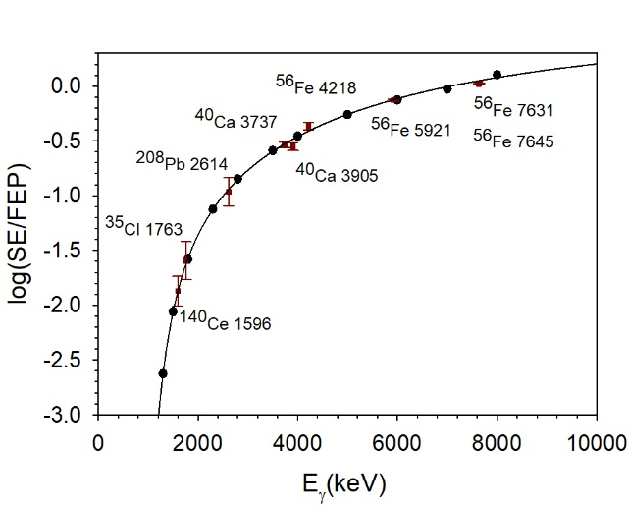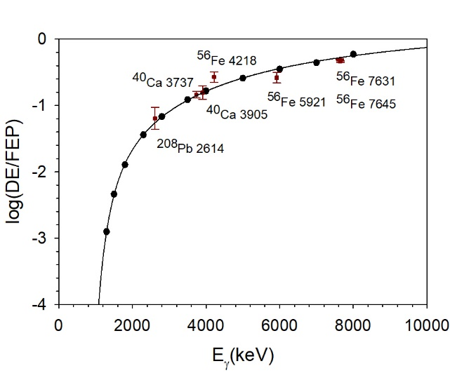

Twenty nine gamma lines from the interaction of fast neutrons with chlorine were identified in the CeCl3 spectrum, 15 assigned to the 35Cl(n,n’)35Cl, 8 to the 37Cl(n,n’)37Cl, 5 to the 35Cl(n,p)35S and 1 to the 35Cl(n,α)32P reaction, respectively (see Table 1). In the case of the PVC sample, only 14 fast-neutron-induced lines were measured, 7 related to the 35Cl(n,n’)35Cl, 4 to the 37Cl(n,n’)37Cl and 3 to the 35Cl(n,p)35S reaction. The lower number of observed gamma rays in the PVC spectrum is explained with the lower sensitivity stemming from the much smaller sample mass only partly compensated by the longer measurement time. Since PVC contains carbon we also measured the Doppler-broadened [38,39] gamma ray of the 12C(n,n’γ)12C reaction. Additionally, in both spectra, the main neutron capture lines of chlorine were identified as our neutron spectrum contains epithermal and thermal neutrons [9,10,12]. No significant interferences between the capture lines and the fast-neutron-induced lines of chlorine were observed. The PVC foil was also used to check the composition and absence of crystal water in the CeCl3 sample, as the chlorine peak count rate ratios were found to agree with the nominal chlorine mass ratio. The interference-free (according to [20]) lines at 2645 and 3002 keV from the 35Cl(n,n’γ)35Cl reaction yielded an average chlorine mass of (1.14 ± 0.05) g, which is in good agreement with the value calculated from the nominal composition of the chloride (1.15 g). Therefore, the sample is assumed to contain no water as the hexahydrate would yield a chlorine mass of 0.80 g.

Intensities of the gamma lines were calculated relative to the 1219-keV line of 35Cl. They are compared to the values by Demidov et al. [14] in columns 4 and 7 of Tables 1 and 2. We detected 19 out of 27 lines given in [14], of which only 21 were originally assigned to fast-neutron reactions. The lines listed at 637.2, 824.8, 882.3, 922.0, 1070.6, 1676.4, 2832.9 and 3195.9 keV in [14] were not observed in our measurements. The line at 882.3 keV was not identified due to interference with the 881-keV line of 206Pb induced by inelastic scattering of fast neutrons with the lead shielding [9]. The lines at 637.2 and 1070.6 keV were not detected due to the low mass of the samples. The lines at 824.8, 922.0, 1676.4, 2832.9 and 3195.9 keV were reported as tentative assignments by Demidov et al. and were not placed in any chlorine decay scheme. They are not observed in our measurements, so they most likely do not belong to chlorine. It should be mentioned that according to [20,23] the 1676.4-keV line could be emitted from an excited level at *E*\*= 1755.0 keV of 32P. The 3195.9-keV line could correspond to the SE of a line at 3707.9 keV directly emitted to ground sate (g.s.) in 37Cl [20,22]. The clear presence of the 3195.9-keV line in the spectrum of Demidov et al., which is shown only to 3.5 MeV, together with the absence of a reasonable transition in [20] might support this assumption.

On the other hand, compared to [14] we identify 10 new gamma lines of chlorine that are also reported in [20]. These include the lines at 1701.7, 3918.5, 4110.8, 4176.7 and 4622.2 keV for the 35Cl(n,n’)35Cl, the lines at 1900.0, 3625.5 and 4010.3 for the 37Cl(n,n’)37Cl, the line at 2714.9 keV for the 35Cl(n,p)35S and the line at 78.0 keV for the 35Cl(n,α)32P reaction (see also Figs. 1 and 2). Another gamma ray at 1184.6 keV, listed but unassigned in [14], was found to belong to the 35Cl(n,n’)35Cl reaction.

For the lines at 774.8, 1726.2, 1900.0 and 2347.6 keV in the CeCl3 spectrum, Demidov et al. suggest interferences with lines from the 140Ce(n,n’γ)140Ce reaction. They were corrected using the relative intensities in the evaluated nuclear structure data file (ENSDF) [26] for the corresponding (n,n’γ) reaction, because a large discrepancy in intensity compared to the original work of [14] for those lines was observed. The contributions from the interfering (n,n’γ) reaction to the net counts were calculated as (32.0 ± 5.3)%, (3.7 ± 0.3)%, (17.2 ± 3.1)% and (44.2 ± 2.7)%, respectively.

The correlation between the relative intensities in this work and in [14] is depicted in Fig. 5 for our two measurements. The values have been fitted with the following semi-empirical function [10-12]:

|  |  |
| --- | --- |
|  | (5) |

with *a*= 0.68 ± 0.10 and *b*= 1.07 ± 0.06 for the CeCl3, and *a*= 0.94 ± 0.14 and *b*= 0.99 ± 0.06 for the PVC sample.

The average intensity ratios *I*R*/I*RD of 0.83 ± 0.19 (CeCl3) and *I*R*/I*RDof 0.94 ± 0.16 (PVC) indicate a good agreement between the two measurements. To prove the consistency in a more detailed manner, Fig. 6 shows the two sets of data in the form of a common histogram of the residuals *R* in units of standard deviation [σ] for our two measurements, calculated as [10-12]:

|  |  |
| --- | --- |
|  | (6) |

The fit of the data agrees at the 1.3σ level and the Gaussian centroid is shifted by -1.002, indicating a systematic effect. We assume that the large shift mainly originates from the lines at 774.8, 2179.1 and 2839.6 keV, only observed in the CeCl3 sample. For these lines we found much less intensity compared to [14].

The fast-neutron spectrum-averaged partial cross sections for gamma-ray production calculated by means of Eq. (1) are given in column 5 of Tables 1 and 2. The values of the two datasets agree well with each other, taking into account the uncertainties except for the lines at 1219, 1572, 1726, 1763 and 1991 keV. For the latter the cross sections obtained from the CeCl3 measurement are roughly higher by factors between 1.2 and 1.4 than these derived from the PVC measurement, thus, indicating possible interferences from cerium lines. For the line at 1219 keV we propose the cross section obtained from the PVC irradiation, while for all others the cross sections with the better *R* value, i.e. greater agreement in relative intensity with [14], are suggested. Proposed cross sections are written in bold in Tables 1 and 2.

**Table 1** Prompt gamma rays of 35Cl and 37Cl induced by fast neutrons on CeCl3

|  |  |  |  |  |  |  |  |
| --- | --- | --- | --- | --- | --- | --- | --- |
| Reaction  (*E*thr) | This work | | | | From Demidov Atlas [14] | | *R* |
| *E*γ (keV) | *PE*γ(90°)/(*εE*γ*·fE*γ) ×  10-8 (count) | *I*R(relative)  (%) | <*σE*γ(90°)>  (mb) | *E*γ (keV) | *I*R(relative)  (%) |
| 35Cl(n,n’γ)35Cl  (1.25 MeV) | 930.29 ± 0.10a | 0.37 ± 0.08 | 3.16 ± 0.72 | **2.26 ± 0.51** | 930.5 ± 0.5 | 3.0 ± 1.0 | 0.13 |
| 1184.64 ± 0.08 | 0.47 ± 0.03 | 4.03 ± 0.30 | **2.89 ± 0.19** | 1184.72 ± 0.15b | 3.8 ± 0.4 | 0.47 |
| 1219.25 ± 0.06c | 11.62 ± 0.35 | 100 | 72 ± 2 | 1219.52 ± 0.10 | 100 | - |
| 1701.73 ± 0.14a | 0.12 ± 0.04 | 1.06 ± 0.34 | **0.76 ± 0.24** | - | - | - |
| 1762.92 ± 0.08d | 13.26 ± 0.43 | 114 ± 5 | 82 ± 3 | 1763.27 ± 0.10 | 129 ± 4 | -2.31 |
| 2179.10 ± 0.21 | 0.37 ± 0.03 | 3.22 ± 0.28 | **2.31 ± 0.19** | 2180.8 ± 0.3e | 6.2 ± 0.6 | -4.50 |
| 2645.20 ± 0.12 | 2.51 ± 0.11 | 21.6 ± 1.2 | 15.4 ± 0.7 | 2645.7 ± 0.2 | 25.7 ± 1.5 | -2.19 |
| 2693.78 ± 0.13a,f | 2.03 ± 0.63 | 17.4 ± 5.4 | **12.5 ± 3.9** | 2694.0 ± 0.2 | 19.1 ± 1.5 | -0.30 |
| 2839.60 ± 0.39f | 0.25 ± 0.03 | 2.11 ± 0.26 | **1.51 ± 0.18** | 2840.3 ± 0.4e | 5.4 ± 0.6 | -5.02 |
| 3002.32 ± 0.12f | 2.04 ± 0.09 | 17.6 ± 0.9 | **12.6 ± 0.5** | 3002.2 ± 0.2 | 15.5 ± 1.5 | 1.17 |
| 3162.46 ± 0.11 | 1.68 ± 0.06 | 14.4 ± 0.7 | 10.3 ± 0.4 | 3162.52 ± 0.15 | 16.3 ± 1.5 | -2.65 |
| 3918.46 ± 0.47f | 0.12 ± 0.02 | 1.05 ± 0.17 | **0.75 ± 0.12** | - | - | - |
| 4110.81 ± 0.25g | 0.27 ± 0.05 | 2.30 ± 0.43 | **1.65 ± 0.31** | - | - | - |
| 4176.65 ± 0.75i | 0.61 ± 0.05 | 5.22 ± 0.46 | **3.74 ± 0.31** | - | - | - |
| 4622.17 ± 0.23f | 0.30 ± 0.04 | 2.61 ± 0.38 | **1.87 ± 0.27** | - | - | - |
| 37Cl(n,n’γ)37Cl  (1.77 MeV) | 905.65 ± 0.08 | 0.29 ± 0.02 | 2.53 ± 0.20 | 5.66 ± 0.41 | 906.64 ± 0.15 | 2.9 ± 0.4 | -0.83 |
|  |  |  |  |  |  |  |
| 1726.17 ± 0.08a,d,h | 2.38 ± 0.09 | 20.5 ± 1.0 | 46 ± 2 | 1726.50 ± 0.10 | 25 ± 2 | -2.01 |
| 1899.99 ± 0.28f,h | 0.12 ± 0.03 | 1.06 ± 0.25 | **2.38 ± 0.56** | - | - | - |
| 3085.91 ± 0.14f | 1.17 ± 0.05 | 10.0 ± 0.5 | 22 ± 1 | 3086.3 ± 0.3 | 11.2 ± 1.0 | -1.02 |
| 3103.17 ± 0.11a | 1.29 ± 0.05 | 11.1 ± 0.5 | 25 ± 1 | 3103.29 ± 0.15 | 14.6 ± 1.5 | -2.17 |
| 3625.48 ± 0.90f | 0.24 ± 0.04 | 2.07 ± 0.34 | **4.65 ± 0.74** | - | - | - |
| 3739.47 ± 0.18f | 0.31 ± 0.04 | 2.65 ± 0.32 | **5.93 ± 0.68** | 3742.9 ± 0.5 | 3.0 ± 1.0 | -0.33 |
| 4010.3 ± 0.32 | 0.16 ± 0.02 | 1.37 ± 0.20 | **3.08 ± 0.43** | - | - | - |
| 35Cl(n,p)35S  (0 MeV) | 774.83 ± 0.18h,j | 0.07 ± 0.02 | 0.62 ± 0.17 | **0.45 ± 0.12** | 775.0 ± 0.2 | 1.3 ± 0.3 | -1.95 |
| 1572.05 ± 0.10a | 0.65 ± 0.04 | 5.57 ± 0.38 | **3.99 ± 0.25** | 1572.32 ± 0.13 | 5.9 ± 0.5 | -0.52 |
| 1990.92 ± 0.09 | 1.19 ± 0.04 | 10.2 ± 0.5 | **7.33 ± 0.25** | 1991.43 ± 0.15 | 11.6 ± 1.0 | -1.23 |
| 2347.617 ± 0.11h | 0.51 ± 0.04 | 4.39 ± 0.35 | 3.14 ± 0.23 | 2347.9 ± 0.4 | 6.6 ± 0.6 | -3.19 |
| 2714.90 ± 0.50f | 0.10 ± 0.02 | 0.82 ± 0.20 | **0.59 ± 0.15** | - | - | - |
| 35Cl(n,α)32P  (0 MeV) | 77.97 ± 0.06k | 5.17 ± 0.54 | 45 ± 5 | **32 ± 3** | - | - | - |

*E*thr is the threshold energy of the considered reaction taken from [29,30], *E*γ is the gamma-ray energy, *PE*γ(90°)/(*εE*γ*·fE*γ) the net counts in the gamma-ray peak divided by the full-energy-peak efficiency and the gamma self-absorption factor, *I*R the relative intensity of the gamma ray and <*σE*γ(90°)> the fission-neutron spectrum-averaged partial cross section for gamma-ray production at an angle of 90° between neutron beam and detector determined with Eq. (1). *R* is the residual calculated by means of Eq. (6). Cross sections written in bold are proposed

acorrected for background interferences

bunassigned by Demidov et al.

cnegligible interference from the 140Ce(n,n’γ)140Ce reaction [26], but interference unreported on [20] is assumed as the cross section differs much compared to that given in Table 2

dpossible interference from the 142Ce(n,n’γ)142Ce reaction [27]

emaybe uncorrected interference in [14] from the SE from the 2693.8-keV line of 35Cl

fDoppler-broadened; short-lived transitions in the femtosecond range [21,22,23]

gcorrected for contribution of SE from 4622 keV (32.6% of total counts)

hinterference from 140Ce(n,n’γ)140Ce reaction corrected with relative intensities given in the ENSDF file [26] on [20]

imight be fed from two close-lying short-lived levels; possible, but unlikely to come from 37Cl(n,n’γ)37Cl reaction [22]

jdata from Demidov et al. might be more accurate due to a higher chlorine mass and counting time [14]

kconsiderable self-absorption with *fE*γ= 0.128 ± 0.013, calculated after Eq. (2)

**Table 2** Prompt gamma rays of 35Cl, 37Cl and 12C induced by fast neutrons on PVC

|  |  |  |  |  |  |  |  |  |
| --- | --- | --- | --- | --- | --- | --- | --- | --- |
| Reaction  (*E*thr) | This work | | | | From Demidov Atlas [14] | | | *R* |
| *E*γ (keV) | *PE*γ(90°)/*εE*γ  × 10-8 (count) | *I*R(relative)  (%) | <*σE*γ(90°)>  (mb) | *E*γ (keV) | | *I*R(relative)  (%) |
| 35Cl(n,n’γ)35Cl  (1.25 MeV) | 1184.94 ± 0.16 | 0.17 ± 0.03 | 4.31 ± 0.69 | 2.51 ± 0.44 | 1184.72 ± 0.15a | | 3.8 ± 0.4 | 0.65 |
| 1219.32 ± 0.05 | 3.87 ± 0.14 | 100 | **58 ± 5** | 1219.52 ± 0.10 | | 100 | - |
| 1763.05 ± 0.07 | 4.62 ± 0.15 | 119 ± 6 | **70 ± 6** | 1763.27 ± 0.10 | | 129 ± 4 | -1.36 |
| 2646.08 ± 0.16 | 0.98 ± 0.05 | 25.3 ± 1.6 | **14.7 ± 1.4** | 2645.7 ± 0.2 | | 25.7 ± 1.5 | -0.19 |
| 2694.35 ± 0.18b,c | 0.64 ± 0.15 | 16.5 ± 3.9 | 9.58 ± 2.35 | 2694.0 ± 0.2 | | 19.1 ± 1.5 | -0.64 |
| 3002.46 ± 0.55 | 0.79 ± 0.08 | 20.4 ± 2.1 | 11.9 ± 1.5 | 3002.2 ± 0.2 | | 15.5 ± 1.5 | 1.92 |
| 3162.76 ± 0.13 | 0.59 ± 0.05 | 15.3 ± 1.3 | **8.92 ± 0.98** | 3162.52 ± 0.15 | | 16.3 ± 1.5 | -0.49 |
| 37Cl(n,n’γ)37Cl  (1.77 MeV) | 905.78 ± 0.39 | 0.11 ± 0.03 | 2.89 ± 0.82 | **5.27 ± 1.54** | 906.64 ± 0.15 | 2.9 ± 0.4 | | -0.01 |
|  |  |  |  |  |  | |  |
| 1725.60 ± 0.19b | 0.79 ± 0.05 | 20.6 ± 1.3 | **37 ± 4** | 1726.50 ± 0.10 | 25 ± 2 | | -1.87 |
| 3086.3 ± 0.55c | 0.46 ± 0.10 | 12.0 ± 2.6 | **22 ± 5** | 3086.3 ± 0.3 | 11.2 ± 1.0 | | 0.28 |
| 3103.24 ± 0.18b | 0.46 ± 0.08 | 11.8 ± 2.2 | **22 ± 4** | 3103.29 ± 0.15 | 14.6 ± 1.5 | | -1.04 |
| 35Cl(n,p)35S  (0 MeV) | 1572.83 ± 0.33 | 0.20 ± 0.03 | 5.17 ± 0.78 | 3.01 ± 0.50 | 1572.32 ± 0.13 | 5.9 ± 0.5 | | -0.79 |
| 1991.02 ± 0.17 | 0.34 ± 0.04 | 8.73 ± 1.05 | 5.08 ± 0.71 | 1991.43 ± 0.15 | 11.6 ± 1.0 | | -1.98 |
| 2348.54 ± 0.37c | 0.17 ± 0.03 | 4.41 ± 0.77 | **2.57 ± 0.48** | 2347.9 ± 0.4 | 6.6 ± 0.6 | | -2.24 |
| 12C(n,n’γ)12C  (4.81 MeV)d | 4440.96 ± 0.15b,c | 2.22 ± 0.37 | 100 | 12.8 ± 2.3 | 4438 ± 2 | 109e | | - |

*E*thr is the threshold energy of the considered reaction taken from [29,30], *E*γ is the gamma-ray energy, *PE*γ(90°)/*εE*γthe net counts in the gamma-ray peak divided by the full-energy-peak efficiency, *I*R the relative intensity of the gamma ray and *<σE*γ(90°)*>* the fission-neutron spectrum-averaged partial cross section for gamma-ray production at an angle of 90° between neutron beam and detector determined with Eq. (1). *R* is the residual calculated by means of Eq. (6). Cross sections written in bold are proposed

aunassigned by Demidov et al.

bcorrected for background interferences

cDoppler-broadened; short-lived transitions in the femtosecond range [21,22,23,38]

donly elemental data available from [29,30]

eunclear how this intensity is obtained, it might be a mistake or the absolute intensity determined with the integral cross section. From our work the absolute intensity is 107% by using an integral cross section for fission neutrons of roughly 12 mb [40] with an angular distribution correction factor of *W*(90°)= 1

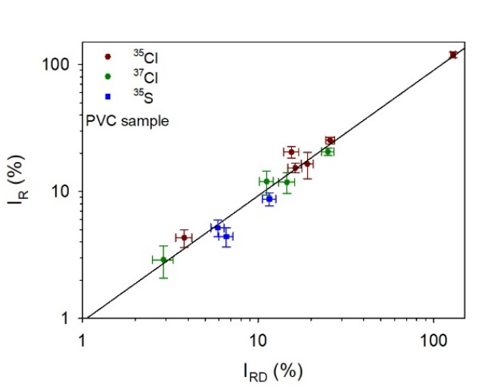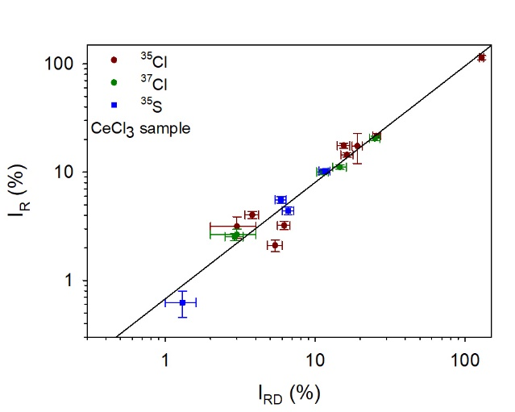

**Fig. 5** Relationship between the relative intensities *I*R of the prompt gamma rays induced by fast-neutron inelastic scattering (n,n’) and (n,p) reactions on chlorine measured in this work and the relative intensities *I*RD tabulated in the Demidov Atlas [14]. The left plot represents data from the PVC spectrum whereas the right plot was obtained with data from the CeCl3 spectrum. The solid line represents the fit of the data with Eq. (5)

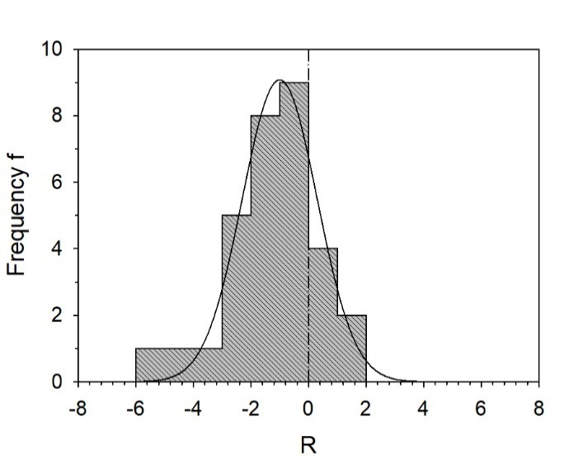

**Fig. 6** Comparison of the relative intensities of the prompt gamma rays induced by fast-neutron inelastic scattering (n,n’), (n,p) and (n,α) reactions on chlorine obtained in this work with the data tabulated in the Demidov Atlas [14] in the form of a histogram of the residuals *R* in units of standard deviation [σ] calculated with Eq. (6). The plot represents data from both the CeCl3 and PVC spectrum. The values of *R* are given in column 8 of Tables 1 and 2. The solid lines represents the fit of the data with a Gaussian

Prompt gamma rays of cerium

Fifty eight gamma lines from inelastic scattering of fast neutrons on cerium were found, one related to 136Ce, 41 to 140Ce and 16 to 142Ce . These gamma rays are depicted in Figs. 1 and 2 and their data are given in Tables 3 and 4. No neutron capture lines from cerium were identified.

Intensities of gamma lines were calculated relative to the 1596-keV line of 140Ce. They are given along with the values determined in [14] in columns 3 and 6 of Tables 3 and 4. We detected 31 out of 45 lines given in [14], of which only 27 lines were originally assigned to fast-neutron reactions. The gamma rays listed at energies of 337.0, 740.0, 774.0, 788.2, 846.3, 983.1, 1041.1, 1045.5, 1059.0, 1098.8, 1233.6, 1463.3, 1526.4, 1620.5, 1724.9, 1812.3, 1899.3 and 1958.5 keV in Demidov’s Atlas are reported as tentative assignments and are unplaced in the decay schemes of cerium isotopes. The lines at 740.0, 983.1, 1059.0, 1233.6, 1526.4 and 1620.5 were observed in the current work and assigned based on data provided in [20]. The 337.0-, 846.3-, 1041.1-, 1463.3- and 1958.5-keV lines are not specified in [20,24-27] and the placement of the line at 1812.3 keV in the level scheme of 140Ce is uncertain [20,26]. In our measurement the lines at 337.0, 846.3, 962.2, 1041.1, 1045.5, 1098.8 and 1463.3 keV were not observed uniquely due to interferences with background lines [7,9]. The lines at 788.2 and 1958.5 keV are mainly associated to the neutron capture lines of 35Cl and the lines at 774.8 and 2347.5 keV are essentially issued from the 35Cl(n,p)35S reaction. The 1724.9-keV line was not identified uniquely due to strong interferences with the 1726.2-keV line of 37Cl and the background lines of 207Pb and 56Fe at 1725 keV [9]. The line at 1899.3 keV listed in [14] is mainly related to the 1900.0-keV line of 37Cl.

The DEs of the lines at 1762.9 keV (35Cl) and 2645.2 keV (35Cl) as well as the SE of the line at 3625.5 keV (37Cl) were found to interfere significantly with the lines at 739.6, 1623.6 and 3118.2 keV, respectively. Their contributions to the net count rates were estimated with Eq. (4) to be (34.9 ± 3.3)%, (41.9 ± 4.9)% and (14.5 ± 2.5)%, respectively. The contribution of the DE of the background line at 2614 keV (208Pb) [7,9] to the net count rate of the 1596.0-keV line is negligible with (0.11 ± 0.02)%. The lines of 140Ce mentioned at 1085 and 1252 keV in [20,26] are identified as escape peaks of the 1596.0-keV line of 140Ce and the 1762.9-keV-line of 35Cl with contributions of (99.3 ± 7.3)% and (94.0 ± 10.3)%, respectively.

On the other hand, in comparison to [14] we have identified 27 new gamma lines (one for 136Ce, 17 for 140Ce and 9 for 142Ce) which are all specified in [20]. Because of the better energy resolution of our detector it was possible to resolve doublets in the lines given by Demidov et al. at energies of 522.0, 894.8 and 1404.3 keV (see Tables 3 and 4).

The correlation between the relative intensities measured in this work and these given in [14] is depicted in Fig. 7 for all lines. The values have been fitted with Eq. (5) yielding the coefficients *a*= 0.86 ± 0.06 and *b*= 0.98 ± 0.05. The average intensity ratio *I*R*/I*RD is 0.93 ± 0.23, indicating a reasonable agreement between the two measurements.

Fig. 8 shows the two sets of data in the form of a histogram of the residuals *R* in units of standard deviation [σ], calculated according to Eq. (6). The fit of the data agrees at the 1.2σ level and the Gaussian centroid is shifted by -0.671, indicating a probable systematic effect.

**Table 3** Prompt gamma rays of 136Cea and 140Ceb induced by inelastic scattering of fast neutrons on CeCl3

|  |  |  |  |  |  |  |
| --- | --- | --- | --- | --- | --- | --- |
| This work | | | | From Demidov Atlas [14] | | *R* |
| *E*γ (keV) | *PE*γ(90°)/(*εE*γ*·fE*γ)  × 10-8 (count) | *I*R(relative)  (%) | <*σE*γ(90°)>  (mb) | *E*γ (keV) | *I*R(relative)  (%) |
| 551.54 ± 0.08c | 0.17 ± 0.02 | 0.40 ± 0.05 | 1230 ± 171 | - | - | - |
| 131.00 ± 0.04 | 1.29 ± 0.05 | 3.07 ± 0.16 | 20 ± 2 | 131.3 ± 0.4 | 3.3 ± 0.8 | -0.28 |
| 241.63 ± 0.03 | 1.75 ± 0.06 | 4.17 ± 0.19 | 28 ± 2 | 241.91 ± 0.10 | 6.5 ± 0.7 | -3.22 |
| 266.16 ± 0.03 | 2.24 ± 0.08 | 5.33 ± 0.25 | 35 ± 3 | 266.61 ± 0.10 | 6.2 ± 0.6 | -1.34 |
| 306.38 ± 0.04 | 1.13 ± 0.05 | 2.69 ± 0.14 | 17.9 ± 1.6 | 306.91 ± 0.15 | 3.3 ± 0.3 | -1.85 |
| 328.17 ± 0.04 | 1.81 ± 0.09 | 4.30 ± 0.25 | 29 ± 3 | 328.67 ± 0.15 | 5.9 ± 0.6 | -2.46 |
| 431.85 ± 0.05d | 0.96 ± 0.06 | 2.29 ± 0.16 | 15.2 ± 1.5 | 432.44 ± 0.15 | 3.0 ± 0.4 | -1.65 |
| 486.35 ± 0.03e | 13.6 ± 0.5 | 32 ± 1 | 215 ± 18 | 487.06 ± 0.05 | 37 ± 4 | -1.10 |
|  |  |  |  |  |  |  |
| 520.38 ± 0.10e,f | 0.24 ± 0.04 | 0.57 ± 0.09 | 3.81 ± 0.65 | - | - | - |
| 739.64 ± 0.12g | 0.18 ± 0.02 | 0.42 ± 0.04 | 2.80 ± 0.35 | 740.0 ± 0.6 | 0.38 ± 0.15 | 0.26 |
| 751.15 ± 0.04 | 2.22 ± 0.07 | 5.27 ± 0.24 | 35 ± 3 | 751.65 ± 0.10 | 5.1 ± 0.5 | 0.31 |
| 815.32 ± 0.04 | 2.00 ± 0.06 | 4.76 ± 0.21 | 32 ± 3 | 815.84 ± 0.10 | 4.6 ± 0.5 | 0.29 |
| 867.52 ± 0.04e | 2.99 ± 0.65 | 7.11 ± 1.56 | 47 ± 11 | 867.8 ± 0.2 | 6.5 ± 1.0 | 0.33 |
| 919.12 ± 0.05 | 0.85 ± 0.03 | 2.02 ± 0.10 | 13.5 ± 1.2 | 919.5 ± 0.2 | 2.1 ± 0.3 | -0.25 |
| 924.83 ± 0.05e | 1.13 ± 0.04 | 2.68 ± 0.12 | 17.8 ± 1.5 | 925.1 ± 0.2 | 2.9 ± 0.4 | -0.53 |
| 950.60 ± 0.05 | 1.05 ± 0.04 | 2.50 ± 0.13 | 16.7 ± 1.5 | 950.84 ± 0.15 | 2.3 ± 0.2 | 0.86 |
| 982.22 ± 0.11e | 0.25 ± 0.07 | 0.60 ± 0.16 | 4.01 ± 1.10 | 981.1 ± 0.4 | 0.64 ± 0.08 | -0.21 |
| 1032.90 ± 0.36h | 0.10 ± 0.03 | 0.24 ± 0.07 | 1.62 ± 0.49 | - | - | - |
| 1088.30 ± 0.13e | 0.45 ± 0.15 | 1.07 ± 0.35 | 7.13 ± 2.39 | - | - | - |
| 1135.20 ± 0.26 | 0.18 ± 0.03 | 0.42 ± 0.06 | 2.80 ± 0.46 | - | - | - |
| 1232.84 ± 0.16 | 0.28 ± 0.03 | 0.66 ± 0.08 | 4.40 ± 0.62 | 1233.6 ± 0.4 | 0.7 ± 0.2 | -0.18 |
| 1282.72 ± 0.19 | 0.12 ± 0.02 | 0.29 ± 0.05 | 1.91 ± 0.37 | - | - | - |
| 1303.20 ± 0.10 | 0.29 ± 0.03 | 0.69 ± 0.07 | 4.60 ± 0.55 | 1304.0 ± 0.8 | 0.8 ± 0.2 | -0.52 |
| 1321.17 ± 0.60h | 0.23 ± 0.04 | 0.53 ± 0.10 | 3.56 ± 0.70 | - | - | - |
| 1404.93 ± 0.09f | 0.45 ± 0.03 | 1.08 ± 0.08 | 7.19 ± 0.74 | - | - | - |
| 1420.19 ± 0.21 | 0.11 ± 0.02 | 0.26 ± 0.05 | 1.74 ± 0.34 | - | - | - |
| 1474.71 ± 0.29c,e,h | 0.13 ± 0.02 | 0.32 ± 0.05 | 2.12 ± 0.38 | - | - | - |
| 1525.70 ± 0.11 | 0.25 ± 0.02 | 0.58 ± 0.06 | 3.88 ± 0.47 | 1526.4 ± 0.5 | 0.49 ± 0.10 | 0.81 |
| 1539.86 ± 0.32d,h | 0.09 ± 0.02 | 0.21 ± 0.06 | 1.39 ± 0.39 | - | - | - |
| 1565.14 ± 0.31d | 0.11 ± 0.03 | 0.27 ± 0.06 | 1.82 ± 0.42 | - | - | - |
| 1595.98 ± 0.07 | 42 ± 1 | 100 | 666 ± 56 | 1596.20 | 100 | - |
| 1619.75 ± 0.32 | 0.10 ± 0.03 | 0.25 ± 0.07 | 1.65 ± 0.48 | 1620.5 ± 1.0 | 0.23 ± 0.08 | 0.16 |
| 1623.62 ± 0.16g | 0.14 ± 0.02 | 0.33 ± 0.04 | 2.23 ± 0.32 | - | - | - |
| 1877.26 ± 0.16 | 0.27 ± 0.02 | 0.65 ± 0.05 | 4.34 ± 0.48 | - | - | - |
| 2051.08 ± 0.32 | 0.06 ± 0.02 | 0.14 ± 0.04 | 0.92 ± 0.25 | - | - | - |
| 2521.41 ± 0.14 | 0.43 ± 0.03 | 1.01 ± 0.07 | 6.73 ± 0.69 | 2521.3 ± 0.5 | 1.4 ± 0.2 | -1.82 |
|  |  |  |  |  |  |  |
| 2546.63 ± 0.26 | 0.16 ± 0.02 | 0.38 ± 0.06 | 2.55 ± 0.42 | 2547.4 ± 0.8 | 0.57 ± 0.18 | -0.99 |
|  |  |  |  |  |  |  |
| 2899.46 ± 0.14 | 0.46 ± 0.03 | 1.10 ± 0.07 | 7.30 ± 0.71 | 2900.1 ± 0.7 | 1.1 ± 0.2 | -0.01 |
| 3118.15 ± 0.13g | 0.39 ± 0.02 | 0.93 ± 0.06 | 6.20 ± 0.62 | 3120.4 ± 1.2i | 0.56 ± 0.12 | 2.73 |
| 3319.29 ± 0.25 | 0.13 ± 0.02 | 0.31 ± 0.04 | 2.08 ± 0.31 | - | - | - |
| 3471.02 ± 0.24 | 0.16 ± 0.02 | 0.39 ± 0.04 | 2.60 ± 0.35 | - | - | - |
| 3643.53 ± 0.37d | 0.09 ± 0.02 | 0.23 ± 0.05 | 1.50 ± 0.34 | - | - | - |
|  |  |  |  |  |  |  |

*E*γ is the gamma-ray energy, *PE*γ(90°)/(*εE*γ*·fE*γ) the net counts in the gamma-ray peak divided by the full-energy-peak efficiency and the gamma self-absorption factor, *I*R the relative intensity of the gamma ray and <*σE*γ(90°)> the fission-neutron spectrum-averaged partial cross section for gamma-ray production at an angle of 90° between neutron beam and detector determined with Eq. (1). *R* is the residual calculated by means of Eq. (6)

areaction threshold for inelastic scattering is 0.56 MeV [41]

breaction threshold for inelastic scattering is 1.61 MeV [29,30]

cgamma ray of 136Ce

dinterference from 142Ce(n,n’γ)142Ce possible with respect to [27]

ecorrected for background interferences

fdoublet with 142Ce (see Table 4)

gcorrected for escape peak interference

hsomewhat cautious assignment, as relative intensities differ considerably compared to data given in [26]

iwrong level energy assigned by Demidov et al. [14]

**Table 4** Prompt gamma rays of 142Cea induced by inelastic scattering of fast neutrons on CeCl3

|  |  |  |  |  |  |  |
| --- | --- | --- | --- | --- | --- | --- |
| This work | | | | From Demidov Atlas [14] | | *R* |
| *E*γ (keV) | *PE*γ(90°)/(*εE*γ*·fE*γ*)*  × 10-8 (count) | *I*R(relative)  (%) | <*σE*γ(90°)>  (mb) | *E*γ (keV) | *I*R(relative)  (%) |
| 522.88 ± 0.08 | 0.25 ± 0.03 | 0.59 ± 0.08 | 32 ± 5 | 522.0 ± 0.3b | 0.83 ± 0.15 | 1.31 |
| 577.46 ± 0.04 | 2.15 ± 0.09 | 5.11 ± 0.26 | 272 ± 24 | 578.1 ± 0.2 | 6.3 ± 0.8 | -1.41 |
| 640.63 ± 0.03 | 10.6 ± 0.3 | 25.0 ± 1.1 | 1333 ± 112 | 641.23 ± 0.06 | 29 ± 3 | -1.23 |
| 892.16 ± 0.13 | 0.23 ± 0.02 | 0.56 ± 0.06 | 30 ± 4 | - | - | - |
| 894.56 ± 0.05 | 1.29 ± 0.05 | 3.06 ± 0.15 | 163 ± 14 | 894.76 ± 0.15c | 4.1 ± 0.5 | -0.96 |
| 1011.07 ± 0.06 | 0.76 ± 0.03 | 1.81 ± 0.10 | 96 ± 9 | 1011.5 ± 0.3 | 2.6 ± 0.4 | -1.91 |
| 1058.13 ± 0.27d | 0.09 ± 0.03 | 0.21 ± 0.07 | 11.3 ± 3.8 | 1059.0 ± 0.15 | 0.63 ± 0.15c | -2.53 |
| 1243.20 ± 0.29e | 0.10 ± 0.02 | 0.24 ± 0.06 | 12.6 ± 3.1 | - | - | - |
| 1362.36 ± 0.14 | 0.42 ± 0.03 | 0.99 ± 0.08 | 53 ± 6 | - | - | - |
| 1388.59 ± 0.17 | 0.12 ± 0.03 | 0.30 ± 0.07 | 15.7 ± 3.9 | - | - | - |
| 1402.36 ± 0.12 | 0.30 ± 0.02 | 0.71 ± 0.06 | 38 ± 4 | 1404.3 ± 0.3f | 1.9 ± 0.2 | -2.12 |
| 1478.43 ± 0.26g | 0.14 ± 0.02 | 0.32 ± 0.05 | 17.1 ± 3.1 | - | - | - |
| 2004.15 ± 0.37 | 0.06 ± 0.02 | 0.15 ± 0.04 | 7.84 ± 2.03 | - | - | - |
| 2038.77 ± 0.34 | 0.09 ± 0.02 | 0.21 ± 0.04 | 11.3 ± 2.2 | - | - | - |
| 2186.63 ± 0.41 | 0.13 ± 0.02 | 0.31 ± 0.06 | 16.6 ± 3.4 | - | - | - |
| 2448.81 ± 0.19 | 0.09 ± 0.02 | 0.22 ± 0.04 | 11.8 ± 2.2 | - | - | - |

*E*γ is the gamma-ray energy, *PE*γ(90°)/(*εE*γ*·fE*γ)the net counts in the gamma-ray peak divided by the full-energy-peak efficiency and the gamma self-absorption factor, *I*R the relative intensity of the gamma ray and <*σE*γ(90°)> the fission-neutron spectrum-averaged partial cross section for gamma-ray production at an angle of 90° between neutron beam and detector determined with Eq. (1). *R* is the residual calculated by means of Eq. (6)

athreshold for inelastic scattering is 0.65 MeV [29,30]

b520 and 523 keV

c892 and 895 keV

dmust be reviewed with caution, as a line at 1637 keV from the same excited level [20,27] is not reported in [14]

eprobably from *E*\*= 3423.61 keV [27]; main line at 2782.2 keV in [20,27] might have been not observed due to lower efficiency

f1402 and 1405 keV

gcorrected for background interference

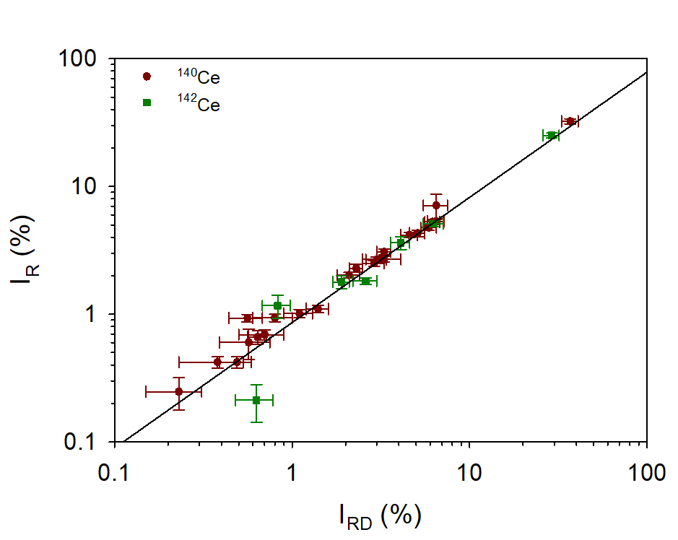

**Fig. 7** Relationship between the relative intensities *I*R of the prompt gamma rays induced by fast-neutron inelastic scattering (n,n’) reactions on cerium measured in this work and the relative intensities *I*RD tabulated in the Demidov Atlas [14]. The solid line represents the fit of the data with Eq. (5)

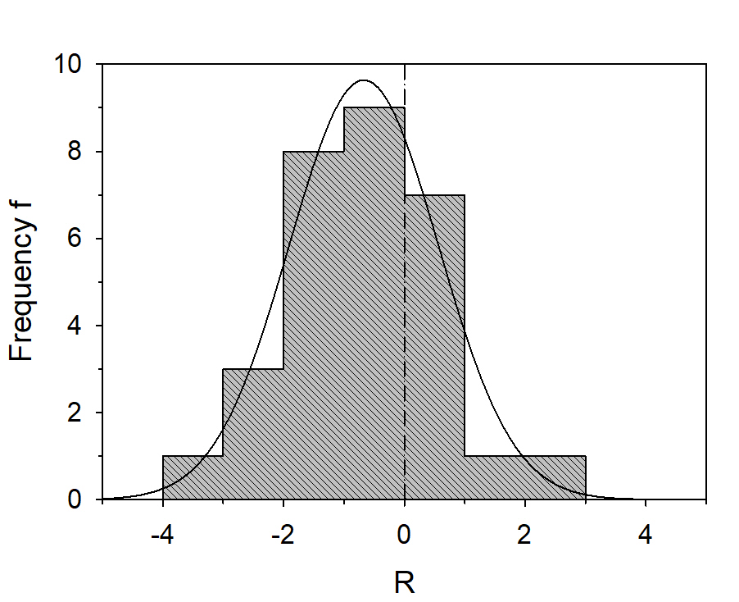

**Fig. 8** Comparison of the relative intensities of the prompt gamma rays induced by fast-neutron inelastic scattering (n,n’) reactions on cerium obtained in this work with the data tabulated in the Demidov Atlas [14] in the form of a histogram of the residuals *R* in units of standard deviation [σ] calculated with Eq. (6). The values of *R* are given in column 7 of Tables 3 and 4. The solid line represents the fit of the data with a Gaussian

Prompt gamma ray of carbon

Since the PVC sample was irradiated for a relatively long time the Doppler-broadened peak at 4441.0 keV from the 12C(n,n’)12C reaction was also identified (see Fig. 2). It was exploited to confirm the result from our previous measurement on calcium carbonate (CaCO3) [12]. A partial cross section of (12.8 ± 2.3) mb determined with Eq. (1) agrees well with that of (14.4 ± 3.3) mb derived in [12], thereby demonstrating reproducibility of our instrument. From our two measurements we derive an average value of (13.3 ± 1.9) mb for fast neutrons, compared to (2.6 ± 0.1) mb (4945.3- keV line of 12C [28]) for thermal neutrons. Thus, in case of equal measurement conditions (i.e. same neutron flux and spectrometer set-up) FaNGaS offers greater sensitivity in the detection of carbon higher by a factor of approximately five.

Detection limit

The detection limit (DL) can be defined as the minimum mass of a pure element that has to be irradiated for a certain time in order to give a net signal with a certain standard deviation σ. For a certain counting time *t*c, neglecting any neutron and gamma beam attenuation effects, it can be calculated with Eq. (1) from the minimum peak area *PE*γ(*c*) that might be estimated according to [42] as:

|  |  |
| --- | --- |
|  | (6) |

where *BE*γ is the area of the background below the gamma line of interest and *c* a predefined value for the relative uncertainty of the peak area.

For a counting live time of 12 h, the DL of cerium and chlorine were calculated for the most intense gamma line of each element by means of Eq. (1) and Eq. (6). The value of *BE*γ was determined from the beam background with HYPERMET-PC [19]. For a value of *c*= 0.5, corresponding to a peak area uncertainty of 50%, the smallest quantity of pure element that can be detected is 1 mg for cerium (140Ce, *E*γ= 1596.0 keV, *<σE*γ*(90°)>* = 666 mb) and 2 mg for chlorine (35Cl, *E*γ= 1763.1 keV, *<σE*γ*(90°)>* = 70 mb).

Conclusions

Emission of prompt gamma rays following fast-neutron inelastic scattering (n,n’), (n,p) and (n,α) reactions on a CeCl3 and a PVC sample were measured with the FaNGaS instrument operated at MLZ. In total, 29 and 58 prompt gamma lines were identified for chlorine and cerium, respectively, and their relative intensities and fast-neutron spectrum-averaged partial gamma-ray production cross sections were determined. In comparison with the work of Demidov et al. [14], 37 gamma lines were detected additionally (10 for chlorine and 27 for cerium) owing to a better detector resolution and a higher mean excitation energy (2.30 MeV). However, 8 lines of chlorine and 14 lines of cerium, partly unassigned in [14], were not observed in our measurements either due to background interferences or lower sample-masses irradiated for a shorter time or were found to disagree with nuclear data provided in [20]. The relative intensities of the lines measured in our work agree reasonably well (1.3σ level for chlorine and 1.2 level for cerium) with the values given in [14]. The detection limits of chlorine and cerium are determined as 2 and 1 mg, respectively, for a counting time of 12 hours. In addition, the partial cross section of the 4.44-MeV line of carbon derived from the measurement of the PVC sample is found to be in good agreement with the value obtained in the previous measurement of CaCO3 [12].

Declaration

The authors have no competing interests to declare that are relevant to the content of this article.

References

1. Schrader CD, Stinner RJ (1961) Remote analysis of surfaces by neutron-gamma-ray inelastic scattering techniques. J Geophys Res 66:1951-1956

2. Jiggins AH, Habbani FI (1976) Prompt gamma-ray analysis using 3.29 MeV neutron inelastic scattering. Int J Appl Radiat Isot 27:689-693

3. Yates SW, Filo AJ, Cheng CY, Coope DF (1978) Elemental analysis by gamma detection following inelastic neutron scattering. J Radioanal Nucl Chem 46:343-355

4. Sowerby BD (1979) Elemental analysis by neutron inelastic scatter gamma rays with a radioisotope source. Nucl Instrum Methods 166:571-579

5. Ahmed MR, Demidov AM, Al-Najjar SA, Al-Amili MA (1974) Use of spectroscopy of gamma-radiation from the inelastic scattering of reactor fast neutrons for elemental analysis. J Radioanal Nucl Chem 23:199-203

6. Rossbach M, Genreith C, Randriamalala T, Mauerhofer E, Révay Zs, Kudejova P, Söllradl S, Belgya T, Szentmiklosi L, Firestone RB, Hurst AM, Bernstein L, Sleaford B, Escher JE (2015) TANDEM: a mutual cooperation effort for transactinide nuclear data evaluation and measurement. J Radioanal Nucl Chem 304:1359-1363

7. Randriamalala TH, Rossbach M, Mauerhofer E, Révay Zs, Söllradl S, Wagner FM (2016) FaNGaS: A new instrument for (n,n´γ) reaction measurements at FRM II. Nucl Instrum Methods A 806:370-377

8. Hable A, Ramsl C, Jericha E, Böck H, Randriamalala TH, Rossbach, M (2017) FaNGaS: Determination of integral fast fission cross sections (n,f) of 238U, 237Np, and 242Pu in a directed fission neutron beam at FRM II, Garching. J Radioanal Nucl Chem DOI 10.1007/s10967-017-5512-7

9. Ilic Z, Mauerhofer E, Stieghorst C, Révay Zs, Rossbach M, Randriamalala TH, Brückel T (2020) Prompt gamma rays induced by inelastic scattering of fission neutrons on iron. J Radioanal Nucl Chem 325:641-645

10. Mauerhofer E, Ilic Z, Stieghorst C, Révay Zs, Rossbach M, Li J, Randriamalala TH, Brückel T (2021) Prompt and delayed gamma rays induced by epithermal and fast neutrons with indium. J Radioanal Nucl Chem 331:535-546

11. Mauerhofer E, Ilic Z, Stieghorst C, Révay Zs, Vezhlev E, Ophoven N, Randriamalala TH, Brückel T (2022) Prompt gamma rays from fast neutron inelastic scattering on aluminum, titanium and copper. J Radioanal Nucl Chem 331:3987-4000

12. Ophoven N, Ilic Z, Mauerhofer E, Randriamalala TH, Vezhlev E, Stieghorst C, Révay Zs, Brückel T, Jolie J, Strub E (2022) Fast neutron induced gamma rays from (n,n’), (n,p) and (n,α) reactions on CaCO3. J Radioanal Nucl Chem 331:5729-5740

13. Wagner F, Kneschaurek P, Kastenmüller A, Loeper-Kabasakal B, Kampfer S, Breitkreutz H, Waschkowski W, Molls M, Petry W (2009) The munich fission neutron therapy facility MEDAPP at the research reactor FRM II. Strahlenther Onkol DOI 10.1007/s00066-008-1878-3

14. Demidov A, Govor L, Cherepantsev M, Ahmed S, Al-Najjar M, Al-Amili N, Al-Assafi N, Rammo N (1978) Atlas of gamma-ray spectra from the inelastic scattering of reactor fast neutrons. Atomizdat, Moscow

15. Bernstein L, Brown D, Basunia S, Hurst A, Kawano T, Kelley J, Kondev F, McCutchan E, Nesaraja C, Slaybaugh R, Sonzogni A, (2015) Nuclear data needs and Capabilities for Applications, White paper LLNL Report LLNL-CONF-676585, http://bang.berkeley.edu/events/ndnca/whitepaper

16. Romano C, Ault T, Bernstein L, Bahran R, Talou P, Quiter B, Pozzi S, Devlin M, Burke J, Bredeweg T, McCutchan E, Stave S, Bailey T, Hogle S, Chapman C, Hurst A, Nelson N, Tovesson F, Hornback D, (2018) Proceedings of the nuclear data roadmapping and enhancement workshop (NDREW) for nonproliferation, In: White paper ORNL/LTR-2018/510, https://info.ornl.gov/sites/publications/Files/Pub111600.pdf

17. Bernstein L, Romano C, Brown D, Casperson R, Descalle MA, Devlin M, Pickett C, Rearden B, Vermeulen C, (2019) Final report for the workshop for applied nuclear Data activities (WANDA), White Paper LLNL-PROC-769849

18. Hurst AM, Bernstein LA, Kawano T, Lewis AM, Song K (2021) The Baghdad Atlas: a relational database of inelastic neutron scattering (n,n´γ) data. Nucl Instrum Meth A 995:165095

19. Révay Zs, Belgya T, Molnár GL (2005) Application of Hypermet-PC in PGAA. J Radioanal Nucl Chem 265:261-265

20. NuDat 3.0 National Nuclear Data Center, Brookhaven National Laboratory https://www.nndc.bnl.gov/nudat3/

21. Chen J, Cameron J, Singh B (2011) Nuclear data Sheets for A= 35. Nucl. Data Sheets 112:2715-2850

22. Cameron J, Chen J, Singh B, Nica N (2012) Nuclear Data Sheets for A= 37. Nucl Data Sheets 113:365-514

23. Ouellet C, Singh B (2011) Nuclear Data Sheets for A= 32. Nucl Data Sheets 112:2199-2355

24. Mccutchan EA (2011) Nuclear Data Sheets for A= 136. Nucl Data Sheets 152:331-667

25. Chen J (2017) Nuclear Data Sheets for A= 138. Nucl Data Sheets 146:1-386

26. Nica N (2018) Nuclear Data Sheets for A= 140. Nucl Data Sheets 154:1-403

27. Johnson TD, Symochko D, Fadil M, Tuli JK (2011) Nuclear Data Sheets for A= 142. Nucl Data Sheets 112:1949-2127

28. Révay Zs, Firestone RB, Belgya T, Molnár (2004) Prompt Gamma-Ray Spectrum. In: Molnár GL (ed) Handbook of prompt gamma activation analysis with neutron beams. Kluwer Academic Publishers, Dordrecht/Boston/New York, pp 173-364

29. Nuclear Data Center, (1996) Japan Atomic Energy Agency, Tables of Nuclear Data https://wwwndc.jaea.go.jp/jendl/j40/j40.html

30. Shibata K, Iwamoto O, Nakagawa T, Iwamoto N, Ichihara A, Kunieda S, Chiba S, Furutaka K, Otuka N, Ohsawa T, Murata T, Matsunobu H, Zukeran A, Kamada S, Katakura J (2010) JENDL-4.0: A new Library for Nuclear Science and Engineering. J Nucl Sci Technol 48(1):1-30

31. Initial MCNP6 Release Overview MCNP6 Version 1.0, Los Alamos National Laboratory report LA-UR-13-22934

32. Goorley T et al. (2017) Initial MCNP6 release Overview. Nucl Technol 180:298-315

33. Conlin JL, Haeck W, Neudecker D, Parsons DK, White MC (2018) Release of ENDF/B-VIII.0-Based ACE Data Files, Los Alamos National Laboratory report LA-UR-18-24034 https://nucleardata.lanl.gov/files/la-ur-18-24034.pdf

34. Brown DA et al. (2018) ENDF/B-VIII.0: The 8th major release of the nuclear reaction data library with CIELO-project cross sections, New Standards and Thermal Scattering Data. Nucl Data Sheets 148:1-142

35. Reilly D et al., (1991) Passive nondestructive assay of nuclear materials https://www.lanl.gov/orgs/n/n1/FMTTD/neut_mc/pdfs/LA_UR_90_0732.pdf

36. NIST XCOM: Photons Cross Sections Database, National Institute of Standards and Technology https://physics.nist.gov/PhysRefData/Xcom/html/xcom1.html

37. Berger MJ, Hubbell JH, Seltzer S, Chang J, Coursey JS, Sukumar R, Zucker DS (2009) XCOM: Photon cross sections database. NIST Standard Reference Database 8:87-3597

38. Barzilov A, Womble P (2014) Study of Doppler broadening of gamma-ray spectra in 14-MeV neutron activation analysis. J Radioanal Nucl Chem 301:811-819

39. Catz AL, Amiel S (1967) Study of lifetimes of nuclear levels by Doppler broadening attenuation using a (Ge)Li gamma-ray spectrometer. Nucl Phys A 92:222-232

40. OECD NEA Data Bank, (2020) JANIS Book of neutron-induced cross-sections https://www.oecd-nea.org/janis/book/book-neutron-2020-09.pdf

41. Evaluated Nuclear Data File (ENDF) Database Version of 2022-10-07, International Atomic Energy Agency (IAEA) https://www-nds.iaea.org/exfor/endf.htm

42. Révay Zs (2009) Determining Elemental Composition Using Prompt γ Activation Analysis. Anal Chem DOI 10.1021/ac9011705