Divalent cation contributions to the co-transport of functionalized multi-walled carbon nanotubes in porous media in the presence of bentonite or goethite nanoparticles: Experiment and simulation

Miaoyue Zhang^{a, b}, Scott A. Bradford^{c}, Erwin Klumpp^{d}, Jiří Šimůnek^{e}, Yijun Moª, Kengbo Dingª, Quan Wan^{b, f}, Shizhong Wangª, Chao Jin^{a, b*}, and Rongliang Qiu^{a, b, f*}

School of Environmental Science and Engineering, Guangdong Provincial Key Laboratory of Environmental Pollution Control and Remediation Technology, Sun Yat-sen University, Guangzhou 510006, P.R. China
^{b}Guangdong Laboratory for Lingnan Modern Agriculture, Guangzhou 510642, China
^{c}USDA, ARS, Sustainable Agricultural Water Systems (SAWS) Unit, 239 Hopkins Road, UC Davis, Davis, CA 95616, USA
^{d}Agrosphere Institute (IBG-3), Forschungszentrum Jülich GmbH, 52425 Jülich, Germany
^{e}Department of Environmental Sciences, University of California Riverside, Riverside, CA 92521, USA
^{f}Guangdong Provincial Key Laboratory of Agricultural & Rural Pollution Abatement and Environmental Safety, College of Natural Resources and Environment, South China Agricultural University, Guangzhou 510642, China

Revision submitted to
Journal of Hydrology
June, 2023
*Corresponding author:
Chao Jin: jinchao3@mail.sysu.edu.cn;
Rongliang Qiu: eesqrl@mail.sysu.edu.cn;
Pages: 17
Tables: 3
Figures: 7

Introduction
The supporting information contains details about interaction energy calculations (S1), batch experiments (S2), molecular dynamics (MD) simulations (S3), and numerical modeling (S4). Table S1 shows the zeta potentials and hydrodynamic diameters of MWCNTs, BNPs, GNPs, MWCNTs-BNPs, and MWCNTs-GNPs in 1 mM CaCl₂. Table S2 shows other fitted parameters based on M1, M2, and M3 models. Table S3 shows the standard error coefficients of fitted model parameters. Figures S1 and S2 show the observed and fitted (M2 and M3 models, respectively) BTCs and RPs in the column experiments. Figure S3 presents plots of the dimensionless interaction energy as a function of the separation distance (h) when a spherical colloid, with properties similar to MWCNTs in QS at the ionic strength of 1 mM KCl or CaCl₂ in the presence or absence of BNPs or GNPs. Figure S4 shows the results of batch experiments.

S1 - Interaction Energy Calculations
The approach of Bradford and Torkzaban (Bradford and Torkzaban, 2013) was used to calculate the total interaction energy (Φ) of a spherical colloid with similar properties to MWCNTs in the presence of various concentrations of BNPs or GNPs. The value of Φ for a spherical colloid and collector system was considered to be the sum of electrostatic, van der Waals, and Born repulsion interaction energies:
$Φ\left(h\right)=Φ_{el}\left(h\right)+Φ_{vdW}\left(h\right)+Φ_{Born}\left(h\right)$ [S1]
where$Φ$ [ML²T⁻²] is the interaction energy on the underlying smooth surface, h [L] is the separation distance from the center of the electrostatic zone, $Φ_{el}$ [ML²T⁻²], $Φ_{vdW}$ [ML²T⁻²], and $Φ_{Born}$ [ML²T⁻²] are the electrostatic, van der Waals, and Born interaction energies on the smooth surface, respectively. The value of$Φ_{el}$ was determined using the constant surface potential interaction expression of Hogg et al. (1966) for a sphere-plate interaction as:
$Φ_{el}\left(h\right)=πεε_{0}r_{c}\left\{2ζ_{1}ζ_{2}ln\left[\frac{1+exp⁡(-κh)}{1-exp⁡(-κh)}\right]+\left(ζ_{1}^{2}+ζ_{2}^{2}\right)ln\left[1-exp⁡(-2κh)\right]\right\}$ [S2]
where ε (dimensionless) is the dielectric constant of the medium, ε₀ [M⁻¹L⁻³T⁴A⁻², where A denotes ampere] is the permittivity in a vacuum, r_{c} [L] is the radius of a colloid, $ζ_{1}$ is the zeta potential of the colloid, $ζ_{1}$ is the zeta potential of the collector, and κ [L⁻¹] is the Debye-Huckel parameter. The value of $Φ_{vdW}$ for a sphere-plate interaction was determined using the expression by Gregory (1981) as:
$Φ_{vdW}\left(h\right)=-\frac{A_{123}r_{c}}{6h}{\left[1+\frac{14h}{λ}\right]}^{-1}$ [S3]
where $A_{123}$ [ML²T⁻² is the combined Hamaker constant, and $λ$ is a characteristic wavelength that was taken as 100 nm (Bendersky and Davis, 2011). The value of $Φ_{Born}$ was calculated from Ruckenstein and Prieve (1976) as:
$Φ_{Born}\left(h\right)=\frac{A_{123}σ_{c}^{6}}{7560}\left[\frac{8r_{c}+h}{{(2r_{c}+7)}^{7}}+\frac{{6r}_{c}-h}{h^{7}}\right]$ [S4]
The collision diameter,$σ_{c}$, was taken as 0.26 nm in order to achieve a primary minimum depth at 0.157 nm, a commonly accepted distance of the closest approach (Elimelech et al., 1998). All interaction energies were made dimensionless by dividing by the product of the Boltzmann constant (k_{B} =1.38×10⁻²³ J K⁻¹) and the absolute temperature (T_{K}).

S2 – Batch experiments
The adsorption of MWCNTs on BNPs or GNPs was conducted as follows: 15 ml of MWCNT suspension with concentrations of 0 - 10 mg L⁻¹ (at the ionic strength of 1 mM KCl or CaCl₂) was added to 0.01 g BNPs or GNPs in 15 ml centrifuge tubes (pH ≈ 5.4). Mixtures were shaken using an over-head shaker for 24 h. Adsorption kinetic experiments indicated that the duration of 24 h was sufficient to achieve adsorption equilibrium. The tubes were then centrifugated (Allegra 64 R, Beckman Coulter) at 2000 rpm for 2 min. The unattached MWCNT, BNPs, or GNPs were measured in the supernatant by the UV-Vis spectrometer (230 nm) and ICP-MS to determine the concentrations of MWCNT and Fe. The calibration curves between absorbance and concentration for GNPs and BNPs at 230 nm were determined to eliminate the suspended BNPs and GNPs in the supernatant. Blank experiments with only MWCNTs suspension or only adsorbents of BNPs or GNPs were also conducted to verify the separation of individual particles (e.g., MWCNTs, BNPs-MWCNTs, or GNPs-MWCNTs). Results indicated that little GNPs and BNPs remained in the supernatant when the background solution was 1 mM KCl. Therefore, the centrifugation was efficient in individually separate MWCNTs, BNPs-MWCNTs, or GNPs-MWCNTs. All the batch experiments were performed in triplicate.

S3-Molecular Dynamics Simulations
Molecular dynamics (MD) simulations were carried out to investigate the mean distance between the centroids of MWCNTs and the binding energies between two nanoparticles (MWCNTs with BNPs or GNPs) in IS=1 mM CaCl₂, which were based on a Charmm 36 force field (Soteras Gutierrez, 2016; Vanommeslaeghe, 2010) and performed using the Gromacs-4.6.7 software package (Polyakov et al., 2008). The time step was 2 fs, and the total run time was 10 ns NPT for the equilibrium MD simulation. We used the relaxed system as a starting configuration. Prior to system relaxation MD, energy minimization was carried out with a composite protocol of steepest descent using termination gradients of 100 . The Nose´-Hoover thermostat (Berendsen et al., 1984) was used to maintain the equilibrium temperature at 298 K and 1 bar, with periodic boundary conditions imposed on all three dimensions. The Particle Mesh-Ewald method (Astrakas et al., 2012; Essmann et al., 1995) was used to compute long-range electrostatics within a relative tolerance of 1x10⁻⁶. A cut-off distance of 1.2 nm was applied to real-space Ewald interactions. The same value was used for van der Waals interactions. The LINCS algorithm (Hess et al., 1997) was applied to constrain bond lengths of hydrogen atoms. A leap-frog algorithm (Wilfred et al., 1988) was used with a time step of 2 fs.

S4-Numerical modeling
HYDRUS-1D includes provisions for inverse parameter estimation using a nonlinear least squares optimization routine. The single-species transport of MWCNTs, BNPs, and GNPs was described with Equations [2-4] and [5-7] by setting $Γ_{C}$ and $Γ_{S}$ to zero, respectively. The M1 and M2 modeling approaches describe the single-species transport and co-transport of MWCNTs, BNPs, and GNPs, respectively. The transport and retention parameters (S_{C}^{max}/C_{o}, k_{aC}, and k_{dC}, or S_{S}^{max}/C_{o}, k_{aS}, and k_{dS}) for MWCNTs, BNPs, and GNPs data sets were independently determined using the M1 approach. The M2 approach allows for competitive blocking by fixing the retention and release parameters to those determined from M1 (S_{C}^{max}/C_{o}, k_{aC}, and k_{dC}, or S_{S}^{max}/C_{o}, k_{aS}, and k_{dS}), and then simultaneously optimizing values of $Γ_{C}$ and $Γ_{S}$ to both MWCNTs, BNPs and, GNPs data sets. The parameter $Γ_{C}$accounts for differences in the cross-sectional areas of the particles and the porous medium surface that contributes to the retention of MWCNTs and natural nanoparticles (BNPs or GNPs). When $S_{C}^{max}$and $S_{S}^{max}$encompass the same area on the porous media surface, the value of $Γ_{C}$=1/$Γ_{S}$=A_{S}/A_{C} (Becker et al., 2015; Zhang et al., 2019), where A_{S} [L²] and A_{C} [L²] are the cross-sectional areas of the natural nanoparticles (BNPs or GNPs) and MWCNT, respectively. The M3 model considers only time-dependent (Langmuirian blocking) retention by fitting S_{C}^{max}/C_{o}, k_{aC}, and k_{dC}, or S_{S}^{max}/C_{o}, k_{aS}, and k_{dS} at a time.

References
Astrakas, L.G., Gousias, C. and Tzaphlidou, M., 2012. Structural destabilization of chignolin under the influence of oscillating electric fields. J. Appl. Phys. 111(7), 104-109.
Becker, M.D., Wang, Y., Pennell, K.D. and Abriola, L.M., 2015. A Multi-Constituent Site Blocking Model for Nanoparticle and Stabilizing Agent Transport in Porous Media. Environ. Sci.-Nano 2(2), 155-166.
Bendersky, M. and Davis, J.M., 2011. DLVO interaction of colloidal particles with topographically and chemically heterogeneous surfaces. J. Colloid Interf. Sci. 353(1), 87-97.
Berendsen, H.J.C.P., Postma, J., Gunsteren, W., Dinola, A.D. and Haak, J.R., 1984. Molecular-Dynamics with Coupling to An External Bath. J. Chem. Phys. 81, 3684.
Bradford, S.A. and Torkzaban, S., 2013. Colloid Interaction Energies for Physically and Chemically Heterogeneous Porous Media. Langmuir 29(11), 3668-3676.
Elimelech, M., Gregory, J., Jia, X. and Williams, R.A., 1998. Particle deposition and aggregation: measurement, modelling and simulation.
Essmann, U., Perera, L., Berkowitz, M.L., Darden, T., Lee, H. and Pedersen, L.G., 1995. A smooth particle mesh Ewald method. J. Chem. Phys. 103(19), 8577-8593.
Gregory, J., 1981. Approximate expressions for retarded van der Waals interaction. J. Colloid Interf. Sci. 83(1), 138-145.
Hess, B., Bekker, H., And, H. and Fraaije, J., 1997. LINCS: A linear constraint solver for molecular simulations. J. Comput. Chem. 18, (12), 1463-1472.
Hogg, R., Healy, T.W. and Fuerstenau, D., 1966. Mutual coagulation of colloidal dispersions. Trans. Faraday Soc. 62, 1638-1651.
Polyakov, N., Epifanovsky, E., Grigorenko, B.L., Krylov, A.I., Nemukhin, A.V. and Guidoni, L., 2009. Quantum chemical benchmark studies of the electronic properties of the green fluorescent protein chromophore: 2. cis-trans isomerization in water. J. Chem. Theory Comput. 5, (7), 1907-1914.
Ruckenstein, E. and Prieve, D.C., 1976. Adsorption and desorption of particles and their chromatographic separation. Aiche J. 22(2), 276-283.
Gutiérrez, I. S., Lin, F. Y., Vanommeslaeghe, K., Lemkul, J. A., Armacost, K. A., Brooks, C. L., MacKerell Jr., A. D., 2016. Parametrization of halogen bonds in the CHARMM general force field: improved treatment of ligand–protein interactions. Bioorgan. Med. Chem. 24, (20), 4812-4825.
Vanommeslaeghe, K.H., Hatcher, E., Acharya, C., Kundu, S., Zhong, S., Shim, J., Darian, E., Guvench, O., Lopes, P., Vorobyov, I., MacKerell Jr., A. D., 2010. CHARMM general force field: A force field for drug-like molecules compatible with the CHARMM all-atom additive biological force fields. J. Comput. Chem. 31, (4), 671-690.
van Gunsteren, W.F. and Berendsen, H., J., C., 1988. A leap-frog algorithm for stochastic dynamics. Mol. Simulat. 1.
Zhang, M., Bradford, S.A., Šimůnek, J., Vereecken, H. and Klumpp, E., 2019. Co-transport of multi-walled carbon nanotubes and sodium dodecylbenzenesulfonate in chemically heterogeneous porous media. Environ. Pollut. 247, 907-916.

Table S1. Hydrodynamic diameters of MWCNTs in the presence and absence of BNPs or GNPs in CaCl₂ at an ionic strength of 1 mM (pH ≈ 5.4).
Concentration of MWCNT  [mg L⁻¹] | Concentration of BNPs | Concentration of GNPs | Hydrodynamic diameter | Zeta potential
Concentration of MWCNT  [mg L⁻¹] | [mg L⁻¹] | [mg L⁻¹] | (nm) | (mV)
1 | 0 | 0 | 244.5 ± 31.0 | -20.9 ± 1.5
1 | 4 | 0 | 764.5 ± 63.1 | -21.7 ± 0.5
1 | 0 | 4 | 1089.4 ± 90.8 | -15.9± 0.8
0 | 4 | 0 | 398.6 ± 30.2 | -16.6 ± 0.9
0 | 0 | 4 | 348.8 ± 14.5 | 27.2 ± 1.2

Table S2. Other fitted model parameters.
Model | Disp. | k_{dC} | k_{dS}
Model | [-] | [min⁻¹] | [min⁻¹]
Co (MWCNTs) = 1 mg L⁻¹, Co (BNPs/GNPs) = 0 mg L⁻¹, 1 mM CaCl₂
M1 | 0.1171 | 0.0002 | NF
Co (MWCNTs) = 0 mg L⁻¹, Co (BNPs) = 4 mg L⁻¹, 1 mM CaCl₂
M1 | 0.01772 | NF | 0.001
Co (MWCNTs) = 0 mg L⁻¹, Co (GNPs) = 4 mg L⁻¹, 1 mM CaCl₂
M1 | 0.01094 | NF | 0.001
Co (MWCNTs) = 1 mg L⁻¹, Co (BNPs) = 4 mg L⁻¹, 1 mM CaCl₂
M1 | 0.332 | 0.0002 | 0.001347
M2 | 0.332 | 0.0002 | 0.001347
M3 | 0.332 | 0.0002 | 0.001347
Co (MWCNTs) = 1 mg L⁻¹, Co (GNPs) = 4 mg L⁻¹, 1 mM CaCl₂
M1 | 0.01321 | 0.0002 | 0.002
M2 | 0.01321 | 0.0002 | 0.002
M3 | 0.01321 | 0.0002 | 0.002
Co (MWCNTs) = 1 mg L⁻¹, Co (BNPs/GNPs) = 0 mg L⁻¹, 1 mM KCl
M1 | 0.1692 | 0.001 | NF
Co (MWCNTs) = 0 mg L⁻¹, Co (BNPs) = 4 mg L⁻¹, 1 mM KCl
M1 | 0.05346 | NF | 0.001
Co (MWCNTs) = 0 mg L⁻¹, Co (GNPs) = 4 mg L⁻¹, 1 mM KCl
M1 | 0.0661 | NF | 0.002
Co (MWCNTs) = 1 mg L⁻¹, Co (BNPs) = 4 mg L⁻¹, 1 mM KCl
M1 | 0.109 | 0.001 | 0.001
M2 | 0.109 | 0.001 | 0.001
M3 | 0.109 | 0.001 | 0.001
Co (MWCNTs) = 1 mg L⁻¹, Co (GNPs) = 4 mg L⁻¹, 1 mM KCl
M1 | 0.05087 | 0.0005 | 0.008205
M2 | 0.05087 | 0.0005 | 0.008205
M3 | 0.05087 | 0.0005 | 0.008205
Disp. is the dispersion coefficient for the column experiments. k_{dC} and k_{dS} are the first-order release rate coefficient of MWCNTs, and of BNPs or GNPs, respectively.

Table S3. Standard error coefficients of fitted model parameters.
Model | S_{C}^{max}/C_{o} | S.E. | Γ_{C} | S.E. | k_{aC} | S.E. | S_{S}^{max}/C_{o} | S.E. | Γ_{S} | S.E. | k_{aS} | S.E.
Model | [cm³g⁻¹] | S_{C}^{max}/C_{o} | [-] | Γ_{C} | [min⁻¹] | k_{aC} | [cm³g⁻¹] | S_{S}^{max}/C_{o} | [-] | Γ_{S} | [min⁻¹] | k_{aS}
Co (MWCNTs)=1 mg L⁻¹, Co (BNPs/GNPs)=0 mg L⁻¹, 1 mM CaCl₂
M1 | 2.752 | 0.167 | NF | NF | 62.91 | 1.860 | NF | NF | NF | NF | NF | NF
Co (MWCNTs)=0 mg L⁻¹, Co (BNPs)=4 mg L⁻¹, 1 mM CaCl₂
M1 | NF | NF | NF | NF | NF | NF | 2.603 | 0.065 | NF | NF | 30.16 | 1.880
Co (MWCNTs)=0 mg L⁻¹, Co (GNPs)=4 mg L⁻¹, 1 mM CaCl₂
M1 | NF | NF | NF | NF | NF | NF | 3.294 | 0.118 | NF | NF | 45 | 6.179
Co (MWCNTs)=1 mg L⁻¹, Co (BNPs)=4 mg L⁻¹, 1 mM CaCl₂
M1 | 2.322 | 0.050 | NF | NF | 56.32 | 0.851 | 2.553 | 0.159 | NF | NF | 22.98 | 2.198
M2 | 2.322 | NF | 4.63E-02 | 0.234 | 56.32 | NF | 2.553 | NF | 5.88E-02 | 2.037 | 22.98 | NF
M3 | 1.37 | 1.639 | NF | NF | 1.06 | 0.856 | 0.939 | 0.095 | NF | NF | 0.591 | 0.069
Co (MWCNTs)=1 mg L⁻¹, Co (GNPs)=4 mg L⁻¹, 1 mM CaCl₂
M1 | 3.153 | 0.134 | NF | NF | 63.98 | 17.762 | 3.051 | 0.398 | NF | NF | 29.14 | 8.080
M2 | 3.153 | NF | 0.21 | 0.379 | 63.98 | NF | 3.051 | NF | 0.12 | 4.948 | 29.14 | NF
M3 | 6.113 | 271.17 | NF | NF | 1.107 | 4.245 | 1.493 | 0.395 | NF | NF | 0.687 | 0.101
Co (MWCNTs)=1 mg L⁻¹, Co (BNPs/GNPs)=0 mg L⁻¹, 1 mM KCl
M1 | 1.621 | 0.059 | NF | NF | 16.47 | 0.335 | NF | NF | NF | NF | NF | NF
Co (MWCNTs)=0 mg L⁻¹, Co (BNPs)=4 mg L⁻¹, 1 mM KCl
M1 | NF | NF | NF | NF | NF | NF | 1.724 | 0.127 | NF | NF | 11.8 | 0.462
Co (MWCNTs)=0 mg L⁻¹, Co (GNPs)=4 mg L⁻¹, 1 mM KCl
M1 | NF | NF | NF | NF | NF | NF | 2.796 | 2.070 | NF | NF | 22.76 | 7.709
Co (MWCNTs)=1 mg L⁻¹, Co (BNPs)=4 mg L⁻¹, 1 mM KCl
M1 | 1.354 | 0.194 | NF | NF | 15.19 | 1.573 | 1.397 | 0.353 | NF | NF | 11.08 | 1.707
M2 | 1.354 | NF | 1.95E-04 | 0.150 | 15.19 | NF | 1.397 | NF | 6.48E-04 | 0.161 | 11.08 | NF
M3 | 0.822 | 0.075 | NF | NF | 0.373 | 0.040 | 0.706 | 0.352 | NF | NF | 0.34 | 0.230
Co (MWCNTs)=1 mg L⁻¹, Co (GNPs)=4 mg L⁻¹, 1 mM KCl
M1 | 1.733 | 0.400 | NF | NF | 39.07 | 6.502 | 2.08 | 0.547 | NF | NF | 13.92 | 1.897
M2 | 1.733 | NF | 4.92E-02 | 0.124 | 39.07 | NF | 2.08 | NF | 1.56E-03 | 0.417 | 13.92 | NF
M3 | 1.271 | 0.887 | NF | NF | 0.82 | 0.410 | 0.945 | 0.097 | NF | NF | 0.41 | 0.004
S.E. is the standard error coefficient for each fitted parameter.

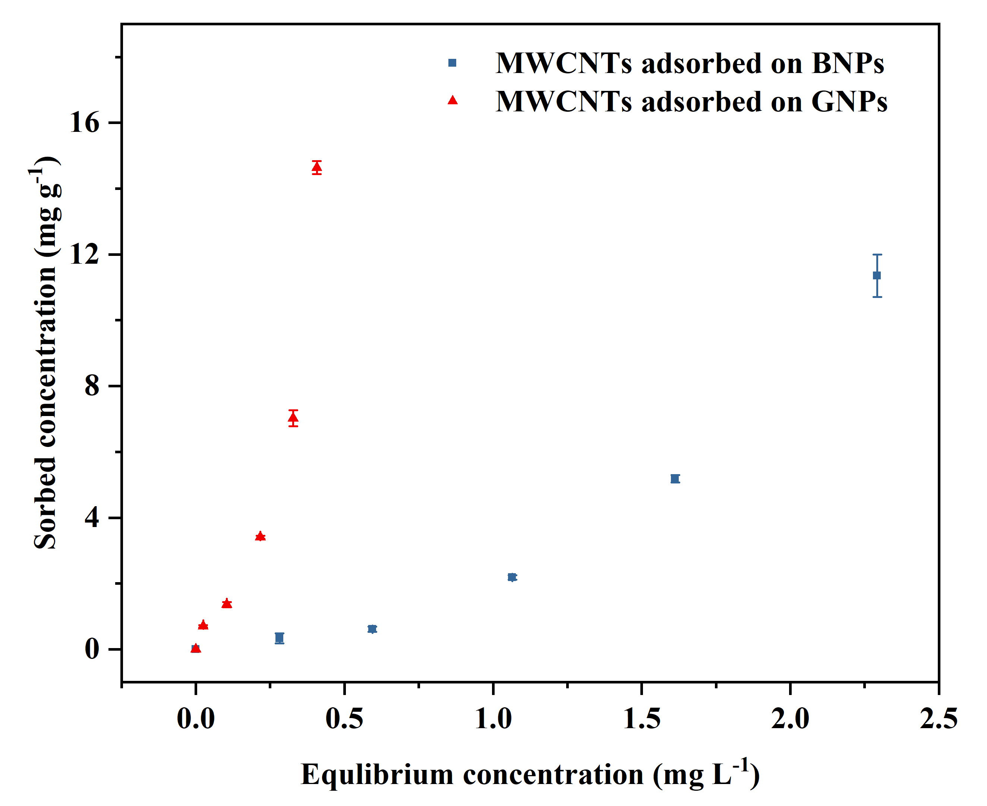
Fig. S1. Batch experiments under quasi-equilibrium conditions of MWCNTs on BNPs or GNPs in CaCl₂ solution at an ionic strength of 1 mM.

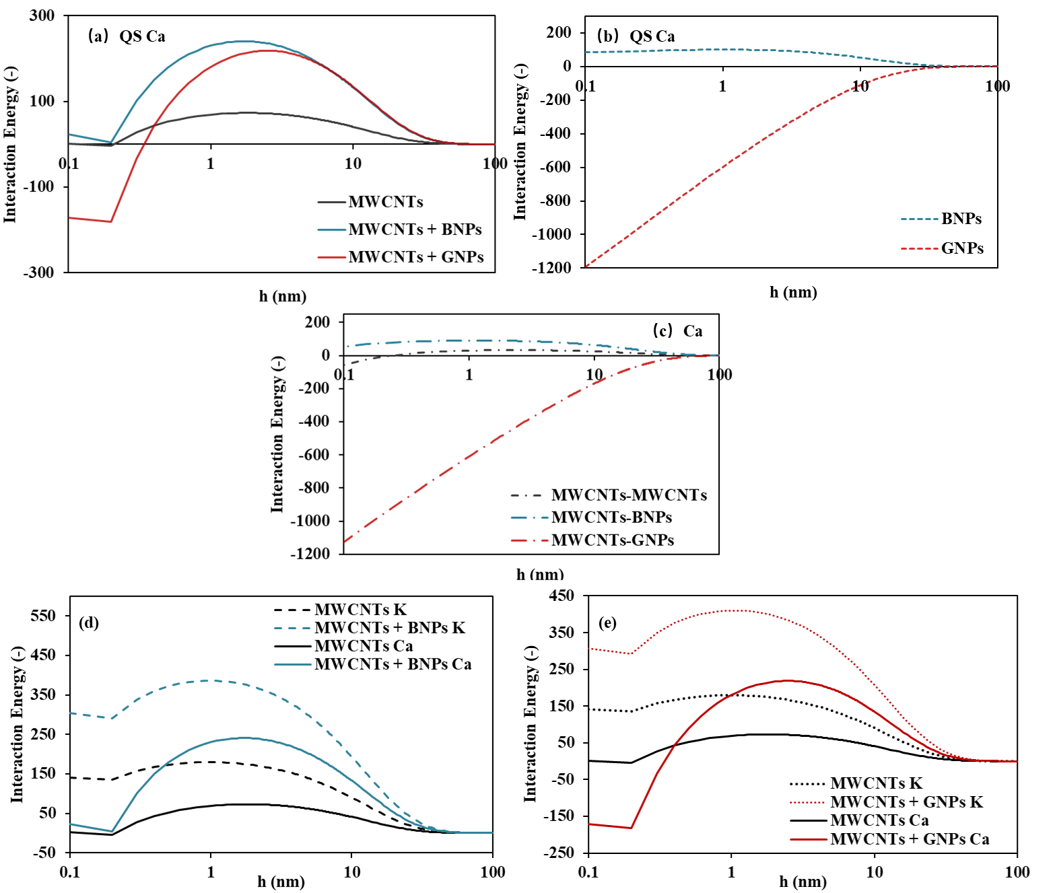
Fig. S2. Plots of the dimensionless interaction energy as a function of separation distance (h) when a spherical colloid, with properties similar to MWCNTs in QS at an ionic strength of 1 mM CaCl₂ or KCl in the presence or absence of BNPs or GNPs. (a) 1 mg L⁻¹ MWCNT with adding 0 and 4 mg L⁻¹ of BNPs or GNPs in 1 mM CaCl₂ in QS; (b) 4 mg L⁻¹ of BNPs or GNPs without MWCNTs in 1 mM CaCl₂ in QS; (c) MWCNTs in the presence or absence of BNPs or GNPs in 1 mM CaCl₂; (d) 1 mg L⁻¹ MWCNT with adding 0 and 4 mg L⁻¹ of BNPs in 1 mM KCl or CaCl₂ in QS; (e) 1 mg L⁻¹ MWCNT with adding 0 and 4 mg L⁻¹ of GNPs in 1 mM KCl or CaCl₂ in QS.
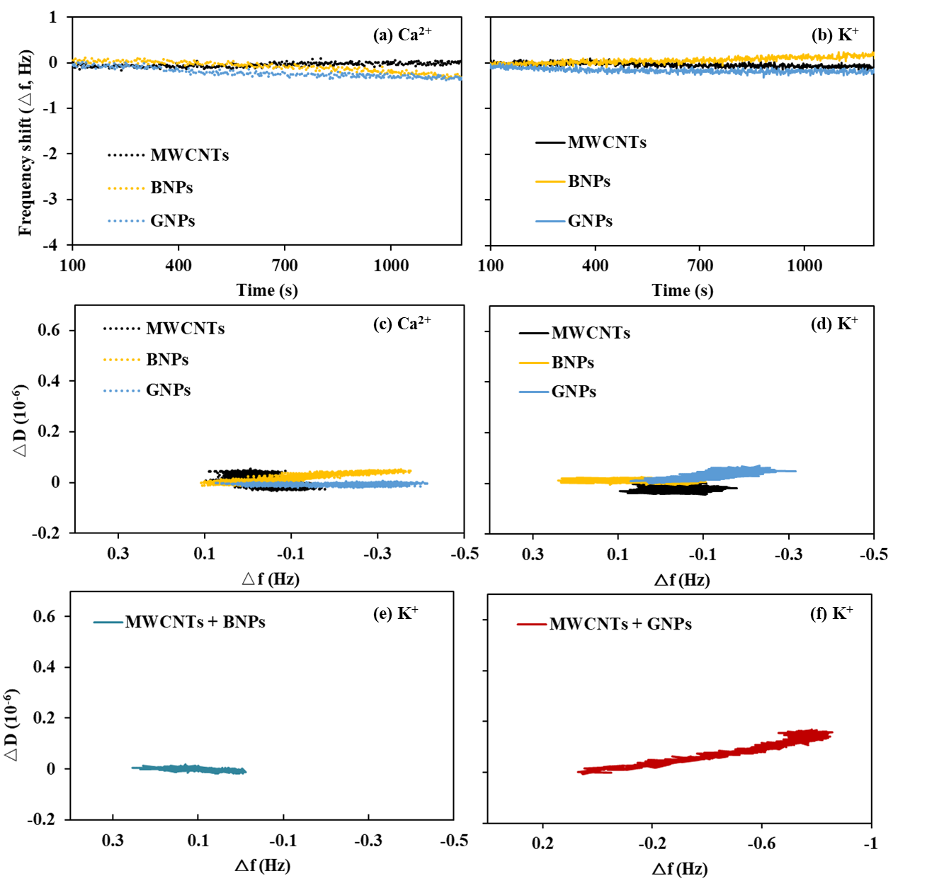
Fig. S3. Δf of MWCNTs (1 mg L⁻¹), BNPs (4 mg L⁻¹), and GNPs (4 mg L⁻¹) in 1 mM CaCl₂ (a) or KCl (b); ΔD/Δf of MWCNTs (1 mg L⁻¹), BNPs (4 mg L⁻¹), and GNPs (4 mg L⁻¹) in 1 mM CaCl₂ (c) or KCl (d); ΔD/Δf of MWCNTs (1 mg L⁻¹) in the presence of BNPs (e) or GNPs (f) (4 mg L⁻¹) in 1 mM KCl.

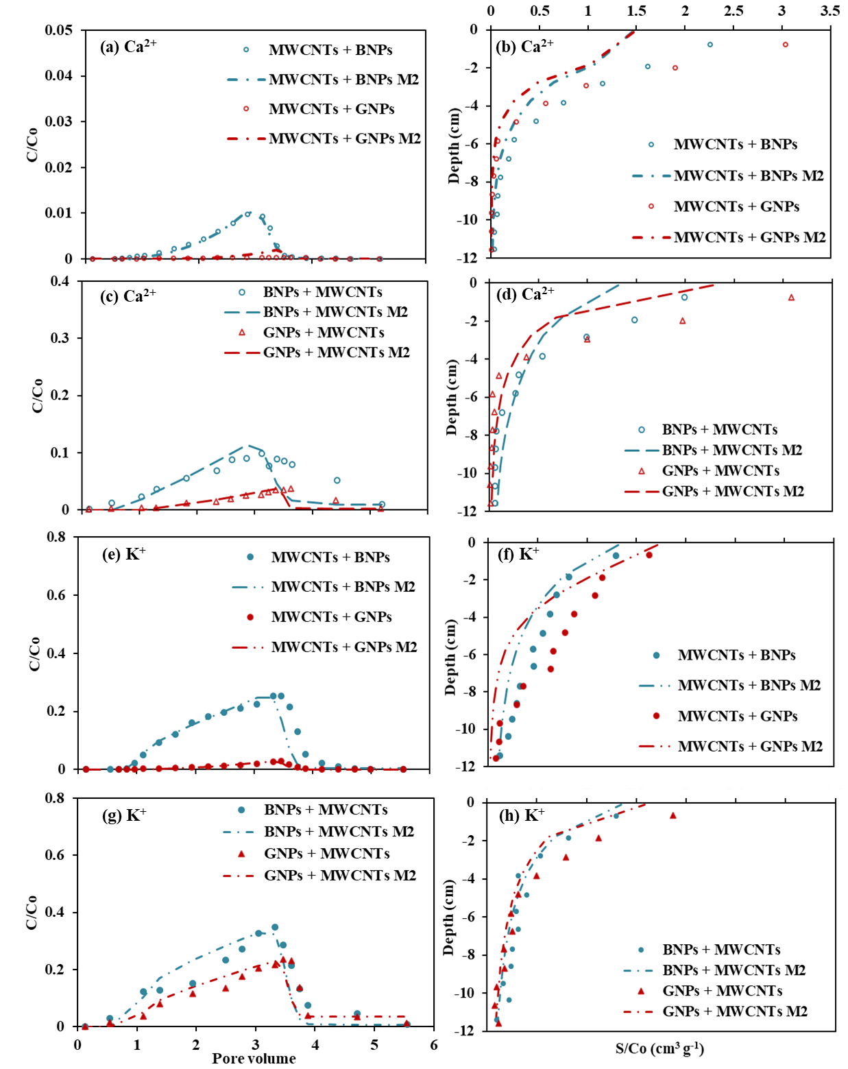
Fig. S4. Observed and fitted (M2) BTCs (a, c, e, and g) and RPs (b, d, f, and h) of MWCNTs, BNPs, and GNPs in quartz sand. (a) BTCs and (b) RPs of MWCNTs with adding 0 and 4 mg L⁻¹ of BNPs or GNPs in 1 mM CaCl₂; (c) BTCs and (d) RPs of BNPs or GNPs with adding 0 and 1 mg L⁻¹ of MWCNTs in 1 mM CaCl₂; (e) BTCs and (f) RPs of MWCNTs with adding 0 and 4 mg L⁻¹ of BNPs or GNPs in 1 mM KCl; (g) BTCs and (h) RPs of BNPs or GNPs with adding 0 and 1 mg L⁻¹ of MWCNTs in 1 mM KCl.
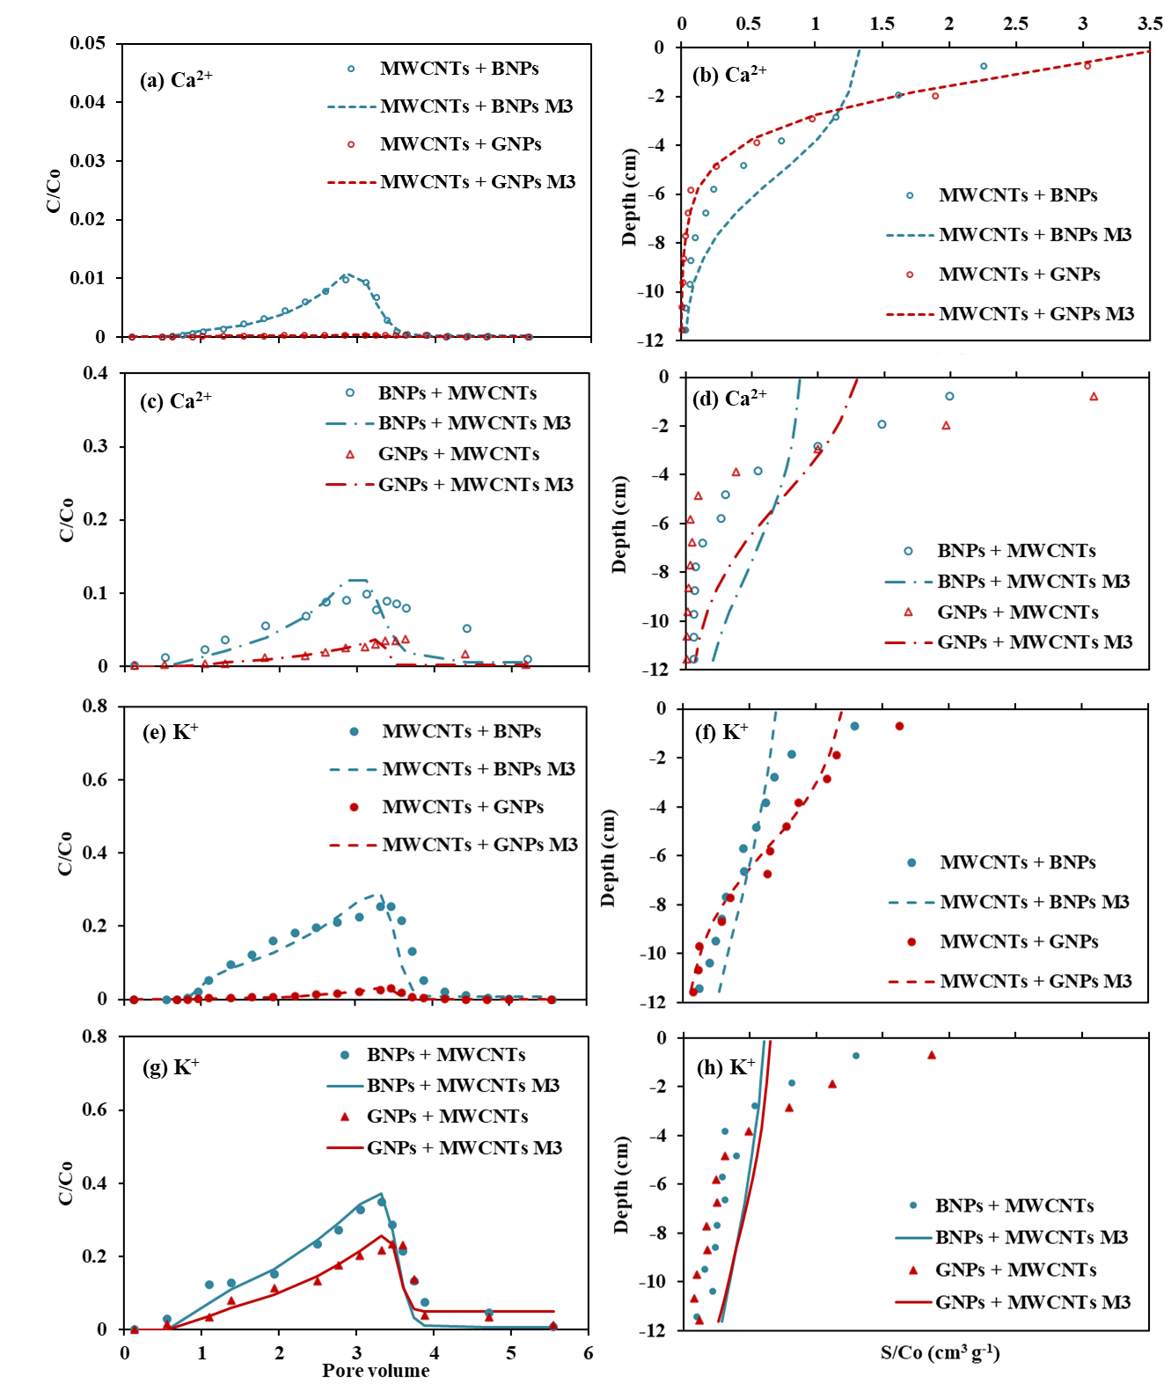
Fig. S5. Observed and fitted (M3) BTCs (a, c, e, and g) and RPs (b, d, f, and h) of MWCNTs, BNPs, and GNPs in quartz sand. (a) BTCs and (b) RPs of MWCNTs with adding 0 and 4 mg L⁻¹ of BNPs or GNPs in 1 mM CaCl₂; (c) BTCs and (d) RPs of BNPs or GNPs with adding 0 and 1 mg L⁻¹ of MWCNTs in 1 mM CaCl₂; (e) BTCs and (f) RPs of MWCNTs with adding 0 and 4 mg L⁻¹ of BNPs or GNPs in 1 mM KCl; (g) BTCs and (h) RPs of BNPs or GNPs with adding 0 and 1 mg L⁻¹ of MWCNTs in 1 mM KCl.

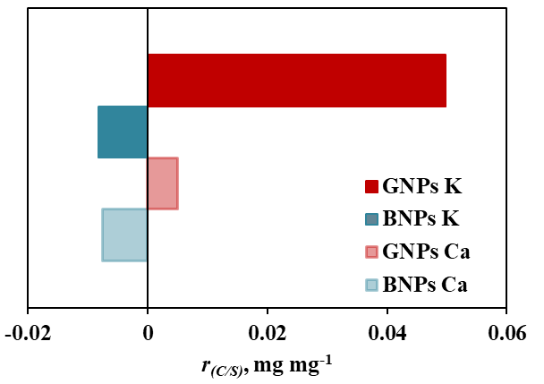
Fig. S6. Mass ratios (a) of retained MWCNTs due to retained BNPs or GNPs in co-transport experiments.

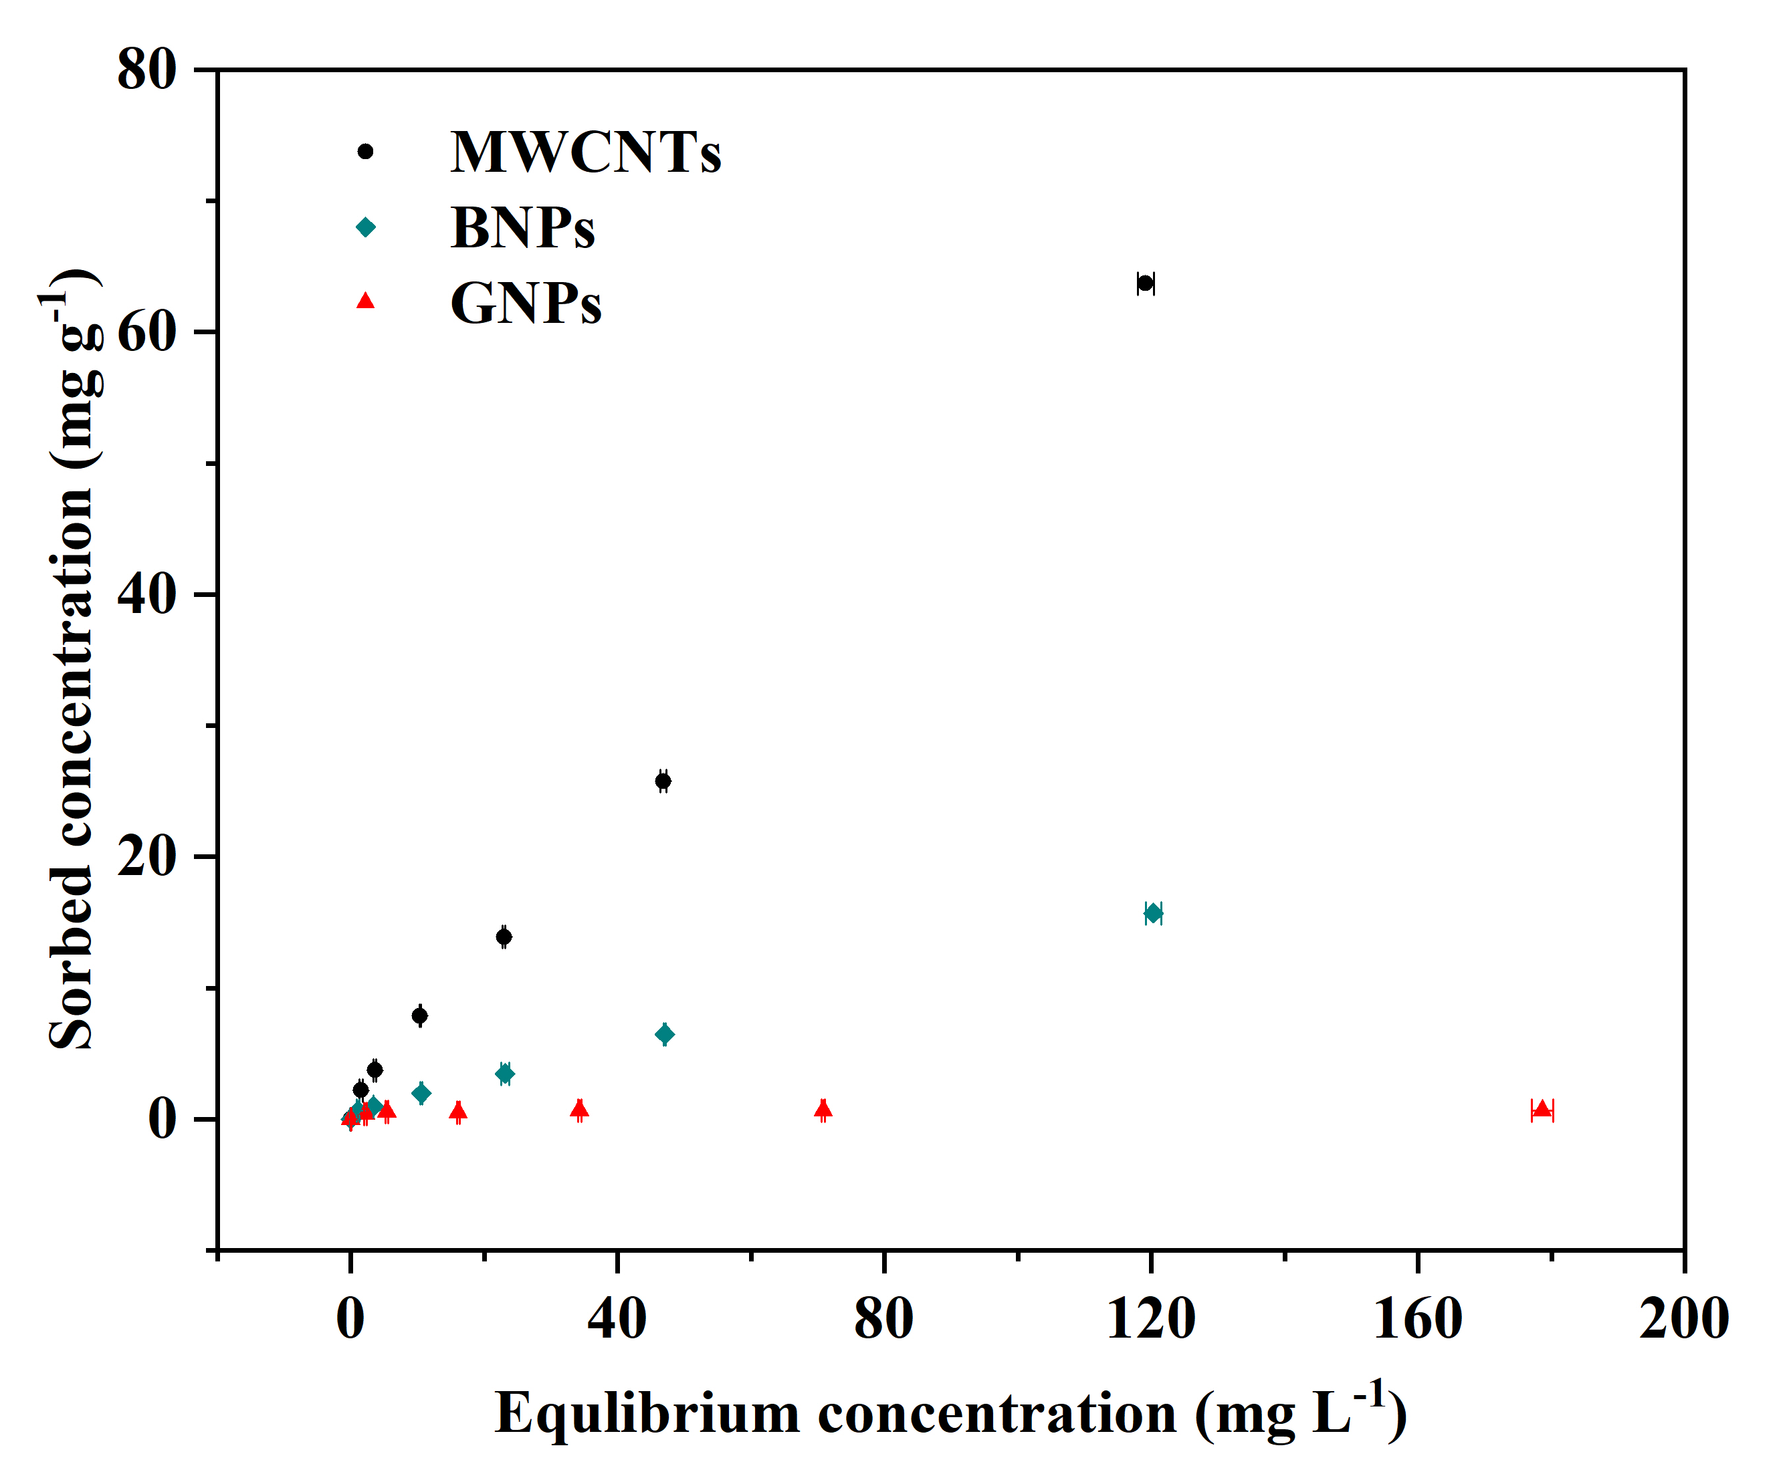
Fig. S7. Batch experiments of Ca²⁺ (IS = 1 mM) onto MWCNTs (1 mg L⁻¹), BNPs (4 mg L⁻¹), and GNPs (4 mg L⁻¹) in Milli-Q water.

