Fentanyl and the Fluorinated Fentanyl Derivative NFEPP

Elicit Distinct Hydrogen-Bond Dynamics of the Opioid Receptor

Samo Lešnik^{1,2}, Urban Bren^{1,2,3}, Tatiana Domratcheva^{4,5},
and Ana-Nicoleta Bondar^{6,7*}

¹University of Maribor, Faculty of Chemistry and Chemical Engineering, Laboratory of Physical Chemistry and Chemical Thermodynamics, Smetanova ulica 17, SI-2000 Maribor, Slovenia
²Institute for Environmental Protection and Sensors, Beloruska ulica 7, 2000 Maribor, Slovenia
³University of Primorska, Faculty of Mathematics, Natural Sciences and Information Technologies, SI-6000 Koper, Slovenia
⁴Department of Chemistry, Lomonosov Moscow State University,
Moscow 119991, Russia
⁵Department of Biomolecular Mechanisms, Max-Plank-Institute fur Medizinische Forschung, D-69120 Heidelberg, Germany
⁶University of Bucharest, Faculty of Physics, Atomiștilor 405, Măgurele 077125, Romania
⁷Forschungszentrum Jülich, Institute of Computational Biomedicine, IAS-5/INM-9, Wilhelm-Johnen Straße, 5428 Jülich, Germany
*Correspondence to nbondar@fizica.unibuc.ro, a.bondar@fz-juelich.de

Abstract
The development of safe therapeutics to manage pain is of central interest for bio-medical applications. The fluorinated fentanyl derivative NFEPP is potentially a safer alternative to fentanyl because unlike fentanyl –which binds to the μ-opioid receptor (MOR) at both physiological and acidic pH– NFEPP might bind to the MOR only at acidic pH typical of inflamed tissue. Knowledge of the protonation-coupled dynamics of the receptor-drug interactions is thus required to understand the molecular mechanism by which receptor activation initiates cell signaling to silence pain. To this end, here we have carried out extensive atomistic simulations of the MOR in different protonation states, in the absence of opioid drugs, and in the presence of fentanyl vs. NFEPP. We used graph-based analyses to characterize internal hydrogen-bond networks that could contribute to the activation of the MOR. We find that fentanyl and NFEPP prefer distinct binding poses and that, in their binding poses, fentanyl and NFEPP partake in distinct internal hydrogen-bond networks leading to the cytoplasmic G-protein binding region. Moreover, the protonation state of functionally important aspartic and histidine sidechains impacts hydrogen-bond networks that extend throughout the receptor, such that the ligand-bound MOR presents at its cytoplasmic G-protein binding side a hydrogen-bonding environment where dynamics depend on whether fentanyl or NFEPP are bound, and on the protonation state of specific MOR groups. The exquisite sensitivity of the internal protein-water hydrogen-bond network to protonation state and to details of the drug binding could enable the MOR to elicit distinct pH- and opioid-dependent responses at its cytoplasmic G-protein binding site.

Introduction
Opioid drugs are widely used to treat pain under medical supervision. They are also central to an unfolding opioid crisis that claims thousands of lives each year.¹⁻³ A promising direction to develop safer opioid drugs is to ensure that the opioid only acts on peripheral sensory neurons.^{4, 5} Such a selective targeting could, in principle, be achieved by exploiting properties of the opioid drugs and of the receptor at the site of interest: Since at peripheral nerves the analgesic effect of the opioid drugs comes primarily from binding of a protonated opioid drug to μ-opioid receptors (MORs),⁶ and inflammation typically associates with acidic pH,⁵ an opioid drug that is more likely to be protonated at acidic, rather than physiological pH, could help target the opioid drug to the acidic tissue. An opioid drug of potential interest to target specifically acidic pH tissue is the fluorinated fentanyl (FNT) derivative N-(3-fluoro-1-phenethylpiperidin-4-yl)-N-phenylpropionamide, known as NFEPP (Figures 1a, b). NFEPP has an experimentally determined pK_{a} of 6.82 (below the pK_{a} value of 8.5 typical of opioid drugs) such that NFEPP could bind preferentially to MORs at acidic pH.⁷⁻¹⁰ But understanding how opioid drugs bind at acidic pH is complicated by the fact that the MOR itself may change protonation depending on pH: Proton sensing appears to be common among G Protein Coupled Receptors (GPCRs),¹¹ and the activation of the MOR appears to be ligand-dependent pH sensitive.¹⁰ This raises the key question of how the protonation state of the MOR impacts its conformational dynamics and, as a consequence, the drug-receptor interactions. To begin to understand mechanisms by which opioid drug binding to the MOR elicits protonation- and ligand-coupled conformational change, here we have carried out extensive atomistic simulations and graph-based analyses of the wild-type and mutant MOR without ligand, bound to NFEPP or to FNT, and with distinct protonation states of key titratable groups.
Class-A GPCRs, which include the MOR, have a number of conserved functional motifs, or switches, where specific rearrangements occur during receptor activation.¹² In the MOR these molecular switches are part of interaction networks that include three titratable sidechains (D114^{2.50}, D147^{3.32}, and H297^{6.52}, Figures 1c, 2) that have been implicated in the conformational dynamics of the MOR, and which may change protonation along the activation path of the MOR.
The inactive MOR bound to a morphinan antagonist¹³ (Figure 2b) has a water-mediated H-bond network that extends from S195^{4.53} to T160^{3.45}, and a second water-mediated H-bond network that extends from D147^{3.32} to Q124^{2.60}; this latter network includes N332^{7.49} and Y336^{7.53} of the NPxxY motif, and W293^{6.48} of CWxP (Figure 2b). In the structure of the active-like, agonist-bound MOR,¹⁴ the water-mediated H-bond network of D147^{3.32} extends to include no fewer than 23 amino acid residues, including the cytoplasmic DRY motif (D164-R165^{3.50}-Y166, Figure 2c), where R165^{3.50} is implicated in G-protein binding.^{15, 16}
The carboxylic sidechain of D147^{3.32} (Figure 1c) is important for ligand binding and/or conformational change for receptor activation, because the D147E mutant MOR has reduced agonist binding affinity.¹⁷ Within one helical turn of D147^{3.32}, Y148^{3.33} and N131 are important for how ORs respond to interactions at the ligand-binding site: Relative to the wild-type, the Y148^{3.33}F mutant MOR has a 3-fold lower binding affinity for morphine, as compared to 72-fold lower affinity for FNT,¹⁸ and the N131A and N131V DOR mutants (corresponding to MOR N150^{3.35}) have constitutive activation of the β-arrestin mediated signaling path.¹⁹ Y336^{7.53} and W293^{6.48} are part of the D147^{3.32} H-bond network in the active-like MOR structure (Figure 2c). Both Y336^{7.53} and W293^{6.48} reorient during receptor activation,²⁰ and the dynamics of W293^{6.48} depends on the ligand bound at the ligand-binding site.²¹
One helical turn away from W293^{6.48}, H297^{6.52} H-bonds to the endogenous peptide agonist DAMGO,^{10, 22} and it influences drug binding to the MOR –the neutral –Nδ1 tautomer of H297^{6.52} promotes deeper binding of the FNT to the MOR,²³ and the H297A mutant has reduced binding affinities for DAMGO and naloxone.¹⁰ Apparently mild effects of the pH and of the H297A mutation on FNT-induced G-protein binding were inferred to arise from lack of H-bond networks including FNT and H297, as FNT lacks hydroxyl groups.¹⁰ This interpretation of the site-directed mutagenesis data appears at odds with more recent computations indicating that, depending on its tautomeric state, H297^{6.52} can hydrogen(H)-bond to the FNT.²³
As noted above for the D147E mutant, when D114^{2.50} (Figure 1c) was mutated to Glu, the agonist binding affinity was decreased.¹⁷ D114N has reduced binding for morphine, but not for naloxone,²⁴ for which affinity is even higher;¹⁷ the double mutation D114^{2.50}N/N332^{7.49}D restores the binding affinity for morphine.²⁴ In the δ-opioid receptor, DOR, the D114^{2.50}A mutation makes natrindole binding, which for the wild-type receptor is inhibitory, a potent activator of biased β-arrestin signaling.¹⁹ The fact that both the length and H-bonding properties of the carboxylic group D114^{2.50} are important for ligand binding is intriguing, because D114 is thought to bind a sodium ion in inactive class A GPCRs, and its protonation state to change during receptor activation.²⁵⁻²⁹ But different studies provide conflicting reports on the likely protonation state of D2.50: A neutral D114 appeared incompatible with agonist binding to the adrenergic receptor α_{2a}AR, which led to the suggestion that deprotonation must occur prior to binding;^{26, 30} in the case of the muscarinic receptor, activation might associate with proton transfer from D147 to D114.²⁵ By contrast, constant pH simulations on the MOR suggested that D114 is negatively charged in both the apo and FNT-bound MOR.²³
Compared to the binding of opioid drugs discussed above, even less is understood about NFEPP. Experiments indicated that NFEPP is more than one order of magnitude less potent than FNT at physiological pH,⁷ and that the binding affinity for NFEEP is high at acidic pH;^{7, 9} computations brought support to the latter experimental observations, as NFEPP bound stronger to the MOR in simulations of the MOR protonated to model acidic conditions, as compared to physiological pH.⁷
Taken together, the observations summarized above suggest that both the length and the charge of D114^{2.50} and D147^{3.32} influence ligand binding. Such a coupling between the protonation states of internal carboxylic groups and ligand binding to the MOR is compatible with the pH sensitivity of MOR activation¹⁰ and, in a broader context, with the emerging concept that proton detection is common among GPCRs.¹¹ But the mechanisms by which the protonation state of the MOR impacts protein conformational dynamics and opioid drug interactions remain unclear.
Atomistic molecular dynamics (MD) simulations are valuable here, because they allow us to probe the protonation-dependent response of the MOR to the binding of FNT vs. NFEPP. To this end, we have carried out 13 independent simulations of the MOR distinguished by the protonation state or mutation of specific amino acid residues; for each of these simulations, we performed a repeat simulation. The total sampling time of the 26 simulations performed amounts to >17μs. We studied the dynamics of the wild-type, ligand-free, apo-MOR, and of the wild-type MOR bound to NFEPP vs. FNT. We performed independent simulations with distinct protonation states of D114^{2.50} and H297^{6.52} (Figure 2) –i.e., titratable sidechains for which protonation and/or H-bonding properties might influence ligand binding and conformational dynamics of the MOR.^{6, 10, 17, 24} To verify how interactions of H297^{6.52} might influence ligand binding, we studied the H297A mutant MOR bound to FNT.
D147^{3.32} is expected to be negatively charged and to engage in ion-pair interactions with the protonated nitrogen atom of the opioid ligand.⁶ Since D3.32 is located close to N3.35 of the sodium-binding site (Figure 1c), to probe the influence of the D147^{3.32} charge on sodium binding to the MOR we studied the dynamics of the MOR with protonated D147; for completeness, and since a protonated D3.32 has been noted for the muscarinic M2 receptor,²⁵ we further explored the dynamics of ligand-bound MOR in a hypothetical D147 protonated state.
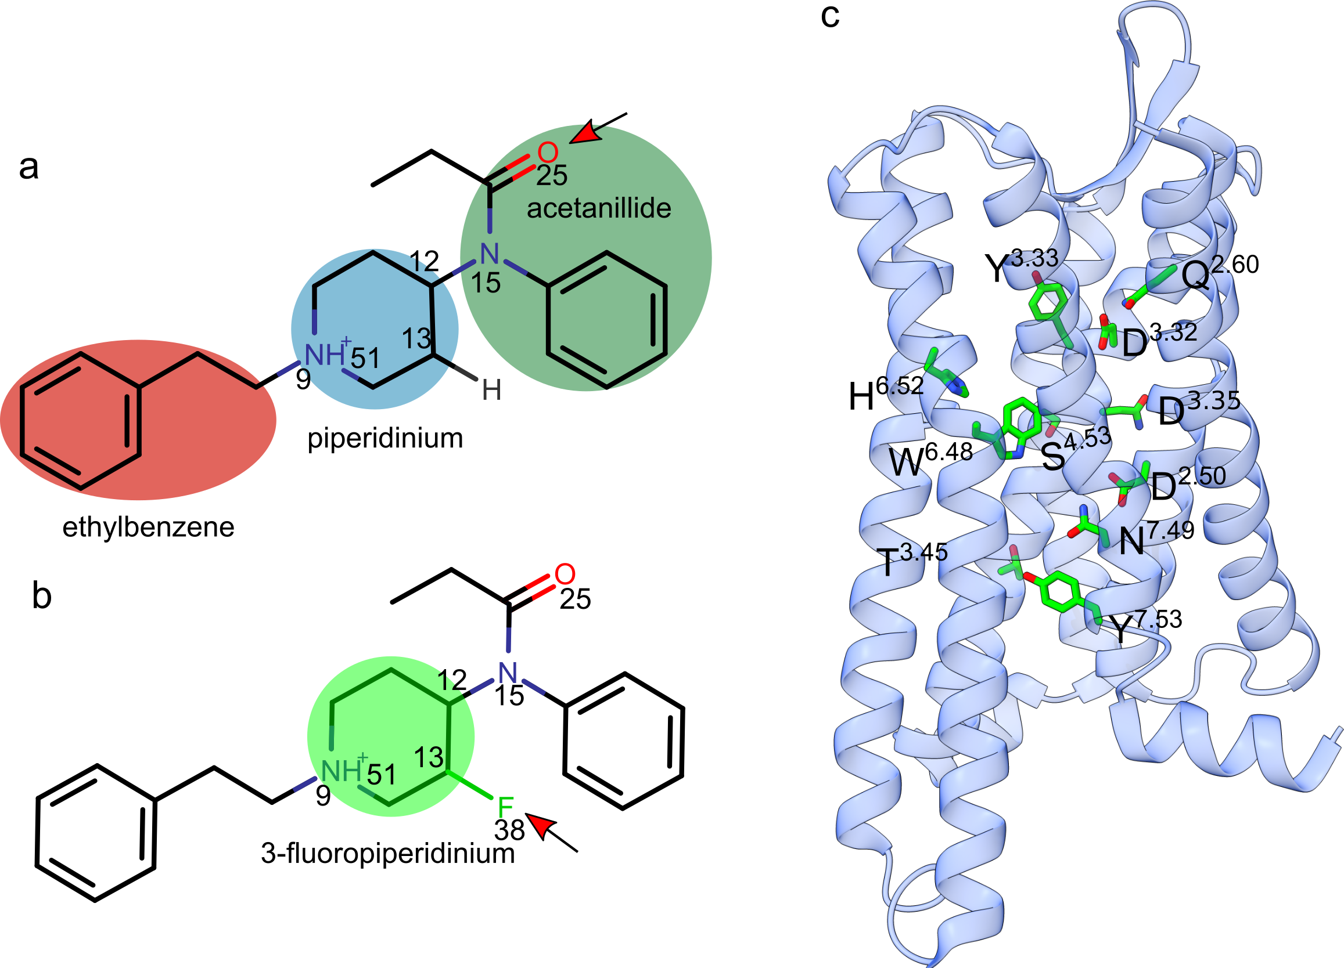Figure 1. Schematic representation of FNT, NFEPP and important amino acid residues of the MOR. (a) FNT with its neutral ethylbenzene moiety highlighted red, acetanilide, dark green, and the positively-charged piperidine moiety, blue. The red arrow indicates the sterically accessible oxygen H-bond acceptor of the acetanillide moiety. (b) NFEPP is a FNT derivative fluorinated on the piperidine moiety (C13). The fluorine atom (F38, see red arrow) can also act as an H-bond acceptor. (c) Selected amino acid residues of the MOR receptor. D2.50, N3.35, S3.39, and S7.46 delineate the sodium-binding pocket. All chemical drawings were prepared using MarvinSketch 19.22, developed by ChemAxon, all molecular graphics were prepared with UCSF Chimera 1.13,¹³ and panels assembled using Inkscape 0.92.

Protein-water H-bond networks are essential determinants of the conformational dynamics of GPCRs, including for the receptor activation.^{31, 32} To derive a comprehensive description of the protonation-coupled dynamics of the MOR, and to characterize how the internal H-bond network rearranges upon ligand binding, we used the graph-based algorithm Bridge^{33, 34} to compute the protein-water H-bond networks sampled by the apo and ligand-bound receptor.
We found that the inter-helical region of apo MOR hosts two water-mediated H-bond networks –one that connects D147 and H297 of the ligand-binding site to the extracellular region of the receptor, and a second H-bond network that connects D114 to DRY to the cytoplasmic side via NPxxY. Transient water-mediated connections between the D114 and D147/H297 H-bond networks may be sampled when either D114 or D147 is neutral –i.e., when either carboxylic sidechain is protonated. When either FNT or NFEPP are bound to the MOR, much of the internal protein-water H-bond network of the MOR is altered, particularly at the ligand-binding and extracellular regions of the receptor –H-bond connections of D147 and H297 rearrange when the ligand is present, and local H-bond rearrangements can associate with altered H-bond dynamics remotely within the network, at the DRY motif where the G protein would bind. Compared to FNT, NFEPP tends to bind somewhat shallower into the MOR. The extended protein-water H-bond networks that connect to FNT vs. NFEPP include ligand-specific H-bonds at sites essential for the functioning of the MOR.
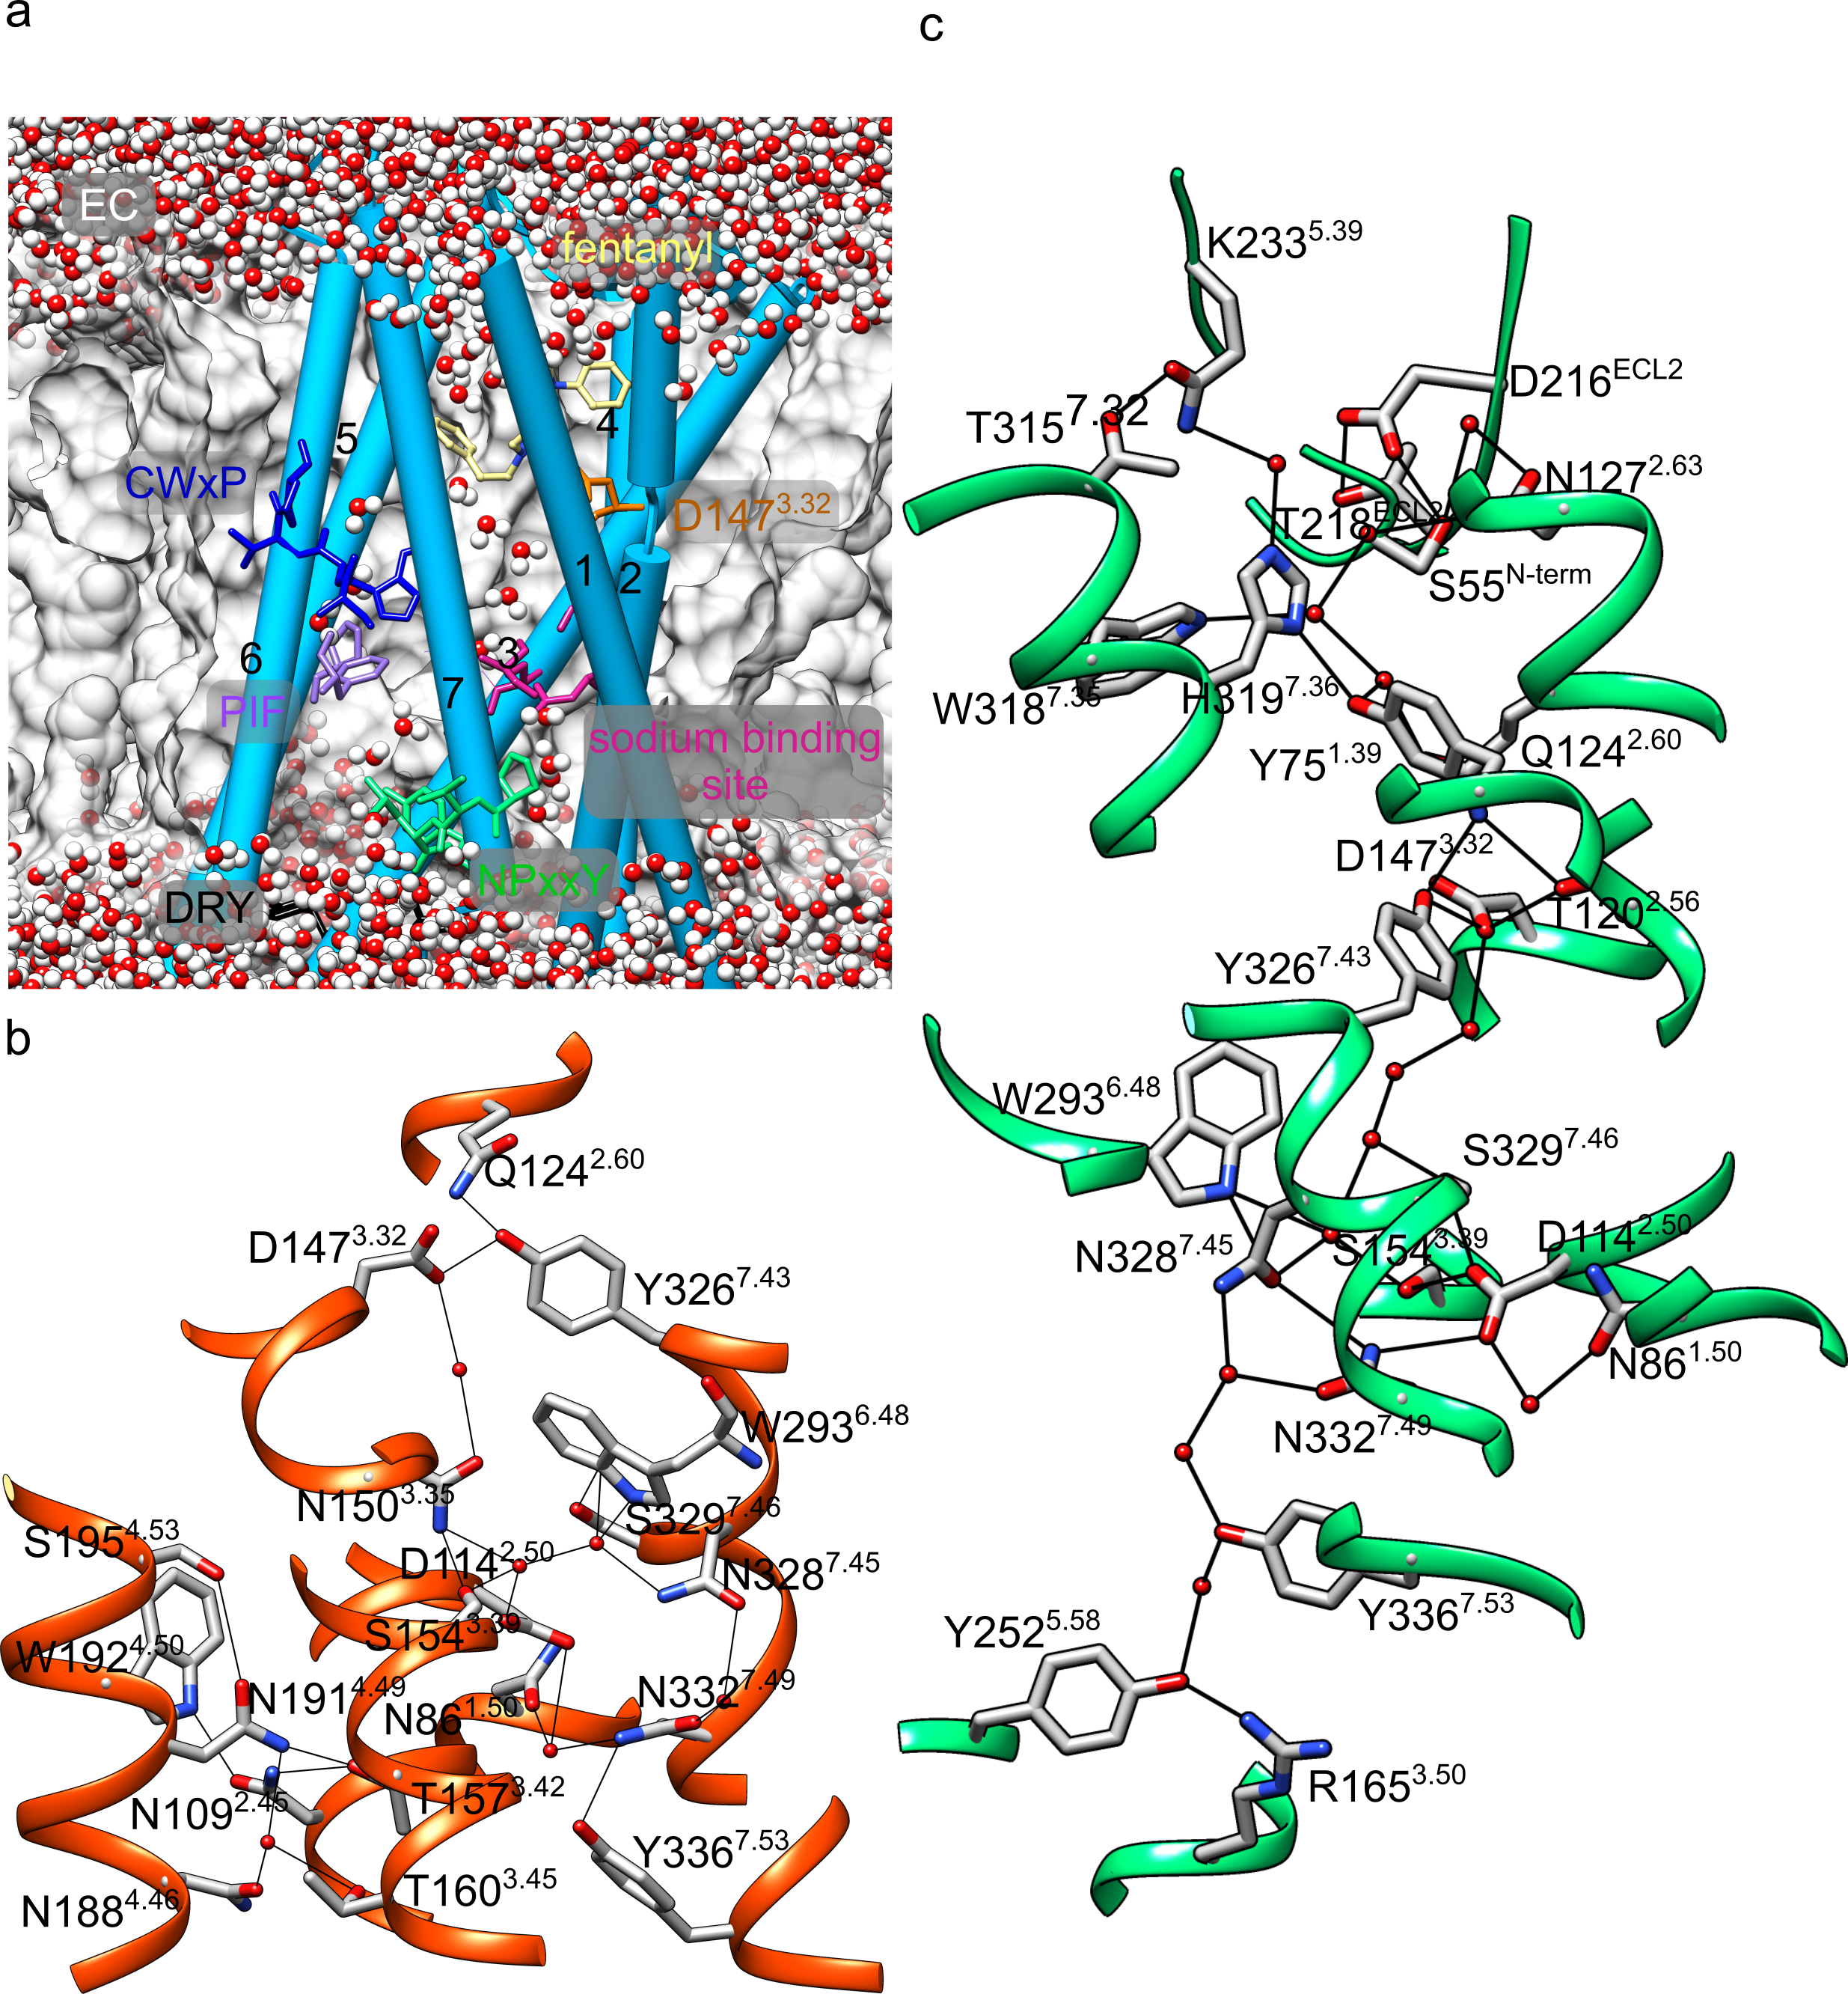
Figure 2. Architecture and internal H-bond network of the MOR. Amino acid residues are labeled according to the mouse MOR and to the Ballesteros-Weinstein (BW) scheme.³⁵ (a) Cut-away view of FNT-bound MOR in a hydrated lipid membrane. FNT is shown as a yellow stick, and the conserved functional motifs CWxP, PIF, NPxxY, and DRY are shown with blue, purple, green, and black sticks, respectively. Red spheres indicate water oxygen atoms solved in the crystal structure. Details about the functional roles of selected amino acid residues are presented in Table S1. (b, c) Internal H-bond network in the crystal structure of inactive (panel a, pdb 4DKL¹³) vs. active MOR (panel c, pdb 5C1M.¹⁴). An illustration of the internal H-bond network in the cryo-EM structure of FNT-bound human MOR³⁶ is presented in Figure S1.

Methods
Starting protein coordinates. For the starting protein coordinates we used the crystal structure of the mouse MOR bound to stabilizing antibody and to the agonist BU72, Protein Data Bank³⁷ (pdb) 5C1M, solved at a resolution of 2.07 Å.¹⁴ We downloaded from the database Orientations of Proteins in Membranes (OPM)³⁸ the coordinates of the MOR oriented along the membrane normal, and removed the antibody fragment and BU72. All 67 water molecules reported by the crystal structure were kept. Coordinates for K269^{6.24}, E270^{6.25}, and R273^{6.28}, and for the H atoms, were generated using CHARMM-GUI.³⁹ The N and C termini were treated with acetyl and methylamide groups, respectively; C140^{3.25} and C217^{45.50} were disulfide bridged.¹⁴ This protein structure was then used for MD simulations of membrane-embedded apo-MOR, and to model MOR bound to FNT or NFEPP. The H297A mutation was prepared with CHARMM-GUI.⁴⁰

Docking of NFEPP and FNT to the MOR. The starting model of FNT bound to MOR was taken from ref.⁴¹; in that work, FNT was placed into the BU72-bound MOR in an amide-piperidine-phenyl (APF) binding-pose such that the positively-charged amine group of FNT overlapped with that of BU72 (Figure S2).⁴² This preserved the interaction between the protonated amine group of the opioid drug and D147^{3.32}, as observed in the crystal structure of the starting BU72-bound MOR;³⁷ the docked phenyl moiety of the FNT has a π-stacking interaction with H297^{6.52}.
To model MOR bound to NFEPP, we started from the coordinates of the FNT-bound MOR prepared as described above, and used UCSF-Chimera⁴³ to replace with fluorine one H atom (on C13, Figures 1a,b) of the piperidine moiety of FNT, and to optimize the geometry of the resulting C-F bond of NFEPP.
Protonation of selected titratable sidechains. The reference simulation consists of the apo MOR with all titratable sidechains in standard protonation, i.e., all Asp and Glu sidechains are negatively charged, all Arg/Lys, positively charged, and all His, neutral -Nδ1 tautomers.
To explore the protonation-coupled dynamics of the MOR, we performed independent simulations of the wild-type MOR, with or without ligand, and with distinct protonations of D114^{2.50}, D147^{3.32}, H54, and H297^{6.52}. We performed an additional simulation for the FNT-bound H297A mutant MOR (Table 1).

Membrane-embedded MOR, MD simulation setup, and force-field parameters. Using CHARMM-GUI,^{39, 44} the MOR with and without bound ligand was placed in a hydrated bilayer of 1-palmytoyl-2-leoyl-sn-glycero-3-phosphatidylcholine (POPC) lipids; Na⁺ and Cl⁻ ions we added at a standard 0.15M neutralizing concentration.
We used CHARMM36m for proteins, ions and lipids,⁴⁵⁻⁴⁹ and the TIP3P water model.⁵⁰ For FNT and NFEPP we used the CHARMM-compatible force field parameters we developed recently.⁵¹

Table 1. Summary of MD simulations performed. A standard protonation indicates that all Asp/Glu sidechains are negatively charged, and all His sidechains are neutral and treated as Nδ1 tautomers. Protonation states distinct than standard are indicated for the corresponding titratable sidechains. A protonated Asp/Glu sidechain is neutral. For simplicity, the simulation label lacks ‘-Nε2’ for the tautomeric state of H54 and H297.

Protein | Ligand | Protonation | Simulation  Label | Length (μs)
 |  |  |  | Main | Repeat
wild type | - | standard | apo-std | 1.0 | 0.5
 |  | H297-Nε2 | apo-H297 | 0.81 | 0.5
 |  | D114 | apo-D114p | 0.80 | 0.5
 |  | D147 | apo-D147p | 0.76 | 0.5
 | FNT | standard | FNT-std | 0.91 | 0.5
 |  | H297-Nε2 | FNT-H297 | 0.84 | 0.5
 |  | D114 | FNT-D114p | 0.70 | 0.5
 |  | D147 | FNT-D147p | 0.78 | 0.5
wild type | NFEPP | standard | NFEPP-std | 0.76 | 0.5
 |  | D147 | NFEPP-D147p | 0.82 | 0.5
 |  | D147, H54-Nε2, H297-Nε2 | NFEPP-D147p- H54-H297 | 0.81 | 0.5
H297A | - | standard | H297A-std | 0.77 | 0.5
 | FNT |  | H297A-FNT-std | 0.80 | 0.5

All MD simulations were performed with NAMD.^{52, 53} Coulomb interactions were computed with smooth Particle Mesh Ewald summation;^{54, 55} for short range real space interactions, we used a switching function from 10 to 12 Å. Following geometry optimization, 225ps of equilibration was performed in six consecutive steps with weak harmonic constraints according to the standard CHARMM-GUI protocol.^{39, 44} Heating and equilibration were performed in the NVT ensemble (constant number of particles N, constant volume V, and constant temperature T) with an integration step of 1 fs. Production runs were performed using the NPT ensemble (constant N, constant pressure P, and constant T = 310.15K) using a Langevin dynamics scheme^{56, 57} with a damping coefficient of 5 ps⁻¹. The lengths of covalent bonds to H atoms were kept fixed.⁵⁸ For the main simulations, the integration step of 1 fs for the first ~400-500ns, and 2fs for the remaining of the trajectories; replica simulations were performed to around ~100ns with 1 fs integration step and the remaining with an integration step of 2fs. All bond lengths involving H atoms were fixed using SHAKE.⁵⁸ Coordinates were saved every 10 ps.
Repeat simulations were initiated from the same starting coordinates as the corresponding main simulations, but with different assignment of atom velocities.

H-bond criteria and graphs of dynamical H-bond networks. We computed direct and water-mediated H-bonds between protein sidechains, and between protein sidechains and H-bonding sites of the ligand. We used standard H-bond criteria, whereby two groups are considered as H-bonded when the distance between the donor and acceptor heavy atoms was ≤3.5Å, and the H-bond angle, ≤60°. When present, FNT and NFEPP were included in the H-bond graph computation.
The occupancy of an H-bond is defined as the ratio of coordinate sets, from the trajectory segment used for analyses, during which the H-bond criteria are met.
To compute graphs of dynamical protein-water H-bond networks we used Bridge2.^{33, 34} An H-bond graph consists of nodes, which here are H-bonding protein sidechains or the ligand, and edges, which are direct protein H-bonds or water-mediated H-bonds between H-bonding groups of the protein or of the ligand. For simplicity, we considered H-bonded water chains of up to three water molecules. The local H-bond cluster (network) of a specific protein group is defined as the collection of nodes and edges that connect to that group of interest. Local H-bond clusters of selected sidechains of the MOR, and of the opioid ligand, were extracted from the H-bond graphs using Connected Component Analyses in Bridge2.³⁴
All H-bond graph computations we present were computed for direct H-bonds between protein sidechains, 3-water bridges between sidechains and, when applicable in the ligand-bound simulations, atoms O25 and H51 of FNT and NFEPP, and atom F38 of NFEPP (Figure 1a,b).
We refer to H-bonds or water-mediated H-bonding bridges as transient when the H-bond occupancy is <25%, frequent, when the occupancy is ≥ 50% but below 70%, and stable, when the occupancy is ≥ 70%. H-bond networks were computed from the last 300ns of each simulation.

Root-mean-squared distance (RMSD) profiles, and time series of sodium ion binding. We monitored, for each simulation, the backbone RMSD profiles relative to the starting crystal structure. All RMSD profiles were computed using the rms.RMSD function of the MDAnalysis^{59, 60} Python library. We present separately the RMSD profiles for the transmembrane helical segments vs. the loops and termini.
To find out whether sodium ion(s) from the aqueous solution may transiently visit the interior of the MOR, we monitored minimum distances between sodium ions and oxygen and nitrogen atoms of the sidechains of E229 (part of an extracellular H-bond network), D114, D147 and H297 of the ligand-binding site, and D114, S154, N150 and S329 at the sodium binding site (Figure 2b).

TM helical reorientation. To characterize the orientation of the TM helical segments, we used the MatchMaker tool⁶¹ in UCSF Chimera 1.13⁴³ to superimpose the starting crystal structure of the MOR (pdb: 5C1M) with the last coordinate set of each MD simulation, and visually inspected each structure overlap.

Results
The overall structure of the MOR remained stable throughout all simulations performed (Figures S3, S4). The average backbone RMSD values for the TM region are within 2 Å (Figures S3, S4), and the relative orientations of the TM segments are typically only marginally affected by ligand binding or protonation change (Figures S5, S6). In what follows we consider as reference simulation the main, 1.0μs-long simulation of wild-type apo MOR with standard protonation states.

Protonation-coupled dynamics of sodium ion binding to apo-MOR. Most of the class A GPCRs have a conserved sodium binding site,⁶² being thought that sodium binding to the inactive receptor has important allosteric effects on receptor activation –interactions between the sodium ion and D114^{2.50} stabilize the inactive state of the receptor, whereas the binding of an agonist perturbs the sodium binding site and the sodium ion leaves the receptor.⁶² A sodium ion bound at the sodium binding site was solved with the crystal structure of the natrindole-bound DOR;¹⁹ in that structure, the sodium ion is coordinated by the sidechains of D2.50, N3.35, S3.39, S7.46, and by two water molecules.¹⁹ Although an electron density compatible with the presence of a sodium ion at D2.50 was suggested,⁶² none of the three-dimensional structures solved for the MOR have coordinates for a D2.50-bound sodium ion. Rapid binding of a sodium ion binding from the extracellular side, on the ~10-10²ns timescale, was observed during recent atomistic simulations of the KOR,⁶³ and in earlier simulations of the DOR, MOR, and KOR.^{64, 65}
In the reference simulation of the apo MOR with standard protonation states, a sodium ion approached E229 within ~200ns, but relocated back to the extracellular bulk (Figure 3). A sodium ion then entered the inter-helical region of the MOR where it sampled dynamical interactions with sidechains of the sodium-binding pocket, but also with D147 and H297 (Figures 3c, S7, S8), and with water molecules (Figure 3b).
Similar dynamics of sodium ion binding to apo MOR with standard protonation states were observed in the replica simulation (Figure S7b). By contrast, sodium ions remained away from the sodium-binding pocket in the four simulations of apo MOR with either D114 or D147 neutral (Figures S7c,d,h,i) – for example, in both simulations with protonated D114, sodium ions remains at least 11 Å away from the sodium-binding pocket of MOR with protonated D114 (Figures S7e,f). Likewise, sodium ions remained away from the sodium-binding pocket in all ligand-bound MOR simulations (Figure S9).
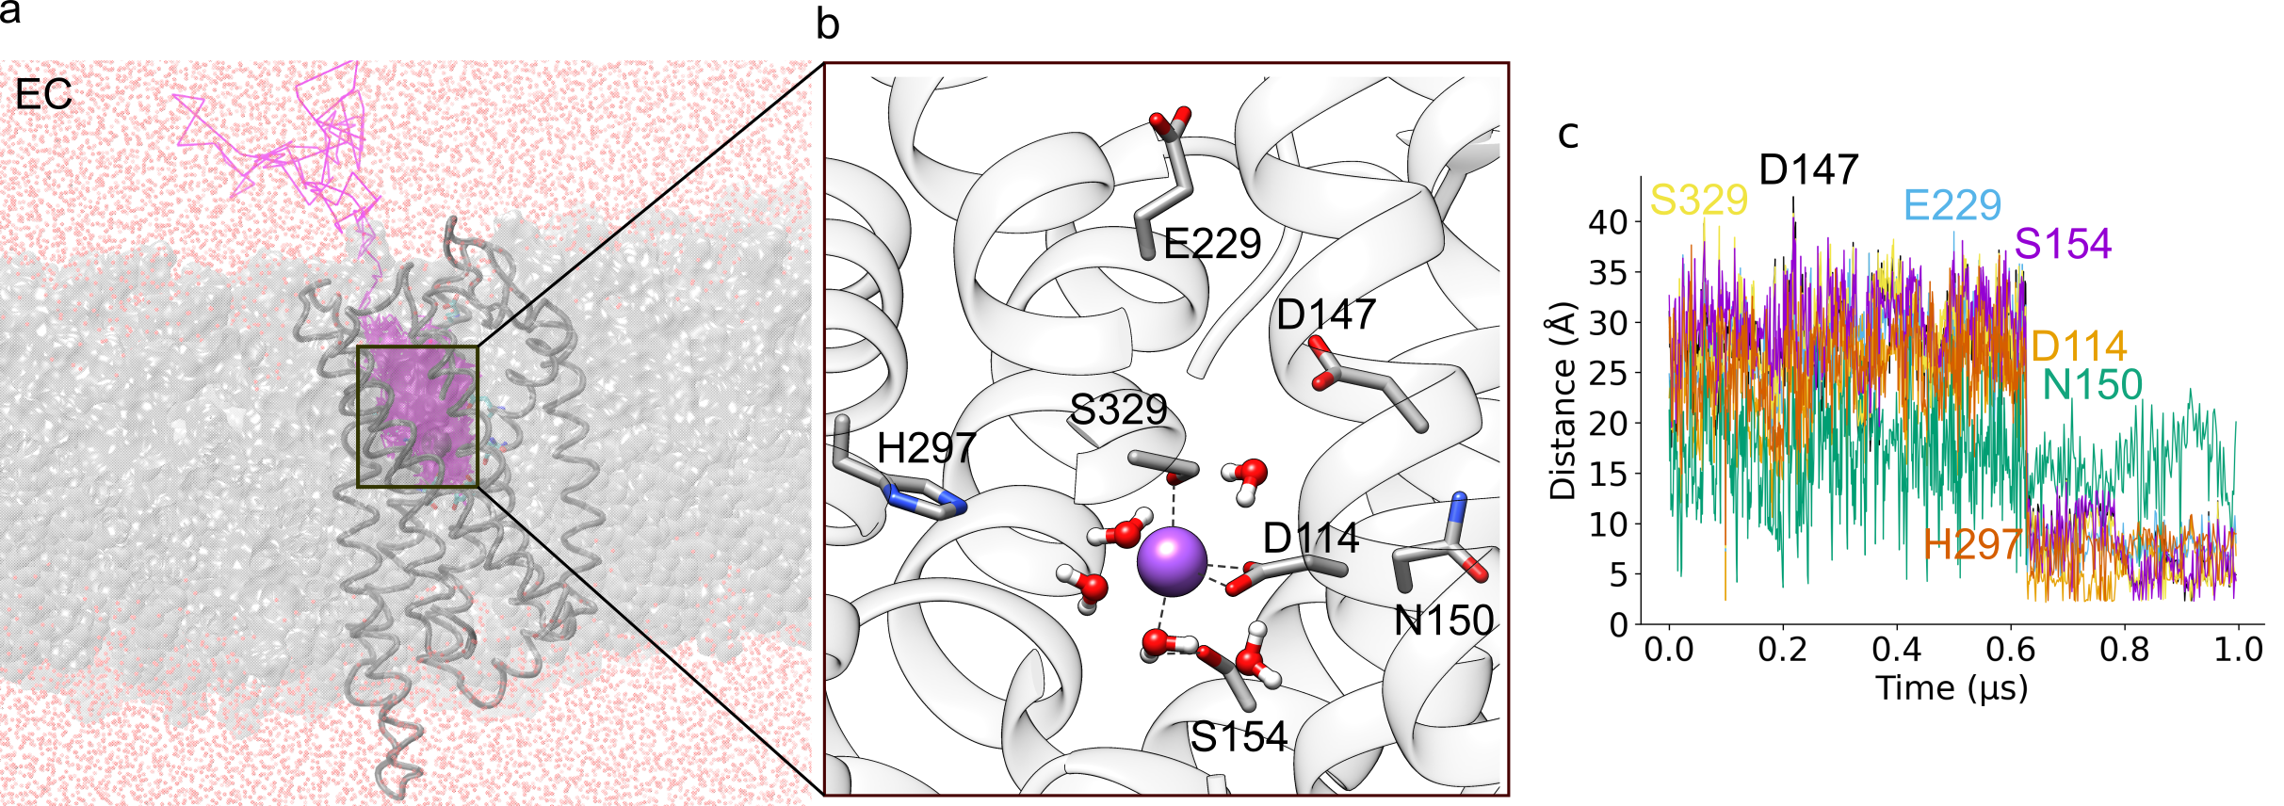
Figure 3. A sodium ion binds at the sodium binding site of apo MOR with standard protonation states. (a) Sodium ion binding to apo MOR. The magenta curve, which shows the coordinates of the sodium ion entering the receptor, was derived from the reference simulation of apo MOR using trajectory_path in Visual Molecular Dynamics, VMD. (b) Close view of the sodium ion bound to apo MOR from a coordinate snapshot of the main simulation; the coordinate snapshot was chosen to illustrate the transient sampling of close interactions between the sodium ion and sidechains that delineate the sodium binding pocket (see also Figure 2a). The magenta sphere represents the sodium ion. (c) Time series of the shortest distances (in Å) between a sodium ion and sidechains that delineate the sodium-binding site. For clarity, time series are shown with a time step of 100ps.

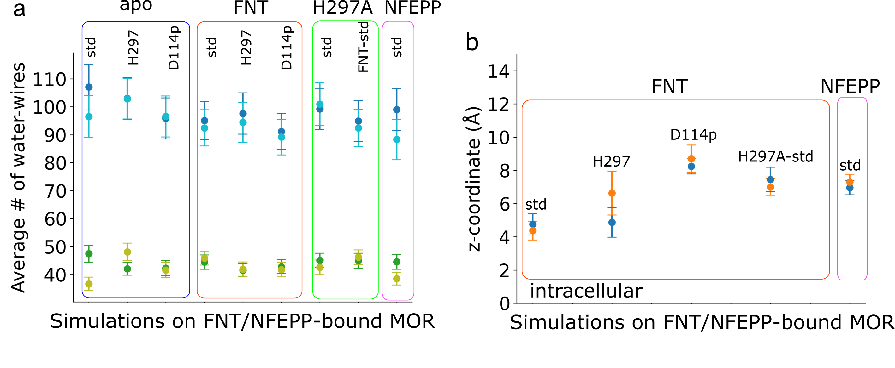
Figure 4. The protonation state of the MOR impacts drug-receptor interactions. (a). Average number of three-water mediated wires between sidechains of the MOR. with occupancies at 25% for main simulations (dark blue), and replica simulations (light blue). Average number of water wires with occupancies at 70% for main simulations (dark green) and replica simulations (light green). (b) Average coordinate along the membrane normal of FNT-N9 vs. NFEPP-N9 computed from main (blue dots) and replica (orange dots) simulations. Note that, for MOR with standard (std) protonation states, FNT is closer to the intracellular side than NFEPP. Profiles computed from simulations of ligand-bound MOR with neutral D147 are presented in Figure S10.

Dynamic protein-water H-bond network of apo MOR with standard protonation states, and the H-bond occupancy threshold. Apo MOR hosts numerous water-mediated and direct H-bonds: some 95-100 direct and water-mediated connections are sampled throughout simulations of apo-MOR (Figures 4a, 5). The finding that many of the connections of the protein-water H-bond graph of the MOR, are infrequent, with occupancies below 20% (Figure 5c), raises the question which H-bond occupancy threshold shall be used for the H-bond graphs.
The graph that includes transient H-bonds with relatively low occupancy (≥ 25%), shows an H-bond network that extends across large regions of the MOR (Figure 5a). H54, D147 and H297 inter-connect to numerous other protein sidechains from the extracellular half of the receptor; D114, with groups of the NPxxY and DRY, are part of a network leading to the cytoplasmic side of the receptor (Figures 3a, 5a, 6a). These two extended H-bond networks can inter-connect via a dynamic H-bond between D147 and S329 (average occupancy of ~24%). A qualitatively similar picture is obtained for the replica simulation of apo MOR with standard protonation states (Figure S11).

When only persistent H-bonds (occupancy ≥ 70%) are considered, the graphs computed from either the main (Figures 7, S12) or replica simulations (Figure S13, S14) of apo MOR with standard protonation states consist of local H-bond clusters: D114 is part of a cluster with S154 and NPY-N332 and Y336, D147, with T120 and N150, and DRY-D164 and Y165 are part of a somewhat larger local cluster with D340 (Figures 7, S12, S13). At the extracellular side, an extended H-bond cluster includes E229 (Figure 7). H297 is part of H-bond graphs shown at lower occupancy of ≥ 25% (e.g., Figures 5, S11), but absent from the graphs of persistent H-bonds.
We inspected closely the relatively low (≥ 25 occupancy) H-bond graphs of each simulation (Figures S15-20), vs. graphs of persistent H-bonds (≥ 70 occupancy). As detailed below, we found that an intermediate H-bond occupancy threshold of 50% would be needed to better capture protonation-dependent H-bond network rearrangements (see, e.g., Figure 8). This finding is compatible with our recent reports that H-bond occupancy thresholds of 50%-60% are reasonable to identify H-bonds sampled in all monomers of spike protein S³⁴ and, respectively, a visual rhodopsin GPCR.⁶⁶
Pursuant to the considerations above, we used a minimum H-bond occupancy of 50% to extract the H-bond clusters of D114, D147 and, where present, FNT/NFEPP. Where needed, we inspected the lower-occupancy H-bond graphs to identify transient connections between specific local H-bond clusters.

Protonation-coupled dynamics of apo MOR. The local cluster of persistent H-bonds of D114 (occupancies ≥70) depends little on the protonation states tested for the MOR: Except for the H-bond between D114 and S329 –absent when D114 is neutral–, the composition of the cluster is largely independent of the protonation state, and even on whether the H297 sidechain is present (Figures 7, S21-26). Likewise, the cytoplasmic H-bond cluster of DRY-D164 and Y165, and the extracellular E229 H-bond cluster, has similar compositions of H-bonding sidechains in apo MOR with different protonation states (Figure 7).
But a number of the more dynamic H-bonds of the MOR respond to the protonation change. In both the reference (main) and repeat simulations with standard protonation states, the local H-bond clusters of D114 and D147 lack frequent (occupancies ≥50%) inter-connections, such that these two protein-water H-bond clusters remain largely separated (Figures 6a, 8a, S27a). By contrast, the D114 and D147 clusters inter-connect frequently directly via S329, or via N150, in both simulations with neutral D114 (Figures 8c, S27c).
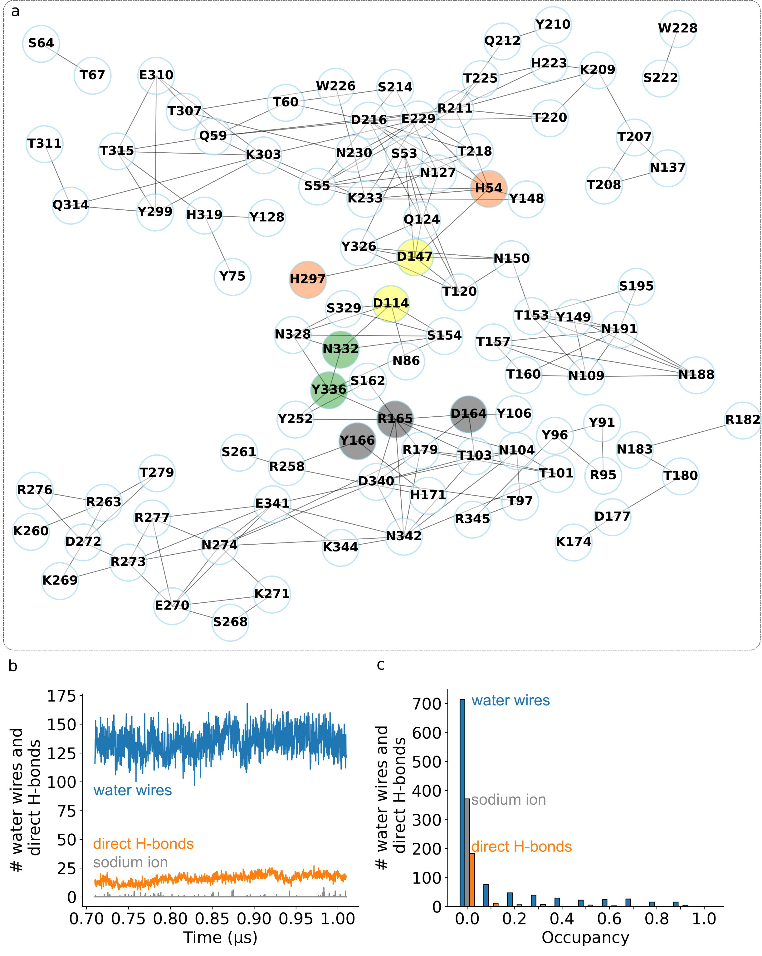Figure 5. Apo MOR hosts an extensive, dynamic protein-water H-bond network. (a) H-bond network computed for the apo MOR reference simulation. Selected graph nodes are colored according to Figure 2a. The minimum H-bond occupancy shown is 25%. A graph with low-occupancy H-bonds that includes sodium ion interactions is presented in Figure S8, and the H-bond graph computed from the repeat simulation, in Figure S28. (b) Time series of all unique H-bond connections sampled at least once during the trajectory segment used for data analyses. The blue profile shows the number of water wires between protein sidechains, orange, direct H-bonds between protein sidechains, and grey, sodium-sidechain and water-mediated interactions between sodium ions and sidechains. (c) Histogram of the average occupancy of all H-bond connections from panel b.

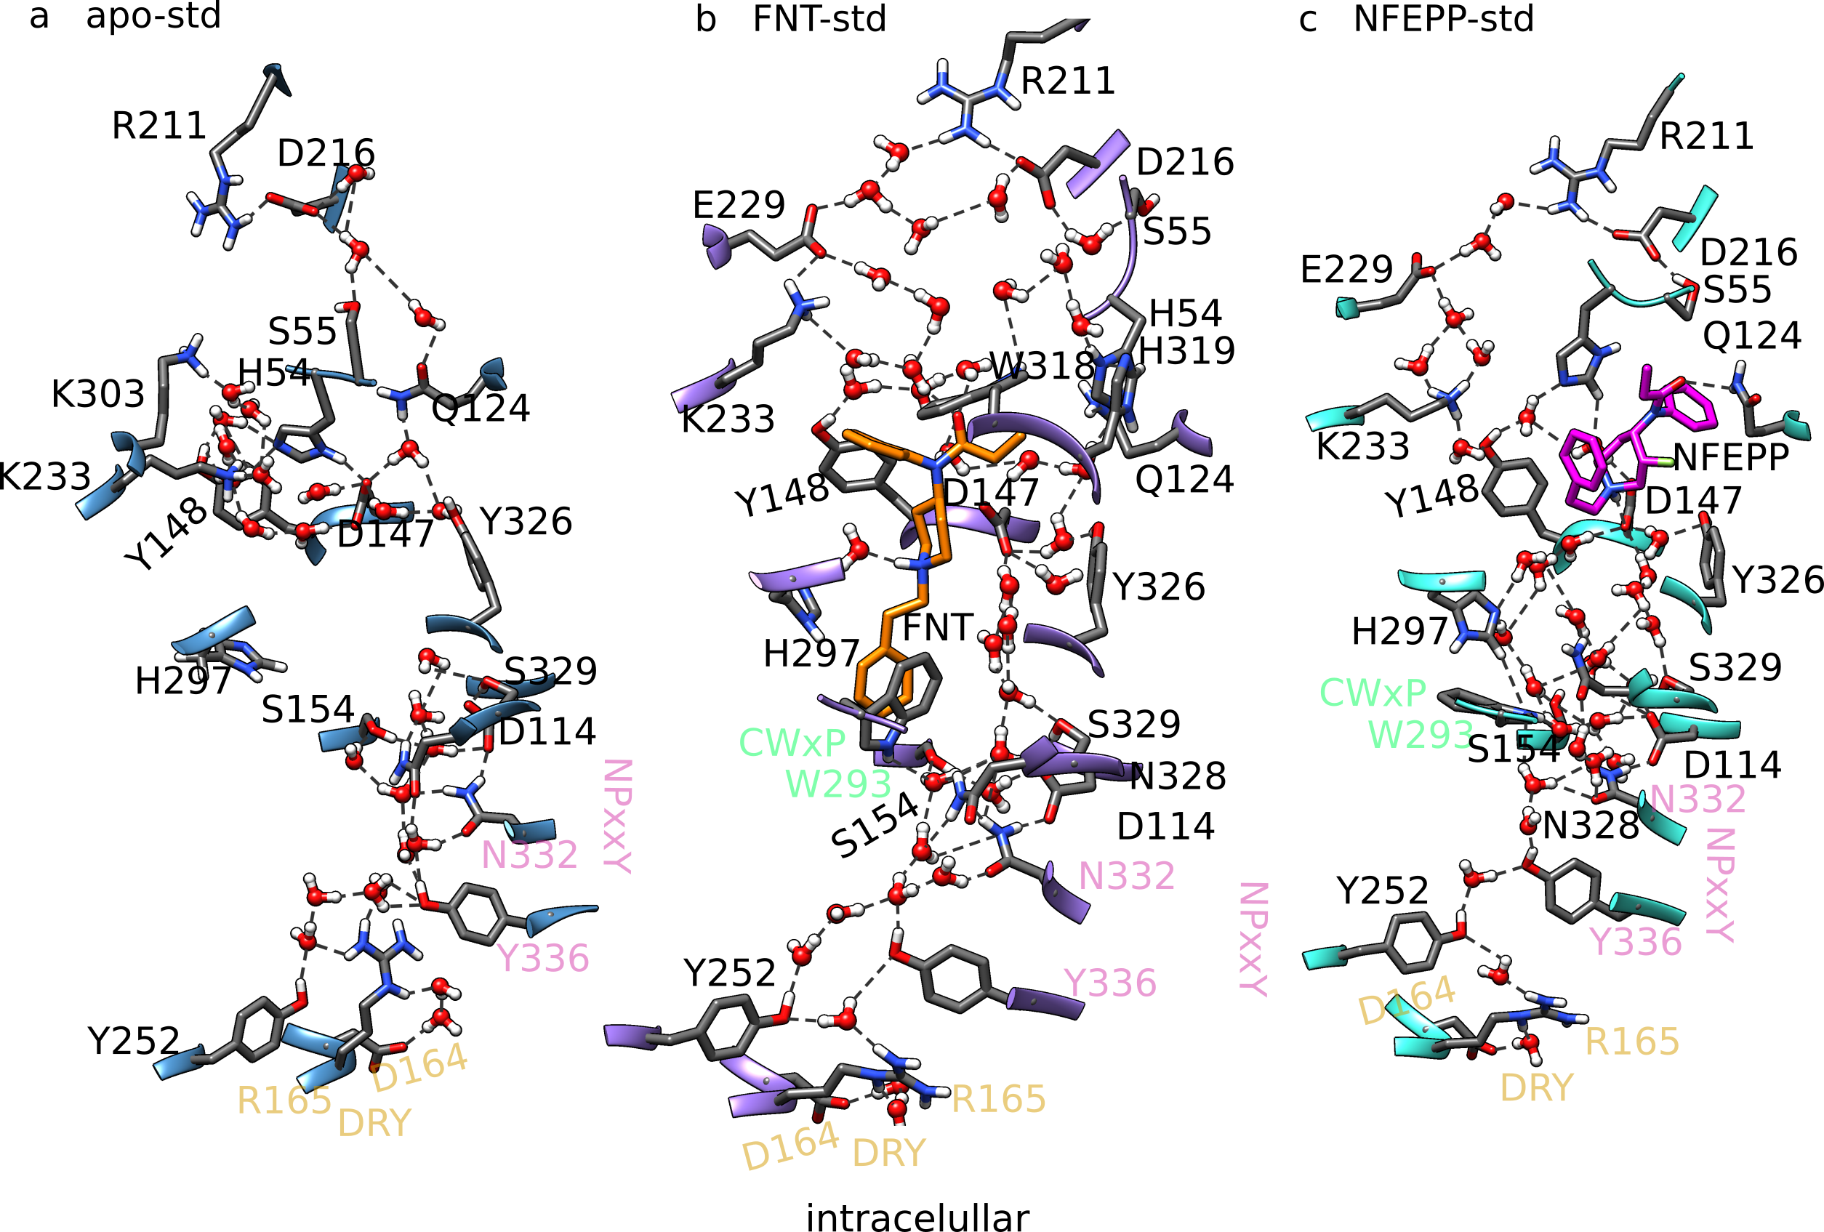
Figure 6. FNT and NFEPP alter the internal protein-water H-bond network of the MOR with standard protonation states. Black lines indicate H-bonds sampled during the main simulations (Table 1); the minimum H-bond occupancy shown is 30%. (a) Protein-water H-bond network of apo-MOR. (b, c) Protein-water H-bond network of the MOR bound to FNT in the H297-binding pose (FNT-std in Table 1, panel b) vs. to NFEPP in the D147 binding pose (NFEPP-std, panel c). Carbon atoms of FNT and NFEPP are colored orange and magenta, respectively.

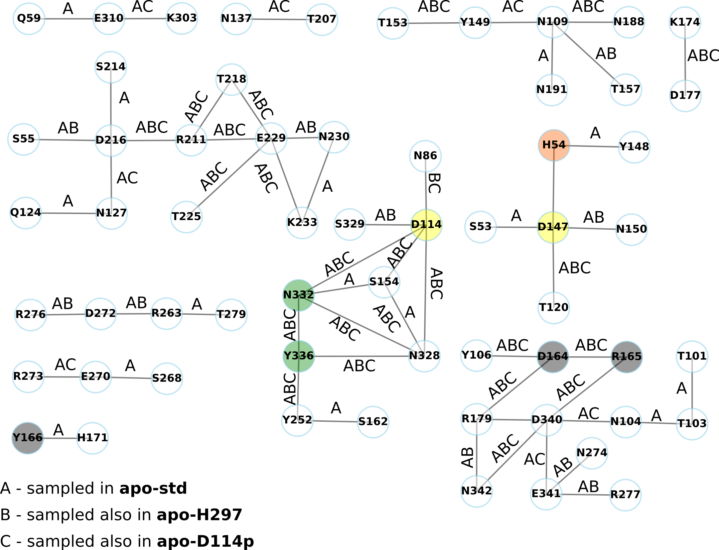
Figure 7. Local clusters of persistent H-bonds of apo MOR. H-bond connections shown are direct or water mediated, and have occupancies of at least 70%. All H-bonds shown are sampled in the reference simulation of wild-type apo-MOR with standard protonation states. Labels A, B, C denote H-bond connections in the apo-std reference simulation, MOR with protonated D114 and, respectively, with H297 described as neutral –Nε2 tautomer (main simulations, see Table 1). The graphs of H-bonds with occupancies ≥70% computed from all main and replica simulations of apo MOR are presented in Figures S21-26.

The S329-mediated connection between D114 and D147 is also sampled both apo-MOR simulations with H297 described as -Nε2 tautomer, albeit with somewhat different occupancies (33% in the main simulation, vs 39% in the repeat simulation).
The ensemble of the simulations performed on apo MOR with distinct protonation states indicate that D114 is part of a core local cluster of persistent H-bonds with a composition that is largely protonation-independent. Of the persistent H-bond connections of D114, and D147, those with S329 and, respectively, with N150, help mediate the protonation-dependent connections between the D114 and D147 H-bond clusters (Figures 7, 8). Low-occupancy S329-mediated H-bond connections between D114 and D147 are sampled in test simulations with protonated D147 (Figures S19), and protonated D147 would also allow infrequent sampling of a direct connection to D114 (Figure S20).

The internal H-bond network of the MOR rearranges when FNT is bound. When all titratable sidechains of the MOR have standard protonation (FNT-std), the FNT samples during the first 300ns a D147-binding pose, whereby FNT-N9 H-bonds to the carboxylic group of D147 and FNT-O25 is close to Q124 (Figures 9a, 9b); for the remaining of the ~0.9μs-long simulation, the FNT switches between an H297-binding pose, whereby FNT-N9 interacts via a water molecule with H297, and a water mediated D147 binding pose (Figures 6b, 9a, 9c). This switching of the FNT H-bonding between D147 and H297 is illustrated by presence of both FNT-D147 and FNT-H297 connections in the graph of H-bond connections with relatively low occupancies of ≥ 25% (Figures 10, S29); the connection to H297 is, however, preferred (Figure S30, S31). A coordinate snapshot from the end of the ~0.9μs simulation of FNT-bound MOR with standard protonation states (Table 1) shows that FNT water-bridged to H297, and an extensive water-mediated H-bond network that includes D114 and D147, and which reaches to the intracellular DRY motif via CWxP and NPxxY (Figure 6b).
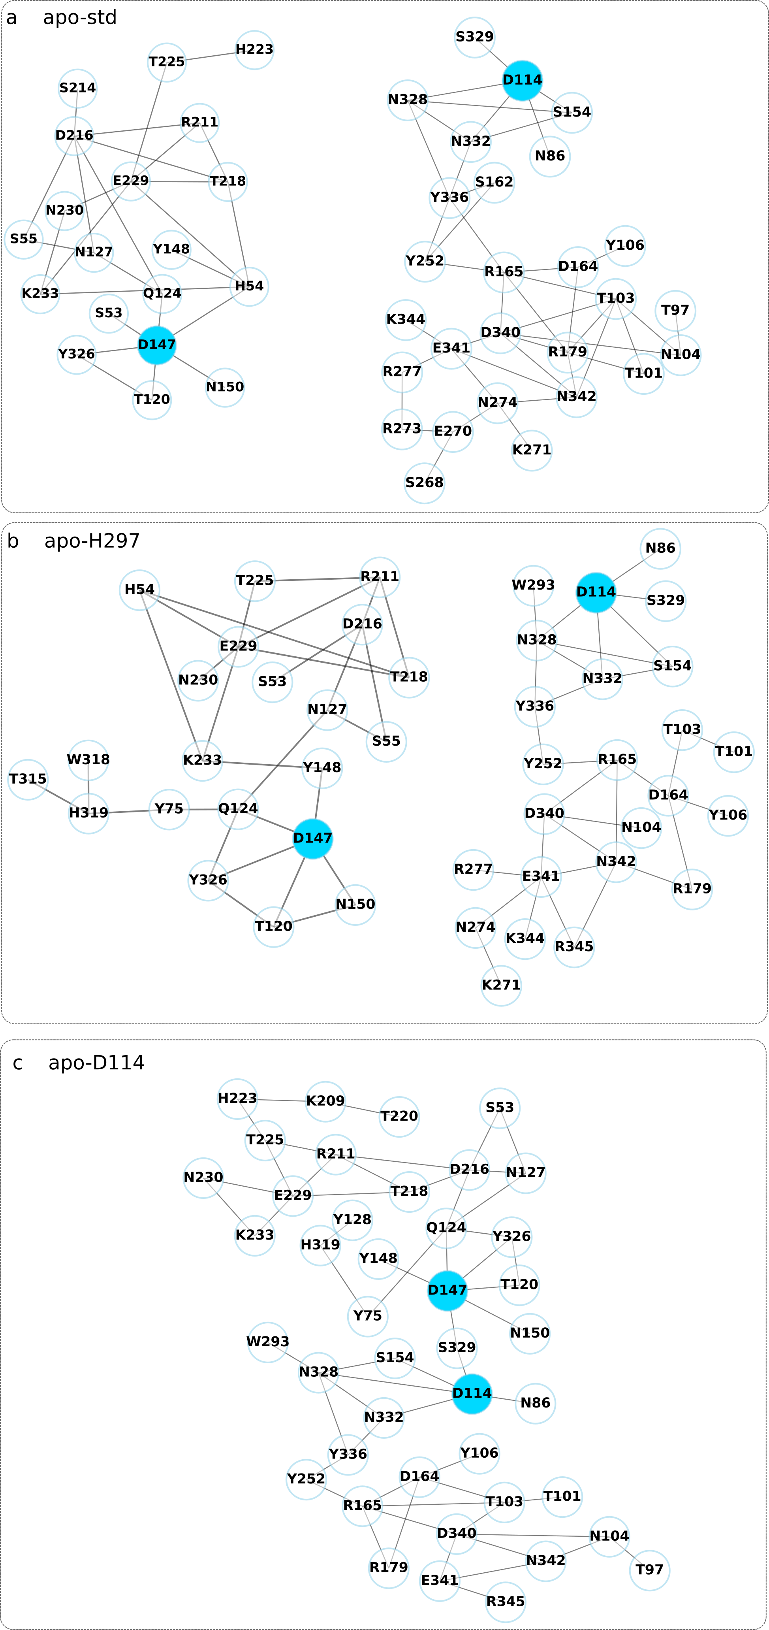
Figure 8. Local H-bond clusters of D114 and D147 of apo MOR depend on the protonation state. The minimum H-bond occupancy is 50%. (a-c) Local H-bond clusters of D114 and D147 extracted, using Connected Components Analyses in Bridge2, from main simulations of apo MOR with standard protonation states (apo-std, panel a), apo MOR with H297 described as a neutral –Nε2 tautomer (apo-H297, panel b), and apo MOR with protonated D114 (apo-D114p, panel c). The corresponding replica graphs are presented in Figure S27.

FNT-bound MOR hosts a network of frequent H-bonds (occupancies ≥ 50%) that inter-connects the FNT not only to the extracellular side, but also to the DRY-D164 and R165 groups at the cytoplasmic side (Figure 10a). In total, no fewer than 45 H-bonding sidechains are part of the dynamic H-bond cluster of the FNT (Figure 10a). D114 and D147 inter-connect via S329, as also observed in some of the apo-MOR simulations with non-standard protonation states (Figures 8c).
The FNT is at about the same depth within the MOR in both simulations of MOR with standard protonation states (Figure 4b). Likewise, the repeat simulation shows that the FNT is part of the network of frequent H-bonds of D147; nevertheless, S329-mediated H-bond connection between the D147 and D114 clusters has a bit lower occupancy (~40%), and the FNT-D147 connections is strongly preferred (Figure S32, S33): an H297 connection is absent even for the low-occupancy H-bond graph (Figure S34). As the FNT-D147 connection was also preferred during the first ~300ns of the main FNT-bound simulation (Figure 9a), this discrepancy could be interpreted to suggest variation in the time needed for the FNT to sample interactions with D147 vs. H297 in the ligand-binding pocket of the MOR.

H-bonding of D114 and H297 influence FNT-MOR H-bond clusters. When H297^{6.52} is an -Nε2 tautomer (FNT-H297 in Table 1), the FNT samples the D147-binding pose during the first ~300ns (Figures 9d-e), then it bridges via water molecules to D147^{3.32} or H297 (Figures 9d, 9f). Though details of the H-bond connections differ, the H-bond graphs of dynamic H-bonds (occupancies ≥ 25%) computed from both simulations of FNT-bound MOR with H297^{6.52}-Nε2 show the FNT connected to both D147 and H297 (Figures S35, S36). In MOR with protonated D114 (FNT-D114p) the FNT prefers a D147 binding pose (Figures 9g, 9i) and, indeed, the protein-water H-bond graphs computed from both FNT-bound MOR simulations with protonated D114 show the FNT bridged to D147 (Figures S37, S38).
To evaluate how FNT-MOR interactions depend on the protonation state of the MOR, we compared the clusters of frequent (occupancies ≥ 50%) H-bonds of the FNT from the four simulations (main and repeats) performed with protonated D114 and H297-Nε2 (Figures 11), corresponding clusters from repeats, (Figure 39), and compared to the FNT H-bond cluster of the MOR with standard protonation states (Figure 10a).
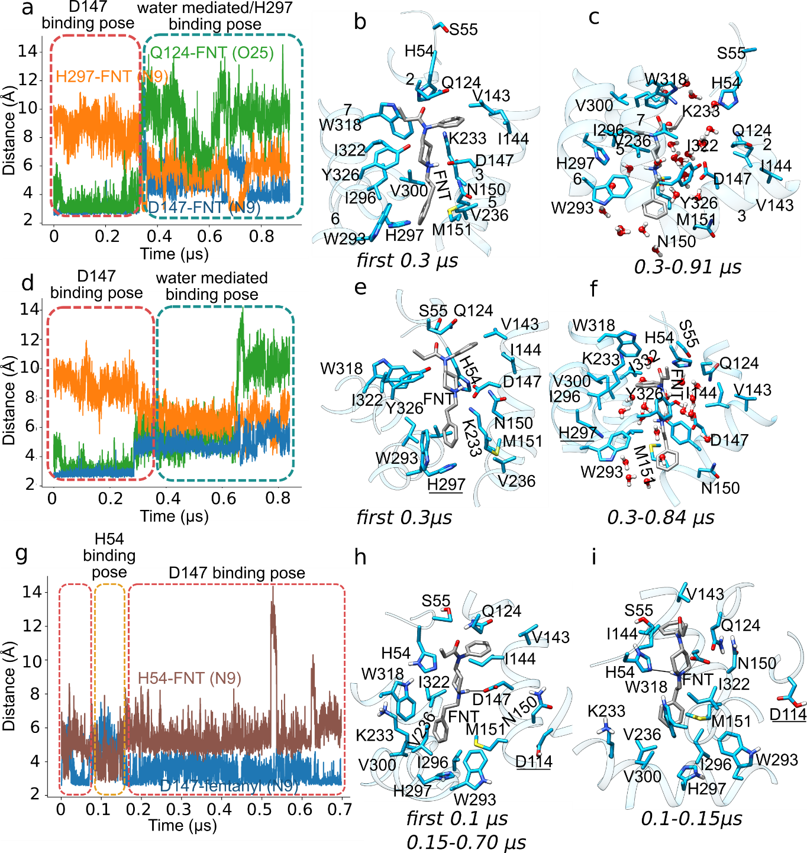Figure 9. Protonation-coupled FNT-MOR interactions. We present time series and molecular of selected FNT-MOR interactions sampled in simulations distinguished by the protonation state of the MOR. (a-c) FNT-MOR interactions in simulations with all amino acid residues in standard protonation states (FNT-std, Table 1) monitored as (panel a) timeseries of the minimum distances between FNT-N9 and D147 (blue), FNT-O25 and Q124 (green), and between FNT-N9 and H297 (orange); panel b illustrates the D147 binding pose, and panel c, a water-mediated H297-binding pose. (d-f) FNT-MOR interactions in simulations with H297^{6.52}-N2ε (FNT-H297 in Table 1). The FNT samples first ~300ns the D147 binding pose (panels d-e), then it water bridges to H297 (panels d, f). (g-i) FNT-MOR interactions in simulations with D114 protonated (FNT-D114p). In panel g we show time series of the distance between FNT-N9 and D147 (blue), and between FNT-N9 and H54 (brown). The FNT samples most of the time the D147 binding pose (panels g, h), and it samples transiently the H54 binding pose for about 50ns (panels g, i).
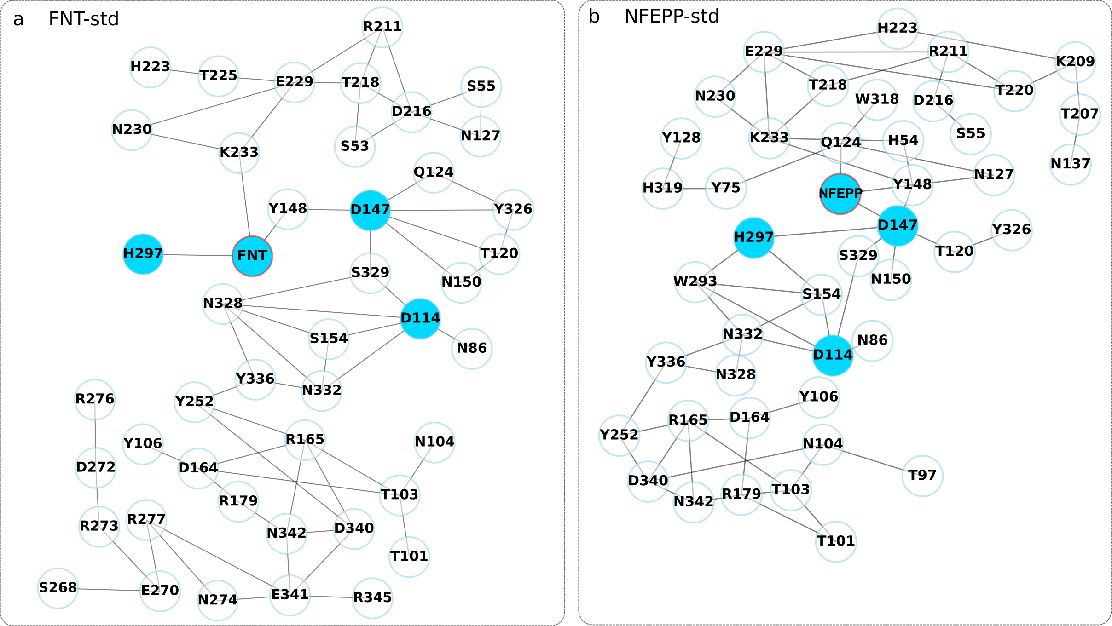
Figure 10. Water-mediated H-bond clusters of the FNT and NFEPP in simulations with standard protonation states of the MOR. The interactions with occupancy below 50% are excluded from the H-bond graphs. The light-blue highlights indicate the residues of interest. (a,b) All four highlighted residues are part of the same water-mediated H-bond network spanning the length of MOR.

We found that the FNT-H297 H-bond, though sampled frequently, is disconnected from the D114/D147 H-bond cluster in both simulations with H297-Nε2 (Figures 11a, S39a). When D114 is neutral, the FNT is part of the D147 cluster of persistent H-bonds –which connects to the D114 cluster via S329 in the main simulation (Figure 11b); likewise, in the corresponding replica simulation, FNT samples persistent H-bonding to D147, and the D147 and D114 clusters may inter-connect via S329, though with a smaller occupancy of 24% (Figure S39b). Test simulations with neutral D147 show that FNT may bridge to H54 (Figures S40, S41).
Given the persistent connections between the FNT and H297 in some of the simulations performed (Figure 10a), we sought to verify how the absence of these interactions in the H297A mutant might impact the binding pose and H-bonding of the FNT. Both simulations on FNT-bound H297A mutant MOR show the FNT being part of a cluster of persistent H-bonds that includes D147 and H54 (Figures S42, S43); this persistent H-bonding between the FNT and D147 is either direct (Figure S42) or mediated by H54 (Figure S43).
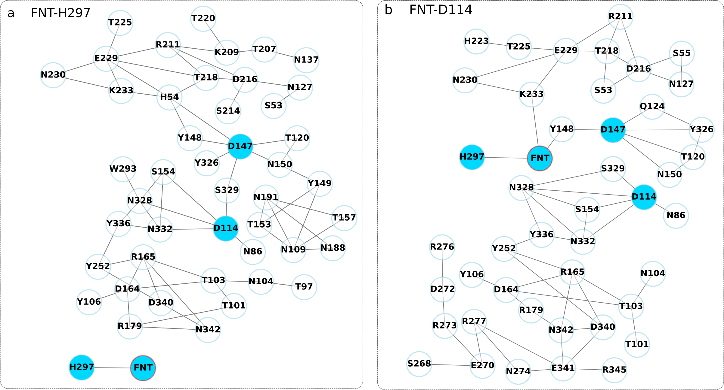Figure 11. FNT-bound simulations with nonstandard protonation states show the water-mediated H-bond interactions of FNT, H297, D147 and D114. The interactions with occupancy below 50% are excluded from the H-bond graphs. The light-blue highlights indicate the residues of interest. (a) The FNT-H297 simulation shows a large cluster containing D147 and D114. FNT and H297 form a separate cluster. (b) All four highlighted residues are part of the same water-mediated H-bond network spanning the length of MOR.

NFEPP is part of a rich network of H-bonds at the extracellular side while connected to DRY via D114 and D147. In both simulations on NFEPP-bound MOR with standard protonation states, NFEPP remains closer to the extracellular side than the FNT (Figure 3b). There, NFEPP samples a largely stable orientation to the MOR (Figure 12a) and it connects to a water-mediated network at the extracellular side of the MOR (Figure 10b). Via persistent connections (occupancies ≥70%) to D147 (Figures 11b, 12b, S44, S45), NFEPP connects to Q124 and Y326; likewise, in both simulations with MOR in standard protonation states, NFEPP has persistent H-bond connections to W318 –a residue whose known to impact ligand binding to the MOR.⁶⁸ As D147 bridges, via the S329-D114, to the cytoplasmic side, the protein-water H-bond network of frequent H-bonds (occupancies ≥50%) shows NFEPP in a network that extends to DRY-D164 and R165 (Figure 11b); though somewhat less frequently (H-bond occupancy of 31%), the NFEPP-D114 network also connects to D114-S329 in the corresponding repeat simulation (Figure S46).
All four test simulations performed with D147 protonated show persistent H-bond (S47-S50) connections between NFEPP and groups other than D147 –e.g., with Q124 (Figures S47, S48, S49), and/or with Y75 and N217 (Figure S50).
The fluorine atom of NFEPP is within about 3 Å of the Y326^{7.43} hydroxyl oxygen atom (Figures 6c, 12b-c). We suggest that this interaction is reasonable. Y326^{7.43} is conserved among opioid receptors, being thought that it participates in the conformational dynamics for receptor activation.¹³ More generally, protein interactions with fluorine atoms of fluorinated drug molecules are observed in various drug-protein structures,⁶⁹ where they are thought to stabilize the drug-binding conformation.
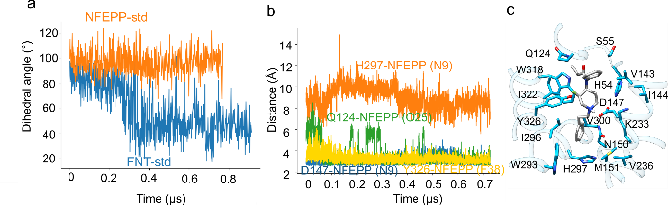Figure 12. Dynamic interactions of NFEPP bound to the MOR. (a) Time series of the dihedral angle that describes the C12-N15 bond twist for FNT (FNT-std, blue) and NFEPP in MOR (NFEPP-std, orange) with standard protonation states. (b) Time series of the shortest distance from NFEPP-N9 to the either of the D147 carboxylic oxygen atoms (blue profile), from NFEPP-N9 to H297-Nε2 (orange), from NFEPP-O25 to Q124-Nε2 (green), and from NFEPP-F38 to Y326-OH (yellow). (c) The preferred binding pose of NFEPP during simulations with standard protonation states of all titratable sidechains (NFEPP-std).

Our previous quantum mechanical computations on isolated FNT vs. NFEPP indicated that, in the FNT, the energy profile for the torsion around the C12-N15 bond (Figure 1) has two minima located at ~45º and ~100º; these two minima are separated by a small energy barrier of <1kcal/mol,⁵¹ which could be easily crossed at room temperature. By contrast, in NFEPP the energy profile for the C12-N15 bond twist has a single energy minimum at around 100º,⁵¹ i.e., this value of the bond twist will be preferred by NFEPP. These features of the intrinsic torsional profile for the C12-N15 bond likely influence dynamics in the protein environment. Regardless of the protonation state of the MOR, NFEPP samples a relatively narrow intervals of values of the C12-N15 bond twist centered at ~90-100º (Figure 12a), which corresponds to the D147 binding pose (Figures 9a,b), and which is consistent with the quantum mechanical computations of the intrinsic torsional profiles of NFEPP.⁵¹ By contrast, and as anticipated from the previous quantum mechanical computations,⁵¹ during all simulations the FNT samples two values of the C12-N15 bond twists, ~90º (the D147 binding pose, Figures 9 a-b), and ~40° (the water-mediated pose, Figures 9 a,c).

Conclusions
How the MOR responds to the binding of a ligand at its extracellular binding site has been studied extensively with experiments and computation (see, e.g., refs.^{68, 70-73}), and pH-dependent binding of naxolone to opioid receptors in rat brain was discussed decades ago. More recently, it was suggested that proton detection is a ubiquitous among class A GPCRs,¹¹ and that the activation of the MOR is pH sensitive.¹⁰ Knowledge of how the protonation state of the MOR impacts opioid drug binding is thus essential, because it could guide the design of drugs tailored to activate MOR at desired pH values –such as inflamed tissue that can associate with pain. To this end, here we used atomistic simulations and graph-based H-bond analyses to understand identify long-distance H-bond networks that could relay structural charge throughout the receptor, and to verify whether such networks couple to the protonation state of the MOR.
In the absence of a ligand, apo MOR with standard protonation states hosts two major protein-water H-bond clusters that include amino acid residues known to be important for function (Figure 13a). At the extracellular side, amino acid residues of the ligand-binding site, including D147 and H297, are part of the same H-bond network with groups implicated in allosteric signal transduction, including Y326 (Figure 13a). Nearby, D114 is part of a persistent cluster of H-bonds with other functionally important sidechains (Figures 7, 13a). At the cytoplasmic side, the H-bond network of the DRY groups extends far into the receptor, to N328, which is part of the local D114 cluster (Figure 13a). That is, although the extracellular and cytoplasmic H-bond networks of the apo-MOR with standard protonation states are not directly connected within the water-mediated H-bond network, they reach to the same region, of Y326-N328 (Figures 6a, 7, 8a, 13a). This spatial proximity between the extracellular and cytoplasmic H-bond networks of apo-MOR with standard protonation states is compatible with the finding that, depending on the protonation and ligand binding states of the MOR, transient H-bonding mediated by S329 may be sampled across the ligand-binding region (Figures 13a, S37). An internal H-bond network that could extend across the entire receptor, and facilitate long-distance conformational coupling, is already largely present in apo-MOR, but its details depend on the protonation state of residues at the ligand-binding site.
Though sidechains part of the protein-water H-bond network of apo-MOR tend to also contribute to the H-bond networks of the FNT- and NFEPP-bound MOR (Figures 10, 12-13), presence of the ligand associates with marked rearrangements of a number of preferred H-bond connections (Figure 13b). The H-bond graphs computed for FNT- vs. NFEPP-bound MOR could be interpreted to suggest that changes in the protonation states of internal sidechains of the MOR associate with different H-bond environments being presented to the ligand, which in turn could shape the dynamics of the drug-receptor interactions.
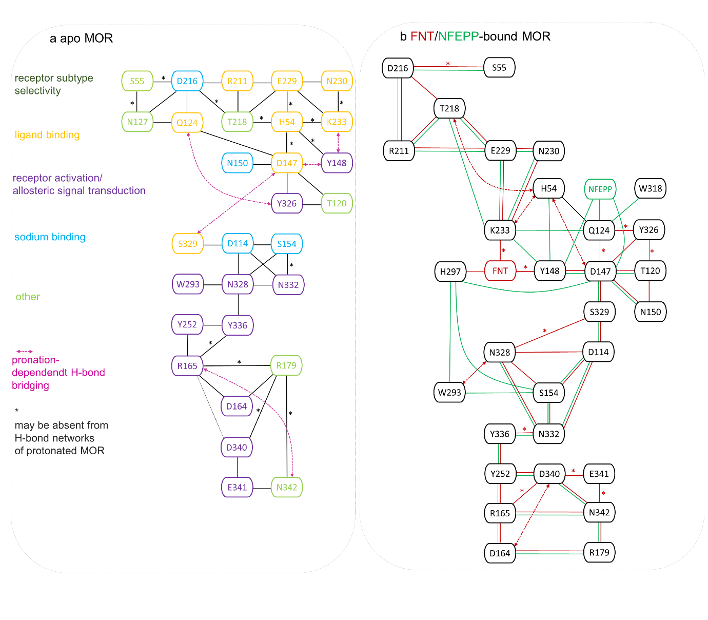
Figure 13. Summary of protonation-coupled H-bond networks of shortest-distance H-bond connections sampled during simulations of apo- vs. ligand-bound wild-type MOR. Some H-bonds presented in the corresponding H-bonds of the apo- and FNT/NFEPP-bound MOR have been omitted for clarity. (a) H-bond network of apo-MOR with selected nodes colored according to the functional role of the amino acid residue (Table S1). Edges colored gray indicate H-bond connections of the MOR with standard protonation states. (b) H-bond networks of the FNT- vs. NFEPP-bound MOR. The scheme was prepared using Microsoft PowerPoint and the H-bond graphs shown in Figures 8, 10 and 11, at 50% occupancy value of water mediated H-bonds.

The internal H-bond network of the MOR includes more titratable sidechains than the three sidechains for which we studied the impact of the protonation state –most notably, H54, D216 and E229 at the extracellular side, and D114 and D164 at the cytoplasmic side. The simulations we presented here, and work on other membrane proteins,^{74, 75} suggests that the internal H-bond network of the MOR would likely change in response the changes in the protonation states of any of these internal titratable sidechains. However, exploring with atomistic simulations and graph computations all possible combinations of the protonation states of titratable sidechains of the MOR would be extremely demanding.
As reviewed in ref.⁴², two main binding poses have been proposed for the FNT: a phenyl-piperidine-amide (FPA) pose, and an APF binding pose –with the FNT’s acetylamide moiety close to N2.63 (Figure S2) and, respectively, close to Y7.43 (Figure S1). Computations were interpreted to suggest that both binding poses allow for stable FNT-MOR interactions, and that an APF binding pose would be preferred;⁴² however, as the accuracy of the OPLS force-field parameters used for the FNT was not reported in that study, further work would needed to conclude on the dynamics of the MOR-bound FNT. To the best of our knowledge, comparatively even less is known about the preferred binding pose of NFEPP. To directly compare how the MOR responds to the binding of FNT vs. NFEPP, all our simulations on ligand-bound MOR were initiated with the FPA pose. Future computations would be required to evaluate how the H-bond networks of the MOR rearranges when FNT vs. NFEPP bind to the MOR in an APF-pose.
Given the relevance of fluorinated compounds for drug design,⁷⁶ we anticipate that the methodology used here could be applied to other pairs of opioid drugs and their fluorinated derivatives. Of immediate interest would be morphine vs. fluorinated morphine, as electronic structure computations predicted for fluorinated morphine with D ring dissection a pK_{a} of ~5.7, as compared to ~8 for for standard morphine.⁷⁷ As our recent force-field parametrization of the FNT and NFEPP has shown, fluorination can alter not only the charge distribution of the opioid compound –as one would anticipate based on the altered pKa value–, but also its torsional energy profiles.⁵¹ As a consequence, to ensure that simulations of the MOR bound to, say, fluorinated morphine, are reliable, force-field parameters of the fluorinated compound would need to be derived, using, e.g., the methodology we presented for FNT vs. NFEPP. ⁵¹
Experimental data, such as from Fourier Transform Infrared spectroscopy, FTIR, will be needed for accurate information about the likely protonation states of key titratable sidechains of the MOR along its activation pathway. The computational framework presented here could be further extended to develop a catalogue of the H-bond fingerprints of the MOR for protonation states and ligands of direct interest to biomedical applications. Recent developments in structural biology, which enabled a detailed molecular picture of how morphine, fentanyl, and other related compounds interact with human MOR, provide the foundation for future experimental and computational studies to evaluate proton-coupled drug binding. Given the significant impact that resolution of the structure and the internal water molecules have on the internal H-bond networks of membrane proteins, including GPCRs,^{63, 78, 79} higher-resolution structures of apo- and ligand-bound human MOR with internal water molecules will be needed to characterize proton sensitivity of the human receptor.

Acknowledgements
The authors gratefully acknowledge the HPC RIVR consortium for computing resources of the HPC systems VEGA and MAISTER, and the allocations of computing time from the HLRN, the North-German Supercomputing Center. Financial support through the Slovenian Research Agency Programme and project grants P2-0046, P2-0438, L2-3175, J1-2471, J1-4398, L2-4430, J3-4498, J7-4638, J4-4633, J1-4414, I0-E015 and J3-4497 is gratefully acknowledged.

Data Availability Statement. MD simulations were performed with the available NAMD software.⁸⁰ H-bond graph analyses were performed with the Bridge software, which is openly available.^{33, 34} Force field parameters for the FNT and NFEPP have been released with a recent publication⁵¹ and are available on the ACS webpage under (https://pubs.acs.org/doi/10.1021/acs.jcim.0c00185?goto=supporting-info) in ParamChem under https://cgenff.umaryland.edu/ . All graph-based analyses of the H-bond networks were performed using the graphical user interface Bridge2; the source files to install Bridge2 are available on the ACS webpage under https://pubs.acs.org/doi/suppl/10.1021/acs.jcim.1c00306/suppl_file/ci1c00306_si_002.zip and on GitLab https://github.com/maltesie/bridge2. H-bond graphs of the MOR are released with the Supporting Information that accompanies this work. Files corresponding to the generation of the MD simulation system and MD production are available at GitLab: https://gitlab.com/samolesnik/mor-dynamics/-/blob/main/CHARMM_NAMD_files.zip.

Supporting Information Available.
The Supporting Information is available free of charge at http://pubs.acs.org. Table S1, summary of the functional roles of selected amino acid residues; Figure S1, H-bond networks in the cryo-EM structure for FNT-bound MOR; Figure S2, starting geometry for FNT-bound MOR; Figure S3, RMSD profiles computed from all main simulations performed; Figure S4, RMSD profiles computed from all replica simulations performed; Figure S5, Molecular graphics comparing the starting coordinates of the MOR with structures and at the end of simulations performed; Figure S6, Molecular graphics comparing the starting coordinates of the opioid-bound MOR with structures at the end of simulations performed; Figure S7, timeseries of the minimum distances between sodium ions and sidechains of selected amino-acid residues of apo MOR; Figure S8, H-bond network of the reference apo MOR showing low-occupancy interactions; Figure S9, time series of the minimum distances between sodium ions and sidechains of selected amino-acid residues of FNT/NFEPP-MOR; Figure S10, average coordinate along the membrane normal of FNT-N9 from simulations with protonated D147; Figures S11-S28, H-bond graphs corresponding to main and replica apo MOR simulations with different protonation states; Figures S29-S41, H-bond network computed from the main and replica MOR simulations with FNT bound to MOR at different protonation states; Figures S42-S43, H-bond networks calculated from apo and FNT-bound MOR with H297A mutation for main and replica simulations; Figures S44-S50, H-bond networks computed from the main and replica simulations of NFEPP-bound MOR with different protonation states.

References
1. Friedman, S. R.; Krawczyk, N.; Perlman, D. C.; Mateu-Gelabert, P.; Ompad, D. C.; Hamilton, L.; Nikolopoulos, G.; Guarino, H.; Cerdá, M., The Opioid Overdose Crisis as a Dialectis of Pain, Dispair, and One-Sided Struggle. Frontiers Public Health 2020, 8, 540423.
2. Ciccarone, D., The Triple Wave Epidemic: Supply and Demand Drivers of the US Opioid Overdose Crisis. Int. J. Drug Policy 2019, 71, 183-188.
3. Alho, H.; Deamaitteis, M.; Lembo, D.; Maremmani, I.; Roncero, C.; Somaini, L., Opioid-Related Deaths in Europe: Strategies for a Comprehensive Approach to Address a Major Public Health Concern. Int. J. Drug Policy 2020, 76, 102616.
4. Stein, C.; Küchler, S., Targeting Inflammation and Wound Healing by Opioids. TRENDS Pharmacol. Sci 2013, 34, 303-312.
5. Stein, C., New Concepts in Opioid Analgesia. Expert Opin. Investig. Drugs 2018, 27, 765-775.
6. Li, J.-G.; Chen, C.; Yin, J.; Rice, K.; Zhang, Y.; Matecka, D.; de Riel, J. K.; DesJarlais, R. L.; Liu-Chen, L.-Y., Asp147 in the Third Transmembrane Helix of the Rat µ Opioid Receptor Forms Ion-Pairing with Morphine and Naltrexone. Life Sciences 1999, 65, 175-185.
7. Spahn, V.; del Vecchio, G.; Labuz, D.; Rodriguez-Gaztelumendi, A.; Massaly, N.; Temp, J.; Durmaz, V.; Sabri, P.; Reidelbach, M.; Machelska, H.; Weber, M.; Stein, C., A Nontoxic Pain Killer Designed by Modeling of Pathological Receptor Conformations. Science 2017, 355, 966-969.
8. Spahn, V.; del Vecchio, G.; Rodriguez-Gaztelumendi, A.; Temp, J.; Labuz, D.; Kloner, M.; Reidelbach, M.; Machelska, H.; Weber, M.; Stein, C., Opioid Receptor Signaling, Analgesic and Side Effects Induced by a Computationally Designed pH-Dependent Agonist. Sci. Rep. 2018, 8, 8965.
9. del Vecchio, G.; Labuz, D.; Temp, J.; Steitz, V.; Kloner, M.; Negrete, R.; Rodriguez-Gaztelumendi, A.; Weber, M.; Machelska, H.; Stein, C., pKa of Opioid Ligands as a Discriminating Factor for Side Effects. Sci. Rep. 2019, 9, 19344.
10. Meyer, J.; del Vecchio, G.; Steitz, V.; Massaly, N.; Stein, C., Modulation of µ-Opioid Receptor Activation by Acidic pH is Dependent on Ligand Structure and an Ionizable Amino Acid Residue. British Journal of Pharmacology 2019, 176, 4510-4520.
11. Kapolka, N. J.; Rowe, J. B.; Taghon, G. J.; Morgan, W. M.; OShea, C. R.; Isom, D. G., Proton-Gated Coincidence Detection is a Common Feature of GPCR Signaling. PNAS 2021, 118, e2100171118.
12. Trzaskowski, B.; Latek, D.; Yuan, S.; Ghoshdastider, U.; Debinski, A.; Filipek, S., Action of Molecular Switches in GPCRs - Theoretical and Experimental Studies. Current Medicinal Chemistry 2012, 19, 1090-1109.
13. Manglik, A.; Kruse, A. C.; Kobilka, T. S.; Thian, F. S.; Mathiesen, J. M.; Sunahara, R. K.; Pardo, L.; Weis, W. I.; Kobilka, B. K.; Granier, S., Crystal Structure of the µ-opioid Receptor Bound to a Morphinan Antagonist. Nature 2012, 485, 321-326.
14. Huang, W.; Manglik, A.; Venkatakrishnan, A. J.; Laeremans, T.; Feinberg, E. N.; Sanborn, A. L.; Kato, H. E.; Livingston, K. E.; Thorsen, T. S.; Kling, R. C.; Granier, S.; Gmeiner, P.; Husbands, S. M.; Trynor, J. R.; Weis, W. I.; Steyaert, J.; Dror, R. O.; Kobilka, B. K., Structural Insights Into µ-opioid Receptor Activation. Nature 2015, 524, 315-321.
15. Deupi, X.; Edwards, P.; Singhal, A.; Nickle, B.; Oprian, D.; Schertler, G.; Standfuss, J., Stabilized G Protein Binding Site in the Structure of Constitutively Active Metharhodopsin-II. Proc. Natl. Acad. Sci. 2011, 109, 119-124.
16. Rasmussen, S. G. F.; DeVree, B. T.; Zou, Y.; Kruse, A. C.; Chung, A. Y.; Kobilka, T. S.; Thian, F. S.; Chae, P. S.; Pardon, E.; Calinski, D.; Mathiesen, J. M.; Shah, S. T. A.; Lyons, J. A.; Caffrey, M.; Gellman, S. H.; Steyaert, J.; Skiniotis, G.; Weis, W. I.; Sunahara, R. K.; Kobilka, B. K., Crystal Structure of the β2 Adrenergic Receptor-Gs Protein Complex. Nature 2012, 477, 549-555.
17. Surratt, C. K.; Johnson, P. S.; Moriwaki, A.; Seidlecj, B. K.; Blaschak, C. J.; Wang, J. B.; Uhl, G. R., µ Opiate Receptor. Charged Transmembrane Domain Amino Acids are Critical for Agonist Recognition and Intrinsic Activity. J. Biol. Chem. 1994, 269, 20548-20553.
18. Mansour, A.; Rtaylor, L. P.; Fine, J. L.; Thompson, R. C.; Hoversten, M. T.; Mosberg, H. I.; Watson, S. J.; Akil, H., Key Residues Defining the mu-Opioid Receptor Binding Pocket: a Site-Directed Mutagenesis Study. J. Neurochem. 1997, 68, 344-353.
19. Fenalti, G.; Giguere, P. M.; Katritch, V.; Huang, X.-P.; Thomson, A. A.; Cherezov, V.; Roth, B. L.; Stevens, R. C., Molecular Control of δ-Opioid Receptor Signalling. Nature 2014, 506, 191-196.
20. Che, T.; Majumdar, S.; Zaidi, S. A.; Ondachi, P.; McCorvy, J. D.; Wang, S.; Mosier, P. D.; Uprety, R.; Vardy, E.; Krumm, B. E.; Han, G. W.; Lee, M.-Y.; Pardon, E.; Steyaert, J.; Huang, X.-P.; Strachan, R. T.; Tribo, A. R.; Pasternak, G. W.; Carroll, F. I.; Stevens, R. C.; Cherezov, V.; Katritch, V.; Wacker, D.; Roth, B. L., Structure of Nanobody-Stabilized Active State of the Kappa Opioid Receptor. Cell 2018, 172, 55-67.
21. Lipiński, P. F. J.; Jarończyk, M.; Dobrowolski, J. C.; Sadlej, J., Molecular Dynamics of Fentanyl Bound to µ-Opioid Receptor. J. Mol. Model. 2019, 25, 144.
22. Koehl, A.; Hu, H.; Maeda, S.; Zhang, Y.; Qu, Q.; Paggi, J. M.; Latorraca, N.; Hilger, D.; Dawson, R.; Matile, H.; Schertler, G. F. X.; Granier, S.; Weis, W. I.; Dror, R. O.; Manglik, A.; Skiniotis, G.; Kobilka, B. K., Structure of the µ-Opioid Receptor-G_{i} Protein Complex. Nature 2018, 558, 547-551.
23. Vo, Q. N.; Mahinthichaichan, P.; Shen, J.; Ellis, C. R., How µ-Opioid Receptor Recognizes Fentanyl. Nature Comm. 2021, 12, 984.
24. Xu, W.; Ozdener, F.; Li, J.-G.; Chen, C.; de Riel, J. K.; Weinstein, H.; Liu-Chen, L.-Y., Functional Role of the Spatial Proximity of Asp114(2.50) in TMH 2 and Asn332(7.49) in TMH 7 of the µ Opioid Receptor. FEBS Lett. 1999, 447, 318-324.
25. Vickery, O. N.; Carvalheda, C. A.; Zaidi, S. A.; Pisliakov, A. V.; Katritch, V.; Zachariae, U., Intracellular Transfer of Na⁺ in an Active-State G-Protein-Coupled Receptor. Structure 2018, 26, 171-180.
26. Zhang, X. C.; Cao, C.; Zhou, Y.; Zhao, Y., Proton Transfer-Mediated GPCR Activation. Protein Cell 2015, 6, 12-17.
27. Lans, I.; Dalton, J. A. R.; Giraldo, J., Selective Protonation of Acidic Residues Triggers Opsin Activation. J. Phys. Chem. B 2015, 119, 9510-9519.
28. Arnis, S.; Fahmy, K.; Hofmann, K. P.; Sakmar, T. P., A Conserved Carboxylic Acid Group Mediates Light-Dependent Proton Uptake and Signaling by Rhodopsin. J. Biol. Chem. 1994, 269, 23879-23881.
29. Zhang, X. C.; Sun, K.; Zhang, L.; Li, X.; Cao, C., GPCR Activation: Protonation and Membrane Potential. Protein Cell 2013, 4, 747-760.
30. Wilson, M. H.; Highfield, H. A.; Limbird, L. E., The Role of a Conserved Inter-Transmembrane Domain Interface in Regulating alpha(2a)-Adrenergic Receptor Conformational Stability and Cell-Surface Turnover. Mol. Pharmacol. 2001, 59, 929-938.
31. Murakami, M.; Kouyama, T., Crystal Structure of Squid Rhodopsin. Nature 2008, 453, 363-367.
32. Venkatakrishnan, A. J.; Ma, A. K.; Fonseca, R.; Latorraca, N. R.; Kelly, B.; Betz, R. M.; Asawa, C.; Kobilka, B. K.; Dror, R. O., Diverse GPCRs Exhibit Conserved Water Networks for Stabilization and Activation. Proc. Natl. Acad. Sci. 2019, 116, 3288-3293.
33. Siemers, M.; Lazaratos, M.; Karathanou, K.; Guerra, F.; Brown, L. S.; Bondar, A.-N., Bridge: A Graph-Based Algorithm to Analyze Dynamic H-Bond Networks in Membrane Proteins. Journal of Chemical Theory and Computation 2019, 15, 6781-6798.
34. Siemers, M.; Bondar, A.-N., Interactive Interface for Graph-Based Analyses of Dynamic H-Bond Networks: Application to Spike Protein S. Journal of Chemical Information and Modeling 2021, 61, 2998-3014.
35. Ballesteros, J. A.; Weinstein, H., Integrated Methods for the Construction of Three-Dimensional Models and Computational Probing of Structure-Function Relations in G Protein-Coupled Receptors. Methods in Neurosciences 1995, 25, 366-428.
36. Zhuang, Y.; Wang, Y.; He, B.; Zhou, X. E.; Guo, S.; Rao, Q.; Yang, J.; Liu, J.; Zhou, Q.; Wang, X.; Liu, M.; Liu, W.; Jiang, X.; Yang, D.; Kiang, H.; Shen, J.; Melcher, K.; Chen, H.; Jiang, Y.; Cheng, X.; Wang, M.-W.; Xie, X.; Xu, H. E., Molecular Recognition of Morphine and Fentanyl by the Human µ-Opioid Receptor. 2022, 185, 4361-4375.
37. Berman, H. M.; Westbrook, J.; Feng, G.; Gilliland, G.; Bhat, T. N.; Weissig, H.; Shindyalov, I. N.; Bourne, P. E., The Protein Data Bank. Nucleic Acid Research 2000, 28, 235-242.
38. Lomize, M.; Pogozheva, I. D.; Joo, H.; Mosberg, H. I.; Lomize, A. L., OPM Database and PPM Server: Resources for Positioning of Proteins in Membranes. Nucleic Acid Research 2011, 40, D370-D376.
39. Jo, S.; Kim, T.; Iyer, V. G.; Im, W., CHARMM-GUI: a Web-Based Graphical User Interface for CHARMM. Journal of Computational Chemistry 2008, 29, 1859-1865.
40. Jo, S.; Kim, T.; Iyer, V. G.; Im, W., CHARMM-GUI: a Web-Based Graphical User Interface for CHARMM. J. Comput. Chem 2008, 29, 1859-1865.
41. Ellis, C. R.; Kruhlak, N. L.; Kim, M. T.; Hawkins, E. G.; Statiskaya, L., Predicting Opioid Receptor Binding Affinity of Pharmacologically Unclassified Designer Substances Using Molecular Docking. PLos One 2018, 13, 0197734.
42. Xie, B.; Goldberg, A.; Shi, L. A., A Comprehensive Evaluation of the Potential Binding Poses of Fentanyl and its Analogs at the µ-Opioid Receptor. Comput. Struct. Biotechnol. 2022, 20, 2309-2321.
43. Pettersen, E. F.; Goddard, T. D.; Huang, C. C.; Couch, G. S.; Greenblatt, D. M.; Meng, E. C.; Ferrin, T. E., UCSF Chimera - a Vizualization System for Exploratory Research and Analysis. J. Comput. Chem 2004, 25, 1605-1612.
44. Wu, E. L.; Cheng, X.; Jo, S.; Rui, H.; Song, K. C.; Dávila-Contreras, E. M.; Qi, Y.; Lee, J.; Monje-Galvan, V.; Venable, R. M.; Klauda, J. B.; Im, W., CHARMM-GUI Membrane Builder toward Realistic Biological Membrane Simulations. J. Comput. Chem 2014, 35, 1997-2004.
45. Brooks, B. R.; Bruccoleri, R. E.; Olafson, B. D.; States, D. J.; Swaminathan, S.; Karplus, M., CHARMM: a Program for Macromolecular Energy, Minimization, and Dynamics Calculations. J. Comput. Chem 1983, 4, 187-217.
46. Beglov, D.; Roux, B., Finite Representation of an Infinite Bulk System: Solvent Boundary Potential for Computer Simulations. J. Chem. Phys. 1994, 100, 9050-9063.
47. Brooks, B. R.; Brooks, C. L. I.; MacKerell Jr., A. D.; Nilsson, L.; Petrella, R. J.; Roux, B.; Won, Y.; Archontis, G.; Bartels, C.; Boresch, S.; Caflisch, A.; Caves, L.; Cui, Q.; Dinner, A. D.; Feig, M.; Fischer, S.; Gao, J.; Hodoscek, M.; Im, W.; Kuczera, K.; Lazaridis, T.; Ma, J.; Ovchinnikov, V.; Paci, E.; Pastor, R. W.; Post, C. B.; Pu, J. Z.; Schaefer, M.; Tidor, B.; Venable, R. M.; Woodcock, H. L.; Wu, X.; Yang, W.; York, D. M.; Karplus, M., CHARMM: the Biomolecular Simulation Program. J. Comput. Chem 2009, 30, 1545-1614.
48. Feller, S. E.; MacKerell Jr., A. D., An Improved Empirical Potential Energy Function for Molecular Simulations of Phospholipids. J. Phys. Chem. B 2000, 104, 7510-7515.
49. Klauda, J. B.; Venable, R. M.; Freites, J. A.; O'Connor, J. W.; Tobias, D. J.; Mondragon-Ramirez, C.; Votrobyov, I.; MacKerell Jr., A. D.; Pastor, R. W., Update of the CHARMM All-Atom Additive Force Field for Lipids: Validation on Six Lipid Types. J. Phys. Chem. B 2010, 114, 7830-7843.
50. Jorgensen, W. L.; Chandrasekhar, J.; Madura, J. D.; Impey, R. W.; Klein, M. L., Comparison of Simple Potential Functions for Simulating Liquid Water. J. Chem. Phys. 1983, 79, 926-935.
51. Lešnik, S.; Hodošček, M.; Bren, U.; Stein, C.; Bondar, A.-N., Potential Energy Function for Fentanyl-Based Opioid Pain Killers. J. Chem. Inf. Model. 2020, 60, 3566-3576.
52. Kalé, L.; Skeel, R.; Bhandarkar, M.; Brunner, R.; Gursoy, A.; Krawetz, N.; Phillips, J.; Shinozaki, A.; Varadarajan, K.; Schulten, K., NAMD2: Greater Scalability for Parallel Molecular Dynamics. J. Comput. Phys. 1999, 151, 283-312.
53. Phillips, J. C.; Braun, B.; Wang, W.; Gumbart, J.; Takjkhorshid, E.; Villa, E.; Chipot, C.; Skeel, R. D.; Kale, L.; Schulten, K., Scalable Molecular Dynamics with NAMD. J. Comput. Chem 2005, 26, 1781-1802.
54. Essmann, U.; Perera, L.; Berkowitz, M. L.; Darden, T.; Lee, H.; Pedersen, L. G., A Smooth Particle Mesh Ewald Method. J. Chem. Phys. 1995, 103, 8577-8593.
55. Darden, T.; York, D.; Pedersen, L., Particle Mesh Ewald: an N x log(N) Method for Ewald Sums in Large Systems. J. Chem. Phys. 1993, 98, 10089-10092.
56. Feller, S. E.; Zhang, Y.; Pastor, R. W.; Brooks, B., Constant Pressure Molecular Dynamics Simulation: The Langevin Piston Method. J. Chem. Phys. 1995, 103, 4613-4621.
57. Martyna, G. J.; Tobias, D. J.; Klein, M. L., Constant-Pressure Molecular-Dynamics Algorithms. J. Chem. Phys. 1994, 101, 4177-4189.
58. Ryckaert, J.-P.; Ciccotti, G.; Berendsen, H. J. C., Numerical Integration of the Cartesian Equations of Motion of a System with Constraints. Molecular Dynamics of n-Alkanes. J. Comput. Phys. 1977, 23, 327-341.
59. Gowers, R. J.; Linke, M.; Barnoud, J.; Reddy, T. J. E.; Melo, M. N.; Seyler, S. L.; Dotson, D. L.; Domanski, J.; Buchoux, S.; Kenney, I. M.; Beckstein, O., MDAnalysis: A Python Package for the Rapid Analysis of Molecular Dynamics Simulations. S. Benthall and S. Rostrup, Editors, Proceedings of the 15th Phyton in Science Conference, Austin, TX, 2016 SciPy 2016, 102-109.
60. Michaud-Agrawal, N.; Denning, E. J.; Woolf, T. B., MDAnalysis: A Toolkit for the Analysis of Molecular Dynamics Simulations. J. Comput. Chem 2011, 32, 2319-2327.
61. Meng, E. C.; Pettersen, E. F.; Couch, G. S.; Huang, C. C.; Ferrin, T. E., Tools for Integrated Sequence-Structure Analysis with UCSF Chimera. BMC Bioinformatics 2006, 7, 339.
62. Katritch, V.; Fenalti, G.; Abola, E. E.; Roth, B. L.; Cherezov, V.; Stevens, R. C., Allosteric Sodium in Class A GPCR Signaling. Trends Biochem. Sci. 2014, 39, 233-244.
63. Bertalan, É.; Lešnik, S.; Bren, U.; Bondar, A.-N., Protein-Water Hydrogen-Bond Networks of G Protein-Coupled Receptors: Graph-Based Analyses of Static Structures and Molecular Dynamics. J. Struct. Biol. 2020, 212, 107634.
64. Shang, Y.; LeRouzic, V.; Schneider, S.; Bisignano, P.; Pasternak, G. W.; Filizola, M., Mechanistic Insights into the Allosteric Modulation of Opioid Receptors by Sodium Ions. Biochemistry 2014, 53, 5140-5149.
65. Yuan, S.; Vogel, H.; Filipek, S., The Role of Water and Sodium Ions in the Activation of the µ-opioid Receptor. Angewandte Chemie International Edition 2013.
66. Bertalan, E.; Lesca, E.; Schertler, G. F. X.; Bondar, A.-N., C-Graphs Tool with Graphical User Interface to Dissect Conserved Hydrogen-Bond Networks: Applications to Visual Rhodopsins. Journal of Chemical Information and Modeling 2021, 61, 5692-5707.
67. Bondar, A.-N., Interplay between Local Protein Interactions and Water Bridging of a Proton Antenna Carboxylate Cluster. BBA - Biomembranes 2022, 1864, 184052.
68. Manglik, A.; Lin, H.; Aryal, D. K.; McCorvy, J. D.; Dengler, D.; Corder, G.; Levit, A.; Kling, R. C.; Bernat, V.; Hübner, H.; Huang, X.-P.; Sassano, M. F.; Giguère, P. M.; Löber, S.; Duan, D.; Scherrer, G.; Kobilka, B. K.; Gmeiner, P.; Roth, B. L.; Stoichet, B. K., Structure-Based Discovery of Opioid Analgesics with Reduced Side Sffects. Nature 2016, 537, 185-190.
69. Müller, K.; Faeh, C.; Diederich, F., Fluirine in Pharmaceuticals: Looking Beyond Intuition. Science 2007, 317, 1881-1886.
70. Schneider, S.; Provasi, D.; Filizola, M., How Oliciceridine (TRV-130) Binds and Stabilizes a µ-Opioid Receptor Conformational State that Selectively Triggers G
Protein Signaling Pathways. Biochemistry 2016, 55, 6456-6466.
71. Mondal, D.; Kolev, V.; Warshel, A., Exploring the Activation Pathway and G_{i} Coupling Specificity of the µ-Opioid Receptor. Proc. Natl. Acad. Sci. 2020, 117, 26218-26225.
72. Ricarte, A.; Daldton, J. A. R.; Giraldo, J., Structural Assessment of Agonist Efficacy in the µ-Opioid Receptor: Morphine and Fentanyl Elicit Different Activation Patterns. J. Chem. Inf. Model. 2021, 61, 1251-1274.
73. Sena, D. M. J.; Cong, X.; Giorgetti, A.; Kless, A.; Carloni, P., Structural Heterogeneity of the μ-Opioid Receptor's Conformational Ensemble in the Apo State. Scientific Reports 2017, 7, 45761.
74. del Val, C.; Bondar, L.; Bondar, A.-N., Coupling between Inter-Helical Hydrogen Bonding and Water Dynamics in a Proton Transporter. J. Struct. Biol. 2014, 186, 95-111.
75. Lazaratos, M.; Siemers, M.; Brown, L. S.; Bondar, A.-N., Conserved Hydrogen-Bond Motifs of Membrane Transporters and Receptors. BBA - Biomembranes 2022, 1864, 183896.
76. Meanwell, N. A., Fluorine and Fluorinated Motifs in the Design and Application of Bioisosters for Drug Design. J. Med. Chem. 2018, 61, 5822-5880.
77. Augenstein, M.; Alexander, N.; Gartner, M., Computational Design and Molecular Modeling of Morphine Derivatives for Preferential Binding in Inflamed Tissue. Pharmacology Research Perspectives 2022, 11, e01075.
78. Bondar, A.-N., Graphs of Hydrogen-Bond Networks to Dissect Protein Conformational Dynamics. J. Phys. Chem. B 2022.
79. Bertalan, E.; Bondar, A.-N., Graphs of Protein-Water Hydrogen-Bond Networks to Dissect Structural Movies of Ion-Transfer Microbial Rhodopsins. Frontiers in Chemistry 2023.
80. Phillips, J. C.; Hardy, D. J.; Maia, J. D. C.; Stone, J. E.; Ribeiro, J. V.; Bernardi, R. C.; Buch, R.; Fiorin, G.; Henin, J.; Jiang, W.; McGreevy, R.; Melo, M. C. R.; Radak, B. K.; Skeel, R. D.; Singahoroy, A.; Wang, Y.; Roux, B.; Aksimentiev, A.; Luthey-Schulten, Z.; Kale, L. V.; Schulten, K.; Chipot, C.; Tajkhorshid, E., Scalable Molecular Dynamics on CPU and GPU Architectures with NAMD. J. Chem. Phys. 2020, 153, 044130.

TOC graphics
