Revealing the intrinsic oxygen evolution reaction activity of perovskite oxides across conductivity ranges using thin film model systems
Lisa Heymann†,*, Iris C. G. van den Bosch§, Daan Wielens§, Ole Kurbjeweit†, Emma van der Minne§, Ellen M. Kiens§, Anton Kaus†, Daniel Schön†, Stephan Menzel†, Bernard Boukamp§, Felix Gunkel†,*, Christoph Baeumer†,§,*

†Peter Gruenberg Institute 7, Forschungszentrum Juelich GmbH, 52428 Juelich, Germany
§MESA+ Institute for Nanotechnology, Faculty of Science and Technology, University of Twente, Enschede, Netherlands
*Corresponding authors

Abstract:
The development of efficient electrocatalysts in water electrolysis is essential to decrease the high overpotentials especially at the anode where the oxygen evolution reaction (OER) takes place. However, establishing catalyst design rules to find optimal electrocatalysts is a substantial challenge. Complex oxides, which are often considered as suitable OER catalysts, can exhibit vastly different conductivity values, making it challenging to separate intrinsic catalytic activities from internal transport limitations. Here, we systematically decouple the limitations arising from electrical bulk resistivity, contact resistances to the catalyst support, and intrinsic OER catalytic properties using a systematic epitaxial thin film model catalyst approach. We investigate the influence of the resistivity of the three perovskite oxides LaNiO_{3-δ} (3.7x10⁻⁴ Ωcm), La_{0.67}Sr_{0.33}MnO_{3-δ} (2.7x10⁻³ Ωcm) and La_{0.6}Ca_{0.4}FeO_{3-δ}, (0.57 Ωcm) on the observed catalytic activity. We tune the electron pathway through the catalyst bulk by comparing insulating and conductive substrates. The conducting substrate reduces the electron pathway through the catalyst bulk from millimeter to nanometer length scale. As we show, for the large electron pathways, the observed catalytic activity scales with the resistivity because of a highly inhomogeneous lateral current density distribution. At the same time, even on the conducting substrate (Nb-doped SrTiO₃), large contact resistances occur that limit the determination of intrinsic catalytic properties. By inserting interfacial dipole layers (in this case LaAlO₃) we lifted these interface resistances, allowing us to reveal the intrinsic catalytic properties of all examined catalysts. We find that La_{0.6}Ca_{0.4}FeO_{3-δ} and LaNiO_{3-δ} exhibit a similar intrinsic overpotential of 0.36 V at 0.1 mA/cm², while their resistivities differ by three orders of magnitude. This finding shows that optimizing the electron pathway of OER catalyst can lead the way to find new structure-activity relationships and to identify high-activity catalysts even if the electronic resistance is high.

Keywords: electrocatalysis, oxygen evolution reaction, conductivity, resistivity, perovskite oxide, interface layer, intrinsic catalytic activity

Introduction
Electrochemical energy conversion technologies such as electrolyzers or fuel cells are crucial for renewable energy storage, e-fuel synthesis, and a non-fossil-based industry^{1,2}. One prominent example is a water electrolyzer where hydrogen is produced on the cathode via the hydrogen evolution reaction and oxygen is produced on the anode via the oxygen evolution reaction (OER). The optimization of catalytic processes taking place at the interface between catalyst and the electrolyte remain a challenge, particularly for the OER as it suffers from sluggish kinetics, that limit the efficiency of the overall reaction^{3,4}. Therefore, the catalytic properties of the OER catalyst material must be optimized to decrease the OER overpotential^{3,4}.
Perovskite oxides are one promising material class to reduce the high overpotentials in the OER. They exhibit an ABO₃ structure where the A-site is typically occupied by rare earth elements and alkaline earth elements, and the B-site is occupied with transition metals⁵. However, the electrical conductivity of perovskites varies by orders of magnitude, depending on the B-site transition metal doping level and/or the defect structure of the material^{6–8}. In the literature, it is often addressed that a high electrical conductivity, ensuring an unhindered electron pathway through the material bulk, is a crucial necessity for a good electrocatalyst⁹. Therefore, perovskites with high resistivity are often described to be poor electrocatalysts such as LaFeO₃, LaCoO₃ or LaMnO₃ ^{10,11}, and low-conductivity perovskites have been discarded from catalyst research in some cases, due to the difficulty to run sufficiently high current¹².
However, it is hard to disentangle whether low electrochemical activity stems from high bulk resistivity or poor intrinsic catalytic properties^{13,14}. The intrinsic catalytic properties reflect the ability to lower the kinetic barriers for the electrochemical reaction at the electrolyte/catalyst interface, independent of their resistivity and additional stack resistances. For example, substituting Ni into the solid-solution series of La_{0.7}Sr_{0.3}Fe_{1-x}Ni_{x}O_{3-δ} induces a phase transition and increased oxygen vacancy content leading to an overall lower resistivity that correlates with the OER performance¹⁵. Furthermore, LaCoO₃ shows comparably low OER activity in experiment, but lowering its resistivity through compressive lattice strain and introducing conductive support layers increases the OER activity^{16,17}. Additionally, contact resistances (induced e.g. through space charge layers) at the interface to the substrate or support layer can dilute the determination of intrinsic catalytic properties^{18–22}. These examples indicate a correlation between electrical and electrochemical properties, yet it remains often unclear if a varied electrical resistivity directly affects the intrinsic catalytic activity of the OER catalyst. Further, the relations between electron transport pathways, bulk and interface resistances remain unclear and pathway-dependent current density losses are not quantified.
In this paper, we systematically decouple the intrinsic catalytic properties from bulk resistivity for perovskite oxides, covering a resistivity range of three orders of magnitude. We employ an epitaxial thin film model system approach to tune the electron transport pathway through the catalyst bulk and thin film stack. Single crystalline epitaxial thin films of perovskite oxides principally give the opportunity to reveal intrinsic properties^{23–25}. These model catalysts are free of catalyst binder and conductive carbon, and exhibit smooth surface morphologies with single crystal facet orientation, allowing to determine catalytic properties also free of grain boundary effects^{23,25,26}.
Here, we choose the three perovskite oxides LaNiO_{3-δ}, La_{0.67}Sr_{0.33}MnO_{3-δ} and La_{0.6}Ca_{0.4}FeO_{3-δ} as epitaxial thin films in (001) orientation, exhibiting the resistivities of 3.7x10⁻⁴ Ωcm, 2.7x10⁻³ Ωcm and 0.57 Ωcm, respectively. Metallic LaNiO_{3-δ} and La_{0.67}Sr_{0.33}MnO_{3-δ} are well studied electrocatalysts especially for OER and ORR (oxygen reduction reaction)^{5,27,28}, while La_{0.6}Ca_{0.4}FeO_{3-δ} was previously considered as an insufficient OER catalyst²⁹. When the thin films are deposited on insulating substrates, the electron transport pathway through the bulk is several millimeters long, and the observed OER activity follows the trend of the resistivities of the three perovskite oxides. To quantify inhomogeneous current density distributions, we conduct a COMSOL study, where the highly resistive La_{0.6}Ca_{0.4}FeO_{3-δ} shows tremendous current density variations along the catalyst/electrolyte interface. Switching to conducting Nb-doped SrTiO₃ substrates decreases the electron transport pathway to nanometer length scales. However, large contact resistances occur between the substrate and thin films as also reported elsewhere^{22,30}. Decreasing the contact resistance via interface engineering finally allows us to reveal the intrinsic catalytic properties of the three perovskites. Surprisingly, the initially inactive and highly resistive La_{0.6}Ca_{0.4}FeO_{3-δ} thin film shows similarly high intrinsic OER activity as the metallic LaNiO_{3-δ}, and La_{0.67}Sr_{0.33}MnO_{3-δ} shows the lowest intrinsic OER activity. The results show that the intrinsic catalytic activity of electrocatalysts across large conductivity ranges can be determined when appropriate and individualized sample design is applied.
Results
10-25 nm thick epitaxial thin films of LaNiO_{3-δ}, La_{0.67}Sr_{0.33}MnO_{3-δ} and La_{0.6}Ca_{0.4}FeO_{3-δ} were grown by pulsed laser deposition (PLD) on single crystal (100) SrTiO₃ substrates. The growth was tracked by reflection high energy electron diffraction (RHEED) enabling us to control the desired thin film thickness on single unit cell level. Figure S1 of the supporting information (SI) shows representative RHEED data, x-ray diffraction (XRD) and atomic force microscopy, confirming the well-defined synthesis of the OER model catalysts. The surface area determined by the AFM deviates by only 1.2 % between samples which has an insignificant impact on the catalytic activity. To determine the electrical resistivity (ρ), the sheet resistance was measured in van der Pauw geometry. The resistivity of LaNiO_{3-δ} is 3.7x10⁻⁴ Ωcm (Figure 1a) followed by La_{0.67}Sr_{0.33}MnO_{3-δ} with one order of magnitude higher resistivity (2.7x10⁻³ Ωcm) and finally La_{0.6}Ca_{0.4}FeO_{3-δ} with three orders of magnitude higher resistivity (0.57 Ωcm). The resistivity values of LaNiO_{3-δ} and La_{0.67}Sr_{0.33}MnO_{3-δ} grown on SrTiO₃ are consistent with the literature^{31–33}. For a sintered La_{0.6}Ca_{0.4}FeO_{3-δ} ceramic, a higher resistivity of 29 Ωcm was reported³⁴. The difference between the epitaxial thin film and sintered ceramic resistivity might stem from grain boundary effects or crystal facet dependent conductivity.
Electrochemical measurements were conducted in a three-electrode configuration, with a rotating disc electrode (RDE). The thin film samples were mounted on the RDE shaft as illustrated in Figure S2a, using the same approach as reported previously²⁷. For thin films deposited on insulating SrTiO₃ substrates, Pt was sputtered on the sample backside, edges, and frontside edges (see sketch in SI Figure S2b and Figure 1b), to provide current collection from the sides of the thin film electrocatalysts.
The OER activity of LaNiO_{3-δ}, La_{0.67}Sr_{0.33}MnO_{3-δ} and La_{0.6}Ca_{0.4}FeO_{3-δ} was assessed using cyclic voltammetry (CV, Figure 1b). The CV scans were iR corrected with the uncompensated resistance (R_{u}) obtained from open circuit potential (OCP) impedance spectroscopy (Figure 1c) with a linear extrapolation of the high frequency region to the x-axis. Note, that the iR correction was applied to the CV curve after the electrochemical testing, as recommended²⁵ for a 100 % iR correction. The displayed CV curves are the average of the forward and backward sweep as illustrated in Figure S3. The current density was determined for the geometric surface area which is the area of the inner O-ring diameter. The LaNiO_{3-δ} thin film shows the highest OER activity with an overpotential (η = E_{OER} – 1.23 V) of 0.37 V at 0.1 mA/cm² followed by La_{0.67}Sr_{0.33}MnO_{3-δ} with η = 0.44 V. The La_{0.6}Ca_{0.4}FeO_{3-δ} thin film shows the lowest OER activity with an overpotential of 0.53 V at 0.1 mA/cm². The observed OER activity is hence scaling with the resistivity of LaNiO_{3-δ}, La_{0.67}Sr_{0.33}MnO_{3-δ} and La_{0.6}Ca_{0.4}FeO_{3-δ}.

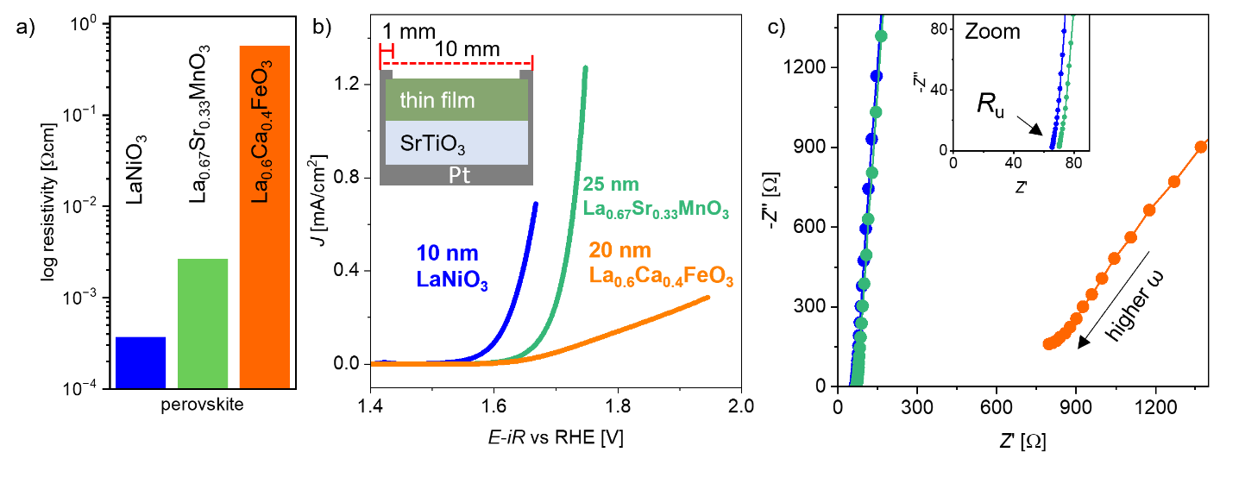
Figure 1: a) Resistivity of LaNiO_{3-δ}, La_{0.67}Sr_{0.33}MnO_{3-δ} and La_{0.6}Ca_{0.4}FeO_{3-δ}. b) Cyclic voltammetry of LaNiO_{3-δ}, La_{0.67}Sr_{0.33}MnO_{3­δ} and La_{0.6}Ca_{0.4}FeO_{3-δ} on SrTiO₃, with Pt side contacts to the back. The film thickness of each material is given in the legend. The CV data is iR corrected and averaged between anodic and cathodic sweep from the second CV cycle (see also SI Figure S3). The sweep rate was 10 mV/s. c) Nyquist plots in the high frequency (ω) range of LaNiO_{3-δ}, La_{0.67}Sr_{0.33}MnO_{3-δ} and La_{0.6}Ca_{0.4}FeO_{3-δ} measured at open circuit voltage (graph colors correspond to the legend in b)). The inset shows a zoom of the Nyquist plot to the high frequency intercept of LaNiO_{3-δ} and La_{0.67}Sr_{0.33}MnO_{3-δ}.

The CV scan of the La_{0.6}Ca_{0.4}FeO_{3-δ} sample exhibits a close-to linear slope at higher current densities, suggesting that an ohmic resistance suppresses the typically expected exponential behavior. This hints at a current limitation caused by the high bulk resistivity of La_{0.6}Ca_{0.4}FeO_{3-δ}, rather than to a limitation caused by its intrinsic catalytic activity. The presence of an additional ohmic resistance in addition to the electrolyte resistance is also apparent in the electrochemical impedance data (Figure 1c). The R_{u} of LaNiO_{3­δ} and La_{0.67}Sr_{0.33}MnO_{3-δ} are 65 Ω and 70 Ω (cf. inset in Figure 1c), while the R_{u} of La_{0.6}Ca_{0.4}FeO_{3-δ} is about an order of magnitude higher (724 Ω). Further, the imaginary part of the impedance, -Z’’, shows a larger offset from the abscissa. This occurs because the catalyst impedance signal overlaps with the impedance signal caused by the reference electrode (see SI Figure S4 for a detailed discussion)^{22,35}. Although the OER CV scan of La_{0.6}Ca_{0.4}FeO_{3-δ} (Figure 1b) was iR corrected with the R_{u} of 724 Ω, this iR correction appears to be insufficient to eliminate all ohmic resistances. A possible reason might be that the employed fitting procedure to determine R_{u} underestimates the true serial resistances in the cell, e.g., due to the large offset from the abscissa. Alternatively, the x-axis offset as measured in impedance spectroscopy might not include all bulk related resistances, a point to which we will return below. Note that typical R_{u} values are between 40 Ω and 60 Ω in 0.1 M KOH with Pt electrodes in this cell geometry (see SI Figure S4a), indicating that our measured R_{u} values contain a small contribution from sample-specific resistance (for LaNiO_{3-δ} and La_{0.67}Sr_{0.33}MnO_{3-δ}), or are dominated by sample resistance, as is the case for La_{0.6}Ca_{0.4}FeO_{3-δ}.
The observed scaling with resistivity may be rationalized by the sample geometry. The chosen side-contacting implies that electrons released in redox reactions at the center of the 10x10 mm² sample must travel up to 4 mm through the bulk of the catalyst layer to reach the metal contact (Figure S2b). The comparably high resistivity of La_{0.6}Ca_{0.4}FeO_{3-δ} suppresses the electron transport from the reaction site at the solid-liquid interface to the metallic contacts to a larger extent than is the case for LaNiO_{3-δ} and La_{0.67}Sr_{0.33}MnO_{3-δ}. Hence, the thin film resistivity might play a significant role for the measured OER activities.
To investigate this possible electron transport limitation in the thin film towards the metallic side contact independent of the sluggish OER kinetics, we employed CV in hexacyanoferrate K₄[Fe(CN)₆]/K₃[Fe(CN)₆] containing electrolyte, constituting the outer-sphere reversible redox couple hexacyanoferrate(II)/(III) (in the following denoted as hexacyanoferrate(II)/(III)). To obtain the typical duck shape of the CV scan, the rotation is turned off for this experiment. In contrast to inner-sphere electrocatalytic reactions like the OER, such outer-sphere fast redox couples have no significant material-dependent kinetic charge-transfer challenges but can directly reveal electronic transport limitations. For barrier-free band alignment at all involved interfaces and a low overall resistance, one expects a reversible redox process with symmetric anodic and cathodic peaks and a small peak potential separation. Any decrease in peak height as well as asymmetries can be related towards electronic resistances in the electrode stack²⁴ (or in some cases toward smaller surface areas³⁶). The redox potential of hexacyanoferrate(II) to hexacyanoferrate(III) is 1.2 V vs. RHE, which is similar to the theoretical OER redox potential, giving the advantage to test electron transport limitations in the relevant potential range²⁴.

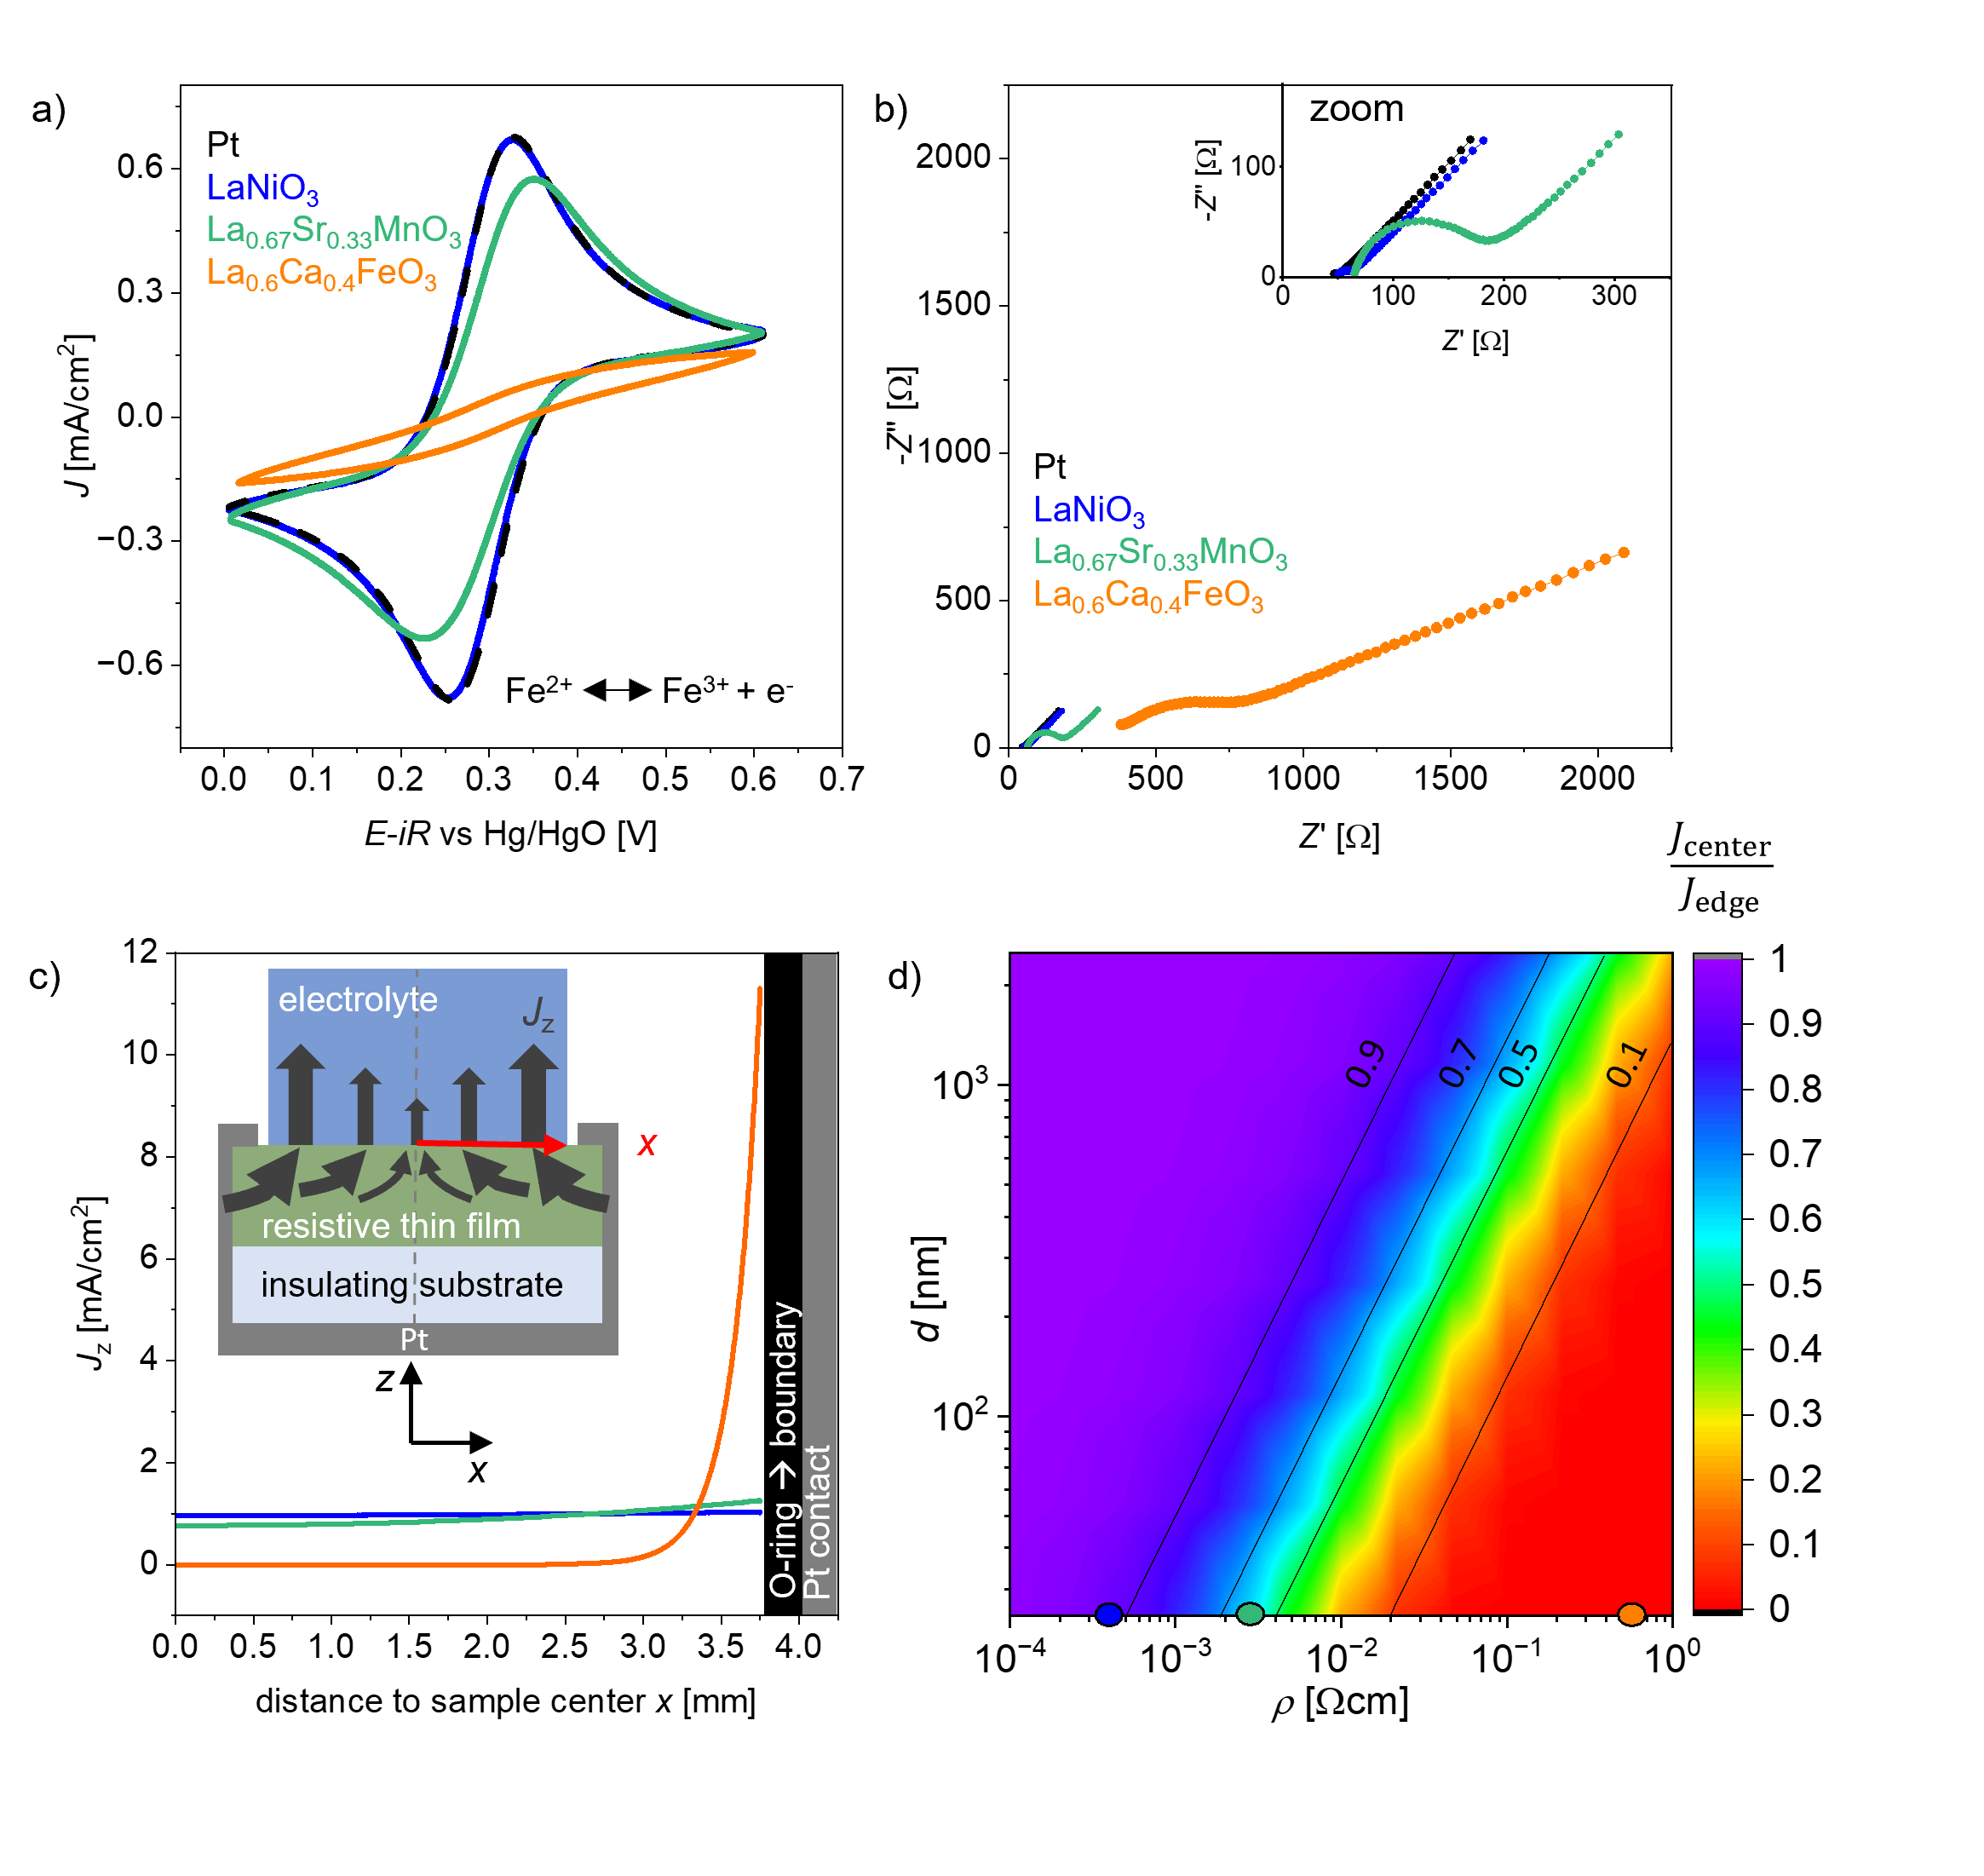
Figure 2: a). Cyclic voltammetry scans of LaNiO_{3-δ}, La_{0.67}Sr_{0.33}MnO_{3-δ} and La_{0.6}Ca_{0.4}FeO_{3-δ} in K₄[Fe(CN)₆]/K₃[Fe(CN)₆] solution. The sweep rate was 30 mV/s. b) Corresponding impedance spectroscopy measured at OCP. The inset shows a zoom to the region of 350 Ω in Z’ direction. c) Simulated current density distribution of the thin films on insulating substrates. The inset shows a sketch of the radial current density distribution J_{z}(x) on resistive thin films along the x axis of the simulation. The dashed line in the center represents the axisymmetric line cut. d) Heat map of the current density variation $\frac{J_{center} }{J_{edge}}$ as a function of catalyst layer resistivity ρ and thickness d. Blue, green and orange dots are the data points for 25 nm thick LaNiO_{3-δ}, La_{0.67}Sr_{0.33}MnO_{3-δ} and La_{0.6}Ca_{0.4}FeO_{3-δ} thin films, respectively.

We compared the hexacyanoferrate(II)/(III) CV scans of 25 nm thick LaNiO_{3-δ}, La_{0.67}Sr_{0.33}MnO_{3-δ} and La_{0.6}Ca_{0.4}FeO_{3-δ} thin films to a Pt thin film acting as an ideally metallic reference (Figure 2a). LaNiO_{3-δ} and Pt exhibit strongly overlapping CV curves, indicating that the electron transport to the side contacts of the LaNiO_{3-δ} thin film is not limiting and the redox reaction exhibits no significant overpotential for LaNiO_{3-δ}. La_{0.67}Sr_{0.33}MnO_{3-δ} shows a slightly increased overpotential for the oxidation and reduction of hexacyanoferrate(II)/(III), as indicated by the slight decrease and shift of the current density maximum towards higher and lower potentials, respectively. In contrast, La_{0.6}Ca_{0.4}FeO_{3-δ} exhibits no clear oxidation and reduction peaks in this potential range, indicating that its high resistivity strongly limits the electron transport.
As can be seen in Figure 2b, the corresponding impedance spectra recorded at OCP in hexacyanoferrate(II)/(III) containing electrolyte show a similar behavior. LaNiO_{3-δ} and Pt exhibit comparable spectra whereas La_{0.67}Sr_{0.33}MnO_{3­δ} exhibits a larger semi-circle in the high frequency range. In the low frequency range, the impedance shows a nearly linear increase at an angle close to 45° for the Pt, LaNiO_{3-δ} and La_{0.67}Sr_{0.33}MnO_{3-δ} thin films, indicating the presence of a semi-infinite Warburg element³⁷ in the equivalent circuit. This feature stems from the mass transport limitations of the hexacyanoferrate(II)/(III) species at the solid/liquid interface. The slight overpotentials observed for La_{0.67}Sr_{0.33}MnO_{3-δ} in the CV scan in Figure 2a could stem from a higher resistivity compared to LaNiO_{3-δ}, but the observed semi-circle in the impedance indicates that there could be a significant interface barrier for the La_{0.67}Sr_{0.33}MnO_{3-δ} thin film reducing the observed currents as well. For La_{0.6}Ca_{0.4}FeO_{3-δ}, R_{u} exhibits a significantly higher value since the higher total resistance of the thin film might add up to the overall observed x-axis offset, similar to the behavior of the impedance shown in Figure 1c. Moreover, the observed semi-circle in the high frequency range is deformed, a characteristic often represented by a constant phase element in equivalent electrical circuits. The low-frequency region shows a distorted incline with a slope less than 45°, which indicates that the condition for an ideal Warburg element is not fulfilled either. Together, the CV and impedance spectroscopy with the hexacyanoferrate(II)/(III) redox couple confirm that thin films with a high resistivity exhibit poor electrochemical performance due to impeded electron transport in the film.
To investigate and quantify the influence of the thin film resistivity on the local current density along the thin film/electrolyte interface, a COMSOL Multiphysics study was conducted for the LaNiO_{3-δ}, La_{0.67}Sr_{0.33}MnO_{3-δ} and La_{0.6}Ca_{0.4}FeO_{3-δ} films which is illustrated in Figure 2c. In the COMSOL simulation, a fixed current of 0.44 mA was applied corresponding to an average current density of 1 mA/cm² as the exposed geometric surface area is 0.44 cm². We simulated the current density distribution J_{z}(x) across the catalyst surface from the sample center to the boundary of the catalyst, i.e. the location of the O-ring at 3.75 mm distance from the sample center. The metallic contacts are located in 4 mm distance to the sample center, approximating the real sample geometry in the RDE setup. J_{z}(x) is the current density perpendicular to the catalyst surface, read out along the sample interface in x direction (further details of the simulation can be found in the methods section and in the SI Figure S5). Our simulation focuses on the current distribution resulting from varying catalyst conductivity, assuming sufficient electrolyte conductivity to enable homogeneous current distribution for metallic electrodes. This is justified for the treatment of the OER, which is always characterized by slow electrode kinetics. These slow kinetics are imposed in the simulation via an additional resistance at the electrode interface³⁸, representing the OER charge transfer resistance.
The resulting current density distribution shows significant differences for the three materials with varying resistivities. For LaNiO_{3-δ}, the current density is almost homogeneously distributed, indicating that the low resistivity does not significantly affect the current pathway through the thin film towards the metallic contacts, and the entire catalyst area contributes similarly to the reaction current. In the sample center, the current density is 0.96 mA/cm² and increases to 1.04 mA/ cm² at the catalyst boundary. To describe the current density variation along the sample profile, we define the ratio $\frac{J_{center} }{J_{edge}}$ which is the current density at the sample center in relation to the catalyst boundary:
$\frac{J_{center} }{J_{edge}}=\frac{J_{z}(x=0 mm) }{J_{z}\left(x=3.75 mm\right)}$.
For LaNiO_{3-δ}, $\frac{J_{center} }{J_{edge}}$ is about 0.92. For La_{0.67}Sr_{0.33}MnO_{3-δ}, however, the current density in the sample center is only 0.76 mA/cm² which is ~20 % lower than the value obtained for LaNiO_{3-δ}. The current density increases continuously from the sample center towards the catalyst boundary reaching a current density of around 1.25 mA/cm². Hence, the one order of magnitude higher resistivity in the La_{0.67}Sr_{0.33}MnO_{3-δ} film leads to a significant change of the current density distribution along the interface, where $\frac{J_{center} }{J_{edge}}$ is only 0.6. This behavior is even more pronounced for La_{0.6}Ca_{0.4}FeO_{3-δ}. Here, the current density is only 3.6 nA/cm² in the sample center and essentially does not contribute to the overall reaction. At 3 mm radial distance, the current density increases to 0.15 mA/cm². And only towards the edge, the current density increases drastically to more than 11 mA/cm² leading to an extremely small $\frac{J_{center} }{J_{edge}}$ ratio of only 2 x 10⁻⁸. Due to the high resistance of the La_{0.6}Ca_{0.4}FeO_{3-δ} thin film, the area close to the metal contacts hence over-proportionally contributes to the current and shows a locally higher current density (as sketched in the inset of Figure 2c). In the supplementary note N1, the possible inhomogeneities caused by electrolyte effects³⁸ are estimated for our setup, where the variation is only about 10 % in the sample center. However, according to our COMSOL simulations, the inhomogeneities caused by the thin film catalyst resistivity can reach values that are orders of magnitude higher. Hence, inhomogeneities caused by the electrolyte effects have a minor influence.
Hence, the COMSOL study shows that the effective surface area accessible for electrochemical reactions is extremely small for La_{0.6}Ca_{0.4}FeO_{3-δ} in the chosen sample geometry. Therefore, for samples with higher resistivity, the observed electrochemical currents can effectively not be related to their geometric surface area that is exposed to the electrolyte, making it impossible to reveal their intrinsic catalytic properties in any electrochemical reaction in such sample geometry. The observed low activity of La_{0.6}Ca_{0.4}FeO_{3-δ} (Figure 1b) thus results from ill-defined normalization of the current density with respect to the total exposed catalyst area.
To determine which resistivity-thickness relations are suitable to reveal the intrinsic properties for this sample geometry, we extended the COMSOL study for the full resistivity range from 10⁻⁴ Ωcm to 1 Ωcm and thin film thicknesses of up to 2.5 µm. The expected current density ratio $\frac{J_{center} }{J_{edge}}$ is determined for various combinations of catalyst resistivity and layer thickness, yielding the heat map shown in Figure 2d.The values for 25 nm thick LaNiO_{3-δ}, La_{0.67}Sr_{0.33}MnO_{3-δ} and La_{0.6}Ca_{0.4}FeO_{3-δ} thin films are marked as blue, green and orange dot, respectively.
We consider the LaNiO_{3-δ} case with $\frac{J_{center} }{J_{edge}}$ = 0.92 as an acceptable scenario to extract intrinsic catalytic properties in this geometry, while for La_{0.67}Sr_{0.33}MnO_{3-δ} with $\frac{J_{center} }{J_{edge}}$ = 0.6 the current density would already be too inhomogeneous for a proper analysis. However, with an exemplary sample thickness of more than 200 nm, $\frac{J_{center} }{J_{edge}}$ would be 0.9 or more also for La_{0.67}Sr_{0.33}MnO_{3-δ}, enabling us to principally reveal the intrinsic catalytic properties of La_{0.67}Sr_{0.33}MnO_{3-δ} in this sample geometry. For La_{0.6}Ca_{0.4}FeO_{3-δ}, however, even a film thickness of 1 µm would only lead to $\frac{J_{center} }{J_{edge}}$ = 0.2, making it impossible to determine the intrinsic catalytic properties in this sample geometry. Figure S6 shows the heatmap on a logarithmic scale, highlighting the extremely small $\frac{J_{center} }{J_{edge}}$ values for resistivities above 2$∙$10⁻² Ωcm.
We emphasize that even though the trends presented in Figure 2d will be valid for any geometrical setup, i.e. $\frac{J_{center} }{J_{edge}}$ increases with increasing film thickness or decreasing film resistivity, the absolute values of $\frac{J_{center} }{J_{edge}}$ depend also on the lateral geometry of the experimental setup. If the setup deviates greatly from the one used here, additional simulations would be required to accurately estimate the variation in the current density across the interface between the thin film and the electrolyte. Nevertheless, the heat map can be used as a qualitative guidance for any thin film geometry applied to OER catalysis. We also note that ohmic drops in the solution can lead to additional inhomogeneity. While the expected variation in current density across the electrode surface caused by electrolyte effects is much smaller than the effects observed for our highly resistive catalysts, it would be necessary to explicitly include the electrode kinetics model developed by Newman ³⁸ in simulations for high-resistivity catalysts for mass-transfer limited reactions, where the electrolyte effects become more relevant.
The previously mentioned ill-defined normalization of the current density in La_{0.6}Ca_{0.4}FeO_{3-δ} can also explain the deformed impedance features observed in Figure 2b. As the current-potential distribution exhibits a strong radial distribution, the equivalent electric circuit needs to be described as a series of R_{u}-RC elements that vary along the solid/liquid interface. Such 2D surface distributions are experimentally observed as a constant phase element in the global impedance^{39–41}, thus explaining the suppressed impedance feature in the high and low frequency ranges observed for La_{0.6}Ca_{0.4}FeO_{3-δ}. An additional reason for the non-ideal Warburg element in Figure 2b could be sideward diffusion of ionic species in the electrolyte, which has been observed as an edge effect⁴² that can principally also occur on metallic electrodes. The phenomenon of varied radial current-potential distribution could also occur in the catalyst bulk where not solely ohmic resistances are present but also capacitive contributions^{43,44} might be present in the lateral dimension. Hence, the catalyst bulk might also be described as 2D distributed RC elements along the lateral dimension. Therefore, R_{u} determined by the x-axis intercept of the impedance at high frequencies does not include all relevant bulk related impedances. In other words, each location on the sample surface exhibits a different ‘effective’ iR value, resulting from increasing series resistances from the edge to the center. This might explain the fact that the linear slope observed for La_{0.6}Ca_{0.4}FeO_{3-δ} in Figure 1a cannot be compensated by a classic iR_{u} correction.
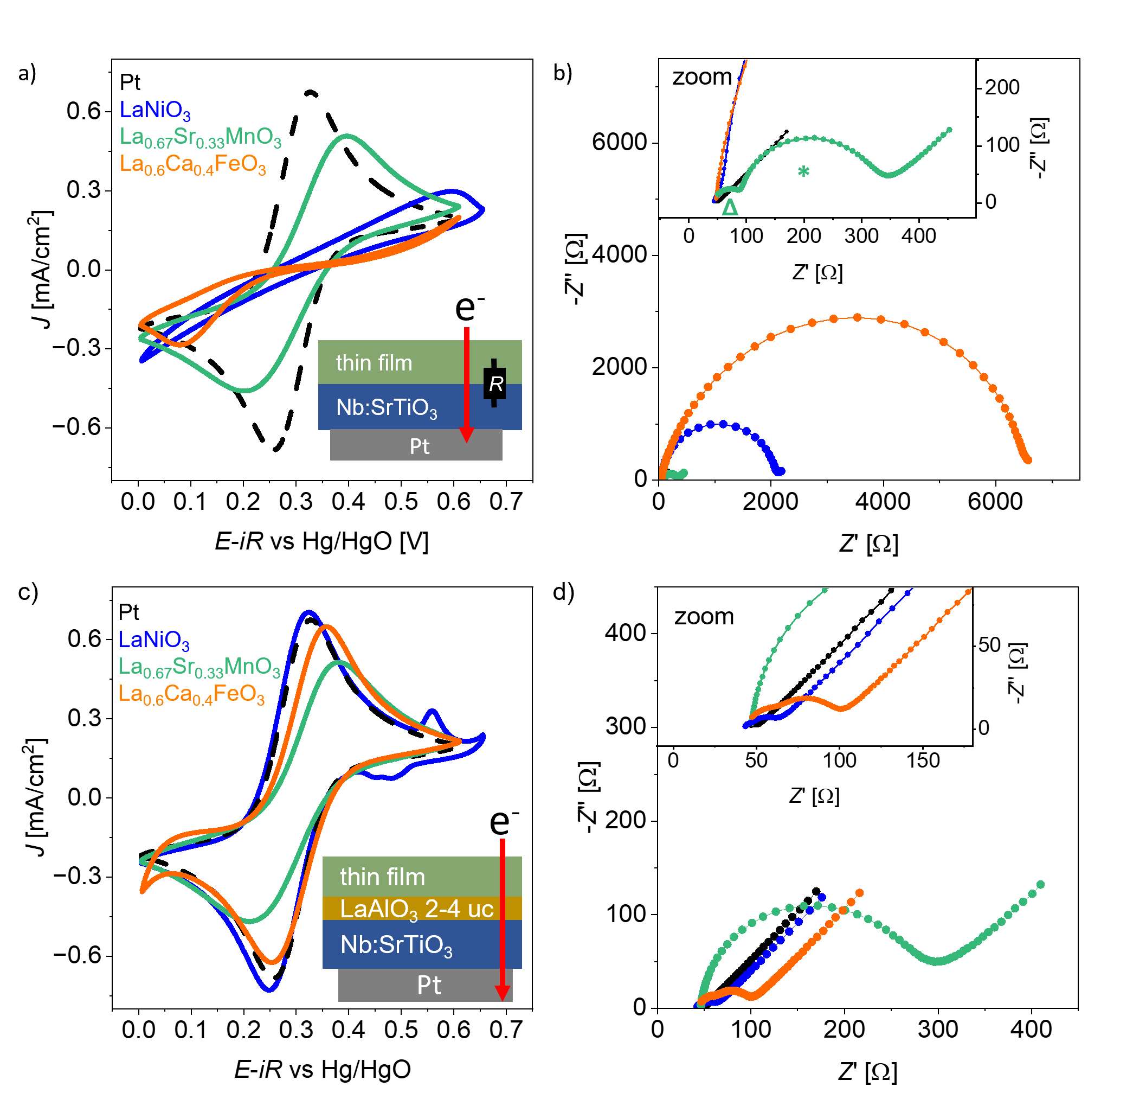
Figure 3: a) Cyclic voltammetry in hexacyanoferrate(II)/(III) electrolyte for LaNiO_{3-δ}, La_{0.67}Sr_{0.33}MnO_{3-δ} and La_{0.6}Ca_{0.4}FeO_{3-δ} thin films grown on Nb:SrTiO₃ in comparison to the platinum sample. The sweep rate was 30 mV/s. b) Corresponding impedance spectra at OCP. Legend corresponds to a). Inset shows the zoom of the lower impedance values. Δ refers to the semi-circle in the high frequency range of La_{0.67}Sr_{0.33}MnO_{3-δ} and * refers to the semi-circle towards lower frequencies. c) Cyclic voltammetry in hexacyanoferrate(II)/(III) electrolyte for Nb:SrTiO₃/2 uc LaAlO₃/ LaNiO_{3­δ}, Nb:SrTiO₃/2 uc LaAlO₃/ La_{0.67}Sr_{0.33}MnO_{3-δ} and Nb:SrTiO₃/4 uc LaAlO₃/ La_{0.6}Ca_{0.4}FeO_{3-δ} thin films in comparison to the platinum sample. The sweep rate was 30 mV/s. For LaNiO_{3-δ} additional oxidation and reduction peaks are seen at 0.55 V and 0.45 vs Hg/HgO, respectively, representing the Ni²⁺/Ni³⁺ redox reaction. d) Corresponding impedance spectra at OCP. Inset shows the zoom to the lower impedance values.
To suppress electron transport limitations and the large radial current density distribution of the resistive thin film electrocatalysts, the chosen OER catalyst layers were deposited on 0.5 wt% Nb-doped SrTiO₃ (Nb:SrTiO₃), which possesses metallic conductivity in the bulk. As sketched in Figure 3a, the electrons can now travel from the solid/liquid interface directly through the only nanometers thick films into the Nb:SrTiO₃ substrate, which can act as current collector. The film thickness is 10 nm for LaNiO_{3-δ}, 20 nm for La_{0.6}Ca_{0.4}FeO_{3-δ} and 25 nm for La_{0.67}Sr_{0.33}MnO_{3-δ} which is far above the thickness where finite size phenomena occur. Here, Pt is only sputtered on the back side of the substrate. In this contacting geometry, La_{0.6}Ca_{0.4}FeO_{3-δ} and notably also LaNiO_{3-δ} show largely suppressed current densities and large peak separations in the hexacyanoferrate(II)/(III) redox reaction (Figure 3a) while the current density of La_{0.67}Sr_{0.33}MnO_{3-δ} is the closest to the Pt reference and the peak separation is much smaller. This indicates that although the travelling distance has changed from a few millimeters in lateral dimensions to a few nanometers in vertical dimension in this sample geometry, the charge transport remains limited. This is particularly observed for the OER catalyst with lowest (La_{0.6}Ca_{0.4}FeO_{3-δ}) and largest (LaNiO_{3-δ}) conductivity, indicating a departure from the systematic scaling with electrical conductivity as observed before. Instead, the observed behavior suggests an interfacial contact resistance across the substrate/thin film interface,^{45–48} resulting from Schottky-type space charge layers.
For a Schottky barrier (the catalyst work function is higher than the Nb:SrTiO₃ electron affinity), it is expected that the electron transport is more hampered for the oxidation reaction rather than for the reduction reaction²⁴. For La_{0.6}Ca_{0.4}FeO_{3-δ}, the oxidation and reduction peak of hexacyanoferrate(II)/(III) are asymmetric, indicating that the (Schottky barrier-type) contact resistance at the Nb:SrTiO₃/thin film interface especially hampers the oxidation from hexacyanoferrate(II) to hexacyanoferrate(III). A similar interface resistance is expected for LaNiO_{3-δ}, which has a work function larger than the Nb:SrTiO₃ electron affinity, as described elsewhere^{30,45,46}. However, the Ni oxidation takes place in the same measured potential window²⁷ as the Fe oxidation, therefore the Ni³⁺ and Fe³⁺ formation might lead to additional asymmetric behavior in the anodic sweep compared to the cathodic sweep seen in Figure 3a.
The Nyquist plots in Figure 3b show large semi-circles for La_{0.6}Ca_{0.4}FeO_{3-δ} and LaNiO_{3-δ} with a real impedance (Z’) of up to several kΩ which may be attributed to the substrate/thin film contact resistance. In contrast, La_{0.67}Sr_{0.33}MnO_{3-δ} exhibits two semi-circles that are below 400 Ω (marked with a green * and Δ in the inset of Figure 3b), indicating a significantly lower contact resistance at the substrate/thin film interface, consistent with the smaller peak separation and higher current densities in the hexacyanoferrate(II)/(III) redox reaction compared to La_{0.6}Ca_{0.4}FeO_{3-δ} and LaNiO_{3-δ}. The semi-circle in the high frequency range (marked with Δ) of La_{0.67}Sr_{0.33}MnO_{3-δ} could stem from the Nb:SrTiO₃/thin film interface impedance and the semi-circle towards lower frequencies (*) could stem from La_{0.67}Sr_{0.33}MnO_{3-δ} -specific and contact-independent behavior as the same order of magnitude impedance was already observed on the insulating substrate (Figure 2b).
The Nyquist plots in Figure 3b show that R_{u} is now in the same range of 40-50 Ω for all three materials, indicating that the additional ohmic resistance of the resistive La_{0.6}Ca_{0.4}FeO_{3-δ} thin film that was observed in Figure 2b, is circumvented in this geometry. Nevertheless, the large contact resistance to the substrate, especially for La_{0.6}Ca_{0.4}FeO_{3-δ} and LaNiO_{3-δ} still affects the electrochemical performance and thus hinders the observation of intrinsic catalytic properties of the OER.
To decrease the contact resistance between the thin film and Nb:SrTiO₃, a 2-4 uc (unit cell) thick interlayer of LaAlO₃ was introduced (see sketch in Figure 3c; corresponding RHEED data are shown in Figure S7). This polar oxide layer induces an electrical dipole which can counteract interfacial space charge layers and Schottky barriers, facilitating the electron transport across the interface^{21,30,49}. We note that the ideal dipole layer thickness to compensate the built-in potentials is specific to the materials at the interface. For the LaNiO_{3­δ} /Nb:SrTiO₃ interface, 2 unit cells (uc) of LaAlO₃ as interlayer effectively decreased the contact resistance, as evident by the resulting CV scan in the hexacyanoferrate(II)/(III) redox couple (Figure 3c) and the impedance at OCP (Figure 3d), both of which are now similar to the Pt reference (Figure 3c and 3d). This shows a clear improvement in comparison to the LaNiO_{3-δ}/Nb:SrTiO₃ sample without LaAlO₃ interlayer (Figure 3a and 3b).
In the case of La_{0.67}Sr_{0.33}MnO_{3-δ}, introducing 2 uc of LaAlO₃ results in a slightly smaller peak separation as can be seen in the hexacyanoferrate(II)/(III) CV scan (comparing Figure 3a and 3c with 0.2 V and 0.17 V peak separation, respectively) but still exhibits a small remaining overpotential. Comparing the impedance data of La_{0.67}Sr_{0.33}MnO_{3-δ} with and without LaAlO₃ interlayer on Nb:SrTiO₃ in Figure 3b and 3d shows that with the LaAlO₃ interlayer, the semi-circle in the high frequency range (Δ) is not visible anymore but the semi-circle marked with a * in Figure 3b remains. The LaAlO₃ interlayer might have compensated the smaller interface resistance at the Nb:SrTiO₃/La_{0.67}Sr_{0.33}MnO_{3-δ} interface, but an additional La_{0.67}Sr_{0.33}MnO_{3-δ}-specific impedance behavior remains, which was observed in all contacting geometries.
For La_{0.6}Ca_{0.4}FeO_{3-δ}, a LaAlO₃ interlayer thickness of 4 uc was required to sufficiently decrease the Nb:SrTiO₃/La_{0.6}Ca_{0.4}FeO_{3-δ} contact resistance. For the Nb:SrTiO₃/LaAlO₃/La_{0.6}Ca_{0.4}FeO_{3-δ} stack, the reduction peak from hexacyanoferrate(III) to hexacyanoferrate(II) shows now similar behavior as the Pt sample (Figure 3c) and the oxidation peak exhibits only a small overpotential. The total impedance was reduced by two orders of magnitude by the 4 uc thick LaAlO₃ interlayer comparing the impedance in Figure 3b and 3d. Only two small semi-circles remain that are observed in the Nyquist plot in Figure 3d. The small remaining overpotential of the oxidation reaction might stem from a small remaining contact resistance at the Nb:SrTiO₃/LaAlO₃/ La_{0.6}Ca_{0.4}FeO_{3-δ} interface and/or from an La_{0.6}Ca_{0.4}FeO_{3-δ} -specific resistance. As a result, the electrochemical performance in this geometry should not be strongly limited by electronic transport anymore despite the high resistivity of La_{0.6}Ca_{0.4}FeO_{3-δ}. This is evidenced by the high currents obtained with the outer-sphere fast redox couple. This indicates that electronic transport limitations are also negligible for electrocatalytic inner-sphere redox reactions such as OER, implying that the measured electrocatalytic current in this geometry directly scales with the intrinsic ability of La0.6Ca0.4FeO3‑δ to catalyze the reaction of interest, here the OER²⁴.
Hence, the three perovskites grown on Nb:SrTiO₃ with LaAlO₃ as charge compensating interlayer were tested in 0.1 M KOH to reveal the intrinsic catalytic activity in the OER with minimized electron transport limitations through the bulk and substrate interface resistance. Note that in contrast to the experiments in hexacyanoferrate(II)/(III) containing electrolyte, RDE rotation is set to 1600 rpm for OER experiments, to remove evolving oxygen gas from the surface during the CV scan. Figure 4a shows the corresponding impedance in 0.1 M KOH of the Nb:SrTiO₃/LaAlO₃/catalyst stacks. The R_{u} is small (40-50 Ω) for the three perovskite oxides indicating no significant ohmic losses through bulk resistivities are present, which is consistent with the observation of the impedance in the hexacyanoferrate(II)/(III) containing electrolyte. For La_{0.6}Ca_{0.4}FeO_{3-δ}, there is a small semi-circle observed (~20 Ω) in the high frequency range which can stem from a small remaining contact resistance at the La_{0.6}Ca_{0.4}FeO_{3-δ}/LaAlO₃/Nb:SrTiO₃ interface. The equivalent circuit and corresponding impedance fit are shown in Figure S9. Overall, however, the R_{u} and the contact resistances to the substrate show significantly lower absolute values than observed in the initial in-plane geometry and LaAlO₃ free thin film stacks on Nb:SrTiO₃, indicating a successful removal of the OER-performance limiting current paths.
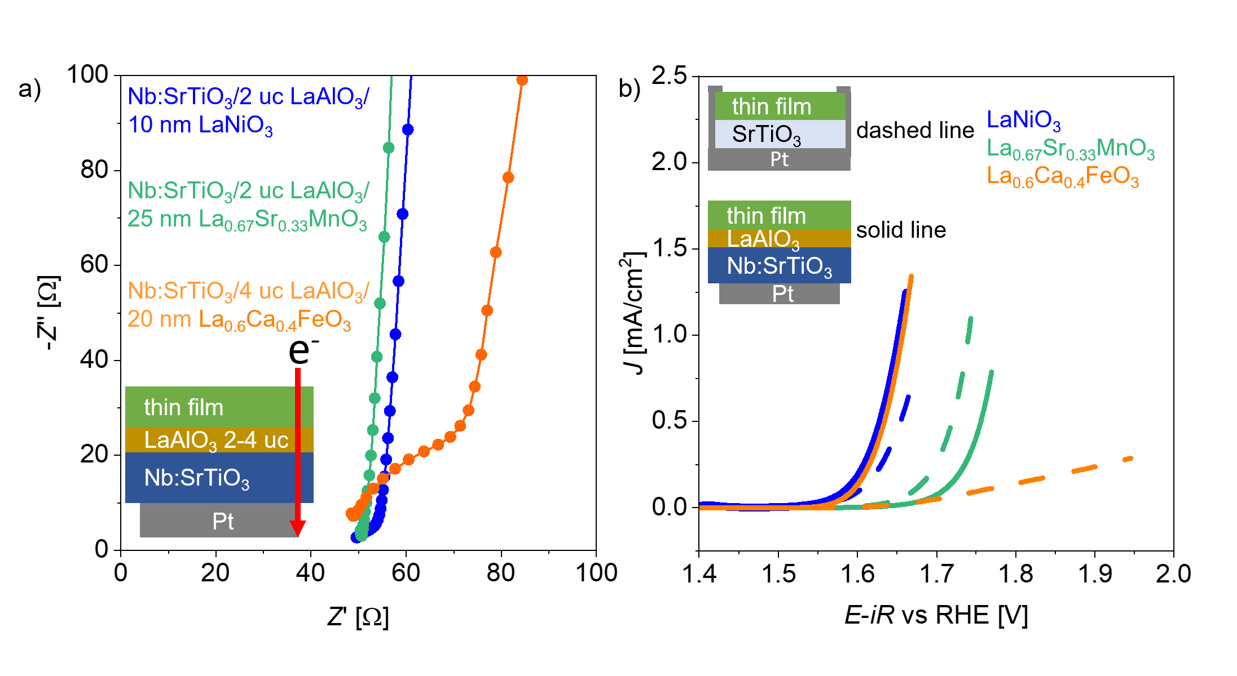
Figure 4: a) Impedance spectra in the high frequency range at OCP for the thin films on Nb:SrTiO₃ with LaAlO₃ interlayer recorded in 0.1 M KOH solution. b) OER catalytic activity of LaNiO_{3-δ}, La_{0.67}Sr_{0.33}MnO_{3-δ} and La_{0.6}Ca_{0.4}FeO_{3-δ} thin films in 0.1 M KOH for the two different contacting geometries sketched in the top left corner. OER performance on the insulating STO substrates are shown as dashed lines (reproduced from Figure 1c for ease of comparison) and OER activities of Nb:SrTiO₃/2 uc LaAlO₃/LaNiO_{3-δ}, Nb:SrTiO₃/2 uc LaAlO₃/La_{0.67}Sr_{0.33}MnO_{3-δ} and Nb:SrTiO₃/4 uc LaAlO₃/La_{0.6}Ca_{0.4}FeO_{3-δ} stacks are shown as solid lines. The sweep rate was 10 mV/s.

Figure 4b shows the OER activity comparison of the two different contacting geometries, SrTiO₃/catalyst and Nb:SrTiO₃/LaAlO₃/catalyst. The SrTiO₃/LaNiO_{3-δ} and Nb:SrTiO₃/LaAlO₃/LaNiO_{3-δ} stacks show a similar η of 0.37 V and 0.36 V at 0.1 mA/cm², respectively. La_{0.67}Sr_{0.33}MnO_{3-δ} shows a higher η than LaNiO_{3-δ} in both contacting geometries with η = 0.44 V and 0.48 V at 0.1 mA/cm² for the SrTiO₃/La_{0.67}Sr_{0.33}MnO_{3-δ} and Nb:SrTiO₃/LaAlO₃/La_{0.67}Sr_{0.33}MnO_{3-δ} stacks, respectively. The deviation between the samples can occur because of small remaining contact resistances to the Nb:SrTiO₃ substrate or because of sample-to-sample deviation. La_{0.6}Ca_{0.4}FeO_{3-δ} exhibits very high η on the insulating substrate (0.53 V at 0.1 mA/cm², as already introduced in Figure 1b), but the Nb:SrTiO₃/LaAlO₃/ La_{0.6}Ca_{0.4}FeO_{3-δ} stack shows remarkably low η of 0.36 V at 0.1 mA/cm², which is similar to LaNiO_{3-δ}. To obtain whether the CV curves shown in figure 4b are dominated by resistances or OER kinetics, the Tafel plots are compared in the SI Figure S8. They show that La_{0.6}Ca_{0.4}FeO_{3-δ} deposited on insulating SrTiO₃ strongly deviates from Tafel-like behavior, reaching values above 500 mV/dec while on Nb:SrTiO₃/LaAlO₃ stacks all three perovskites show reasonable Tafel slope values between 40-90 mV/dec. This highlights that in a well-chosen contacting geometry, iR correction by the x-axis intercept is reasonable and that we can reveal the intrinsic catalytic activity of poorly conducting electrocatalysts.
Hence, La_{0.6}Ca_{0.4}FeO_{3-δ} exhibits a similar intrinsic catalytic activity in the OER as LaNiO_{3-δ}, although it has three orders of magnitude higher resistivity. In turn, La_{0.67}Sr_{0.33}MnO_{3-δ} - exhibiting intermediate resistivity among the three tested perovskites - shows the lowest intrinsic OER catalytic activity compared to LaNiO_{3-δ} and La_{0.6}Ca_{0.4}FeO_{3-δ}. As a result, the intrinsic OER activity of the perovskite oxides does not scale monotonically with their electronic resistivity, and in fact, even a high resistivity perovskite can exhibit high OER performance – a result that could not have been revealed without dedicated and systematic choice of the sample substrate and interfacial layers.
Discussion
By tuning the bulk electron transport from millimeter to nanometer scales, and additionally minimizing the contact resistance in the sample stack, the intrinsic catalytic properties in the OER could be revealed for LaNiO_{3-δ}, La_{0.67}Sr_{0.33}MnO_{3-δ} and even for the highly resistive La_{0.6}Ca_{0.4}FeO_{3-δ}. The observed OER overpotential trend changes from η(LaNiO_{3-δ}) < η(La_{0.67}Sr_{0.33}MnO_{3-δ}) < η(La_{0.6}Ca_{0.4}FeO_{3-δ}), as observed in resistance-dominated geometry with inhomogeneous current contribution across the catalyst interface, to η(LaNiO_{3-δ}) ≈ η(La_{0.6}Ca_{0.4}FeO_{3-δ}) < η(La_{0.67}Sr_{0.33}MnO_{3-δ}) as intrinsic catalytic activity trend. Hence, the intrinsic properties of perovskite catalysts do not necessarily scale with their resistivity when the catalyst bulk electron transport is limited to small distances. We note that it is expected that the electronic structure, covalency, and hybridization vary among the samples. Yet, the metallic LaNiO_{3-δ} and the highly resistive La_{0.6}Ca_{0.4}FeO_{3-δ} can show remarkably similar intrinsic OER activity, provided that the current pathways are properly controlled.
However, even small residual interface resistances like the remaining interface resistance of around 20 Ω at the Nb:SrTiO₃/LaAlO₃/ La_{0.6}Ca_{0.4}FeO_{3-δ} interface might affect the overall observed overpotential, diluting the revelation of intrinsic properties. This is especially noticeable at higher current densities. For small currents such as 0.1 mA, a 20 Ω series resistance leads to 2 mV additional ohmic overpotential, whereas for 10 mA this already leads to 200 mV ohmic overpotential. Additionally, as such Schottky-barrier-type resistances are voltage dependent, the interface resistance might change with applied potential, which might dilute the revelation of intrinsic properties as well.
A similar OER activity trend compared to our findings for the Nb:SrTiO₃/LaAlO₃/thin film stacks was obtained for LaNiO_{3-δ,} La_{0.75}Ca_{0.25}FeO_{3-δ}, La_{0.5}Ca_{0.5}FeO_{3-δ} and La_{0.5}Ca_{0.5}MnO_{3-δ} at 50 µA/cm² by Suntivich et al. in powder experiments (grain size 0.2-1.0 µm) with conductive carbon⁵. In their study, a lower activity was observed also for the manganite La_{0.5}Ca_{0.5}MnO_{3-δ} compared to the nickelate and calcium doped ferrates (η (LaNiO_{3-δ}) ≈ η (La_{0.5}Ca_{0.5}FeO_{3-δ}) < η (La_{0.5}Ca_{0.5}MnO_{3-δ})). In contrast, it is also reported in the literature that especially La_{0.6}Ca_{0.4}FeO_{3-δ} in the solid solution series of La_{1-x}Ca_{x}FeO_{3-δ} has a low catalytic activity²⁹ with an overpotential (at 50 µA/cm²) comparable to what we observed for La_{0.6}Ca_{0.4}FeO_{3-δ} on the insulating substrate with a long bulk electron transport pathway. Also, the previously reported Tafel slope was 242 mV/dec for La_{0.6}Ca_{0.4}FeO_{3-δ}, ²⁹ exceeding reasonable OER Tafel slope values between 30-120 mV/dec by far, similar to our La_{0.6}Ca_{0.4}FeO_{3-δ} sample on the insulating substrate. One reason for the higher overpotentials and Tafel slopes observed (compared to our Nb:SrTiO₃/LaAlO₃/La_{0.6}Ca_{0.4}FeO_{3-δ} sample and to the findings of Suntivich et al.) could be a larger grain size in the catalyst powder of the highly resistive La_{0.6}Ca_{0.4}FeO_{3-δ}. This could extend the electron transport pathway through the powder bulk significantly even with conductive carbon, so that larger current losses occur. Additionally, conductive carbon can, for example, change the valence state of the B-site or can act as a co-catalyst^{8,50,51}, hindering to reveal intrinsic catalytic properties as well.
Our findings and the comparison to the literature indicate that the establishment of catalyst design rules must be taken with care, especially when materials across large resistivity ranges are tested and substrate-to-catalyst contact resistances occur. One design rule addressed in the literature stems from the observation that a small charge transfer energy leads to higher OER activity¹¹. However, a large charge transfer energy (which is the energy distance between the occupied O 2p and first unoccupied transition metal 3d states) typically also leads to a lower conductivity, which can lead to lower measured (but not lower intrinsic) OER activity¹¹. Therefore, it is crucial not to assume a direct correlation between low conductivity and low OER catalytic activity, which has become obvious from our revelation that metal oxides with low conductivity can exhibit high catalytic activity. Extra steps have to be taken to disentangle intrinsic catalytic activity from conductivity to accurately assess performance. As we have shown, this can be achieved using epitaxial model systems with appropriate current collectors and favorable interface properties.

Conclusion
We have shown that highly resistive perovskite oxides can be intrinsically as active as quasi metallic electrocatalysts in the OER. We decoupled the bulk resistivity and substrate/thin film contact resistances from intrinsic catalytic processes at the solid/liquid interface for the three perovskites LaNiO_{3-δ}, La_{0.67}Sr_{0.33}MnO_{3-δ} and La_{0.6}Ca_{0.4}FeO_{3-δ} by keeping the electron transport pathway through the catalyst bulk on the nanometer scale and minimizing the contact resistance to the Nb:SrTiO₃ substrate. Through insertion of a LaAlO₃ dipole layer, the contact resistance between NbSrTiO₃ and catalyst was strongly decreased. Thus, we could reveal that LaNiO_{3-δ} and La_{0.6}Ca_{0.4}FeO_{3-δ} have similar intrinsic catalytic properties, even though La_{0.6}Ca_{0.4}FeO_{3-δ} has 3 orders of magnitude higher resistivity compared to LaNiO_{3­δ}. La_{0.67}Sr_{0.33}MnO_{3-δ} has intrinsically a lower OER activity compared to La_{0.6}Ca_{0.4}FeO_{3-δ} and LaNiO_{3-δ}. Hence, electrical conductivity does not necessarily correlate with intrinsic catalytic properties. Therefore, it is of high importance to quantify electron pathway dependent current density losses in chosen sample geometries as well as to distinguish intrinsic properties from resistivity for the establishment of OER catalyst design rules.

Experimental Methods:
Thin film fabrication: The epitaxial thin films were deposited by PLD on single crystal SrTiO₃ and Nb:SrTiO₃ 10x10 mm² substrates in (100) orientation. LaNiO_{3-δ} was grown with a fluence of 1.9 J/cm² with a pulse repetition rate of 2 Hz, with a target to substrate distance of 50 mm and with an oxygen partial pressure of 0.04 mbar at 450 °C (650°C respectively for the sample discussed in Figs. 2a,b. The growth temperature can have an influence on the catalytic activity but does not drastically change the conductivity that is important for the hexacyanoferrate(II)/(III) CV experiment²⁷)). La_{0.67}Sr_{0.33}MnO_{3-δ} was grown with a fluence of 2 J/cm², with a pulse repetition rate of 2 Hz and target to substrate distance of 50 mm at a growth temperature of 750 °C and oxygen partial pressure of 0.266 mbar. The LaAlO₃ interlayer between Nb:SrTiO₃ and LaNiO_{3-δ} and La_{0.67}Sr_{0.33}MnO_{3-δ} respectively was grown with a fluence of 1.4 J/cm², 1 Hz pulse repetition rate at a growth temperature of 650 °C and an oxygen partial pressure of 0.002 mbar. La_{0.6}Ca_{0.4}FeO_{3-δ} was deposited at 650 °C, with a laser fluence of 2.2 J/cm² and oxygen partial pressure of 0.05 mbar, and the target to substrate distance was 55 mm. An LaAlO₃ interlayer was grown on Nb:SrTiO₃ at 700 °C with 1.8 J/cm² laser fluence and 1x10⁻⁴ mbar oxygen partial pressure.
Physical characterization: Atomic force microscopy scans were recorded with a Cypher SPM (Research Asylum, Germany) atomic force microscope in tapping mode. XRD was conducted with a D8 ADVANCE diffractometer (Bruker AXS GmbH, Germany) that is equipped with a Cu cathode for K_{α} radiation and the scans were recorded in 2θ-ω geometry.
Electrochemical characterization: To ensure electrical contact in the electrochemical cell, the samples deposited on SrTiO₃ were sputtered with 50 nm Pt on the backside, edges and front edges (as shown in the SI Figure S2). Samples grown on Nb:SrTiO₃ were sputtered only from the back side. Electrochemical measurements of the thin films were conducted with a RDE with a rotation speed of 1600 rpm in a three-electrode configuration in 0.1 M KOH. The KOH pellets were provided from Sigma Aldrich (purity 99.99 %) and dissolved in deionized water (Milli-Q, >18.2 MΩcm). The counter electrode was a spiraled Pt wire. The reference electrode was a Hg/HgO electrode protected from the solution by a Teflon tube filled with 1 M KOH. The thin films were mounted on the RDE with a custom-made PEEK holder. The thin film back side and front edges were sealed with an O-ring from the electrolyte. Here, the back of the substrate is mechanically pressed against the rotary shaft of the RDE. The geometric surface area that is exposed to the electrolyte is equal to the inner area of the O-ring.
To obtain the OER activity in 0.1 M KOH, the electrolyte was purged with O₂ gas for 30 min before and during the measurement. Before determining the OER activity with CV, impedance spectroscopy was recorded at OCP and double layer capacitance measurements were conducted in the range from 0.0 to 0.1 V vs Hg/HgO (for La_{0.6}Ca_{0.4}FeO_{3-δ} from 0.1 to 0.2 V) with an increasing scan rate from 10 to 500 mV/s. To record the redox behavior of LaNiO_{3-δ} thin films, the potential window from 0.2 to 0.65 V vs Hg/HgO was recorded with an increasing scan rate from 10 to 500 mV/s. To determine the OER activity, CV scans were conducted from 0.2 V up to 1.15 V vs Hg/HgO to reach at least 0.5 mA/cm². OER currents were normalized by the geometric surface area, as appropriate for epitaxial thin films²⁵ and as justified by the low measured specific surface area. While powder catalyst activity is typically determined above 10 mA/cm², epitaxial thin film activity determination is appropriate at a current density of 0.1 mA/cm² as they exhibit such smooth and single-crystal-like surface morphologies²⁵. Hence the OER performance was determined in a current range not exceeding 1.2 mA/cm². The Hg/HgO electrode was calibrated against the RHE (HydroFlex, USA). The averaged value of 0.887 V vs Hg/HgO was used to determine the obtained voltage on the RHE scale. The impedance was recorded in a frequency range of 100 kHz to 0.1 Hz with an amplitude of 20 mV. As the uncompensated resistance is observed in the range of 10 kHz, the spectra are shown for data points from 10 kHz and below (see for clarity SI Figure S4). Electrochemical measurements with the hexacyanoferrate(II)/(III) redox couple were conducted in a 0.1 M KOH solution with an equimolar concentration of 0.003 mol/l of K₄[Fe(CN)₆] [H₂O] and K₃[Fe(CN)₆] (Sigma Aldrich (99.5 % and 99.0%). The RDE rotation was off for the experiments in the hexacyanoferrate(II)/(III) containing electrolyte. Impedance was recorded at OCP and CV scans were recorded between 0-0.6 V vs Hg/HgO. For LaNiO_{3-δ} the window was extended to 0.65 V to obtain a possible contribution from Ni oxidation.
COMSOL study: Simulations for the current density distribution along the film/electrolyte interface were carried out in COMSOL Multiphysics® 6.2 by using the Electric Currents (ec) module. A detailed sketch, description of the simulation and the corresponding parameter values can be found in the SI Figure S5. Current is injected from the Pt back electrode of the substrate and travels to the thin film edge and subsequently to the sample center with resistivities as listed in the main text. The electrons travel through an interfacial boundary layer to the electrolyte with a resistance that was set to 100 Ω, representing typical charge transfer resistances at low applied voltage. Finally, they travel through the electrolyte to the counter electrode (ground). As the thin film has a large aspect ratio (25 nm thickness vs 3.75 cm length, i.e. the distance from the sample center to the O-ring), initial coarse simulations were carried out to optimize the geometry and mesh as much as possible. Here, we used a 2D axisymmetric geometry to further reduce the amount of mesh elements. As expected, since the substrate has a very large resistance, no current flows from the Pt electrode through the substrate itself. Hence, in the final model, the substrate was removed to reduce the amount of mesh elements. A combination of free quad and boundary layer meshes was used to create a mesh with a high quality while keeping the number of meshing elements in a reasonable range (mesh sketch can be found in the SI Figure S5). The current densities J_{z}(x) shown in Figure 2c are extracted by a line cut at the boundary between the thin film and the electrolyte.

Corresponding authors:
Lisa Heymann - Peter Gruenberg Institute 7, Forschungszentrum Juelich GmbH, 52425 Juelich, Germany; orcid.org/0000-0002-0207-7840;
Email: l.heymann@fz-juelich.de
Felix Gunkel − Peter Gruenberg Institute 7, Forschungszentrum Juelich GmbH, 52425 Juelich, Germany; orcid.org/0000-0003-1178-9986;
Email: f.gunkel@fz-juelich.de
Christoph Baeumer − MESA+ Institute for Nanotechnology, Faculty of Science and Technology, University of Twente, 7522 NB Enschede, Netherlands; Peter Gruenberg Institute 7, Forschungszentrum Juelich GmbH, 52425 Juelich, Germany; orcid.org/0000-0003-0008-514X
Email: c.baeumer@utwente.nl

Acknowledgements:
We thank Grigory Potemkin, Shreyas Harsha, and Tursun Abudukade for the experimental support. We thank Dr. Marco Altomare for the insightful discussion. We gratefully acknowledge funding from the European Union (ERC, 101040669 - Interfaces at Work). Views and opinions expressed are however those of the author(s) only and do not necessarily reflect those of the European Union or the European Research Council. Neither the European Union nor the granting authority can be held responsible for them.

Author contribution:
L.H., I.v.d.B., F.G. and C.B. conceived and designed the experiments. L.H. and I.v.d.B conducted electrochemical experiments. L.H., I.v.d.B., E.v.d.M. and E.K. fabricated the thin film samples. L.H. and E.v.d.M. conducted resistivity measurements. D.W. conceptualized and conducted the COMSOL simulations. D.S. and S.M. refined the mesh of the COMSOL model. O.K. and A.K. provided experimental support and scientific discussion. B.B. advised on an in-depth understanding of impedance data. L.H., I.v.d.B., B.B., F.G. and C.B. conducted in-depth scientific discussions on electrochemical and physical analysis during the whole experimental progress. L.H., I.v.d.B., D.W., F.G. and C.B. wrote the manuscript with contributions from all authors. F.G. and C.B. supervised the research project.
Associated content:
Supporting Information: RHEED, AFM and XRD of LaNiO_{3-δ}, La_{0.67}Sr_{0.33}MnO_{3-δ} and La_{0.6}Ca_{0.4}FeO_{3-δ} thin films; sketch of thin film placement on the RDE and sketch of O-ring placement and sputtered Pt contacts; methodology of averaging the CV forward and backward sweep; Impedance spectra at high frequencies showing reference electrode contribution; COMSOL simulation sketch, parameter values, mesh, and simulation description; heatmap of Figure 2d on a logarithmic scale; RHEED of 2 unit cell LaAlO₃ deposition and subsequent LaNiO_{3-δ} deposition; Tafel plot and its first derivative of figure 4b; equivalent circuit and impedance fit of the Nb:SrTiO₃/LaAlO₃/La_{0.6}Ca_{0.4}FeO_{3-δ} stack in figure 4a.

References:
(1) International Energy Agency. The Future of Hydrogen; International Energy Agency (IEA), 2019. https: //www.iea.org/reports/the-future-of-hydrogen.
(2) Carrara, S.; Bobba, S.; Blagoeva, D.; Alves Dias, P.; Cavalli, A.; Georgitzikis, K.; Grohol, K.; Itul, A.; Kuzov, T.; Latunussa, C.; Lyons, L.; Malano, G.; Maury, T.; Prior Arce, A.; Somers, J.; Telsnig, T.; Veeh, C.; Wittmer, D.; Black, C.; Pennington, D.; Christou, M. Supply Chain Analysis and Material Demand Forecast in Strategic Technologies and Sectors in the EU – A Foresight Study; Policy assessment, Anticipation and foresight, Risk assessment KJ-NA-31-437-EN-N (online),KJ-NA-31-437-EN-C (print); Publications Office of the European Union: Luxembourg (Luxembourg), 2023. https://doi.org/10.2760/386650 (online),10.2760/334074 (print).
(3) Xie, X.; Du, L.; Yan, L.; Park, S.; Qiu, Y.; Sokolowski, J.; Wang, W.; Shao, Y. Oxygen Evolution Reaction in Alkaline Environment: Material Challenges and Solutions. Advanced Functional Materials 2022, 32 (21), 2110036. https://doi.org/10.1002/adfm.202110036.
(4) Liu, J.; Liu, H.; Chen, H.; Du, X.; Zhang, B.; Hong, Z.; Sun, S.; Wang, W. Progress and Challenges Toward the Rational Design of Oxygen Electrocatalysts Based on a Descriptor Approach. Advanced Science 2020, 7 (1), 1901614. https://doi.org/10.1002/advs.201901614.
(5) Suntivich, J.; May, K. J.; Gasteiger, H. A.; Goodenough, J. B.; Shao-Horn, Y. A Perovskite Oxide Optimized for Oxygen Evolution Catalysis from Molecular Orbital Principles. Science 2011, 334 (6061), 1383–1385. https://doi.org/10.1126/science.1212858.
(6) Gunkel, F.; Christensen, D. V.; Chen, Y. Z.; Pryds, N. Oxygen Vacancies: The (in)Visible Friend of Oxide Electronics. Applied Physics Letters 2020, 116 (12), 120505. https://doi.org/10.1063/1.5143309.
(7) George, G., Ede, S.R., & Luo, Z., C. Press. Fundamentals of Perovskite Oxides: Synthesis, Structure, Properties and Applications (1st Ed.); 2020.
(8) Liu, L.-B.; Yi, C.; Mi, H.-C.; Zhang, S. L.; Fu, X.-Z.; Luo, J.-L.; Liu, S. Perovskite Oxides Toward Oxygen Evolution Reaction: Intellectual Design Strategies, Properties and Perspectives. Electrochemical Energy Reviews 2024, 7 (1), 14. https://doi.org/10.1007/s41918-023-00209-2.
(9) Lakhanlal; Caspary Toroker, M. Filling the Gaps on the Relation between Electronic Conductivity and Catalysis of Electrocatalysts for Water Splitting Using Computational Modelling. Current Opinion in Electrochemistry 2023, 40, 101342. https://doi.org/10.1016/j.coelec.2023.101342.
(10) Cheng, X.; Fabbri, E.; Yamashita, Y.; Castelli, I. E.; Kim, B.; Uchida, M.; Haumont, R.; Puente-Orench, I.; Schmidt, T. J. Oxygen Evolution Reaction on Perovskites: A Multieffect Descriptor Study Combining Experimental and Theoretical Methods. ACS Catal. 2018, 8 (10), 9567–9578. https://doi.org/10.1021/acscatal.8b02022.
(11) Hong, W. T.; Stoerzinger, K. A.; Lee, Y.-L.; Giordano, L.; Grimaud, A.; Johnson, A. M.; Hwang, J.; Crumlin, E. J.; Yang, W.; Shao-Horn, Y. Charge-Transfer-Energy-Dependent Oxygen Evolution Reaction Mechanisms for Perovskite Oxides. Energy Environ. Sci. 2017, 10 (10), 2190–2200. https://doi.org/10.1039/C7EE02052J.
(12) Egelund, S.; Caspersen, M.; Nikiforov, A.; Møller, P. Manufacturing of a LaNiO₃ Composite Electrode for Oxygen Evolution in Commercial Alkaline Water Electrolysis. International Journal of Hydrogen Energy 2016, 41 (24), 10152–10160. https://doi.org/10.1016/j.ijhydene.2016.05.013.
(13) Zou, S.; Burke, M. S.; Kast, M. G.; Fan, J.; Danilovic, N.; Boettcher, S. W. Fe (Oxy)Hydroxide Oxygen Evolution Reaction Electrocatalysis: Intrinsic Activity and the Roles of Electrical Conductivity, Substrate, and Dissolution. Chem. Mater. 2015, 27 (23), 8011–8020. https://doi.org/10.1021/acs.chemmater.5b03404.
(14) Burke, M. S.; Enman, L. J.; Batchellor, A. S.; Zou, S.; Boettcher, S. W. Oxygen Evolution Reaction Electrocatalysis on Transition Metal Oxides and (Oxy)Hydroxides: Activity Trends and Design Principles. Chem. Mater. 2015, 27 (22), 7549–7558. https://doi.org/10.1021/acs.chemmater.5b03148.
(15) Fan, L.; Rautama, E. L.; Lindén, J.; Sainio, J.; Jiang, H.; Sorsa, O.; Han, N.; Flox, C.; Zhao, Y.; Li, Y.; Kallio, T. Two Orders of Magnitude Enhancement in Oxygen Evolution Reactivity of La_{0.7}Sr_{0.3}Fe_{1−x}Ni_{x}O_{3−δ} by Improving the Electrical Conductivity. Nano Energy 2022, 93, 106794. https://doi.org/10.1016/j.nanoen.2021.106794.
(16) Stoerzinger, K. A.; Choi, W. S.; Jeen, H.; Lee, H. N.; Shao-Horn, Y. Role of Strain and Conductivity in Oxygen Electrocatalysis on LaCoO₃ Thin Films. J. Phys. Chem. Lett. 2015, 6 (3), 487–492. https://doi.org/10.1021/jz502692a.
(17) Yun, T. G.; Heo, Y.; Bin Bae, H.; Chung, S.-Y. Elucidating Intrinsic Contribution of D-Orbital States to Oxygen Evolution Electrocatalysis in Oxides. Nature Communications 2021, 12 (1), 824. https://doi.org/10.1038/s41467-021-21055-0.
(18) Heymann, L.; Weber, M. L.; Wohlgemuth, M.; Risch, M.; Dittmann, R.; Baeumer, C.; Gunkel, F. Separating the Effects of Band Bending and Covalency in Hybrid Perovskite Oxide Electrocatalyst Bilayers for Water Electrolysis. ACS Appl. Mater. Interfaces 2022, 14 (12), 14129–14136. https://doi.org/10.1021/acsami.1c20337.
(19) Akbashev, A. R.; Zhang, L.; Mefford, J. T.; Park, J.; Butz, B.; Luftman, H.; Chueh, W. C.; Vojvodic, A. Activation of Ultrathin SrTiO₃ with Subsurface SrRuO₃ for the Oxygen Evolution Reaction. Energy Environ. Sci. 2018, 11 (7), 1762–1769. https://doi.org/10.1039/C8EE00210J.
(20) Baniecki, J. D.; Yamaguchi, H.; Harnagea, C.; Ricinschi, D.; Gu, Z.; Spanier, J. E.; Yamazaki, T.; Aso, H. Enhanced Stability and Thickness-Independent Oxygen Evolution Electrocatalysis of Heterostructured Anodes with Buried Epitaxial Bilayers. Advanced Energy Materials 2019, 9 (28), 1803846. https://doi.org/10.1002/aenm.201803846.
(21) Yajima, T.; Hikita, Y.; Minohara, M.; Bell, C.; Mundy, J. A.; Kourkoutis, L. F.; Muller, D. A.; Kumigashira, H.; Oshima, M.; Hwang, H. Y. Controlling Band Alignments by Artificial Interface Dipoles at Perovskite Heterointerfaces. Nature Communications 2015, 6 (1), 6759. https://doi.org/10.1038/ncomms7759.
(22) Burton, A. R.; Paudel, R.; Matthews, B.; Sassi, M.; Spurgeon, S. R.; Farnum, B. H.; Comes, R. B. Thickness Dependent OER Electrocatalysis of Epitaxial LaFeO₃ Thin Films. J. Mater. Chem. A 2022, 10 (4), 1909–1918. https://doi.org/10.1039/D1TA07142D.
(23) Weber, M. L.; Gunkel, F. Epitaxial Catalysts for Oxygen Evolution Reaction: Model Systems and Beyond. Journal of Physics: Energy 2019, 1 (3), 031001. https://doi.org/10.1088/2515-7655/ab1577.
(24) Antipin, D.; Risch, M. Trends of Epitaxial Perovskite Oxide Films Catalyzing the Oxygen Evolution Reaction in Alkaline Media. Journal of Physics: Energy 2020, 2 (3), 032003. https://doi.org/10.1088/2515-7655/ab812f.
(25) Adiga, P.; Stoerzinger, K. A. Epitaxial Oxide Thin Films for Oxygen Electrocatalysis: A Tutorial Review. Journal of Vacuum Science & Technology A 2022, 40 (1), 010801. https://doi.org/10.1116/6.0001429.
(26) Füngerlings, A.; Wohlgemuth, M.; Antipin, D.; van der Minne, E.; Kiens, E. M.; Villalobos, J.; Risch, M.; Gunkel, F.; Pentcheva, R.; Baeumer, C. Crystal-Facet-Dependent Surface Transformation Dictates the Oxygen Evolution Reaction Activity in Lanthanum Nickelate. Nature Communications 2023, 14 (1), 8284. https://doi.org/10.1038/s41467-023-43901-z.
(27) Baeumer, C.; Li, J.; Lu, Q.; Liang, A. Y.-L.; Jin, L.; Martins, H. P.; Duchoň, T.; Glöß, M.; Gericke, S. M.; Wohlgemuth, M. A.; Giesen, M.; Penn, E. E.; Dittmann, R.; Gunkel, F.; Waser, R.; Bajdich, M.; Nemšák, S.; Mefford, J. T.; Chueh, W. C. Tuning Electrochemically Driven Surface Transformation in Atomically Flat LaNiO₃ Thin Films for Enhanced Water Electrolysis. Nature Materials 2021, 20 (5), 674–682. https://doi.org/10.1038/s41563-020-00877-1.
(28) Stoerzinger, K. A.; Risch, M.; Suntivich, J.; Lu, W. M.; Zhou, J.; Biegalski, M. D.; Christen, H. M.; Ariando, null; Venkatesan, T.; Shao-Horn, Y. Oxygen Electrocatalysis on (001)-Oriented Manganese Perovskite Films: Mn Valency and Charge Transfer at the Nanoscale. Energy Environ. Sci. 2013, 6, 1582.
(29) Sankannavar, R.; Sarkar, A. The Electrocatalysis of Oxygen Evolution Reaction on La_{1−x}Ca_{x}FeO_{3−δ} Perovskites in Alkaline Solution. International Journal of Hydrogen Energy 2018, 43 (9), 4682–4690. https://doi.org/10.1016/j.ijhydene.2017.08.092.
(30) Nishio, K.; Shirasawa, T.; Shimizu, K.; Nakamura, N.; Watanabe, S.; Shimizu, R.; Hitosugi, T. Tuning the Schottky Barrier Height at the Interfaces of Metals and Mixed Conductors. ACS Appl. Mater. Interfaces 2021, 13 (13), 15746–15754. https://doi.org/10.1021/acsami.0c18656.
(31) Sergeenkov, S.; Cichetto, L.; Zampieri, M.; Longo, E.; Araújo-Moreira, F. M. Scaling like Behaviour of Resistivity Observed in LaNiO₃ Thin Films Grown on SrTiO₃ Substrate by Pulsed Laser Deposition. Journal of Physics: Condensed Matter 2015, 27 (48), 485307. https://doi.org/10.1088/0953-8984/27/48/485307.
(32) Yin, H. Q.; Zhou, J.-S.; Goodenough, J. B. Near-Room-Temperature Tunneling Magnetoresistance in a Trilayer La_{0.67}Sr_{0.33}MnO₃/La_{0.85}Sr_{0.15}MnO₃/La_{0.67}Sr_{0.33}MnO₃ Device. Applied Physics Letters 2000, 77 (5), 714–716. https://doi.org/10.1063/1.127095.
(33) Boschker, H.; Huijben, M.; Vailionis, A.; Verbeeck, J.; Aert, S. van; Luysberg, M.; Bals, S.; Tendeloo, G. van; Houwman, E. P.; Koster, G.; Blank, D. H. A.; Rijnders, G. Optimized Fabrication of High-Quality La_{0.67}Sr_{0.33}MnO₃ Thin Films Considering All Essential Characteristics. Journal of Physics D: Applied Physics 2011, 44 (20), 205001. https://doi.org/10.1088/0022-3727/44/20/205001.
(34) Irmak, A. E. Structural and Electrical Properties of Ca²⁺ Doped LaFeO₃: The Effect of A-Site Cation Size Mismatch. Engineering, Technology & Applied Science Research 2020, Vol. 10 (No. 2), 5538–5546.
(35) Tran, A.-T.; Huet, F.; Ngo, K.; Rousseau, P. Artefacts in Electrochemical Impedance Measurement in Electrolytic Solutions Due to the Reference Electrode. Electrochimica Acta 2011, 56 (23), 8034–8039. https://doi.org/10.1016/j.electacta.2010.12.088.
(36) Davies, T. J.; Banks, C. E.; Compton, R. G. Voltammetry at Spatially Heterogeneous Electrodes. Journal of Solid State Electrochemistry 2005, 9 (12), 797–808. https://doi.org/10.1007/s10008-005-0699-x.
(37) Muralidharan, V. B. Warburg Impedance - Basics Revisited. Anti-Corrosion Methods and Materials 1997, 44 (1), 26–29.
(38) Newman, J. CURRENTS BELOW THE LIMITING CURRENT. In Electrochemical systems; John Wiley & Sons, 2021.
(39) Hirschorn, B.; Orazem, M. E.; Tribollet, B.; Vivier, V.; Frateur, I.; Musiani, M. Determination of Effective Capacitance and Film Thickness from Constant-Phase-Element Parameters. Electrochimica Acta 2010, 55 (21), 6218–6227. https://doi.org/10.1016/j.electacta.2009.10.065.
(40) Huang, V. M.-W.; Vivier, V.; Orazem, M. E.; Pébère, N.; Tribollet, B. The Apparent Constant-Phase-Element Behavior of a Disk Electrode with Faradaic Reactions: A Global and Local Impedance Analysis. Journal of The Electrochemical Society 2006, 154 (2), C99. https://doi.org/10.1149/1.2398894.
(41) Pospisil, J.; Marackova, L.; Zmeskal, O.; Kovalenko, A. Universal Approach for Diffusion Quantification Applied to Lead Halide Perovskite Single Crystals. Applied Physics A 2023, 129 (2), 129. https://doi.org/10.1007/s00339-023-06398-3.
(42) Oldham, K. B. Edge Effects in Semiinfinite Diffusion. Journal of Electroanalytical Chemistry and Interfacial Electrochemistry 1981, 122, 1–17. https://doi.org/10.1016/S0022-0728(81)80136-2.
(43) Balaya, P.; Jamnik, J.; Fleig, J.; Maier, J. Mesoscopic Hole Conduction in Nanocrystalline SrTiO3 : A Detailed Analysis by Impedance Spectroscopy. Journal of The Electrochemical Society 2007, 154 (6), P69. https://doi.org/10.1149/1.2716555.
(44) Menke, T.; Meuffels, P.; Dittmann, R.; Szot, K.; Waser, R. Separation of Bulk and Interface Contributions to Electroforming and Resistive Switching Behavior of Epitaxial Fe-Doped SrTiO3. Journal of Applied Physics 2009, 105 (6), 066104. https://doi.org/10.1063/1.3100209.
(45) Chien, T.; Liu, J.; Yost, A. J.; Chakhalian, J.; Freeland, J. W.; Guisinger, N. P. Built-in Electric Field Induced Mechanical Property Change at the Lanthanum Nickelate/Nb-Doped Strontium Titanate Interfaces. Scientific Reports 2016, 6 (1), 19017. https://doi.org/10.1038/srep19017.
(46) Yoo, H. K.; Chang, Y. J.; Moreschini, L.; Kim, H.-D.; Sohn, C. H.; Sinn, S.; Oh, J. S.; Kuo, C.-T.; Bostwick, A.; Rotenberg, E.; Noh, T. W. Insulating-Layer Formation of Metallic LaNiO₃ on Nb-Doped SrTiO₃ Substrate. Applied Physics Letters 2015, 106 (12), 121601. https://doi.org/10.1063/1.4916225.
(47) Lu, H. X.; Zhang, J.; Zhang, H. R.; Li, Y.; Chen, Y. S.; Shen, B. G.; Sun, J. R. A Conductive Scanning Study of La_{0.67}Sr_{0.33}MnO₃/Nb:SrTiO₃ Hetero-Junction. Applied Physics Letters 2016, 108 (5), 051608. https://doi.org/10.1063/1.4941419.
(48) Zhan, J. M.; Li, P. G.; Liu, H.; Tao, S. L.; Ma, H.; Shen, J. Q.; Pan, M. J.; Zhang, Z. J.; Wang, S. L.; Yuan, G. L. Carrier Tuning the Metal-Insulator Transition of Epitaxial La_{0.67}Sr_{0.33}MnO₃ Thin Film on Nb Doped SrTiO₃ Substrate. AIP Advances 2016, 6 (4), 045001. https://doi.org/10.1063/1.4945694.
(49) Hikita, Y.; Nishio, K.; Seitz, L. C.; Chakthranont, P.; Tachikawa, T.; Jaramillo, T. F.; Hwang, H. Y. Band Edge Engineering of Oxide Photoanodes for Photoelectrochemical Water Splitting: Integration of Subsurface Dipoles with Atomic-Scale Control. Advanced Energy Materials 2016, 6 (7), 1502154. https://doi.org/10.1002/aenm.201502154.
(50) Mohamed, R.; Cheng, X.; Fabbri, E.; Levecque, P.; Kötz, R.; Conrad, O.; Schmidt, T. J. Electrocatalysis of Perovskites: The Influence of Carbon on the Oxygen Evolution Activity. Journal of The Electrochemical Society 2015, 162 (6), F579. https://doi.org/10.1149/2.0861506jes.
(51) Zhu, Y.; Zhou, W.; Shao, Z. Perovskite/Carbon Composites: Applications in Oxygen Electrocatalysis. Small 2017, 13 (12), 1603793. https://doi.org/10.1002/smll.201603793.

