Supporting Information
Anion Effects on Crystal Water Reactivity and Cathode-Electrolyte Interphase of Prussian Blue in Sodium-Ion Batteries
Jooyoung Jang^{a†}, Hyebin Jeong^{b†}, Jeongsoo Hong^{b}, Carsten Korte^{c}, Sangwon Kim^{d}, and Changshin Jo^{a,b,}*
† These authors contributed equally to this work.

ªDepartment of Battery Engineering, Pohang University of Science and Technology (POSTECH), 77 Cheongam-ro, Nam-gu, Pohang, Gyeongbuk, 37673, Republic of Korea
^{b}Department of Chemical Engineering, Pohang University of Science and Technology (POSTECH), 77 Cheongam-ro, Nam-gu, Pohang, Gyeongbuk, 37673, Republic of Korea
^{c}Institute of Energy Technologies (IET-4), Electrochemical Process Engineering, Forschungszentrum Jülich GmbH, 52428 Jülich, Germany
^{d}Korea Institute of Science and Technology (KIST) Europe and Transfercenter Sustainable Electrochemistry, Saarland University, Saarbrücken, Germany
Corresponding Author
Changshin Jo, jochangshin@postech.ac.kr
Experimental Section
Materials
Sodium ferrocyanide decahydrate (Sigma-Aldrich), Iron(II) chloride tetrahydrate (Alfa Aesar), Trisodium citrate (Alfa Aesar), Super C (MTI Korea), Poly(vinylidene fluoride) (PVdF, Sigma-Aldrich), 1-mehtyl-2-pyrrolidinone (NMP, Sigma-Aldrich), Sodium trifluoromethanesulfonimide (Sigma-Aldrich), Sodium perchlorate (Alfa Aesar), Ethylene carbonate (EC):dimethyl carbonate (DMC) (1:1 vol%) + 5 wt% fluoroethylene carbonate (FEC) (Dongwha Electrolyte Co., Ltd)

Synthesis of PB Cathode Materials
PB was prepared by simple co-precipitation method. 0.02M of Na₄Fe(CN)₆·10H₂O (Solution A) and 0.03M of FeCl₂·4H₂O (Solution B) solution were prepared in different beaker. Then, 7.5 g of trisodium citrate is added into both solution to chelate transition metal ions. After mixing each solution in inert atmosphere, Solution A is added into the Solution B with a peristaltic pump. The mixture was stirred for another 2 h after complete injection, and aged for at least 24 h at room temperature. The mixture was centrifuged and washed with DI water several times. The achieved precipitation was dried under vacuum at 120 °C for 24 h.

Material Characterization
Fourier transform infrared (FTIR) spectroscopy (Perkin Elmer Model Spectrum Two) was used to determine the functional groups and the chemical interactions on the electrolytes. ¹H nuclear magnetic resonance (NMR) experiments were carried out using a Bruker AVANCE III 600 MHz spectrometer, with DMSO-d₆ as the solvent. Thermogravimetric analysis (TGA 5500, TA Instruments) was used to measure the residual contents of crystal water within the PB structure. The PB electrode was heated in N₂ atmosphere from 30 °C to 300 °C with a ramping rate of 5 °C min⁻¹. Time-of-flight secondary ion mass spectrometry (ToF-SIMS, M6, IONTOF GmbH) was used to observe the component spatial distribution of the surface of PB electrode. High resolution field emission transmission electron microscopy (HR FE-TEM, JEM-2200FS, JEOL) was used to identify the thickness of CEI layer on PB and achieve selected area electron diffraction (SAED) patterns of CEI layer and bulk PB. Scanning electron microscopy (SEM, JEOL JSM-7401F, JSM-7900F) was used to investigate the surface morphologies. X-ray photoelectron spectroscopy (XPS, Thermo Scientific ESCALAB 250) was used to determine the chemical composition of the samples. Elements of Cu electrode were measured by using an energy dispersive spectroscopy (EDS) analysis.

Preparation of PB Electrode
The PB electrodes are prepared by slurry-casting method on Al foil. The slurry consists of active material (PB), conductive agent (Super C) and binder (PVdF) for a weight ratio of 8:1:1 with NMP as a solvent. The as-made slurry was casted on Al foil and dried at 120 °C vacuum oven for 12 h. The PB electrode was punched into circular shape (diameter: 10 mm, area: 0.7854 cm²). The loading amount of active material was 5.0 ± 0.5 mg cm⁻².

Electrochemical characterization
CR2032-type coin cells were assembled for the electrochemical tests. GF/D was used as the separator. The electrolyte consisted of 1 M NaClO₄ or NaTFSI dissolved in blank solvent (EC+DMC+FEC). 300 μL of electrolyte added into the cell before the cell was crimped. All the electrochemical tests were performed using a WBCS3000L (WonAtech) cell test system.
Galvanostatic charge/discharge (GCD) test was used to investigate the reversibility of Na⁺ storage ability of PB electrode. All cells in this paper was cycled at 1 C (=170 mA g⁻¹) after 2 formation cycles at 0.1 C (=17 mA g⁻¹). The charge cut-off voltage was set to 4.0 V or 4.2 V, while discharge cut-off voltage was identical to 2.0 V for all tests.
Electrochemical impedance spectroscopy (EIS) test was used to measure ionic conductivity (σ) from Nyquist plot. The cell was composed with two titanium (Ti) foil, GF/D as separator, and electrolyte. Impedance measurements were carried out between 10 kHz to 0.02 Hz with an AC amplitude of 10 mV using a ZIVE MP1 (WonAtech Co., Korea) workstation. The equation of ionic conductivity can be expressed as σ = l/R_{b}A, where σ is conductivity, and l, R_{b}, and A represent the separator thickness, the bulk resistance, and the electrode area, respectively.
To investigate the Na stripping/plating behavior, NaǁCu asymmetric and Na symmetric configuration cells were fabricated and tested with various current densities and areal capacities. For rate test, Zn symmetric cells were tested with capacity of 1 mA h cm⁻² with different current densities (0.5, 1, 2, 5, and 10 mA cm⁻²) for each 10 cycles.
For ex situ SEM analysis of Na electrodes, the Na symmetric cells and full-cells were fabricated and tested with varying current densities and areal capacities. After Na stripping and plating process, the electrodes were treated as follows: The cycled coin cell was disassembled, and the electrode was rinsed with DMC water two times and dried. Subsequently, the electrode was attached to the SEM mount using carbon tape, and top-view SEM images were obtained.
To observe initial deposition morphologies, the NaǁCu cells were passed through a single deposition process at a current density of 1 mA cm⁻² for five-minutes. Moreover, Na symmetric cells were tested for 5 and 50 cycles to determine the Na deposition behavior at deep cycling of 1 mA cm⁻² with 1 mA h cm⁻².

Figure S1. (a−b) dQ/dV plots of PB electrodes at first cycle depending on charge cut-off voltages under 0.1 C (blue-NaClO₄, orange-NaTFSI). (c) GCD profiles of first charge at 0.1 C. (d) Discharge average voltage decay during 500 cycles

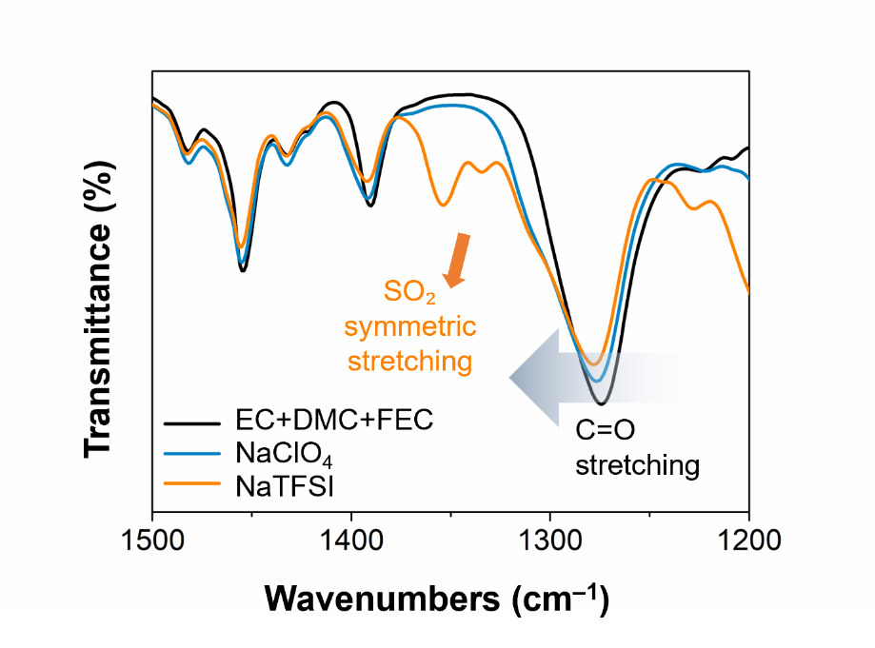
Figure S2. FTIR spectra of blank solvent (EC+DMC+FEC), NaClO₄- and NaTFSI-based electrolyte.

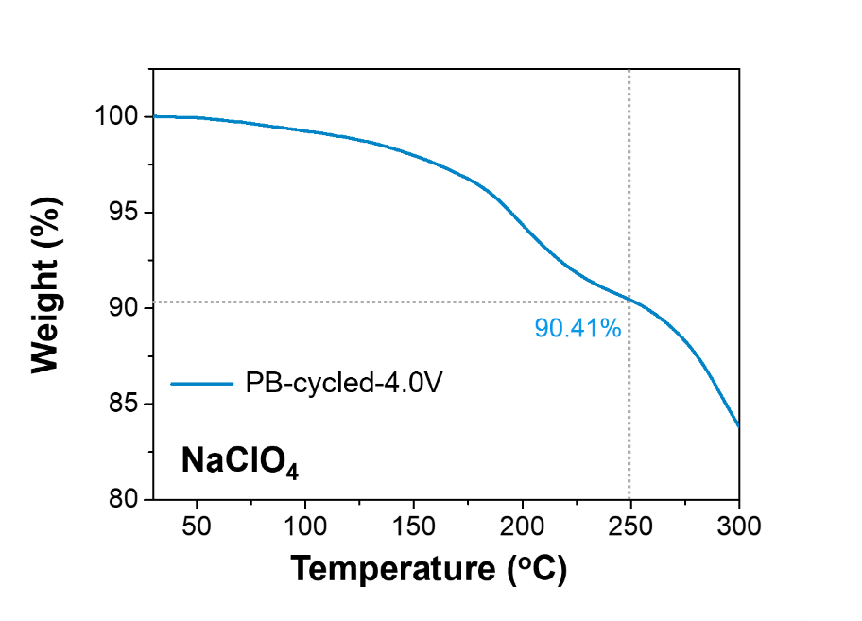
Figure S3. TGA curve of PB electrode charged to 4.0 V in NaClO₄ system.

Figure S4. ¹H-NMR spectra of DMC solution that immersed separator in the PB cell after 1st and 50th charge cycle.

Note: Consistent with the FTIR results, the water that released from the PB electrodes could lead to the formation of a robust hydration shell around Na⁺ in the NaClO₄ system due to its high hydration energy, thereby suppressing the interaction between Na⁺ and DMC. By contrast, in the NaTFSI system, the lower hydration energy of TFSI⁻ anion could prevent water from fully coordinating with Na⁺, which allows DMC to interact more directly with Na⁺, resulting in a reduced electron density of DMC. As a result, the ¹H-NMR peak of DMC in the NaTFSI system shifts further downfield (i.e., to higher ppm) relative to that in the NaClO₄ system.

Figure S5. SEM images of PB electrode with (a) NaClO₄ and (b) NaTFSI electrolytes after 50 cycles.
Figure S6. SEM images of Na electrodes from full cells with (a) NaClO₄ and (b) NaTFSI electrolytes after 50 cycles.

Anion effects on sodium metal anode

To evaluate how electrolyte salts influence Na metal deposition behavior, chronoamperometry tests were conducted, providing insights into the electrochemical deposition behavior at the electrode–electrolyte interface (Figure S7). The Cottrell equation indicates that fluctuations in current density correlate with changes in the effective surface area of the electrode, suggesting the possibility of dendrite formation. For the NaClO₄ electrolyte, the current density increased sharply and then decreased within the first 100 seconds, with a short circuit occurring at 600 seconds. Conversely, in the NaTFSI system, the current density was maintained consistently over an extended period. Overall, these results demonstrate that the NaTFSI electrolyte promotes more stable and continuous Na deposition, whereas the NaClO₄ electrolyte is more susceptible to dendrite formation and short-circuiting.
The initial deposition behavior plays a critical role in determining the electrode's microstructure and interfacial properties, which can significantly impact subsequent cycling performance. For this, the initial Na deposition behavior was monitored using SEM images of Cu electrodes in Na||Cu asymmetric cells at a current density of 1 mA cm⁻² for 5 minutes. In the NaClO₄ electrolyte, SEM images revealed that Na deposition occurred unevenly, forming island-like agglomerates (Figures S8a, S9a−c). In contrast, the NaTFSI electrolyte facilitated uniform Na deposition across the entire Cu electrode surface (Figures S8b, S9d, e). As corroborated by EDS mapping, the Cu electrode in the NaClO₄ system exhibited non-uniform deposition with portions of the Cu substrate remaining exposed (Figure S9b). That is, the NaTFSI electrolyte promotes a uniform Na⁺ flux and enhances the interfacial compatibility between the electrode and electrolyte.
Building on these initial deposition observations, the impact of salt anions on long-term cycle stability was investigated using Na symmetric cell tests. Considering that the current density is 1 mA cm⁻² when the PB loading level is 6 mg cm⁻², the electrochemical tests were performed under the conditions of 1 mA cm⁻² of current density and 1 mA h cm⁻² of areal capacity in a Na symmetric cell. The cell employing the NaTFSI electrolyte demonstrated stable operation for more than 250 hours, while the cell with the NaClO₄ electrolyte experienced a short circuit at the 53rd cycle (Figure S10). Furthermore, rate tests at a fixed areal capacity of 1 mA h cm⁻² across various current densities revealed that the NaClO₄ system exhibited a marked voltage rise at 10 mA cm⁻², whereas the NaTFSI system maintained a consistent voltage profile (Figure S11). In addition, during a subsequent cycle set, the NaClO₄ cell short-circuited at 2 mA cm⁻², in contrast to the NaTFSI cell, which remained stable even at 5 mA cm⁻². These results confirm that the NaTFSI electrolyte improves the stability of Na metal deposition and stripping, thereby enhancing long-term cycling performance.
To further support the electrochemical performance results, the Na deposition morphology was examined following extended cycles. Na symmetric cells were disassembled after 5 and 50 cycles at 1 mA cm⁻² and 1 mA h cm⁻² for SEM analysis. As observed in the Na||Cu tests, the electrode with the NaClO₄ electrolyte exhibited unreacted regions with Na aggregates on the surface (Figure S12a, S13a), while those with the NaTFSI electrolyte exhibited a uniform Na deposition over a broad area (Figure S12b, S13b).
The interfacial stability and reversibility of Na electrode is critically influenced by the composition of the SEI composition, which is governed by the electrolyte salt. ^{1, 2} In Na symmetric cells cycled at 1 mA cm⁻² and 1 mA h cm⁻² for 5 cycles, the XPS spectrum on the Na electrode showed an N 1s peak between 399 and 401 eV, confirming the presence of nitrogen from the TFSI– anion within the SEI layer (Figure S14). Under reductive conditions, the NaTFSI undergoes decomposition via cleavage of the N–S bond, forming NSO₂CF₃⁻ and SO₂CF₃⁻, subsequent cleavage of the C–S bond in SO₂CF₃⁻ produces SO₂⁻ and CF₃⁻. Further decomposition of the CF₃⁻ moiety through C–F bond cleavage results in the formation of C–F and F⁻, yielding NaF. ³⁻⁵ These TFSI⁻ decomposition products—comprising C–F, NaF, and S-based organic–inorganic hybrid species—contribute to the formation of a robust and stable SEI, as evidenced by the characteristic S–F and Na–F peaks in the F 1s spectrum (Figure S15). In contrast, ClO₄⁻-based electrolytes predominantly form an SEI composed of oxygenated species (e.g., O₂, Li₂O), which may exhibit inferior chemical and mechanical stability.

Figure S7. Chronoamperometry test results for Na symmetric cells using NaClO₄ and NaTFSI electrolytes.
Figure S8. SEM images of the Cu electrode following a 5-minute deposition at 1 mA cm⁻² with (a) NaClO₄ and (b) NaTFSI electrolytes.
Figure S9. SEM images and EDS elemental maps (Cu and Na) of the Cu electrodes with (a−c) NaClO₄ and (d−e) NaTFSI electrolytes after initial deposition process at 1 mA cm⁻² for 5 minutes.

Figure S10. Voltage profiles of Na symmetric cells at 1 mA cm⁻² and 1 mA h cm⁻².
Figure S11. Voltage profiles of Na symmetric cells with NaClO₄ and NaTFSI electrolytes with capacity of 1 mA h cm⁻² with different current densities.

Figure S12. SEM images of Na electrodes from Na symmetric cells after 5 cycles using (a) NaClO₄ and (b) NaTFSI electrolytes.
Figure S13. SEM images of the Na electrodes from Na symmetric cells at 1 mA cm⁻² and 1 mA h cm⁻² after 50 cycles with (e) NaClO₄ and (f) NaTFSI electrolytes.

Figure S14. X-ray Photoelectron Spectroscopy (XPS) analysis of N 1s spectrum of the Na electrode, confirming the incorporation of nitrogen species from the TFSI⁻ anion into the SEI.

Figure S15. F 1s XPS spectra of Na electrodes after 50 cycles.

REFERENCES
(1) Ma, M.; Chen, B.; Yang, X.; Liu, Y.; Dai, S.; Qi, X.; Hu, Y.-S.; Pan, H. Solvent Reorganization and Additives Synergistically Enable High-Performance Na-Ion Batteries. ACS Energy Lett. 2023, 8 (1), 477-485. DOI: 10.1021/acsenergylett.2c02353.
(2) Eshetu, G. G.; Elia, G. A.; Armand, M.; Forsyth, M.; Komaba, S.; Rojo, T.; Passerini, S. Electrolytes and Interphases in Sodium-Based Rechargeable Batteries: Recent Advances and Perspectives. Adv. Energy Mater. 2020, 10 (20), 2000093. DOI: 10.1002/aenm.202000093.
(3) Lee, Y.; Lee, J.; Lee, J.; Kim, K.; Cha, A.; Kang, S.; Wi, T.; Kang, S. J.; Lee, H.-W.; Choi, N.-S. Fluoroethylene Carbonate-Based Electrolyte with 1 M Sodium Bis(fluorosulfonyl)imide Enables High-Performance Sodium Metal Electrodes. ACS Appl. Mater. Interfaces. 2018, 10 (17), 15270-15280. DOI: 10.1021/acsami.8b02446.
(4) Eshetu, G. G.; Diemant, T.; Hekmatfar, M.; Grugeon, S.; Behm, R. J.; Laruelle, S.; Armand, M.; Passerini, S. Impact of the Electrolyte Salt Anion on the Solid Electrolyte Interphase Formation in Sodium Ion Batteries. Nano Energy 2019, 55, 327-340. DOI: 10.1016/j.nanoen.2018.10.040.
(5) Fondard, J.; Irisarri, E.; Courreges, C.; Palacín, M. R.; Ponrouch, A.; Dedryvère, R. SEI Composition on Hard Carbon in Na-Ion Batteries After Long Cycling: Influence of Salts (NaPF₆, NaTFSI) and Additives (FEC, DMCF). J. Electrochem. Soc. 2020, 167 (7), 070526. DOI: 10.1149/1945-7111/ab75fd.

