Correlation of Pedotransfer Function Residuals with Input Variables and the Effect of Database Similarity on Predictive Performance
Wenhao Shi^{1,2}, Yonggen Zhang^{1,2*}, Lutz Weihermüller², Attila Nemes^{3,4}, Marcel G. Schaap⁵, and Harry Vereecken²
¹ Institute of Surface-Earth System Science, School of Earth System Science, Tianjin University, Tianjin, China
² Agrosphere Institute IBG-3, Forschungszentrum Jülich GmbH, Jülich, Germany
³ Division of Environment and Natural Resources, Norwegian Institute of Bioeconomy Research, Ås, Norway
⁴ Faculty of Environmental Sciences and Natural Resource Management, Norwegian University of Life Sciences, Ås, Norway
⁵ Department of Environmental Science, University of Arizona, Tucson, Arizona, USA
*Correspondence to: Yonggen Zhang (ygzhang@tju.edu.cn)

Key findings:
  - Evaluated PTF performance using 51,900 soils and a representative PTF model
  - Adding new inputs to PTFs reduces residual correlations and improves performance
  - Higher residual-input correlations are associated with inferior PTF performance
  - Stronger similarity between developed and applied datasets enhances PTF performance
  - More PTF inputs reduce sensitivity to dataset similarity and improve robustness

Abstract
Pedotransfer functions (PTFs) are widely used as an efficient alternative for estimating soil hydraulic properties. However, insufficient understanding of how specific input data characteristics drive PTF prediction performance, coupled with challenges in assessing PTF transferability beyond their development datasets, limit their robustness and broad application. Here, we employed the hierarchical Rosetta3 as the development dataset and evaluated its PTF performance using two independent application datasets (National Cooperative Soil Survey (NCSS) and HYBRAS-V2), comprising over 51,900 samples. To further investigate the effect of the input similarity on PTF performance, the Chamfer Distance (CD) was used to quantify the similarity between the development and application datasets. The extensive NCSS database allowed us to stratify the application dataset by soil temperature regimes, texture classes, and depths for a detailed performance evaluation. Results showed that incorporating additional inputs (e.g., bulk density, field capacity, and wilting point) moderately reduces the correlations between these newly added inputs and the estimation residuals, and that higher residual-input correlations are associated with inferior PTF performance. Furthermore, a lower CD (better resemblance of development and application dataset) leads to better PTF performance. However, increasing input complexity using the hierarchical Rosetta3 models mitigates this effect of resemblance, enhancing robustness across diverse soil and environmental conditions. These findings highlight the importance of analyzing residual-input correlations and suggest that quantifying input-data similarity between PTF development and application datasets can serve as a practical approach to assess the transferability of PTFs.
Keywords: hydraulic properties, water retention, pedotransfer function, dataset similarity, predictive performance

1 Introduction
Soil water content is a critical driver of the hydrological cycle, agricultural productivity, and ecosystem functioning, as it governs the exchange of mass, energy, and terrestrial biogeochemical processes between the land surface and the atmospheric boundary layer (Vereecken et al., 2016; Fatichi et al., 2020; Dong et al., 2022). Accurate simulation of these interconnected processes is essential for reliable quantification of surface runoff, soil-vegetation-atmosphere transfer fluxes, groundwater recharge, terrestrial carbon sequestration, and surface energy balances (Arora, 2002; Mathias et al., 2017; Bigeard et al., 2019). Soil hydraulic properties (SHPs) are crucial for predicting the soil water movement and soil water availability. These properties, encompassing soil water retention and hydraulic conductivity, are often described by widely used soil water retention models such as the Brooks-Corey (Brooks and Corey, 1964), van Genuchten (van Genuchten, 1980), Kosugi (Kosugi, 1996, 1994), and hydraulic conductivity functions such as Mualem (1976). These models provide mathematical frameworks to describe how soil holds water and how water moves through it under different soil water contents. Unfortunately, these properties exhibit strong spatial variability, influenced by intrinsic soil characteristics such as soil texture, organic carbon content, bulk density, but also by environmental factors as well as human-induced soil management (e.g., tillage, irrigation, and land use change) that impact soil formation (Liu et al., 2023; Labaz et al., 2024; Blanka-Végi et al., 2025). The direct measurement of SHPs, however, is usually time-consuming, labor-intensive, and challenged by spatial heterogeneity and limited measurement infrastructure availability (Cornelis et al., 2001). To overcome these challenges, pedotransfer functions (PTFs) have been developed and proven to be an efficient approach for indirectly estimating SHPs (Bouma, 1989; Van Looy et al., 2017; Weber et al., 2024).
As predictive models, PTFs estimate soil hydraulic properties using empirical relationships derived from readily available or easily measured soil properties, such as soil texture, bulk density, organic carbon content, and other relevant information (Wang et al., 2012; Tóth et al., 2015; Zhang and Schaap, 2017). The efficiency and practicality of PTFs enable their use as cost-effective tools in hydrological applications, serving as essential components in large scale hydrological, land surface, and global climate models (Dai et al., 2013; Levi et al., 2015).
Driven by the growing demands for enhanced model performance and robustness, the development of PTFs has primarily progressed along two lines, i.e., the expansion of predictors and the advancement of modeling approaches (Vereecken et al., 2010). In the past decades, PTFs have expanded from relying on basic soil properties as predictors (Cosby et al., 1984; Carsel and Parrish, 1988) to incorporate additional chemical and morphological properties, soil structural characteristics such as mean weight diameter, and water retention properties such as water content measured at field capacity or wilting point (Schaap et al., 2001; Zhang and Schaap, 2017; Gupta et al., 2021; Basset et al., 2023). However, the selection of predictors varies across different PTFs and the relationship between specific predictors and the predictive performance of PTFs remains insufficiently explored, which constrains a systematic understanding of which predictors most effectively enhance the model performance, and therefore, reducing corresponding uncertainties in the prediction.
Fuentes-Guevara et al. (2022) highlighted, that PTF performance is controlled by the correlation structure of input and output variables. This conclusion is based on the analysis of correlation patterns between the inputs used for PTF development and application, as evidenced by their evaluation of PTFs from temperate, subtropical, and tropical climates applied to 100 soil samples collected in a subtropical climate in southern Brazil. Their findings suggested that correlation structures between datasets, rather than geographical or pedoclimatic similarity, are critical for accurate SHP estimation by PTFs, offering insights for applying PTFs to diverse soil textures and depths.
In terms of modeling approaches, the PTFs have evolved from simple look-up tables and linear regression (Rawls et al., 2003; Gunarathna et al., 2019; Ramos et al., 2023) to advanced machine learning algorithms, including neural network, support vector machine, and random forest approaches (Lamorski et al., 2008; Twarakavi et al., 2009; Sedaghat et al., 2022). Such methodological and technological advancements have improved the predictive performance of PTFs, enhancing their robustness and applicability in diverse environmental conditions. Nevertheless, these improvements are not solely driven by advanced techniques used in the PTF development but also still largely depend on the selection of appropriate predictors, as the quality and relevance of input variables strongly influence PTF prediction accuracy (Li et al., 2024).
Despite substantial improvements in the predictive performance of PTFs through continued development and updates, many studies highlighted that the applicability of PTFs remains constrained by the distribution of data used in PTF development (Bayabil et al., 2019; Kotlar et al., 2019). This limitation results from the inherent spatial variability of soil properties, which restricts our ability to generalize PTFs across diverse regions and soil types. In order to improve the performance of estimating SHPs, numerous studies have been devoted to developing new PTFs adapted to specific regions and soil types (Wösten et al., 1999; Lamorski et al., 2008; Wang et al., 2012; Gunarathna et al., 2019). While the number of published PTFs keeps increasing, the selection of the most suitable PTF(s) and corresponding predictors to estimate SHPs still presents a challenge for users, especially in cases where region-specific PTFs are lacking (Loosvelt et al., 2011).
To address this challenge, users typically adopt two main approaches for selecting PTFs: (1) select those with higher predictive performance, or (2) compare general characteristics such as geomorphic location, soil description (e.g., land use, soil type), and summary statistics in the development dataset with those of the application dataset to identify the most appropriate PTFs (Miti et al., 2023). Nevertheless, both approaches have notable limitations. Predictive performance of PTFs is typically evaluated during PTF development and may not generalize well to the applied regions, especially if no reference data are available in those regions. Similarly, comparing general characteristics relies heavily on subjective judgment and lacks quantitative criteria to assess dataset similarity. Therefore, to assess the transferability of PTFs across different regions, alternative strategies are needed to determine whether a published PTF can be applied outside its development domains.
One such strategy involves using distance metrics to quantify the similarity between the development dataset (analogous to the calibration dataset) and the application datasets, as proposed by Nemes et al. (2006), who applied the metrics within a k-nearest neighbor (k-NN) method to identify soils most similar to the application datasets. Apparently, the effectiveness of such method strongly depends on the ability of selection of the ‘most similar’ (nearest) soils. Tranter et al. (2009) proposed a protocol for delineating the applicability domain of PTFs by computing the similarity between the applied soils and the calibration dataset using standard distance metrics, particularly standardized Euclidean and Mahalanobis distances. Unlike k-NN, which searches for local analogues, this method defines a global threshold to identify whether a new sample falls within the domain of validity of a PTF. However, while this protocol provides a cutoff value (e.g., the 97.5% percentile of the cumulative χ² distribution) to identify samples falling outside the applicability domain of a PTF, it does not indicate how prediction performance varies with increasing dissimilarity from the calibration dataset. A more rigorous approach might be to use distance metrics to provide approximate indications of PTF performance, thereby allowing users to make decisions regarding which PTFs to adopt.
Despite the fact that numerous studies have explored the performance of PTFs for estimating soil hydraulic properties, most of these efforts typically rely on datasets confined to specific regions (Wang et al., 2012; Gunarathna et al., 2019; Miti et al., 2023). Large-scale datasets encompassing diverse climate regions, soil textures, and soil depths have unfortunately rarely been employed to assess PTF generalizability. Moreover, existing work rarely examines how dataset similarity influences PTF performance across heterogeneous soil datasets. In response to these gaps, we present a comprehensive evaluation of PTF performance, using the National Cooperative Soil Survey (NCSS) dataset (National Cooperative Soil Survey, 2017) comprising over 48,600 samples and also the Hydrophysical database for Brazilian soil (HYBRAS) Version 2 dataset with over 3,200 samples, amounting to more than 51,900 samples overall. These datasets enable us to investigate the impact of correlation structures and dataset similarity on the predictive performance for soils of different pedoclimate regions, textural classes, and depths, enhancing the knowledge of the applicability of PTFs in diverse soil environments.
In this study, we aim to: (a) evaluate how the predictive performance of PTFs is affected by the correlations between PTF residuals and input variables, based on two large and independent soil datasets (NCSS and HYBRAS-V2); (b) assess the impact of dataset similarity, measured by Chamfer Distance (CD), on the predictive performance of PTFs based on the PTF development dataset (e.g., Rosetta3) and these two applied large and independent soil datasets; and (c) evaluate how the inclusion of additional input variables in hierarchical Rosetta3 PTF models modulates the effect of dataset similarity on predictive performance across diverse soil textural and environmental (e.g., temperature and depth) conditions.

2 Materials and Methods

2.1 Soil water retention function and PTFs

2.1.1 van Genuchten model (VG model)
The soil water retention curve (SWRC) was described using the van Genuchten (van Genuchten, 1980) model:
(1)
where θ is volumetric soil water content (cm³ cm⁻³) at pressure head h (cm), θ_{r} and θ_{s} are the residual and saturated water contents (cm³ cm⁻³), respectively, α (cm⁻¹) and n (dimensionless) are shape parameters, whereby m is related to n by m = 1-1/n.

2.1.2 Dataset for PTF Development: Rosetta3 dataset
Rosetta3 (Zhang and Schaap, 2017), a well-trained artificial neural network-based set of PTFs, uses a hierarchical approach that allows users to estimate soil hydraulic parameters of the VG model. Built on the same dataset as Rosetta (Schaap et al., 2001), the development database of Rosetta3 contains 2,134 soil samples for water retention with a total of 20,574 retention points from three widely used databases of Rawls et al. (1982), Ahuja et al. (1989), and UNSODA (Leij et al., 1996; Nemes et al., 2001).
Table 1. Five hierarchical PTF models of the Rosetta3. Soil texture classification is based on the United States Department of Agriculture (USDA) system. Field capacity and wilting point are defined in terms of volumetric water content.
Model | Input variables
H1w | Soil texture class
H2w | Percentages of sand, silt and clay
H3w | Percentages of sand, silt and clay, bulk density
H4w | Percentages of sand, silt and clay, bulk density, field capacity
H5w | Percentages of sand, silt and clay, bulk density, field capacity, wilting point
These hierarchical set of Rosetta3 PTFs employ bootstrap resampling and recalibration with weighted statistics to improve the predictive accuracy of soil hydraulic parameters, and have been demonstrated to reliably estimate the VG parameters and their associated uncertainties (Hu et al., 2022; Li et al., 2023; Shao et al., 2023). To provide broad applicability across diverse input dataset, Rosetta3 includes five hierarchical models (H1w to H5w) with flexibility towards available input data. The first model (H1w) is a class PTF, consisting of a look-up table that provides parameter averages for each of the 12 USDA soil textural classes. All other models (H2w to H5w) are based on textural information (sand, silt, clay percentage) as inputs, whereby higher hierarchical numbers also need additional inputs such as bulk density, water content at field capacity or wilting point. An overview of inputs is listed in Table 1. We note that Rosetta3 does not utilize soil organic carbon (OC) as an input despite its significance in many other PTFs. This exclusion is largely attributed to the correlation between OC and bulk density, which allows bulk density to serve as a proxy in the Rosetta3 framework (Zhang and Schaap, 2019). Consequently, OC was not included as a separate input in our analysis. In this study, Rosetta3 was applied through the “ROSETTA()” function in the “soilDB” package (version 2.7.7) within R (version 4.1.0).

2.2 Datasets for PTF Evaluation
In this study, the NCSS database (National Cooperative Soil Survey, 2017) and the unpublished HYBRAS-V2 database were used as independent application datasets for performance evaluation and similarity analysis between the development and application datasets.
The NCSS soil characterization database, maintained by the USDA-NRCS, is a source of soil data that has been widely used to independently evaluate PTFs (Ramcharan et al., 2017; Dai et al., 2019; Zhang et al., 2020). After data quality analysis by Zhang et al. (2020), 49,855 soil samples with a total of 118,599 water retention points were used, with water contents measured at h of -60, -100, -330, -1,000, -2,000, or -15,000 cm. Here, it has to be mentioned, that the NCSS database contains a dominant proportion of water content measurements at h = -330 cm (41.6%) and h = -15,000 cm (41.4%), approximating field capacity (hereafter denoted as FC) and permanent wilting point (hereafter denoted as WP), respectively. Only a small fraction of water content measurements took place at the other pressure heads (0.9%, 5.3%, 0.3%, and 10.4% at h = -60, -100, -1,000, and -2,000 cm, respectively). However, the large number of measurements at FC and WP makes it suitable to be used as input for the H4w and H5w PTFs in Rosetta3. The NCSS database covers mainly the continental United States (87.7% of data) but also other regions of the globe (12.3% of data).
The HYBRAS-V2 database is an updated version of the published HYBRAS database (Ottoni et al., 2018, 2019) and compiles information on the physical and hydraulic properties of numerous tropical or subtropical Brazilian soils, sourced from over 60 scientific studies. The database contains 8,546 samples with a total of 38,943 water retention points. The wide diversity of pedogenesis and soil formation factors in Brazil and the coverage of those in the database provide possibilities to analyze the results across different regions (Totola et al., 2023).
To meet the input requirements of Rosetta3, the selected soil samples had to satisfy specific criteria. These include the availability of soil texture information (mass percentages of sand, silt, and clay), bulk density (BD), and water content at FC and WP, all of which serve as input for the PTFs. In addition, soil water content measured across a wide range of pressure heads (0 to -15000 cm) was required for PTF evaluation. Following these criteria, 48,629 and 3,294 soil samples were selected from the NCSS and HYBRAS-V2 databases, respectively, yielding a total of 51,923 samples.

2.3 Sub-grouping of the NCSS Database
Given the large size of the NCSS database (48,629 soil samples) and considering the impact of dataset similarity on PTF performance across diverse soil and environmental conditions, the NCSS dataset was subdivided into smaller data pools to allow for detailed evaluation of the similarity between the Rosetta development dataset and application datasets for different temperature regimes, soil textural classes, and soil depths. Therefore, the following criteria were used as grouping factors: i) USDA-defined soil temperature regimes (USDA-NRCS, 1993) based on mean annual soil temperatures, ii) USDA soil texture classes, and iii) depth intervals in 10 cm increments. Only subsets with a sufficient number of soil samples were retained to allow a statistically meaningful analysis, with the number of soil samples in each subset detailed in Figure 1.
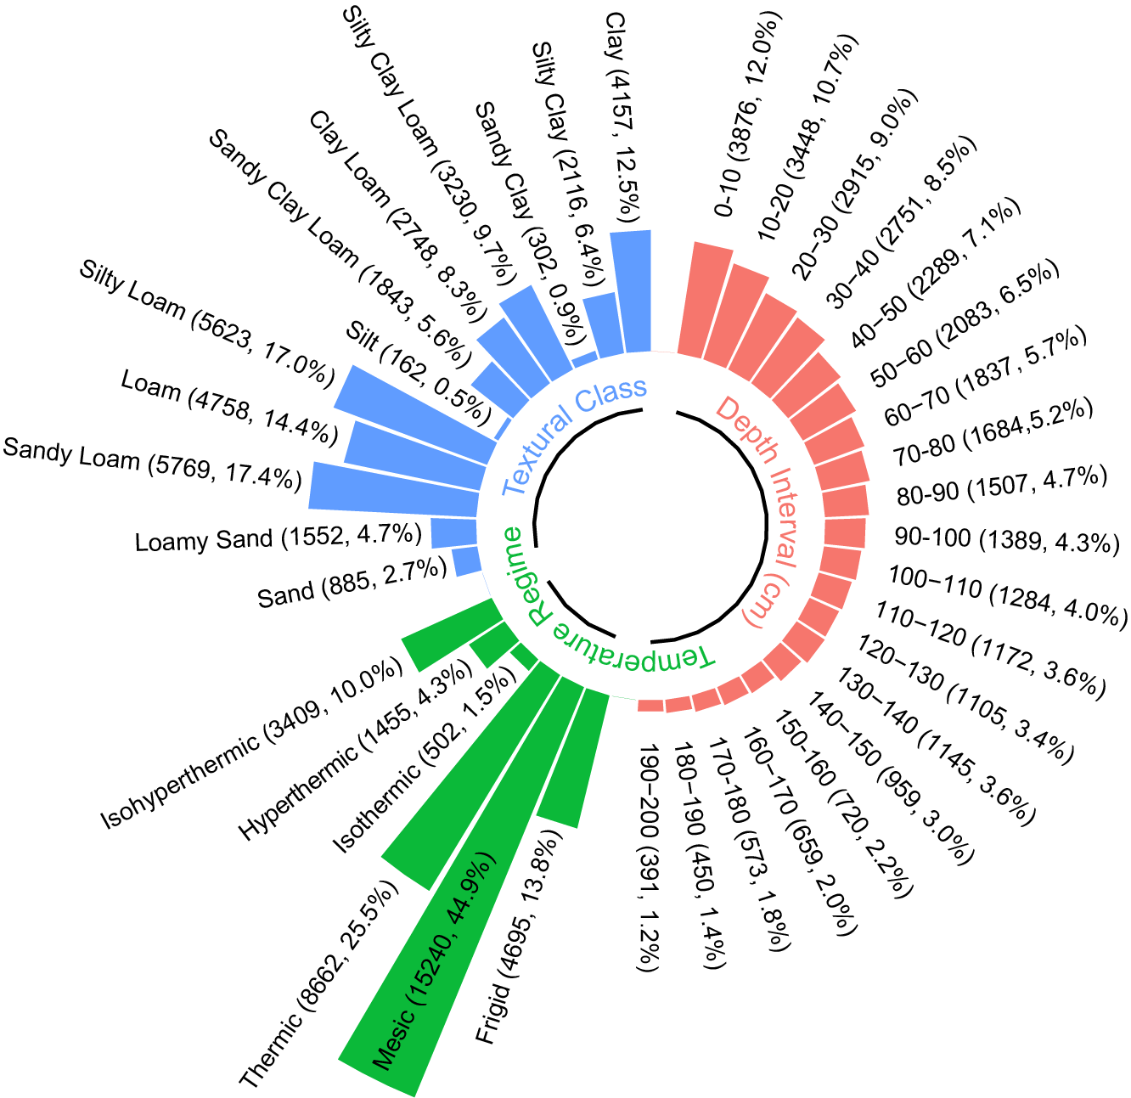
Figure 1. Numbers and percentages of soil samples in NCSS subsets classified by temperature regime (green), USDA textural class (blue), and depth interval (red). Some subsets of temperature regimes were excluded due to insufficient sample sizes for statistically meaningful analysis.
Among these grouping criteria, soil depth is particularly important for characterizing the vertical heterogeneity of the dataset. To visualize this, Figure 2 illustrates the distribution of soil texture and bulk density at 10 cm intervals. The results show a typical pattern where, on average, clay content increases and sand/silt decrease in the upper 50 cm, but stabilizes at greater depths (Figures 2a-c), while bulk density exhibits a progressive upward trend throughout the profile (Figure 2d). These depth-dependent distributions reflect characteristic soil pedogenic processes, such as clay translocation from surface horizons and increased compaction associated with reduced biological activity in deeper layers (Phillips, 2007; Lu et al., 2019).
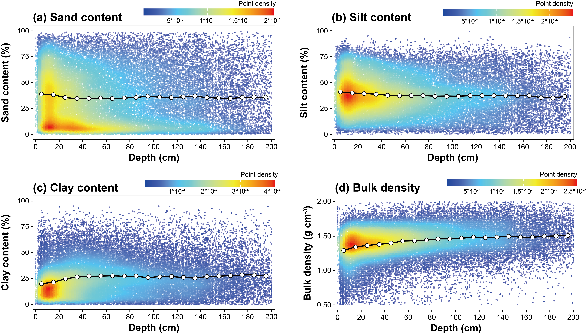
Figure 2. Scatter plots of all data used in the NCSS dataset; red represents high data density, blue low density. The white circles connected by the black line represent the mean values of each basic soil property calculated at 10 cm depth intervals. (a) Sand content, (b) Silt content, (c) Clay content, and (d) Bulk density.

2.4 Statistical Evaluation
A correlation analysis was performed between the input variables and the residuals, which were defined as the differences between the estimated water contents obtained from the Rosetta3 PTF at given pressure heads and the corresponding measured values in the application datasets (i.e., NCSS and HYBRAS-V2). The residuals were calculated as:
(2)
where $θ_{i}(h_{i})$ is the measured soil water contents, and $θ_{i}^{'}(h_{i})$ is the estimated soil water contents at given pressure head h.
The performance metrics of each model in the Rosetta3 PTF (H1w to H5w) were quantified using the adjusted coefficient of determination (R²_{adj}) and the root mean square error (RMSE). R²_{adj} is defined as:
with (3)
where N is the number of measured ($θ_{i}(h_{i})$) and estimated ($θ_{i}^{'}(h_{i})$) soil water contents at given pressure head h, k is the number of predictors for each model in Rosetta3 PTF, and is the average of .
RMSE is defined as:
(4)
Mean error (ME) is used to quantify the systematic errors between the measurements and estimations as:
(5)

2.5 Chamfer Distance for Dataset Similarity Assessment
In order to quantify the similarity between the development (Rosetta3) and application (subsets of NCSS) datasets in multidimensional variable spaces, the Chamfer Distance (CD) (Fan et al., 2017) was calculated, which is a symmetric nearest neighbor method used to measure the difference between data points from the development and application datasets.
The CD has been widely applied because of its efficient computation and flexible applicability for point sets with different point numbers (Wu et al., 2021; Huang et al., 2024). Compared to other nearest neighbor methods, CD approximates the Euclidean distances using integer-weighted assignments, offering both computational efficiency and sensitivity to structural differences between datasets. These properties make it suitable for evaluating the similarity between large datasets. Additionally, CD is a powerful tool for comparing distributions of multi-dimensional data without requiring pointwise correspondence. Moreover, CD can be effectively applied to either the original high-dimensional soil property space or data transformed by dimensionality reduction techniques (e.g., principal component analysis or t-SNE), allowing flexible analysis while maintaining a clear interpretation of similarity as a geometric distance (Dommaraju et al., 2023). The CD is defined as:
(6)
where A and B denote the development and application dataset, respectively, a and b represent individual data points respectively in the A and B datasets, and “|| ||” describes the Euclidean distance (a squared distance) between two data points. It should be noted that the CD assumes equal weighting for all input variables, which may not fully capture their relative importance. However, quantifying precise variable weights is challenging. Therefore, in this study we implemented equal weighting to ensure a balanced contribution from all variables, which is a justifiable compromise that helps maintain consistency in the analysis. A detailed description of the CD calculation procedure is illustrated in Text S1 in the Supporting Information.
As our dataset consists of different soil properties (sand, silt, and clay content, bulk density, and water content at FC and WP), the procedure described has to be performed in multiple dimensions (for each property individually). As the properties in the multidimensional soil property space have different units, the data were standardized by Eq. (7) to remove differences in units.
(7)
where x denotes the original value, μ represents the mean of the variable, σ is the standard deviation, and x_{scaled} is the standardized value with zero mean and unit variance. While standardization removes the effects of differing units and scales, the subsequent use of Euclidean distance in CD implicitly treats variables as independent and equally weighted, which may not fully reflect their unequal importance or correlations. To assess the potential impact of these assumptions, we additionally applied the Mahalanobis distance, which accounts for variable correlations among inputs. Details and results are provided in the Supporting Information (Text S2 and Figure S1).

3 Results and Discussion

3.1 General Dataset Statistics and Properties
The distribution of the selected soil samples from the Rosetta3, NCSS, and HYBRAS-V2 datasets in the USDA soil textural triangle is shown in Figure 3. As can be seen, in the Rosetta3 and HYBRAS-V2 datasets (Figures 3a and 3c), the distribution of soil samples in the different textural classes does not span over all texture classes. In the Rosetta3 dataset, sandy loam (22.5%), silty loam (15.5%), and sand (14.3%) are the main soil textural classes, accounting for more than 50% of the samples. In contrast, clay is the predominant soil textural class (56.3%) in the HYBRAS-V2 dataset, followed by sandy clay loam (12.3%), loam (6.5%), and sandy clay (6.4%). In comparison, the distribution of the NCSS samples covers all textural classes, with a predominance of data in the sandy loam (18.1%), silty loam (17.4%), and loam (14.7%) classes.
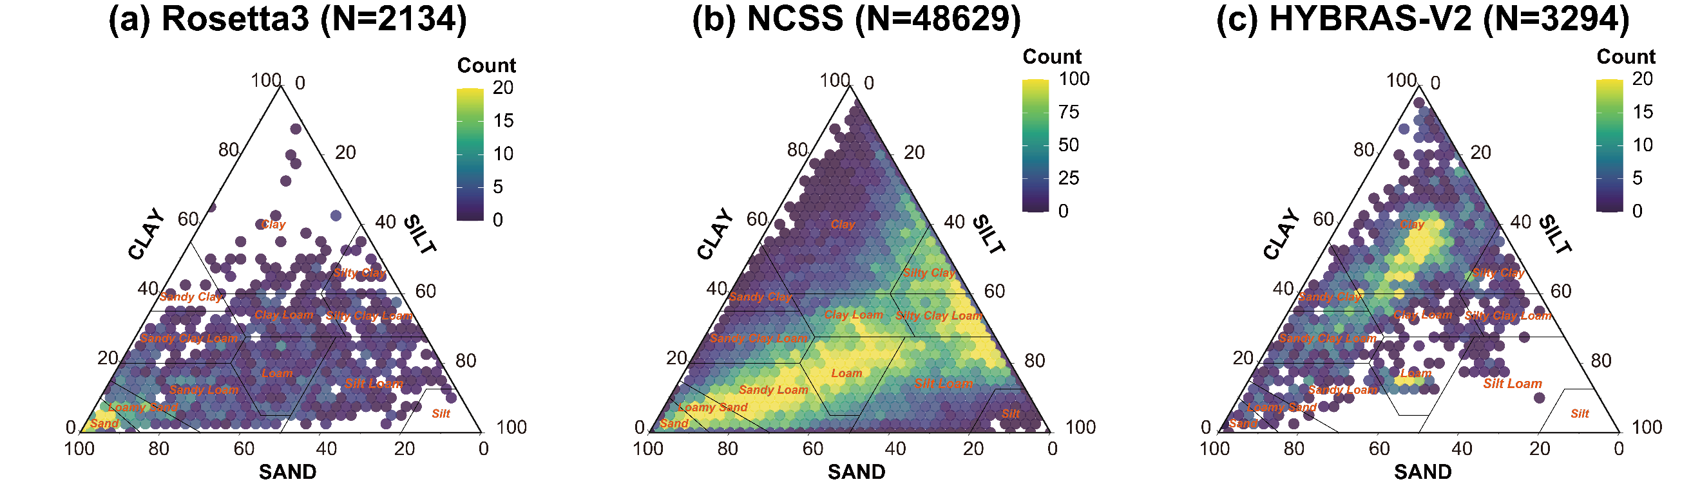
Figure 3. Textural distribution of soil samples in three datasets (Rosetta3, NCSS, and HYBRAS-V2) in the USDA soil textural triangle. Legend indicates the number of soil samples.
The distribution of the basic soil properties (texture, bulk density, water content at FC and WP) across the development dataset (Rosetta3) and the two application datasets (NCSS, and HYBRAS-V2) are shown in Figure 4. In general, samples in the Rosetta3 dataset have higher sand and lower clay content than the samples in the other two datasets. In Rosetta3, sand content accounts for more than 40% for most samples. In contrast, clay content shows a substantial difference between Rosetta3 and HYBRAS-V2 with much higher clay contents for the Brazilian soils, whereas the difference between Rosetta3 and NCSS is relatively small with slightly larger clay contents in the NCSS dataset, shown in Figure 4. In contrast, the three datasets show relatively minor differences in silt content and exhibit a similar distribution of bulk densities. For both water content at FC and WP, Rosetta3 showed somewhat lower values compared to the NCSS and HYBRAS-V2 datasets. In the Supporting Information, Table S1 provides descriptive statistics (mean and standard deviation) and Welch’s t-test results (t statistic, degrees of freedom, and p-value) for the comparison of the application datasets (NCSS and HYBRAS-V2) with the development dataset (Rosetta3 dataset).
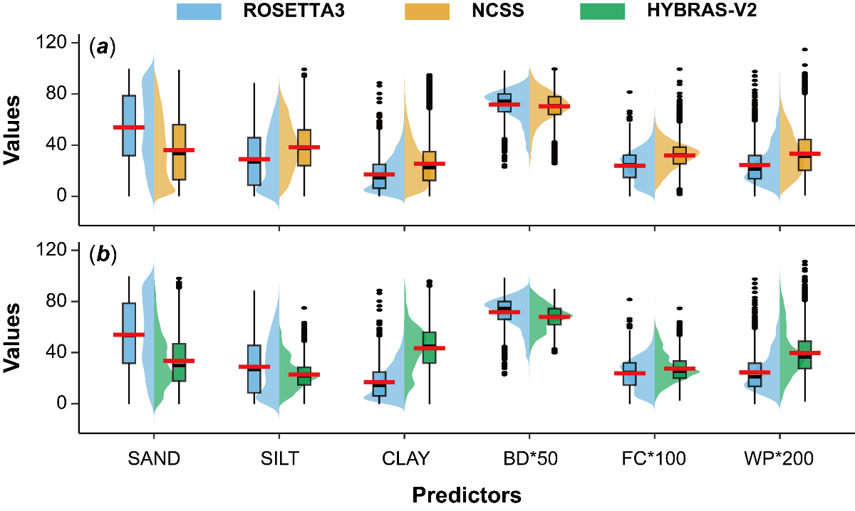
Figure 4. Distributions of soil properties (sand, silt, clay, bulk density, water content at field capacity (FC) and wilting point (WP)) for the soil samples of (a) Rosetta3 (blue) and NCSS (orange), and (b) Rosetta3 (blue) and HYBRAS-V2 (green) datasets. The box plots display the descriptive statistics (quartiles and outliers), with the black horizontal line indicating the median, while the adjacent colored violin plots represent the kernel density to visualize the shape of the data distribution. The red lines indicate the mean values of each property. For visualization purposes, bulk density (BD), water content at FC and WP were scaled by factors of 50, 100, and 200, respectively.
To analyze the variability in soil characteristics between the three datasets, the relationship among the basic soil properties (soil texture, bulk density, water content at FC and WP) was analyzed. Table 2 shows the correlation structure of the basic soil properties for the three datasets, whereby the datasets exhibited slight differences in the correlations among the soil properties. Not surprisingly, some correlation patterns are similar; for example, sand content is typically negatively related with silt and clay content, as also shown by Fuentes-Guevara et al. (2022). In addition, sand content has also a (negative) relationship with water content at both FC and WP, while those are positively correlated with silt and clay contents. This is because larger sand particles form wider pores that drain water more readily under weaker capillary forces, leading to lower water retention; conversely, finer silt and clay particles create narrower pores with stronger capillary retention, resulting in higher water content at these points. The observed consistency indicates, that internal correlations among the datasets are similar, thereby supporting the validity of subsequent comparisons among these three datasets.
Table 2. Correlation matrix (Pearson Correlation (r)) between soil properties in the Rosetta3, NCSS, and HYBRAS-V2 datasets. BD = bulk density, FC = field capacity, and WP = wilting point.
 | SAND  (%) | SILT  (%) | CLAY  (%) | BD  (g cm⁻³) | Water content  at FC  (cm³ cm⁻³) | Water content  at WP  (cm³ cm⁻³)
Rosetta3
SAND (%) | 1 | -0.89 | -0.66 | 0.37 | -0.76 | -0.53
SILT (%) |  | 1 | 0.25 | -0.45 | 0.61 | 0.24
CLAY (%) |  |  | 1 | -0.04 | 0.61 | 0.73
BD (g cm⁻³) |  |  |  | 1 | -0.50 | -0.15
Water content at FC (cm³ cm⁻³) |  |  |  |  | 1 | 0.70
Water content at WP (cm³ cm⁻³) |  |  |  |  |  | 1
NCSS
SAND (%) | 1 | -0.76 | -0.67 | 0.28 | -0.71 | -0.66
SILT (%) |  | 1 | 0.02 | -0.19 | 0.39 | 0.12
CLAY (%) |  |  | 1 | -0.21 | 0.64 | 0.88
BD (g cm⁻³) |  |  |  | 1 | -0.51 | -0.25
Water content at FC (cm³ cm⁻³) |  |  |  |  | 1 | 0.74
Water content at WP (cm³ cm⁻³) |  |  |  |  |  | 1
HYBRAS-V2
SAND (%) | 1 | -0.55 | -0.80 | 0.49 | -0.74 | -0.76
SILT (%) |  | 1 | -0.06 | 0.00 | 0.46 | 0.46
CLAY (%) |  |  | 1 | -0.59 | 0.56 | 0.58
BD (g cm⁻³) |  |  |  | 1 | -0.50 | -0.43
Water content at FC (cm³ cm⁻³) |  |  |  |  | 1 | 0.94
Water content at WP (cm³ cm⁻³) |  |  |  |  |  | 1

3.2 Pearson’s Correlation (r) of PTF Residuals with Input Variables
To assess how the variations in basic soil properties from the NCSS and HYBRAS-V2 datasets influence Rosetta3’s predictions of water content at given pressure heads, a correlation analysis was conducted between the input variables and the estimation residuals. By examining these correlations, we can evaluate how effectively the PTF has incorporated information from each input variable into its predictions. A high correlation between residuals and an input variable indicates that the PTF has not fully captured that influence of the variable, meaning there is still useful information in the variable that could be utilized to reduce prediction errors. It is noted that correlation does not imply causation. Reduction in correlation between an input and residuals should not be regarded as mechanistic evidence that the PTF better utilizes a given predictor. Instead, such correlations are primarily diagnostic. A reduction in correlation may also simply result from the fact that adding input variables (such as FC) constrains the shape of the soil water retention curve.
To perform the analysis, the following steps were applied: First, the basic soil properties of the two different datasets (NCSS or HYBRAS-V2) were selected and fed into the five Rosetta3 PTFs (H1w to H5w). Second, the estimated soil hydraulic parameters (VG parameters) from the PTFs were used to estimate the soil water contents at the given pressure heads corresponding to the water content/pressure head pairs measured in the two datasets. Third, the residuals between the PTF-estimated soil water contents at given pressure heads and the measured water contents at the same pressure heads from the datasets were calculated. Finally, the Pearson correlation coefficient (r) between these residuals and the corresponding basic soil properties used as inputs for the PTF was calculated. The calculated correlation coefficient was then used to evaluate the extent to which these predictors (e.g., textural class in H1w, textural percentage in H2w, and additionally including BD in H3w) contribute to improving the overall PTF performance (expressed as RMSE and ME). Additionally, the potential contribution of individual predictors to the overall performance and its improvement were analyzed from the listed correlation coefficients. In general, a lower r between an input variable and the residuals indicates that the input has been effectively utilized by the PTF and contributes to improving predictive performance. Since each hierarchical PTF model has different predictors, to capture the overall correlation, we additionally included in the table the sum of the absolute correlation coefficients (sum(|r|)) between the estimation residuals and all input variables.
As shown in Table 3, the correlation analysis revealed that the inclusion of additional input variables can moderately reduce the correlation between the newly added input variables and the PTF estimated residuals. For instance, moving from H2w to H3w, the addition of bulk density as a new input variable to the PTF led to a notable decrease in the correlation between bulk density and estimation residuals in both datasets (from -0.32 to -0.24 for NCSS and from -0.17 to -0.13 for HYBRAS-V2). In addition, the inclusion of the water content at WP reduced the correlation between WP and estimation residuals from 0.08 to 0 in NCSS, and from 0.18 to 0.14 in HYBRAS-V2 when using H5w compared to the employment of H4w. Adding water content at FC as an input in H4w also resulted in a decrease in the correlation from 0.26 to 0.04 for NCSS, but with a minimal increase from 0.09 to 0.11 for HYBRAS-V2.
As the correlation coefficient does not include information regarding the accuracy of the PTF performance (how well the measured water contents were reproduced by the PTFs), the root mean squared error (RMSE) and mean error (ME) between estimated and measured water contents at given pressure heads were calculated and listed in Table 3. Given that ME reflects systematic bias and can be affected by offset between opposing bias, RMSE provides a clearer indication of the overall prediction performance. As can be seen, the RMSE generally decreases if more predictors are used in the PTFs. For example, for the NCSS dataset, the RMSE decreased from 0.070 cm³ cm⁻³ when using only texture class as input (H1w) to 0.027 cm³ cm⁻³ when using all predictors (H5w). The same holds for HYBRAS-V2, decreasing from 0.088 cm³ cm⁻³ for H1w to 0.040 cm³ cm⁻³ for H5w PTF. Compared with the PTFs from H1w to H3w, in which the predictors evolve from soil texture types to textural percentages and then to the inclusion of bulk density, adding water content at FC as an additional predictor for H4w leads to a substantial improvement in PTF performance (RMSE from 0.060 to 0.034 cm³ cm⁻³ for NCSS and from 0.080 to 0.048 cm³ cm⁻³ for HYBRAS-V2). This may be attributed to the fact that the inclusion of measured water content as an additional input provides direct and effective constraints on the shape of the SWRC, thereby resulting in estimated water contents that more closely match the measured values and enhancing model performance. However, when WP is included in H5w, the improvement in RMSE is not as dramatic, as compared to including FC in H4w relative to H3w for both the NCSS and HYBRAS-V2 datasets, with RMSE values decreasing from 0.034 to 0.027 cm³ cm⁻³ for NCSS and from 0.048 to 0.040 cm³ cm⁻³ for HYBRAS-V2. This may be due to the strong correlation between FC and WP (>0.7; see Table 2) which implies that, WP adds marginally new information beyond FC, resulting in only limited improvement in PTF performance. In addition, the higher water content values at FC compared to WP, combined with the typically denser distribution of measured soil water retention points near FC relative to WP in the water retention curve, may make FC more informative for constraining the wet range, contributing to its greater impact on RMSE reduction.
Table 3. Pearson Correlations (r) between residuals of estimated and measured soil water contents for all measured pressure heads reported in the NCSS or HYBRAS-V2 dataset and corresponding input variables for Rosetta3 H1w-H5w PTFs. BD = bulk density, FC = water content at field capacity, and WP = water content at wilting point. Texture is expressed in %, BD in g cm⁻³, and FC and WP in cm³ cm⁻³. The numbers in bold indicate the correlations for the additional input variables that differentiate each higher-order Rosetta3 PTF model from the previous PTF.
Model | Input Variables | SAND | SILT | CLAY | BD | FC | WP | sum(|r|) | ME | RMSE
NCSS dataset (N = 48629)
H1w | Soil texture class | -0.04 | -0.07 | 0.14 | -0.31 | 0.37 | 0.28 | 1.22 | -0.024 | 0.070
H2w | Sand, silt and clay | -0.01 | -0.07 | 0.10 | -0.32 | 0.36 | 0.26 | 1.13 | -0.021 | 0.065
H3w | Sand, silt and clay; BD | -0.02 | -0.03 | 0.07 | -0.24 | 0.26 | 0.21 | 0.84 | -0.019 | 0.060
H4w | Sand, silt and clay; BD; FC | 0.03 | -0.05 | 0.01 | -0.08 | 0.04 | 0.08 | 0.28 | -0.004 | 0.034
H5w | Sand, silt and clay; BD, FC, WP | 0.12 | -0.14 | -0.03 | -0.06 | -0.05 | 0.00 | 0.39 | -0.004 | 0.027
Correlation between sum(|r|) and RMSE |  |  |  |  |  | 0.96
HYBRAS-V2 dataset (N = 3294)
H1w | Soil texture class | -0.15 | 0.04 | 0.15 | -0.20 | 0.23 | 0.21 | 0.97 | -0.002 | 0.088
H2w | Sand, silt and clay | -0.11 | 0.06 | 0.09 | -0.17 | 0.16 | 0.15 | 0.73 | 0.001 | 0.080
H3w | Sand, silt and clay; BD | -0.13 | 0.05 | 0.12 | -0.13 | 0.09 | 0.13 | 0.66 | 0.013 | 0.080
H4w | Sand, silt and clay; BD; FC | -0.12 | 0.08 | 0.09 | -0.16 | 0.11 | 0.18 | 0.74 | -0.027 | 0.048
H5w | Sand, silt and clay; BD, FC, WP | -0.07 | -0.02 | 0.10 | -0.13 | 0.08 | 0.14 | 0.54 | -0.020 | 0.040
Correlation between sum(|r|) and RMSE |  |  |  |  |  | 0.67
Finally, the correlation between the sum(|r|) and RMSE is also calculated, which reflects the intrinsic relationship between the overall correlation of input variables and the predictive performance of the PTFs. Strong positive correlation coefficients (r) were observed for both datasets in Table 3, with values of 0.96 for NCSS and 0.67 for HYBRAS-V2. Additional analyses along the soil water retention curve were carried out for different pressure head ranges and are presented in the Supporting Information (Table S2). Overall, consistent relationships between RMSE and sum|r| were observed across most pressure ranges. Fuentes-Guevara et al. (2022) also observed that when relatively high correlations exist between estimation residuals and input variables, PTFs tend to produce lower PTF performance in terms of higher RMSE values, with their studies relying on subtropical soils with 100 samples. The relatively high correlations between the residuals and input variables in their work again suggest that these input variables may not be effectively utilized by the PTFs. Our work relying on a substantially higher number of samples (48,629 and 3,294 soil samples for the NCSS and HYBRAS-V2 databases, respectively) further strengthens that, the predictive performance of PTFs can be informed by the correlations between PTF estimation residuals and input variables. This larger-scale validation extends the findings of Fuentes-Guevara et al. (2022) beyond subtropical soils, demonstrating that residual-input correlations serve as a robust diagnostic metric across diverse pedoclimatic regions and dataset sizes. By quantifying how well PTFs utilize input information, such analyses can guide the optimization of predictor selection during PTF development, prioritizing uncorrelated or weakly correlated variables to minimize residual dependencies and enhance PTF performance. Moreover, these correlations offer a practical tool for end-users to evaluate the suitability of existing PTFs for new application datasets, potentially reducing PTF prediction uncertainties. Future PTF studies could benefit from incorporating residual-input correlation assessments and report them alongside performance metrics to improve transparency and facilitate broader transferability.

3.3 Similarity analysis between the PTF development dataset and application dataset
While the previous section examined the correlations between PTF residuals and input variables to assess how effectively the PTF models utilize input information within a given dataset, this section shifts focus to the correlations among input variables across different datasets. Specifically, we investigate how similarities (or dissimilarities) in the distribution of input variables between the PTF development dataset (Rosetta3) and application datasets (NCSS subsets) influence overall prediction accuracy, as such distributional differences can degrade PTF performance when PTFs are transferred to new domains. McBratney et al. (2002) similarly emphasized that applying PTFs outside their original development domain is often associated with significant errors. These predictive errors mainly result from distributional differences in soil properties between the PTF development and application datasets, highlighting the necessity to evaluate and validate published PTFs prior to their broader application.
Figure 5. Chamfer Distance (CD) vs. RMSE between PTF estimated and measured soil water contents for reported pressure heads, taken from the NCSS dataset. (a) Temperature regimes with six subsets from frigid to isohyperthermic, (b) 12 USDA soil texture classes, and (c) 20 soil depths were used to subdivide the NCSS dataset. Points in different shapes indicate different Rosetta3 PTFs (H2w: circle, H3w: square, H4w: diamond, H5w: triangle), and filling colors in the points indicate the different subsets. Fitted curves with different colors (H2w: red, H3w: green, H4w: blue, H5w: purple) are shown for different PTFs with regression equation and corresponding R²_{adj}.
To address this challenge, we assess whether the differences between the PTF development dataset (here Rosetta3) and the application dataset (here the NCSS) contribute to the PTFs performance by analyzing data similarity. To enable a detailed evaluation of dataset similarity and its impact on PTF performance across diverse pedoclimatic and environmental conditions, we subdivided the NCSS dataset into subsets based on soil temperature regime, USDA soil texture classes, and soil depth. For the soil temperature regimes, six classes were identified from frigid to isohyperthermic. For the soil texture, the dataset was divided into 12 USDA textural classes, and for soil depth, increments of 10 cm depth were used up to 200 cm, allowing classification into 20 classes. For each class, the Chamfer Distance (CD) was calculated, which provides information on the dataset similarity, whereby higher CD values indicate larger dataset dissimilarity. The CD is plotted against the RMSE between estimated and measured water contents for the reported pressure heads in the NCSS dataset. The results for the temperature regimes, soil textural classes, and soil depths are shown in Figure 5, whereby different PTFs (H2w to H5w) were applied. To provide further evidence to the robustness of our results, a dataset similarity analysis using the Mahalanobis distance, which accounts for variable correlations, was also performed, which showed comparable trends between the two analyses (see Text S2 and Figure S1 in the Supporting Information).
For the different temperature regimes, a positive CD-RMSE correlation (indicated by a positive slope of the regression line for each Rosetta3 PTF model) can be observed in Figure 5a, with the slopes decreasing from 0.292 for the H2w PTF to 0.010 for the H5w PTF. For an individual PTF, such as H2w (circle dots and red fitted line), higher CD values (indicating lower dataset similarity) are associated with higher RMSE, reflecting inferior PTF performance when applied to datasets with larger differences relative to the input of the Rosetta development dataset. In particular, isothermic (cyan color) and isohyperthermic (pink color) soils, predominant in lowland tropical regimes, exhibit higher RMSE values across all Rosetta3 PTFs (H2w to H5w) compared to mesic (yellow color) and thermic (green color) regimes, as also shown in Figure 6a. On the other hand, mesic and thermic soils showed lower RMSE values (e.g., ~0.057-0.058 and ~0.024-0.027 cm³ cm⁻³ for H2w and H5w PTFs) compared to isothermic and isohyperthermic soils (e.g., ~0.097-0.126 and ~0.029-0.032 cm³ cm⁻³ for H2w and H5w PTFs), highlighting better performance of Rosetta3 for temperate climates. This reflects the data on which Rosetta3 has been calibrated, as the data are predominantly from soil samples originating from temperate regimes (Zhang and Schaap, 2017), which might limit its performance for tropical isothermic and isohyperthermic soils. Moreover, such differences might not be solely due to differences in the datasets that are reflected in CD, but can also be a result from the underrepresentation of specific textural classes in the development dataset relative to the application dataset. For example, under the isothermic and isohyperthermic temperature regimes, clay is the dominant soil texture class (accounting for 30.6% and 42.2% of the samples in the NCSS dataset, respectively), whereas the clay texture class is only represented by 4.3% (52 samples) in the Rosetta3 dataset. This underrepresentation likely reduces the similarity between the datasets and contributes to the inferior performances of Rosetta3 on isothermic and isohyperthermic soils.
Figure 6. Root mean square error (RMSE) for NCSS subsets across (a) soil temperature regimes, (b) USDA soil texture classes, (c) soil depths, with points colored by Rosetta3 models (H2w: red, H3w: green, H4w: blue, H5w: purple).
Figure 5b illustrates the relationship between CD and RMSE for 12 USDA soil textural classes. Again, a positive CD-RMSE correlation can be observed, with the slopes of the regression lines for each Rosetta3 PTF model decreasing from 0.088 (H2w) to 0.016 (H5w). As shown in Figure 6b, soils with high sand (e.g., sand, loamy sand, and sandy loam in USDA soil texture classes) or clay content, exhibit higher RMSE values compared to medium-textured soils (e.g., silty loam, silty clay loam, sandy clay loam, loam, and clay loam, in USDA soil texture classes). For clay, as discussed previously, its underrepresentation in the Rosetta3 dataset may contribute to inferior predictive performance compared to other soil texture classes. With respect to sand, while it is well represented in the Rosetta3 dataset, the low proportion of sand samples (2.7%, 885 samples) in the NCSS dataset also indicates the mismatch between the development and application datasets. For subsets representing different soil depths, Figure 5c also illustrates a positive CD-RMSE correlation, with the slopes of the regression lines for each Rosetta3 PTF model decreasing from 0.143 (H2w) to 0.024 (H5w). In general, subsurface layers (e.g., deeper than 70 cm) exhibit higher RMSE values (e.g., ~0.067-0.072 cm³ cm⁻³ for H2w, ~0.026-0.035 cm³ cm⁻³ for H5w, see Figure 6c) compared to surface layers (e.g., 0-70 cm) (e.g., ~0.057-0.066 cm³ cm⁻³ for H2w, ~0.024-0.027 cm³ cm⁻³ for H5w). This disparity might be attributed to the greater representation of surface layer samples in the Rosetta3 development dataset, which enhances predictive performance for these soils. In the NCSS dataset, we found that sand and silt contents decrease with increasing depth, while clay content and bulk density increase (see Figure 2). As shown in Figure 3a, sand content is overrepresented in the Rosetta3 dataset. Consequently, these vertical variations in basic soil properties indicate that deeper soil layers have lower sand and higher clay contents, which are underrepresented in Rosetta3, leading to inferior predictive performance.
Increasing the complexity of Rosetta3 from H2w (inputs: sand, silt, clay percentages) to H3w (including bulk density), H4w (adding water contents at FC), and H5w (integrating water contents at WP) progressively reduces the slope of the fitted CD vs. RMSE lines across diverse soil temperature, soil textural classes, and soil depth conditions, as shown in Figure 5. A higher positive slope in the CD-RMSE relationship indicates that RMSE increases more rapidly with decreasing dataset similarity (i.e., higher CD values), reflecting greater sensitivity to dataset dissimilarity in simpler models such as H2w; however, the flatter slopes in H5w suggest diminished dependence on similarity. This indicates that feeding more input variables into the PTFs mitigates the impact of dataset dissimilarity on the prediction accuracy in terms of RMSE values. For example, incorporating additional inputs such as bulk density or measured water contents at FC or WP reduces such sensitivity, which offers a strategy towards improving performance and eventually building trust in the performance of PTFs over large geographical areas and across climatic regions.
The linear regression equations provided in Figure 5 show the relationship between CD and RMSE values for each Rosetta3 PTF. This CD-RMSE relationship enables end-users to estimate the approximate predictive performance of a PTF by simply calculating the CD value between the development dataset and their own application dataset. With more inputs used (e.g., the H4w and H5w models in this study), the relationship between CD and RMSE diminishes. It is important to recognize that the CD metric is constrained by the specific variables included in its input space. If the application dataset possesses significant drivers (such as high OC) that are not present in the PTF’s input variables, the CD may reflect an apparent similarity that fails to account for their hidden effects. Nevertheless, the inclusion of bulk density and water retention points (e.g., FC and WP) in PTF models likely provides an indirect proxy for such effects of OC. This implicit information potentially explains the observed robustness of the H4w and H5w models, even when OC was not an input.
Reflecting this implicit robustness, the results in Figure 5 show that for more complex models (e.g., H4w and H5w), the RMSE values remain consistently low across all soil temperature regimes, soil textures and soil depth ranges, which supports the wider applicability of such PTFs. As the CD-RMSE relationship weakens (i.e., flatter slopes) in more complex models, the overall predictive performance improves, as indicated by lower RMSE values. Compared to the traditional approaches that select PTFs primarily based on the similar soil types or environmental conditions between development and application datasets, this approach enables a more quantitative and transparent assessment of potential PTF applicability and therefore, offers valuable guidance for PTF selection. Based on this insight, we recommend that authors of new PTFs should also report their training data and summary statistics, enabling end-users to calculate CD values and assess the likely performance of the developed PTF for their data.

4 Summary and Conclusions
This study evaluated the factors influencing the predictive performance and transferability of pedotransfer functions (PTFs), employing the hierarchical Rosetta3 as a representative development model, tested against two independent large application datasets (i.e., NCSS and HYBRAS-V2). We investigated how correlations between PTF input variables and residuals (calculated as the differences between measured and estimated soil water content) affect the performance of PTFs. Furthermore, we assessed how the similarity (or dissimilarity) in the distribution of input variables between the Rosetta3 development dataset and these application datasets influences the predictive accuracy of PTFs. The work leads to the following major conclusions:
First, incorporating additional input variables, such as bulk density and water contents at field capacity and wilting point, into PTF models (as demonstrated with Rosetta3) moderately reduces the correlations between these newly added variables and the estimation residuals. This reduction leads to improved predictive performance, as evidenced by decreasing RMSE values across both the NCSS and HYBRAS-V2 datasets. The sum of absolute residual-input correlations showed a strong positive correlation with RMSE (with r = 0.96 for NCSS dataset and 0.67 for HYBRAS-V2 dataset), indicating that higher residual-input correlations are associated with inferior PTF performance. This highlights the critical role of residual-input correlation structures in PTF performance and underscores their values as a valuable diagnostic tool for optimizing predictor selection during PTF development.
Second, the similarity between the development and application datasets, quantified by Chamfer Distance (CD), strongly influences PTF prediction performance, although this influence diminishes for PTFs with complex input variables. A positive CD-RMSE relationship was observed across NCSS subsets classified by temperature regimes, soil textural classes, and soil depths; lower dataset similarity (higher CD) was consistently associated with higher RMSE values for the prediction of water contents. For example, tropical soils, or deeper soil layers generally exhibited poorer predictive performance, reflecting the challenge of applying temperate-trained PTFs, such as Rosetta3, to dissimilar datasets. These results highlight the importance of considering dataset similarity when applying PTFs to regions with contrasting soil properties.
Third, increasing input complexity within hierarchical PTF models (exemplified by Rosetta3 H1w to H5w), mitigates the impact of dataset dissimilarity. Incorporating additional inputs, e.g., from H2w (sand, silt, clay percentages) to H3w (including additional bulk density), H4w (integrating water contents at FC), and H5w (adding water contents at WP), progressively reduces the sensitivity of PTF predictions to dataset dissimilarity. This is evidenced by a decreasing slope in the CD-RMSE relationship across all soil characteristics. Consequently, the value of CD as an indicator of RMSE diminishes with increasing input complexity. Such enhanced input complexity improves the robustness of PTFs, particularly for applications to large and diverse datasets, such as NCSS and HYBRAS-V2.
In conclusion, this study highlights the importance of addressing both residual-input correlations and input-input dataset similarity to improve PTF performance across heterogeneous soil environments. The findings suggest that PTF development should leverage diverse, representative datasets, particularly to reduce biases in underrepresented soils such as those in tropical regions. Future research should focus on refining input selection strategies to enhance prediction performance and generalizability across diverse soil properties.
In addition, we suggest that papers on newly developed PTFs should also report the input data used for training. This would enable users to run data diagnostics, calculate residual-input correlations and data similarity, and roughly estimate the RMSE of the PTF based on the CD-RMSE relationship derived in this study across soil characteristics. This is particularly relevant for simpler models with fewer inputs, as the CD-RMSE relationship is most pronounced in those cases, and diminishes with increasing input complexity.

5 Acknowledgments
Y. Zhang was supported by the National Natural Science Foundation of China (grant numbers: 42472327, 42077168). M.G. Schaap was supported, in part, by USDA-NIFA W-5188 Western Regional Soil Physicists and USDA-NRCS Award NR233A750023C022. A. Nemes acknowledges support by the Climasoil project (Klimaforsk program, pr. no. 325253) funded by The Research Council of Norway. The National Cooperative Soil Survey (NCSS) database is available at https://ncsslabdatamart.sc.egov.usda.gov/. The HYBRAS v1 (version 1) database can be accessed at https://www.sgb.gov.br/hybras.

References
Arora, V., 2002. Modeling Vegetation as a Dynamic Component in Soil‐Vegetation‐Atmosphere Transfer Schemes and Hydrological Models. Reviews of Geophysics 40. https://doi.org/10.1029/2001RG000103
Basset, C., Abou Najm, M., Ghezzehei, T., Hao, X., Daccache, A., 2023. How does soil structure affect water infiltration? A meta-data systematic review. Soil and Tillage Research 226, 105577. https://doi.org/10.1016/j.still.2022.105577
Bayabil, H.K., Dile, Y.T., Tebebu, T.Y., Engda, T.A., Steenhuis, T.S., 2019. Evaluating infiltration models and pedotransfer functions: Implications for hydrologic modeling. Geoderma 338, 159-169. https://doi.org/10.1016/j.geoderma.2018.11.028
Bigeard, G., Coudert, B., Chirouze, J., Er-Raki, S., Boulet, G., Ceschia, E., Jarlan, L., 2019. Ability of a soil-vegetation-atmosphere transfer model and a two-source energy balance model to predict evapotranspiration for several crops and climate conditions. Hydrol. Earth Syst. Sci. 23, 5033-5058. https://doi.org/10.5194/hess-23-5033-2019
Blanka-Végi, V., Tobak, Z., Sipos, G., Barta, K., Szabó, B., Van Leeuwen, B., 2025. Estimation of the Spatiotemporal Variability of Surface soil Moisture Using Machine Learning Methods Integrating Satellite and Ground-based Soil Moisture and Environmental Data. Water Resour Manage. https://doi.org/10.1007/s11269-024-04069-3
Bouma, J., 1989. Using soil survey data for quantitative land evaluation, in: Stewart, B.A. (Ed.), Advances in Soil Science, Advances in Soil Science. Springer US, New York, NY, pp. 177-213. https://doi.org/10.1007/978-1-4612-3532-3_4
Brooks, R.H., Corey, A.T., 1964. Hydraulic properties of porous media. In Hydrology papers (p. 37). https://doi.org/Colorado%2520State%2520University.
Carsel, R.F., Parrish, R.S., 1988. Developing joint probability distributions of soil water retention characteristics. Water Resour. Res. 24, 755-769. https://doi.org/10.1029/WR024i005p00755
Cornelis, W.M., Ronsyn, J., Van Meirvenne, M., Hartmann, R., 2001. Evaluation of Pedotransfer Functions for Predicting the Soil Moisture Retention Curve. Soil Science Soc of Amer J 65, 638-648. https://doi.org/10.2136/sssaj2001.653638x
Cosby, B.J., Hornberger, G.M., Clapp, R.B., Ginn, T.R., 1984. A Statistical Exploration of the Relationships of Soil Moisture Characteristics to the Physical Properties of Soils. Water Resour. Res. 20, 682-690. https://doi.org/10.1029/WR020i006p00682
Dai, Y., Shangguan, W., Duan, Q., Liu, B., Fu, S., Niu, G., 2013. Development of a China dataset of soil hydraulic parameters using pedotransfer functions for land surface modeling. Journal of Hydrometeorology 14, 869-887. https://doi.org/10.1175/JHM-D-12-0149.1
Dai, Y., Xin, Q., Wei, N., Zhang, Y., Shangguan, W., Yuan, H., Zhang, S., Liu, S., Lu, X., 2019. A Global High‐Resolution Data Set of Soil Hydraulic and Thermal Properties for Land Surface Modeling. J. Adv. Model. Earth Syst. 11, 2996-3023. https://doi.org/10.1029/2019MS001784
Dommaraju, N., Bujny, M., Menzel, S., Olhofer, M., Duddeck, F., 2023. Evaluation of geometric similarity metrics for structural clusters generated using topology optimization. Appl Intell 53, 904-929. https://doi.org/10.1007/s10489-022-03301-0
Dong, J., Akbar, R., Gianotti, D.J.S., Feldman, A.F., Crow, W.T., Entekhabi, D., 2022. Can Surface Soil Moisture Information Identify Evapotranspiration Regime Transitions? Geophys. Res. Lett. 49, e2021GL097697. https://doi.org/10.1029/2021GL097697
Fan, H., Su, H., Guibas, L., 2017. A Point Set Generation Network for 3D Object Reconstruction from a Single Image, in: 2017 IEEE Conference on Computer Vision and Pattern Recognition (CVPR). Presented at the 2017 IEEE Conference on Computer Vision and Pattern Recognition (CVPR), IEEE, Honolulu, HI, pp. 2463-2471. https://doi.org/10.1109/CVPR.2017.264
Fatichi, S., Or, D., Walko, R., Vereecken, H., Young, M.H., Ghezzehei, T.A., Hengl, T., Kollet, S., Agam, N., Avissar, R., 2020. Soil structure is an important omission in Earth System Models. Nat. Commun. 11, 522. https://doi.org/10.1038/s41467-020-14411-z
Fuentes-Guevara, M.D., Armindo, R.A., Timm, L.C., Nemes, A., 2022. Data correlation structure controls pedotransfer function performance. Journal of Hydrology 614, 128540. https://doi.org/10.1016/j.jhydrol.2022.128540
Gunarathna, M.H.J.P., Sakai, K., Nakandakari, T., Momii, K., Kumari, M.K.N., Amarasekara, M.G.T.S., 2019. Pedotransfer functions to estimate hydraulic properties of tropical Sri Lankan soils. Soil and Tillage Research 190, 109-119. https://doi.org/10.1016/j.still.2019.02.009
Gupta, S., Lehmann, P., Bonetti, S., Papritz, A., Or, D., 2021. Global Prediction of Soil Saturated Hydraulic Conductivity Using Random Forest in a Covariate‐Based GeoTransfer Function (CoGTF) Framework. J Adv Model Earth Syst 13, e2020MS002242. https://doi.org/10.1029/2020MS002242
Hu, J., Che, T., Sun, H., Yang, X., 2022. Numerical modeling and simulation of thermo-hydrologic processes in frozen soils on the Qinghai-Tibet Plateau. Journal of Hydrology: Regional Studies 40, 101050. https://doi.org/10.1016/j.ejrh.2022.101050
Huang, T., Liu, Q., Zhao, X., Chen, J., Liu, Y., 2024. Learnable Chamfer Distance for point cloud reconstruction. Pattern Recognition Letters 178, 43-48. https://doi.org/10.1016/j.patrec.2023.12.015
Kosugi, K., 1996. Lognormal distribution model for unsaturated soil hydraulic properties. Water Resources Research 32, 2697-2703. https://doi.org/10.1029/96WR01776
Kosugi, K., 1994. Three‐parameter lognormal distribution model for soil water retention. Water Resour. Res. 30, 891-901. https://doi.org/10.1029/93WR02931
Kotlar, A.M., De Jong Van Lier, Q., Barros, A.H.C., Iversen, B.V., Vereecken, H., 2019. Development and Uncertainty Assessment of Pedotransfer Functions for Predicting Water Contents at Specific Pressure Heads. Vadose Zone Journal 18, 190063. https://doi.org/10.2136/vzj2019.06.0063
Labaz, B., Hartemink, A.E., Zhang, Y., Stevenson, A., Kabała, C., 2024. Organic carbon in Mollisols of the world - A review. Geoderma 447, 116937. https://doi.org/10.1016/j.geoderma.2024.116937
Lamorski, K., Pachepsky, Y., Sławiński, C., Walczak, R.T., 2008. Using Support Vector Machines to Develop Pedotransfer Functions for Water Retention of Soils in Poland. Soil Science Soc of Amer J 72, 1243-1247. https://doi.org/10.2136/sssaj2007.0280N
Levi, M.R., Schaap, M.G., Rasmussen, C., 2015. Application of Spatial Pedotransfer Functions to Understand Soil Modulation of Vegetation Response to Climate. Vadose Zone Journal 14, 1-14. https://doi.org/10.2136/vzj2014.09.0126
Li, F., Kurtz, W., Hung, C.P., Vereecken, H., Hendricks Franssen, H.-J., 2023. Water table depth assimilation in integrated terrestrial system models at the larger catchment scale. Front. Water 5, 1150999. https://doi.org/10.3389/frwa.2023.1150999
Li, X., Wang, H., Qin, S., Lin, L., Wang, X., Cornelis, W., 2024. Evaluating ensemble learning in developing pedotransfer functions to predict soil hydraulic properties. Journal of Hydrology 640, 131658. https://doi.org/10.1016/j.jhydrol.2024.131658
Liu, Y., Yang, Y., Song, J., 2023. Variations in Global Soil Moisture During the Past Decades: Climate or Human Causes? Water Resources Research 59, e2023WR034915. https://doi.org/10.1029/2023WR034915
Loosvelt, L., Pauwels, V.R.N., Cornelis, W.M., De Lannoy, G.J.M., Verhoest, N.E.C., 2011. Impact of soil hydraulic parameter uncertainty on soil moisture modeling. Water Resources Research 47, 2010WR009204. https://doi.org/10.1029/2010WR009204
Lu, Y., Si, B., Li, H., Biswas, A., 2019. Elucidating controls of the variability of deep soil bulk density. Geoderma 348, 146-157. https://doi.org/10.1016/j.geoderma.2019.04.033
Mathias, S.A., Sorensen, J.P.R., Butler, A.P., 2017. Soil moisture data as a constraint for groundwater recharge estimation. Journal of Hydrology 552, 258-266. https://doi.org/10.1016/j.jhydrol.2017.06.040
McBratney, A.B., Minasny, B., Cattle, S.R., Vervoort, R.W., 2002. From pedotransfer functions to soil inference systems. Geoderma 109, 41-73. https://doi.org/10.1016/S0016-7061(02)00139-8
Miti, C., Mbanyele, V., Mtangadura, T., Magwero, N., Namaona, W., Njira, K., Sandram, I., Lubinga, P.N., Chisanga, C.B., Nalivata, P.C., Chimungu, J.G., Nezomba, H., Phiri, E., Lark, R.M., 2023. The appraisal of pedotransfer functions with legacy data; an example from southern Africa. Geoderma 439, 116661. https://doi.org/10.1016/j.geoderma.2023.116661
Mualem, Y., 1976. A new model for predicting the hydraulic conductivity of unsaturated porous media. Water Resour. Res. 12, 513-522. https://doi.org/10.1029/WR012i003p00513
National Cooperative Soil Survey, 2017. National Cooperative Soil Survey Characterization database.
Nemes, A., Rawls, W.J., Pachepsky, Y.A., 2006. Use of the Nonparametric Nearest Neighbor Approach to Estimate Soil Hydraulic Properties. Soil Science Soc of Amer J 70, 327-336. https://doi.org/10.2136/sssaj2005.0128
Ottoni, M.V., Ottoni Filho, T.B., Lopes-Assad, M.L.R.C., Rotunno Filho, O.C., 2019. Pedotransfer functions for saturated hydraulic conductivity using a database with temperate and tropical climate soils. Journal of Hydrology 575, 1345-1358. https://doi.org/10.1016/j.jhydrol.2019.05.050
Ottoni, M.V., Ottoni Filho, T.B., Schaap, M.G., Lopes-Assad, M.L.R.C., Rotunno Filho, O.C., 2018. Hydrophysical Database for Brazilian Soils (HYBRAS) and Pedotransfer Functions for Water Retention. Vadose Zone Journal 17, 1-17. https://doi.org/10.2136/vzj2017.05.0095
Phillips, J.D., 2007. Development of texture contrast soils by a combination of bioturbation and translocation. CATENA 70, 92-104. https://doi.org/10.1016/j.catena.2006.08.002
Ramcharan, A., Hengl, T., Beaudette, D., Wills, S., 2017. A Soil Bulk Density Pedotransfer Function Based on Machine Learning: A Case Study with the NCSS Soil Characterization Database. Soil Science Society of America Journal 81, 1279-1287. https://doi.org/10.2136/sssaj2016.12.0421
Ramos, T.B., Darouich, H., Gonçalves, M.C., 2023. Development and functional evaluation of pedotransfer functions for estimating soil hydraulic properties in Portuguese soils: Implications for soil water dynamics. Geoderma Regional 35, e00717. https://doi.org/10.1016/j.geodrs.2023.e00717
Rawls, W.J., Pachepsky, Y.A., Ritchie, J.C., Sobecki, T.M., Bloodworth, H., 2003. Effect of soil organic carbon on soil water retention. Geoderma 116, 61-76. https://doi.org/10.1016/S0016-7061(03)00094-6
Schaap, M.G., Leij, F.J., Van Genuchten, M.Th., 2001. Rosetta: A computer program for estimating soil hydraulic parameters with hierarchical pedotransfer functions. J. Hydrol. 251, 163-176. https://doi.org/10.1016/S0022-1694(01)00466-8
Sedaghat, A., Shahrestani, M.S., Noroozi, A.A., Fallah Nosratabad, A., Bayat, H., 2022. Developing pedotransfer functions using Sentinel-2 satellite spectral indices and Machine learning for estimating the surface soil moisture. Journal of Hydrology 606, 127423. https://doi.org/10.1016/j.jhydrol.2021.127423
Shao, W., Chen, S., Li, M., Su, Y., Ni, J., Dong, J., Zhang, Y., Yang, Z., 2023. Reducing uncertainties in hydromechanical modeling with a recently developed Rosetta 3 podeotransfer function. Engineering Geology 324, 107250. https://doi.org/10.1016/j.enggeo.2023.107250
Tóth, B., Weynants, M., Nemes, A., Makó, A., Bilas, G., Tóth, G., 2015. New generation of hydraulic pedotransfer functions for Europe: New hydraulic pedotransfer functions for Europe. Eur J Soil Sci 66, 226-238. https://doi.org/10.1111/ejss.12192
Totola, L.B., Bicalho, K.V., Hisatugu, W.H., 2023. Artificial neural networks for predicting soil water retention data of various Brazilian soils. Earth Sci Inform 16, 3579-3595. https://doi.org/10.1007/s12145-023-01115-3
Tranter, G., McBratney, A.B., Minasny, B., 2009. Using distance metrics to determine the appropriate domain of pedotransfer function predictions. Geoderma 149, 421-425. https://doi.org/10.1016/j.geoderma.2009.01.006
Twarakavi, N.K.C., Šimůnek, J., Schaap, M.G., 2009. Development of Pedotransfer Functions for Estimation of Soil Hydraulic Parameters using Support Vector Machines. Soil Sci. Soc. Am. J. 73, 1443-1452. https://doi.org/10.2136/sssaj2008.0021
USDA-SCS, 1993. Map:Soil Temperature Regimes of the United States. https://doi.org/Fort%2520Worth,%2520TX.%25201%252015,000,000
Van Genuchten, M.Th., 1980. A closed‐form equation for predicting the hydraulic conductivity of unsaturated soils. Soil Sci. Soc. Am. J. 44, 892–898. https://doi.org/10.2136/sssaj1980.03615995004400050002x
Van Looy, K., Bouma, J., Herbst, M., Koestel, J., Minasny, B., Mishra, U., Montzka, C., Nemes, A., Pachepsky, Y.A., Padarian, J., Schaap, M.G., Toth, B., Verhoef, A., Vanderborght, J., van der Ploeg, M.J., Weihermueller, L., Zacharias, S., Zhang, Y., Vereecken, H., 2017. Pedotransfer functions in Earth system science: Challenges and perspectives. Rev. Geophys. 55, 1199-1256. https://doi.org/10.1002/2017RG000581
Vereecken, H., Schnepf, A., Hopmans, J.W., Javaux, M., Or, D., Roose, T., Vanderborght, J., Young, M.H., Amelung, W., Aitkenhead, M., Allison, S.D., Assouline, S., Baveye, P., Berli, M., Brüggemann, N., Finke, P., Flury, M., Gaiser, T., Govers, G., Ghezzehei, T., Hallett, P., Hendricks Franssen, H.J., Heppell, J., Horn, R., Huisman, J.A., Jacques, D., Jonard, F., Kollet, S., Lafolie, F., Lamorski, K., Leitner, D., McBratney, A., Minasny, B., Montzka, C., Nowak, W., Pachepsky, Y., Padarian, J., Romano, N., Roth, K., Rothfuss, Y., Rowe, E.C., Schwen, A., Šimůnek, J., Tiktak, A., Van Dam, J., Van Der Zee, S.E.A.T.M., Vogel, H.J., Vrugt, J.A., Wöhling, T., Young, I.M., 2016. Modeling Soil Processes: Review, Key Challenges, and New Perspectives. Vadose Zone Journal 15, vzj2015.09.0131. https://doi.org/10.2136/vzj2015.09.0131
Vereecken, H., Weynants, M., Javaux, M., Pachepsky, Y., Schaap, M.G., Van Genuchten, M.Th., 2010. Using pedotransfer functions to estimate the van Genuchten–Mualem soil hydraulic properties: A review. Vadose Zone J. 9, 795-820. https://doi.org/10.2136/vzj2010.0045
Wang, Y., Shao, M., Liu, Z., 2012. Pedotransfer Functions for Predicting Soil Hydraulic Properties of the Chinese Loess Plateau. Soil Science 177, 424-432. https://doi.org/10.1097/SS.0b013e318255a449
Weber, T.K.D., Weihermüller, L., Nemes, A., Bechtold, M., Degré, A., Diamantopoulos, E., Fatichi, S., Filipović, V., Gupta, S., Hohenbrink, T.L., others, 2024. Hydro-pedotransfer functions: a roadmap for future development. Hydrol. Earth Syst. Sci. 28, 3391–3433.
Wösten, J.H.M., Lilly, A., Nemes, A., Le Bas, C., 1999. Development and use of a database of hydraulic properties of European soils. Geoderma 90, 169-185. https://doi.org/10.1016/S0016-7061(98)00132-3
Wu, T., Pan, L., Zhang, J., Wang, T., Liu, Z., Lin, D., 2021. Balanced Chamfer Distance as a Comprehensive Metric for Point Cloud Completion, in: Adv. Neural Inf. Process. Syst. pp. 29088–29100.
Zhang, Y., Schaap, M.G., 2019. Estimation of saturated hydraulic conductivity with pedotransfer functions: A review. J. Hydrol. 575, 1011-1030. https://doi.org/10.1016/j.jhydrol.2019.05.058
Zhang, Y., Schaap, M.G., 2017. Weighted recalibration of the Rosetta pedotransfer model with improved estimates of hydraulic parameter distributions and summary statistics (Rosetta3). J. Hydrol. 547, 39-53. https://doi.org/10.1016/j.jhydrol.2017.01.004
Zhang, Y., Schaap, M.G., Wei, Z., 2020. Development of Hierarchical Ensemble Model and Estimates of Soil Water Retention With Global Coverage. Geophys. Res. Lett. 47, e2020GL088819. https://doi.org/10.1029/2020GL088819

