Thermophoresis of charged colloidal spheres and rods

Simone Wiegand^{1,2*}, Zilin Wang¹, Johan Buitenhuis¹ and Jan K.G. Dhont^{1,3}
¹ ICS-3 Soft Condensed Matter, Forschungszentrum Jülich GmbH, D-52428 Jülich, Germany
² Chemistry Department – Physical Chemistry, University Cologne, D-50939 Cologne, Germany
³ Institute of Physics, Heinrich-Heine- Universität, D-40225 Düsseldorf, Germany

Recently Dhont and Briels [1] calculated the double-layer contribution to the single-particle thermal diffusion coefficient of charged, spherical colloids with arbitrary double-layer thickness. In this approach three forces are taken into account, which contribute to the total thermophoretic force on a charged colloidal sphere due its double layer: This concept has successfully been used to describe the Soret coefficient of Ludox particles as function of the Debye length [2]. A good agreement between experiment and theory was found with only one adjustable parameter, the intercept at zero Debye length, which measures the contribution of the solvation layer and possibly the colloid core material to the Soret coefficient.
Later the concept was extended for charged colloidal rods [3]. As model system we used the charged, rod-like fd-virus. The Soret coefficient of the fd-viruses increases monotonically with increasing Debye length, while there is a relatively weak dependence on the rod-concentration when the ionic strength is kept constant. Additionally to the intercept at zero Debye length we used the surface charge density as an adjustable parameter. Applying the theoretical model to the experimental data we found a surface charge density, which compares well the one determined by electrophoresis measurements taking into account the ion condensation. Additionally we studied the interplay between steric and charge contribution by grafting polyethylene glycol chains to the fd-virus. For short Debye lengths we find a clear contribution of the polymer chains to the thermodiffusion coefficient, which fades out for longer Debye lengths, when the polymer chains fit into the electrostatic layer. On the other hand it turns out that the diffusion coefficient is less sensitive to the grafting and the theoretical expression of the second virial coefficient of rods can be applied to the bare and the grafted fd-virus.
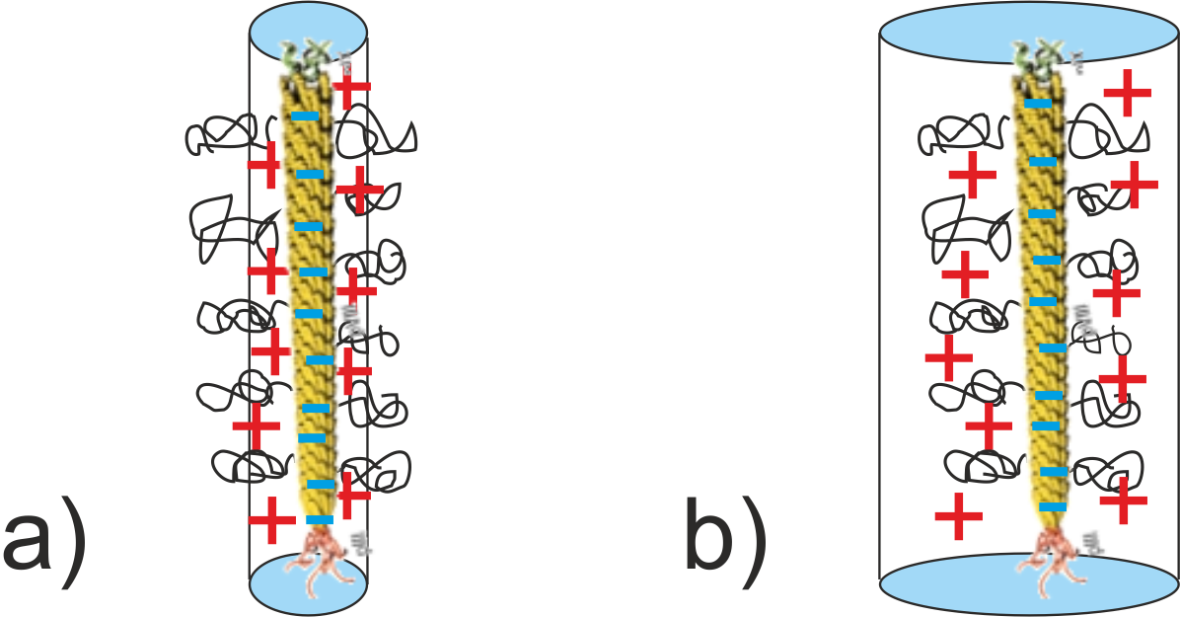
Figure 1: Illustration of the steric and electrostatic contributions at different Debye lengths. a) At high ionic strength the polymer chains exceed the electrostatic range. The system is dominated by hysteric repulsion. b) For low salt content and long range electrostatic interaction the thermophoretic behavior is dominated by charge effects.

REFERENCES
- J.K.G. Dhont and W.J. Briels, Eur. Phys. J. E 25, 61(2008).
- H. Ning, J.K.G. Dhont, and S. Wiegand, Langmuir, 24, 2426(2008).
- Z. Wang, H. Kriegs, J. Buitenhuis, J.K.G. Dhont, and S. Wiegand, Soft Matter, 9, 8697(2013).

