On the consensus nomenclature rules for radiopharmaceutical

chemistry – Reconsideration of radiochemical conversion

Matthias M. Herth a,b,⁎, Simon Ametamey c, Dmitrii Antuganov d, Andreas Bauman e, Mathias Berndt f,

Allen F. Brooks g, Guy Bormans h, Yearn Seong Choe i, Nic Gillings b, Urs O. Häfeli j, Michelle L. James k,

Klaus Kopka l, Vasko Kramer m, Raisa Krasikova n, Jacob Madsen b, Linjing Mu c, Bernd Neumaier o,

Markus Piel p, Frank Rösch p, Tobias Ross q, Roger Schibli c, Peter J.H. Scott g, Vladimir Shalgunov a, Neil Vasdev r,WolfgangWadsak s, Brian M. Zeglis t,u

a Department of Drug Design and Pharmacology, University of Copenhagen, Jagtvej 160, 2100 Copenhagen, Denmark

b Department of Clinical Physiology, Nuclear Medicine & PET, Rigshospitalet, Blegdamsvej 9, 2100 Copenhagen, Denmark

c Department of Chemistry and Applied Biosciences, ETH Zurich, Vladimir-Prelog-Weg 1-5/10, 8093 Zürich, Switzerland

d Almazov Northwest Federal Medical Research Center, Ministry of Health of the Russian Federation, ul. Akkuratova 2, St. Petersburg 197341, Russia

e Clinic of Radiology and Nuclear Medicine, University of Basel Hospital, Petersgraben 4, CH-4031 Basel, Switzerland

f Life Molecular Imaging GmbH, Tegeler Str. 6-7, D-13353 Berlin, Germany

g Department of Radiology, University of Michigan Medical School, 1301 Catherine St, Ann Arbor, MI 48109, USA

h Laboratory for Radiopharmaceutical Research, KU Leuven, Herestraat 49, box 821, 3000 Leuven, Belgium

i Department of Nuclear Medicine, Samsung Medical Center, Sungkyunkwan University School of Medicine, 81 Irwon-ro, Gangnam-gu, Seoul 06351, Republic of Korea

j Faculty of Pharmaceutical Sciences, University of British Columbia, 2405 Wesbrook Mall, Vancouver, BC V6T 1Z3, Canada

k Department of Radiology and Department of Neurology and Neurological SciencesMolecular Imaging Program at Stanford (MIPS), Stanford University School ofMedicine, 1201Welch Road, P-

206, Stanford, CA 94305, USA

l Institute of Radiopharmaceutical Cancer Research, Helmholtz-Zentrum Dresden-Rossendorf (HZDR), Bautzner Landstraße 400, D-01328 Dresden, Germany

m Positronpharma SA, Providencia, 7500921 Santiago, Chile

n N.P. Bechtereva Institute of Human Brain, Russian Academy of Science, Laboratory of Radiochemistry, 9 Ak. Pavlova St., 197376 St. Petersburg, Russia

o Institute of Neuroscience and Medicine, Forschungszentrum Jülich, D-52425 Jülich, Germany

p Department of Chemistry, Johannes Gutenberg-Universität Mainz, Fritz-Strassmann-Weg 2, D-55128 Mainz, Germany

q Department of Nuclear Medicine, Hannover Medical School, Carl-Neuberg-Straße 1, D-30625 Hannover, Germany

r Azrieli Centre for Neuro-Radiochemistry, Brain Health Imaging Centre, Centre for Addiction and Mental Health & Department of Psychiatry, University of Toronto, 250 College St., Toronto M5T-

1R8, ON, Canada

s Department of Biomedical Imaging und Image-guided Therapy, Medical University of Vienna, Waehringer Guertel 18-20, A-1090 Vienna, Austria

t Department of Chemistry, Hunter College of the City University of New York, New York, NY, USA

u Department of Radiology, Memorial Sloan Kettering Cancer Center, New York, NY, USA

Abstract

Radiochemical conversion is an important term to be included in the “Consensus nomenclature rules for radiopharmaceutical chemistry”. Radiochemical conversion should be used to define reaction efficiency by measuring the transformation of components in a crude reactionmixture at a given time,whereas radiochemical yield is better suited to define the efficiency of an entire reaction process including, for example, separation, isolation, filtration,and formulation.

Keywords:

Nomenclature, Terminology, Consensus guidelines, Radiopharmaceutical sciences, Nuclear chemistry, Radiochemistry, Radiochemical conversion, Radiochemical yield

Dear Editor,

We are writing to you with respect to the recent “Consensus nomenclature rules for radiopharmaceutical chemistry” [1,2]. We understand and appreciate that the intent of this initiative was to generate a consensus for terms and definitions used within the field of radiopharmaceutical chemistry. The initiative has been well adopted by the radiopharmaceutical chemistry community and is intended to ensure unambiguous communication of scientific findings and diminish misunderstandings thereof. We concur with these aims and believe that the guidelines presented are an excellent first step in this direction. However, in our opinion, the suggested definition of radiochemical yield (RCY) isunclear. As defined, the termRCY can be used to describe the reaction efficiency of a specific radiolabeling step but also the overall process efficiency of an entire radiosynthetic procedure [1,2]. This ambiguity can lead to major misunderstandings with respect to the achievable yield of a given radiolabeling process. Terms that unambiguously distinguish parameters connected to reaction and process efficiencieswould prevent contradictions in the communication of scientific results and avoid misunderstandings. As such, we recommend the use of specific terms for both types of efficiencies and therefore advocate for the addition of new terminology to the consensus nomenclature rules. Mirroring the terminology of synthetic organic chemistry, we propose the use of distinct terms for the reaction efficiency and the overall process efficiency of a given radiolabeling step, which — as we have noted — are misrepresented with the current definition of RCY. To this end, we propose the use of the term radiochemical conversion (RCC) to define reaction efficiency. The current consensus nomenclature rules allow for the use of RC to describe the procedure efficiency (in which the activity of the purified product is compared to the starting activity) as well as the *reaction ef*ﬁ*ciency* (in which chromatographic analysis is usually performed on an aliquot from a reaction solution) [2]. Consequently, RCY can drastically vary for the same reaction depending on how it is measured. For example, this ambiguity becomes especially clear in the case of copper-mediated aromatic 18F-ﬂuorinations: for one speciﬁc reaction, the “*reaction ef*ﬁ*ciency RCY*” based on aliquot analysis can be on the order of 75%, whereas the “*process ef*ﬁ*ciency RCY*” can be below 20% [3]. In this context, the term RCY (given its present deﬁnition) is unclear, and the reaction efﬁciency and process efﬁciency can easily be confused with each other, especially for scientists outside the radiopharmaceutical chemistry community. In synthetic organic chemistry, similar challenges have been addressed using distinct terms for reaction efﬁciency and overall process efﬁciency [4,5]. In this respect, the term *conversion* is frequently used to describe the reaction efﬁciency, *i.e.* the transformation of the reactants. Conversion is typically monitored by chromatography (TLC, GC, or HPLC) or NMR spectroscopy and is reported as the ratio of the concentration of product observed at a given time point to the maximum theoretically achievable concentration of said product. In contrast, the *yield* of a chemical reaction refers to the number of moles of the puriﬁed product in relation to the number of moles of the limiting starting material. Consequently, the yield is not only dependent on the efﬁciency of the reaction (i.e. the conversion) but also on other important factors, such as losses during work-up and puriﬁcation.

The authors of the “consensus nomenclature” guideline are aware of the issues that have arisen from the ambiguity of the term “radiochemical yield”, as they have stated in the follow-up report [2]: “In fact, many papers do not clearly report that the stated radiochemical yields are only based on chromatographic analyses of small aliquots from reaction solutions. The concern with this practice is that the reported product fraction only represents the activity eluted from an HPLC column, overlooking any components that are not eluted or transferred during the analysis workup procedure. This can lead to overestimation of radiochemical yields and inconsistent comparisons of the robustness and applicability of methods across laboratories.” Nevertheless, they maintain that the use of alterna- tive terms for individual reaction processes and steps is “neither necessary nor advantageous”.

We disagree with this conclusion. Therefore, we propose introducing the term RCC to describe reaction efﬁciency while keeping the term RCY to describe process efﬁciency. Fig. 1 illustrates how the terms RCC and RCY should be used to describe reaction efﬁciencies and process efﬁciencies, respectively, for single- or multi-step radiolabeling sequences.

References

[1] Coenen HH, Gee AD, Adam M, Antoni G, Cutler CS, Fujibayashi Y, et al. Consensus no- menclature rules for radiopharmaceutical chemistry — setting the record straight. Nucl Med Biol. 2017;55:v–xi.

[2] Coenen HH, Gee AD, Adam M, Antoni G, Cutler CS, Fujibayashi Y, et al. Status of the ‘consensus nomenclature rules in radiopharmaceutical sciences’ initiative. Nucl Med Biol. 2019;71:19–22.

[3] Tredwell M, Preshlock SM, Taylor NJ, Gruber S, Huiban M, Passchier J, et al. A general copper-mediated nucleophilic 18F ﬂuorination of arenes. Angew Chem Int Ed. 2014; 53:7751–5.

[4] Schafer WA, Hobbs S, Rehm J, Rakestraw DA, Orella C, McLaughlin M, et al. Mobile tool for HPLC reaction monitoring. Org Process Res Dev. 2007;11:870–6.

[5] Gomez MV, De La Hoz A. NMR reaction monitoring in ﬂow synthesis. Beilstein J Org Chem. 2017;13:285–300.

[6] Edem PE, Steen EJL, Kjær A, Herth MM. Fluorine-18 radiolabeling strategies—advan- tages and disadvantages of currently applied labeling methods. Late-stage ﬂuorina- tion bioact. Mol. Biol. Substrates. Elsevier; 2019. p. 29–103.

[7] Vogel AI, Tatchell AR, Furnis BS, Hannaford AJ, Smith PWG. Vogel’s textbook of prac- tical organic chemistry. 5th ed.. Pearson; 1996.

Glossary

Reaction efﬁciency describes the efﬁciency of the transformation of components in a chem- ical reaction. In organic chemistry, the reaction efﬁciency is described with the term con- version [4,5].

Proposed term: Radiochemical conversion (RCC) is a measure of the reaction efﬁciency of a radiochemical reaction. It is based on the reaction of an available radioactive nuclide or synthon with a starting material (decay-corrected). RCC is typically determined via the chromatographic analysis (e.g. radio-TLC or radio-HPLC) of a small aliquot from a reaction solution. Losses during these measurements that arise from the volatility of the reactant or product or from the retention of a radioactive reaction component within the stationary phase should be accounted for. RCC should not be confused with radiochemical purity (RCP), even though the methodology to determine RCC and RCP is the same. RCP refers to the purity of the isolated product, while RCC describes the content of a product in a crude or semi-puriﬁed reaction mixture before isolation and formulation [6].

Process efﬁciency is a measure of the efﬁciencies of all sub-processes and/or steps of a spe- ciﬁc procedure. If the process in question is a chemical synthesis, the process efﬁciency can be described using the term “yield” [7].

Radiochemical yield (RCY) is a measure of the process efﬁciency of a radioactive labeling procedure and refers only to the isolated, puriﬁed, and formulated radiochemical product. It is deﬁned as “The amount of radioactivity in the isolated product expressed as the percentage of related starting radioactivity used in the corresponding synthesis (step)” [2]. Both quantities must be decay-corrected to the same time point. The overall RCY for a multi-step synthesis is based on the RCYs for each synthetic step in said process.

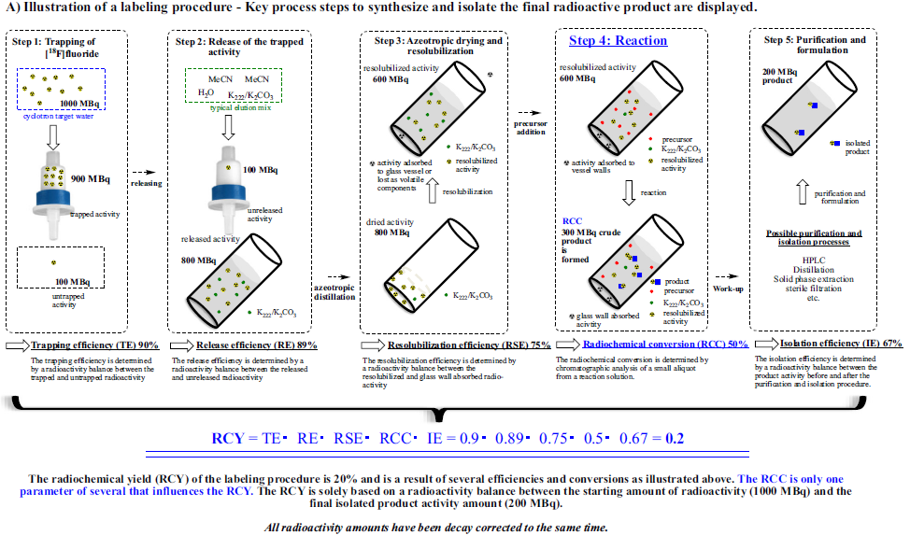

Fig. 1. The difference between RCC and RCY as exempliﬁed using a standard 18F-labeling procedure. (A) A radiolabeling process is depicted. The labeling process efﬁciency is described with the term RCY and is dependent on a number of factors including the reaction efﬁciency, which is deﬁned by the RCC of the reaction. (B) The use of RCC, RCY, and overall RCY illustrated for a two-step reaction.