**(Optochemical) control of synthetic microbial co-culture interactions on microcolony level**

Alina Burmeister1,2, Qiratt Akhtar1, Lina Hollmann1, Niklas Tenhaef1, Fabienne Hilgers5, Fabian Hogenkamp6, Sascha Sokolowsky1, Jan Marienhagen1,3, Stephan Noack1, Dietrich Kohlheyer1,4 and Alexander Grünberger2*

­­1 Institute of Bio- and Geosciences, IBG-1: Biotechnology, Forschungszentrum Jülich, 52425 Jülich, Germany

2 Multiscale Bioengineering, Bielefeld University, 33615 Bielefeld, Germany

3 Institute of Biotechnology, RWTH Aachen University, 52074 Aachen, Germany

4 Aachener Verfahrenstechnik (AVT-MSB), RWTH Aachen University, 52074 Aachen, Germany

5 Institute of Molecular Enzyme Technology, Heinrich-Heine-University Düsseldorf, Forschungszentrum Jülich, 52428 Jülich, Germany

6 Institute of Bioorganic Chemistry, Heinrich Heine University Düsseldorf, Forschungszentrum Jülich, 52428 Jülich, Germany

­­*Corresponding author:

E-Mail: alexander.gruenberger@uni-bielefeld.de

Phone: +49-521-106-5289

**Abstract**

Synthetic microbial co-cultures carry enormous potential for applied biotechnology and are increasingly subject of fundamental research. So far, most co-cultures have been designed and characterized based on bulk cultivations without considering the potentially highly heterogeneous and diverse single-cell behavior. However, an in-depth understanding of co-cultures including their interacting single cells is indispensable for the development of novel cultivation approaches and control of co-cultures.

We present the development, validation and experimental characterization of an optochemically controllable bacterial co-culture on microcolony level consisting of two *Corynebacterium glutamicum* strains. Our co-culture combines an L-lysine auxotrophic strain together with a L-lysine-producing variant carrying the genetically IPTG-mediated induction of L-lysine production. We implemented two control approaches utilizing IPTG as inducer molecule. Firstly, unmodified IPTG was supplemented to the culture enabling a medium-based control of the production of L-lysine, which serves as the main interacting component. Secondly, optochemical control was successfully performed by utilizing photocaged IPTG activated by appropriate illumination. Both control strategies were validated studying cellular growth on microcolony level. The novel microfluidic single-cell cultivation strategies applied in this work can serve as a blueprint to validate cellular control strategies of synthetic mono- and co-cultures with single-cell resolution at defined environmental conditions.

**Introduction**

Understanding interactions and pathways in microbial communities has become a major interest in synthetic biology to expand the toolbox of applications and explore the potential of communities for new or improved biotechnological processes.1–3 For the design and modification of natural and synthetic co-cultures, bottom-up engineering approaches4 as well as *in situ* microbiome engineering of bacterial communities5 have been applied. Especially cooperative interactions such as commensalism and syntrophy are advantageous for biotechnological processes.6 Exploiting these interaction modes aims at distributing metabolic tasks between different strains, which would allow for higher productivity and more precise pathway optimization as each strain can be engineered individually and carries a smaller metabolic burden.7

The greatest challenge in understanding microbial communities is the analysis of their complex interactions on different spatio-temporal scales, which can be highly dynamic and difficult to predict.8 Analysis of population behavior in co-cultures has mostly been performed within the limits of lab scale cultivations, average measurements, and off-line sample analysis, such as metagenomics or flow cytometry.9,10 However, recent studies have shown that especially short-range interactions play a pivotal role in functions of microbial communities.11,12 According to Co *et al.*, cells interact only in a range of a few cell length with community members to exchange metabolites.11

These short-range cell-cell interactions can be analyzed with microfluidic cultivation devices and appropriate time-lapse microscopy.13 In the past, microfluidics has mainly been employed for the analysis of microbial monocultures14,15, but a few studies investigating synthetic co-cultures have been published recently.16,17 These devices provide access to single-cell resolution as well as controllable environmental conditions. In combination with (fluorescence) time-lapse microscopy, microfluidics enables cell cultivations and analysis with exceptional spatio-temporal resolution. Detailed insights obtained from single-cell analysis are indispensable for the development of promising control strategies for synthetic co-cultures.

Controlling co-cultures is an emerging topic within the research field of synthetic co-cultures. The application of co-cultures in biotechnological processes is still scarce, as their dynamic control remains challenging at the bulk level. Recently, control mechanisms for co-cultures including the engineering of strains for co-culture self-regulation via quorum sensing (QS)18,19, toxin-antitoxin interaction20, gene transfer21 and metabolite exchange22 have been successfully demonstrated (Table 1A). Online control of individual co-culture members (Table 1B) or a single co-culture member (Table 1C) has been achieved by the addition of QS molecules23 or antibiotics.24 Particularly, supplementing inducer molecules or antibiotics provides dynamic control of individual populations in a co-culture. Furthermore, theoretical strategies enabling the control of co-cultures were described.21,25 However, most of the recently demonstrated approaches have in common that they enable the essential stabilization of the population ratios of the interacting organisms (Table 1A), but are not suitable for online process control. Dynamic control tools in terms of online and noninvasive regulation of co-cultures have rarely been applied in previous studies.

Optogenetics is a relatively new technology, that employs naturally occurring light-responsive proteins and transfers them into genetically encoded protein switches to control cellular processes with unprecedented temporal and spatial resolution.26 It carries great potential for the online control of cultures with light in an extraordinary fast, precise, and minimal invasive fashion.27 The different methods applied for light control can be divided into three categories, namely irreversible photo(de)activation (uncaging), reversible photo-switching and optogenetics.28

With irreversible photo(de)activation molecular processes are regulated using photolabile protection groups linked to key locations or molecules, which can be cleaved upon light exposure, thereby releasing the active inducer compound. These protection groups can be linked to a wide range of molecules such as IPTG, carbohydrates or antibiotics.29,30 By implementing two complementary antibiotics caged by different photo-sensitive protection groups, Velema *et al.* demonstrated the online control of a co-culture incorporating *Escherichia coli* and *Staphylococcus aureus* cells by releasing the specific antibiotics upon exposure to different wavelengths.24

If a reversible control over cellular processes is required, reversible photo-switches can be applied, where bistable molecules can undergo a reversible change of their structure upon light irradiation.31 Optogenetics combines these rather synthetic chemical approaches and aims at introducing them into living organisms by utilizing genetically encoded photosensitive proteins. However, the natural and synthetic control tools are often combined and a clear discrimination is not possible.28

Successful gene regulation on the single-cell level was published by Rullan *et al.* in a study showing transcriptional regulation in yeast with a photosensitive transcription factor by using a digital micromirror device projector.32 Another example on the population level is the automated optogenetic feedback control of a key metabolic enzyme in *E. coli* for dynamic control of the growth rate by using a light-switchable cyanobacterial two-component system as described by Milias-Argeitis *et al*..33 Other examples of light switchable cellular systems are described in the review of Szymanski et al..31 However, most of these optogenetic tools have not yet been implemented for the control of the co-culture behavior.

Here, we demonstrate the control of a synthetic co-culture at the microcolony level based on engineered *C. glutamicum* strains. In this co-culture, a L-lysine production strain is directly controlled, which in turn influences the growth of the interacting partner, a L-lysine auxotrophic strain. We applied two gradually engineered co-culture control strategies. First, an invasive, IPTG-inducible L-lysine expression system and secondly, a light control-based approach by supplementing photocaged IPTG (cIPTG) to the culture medium, whereby the L-lysine production is induced after releasing the active IPTG molecules upon UV-A light exposure. Our microcolony cultivations and analyses were performed utilizing our recently developed microfluidic co-cultivation platform enabling environmental control as well as defined light exposure to monolayer cell colonies.17

**Table 1** Recently employed tools for the control of co-cultures.

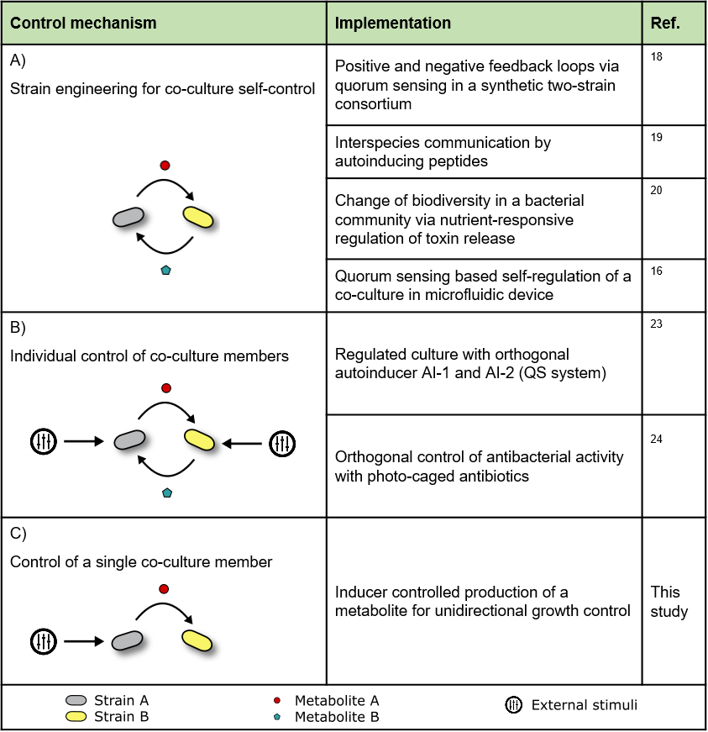

**Results and Discussion**

**Pre-evaluation of the synthetic co-culture model**

For the analysis of intraspecies interaction, we assembled synthetic co-cultures with unidirectional dependency. In search of a suitable co-culture model, we cultivated the lysine auxotrophic strain *C. glutamicum* Δ*lysA* pEKEx2-eYFPtogether with a wild-type strain and with *C. glutamicum* DM1727, which carries a *pyc* mutation. Both co-cultures showed no significant fluorescence signal, indicating that not enough L-lysine was secreted by these strains to sufficiently feed *C. glutamicum* Δ*lysA* for cell growth (Figure S2). Consequently, we aimed for L-lysine production strains with higher L-lysine titers and chose *C. glutamicum* DM1800 and DM1727 pEKEx2-*lysC*-βFBR. *C. glutamicum* DM1800 carries a *pyc* and *lysC* mutation for an improved L-lysine production (Figure 1A), *C. glutamicum* DM1727 pEKEx2-*lysC*-βFBR carries also a *pyc* mutation but additionally the IPTG-inducible feedback resistant aspartate kinase (*lysC*) on a plasmid for controlled L-lysine production (Figure 1B). If the strain DM1727 pEKEx2-*lysC*-βFBR is induced by IPTG, it is expected to have a similar L-lysine production as strain DM1800.

All experiments were performed in defined CGXII medium and the auxotrophic strain was fed with the L-lysine secreted by a corresponding producer strain in the co-culture. L-lysine was the only growth-limiting factor as all other nutrients were present in excess.

To quantify the lysine secretion of the producer strains, we analytically determined the L-lysine concentration in the culture supernatant at different time points during microbioreactor cultivation of the producer strains (Figure 1C). *C. glutamicum* DM1800 produced the highest amount of L-lysine with a measured maximum concentration of 4.89 mM after 20 hours cultivation time. Strain DM1727 pEKEx2-*lysC*-βFBR induced with 15 µM IPTG produced nearly the same amount and reached a maximum concentration of 4.61 mM in the supernatant. Without the addition of IPTG, *C. glutamicum* DM1727 pEKEx2-*lysC*-βFBR produced around 1 mM L-lysine, which proves that the promotor system is not completely tightly regulated.

For co-cultivation experiments, we performed microbioreactor cultivations with online measurement of backscatter and YFP intensity to characterize the general strain behavior. As we used strains with similar phenotypes regarding cell size and morphology, the increase in biomass of the two populations in our co-cultures could not be differentiated by the applied backscatter measurements (Figure 1D top). The growth rates of all co-cultures calculated from backscatter measurements are listed in table 2. Yet, due to the Δ*lysA* strain expressing eYFP, co-cultures showed different average fluorescence intensities (Figure 1D bottom). The fluorescence intensities revealed that the co-culture of *C. glutamicum* Δ*lysA* + DM1727 pEKEx2-*lysC*-βFBR with IPTG induction reached a slightly lower final fluorescence intensity compared to the co-culture of *C. glutamicum* Δ*lysA* + *C. glutamicum* DM1800.

The control co-cultivation of the Δ*lysA* strain together with *C. glutamicum* DM1727 pEKEx2-*lysC*-βFBR without IPTG addition, showed that even without induction the producer strain secreted obviously low levels of L-lysine, causing growth of the Δ*lysA* strain, which becomes apparent in a fluorescence intensity of approximately 25 a.u. (Figure 1D bottom). These results are in accordance with the measured L-lysine concentrations, determined in the monocultures of the producer strains.

For comparison, we additionally performed microbioreactor cultivations, in which all strains were cultured separately and backscatter signals as well as fluorescence intensity values were measured (Figure S1). The results show that the fluorescence intensity values of the co-cultures were below the fluorescence intensity values of monocultures with the fluorescing auxotrophic strain (L-lysine supplementation), but higher than for cultivations with the non-fluorescing L-lysine production strains (Figure S1). This indicates that the Δ*lysA* strain grew successfully within the co-cultures, but a precise determination of the biomass would be difficult to implement. However, based on our observations, we assumed that the fluorescence intensities of the auxotrophic strain and thus the average co-culture fluorescence can be used to approximately monitor L-lysine production.

The results show that *C. glutamicum* Δ*lysA* grew successfully in co-cultivation with the different L-lysine producers and even a control of L-lysine production by IPTG supplementation was achieved. However, detailed measurements of the correlation between fluorescence and cell mass and individual growth dynamics of the co-culture members are challenging to obtained in bulk measurements. The fluorescence indicates growth of the Δ*lysA* strain in co-cultures but the correlation of the fluorescence intensity to the cell mass could be imprecise. For detailed insights into the population and analysis of the time-resolved cell-to-cell heterogeneity and strain interactions, we performed microcolony cultivation experiments in microfluidic devices, as described in the following sections.

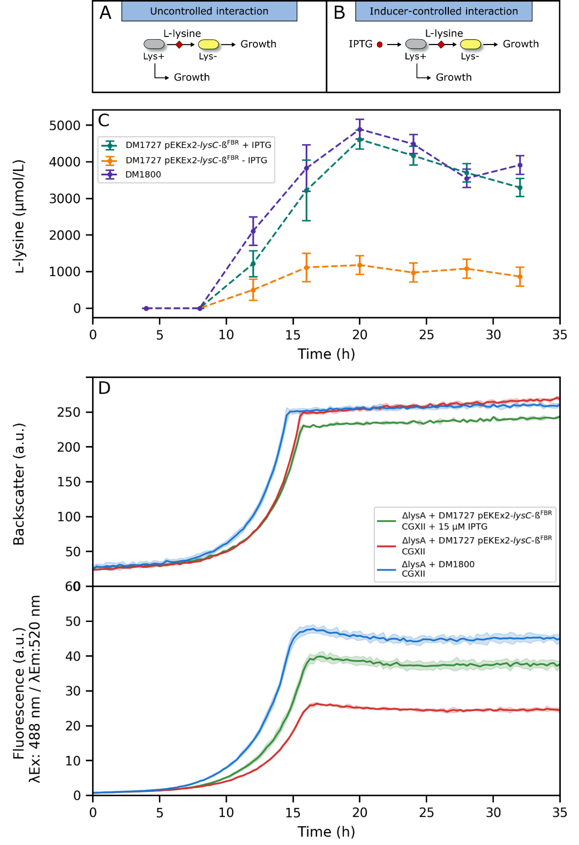

**Figure 1** Bulk analysis of L-lysine production and co-cultures using microtiter plate cultivations. (A) Illustration of synthetic co-culture model with uncontrolled interaction between a L-lysine production strain and a L-lysine auxotrophic strain. (B) Illustration of synthetic co-culture model with IPTG-controlled L-lysine production, which feeds a L-lysine auxotrophic strain for cell growth. (C) Measurement of extracellular L-lysine accumulation during cultivation of C. glutamicum DM1800 and DM1727 pEKEx2-lysC-βFBR with and without IPTG addition. Samples were drawn by a liquid handling system at distinct sampling points and measured via HPLC. Mean values (points) and standard deviations (error bars) were estimated via error propagation from two analytical replicates. (D) Time course of online backscatter and fluorescence data for co-cultures of C. glutamicum ΔlysA + DM1800 and C. glutamicum ΔlysA + DM1727 pEKEx2-lysC-βFBR with and without IPTG. Mean values (lines) and standard deviations (underlaying areas) were estimated from three independent replicate cultures, respectively.

|  |  |
| --- | --- |
| **Co-culture and condition** | **Average specific growth rate (h-1)** |
| Δ*lysA* + DM1727 pEKEx2-*lysC*-βFBR,  CGXII + 15 µM IPTG | 0.36 ± 0.01 |
| Δ*lysA* + DM1727 pEKEx2-*lysC*-βFBR,  CGXII | 0.38 ± 0.01 |
| Δ*lysA* + DM1800,  CGXII | 0.39 ± 0.01 |

***Table 2*** *Average growth rates of co-cultures in microtiter plate cultivations. Growth rates and standard deviations were calculated from three independent replicates using spline approximation.*

**Interaction analysis on microcolony level**

For microfluidic co-cultivation experiments, cells were cultivated in monolayer growth chambers, which restricted cell growth to a single cell layer ideally for the subsequent image analysis.34 Strains were spatially separated inside the monolayer growth chambers by a membrane with several interconnecting nanochannels, which allowed the exchange of metabolites by diffusion. The spatial separation was necessary to restrict the faster growing producer strain from overgrowing the slower growing auxotrophic strain when cultivated in a single chamber simultaneously (see Burmeister *et al.*, 17). Metabolite exchange inside the chambers was mainly dependent on diffusion through the interconnecting nanochannels defined by the chamber geometry.17 To examine the growth rate of *C. glutamicum* Δ*lysA* in co-cultivation together with the L-lysine producer *C. glutamicum* DM1800, we emulated batch cultivation conditions by stopping the continuous medium flow when the channels were perfused with fresh defined CGXII medium for one hour after cell inoculation.

Figure 2A depicts growth curves of strains DM1800 and Δ*lysA* in five separate growth chambers. *C. glutamicum* DM1800 grew exponentially with an average growth rate of **avg = 0.34 ± 0.01 h-1 until the chamber was completely overgrown and the cell numbers stagnated after approximately 5 h cultivation time. Noteworthy, image analysis was not viable from this timepoint on because the cells grew so densely that single cells were not recognizable. *C. glutamicum* Δ*lysA* showed an average growth rate of **avg = 0.30 ± 0.02 h-1. After around 4 h cultivation time, in which mainly the producer strain increased its cell number, L-lysine accumulated inside the chambers at concentrations high enough to enable growth of the Δ*lysA* strain. The apparent lag phase of the Δ*lysA* strain also occurred during the microbioreactor co-cultivations. The YFP fluorescence of the co-culture showed a delay of several hours compared to the YFP signal of the Δ*lysA* monoculture in the microbioreactor (see Figure 1D and Figure S1). This indicates that a minimum L-lysine concentration was necessary to induce cell growth of *C. glutamicum* Δ*lysA*. This in turn could only be achieved when a sufficient amount of producer cells was reached (here approx. 600 cells), which depends on the microfluidic chamber design, the cultivation mode and the genetic background of the producer strain.

In order to get an estimate for this L-lysine concentration threshold in our setup, we performed microfluidic perfusion cultivations with monocultures of the Δ*lysA* strain under various constant L-lysine concentrations (Figure S3 A). Our results show that a minimum of 10 µM L-lysine is necessary to induce cell division of *C. glutamicum* Δ*lysA.* With L-lysine concentrations below 10 µM no cell growth could be observed.However, under these very low concentrations cells showed long division ages and highly heterogeneous growth behavior (Figure S3 B). The variance of division age was at approximately 3 h2 for 10 µM, while no heterogeneity effects could be observed at supplemented concentrations above 1 mM.

As a control experiment, we also performed microfluidic co-cultivations of *C. glutamicum* Δ*lysA* together with a *C. glutamicum* wildtype strain (Figure S4 A). Results show that the wildtype did not secrete sufficient amounts of L-lysine to induce growth of the Δ*lysA* strain*,* which was in accordance with our expectations, as the L-lysine production is negatively feedback regulated in the wild type.35

In a next step, we aimed to control the interaction and analyzed the growth behavior of *C. glutamicum* Δ*lysA* in co-culture together with strain *C. glutamicum* DM1727 pEKEx2-*lysC*-βFBR*.*

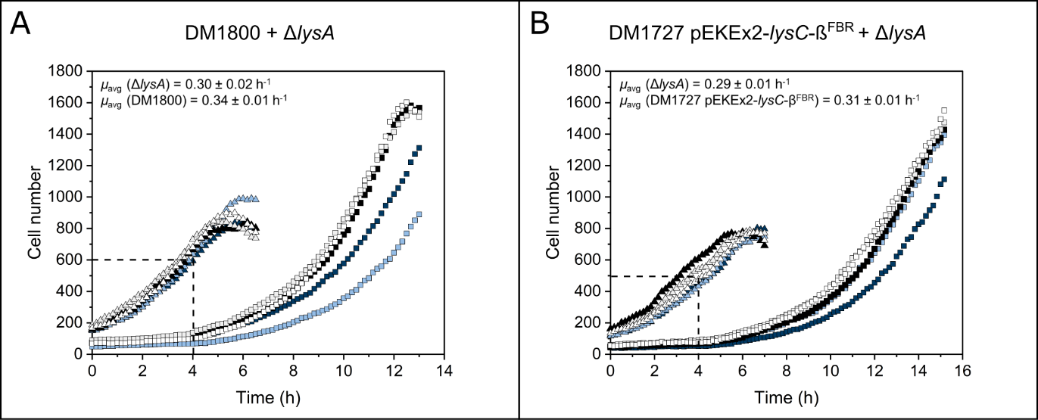

**Figure 2** Microcolony growth analysis of C. glutamicum co-cultures during uncontrolled and controlled interaction. (A) Growth curves of five growth chambers of L-lysine producer C. glutamicum DM1800 (triangles) and C. glutamicum ΔlysA (squares) in co-cultivation. (B) Growth curves of five growth chambers of inducible L-lysine producer C. glutamicum DM1727 pEKEx2-lysC-βFBR (triangles) and C. glutamicum ΔlysA (squares) in co-cultivation. Each color represents one pair of microcolonies in on cultivation chamber.

**Interaction control on microcolony level**

The inducer-controlled co-culture model consisted of the two strains Δ*lysA* and DM1727 pEKEx2-*lysC*-βFBR. IPTG supplemented to the medium induced the production of L-lysine by strain DM1727 pEKEx2-*lysC*-βFBR, which feeds the Δ*lysA* strainenabling cell growth*.* The induced co-cultures revealed similar results compared to the uncontrolled co-cultivations. *C. glutamicum* Δ*lysA* grew with an average growth rate of **avg = 0.29 ± 0.01 h-1 in co-cultivation together with *C. glutamicum* DM1727 pEKEx2-*lysC*-βFBR (**avg = 0.31 ± 0.01 h-1) and 15 µM IPTG (Figure 2B). The similar growth behavior of the co-cultures is in accordance with our expectations regarding their genotypes as both production strains exhibit a *pyc* mutation and (for DM1727 pEKEx2-*lysC*-βFBR aninduced) feedback resistant aspartate kinase (*lysC*) for improved L-lysine production.

Control experiments without adding IPTG to the inducer-controllable co-culture resulted in no growth of the Δ*lysA* strain in the microfluidic setup (Figure S5). In comparison to the microbioreactor cultivations, where a slight growth of ΔlysA was visible, small amounts of produced lysine are rapidly washed away with the medium flow in the microfluidic setup because of the continuous cultivation mode. In microbioreactor batch cultivations small amounts of produced lysine could accumulate over time and induce cell growth of ΔlysA. Here, the leakiness of the used promotor becomes apparent and confirms the results of previous studies describing the leakiness of several promotors in *C. glutamicum*.36,37

We also tested the strain DM1727 without the plasmid pEKEx2-*lysC*-βFBR in a co-culture with *C. glutamicum* Δ*lysA*. The minimal amount of L-lysine produced and secreted by this mutant was also not sufficient to promote growth of *C. glutamicum* Δ*lysA* (Figure S4 B).

Similar to the uncontrolled co-culture, a growth lag-phase of *C. glutamicum* Δ*lysA* was observed in the controlled co-culture and the auxotrophic strain only started to grow, when *C. glutamicum* DM1727 pEKEx2-*lysC*-βFBR had reached a cell number of approximately 500 cells.

**Interaction control by UV illumination**

Fast and precise control of interaction between our strains Δ*lysA* and DM1727 pEKEx2-*lysC*-βFBR in a noninvasive fashion was achieved by the photocaged compound cIPTG38, which was activated upon short UV-A exposure (Figure 3A, B).39 This way, cIPTG molecules are transported into the cells before they are uncaged with UV-A light, leading to a faster induction and more homogeneous promotor activation, which could be demonstrated in previous studies.40 For a more detailed description of the synthesis and molecular mechanism of uncaging cIPTG the reader is referred to Young and Deiters38 and Binder *et al*..29

Before microfluidic co-cultivation experiments, a UV-A toxicity test was performed by exposing *C. glutamicum* to UV-A light for 0 s, 1 min and 5 min (Figure S7). Growth rates were compared to find out if the UV-A light has an influence on the viability of the cells. The results showed no significant difference in growth rates between the different exposure times. However, after 1 min UV-A exposure time a slight growth delay could be observed compared to unexposed cells. At 5 min UV-A exposure an even longer lag-phase could be observed, indicating that some cells might be killed or impaired in growth. So, we assumed that a maximum exposure time of 1 min could be applied in our experiments without having a noticeable negative influence on the cell viability.

In microfluidic co-cultivation experiments, cIPTG was added to the medium and the chip was perfused for 1 h. Subsequently, the medium flow was stopped and an additional waiting time of 30 min was applied to emulate batch conditions and to ensure intracellular uptake of cIPTG inside the DM1727 pEKEx2-*lysC*-βFBR cells. To uncage the photosensitive molecules, single chambers were illuminated by UV-A light for 10 s, 30 s and 60 s.

Results show that *C. glutamicum* Δ*lysA* started to grow solely when the chamber was exposed to UV-A light, while in non-exposed chambers Δ*lysA* cell numbers remained nearly constant at the level of inoculation (Figure 3C).

Comparing different exposure times, it becomes evident that 30 s and 60 s exposure leads to slightly higher growth rates compared to 10 s exposure time (Figure 3D). After 10 s *C. glutamicum* Δ*lysA* showed an average growth rate of *µ*avg = 0.17 ± 0.04 h-1, after 30 s the growth rate determined was *µ*avg = 0.20 ± 0.02 h-1 and after 60 s exposure time the growth rate was *µ*avg = 0.19 ± 0.03 h-1. However, only between no UV-A exposure (0 s cIPTG) and all three exposure times a significant growth rate difference was found (p < 0.05). The difference in growth rate between 10 s and 30 s exposure (p = 0.09) as well as between 30 s and 60 s exposure (p = 0.57) was not significant. Yet, the standard deviation was greater for 10 s, which might be an indication that not all cIPTG molecules were uncaged after this short exposure time or not enough cIPTG was taken up by the cells and a more heterogeneous colony response was the result.

During microfluidic experiments, we also observed heterogeneous YFP expression in Δ*lysA* cells. To verify this, we measured the fluorescence distribution in *C. glutamicum* Δ*lysA* in the different co-culture experiments. Co-cultivation with *C. glutamicum* DM1800 or DM1727 pEKEx2-*lysC*-βFBR with IPTG induction revealed average coefficients of variation of CV = 31 % and CV = 35 %, respectively (Figure S6 A, B). Interestingly, heterogeneity in YFP expression was the highest when *C. glutamicum* Δ*lysA* was co-cultured with *C. glutamicum* DM1727 pEKEx2-*lysC*-βFBR and the L-lysine production was induced with cIPTG (CV = 39 %) (Figure S6 C). However, the fact that the Δ*lysA* strainis not expressing YFP in a homogeneous manner might influence the interpretation of fluorescence intensities in larger scale co-cultivations that we performed in the BioLector device (cmp. Fig. 1) and a correlation between cell mass and fluorescence intensity might be misleading. In contrast, microfluidic co-cultivations depict a more precise analysis of the co-culture with single cell numbers and fluorescence measurements with a high temporal resolution.

The standard IPTG induction resulted in generally higher growth rates compared to light induction, even though only 15 µM IPTG was used compared to 100 µM cIPTG in the light-controlled experiments. The reason for this might be that not enough cIPTG diffused into the cells leading to a weaker induction of the producer cells.

Control chambers without UV-A exposure showed a low growth rate, which might be caused by unintentionally uncaged IPTG molecules or a not tightly regulated promotor.

Light control was successfully achieved by the application of photocaged IPTG and UV-A exposure of the microfluidic co-culture. Results revealed that different exposure times could be used in the future to gradually control the interaction as shorter exposure times led to lower growth rates of *C. glutamicum* Δ*lysA.* Photo-activation of L-lysine producer cells led to generally lower growth rates compared to standard IPTG induction but by adjusting the cIPTG concentrations, exposure times and light intensities similar growth rates can be expected as uncaging of cIPTG and cell induction is highly sensitive to these parameters.41 The exposure of selected chambers during microscopy and the subsequent analysis of single-cell growth gives precise insights into strain interaction and shows that different synthetic biology tools can be combined to create light controlled consortia.

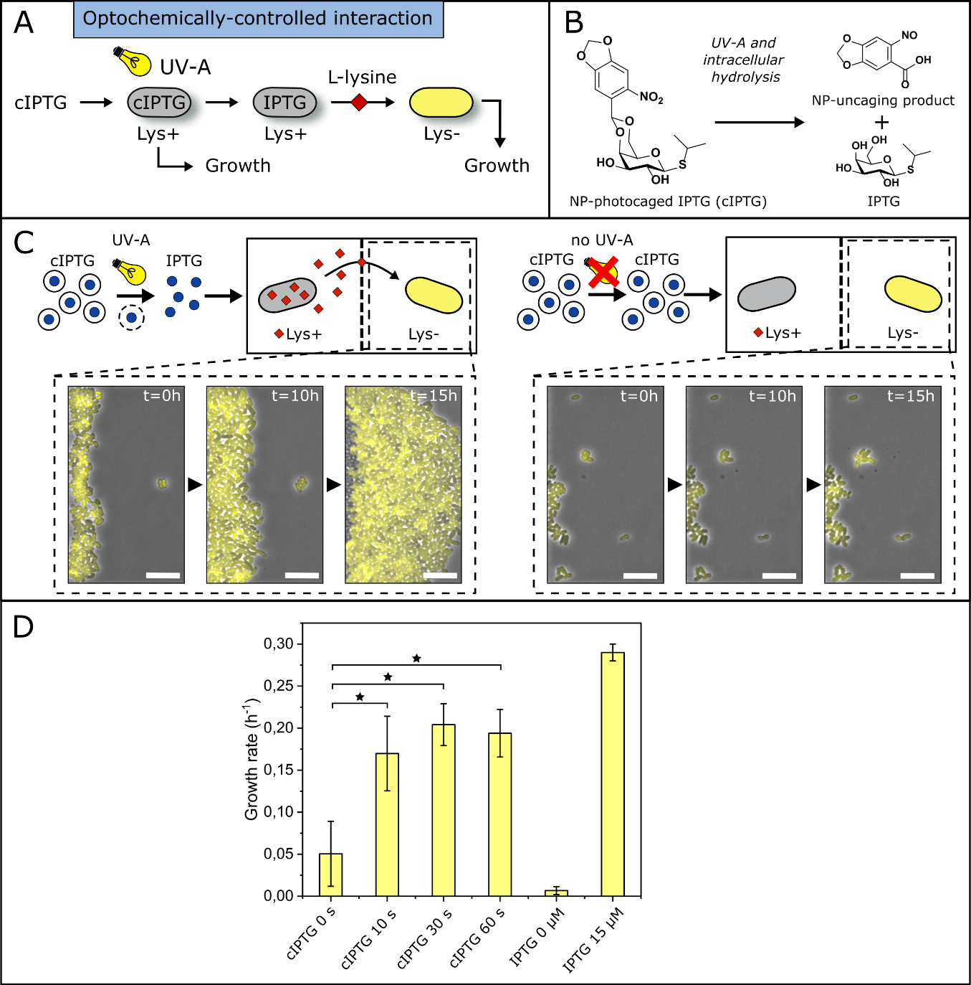

**Figure 3** Optochemically-controlled interaction with photocaged IPTG as inducer for L-lysine production. (A) For the optochemical control, 100 µM caged IPTG was added to the medium of a C. glutamicum ΔlysA and DM1727 pEKEx2-lysC-βFBR co-culture. Upon UV-A exposure (λ = 360 nm, I=1,2 µW) the protection group is released and IPTG can induce L-lysine production in DM1727 pEKEx2-lysC-βFBR, which feeds the ΔlysA strain. (B) Molecular structure and uncaging mechanism of NP-photocaged IPTG (cIPTG) as described by Young and Deiters.38 (C) Microscopic time-lapse images showing the cell monolayer of the L-lysine auxotrophic strain in the microfluidic co-culture chamber. Images revealed the growth of C. glutamicum ΔlysA when the chamber was shortly exposed to UV-A light (left). No UV-A exposure resulted in no growth of the ΔlysA strain (right). Scale bars = 10 µm. (D) Comparison of average growth rates of C. glutamicum ΔlysA under different co-culture conditions with C. glutamicum DM1727 pEKEx2-lysC-βFBR. For each condition eight chambers from two independent experiments were analyzed. Significant differences (p < 0.05) are indicated by stars.

**Future challenges**

Microfluidic single-cell analysis enables new insights into cell dynamics under defined and constant conditions42 or batch conditions.43

For high-throughput data analysis, image analysis workflows need to be optimized to analyze these large data sets with reliable methods. Several image analysis tools have been developed in the last years, but evaluation of co-culture data is notably challenging. Phenotypically identical or similar strains need to be spatially separated from each other by microfluidic structures, or must be optically traceable, for example by fluorescence labeling. For the determination of intracellular L-lysine concentration, a L-lysine reporter strain could be utilized.44 This way intracellular concentration of L-lysine can be correlated to fluorescence intensity, which reveals information about relative concentration differences.

Single-cell cultivation tools can also be applied to validate different control strategies as they offer unprecedented control over the extracellular environment. Hence, long term dynamics under constant or fluctuating45 environmental conditions as well as heterogeneity studies could be realized.

In this study we used an irreversible on/off control system which offers only limited control over the co-culture. Furthermore, the expression system used, is not completely tight as can be seen in Figure 1C. For a more precise control of co-cultures, a system with more tight and gradual controllable promotors would be the next step. Such systems with tetracycline or arabinose inducible promotors have already been established in *C. glutamicum.*37,46,47 In the study of Lausberg *et al*. a tight tetracycline inducible expression vector for *C. glutamicum* was developed to gradually increase the synthesis of a gene of interest upon gradual increase of inducer concentration.

Fast and reversible control over a co-culture could be achieved with photo-switches. Photo-switches are mostly based on a chromophore, that can change the conformation of an attached protein upon light irradiation and switches between two or more isomeric forms.31 However, not all synthetically designed photo-switches are suitable for biological applications as their absorption maximum must be at wavelengths which are not harmful to living cells. As in our case, the use of UV-A light is critical and therefore the light intensity and exposure time is limited.28 But the toolbox for biological applications of optogenetic switches is constantly growing and offers a broad range of wavelengths for activation and deactivation of proteins (https://www.optobase.org). For a completely non-invasive culture control, photo-switches need to be genetically encoded. Utilizing these tools for co-cultures will offer a higher spatiotemporal control over the interactions between co-cultures members.

**Conclusion**

We constructed and characterized a controllable synthetic microbial consortium with single-cell resolution. All strains were analyzed separately in co-culture in microtiter plate cultivations as well as microfluidic microcolony cultivations. A newly established microfluidic co-cultivation platform was utilized for a highly temporal and spatial resolved interaction analysis. Here, a L-lysine auxotrophic strain was co-cultured with an either uncontrollable or an IPTG-controllable L-lysine production strain, respectively. The L-lysine auxotrophic strain Δ*lysA* could only grow in co-cultivation with the L-lysine producer in productive state, while the producer was not dependent on the auxotrophic strain. The controllable L-lysine production strain could successfully feed the Δ*lysA* strain when IPTG was added to the medium. A light-controllable interaction was achieved by supplementing the medium with photocaged IPTG and subsequent induction upon short UV-A exposure.

This study discloses how microfluidic analysis in combination with synthetic biology and optochemical control tools aid to characterize and directly control newly established synthetic consortia. The online control of one co-culture member, which directly influences the growth of the second member, is an example of how engineering tools could be used to design, control, and analyze promising co-cultures.

**Materials and methods**

**Strains and plasmids**

All bacterial strains, plasmids, and oligonucleotides used in this study as well as their relevant characteristics and sources are listed in Table 2. *E. coli* DH5α was used for cloning purposes and was cultivated in LB medium at 37 °C.48 *C. glutamicum* strains were cultivated at 30 °C in brain heart infusion (BHI) medium (Difco Laboratories, Detroit, USA). For molecular cloning work, standard protocols, such as DNA restriction, and ligation were carried out. All enzymes were purchased from Thermo Scientific (Schwerte, Germany). The constructed plasmids are listed in Table 3. Electroporation for transformation of *C. glutamicum* strains was done as described previously.49

**Table 3** Strains, plasmids and oligonucleotides used in this study.

|  |  |  |
| --- | --- | --- |
|  | **Relevant features** | **Reference** |
| **Strains** | | |
| *C. glutamicum* ATCC 13032 | Wild-type strain, biotin-auxotrophic | 50 |
| *C. glutamicum* Δ*lysA* | L-lysine auxotrophic ATCC 13032 derivative with deletion of the gene *lysA* (cg1334) | 51,52 |
| *C. glutamicum* DM1800 | ATCC 13032 derivative with an amino acid substitution (Pro458Ser) in the pyruvate carboxylase gene (*pyc*P458S, cg0791) and a feedback resistant aspartate kinase (*lysC*T311I*, cg0306*) | Evonik, Degussa |
| *C. glutamicum* DM1727 | ATCC 13032 derivative with an amino acid substitution (Pro458Ser) in the pyruvate carboxylase gene (*pyc*P458S, cg0791) | Evonik, Degussa |
| *E. coli* DH5α | F– Φ80lacZΔM15 Δ(lacZYA-argF)U169 recA1 endA1 hsdR17 (rK–, mK+) phoA supE44 λ– thi-1 gyrA96 relA1 | Invitrogen  (Karlsruhe, Germany) |
| **Plasmids** | | |
| pEKEx2-eYFP | Kanr; *C. glutamicum/E. coli* shuttle vector for regulated gene expression with inserted eYFP  (Ptac, lacIq, pBL1 oriVC.*glutamicum*, pUC18 oriVE.*coli*) | 51,53 |
| pEKEx2-*lysC*-βFBR | Kan**r**; pEKEx2 derivative for the regulated expression of *lysC*-βFBR (feedback-resistant aspartokinase *lysC* beta subunit) | This study |
| **Oligonucleotides** | **DNA Sequence (5′- 3′)** | **Purpose** |
| pEKEx2_fw | CGGCGTTTCACTTCTGAGTTCGGC | DNA sequencing of inserts cloned into pEKEx2 |
| pEKEx2_rv | GATATGACCATGATTACGCCAAGC |

**Growth medium**

For microfluidic experiments *C. glutamicum* strains were cultivated in defined CGXII medium at 30 °C.54 Pre-cultures of *C. glutamicum* Δ*lysA* were additionally supplemented with 1.5 mM L-lysine. L-lysine production in *C. glutamicum* DM1727 pEKEx2-*lysC*-βFBR was induced by the addition of 15 µM IPTG or 100 µM cIPTG. All chemicals were of analytical quality and purchased from Merck KGaA, Darmstadt, Germany.

**Synthesis of photocaged IPTG**

The synthesis of NP-photocaged IPTG was conducted according to Young and Deiters38 and was previously described in Binder *et al*..29 After IPTG and 6-nitropiperonal were dissolved in DMSO, the mixture was cooled down to 0 °C and concentrated sulfuric acid was added. The reaction was warmed up to room temperature and after 24 h the mixture was quenched with water and extracted with ethyl acetate. The dried organic layer was concentrated under reduced pressure and the residue was first purified by flash-column chromatography and MPLC.

**Pre-cultivation**

Overnight pre-cultures were inoculated from glycerol stocks in 20 ml of defined CGXII medium. Culture flasks were incubated at 30 °C and 120 rpm. *C. glutamicum* Δ*lysA* cultures were additionally supplemented with 1.5 mM L-lysine and 25 mg/l kanamycin. *C. glutamicum* DM1727 pEKEx2-*lysC*-βFBR was supplemented with 25 mg/l kanamycin. Antibiotics were excluded from main cultures and co-cultivation experiments.

**Microfluidic device fabrication and cultivation**

The cultivation device was molded from a silicon wafer structured with two layers of the photoresist SU-8 in a prior photolithographic process. The process of wafer fabrication and PDMS molding is described in detail in Grünberger *et al..*55 The device has a size of 3 cm x 4 cm x 0.4 cm (Figure 4A). It incorporates three cultivation channels with two inlets and two outlets each (Figure 4B). Each cultivation channel has an array of parallel shallow cultivation regions (60 µm x 70 µm x 1 µm) which are connected in the center by a grid-like structure (grid spacing 600 nm, modified from17) (Figure 4C). For the cultivation experiments, two different strains can be loaded into the chambers through the two independent supply channels (Figure 4C left). After the cell inoculation, the chip was perfused with fresh medium for one hour. Subsequently, the flow was stopped, and the image acquisition was started (Figure 4C right).

The microfluidic cultivation was performed on an inverted time-lapse imaging microscope (Nikon Eclipse Ti, Nikon, Germany). The microscope was equipped with an incubation chamber (PECON; Germany) enabling constant temperature conditions. The bonded PDMS-chip was fixed in an in-house fabricated chip-holder and images were taken with an 100x oil immersion objective (CFI Plan Apo Lambda DM 100X, NA 1.45, Nikon Instruments, Germany) and a CCD camera (ANDOR LUCA R DL604, Oxford Instruments, United Kingdom).

Cells were trapped randomly inside the shallow cultivation chambers by flushing cell suspension through the deeper supply channels.56 After enough cells were trapped, the inlets of the supply channels were connected to medium syringes, which were fixed in multiple syringe pumps (neMESYS, CETONI, Germany). A continuous flow of fresh medium at 200 nl/min ensured constant environmental steady-state conditions. Chamber positions were manually selected with the microscope software (NIS Elements AR 4.30.02, Nikon microscopy) and images of each chamber position were acquired in 10 min time intervals.

For optochemical experiments, specific chambers were exposed to UV-A light through the objective, using the fluorescence light source (SOLA light engine, lumencor, USA) and a DAPI filter (λex= 360 nm, λdichroic= 400 nm, λem= 460 nm). The measured light intensity at λem= 360 nm was I=1,2 µW.

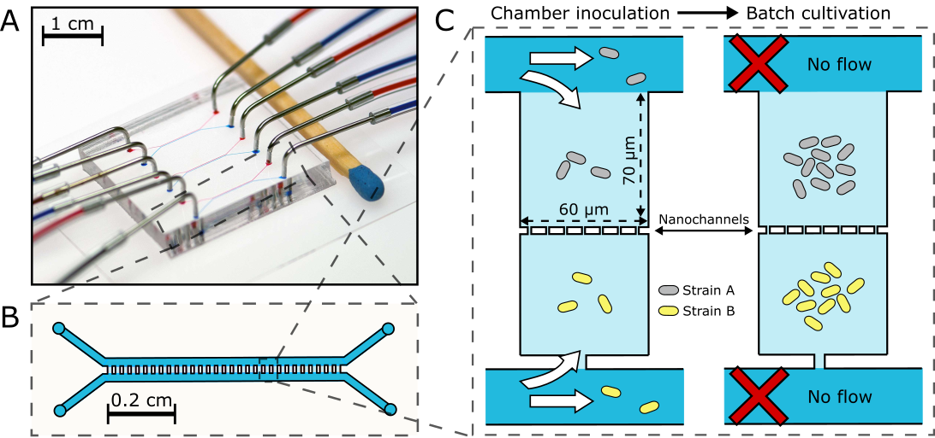

**Figure 4** Microfluidic single-cell co-cultivation device. (A) Image of a PDMS chip (match for size reference). (B) Illustration of one cultivation channel incorporating 50 cultivation chambers. (C) Illustration of a single co-cultivation chamber consisting of two chamber compartments separated by nanochannels (height = 1 µm, width = 600 nm). First, both strains are inoculated into the shallow cultivation chambers (height 1 µm) by flushing the cell suspension through the deeper supply channels (height 11 µm). Cells get randomly stuck in the cultivation chamber regions. Second, before time-lapse image acquisition, the flow is stopped to create batch conditions.

**Image analysis**

Images were processed and analyzed using the software Fiji.57,58 Using a tailor-made plug-in cells were separated from the background by applying different consecutive operations such as k-means clustering, despeckle filter, dilatation and watershed transformation. The final clustered phase contrast image was used as a mask for the fluorescence images at each time point. Subsequently, the particle analyzer was applied to determine the cell number as well as the area and fluorescence signal of each cell.

In detail, first the stack of the phase contrast images was split from the stack of fluorescence images. The phase contrast images were segmented with the plugin *k-means clustering*. Then the *threshold* function was used to select the cluster including the cells followed by the *despeckle* filter to remove noise. For better cell segmentation of cells that lie close together the *adjustable watershed* operation was performed. The segmented image was used as a mask for the fluorescence image and with the subtract function of the image calculator the cell clusters were extracted from the fluorescence images. The *threshold* function was again used to select only the fluorescing cells. Finally, the *particle analyzer* was applied to count the cells in each image.

**Microbioreactor cultivation**

For microtiter plate cultivations, pre-cultures done in shake flasks were centrifuged, the supernatant was discarded and OD600 was adjusted to 0.1 with fresh defined CGXII medium. Glucose concentration of this medium was 10 g/l and L-lysine concentration for controls was 10 mM. Depending on the condition, the defined medium contained varying amounts of IPTG. All cultivations were done in triplicates with a culture volume of 800 µL per well. For co-cultivations resuspended precultures were mixed in a ratio of 1:1.

Cultivations were performed in BioLector devices (m2p-labs GmbH, Baesweiler, Germany) using specialized 48-well microtiter plates (FlowerPlate, m2p-labs GmbH, Baesweiler, Germany) with optodes for measuring pH and dissolved oxygen and covered with gas-permeable sealing foils to minimize evaporation. Plates were shaken at 1400 rpm. The cultivation chamber was kept at 30 °C and 85 % humidity and was gassed with air. The BioLector device measured a backscatter (scattered light) signal, which correlates to the biomass of the culture, and fluorescence parameters either from the optodes or from the culture itself.

Specific growth rates were calculated from the backscatter signal by spline approximation similar to the method described by Radeck, Tenhaef et al.59 Instead of MATLAB, Python (Python Software Foundation, https://www.python.org/) with the packages numpy,60 scipy61 and csaps (https://github.com/espdev/csaps) was used. The backscatter signal was blanked by using the first data point and approximated by using the function “UnivariateSpline” from the csaps package. The first derivative of the resulting spline function was calculated by using the scipy method “interpolate.PPoly.derivative”. By dividing the resulting function by the blanked backscatter signal, the specific growth rate over time was calculated. The average of all data points laying in the exponential growth phase was formed to calculate the average specific growth rate.

**Product analysis**

Amino acid quantification was carried out by a high-performance liquid chromatography‐based method using an Agilent 1260 Infinity II system (Agilent Technologies Inc., Santa Clara, CA, USA) with precolumn derivatization using ortho‐phthalaldehyde and separation by a hydrophobic core shell column (Kinetex 5 µm EVO C18 100 Å 150 x 4.6 mm, Phenomenex Inc., Torrance, CA, USA). The derivatized amino acids were detected by fluorescence detection (Ex: 230 nm; Em: 460 nm). Mobile phase A contained per liter of deionized water 26 mmol NaH2PO4, 14.8 mmol Na2HPO4, and 0.5 % (v/v) tetrahydrofurane. pH was adjusted to 7.2 using a 10 M NaOH solution. Mobile phase B contained per liter 50 % (v/v) methanol, 45 % (v/v) acetonitrile, and 5 % (v/v) water. During one sample run, gradient elution (*t* = 0 min: B = 2 %, *t* = 2 min: B = 38 %, *t* = 6 min: B = 42 %, *t* = 7 min: B = 70 %, *t* = 13 min: B = 100 %, *t* = 17 min: B = 0 %) was done from mobile phase A to mobile phase B. Errors originating from derivatization efficiency were corrected by using α‐aminobutyric acid as internal standard. Each sample was measured as an analytical duplicate. Quantification was done by external calibration. Measurement errors were estimated by error propagation analysis using parametric bootstrapping and Monte Carlo sampling.62

**Acknowledgements**

A.G. gratefully acknowledges the Deutsche Forschungsgemeinschaft (DFG, German Research Foundation – 428038451) and the Helmholtz Association for funding this project (PD-311). S.N. acknowledges support from the Deutsche Forschungsgemeinschaft (priority program SPP2170, project no. 427904493). We thank Yannic Kerkhoff for support in image analysis.

**Supporting Information**

* Bulk analysis of co-culture strains using microtiter plate cultivations (S1 and S2)
* Growth characterization of *C. glutamicum* ∆*lysA* in microfluidic growth channels (S3)
* Cell numbers of *C. glutamicum* ∆*lysA* in co-cultivation with *C. glutamicum* wildtype and DM1727 in microfluidic growth chambers (S4)
* Control experiment of *C. glutamicum* Δ*lysA* in co-cultivation with *C. glutamicum* DM1727 pEKEx2-lysC-βFBR without the addition of IPTG in microfluidic growth chambers (S5)
* Fluorescence distribution of *C. glutamicum* Δ*lysA* in co-cultivation (S6)
* UV-A toxicity test with *C. glutamicum* (S7)

**Author Contribution**

Conceptualization and investigation: AB, AG. Experiments and analysis: AB, QA, LH, NT, FH, SS. Resources and review: JM, SN, DK. Writing: AB, AG.

**References**

(1) Cao, X.; Hamilton, J. J.; Venturelli, O. S. Understanding and Engineering Distributed Biochemical Pathways in Microbial Communities. *Biochemistry* **2019**, *58* (2), 94–107. https://doi.org/10.1021/acs.biochem.8b01006.

(2) Noack, S.; Baumgart, M. Communities of Niche-Optimized Strains: Small-Genome Organism Consortia in Bioproduction. *Trends Biotechnol.* **2019**, *37* (2), 126–139. https://doi.org/10.1016/j.tibtech.2018.07.011.

(3) Johnson, D. R.; Noack, S. Editorial Overview: Causes and Biotechnological Application of Microbial Metabolic Specialization. *Curr. Opin. Biotechnol.* **2020**, *62*, iii–vi. https://doi.org/10.1016/j.copbio.2020.01.007.

(4) Lindemann, S. R.; Bernstein, H. C.; Song, H.-S.; Fredrickson, J. K.; Fields, M. W.; Shou, W.; Johnson, D. R.; Beliaev, A. S. Engineering Microbial Consortia for Controllable Outputs. *ISME J.* **2016**, *10* (9), 2077–2084. https://doi.org/10.1038/ismej.2016.26.

(5) Sheth, R. U.; Cabral, V.; Chen, S. P.; Wang, H. H. Manipulating Bacterial Communities by in Situ Microbiome Engineering. *Trends Genet.* **2016**, *32* (4), 189–200. https://doi.org/10.1016/j.tig.2016.01.005.

(6) Brenner, K.; You, L.; Arnold, F. H. Engineering Microbial Consortia: A New Frontier in Synthetic Biology. *Trends Biotechnol* **2008**, *26* (9), 483–489. https://doi.org/10.1016/j.tibtech.2008.05.004.

(7) Saini, M.; Chiang, C. J.; Li, S. Y.; Chao, Y. P. Production of Biobutanol from Cellulose Hydrolysate by the Escherichia Coli Co-Culture System. *FEMS Microbiol. Lett.* **2016**, *363* (4), 1–5. https://doi.org/10.1093/femsle/fnw008.

(8) Kim, H. J.; Boedicker, J. Q.; Choi, J. W.; Ismagilov, R. F. Defined Spatial Structure Stabilizes a Synthetic Multispecies Bacterial Community. *Proc. Natl. Acad. Sci.* **2008**, *105* (47), 18188–18193. https://doi.org/10.1073/pnas.0807935105.

(9) Liu, Z.; Cichocki, N.; Bonk, F.; Günther, S.; Schattenberg, F.; Harms, H.; Centler, F.; Müller, S. Ecological Stability Properties of Microbial Communities Assessed by Flow Cytometry. *mSphere* **2018**, *3* (1), 1–13. https://doi.org/10.1128/mSphere.00564-17.

(10) Jiménez, D. J.; de Lima Brossi, M. J.; Schückel, J.; Kračun, S. K.; Willats, W. G. T.; van Elsas, J. D. Characterization of Three Plant Biomass-Degrading Microbial Consortia by Metagenomics- and Metasecretomics-Based Approaches. *Appl. Microbiol. Biotechnol.* **2016**, *100* (24), 10463–10477. https://doi.org/10.1007/s00253-016-7713-3.

(11) Co, A. D.; van Vliet, S.; Kiviet, D. J.; Schlegel, S.; Ackermann, M. Short-Range Interactions Govern the Dynamics and Functions of Microbial Communities. *Nat. Ecol. Evol.* **2020**. https://doi.org/10.1038/s41559-019-1080-2.

(12) van Vliet, S.; Dal Co, A.; Winkler, A. R.; Spriewald, S.; Stecher, B.; Ackermann, M. Spatially Correlated Gene Expression in Bacterial Groups: The Role of Lineage History, Spatial Gradients, and Cell-Cell Interactions. *Cell Syst.* **2018**, *6* (4), 496-507.e6. https://doi.org/10.1016/j.cels.2018.03.009.

(13) Coluccio, M. L.; Perozziello, G.; Malara, N.; Parrotta, E.; Zhang, P.; Gentile, F.; Limongi, T.; Raj, P. M.; Cuda, G.; Candeloro, P.; Di Fabrizio, E. Microfluidic Platforms for Cell Cultures and Investigations. *Microelectron. Eng.* **2019**, *208* (January), 14–28. https://doi.org/10.1016/j.mee.2019.01.004.

(14) Lecault, V.; White, A. K.; Singhal, A.; Hansen, C. L. Microfluidic Single Cell Analysis: From Promise to Practice. *Curr. Opin. Chem. Biol.* **2012**, *16* (3–4), 381–390. https://doi.org/10.1016/j.cbpa.2012.03.022.

(15) Long, Z.; Nugent, E.; Javer, A.; Cicuta, P.; Sclavi, B.; Cosentino Lagomarsino, M.; Dorfman, K. D. Microfluidic Chemostat for Measuring Single Cell Dynamics in Bacteria. *Lab Chip* **2013**, *13* (5), 947–954. https://doi.org/10.1039/c2lc41196b.

(16) Alnahhas, R. N.; Winkle, J. J.; Hirning, A. J.; Karamched, B.; Ott, W.; Josić, K.; Bennett, M. R. Spatiotemporal Dynamics of Synthetic Microbial Consortia in Microfluidic Devices. *ACS Synth. Biol.* **2019**, *8* (9), 2051–2058. https://doi.org/10.1021/acssynbio.9b00146.

(17) Burmeister, A.; Hilgers, F.; Langner, A.; Westerwalbesloh, C.; Kerkhoff, Y.; Tenhaef, N.; Drepper, T.; Kohlheyer, D.; von Lieres, E.; Noack, S.; Grünberger, A. A Microfluidic Co-Cultivation Platform to Investigate Microbial Interactions at Defined Microenvironments. *Lab Chip* **2019**, *19* (1), 98–110. https://doi.org/10.1039/C8LC00977E.

(18) Chen, Y.; Kim, J. K.; Hirning, A. J.; Josi, K.; Bennett, M. R. Emergent Genetic Oscillations in a Synthetic Microbial Consortium. *Science (80-. ).* **2015**, *349* (6251), 986–989. https://doi.org/10.1126/science.aaa3794.

(19) Marchand, N.; Collins, C. H. Peptide-Based Communication System Enables Escherichia Coli to Bacillus Megaterium Interspecies Signaling. *Biotechnol. Bioeng.* **2013**, *110* (11), 3003–3012. https://doi.org/10.1002/bit.24975.

(20) Hol, F. J. H.; Voges, M. J.; Dekker, C.; Keymer, J. E. Nutrient-Responsive Regulation Determines Biodiversity in a Colicin-Mediated Bacterial Community. *BMC Biol.* **2014**, *12* (1), 1–14. https://doi.org/10.1186/s12915-014-0068-2.

(21) Goñi-Moreno, A.; Amos, M.; de la Cruz, F. Multicellular Computing Using Conjugation for Wiring. *PLoS One* **2013**, *8* (6), e65986. https://doi.org/10.1371/journal.pone.0065986.

(22) Kouya, T.; Ishiyama, Y.; Tanaka, T.; Taniguchi, M. Evaluation of Positive Interaction for Cell Growth between Bifidobacterium Adolescentis and Propionibacterium Freudenreichii Using a Co-Cultivation System with Two Microfiltration Modules. *J. Biosci. Bioeng.* **2013**, *115* (2), 189–192. https://doi.org/10.1016/j.jbiosc.2012.09.005.

(23) Stephens, K.; Pozo, M.; Tsao, C. Y.; Hauk, P.; Bentley, W. E. Bacterial Co-Culture with Cell Signaling Translator and Growth Controller Modules for Autonomously Regulated Culture Composition. *Nat. Commun.* **2019**, *10* (1), 4129. https://doi.org/10.1038/s41467-019-12027-6.

(24) Velema, W. A.; Van Der Berg, J. P.; Szymanski, W.; Driessen, A. J. M.; Feringa, B. L. Orthogonal Control of Antibacterial Activity with Light. *ACS Chem. Biol.* **2014**, *9* (9), 1969–1974. https://doi.org/10.1021/cb500313f.

(25) Ren, X.; Baetica, A.-A.; Swaminathan, A.; Murray, R. M. Population Regulation in Microbial Consortia Using Dual Feedback Control. In *2017 IEEE 56th Annual Conference on Decision and Control (CDC)*; IEEE, 2017; Vol. 2018-Janua, pp 5341–5347. https://doi.org/10.1109/CDC.2017.8264450.

(26) Kolar, K.; Knobloch, C.; Stork, H.; Žnidarič, M.; Weber, W. OptoBase: A Web Platform for Molecular Optogenetics. *ACS Synth. Biol.* **2018**, *7* (7), 1825–1828. https://doi.org/10.1021/acssynbio.8b00120.

(27) Deisseroth, K. Optogenetics. *Nat. Methods* **2011**, *8* (1), 26–29. https://doi.org/10.1038/nmeth.f.324.

(28) Brieke, C.; Rohrbach, F.; Gottschalk, A.; Mayer, G.; Heckel, A. Light-Controlled Tools. *Angew. Chemie - Int. Ed.* **2012**, *51* (34), 8446–8476. https://doi.org/10.1002/anie.201202134.

(29) Binder, D.; Grünberger, A.; Loeschcke, A.; Probst, C.; Bier, C.; Pietruszka, J.; Wiechert, W.; Kohlheyer, D.; Jaeger, K. E.; Drepper, T. Light-Responsive Control of Bacterial Gene Expression: Precise Triggering of the Lac Promoter Activity Using Photocaged IPTG. *Integr. Biol. (United Kingdom)* **2014**, *6* (8), 755–765. https://doi.org/10.1039/c4ib00027g.

(30) Binder, D.; Bier, C.; Grünberger, A.; Drobietz, D.; Hage-Hülsmann, J.; Wandrey, G.; Büchs, J.; Kohlheyer, D.; Loeschcke, A.; Wiechert, W.; Jaeger, K. E.; Pietruszka, J.; Drepper, T. Photocaged Arabinose: A Novel Optogenetic Switch for Rapid and Gradual Control of Microbial Gene Expression. *ChemBioChem* **2016**, *17* (4), 296–299. https://doi.org/10.1002/cbic.201500609.

(31) Szymański, W.; Beierle, J. M.; Kistemaker, H. A. V.; Velema, W. A.; Feringa, B. L. Reversible Photocontrol of Biological Systems by the Incorporation of Molecular Photoswitches. *Chemical Reviews*. 2013. https://doi.org/10.1021/cr300179f.

(32) Rullan, M.; Benzinger, D.; Schmidt, G. W.; Milias-Argeitis, A.; Khammash, M. An Optogenetic Platform for Real-Time, Single-Cell Interrogation of Stochastic Transcriptional Regulation. *Mol. Cell* **2018**, *70* (4), 745-756.e6. https://doi.org/10.1016/j.molcel.2018.04.012.

(33) Milias-Argeitis, A.; Rullan, M.; Aoki, S. K.; Buchmann, P.; Khammash, M. Automated Optogenetic Feedback Control for Precise and Robust Regulation of Gene Expression and Cell Growth. *Nat. Commun.* **2016**, *7* (May). https://doi.org/10.1038/ncomms12546.

(34) Grünberger, A.; Probst, C.; Helfrich, S.; Nanda, A.; Stute, B.; Wiechert, W.; von Lieres, E.; Nöh, K.; Frunzke, J.; Kohlheyer, D. Spatiotemporal Microbial Single-Cell Analysis Using a High-Throughput Microfluidics Cultivation Platform. *Cytom. Part A* **2015**, *87* (12), 1101–1115. https://doi.org/10.1002/cyto.a.22779.

(35) Ohnishi, J.; Mitsuhashi, S.; Hayashi, M.; Ando, S.; Yokoi, H.; Ochiai, K.; Ikeda, M. A Novel Methodology Employing Corynebacterium Glutamicum Genome Information to Generate a New L-Lysine-Producing Mutant. *Appl. Microbiol. Biotechnol.* **2002**, *58* (2), 217–223. https://doi.org/10.1007/s00253-001-0883-6.

(36) Pátek, M.; Nešvera, J.; Guyonvarch, A.; Reyes, O.; Leblon, G. Promoters of Corynebacterium Glutamicum. *J. Biotechnol.* **2003**, *104* (1–3), 311–323. https://doi.org/10.1016/S0168-1656(03)00155-X.

(37) Lausberg, F.; Chattopadhyay, A. R.; Heyer, A.; Eggeling, L.; Freudl, R. A Tetracycline Inducible Expression Vector for Corynebacterium Glutamicum Allowing Tightly Regulable Gene Expression. *Plasmid* **2012**, *68* (2), 142–147. https://doi.org/10.1016/j.plasmid.2012.05.001.

(38) Young, D. D.; Deiters, A. Photochemical Activation of Protein Expression in Bacterial Cells. *Angew. Chemie - Int. Ed.* **2007**, *46* (23), 4290–4292. https://doi.org/10.1002/anie.200700057.

(39) Binder, D.; Frohwitter, J.; Mahr, R.; Bier, C.; Grünberger, A.; Loeschcke, A.; Peters-Wendisch, P.; Kohlheyer, D.; Pietruszka, J.; Frunzke, J.; Jaeger, K.; Wendisch, V.; Drepper, T. Light-Controlled Cell Factories – Employing Photocaged IPTG for Light-Mediated Optimization of Lac-Based Gene Expression and (+)-Valencene Biosynthesis in Corynebacterium Glutamicum. *Appl. Environ. Microbiol.* **2016**, No. 20, 6141–6149. https://doi.org/10.1128/AEM.01457-16.Editor.

(40) Binder, D.; Drepper, T.; Jaeger, K. E.; Delvigne, F.; Wiechert, W.; Kohlheyer, D.; Grunberger, A. Homogenizing Bacterial Cell Factories: Analysis and Engineering of Phenotypic Heterogeneity. *Metab Eng* **2017**, *42*, 145–156. https://doi.org/10.1016/j.ymben.2017.06.009.

(41) Wandrey, G.; Bier, C.; Binder, D.; Hoffmann, K.; Jaeger, K.-E.; Pietruszka, J.; Drepper, T.; Büchs, J. Light-Induced Gene Expression with Photocaged IPTG for Induction Profiling in a High-Throughput Screening System. *Microb. Cell Fact.* **2016**, *15* (1), 63. https://doi.org/10.1186/s12934-016-0461-3.

(42) Lindemann, D.; Westerwalbesloh, C.; Kohlheyer, D.; Grünberger, A.; Von Lieres, E. Microbial Single-Cell Growth Response at Defined Carbon Limiting Conditions. *RSC Adv.* **2019**, *9* (25), 14040–14050. https://doi.org/10.1039/c9ra02454a.

(43) Kaganovitch, E.; Steurer, X.; Dogan, D.; Probst, C.; Wiechert, W.; Kohlheyer, D. Microbial Single-Cell Analysis in Picoliter-Sized Batch Cultivation Chambers. *N. Biotechnol.* **2018**, *47*, 50–59. https://doi.org/10.1016/j.nbt.2018.01.009.

(44) Binder, S.; Schendzielorz, G.; Stabler, N.; Krumbach, K.; Hoffmann, K.; Bott, M.; Eggeling, L. A High-Throughput Approach to Identify Genomic Variants of Bacterial Metabolite Producers at the Single-Cell Level. *Genome Biol* **2012**, *13* (5), R40. https://doi.org/10.1186/gb-2012-13-5-r40.

(45) Täuber, S.; Lieres, E.; Grünberger, A. Dynamic Environmental Control in Microfluidic Single‐Cell Cultivations: From Concepts to Applications. *Small* **2020**, *16* (16), 1906670. https://doi.org/10.1002/smll.201906670.

(46) Zhang, Y.; Shang, X.; Lai, S.; Zhang, G.; Liang, Y.; Wen, T. Development and Application of an Arabinose-Inducible Expression System by Facilitating Inducer Uptake in Corynebacterium Glutamicum. *Appl. Environ. Microbiol.* **2012**, *78* (16), 5831–5838. https://doi.org/10.1128/AEM.01147-12.

(47) Lee, M. J.; Kim, P. Recombinant Protein Expression System in Corynebacterium Glutamicum and Its Application. *Front. Microbiol.* **2018**, *9* (OCT). https://doi.org/10.3389/fmicb.2018.02523.

(48) Bertani, G. Studies on Lysogenesis. I. The Mode of Phage Liberation by Lysogenic Escherichia Coli. *J. Bacteriol.* **1951**, *62* (3), 293–300.

(49) Eggeling, L.; Bott, M. *Handbook of Corynebacterium Glutamicum*; 2005. https://doi.org/10.1201/9781420039696.

(50) Abe, S.; Takayama, K. I.; Kinoshita, S. Taxonomical Studies on Glutamic Acid-Producing Bacteria. *J. Gen. Appl. Microbiol.* **1967**, *13* (3), 279–301. https://doi.org/10.2323/jgam.13.279.

(51) Hentschel, E.; Will, C.; Mustafi, N.; Burkovski, A.; Rehm, N.; Frunzke, J. Destabilized EYFP Variants for Dynamic Gene Expression Studies in Corynebacterium Glutamicum. *Microb. Biotechnol.* **2013**, *6* (2), 196–201. https://doi.org/10.1111/j.1751-7915.2012.00360.x.

(52) Vrljic, M.; Kronemeyer, W.; Sahm, H.; Eggeling, L. Unbalance of L-Lysine Flux in Corynebacterium Glutamicum and Its Use for the Isolation of Excretion-Defective Mutants. *J. Bacteriol.* **1995**, *177* (14), 4021–4027. https://doi.org/10.1128/jb.177.14.4021-4027.1995.

(53) Eikmanns, B. J.; Kleinertz, E.; Liebl, W.; Sahm, H. A Family of Corynebacterium Glutamicum/Escherichia Coli Shuttle Vectors for Cloning, Controlled Gene Expression, and Promoter Probing. *Plasmid* **1991**, *102*, 93–98.

(54) Unthan, S.; Grünberger, A.; van Ooyen, J.; Gätgens, J.; Heinrich, J.; Paczia, N.; Wiechert, W.; Kohlheyer, D.; Noack, S. Beyond Growth Rate 0.6: What Drives Corynebacterium Glutamicum to Higher Growth Rates in Defined Medium. *Biotechnol. Bioeng.* **2014**, *111* (2), 359–371. https://doi.org/10.1002/bit.25103.

(55) Gruenberger, A.; Probst, C.; Heyer, A.; Wiechert, W.; Frunzke, J.; Kohlheyer, D. Microfluidic Picoliter Bioreactor for Microbial Single-Cell Analysis: Fabrication, System Setup, and Operation. *J. Vis. Exp.* **2013**, No. 82, 50560. https://doi.org/10.3791/50560.

(56) Probst, C.; Grünberger, A.; Braun, N.; Helfrich, S.; Nöh, K.; Wiechert, W.; Kohlheyer, D. Rapid Inoculation of Single Bacteria into Parallel Picoliter Fermentation Chambers. *Anal. Methods* **2015**, *7* (1), 91–98. https://doi.org/10.1039/c4ay02257b.

(57) Ducret, A.; Quardokus, E. M.; Brun, Y. V. MicrobeJ, a Tool for High Throughput Bacterial Cell Detection and Quantitative Analysis. *Nat. Microbiol.* **2016**, *1* (7), doi:10.1038/nmicrobiol.2016.77.

(58) Schindelin, J.; Arganda-Carreras, I.; Frise, E.; Kaynig, V.; Longair, M.; Pietzsch, T.; Preibisch, S.; Rueden, C.; Saalfeld, S.; Schmid, B.; Tinevez, J. Y.; White, D. J.; Hartenstein, V.; Eliceiri, K.; Tomancak, P.; Cardona, A. Fiji: An Open-Source Platform for Biological-Image Analysis. *Nat. Methods* **2012**, *9* (7), 676–682. https://doi.org/10.1038/nmeth.2019.

(59) Radek, A.; Tenhaef, N.; Müller, M. F.; Brüsseler, C.; Wiechert, W.; Marienhagen, J.; Polen, T.; Noack, S. Miniaturized and Automated Adaptive Laboratory Evolution: Evolving Corynebacterium Glutamicum towards an Improved D-Xylose Utilization. *Bioresour. Technol.* **2017**, *245*, 1377–1385. https://doi.org/10.1016/j.biortech.2017.05.055.

(60) Harris, C. R.; Millman, K. J.; van der Walt, S. J.; Gommers, R.; Virtanen, P.; Cournapeau, D.; Wieser, E.; Taylor, J.; Berg, S.; Smith, N. J.; Kern, R.; Picus, M.; Hoyer, S.; van Kerkwijk, M. H.; Brett, M.; Haldane, A.; del Río, J. F.; Wiebe, M.; Peterson, P.; Gérard-Marchant, P.; Sheppard, K.; Reddy, T.; Weckesser, W.; Abbasi, H.; Gohlke, C.; Oliphant, T. E. Array Programming with NumPy. *Nature* **2020**, *585* (7825), 357–362. https://doi.org/10.1038/s41586-020-2649-2.

(61) Virtanen, P.; Gommers, R.; Oliphant, T. E.; Haberland, M.; Reddy, T.; Cournapeau, D.; Burovski, E.; Peterson, P.; Weckesser, W.; Bright, J.; van der Walt, S. J.; Brett, M.; Wilson, J.; Millman, K. J.; Mayorov, N.; Nelson, A. R. J.; Jones, E.; Kern, R.; Larson, E.; Carey, C. J.; Polat, İ.; Feng, Y.; Moore, E. W.; VanderPlas, J.; Laxalde, D.; Perktold, J.; Cimrman, R.; Henriksen, I.; Quintero, E. A.; Harris, C. R.; Archibald, A. M.; Ribeiro, A. H.; Pedregosa, F.; van Mulbregt, P.; Vijaykumar, A.; Bardelli, A. Pietro; Rothberg, A.; Hilboll, A.; Kloeckner, A.; Scopatz, A.; Lee, A.; Rokem, A.; Woods, C. N.; Fulton, C.; Masson, C.; Häggström, C.; Fitzgerald, C.; Nicholson, D. A.; Hagen, D. R.; Pasechnik, D. V.; Olivetti, E.; Martin, E.; Wieser, E.; Silva, F.; Lenders, F.; Wilhelm, F.; Young, G.; Price, G. A.; Ingold, G. L.; Allen, G. E.; Lee, G. R.; Audren, H.; Probst, I.; Dietrich, J. P.; Silterra, J.; Webber, J. T.; Slavič, J.; Nothman, J.; Buchner, J.; Kulick, J.; Schönberger, J. L.; de Miranda Cardoso, J. V.; Reimer, J.; Harrington, J.; Rodríguez, J. L. C.; Nunez-Iglesias, J.; Kuczynski, J.; Tritz, K.; Thoma, M.; Newville, M.; Kümmerer, M.; Bolingbroke, M.; Tartre, M.; Pak, M.; Smith, N. J.; Nowaczyk, N.; Shebanov, N.; Pavlyk, O.; Brodtkorb, P. A.; Lee, P.; McGibbon, R. T.; Feldbauer, R.; Lewis, S.; Tygier, S.; Sievert, S.; Vigna, S.; Peterson, S.; More, S.; Pudlik, T.; Oshima, T.; Pingel, T. J.; Robitaille, T. P.; Spura, T.; Jones, T. R.; Cera, T.; Leslie, T.; Zito, T.; Krauss, T.; Upadhyay, U.; Halchenko, Y. O.; Vázquez-Baeza, Y. SciPy 1.0: Fundamental Algorithms for Scientific Computing in Python. *Nat. Methods* **2020**, *17* (3), 261–272. https://doi.org/10.1038/s41592-019-0686-2.

(62) Efron, B. Bootstrap Methods: Another Look at the Jackknife. *Ann. Stat.* **1979**, *7* (1), 1–26. https://doi.org/10.1214/aos/1176344552.

**For Table of Contents Only**

