The Charge Transport Mechanism in Brønsted-Acidic Protic Ionic Liquid/Water Systems – An NMR and QENS Study

Jingjing Lin,a,b Daria Noferini,c,d Emmanouil Veroutis,e,f Carsten Korte,a,b* Olaf Holderer, c

a Forschungszentrum Jülich GmbH, Institute of Energy and Climate Research - Fuel Cells (IEK-14), 52425 Jülich, Germany

b RWTH Aachen University, 52062 Aachen, Germany

c Forschungszentrum Jülich GmbH, Jülich Centre for Neutron Science (JCNS) at Heinz Maier-Leibnitz Zentrum (MLZ), 85747 Garching, Germany

d European Spallation Source ERIC, P.O. Box 176, 22100 Lund, Sweden

e Forschungszentrum Jülich GmbH, Institute of Energy and Climate Research - Fundamental Electrochemistry (IEK-9), 52428 Jülich, Germany

f RWTH Aachen University, Institute of Technical and Macromolecular Chemistry, 52062 Aachen, Germany

KEYWORDS: protic ionic liquid, proton transport, NMR, quasielastic neutron scattering, fuel cell

**ABSTRACT**

In this study, a protic ionic liquid (PIL), 2-Sulfoethylmethylammonium triflate [2-Sema][TfO] is considered as a potential new proton conducting electrolyte for future polymer membrane fuel cells capable of ambient air operation above 100 °C. The proton dynamics of the PIL with residual water are examined as a function of the hydration level on different time scales using pulsed field gradient nuclear magnetic resonance (PFG-NMR) and quasi-elastic neutron scattering (QENS). The separation of the different contribu­ting relaxation processes enables a quantification of the proton fractions for the underlying hopping or vehicular motions. The hopping motion of the water in the time scale of picosecond and the vehicular motion in the time scale of nanosecond are detected by means of QENS. Such dynamic processes can be well described by the Chudley-Elliot jump model. This emphasised the presence of fixed jump lenghts. In the timescale of millisecond, the cooperative transport of the active protons of the acidic SO3H group and of the H2O molecules, as well as the vehicular transport of the PIL cations are detected by NMR. The different diffusion coefficients obtained by the NMR and QENS techniques are discussed in detail.

**1. INTRODUCTION**

The operation of polymer electrolyte fuel cells (PEFCs) at elevated temperatures above 100 °C carries significant advantages, such as: *i*) a simplified system setup because water recyclation and feed gas humidification is not necessary, *ii*) a more efficient cooling of the cell, *iii*) the possibility of recovering high-grade waste heat and *iv*) a lower sensiti­vity to CO contamination.[1-3] This is especially the case for electric cars. At elevated temperatures, a suitable membrane material instead of NAFION should maintain its conductivity also at anhydrous conditions. High temperature PEFCs (HT-PEFCs) that use phosphoric acid (H3PO4)-doped polybenzimidazole (PBI) mem­branes are able to operate without humidification.[1, 4, 5] However, a slow cathodic oxygen reduction reaction (ORR) ki­netics will be caused by the presence of H3PO4.[6] This results from an insufficient oxygen solubility and diffusivity, and also an inhibition effect from the ad­sorption of H3PO4 and its anionic species on active sites of the redox catalyst platinum.[7, 8] Thus, there is a necessity for alternative proton-conducting electrolytes that opera­te under non-aqueous conditions in the temperature range of 100–160°C.

Protic ionic liquids (PILs) have drawn research attention for possible application as non-aqueous electrolytes in PEFCs at operating temperatures above 100 °C, due to their low lattice energy, wide electrochemical windows, good conductivity and low flam­ma­bility.[9-14] In an anhydrous PIL, protons can only be transported *via* the motion of protonated ionic species by a vehicle mechanism.[15] Conductivity and viscosity are coupled to each other as per the Stokes-Einstein relation.[16, 17] Therefore, a drawback of electrolytes based on PILs is often a poor conductivity due to a comparably high viscosity. However, PILs with strong acidic ions are often highly hygroscopic. Considering the fact that water will be gen­era­ted on the cathode side during fuel cell operation,[18] this will result in a steady-state concentration of residual water due to the hygroscopicity of the strongly acidic PIL and the fuel cell’s load-dependent water production. Water can partici­pate in the proton transfer process in the PILs by enabling a cooperative transport me­chanism, acting as a proton acceptor, carrier and donor.[19, 20]

Considering the covered distances and the related time scales, there are three different types of motional processes for the proton conduction in a PIL: *i*) a slow long-range vehicular migration by the translational diffusion of proton carrying species[21] *ii*) a fast long-range cooperative/Grotthuss-like migration by a sequence of fast uncorrelated proton hoppings between different neighbouring proton acceptors/donors through the H-bond network[22] and *iii*) a local fast proton hopping between neighboring proton acceptors/donors.[23] Thus, the local motional process *iii*) includes both the fast uncorrelated hopping that underlies the long range cooperative migration and the strongly correlated (to-and-fro) hopping that does not contribute to any long-range migration. In the case of the cooperative migraton mechanism ii) the proton charge carriers cover distances on the order of 10 Å in time scales on the order of μs, while the individual protons hop over distances of about 2 Å with time scales on the order of ns.[23-26]

In a previous study, the proton transport mechanisms in a system consisting of a highly acidic ionic liquid, 2-Sulfo­ethyl­methylammonum triflate [2-Sema][TfO] and H2O has been investigated by using 1H-NMR and 1H-PFG-NMR.[19] The acidity of the [2-Sema]+ cationcontaining an -SO3H groupis estimated to be p*K*A1 ≈ −1.[18] Thus, its acidity is comparable to that of hydroxonium cations H3O+ (p*K*A = 0). The protolysis equilibrium between the [2-Sema]+ cation and water leads to fast intermolecular proton transfers. The cooperative and the vehicular transport can be detected by NMR. The 1H-NMR spectrum of [2-Sema][TfO] with an equimolar content of water is depicted in Figure 1 (50 mol%, respectively 6 wt% H2O). There are no separate peaks for the active protons in the SO3H moieties, H2O mole­cules and H3O+ ions. The exchange rates of these active protons are too fast compared to the energetic separation expressed as a frequency difference Δ*ν*, *i.e.*, the time scale of the NMR experiment.[27] This leads to a combined signal of the SO3H/H2O/H3O+ protons at an averaged ppm value, which depends on the relative populations of the species. Moreover, according to the 1H-PFG-NMR measure­ments, the self-diffusion coefficient of the SO3H/H2O/H3O+ pro­tons is higher compared to the other protons of the cation, *i.e.* the C-H and N-H pro­tons. This observation indicates the presence of a fast cooperative transport provided by a fast proton exchange between the SO3H moieties and H2O molecules.[19, 20] However, the local motional process, *i.e.* the fast proton hopping, occuring on time scales of nano- to picoseconds, is not covered by PFG-NMR.[28]

Quasi-elastic neutron scattering (QENS) is a powerful tool for studying the diffusion­nal dynamics of protons at a molecular level.[29-34] An advantage of QENS compared to PFG-NMR methods is its ability to detect spatial information of the diffusion process by using the dependence of the scattering signal on the momentum transfer *Q*. QENS is thus able to directly detect the nanosecond to picosecond proton dynamics across a wide *Q* range. Compared to the nuclei of other elements, 1H has the largest incoherent scattering cross section. By employing QENS, the proton dynamics can be spatially resolved on molecular length and time scales. Proton hopping in PILs was character­rized in QENS experiments.[28, 35] Burankova et al. investigated the triethylammonium triflate (TEA-TfO) using QENS. They observed a hopping motion of the NH protons that was faster than the vehicular diffusion of the cation.[28] The interplay between the vehi­cular and proton hopping was scrutinized for imidazolium bis(tri­fluoromethylsufonyl)­imide ([Im][TFSI]) with excess imidazole by means of QENS and PFG-NMR by Hoarfrost et at.[35] The significant presence of proton hopping as a prerequisite for long-range cooperative transport becomes manifest in a high proton conductivity of [Im][TFSI] with excess imidazole.[35]

In this study, we investigate the [2-Sema][TfO] from neat to mixtures with an equimolar water content *via* QENS and PFG-NMR in order to gain insights into the proton transport dy­namics. Motivated by the intent to utilise PILs as future electrolytes at elevated operation temperature, the ratio of the different proton motion processes, in particular, in the presence of H2O was considered. The different diffusion coefficients obtained by the PFG-NMR and QENS techniques are discussed below.

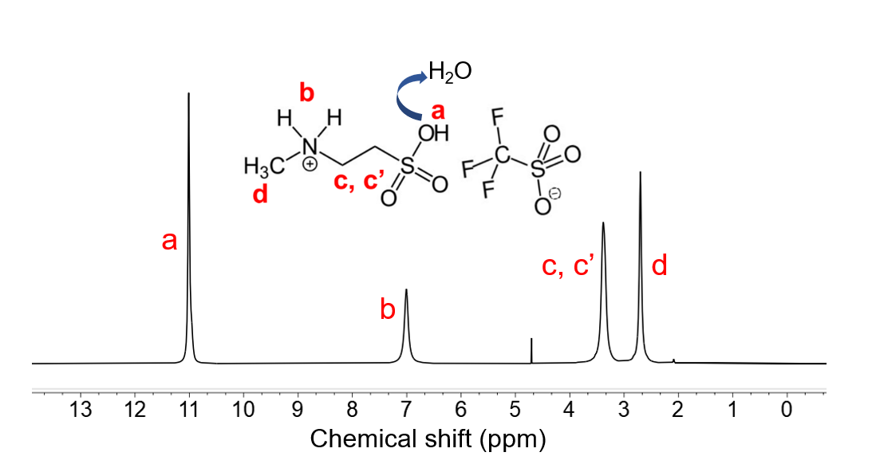

**Figure 1.** The 1H-NMR spectrum of [2-Sema][TfO] with an equimolar water content (6 wt% H­2O) at 25oC. Peaks at 2.1 ppm and 4.8 ppm correspond to an impurity and the residual non deuterated proton of D2O in the capillary, respectively.

**2. EXPERIMENTAL**

**2.1 Preparation of the used PILs and PIL + H2O mixtures**

2-Sulfoethylmethylammonum triflate [2-Sema][TfO] was prepared by slowly adding Trifluoromethanesulfonic acid (reagent grade 98%, Sigma Aldrich, USA) to 2-Methyl­amino­ethansulfonic acid (N-Methyltaurine ≥99%, Sigma Life Science, USA). A more detailed de­scription can be found elsewhere.[36] By using Karl-Fischer titration, an initial water con­tent of 0.67 wt% could be found (coulometric mode, 852 Titrando/Metrohm AG).

By adding appropriate amounts of H2O, a series with mass fractions of 0.67–6 wt% was obtained. The actual (absolute) H2O content was verified by Karl-Fischer titration. A water content of ~6 wt% corresponds to an equimolar ratio of PIL and H2O molecules.

N-Methyltaurine powder was mixed with D2O in a 1:5 molar ratio for 48 h at room tempe­rature to affect the deuteration of the active protons. The obtained deuterated sample was hea­ted to 120 oC to fully remove the remaining H2O and D2O. The deuteration process was then repeated to achieve complete exchange of the NH2 group.

**2.2 1H and PFG-NMR measurement**

The acquisition of the 1H NMR spectra was performed using a Bruker 600 MHz spec­trometer, equipped with a 5 mm cryoprobe. A capillary filled with D2O, was included in the sample tubes to providefield frequency lock. Measurements were conduc­ted at ambient temperature (25 °C).

The PFG-NMR experiments were performed on a Bruker Avance III HD spectrometer operating at 600 MHz 1H frequency, equipped with a 5 mm BBO-H/F-Z Gradient diffusion probe (max. 17 T/m at 60A). A BCU-I chiller unit was used to regulate the temperature (25±0.3°C), which was calibrated with methanol-d4 (CD3OD, ≥99.8% purity, Sigma-Aldrich).[37] For the diffusion measurements a stimulated echo sequence with an additional eddy current delay (ledSTE) was employed. The diffusion and gradient lengths were fixed to 350 ms and 2 ms respectively and the gradient strength was linearly increased in 16 increments. The sample was allowed to equili­brate for at least 10 min prior to each measurement. The data were fitted with the Stejskal-Tanner equation[38] (Eq. 1) in order to obtain the diffusion coefficients. The experimen­tal uncertainty in the diffusion coefficients was about 4%, which was estimated by repeating the measurement three times.

The proton diffusion coeffi­cients were obtained from the intensity decay as a function of the pulsed field gradient strength *G* as,

(1)

where *D* is the diffusion coefficient, *γ* the 1H gyromagnetic ratio, *δ* the gradient duration and the diffusion time.

**2.3 QENS measurement**

The QENS experiments were performed using the SPHERES high-resolution backscattering spectrometer at the Heinz Maier-Leibnitz Zentrum (MLZ) in Garching, Germany.[39, 40] An inci­dent wavelength of 6.27 Å and Si111 (unpolished) analysers were used in the SPHERES spectro­meter, resulting in a resolution of 0.66 µeV (full width at half maximum, FWHM). The mea­surements were conducted by operating the Doppler-monochromator at 4.7 m/s, yielding a dynamic range of ca ±30 µeV. The full *Q*-range coverage in reciprocal space went from ~0.4 to ~1.8 Å−1 (the range used for the data evaluation was from ~0.7 to ~1.6 Å−1), which trans­lates to *d* = 2/*Q* in real space, *i.e.* in the range of the atomic and molecular length scales. Due to the large incoherent scattering cross sec­tion of hydrogen, the scattering func­tion *S*(*Q*,), which is the double Fourier transform of the Van Hove cor­relation function from real space into reciprocal space and from time to the energy domain, is domina­ted by the incoherent hydrogen scattering. Incoherent scattering thus provides the Fourier transform of the self-correlation function of individual hydrogen atoms without correlation between different H atoms. The ionic liquid [2-Sema][TfO] has high Brønsted aci­dity. It is aggressive to aluminium, which is a standard material for QENS sample hol­ders. Thus, 3 cm x 3 cm x 0.5 mm quartz cells were used instead. During the experi­ment the cell was carried by an Al frame placed in front of the beam on the sample table within the instrument housing. The cell was orientated at 45° in transmission. The measurements were performed at 25°C. An empty cell was measu­red for the background subtraction. The signal from a vana­dium foil with the same geo­metry was then used for nor­malisation of the detector and as the resolu­tion function.

**2.4 QENS data analysis**

The data were fitted by using a model with two Lorentzian scattering functions, *L1* and *L2*:[29]

(2)

The amplitudes of the two Lorentz functions *L*1 and *L*2 were denoted as *A*1 and *A*2. An additional amplitude of an elastic contribution *δ* is expressed as *Aelast*, which results from protons moving too slow for the energy window probed by backscattering spectroscopy. The contribution from the sample container was subtracted. The functions were convoluted with the resolution function *R*(*Q*,). A remaining flat background is accounted for by the last term *bkg*. It comes from scattering processes with much larger energy transfer than the energy window of the backscattering spectrometer.

Each diffusive process measured with QENS can be regarded on macroscopic scales as the Fourier transform in time and space of the solution of Fick’s second law of diffusion,[29] the van Hove correlation function, which is a Lorentzian in (Q,)-space. If several different diffusion processes are expected from the composition of the sample, a Lorentzian for each contribution has to be considered. Two Lorentzians *Li* (*i* = 1, 2) were required in the present case to sufficiently describe the experimental data, indicating the presence of two dynamic processes in the energy window of the backscattering spectrometer. The Lorentzians have the form:

(3)

The half width at half maximum (HWHM) *Γi* is connected to the timescale of the motion proces­ses. Its *Q*-dependence conveys information regarding the type of the motion process. In the limit of large length scales (small *Q* values and the modulus of the reciprocal wave vector), *Γi* relates to the self-diffusion coefficient *Di* of the proton species involved in the motion process by *Γi* =*ħDiQ*2.[41] The short range behaviour can be mo­delled with a jump diffusion model,[42] in which the self-diffusion coefficient depends on a residence time τ*i* at a certain position and a jump length to the next position: *Di* = /(6**). For fixed jump lengths, the Chudley and Elliot model gives:[43]

(4)

For very short distances (*i.e.* a large *Q*) the rate approaches the residence time, *Γi* =*ħ/τi*, and for large distances the self-diffusion is recovered *Γi* =*ħDiQ*2.

**3. RESULTS AND DISCUSSION**

**3.1 Proton dynamics of the [2-Sema]+ cation in [2-Sema][TfO]-H2O mixtures**

The QENS spectra of [2-Sema][TfO] for *Q* = 1.11 Å−1 with a water content of 0.67, 2, 4 and 6 wt% are shown in Figure 2. The value of *Q* = 1.11 Å−1 is the average value over 5 individual detectors from 0.78 to 1.4 Å−1. The solid red curve is obtained by fitting the data using Eq. (2). The broad Lorentzian *L*1 (solid blue) represents a faster process, the narrow Lorent­zian, *L*2 (solid green) represents a slower process and the elastic intensity *δ*, (dashed orange) represents dynamics which are too slow to be properly resolved by the instrument at the investigated temperature. The constant background *bkg* is repre­sented by a dashed green line. However, it is difficult to separate *L*2 from the elastic contribu­tion *δ* by the fitting procedure. Thus, the two components are not assigned to specific motions, but rather considered as an average of the slow vehi­cular diffusion processes. A more detailed discussion of the different components is presented in this sec­tion as shown in Figure 5.

It can be noticed that, of the three proton motion processes that are listed in the introduction, the second of these—the cooperative transport—is a long-range transport process by subsequent short-range hopping processes of more than one individual proton from site to site, instead of the continuous motion of a single proton. Thus, in the timescale of QENS, the (complex) co­operative transport would not contri­bute to the Lorentzians, whereas the other two processes, *i.e.* the proton hopping and vehicular transports will be represented by the Lorentzians in the QENS spectra.

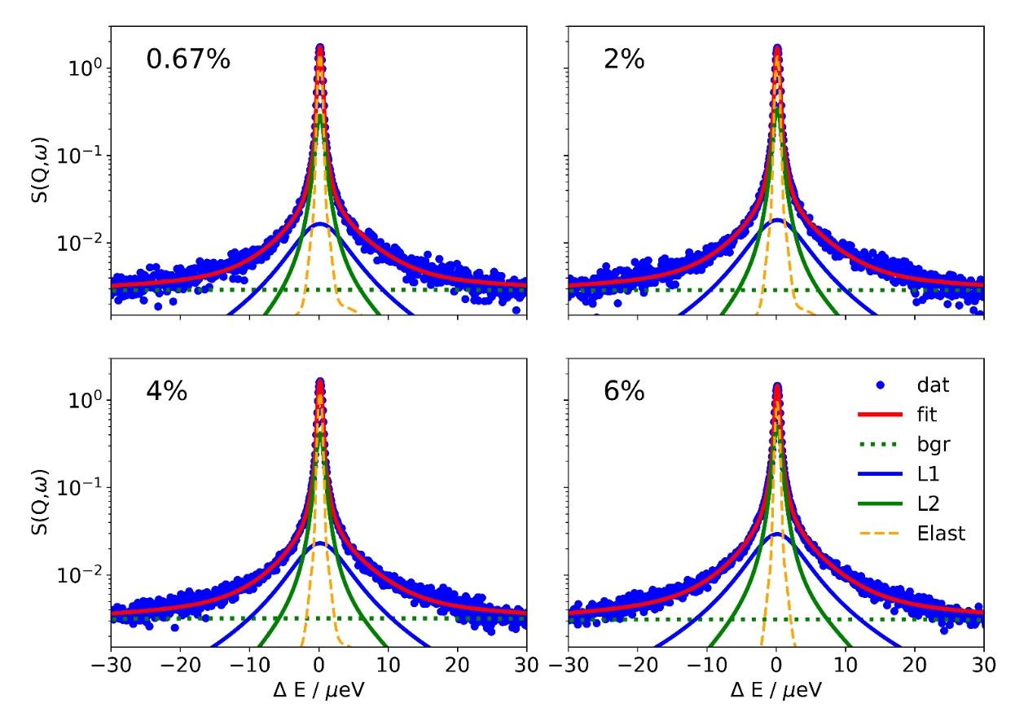

**Figure 2**. The QENS spectrum of [2-Sema][TfO] with 0.67, 2, 4, and 6 wt% water content for *Q* = 1.11 Å−1. The solid red lines are the total fits to the data, while the solid blue and green lines are the component fits (two Lorentizian functions.) The dashed green line is the background and the dashed orange line is the contribution of elastic intensity.

The *Q*-dependence of the *Γi* of the sample with an equimolar water content (6 wt%) is depicted in Figure 3. The *Q*-dependencies of the other samples with water contents of 0.67, 2 and 4 wt%, are depicted in Figure S2 in the supplementary information section. The data points are plotted with a binning of two adjacent *Q*-values. The curves in Figure 3 are fits according to the Chudley and Elliott model as conveyed in Eq. (4), the fitting values and are listed in Table 2. Models that include a jump length dis­tribution, such as the Hall and Ross model[44] (with a Gaussian jump length distri­bution) or the Singwi and Sjölander model38 with an expo­nential distribution did not satisfactorily match the progression of the data points. Therefore, the simplest possibility of a fixed jump length has been maintained for modelling the data. The HWHM *Γ*1of *L*1 shown in Figure 3 (a) is essen­tially *Q*-independent in the interval *Q*2 = 1.0–2.5 Å−2.This suggests a short-range proton hopping between neighbouring molecules/ions. The data point at *Q*2= 2.6 Å−2, appears to be an outlier. At this high *Q*-values, however, the background of the spectra is fairly high and so the fit of the fast component is less reliable, as is apparent from the high associated error. In the case of *L*2 shown in Figure 3 (b), the QENS broadening increases with *Q* up to the highest measured values, which is evident for the diffusional nature of the process, and therefore a vehicular motion process is in­dicated. With a small *Q*, there is a virtually linear dependence of the HWHM *Γ2* with *Q*2, which corresponds to a continuous diffusion.[29] There is no distinct plateau in the *Γ2 vs. Q*-data for *L*2. The diffusion coefficient *D*2 is well defined as the slope of the *L2* fitting curve at low *Q*. Thus, the faster Lorentzian*L*1 is related to a proton hopping process, whereas the slower Lorentzian *L*2 is related to a vehicular motion of the species.

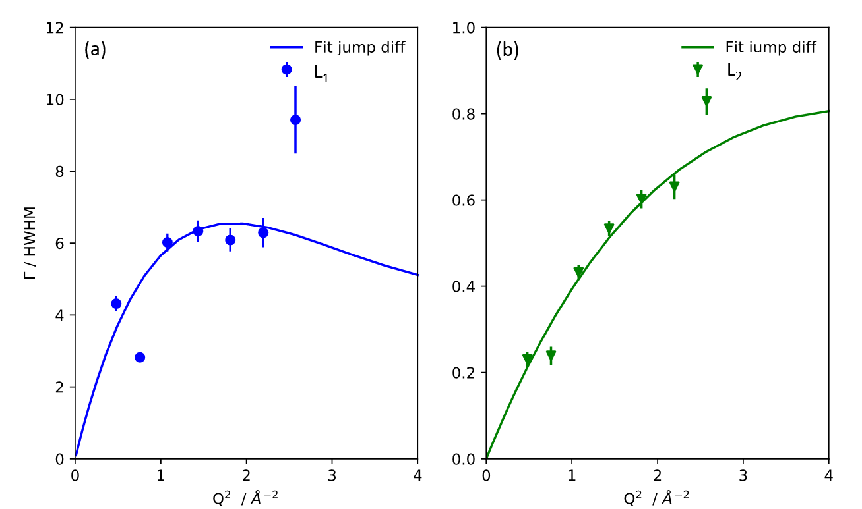

**Figure 3**. The *Q*-dependence of HWHM ** of (a) the *L*1 and (b) the *L*2 in the equimolar water content (6 wt% H2O) [2-Sema][TfO]. Solid lines correspond to fits with Eq.(4).

When considering the short-range hopping process, the kinetics of the proton transfer is related to the acidity (pKA) of the species. The state of the protolysis equilibrium between the proton donor and of the conjugated acid of the proton acceptor depends on the acidity difference Δp*K*A. The equilibrium constant *K*A is equal to the ratio of the rate constant for the proton transfer from the donator to the acceptor and for the back transfer in the opposite direction, which is also the ratio of the residence times. In the mixture of [2-Sema][TfO] and H2O, the protons of the SO3H and the NH2+ moiety, the H2O and H3O+ protons can be regarded as active compared to the methyl and ethyl protons. Thus, in the network of H-bonds between [2-Sema]+ and H3O+ cations, [TfO]− anions and H2O molecules, each of these protons is in a dynamic equilibrium. However, compared to the highly acidic SO3+ moiety or the H3O+ cation, the NH2+ moiety has a much lower acidity. It is about ten orders of magnitude lower ([2-Sema]+: pKA1 = -1; 2-Methyltaurine: pKA2 = 10.2; H3O+: pKA = 0.0).[18] Thus, the rate of proton transfers starting from the NH2+ moiety to neighbouring acceptors protons is much lower compared to the other donors such as the SO3H moiety or the H3O+ cation. This suggests that a proton will largely stay on the NH2+ moiety for relatively long time periods.

In the time scale of an NMR experiment, the high activity of the SO3H protons is evident when observing the proton exchange with H2O, whereas the NH2+ protons show almost no exchange. When the water content increases, only a slight shift of the NH2+ signal due to the solvation can be observed, as shown in Figure S3 in the SI. However, when considering the 1H-NMR spectra of N-Methyltaurine before and after the deuteration, as shown in Figure 4, the decrease of the signal assigned to the NH2+ protons indicates that they are exchanged by deuterons. Only traces can be detected at 4.7 ppm (1H traces from D2O, the integrals of the signals are depicted in Figure S4 in the supplementary Information). This indicates that the NH2+ protons are active but the exchange with D2O is fairly slow.

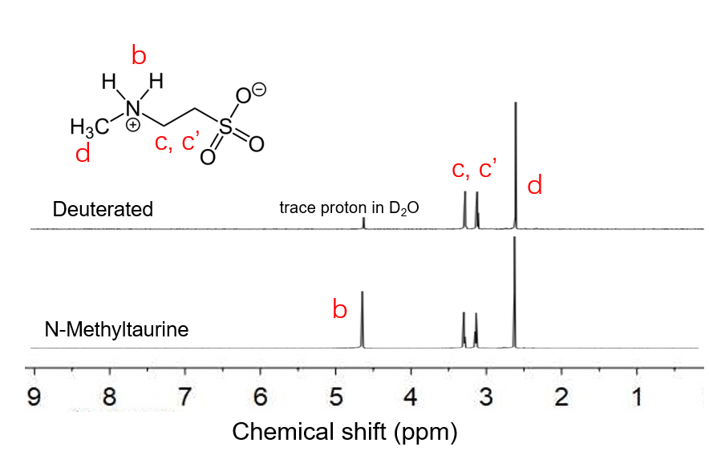

**Figure 4.** 1H NMR spectra of N-Methyltaurine and the deuterated N-Methyltaurine (solvent: D2O).

With respect to the QENS measurements, for a value of *Q*= 1.11 Å−1, the relative amplitudes *A*1 and *A*2 of the Lorentz functions and the relative amplitude *A*elast of the *δ*-function at various water contents are depicted in Figure 5. The normalized amplitudes represent the fraction of the different motional processes in the sample. The value of *A*1 in the “nearly” neat sample of 0.12 corresponds approximately to the fraction of protons in the SO3H moiety, *i.e* 1:10 of the protons in a [2-Sema][TfO] “unit”. Thus, the faster process *L*1 with the larger diffusion coefficient is most likely attributed to the hopping of SO3H protons. Similar to NMR, the hopping of the lower acidity NH2+ protons cannot be detected by means of QENS. The slower process *L*2 corresponds to the protons that follow the vehicular motion, *i.e.* the CHn and NH2+ protons of the [2-Sema]+ cation.

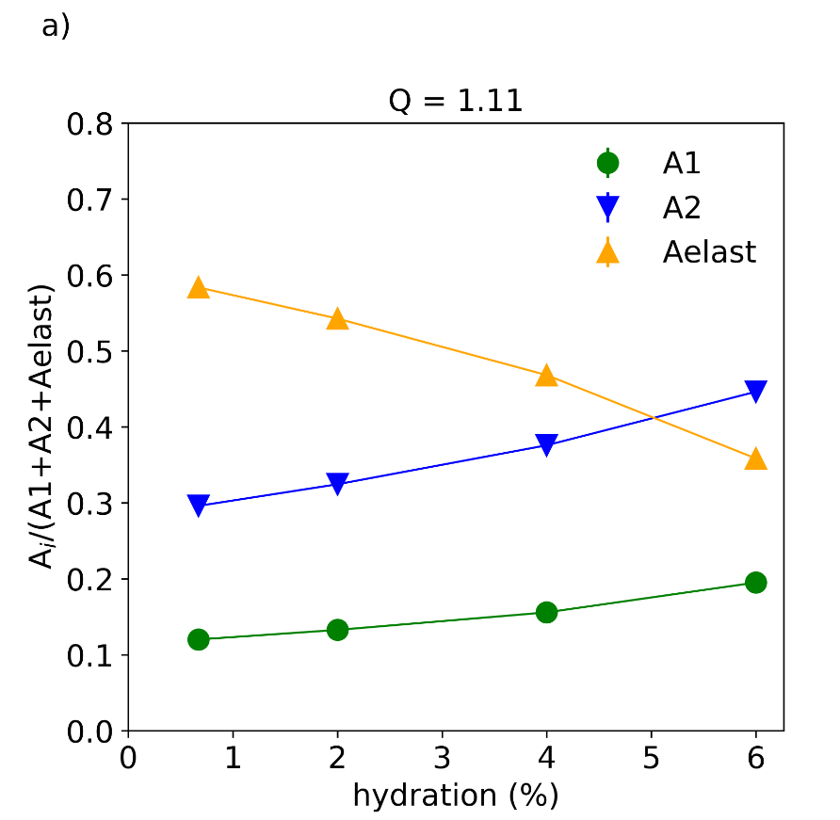

**Figure 5.** Relative amplitudes *A*1, *A*2 and *A*elast as a function of water content at *Q*= 1.11 Å−1. The absolute scattered intensity increases from the lowest to highest hydration level by 7%. Solid lines are guide to the eyes.

**3.2 Proton dynamics of H2O in [2-Sema][TfO]-H2O mixtures**

As depicted in Figure 5, both amplitudes *A*1 and *A*2 exhibit an increase with increasing H2O concentration. Consequently, the amplitude of the elastic contribution *A*elast decreases with increasing hydration and the H2O molecules can take part in both the hopping and the vehicular motion. Due to the comparable acidities of the [2-Sema]+ cation and the hydroxonium cations, in the protolysis equilibrium of [2-Sema][TfO]-H2O mixtures, the H2O molecules will be protonated to a significant extent and H3O+ will be formed. The increase of *A*1 indicates the formation of H3O+ cations, and the participation of H3O+ in the hopping transport. At the same time, the water molecules participate to the obser­ved vehicular motion. It can be assumed that the vehicular motion of the water molecules is faster compared to the[2-Sema]+ cation, since the size of water molecules is much smaller than the [2-Sema]+ cation. This suggests that the vehicular motion of the H2O molecules is covered by the time scale of SPHERES and is assigned to *L2*.

However, *L*2 cannot be separated from the elastic contribu­tion during the fitting procedure. Thus, the sum of *A*2 + *A*elast is considered as the fraction of the vehicular motion by both the H2O and [2-Sema]+ molecules. The *A*1 is attributed to the fraction of hopping motion of the SO3H and H3O+ protons. The value of the proton amplitudes in fast and slow motions are listed in Table 1.

**Table 1.** The proton amplitudes of the mixtures in fast and slow motions.

|  |  |  |  |  |  |
| --- | --- | --- | --- | --- | --- |
| Sample | Fast motion (*A*1) | |  | | Slow motion (*A*2 + *A*elast) |
|  |  | |  | |
| 0.67wt% | 0.120 |  | | 0.880 | |
| 2 wt% | 0.133 |  | | 0.867 | |
| 4 wt% | 0.156 |  | | 0.844 | |
| 6 wt% | 0.195 |  | | 0.805 | |

In the [2-Sema][TfO]-H2O mixtures, the protolysis reaction between the [2-Sema]+ cation and the water leads to an intermolecular proton transfer as follows:[19]

CH3NH2+CH2CH2SO3**H** (Sema+) + H2O ⇄ CH3NH2+CH2CH2SO3**−** (Mtau)+ **H**3O**+** (7)

*k*←

*k*→

The equlibrium constant of this protolysis reaction depends on the different acidities of the cation [2-Sema]+ and H3O+:

(8)

where the *ci* corresponds to the molar concentration of the species *i*. If the number of protons of the species is taken into account, the theoretical amplitudes of the hopping motion and the vehicular motion can be related to the molar fractions by Eq (9) and (10):

(9)

(10)

where the and are the initial molar fractions of the [2-Sema]+ and H2O in the mixtures, respectively. The number of protons of the [2-Sema]+ cation is 10 and of H2O is two. The value of corresponds to the total number of protons in the mixtures. The number of active protons of the [2-Sema]+ cation is equal to , *i.e.* only the SO3H moiety. The number of protons in the [2-Sema]+ cation which is attributed to the vehicular motion is equal to , where and are the molar fractions of H3O+ and H2O in the protolysis equilibrium (Eq. (7)). For the H3O+, the three protons are chemically identical and hence these are all equally belong to the fraction of hopping protons. In the case of H2O, both protons are considered to the fraction of vehicular motion. For all the mixtures, the sum of *A*hop and *A*vehi equals to 1.

The molar fraction of the samples with various water content can be calculated by taking the experimental amplitude values *A*1 and *A*2 + *A*elast into Eq. (9) and (10). According to Eq. (7), the value of is equal to . Consequently, the molar fractions of the species [2-Sema]+, [TfO]-, H2O, MTau and H3O+ can be obtained. Figure 6 depicts the distribution of the molar fraction of the species as a function of the initial water content . According to the calculation, the protons of the H2O molecules in the [2-Sema][TfO]-H2O mixtures are partially involved into the hop­ping motion, whereas theremaining part of the H2O protons undergoes correspondingly a vehicular motion as H2O molecules. The hopping motion is in the time scale on the order of 100 ps and the vehicular motion is in the time scale of 1–5 ns. The resulting equilibrium constants *K*A of the samples with different water content are also shown in Figure 6. In the sample with an equimolar water content (6 wt%), the molar fraction of the protons yields a value of *K*A= 4.02. The molar fractions and the equilibrium constants for the species in the mixtures are listed in Table S1 in supplementary information section.

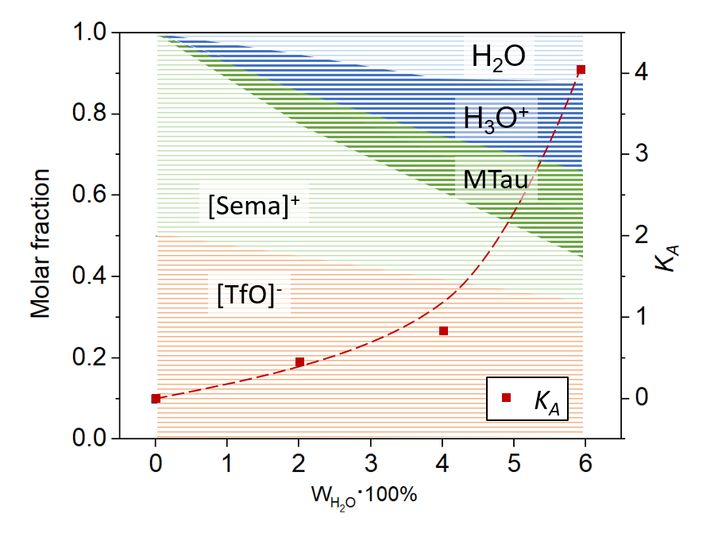

**Figure 6.** (left axis) The distributions of the proton mole fractions in the [2-Sema][TfO]-H2O mixtures, and (right axis) the values of *KA* as a function of water contents. The orange area represents the molar fraction of the [TfO]-, the light green and the dark green areas represent the [2-Sema]+ and the N-methyltaurine (MTau), respectively. The light blue and dark blue areas represent the H2O and H3O+, repectively. The red line is a guide to the eyes.

**3.3** **Diffusion coefficients by PFG-NMR and QENS**

The obtained fit parameters from the backscattering spectroscopy, the diffusion coefficient *D*, the residence time *τ* and the jump length of *L*1 and *L*2 are summarized as a function of water content in Table 2. The model describes the diffusional motion in terms of jumps, with the length between different sites, where τ is the average time bet­ween the jumps of the diffusing molecules.

**Table 2.** The *D*i by the PFG-NMR and fit parameters obtained with the Chudley and Elliott model at 25 oC. Due to the high viscosity of the samples with 0.67 and 2 wt% water their diffusion coefficients cannot be determined by PFG-NMR. Errors for the parameters are listed in Table S2 in the SI.

|  |  |  |  |  |  |  |  |  |
| --- | --- | --- | --- | --- | --- | --- | --- | --- |
|  | NMR | | QENS | | | | | |
| Sample | N1·10-13 | N2·10-13 | Q1·10-11 | 1·10-10 | 1 | Q2·10-12 | 2·10-10 | 2 |
| [m2/s] | [m2/s] | [m2/s] | [s] | [Å] | [m2/s] | [s] | [Å] |
| 0.67wt% | - | - | 18.2 | 1.11 | 3.50 | 6.15 | 3.95 | 1.21 |
| 2wt% | - | - | 15.9 | 1.07 | 3.19 | 5.10 | 3.56e-3 | 3.30e-2 |
| 4wt% | 3.5 | 2.34 | 15.1 | 1.21 | 3.31 | 6.02 | 5.39 | 1.39 |
| 6wt% | 20 | 3.15 | 14.9 | 1.22 | 3.31 | 7.46 | 9.86 | 2.11 |

The diffusion coefficients obtained by the PFG-NMR are listed in Table 2 and they are denoted as *D*N. The absence of data for the samples with a water content of 0.67 and 2 wt% is due to the very high viscosity, which limits the use of PFG-NMR. Similarly to the results obtained from QENS, both fast and slow processes can be detected by PFG-NMR. The fast process is related to the cooperative transport of the SO3H/H2O protons and its corresponding diffusion coefficient is denoted as *D*N1, whereas the slow process is related to the vehicular transport of the [2-Sema]+ cation and its diffusion coefficient is denoted as *D*N2. The raw NMR spectra and corresponding normalized intensities as a function of gradient strength are shown in Figure S5 in the SI. The diffusion coeffi­cients obtained by NMR are both slower than those obtained by QENS. Specifically, *D*N1is two orders of magnitude lower than *D*Q1, whereas *D*N2 is one order of magnitude lower than *D*Q2. This is quite reasonable as the two techniques cover very different length- and time-scales. Neutron backscattering covers length scales on the order of nm and time scales on the order of ps-ns while PFG-NMR covers timescales on the order of ms.[45] As a result, the diffusion coefficients obtained by PFG-NMR and by QENS relate different motions of molecules.

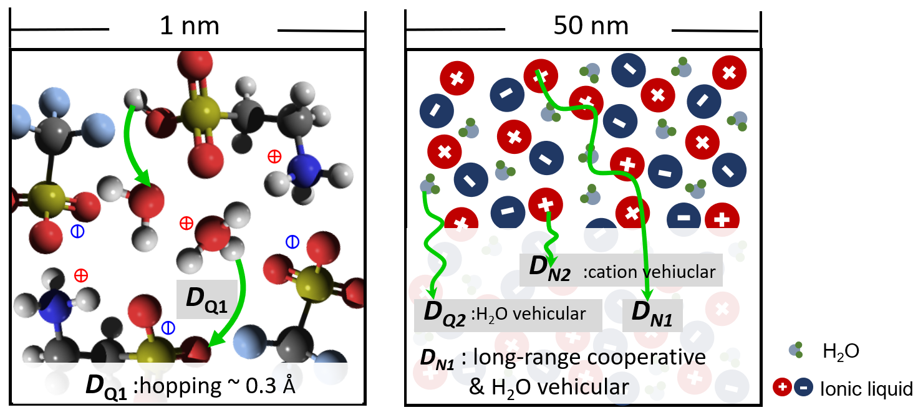

**Figure 7.** Schematic representation of the equimolar [2-Sema][TfO]-H2O mixture and the diffusion coefficients in nanoscale.

A schematic representation of the proton dynamics, as well as the differences in diffusion coefficients by means of PGF-NMR and QENS is shown in Figure 7. *D*Q1 is the diffusion coefficient of the (short range) hopping motion. Within the time scale of QENS, the jump length of the proton hopping motion is around 3 Å. Considering the size of the molecules as well as the expected intermolecular distances, the jump length was found to be in accordance with literature.[46] By means of NMR, it is not possible to distinguish the hopping and vehicular dynamics of H2O, due to the limitation of the NMR technique. Only an averaged chemical shift of -SO3H, H2O and H3O+ protons is observed in the 1H-NMR spectrum (see in Figure 1). The value of *D*N1 corresponds to a population weighted average between the hopping of SO3H/H2O protons and a vehicular diffusional motion of H2O molecules.

In the case of the slower processes, the diffusion coefficient *D*N2 represents the vehicular transport of the [2-Sema]+ cation. The slow neutron backscattering components correspond to the diffusion of the smaller H2O molecules, which may also comprise an average dif­fusion of the larger [2-Sema]+ cation molecules. Therefore, the *D*Q2 is faster than the diffusing rate of the [2-Sema]+ cation, which results in the *D*Q2 being one order of magnitude faster than *D*N2. On the other hand, the diffusion of the molecules may be restricted by the H-bonding network. Meanwhile, due to the size difference between the molecules, it is likely that the water molecules are wrapped between the [2-Sema][TfO] ions. A spatially constrained diffusion process has been reported in literature and may be directly associated with the presence of cages[47-49] or other inhomogeneous regions in the [2-Sema][TfO]-H2O system. This can be inferred from the constant HWHM *Γ*/2 rates of the motions as a function of water content as shown in Figure S6 in the SI.

**4. CONCLUSION**

The proton dynamics in a protic ionic liquid [2-Sema][TfO] with residual water were investigated on different time scales by means of PFG-NMR and QENS. The hop­ping motion in the time scale of ps and the vehicular motion of the water molecule in the time scale of ns are detected by QENS, respectively. Such dynamic processes are well described by the Chudley-Elliot jump model. A fixed jump length of ~3 Å is obtained. The protolysis equilibrium constant at 25 °C can be derived from the data. A value of *K*A= 4.02 is determined for an equimolar H2O content (6 wt% H2O). In the timescale of ms, the long-range cooperative transport of the SO3H/H2O/H3O+ protons, as well as the vehicular transport of the PIL cations are elucidated by NMR. The difference in the diffusion coefficient as obtained by means of PFG-NMR and QENS relate different motions of molecules. By combining the results of the two methods, the transport pathways of the proton dy­namics in the ionic liquid [2-Sema][TfO]-H2O mix­tures regarding all participating species have been determined. The proton hopping and cooperative transport are expected to have an impact on the conductivity and indicate the prospect of the high acidic PILs as candi­dates for electrolytes in PEFCs operating at elevated temperatures.

Author Contributions

J.L. designed the experiments and drafted the manuscript. D.N. and O.H. performed the QENS experiments and analysed the data. E.V. performed PGF-NMR experiments and had a great impact on the revision of the manuscript. C.K. initiated and supervised the project. All the authors contributed to the preparation of the manuscript.

Acknowledgements

This work is partially supported by the China Scholarship Council (Grant No.: 201706060187). We are thankful to C. Wood for proofreading the manuscript.

References

[1] J.A. Asensio, E.M. Sánchez, P. Gómez-Romero, Proton-conducting membranes based on benzimidazole polymers for high-temperature PEM fuel cells. A chemical quest, Chemical Society Reviews, 39 (2010) 3210-3239.

[2] D.J. Jones, J. Rozière, Recent advances in the functionalisation of polybenzimidazole and polyetherketone for fuel cell applications, Journal of Membrane Science, 185 (2001) 41-58.

[3] E. Quartarone, P. Mustarelli, Polymer fuel cells based on polybenzimidazole/H 3 PO 4, Energy & Environmental Science, 5 (2012) 6436-6444.

[4] Q. Li, J.O. Jensen, R.F. Savinell, N.J. Bjerrum, High temperature proton exchange membranes based on polybenzimidazoles for fuel cells, Progress in polymer science, 34 (2009) 449-477.

[5] L. Vilčiauskas, M.E. Tuckerman, G. Bester, S.J. Paddison, K.-D. Kreuer, The mechanism of proton conduction in phosphoric acid, Nature chemistry, 4 (2012) 461.

[6] K. Wippermann, J. Wackerl, W. Lehnert, B. Huber, C. Korte, 2-Sulfoethylammonium Trifluoromethanesulfonate as an Ionic Liquid for High Temperature PEM Fuel Cells, Journal of The Electrochemical Society, 163 (2015) F25-F37.

[7] K. Hsueh, E. Gonzalez, S. Srinivasan, Electrolyte effects on oxygen reduction kinetics at platinum: a rotating ring-disc electrode analysis, Electrochimica Acta, 28 (1983) 691-697.

[8] K.L. Hsueh, E. Gonzalez, S. Srinivasan, D.T. Chin, Effects of phosphoric acid concentration on oxygen reduction kinetics at platinum, Journal of the Electrochemical Society, 131 (1984) 823-828.

[9] A. Noda, M.A.B.H. Susan, K. Kudo, S. Mitsushima, K. Hayamizu, M. Watanabe, Brønsted acid− base ionic liquids as proton-conducting nonaqueous electrolytes, The Journal of Physical Chemistry B, 107 (2003) 4024-4033.

[10] M.A.B.H. Susan, T. Kaneko, A. Noda, M. Watanabe, Ion gels prepared by in situ radical polymerization of vinyl monomers in an ionic liquid and their characterization as polymer electrolytes, Journal of the American Chemical Society, 127 (2005) 4976-4983.

[11] M.M. Mannarino, D.S. Liu, P.T. Hammond, G.C. Rutledge, Mechanical and transport properties of layer-by-layer electrospun composite proton exchange membranes for fuel cell applications, ACS applied materials & interfaces, 5 (2013) 8155-8164.

[12] D.E. Smith, D.A. Walsh, The Nature of Proton Shuttling in Protic Ionic Liquid Fuel Cells, Advanced Energy Materials, 9 (2019).

[13] L. Koók, B. Kaufer, P. Bakonyi, T. Rózsenberszki, I. Rivera, G. Buitrón, K. Bélafi-Bakó, N.J.J.o.m.s. Nemestóthy, Supported ionic liquid membrane based on [bmim][PF6] can be a promising separator to replace Nafion in microbial fuel cells and improve energy recovery: A comparative process evaluation, 570 (2019) 215-225.

[14] J. Escorihuela, A. Garcia-Bernabe, A. Montero, O. Sahuquillo, E. Gimenez, V. Compan, Ionic Liquid Composite Polybenzimidazol Membranes for High Temperature PEMFC Applications, Polymers (Basel), 11 (2019).

[15] K.-D. Kreuer, Proton conductivity: materials and applications, Chemistry of materials, 8 (1996) 610-641.

[16] F. Fujara, B. Geil, H. Sillescu, G. Fleischer, Translational and rotational diffusion in supercooled orthoterphenyl close to the glass transition, Zeitschrift für Physik B Condensed Matter, 88 (1992) 195-204.

[17] I. Chang, H. Sillescu, Heterogeneity at the glass transition: Translational and rotational self-diffusion, The Journal of Physical Chemistry B, 101 (1997) 8794-8801.

[18] K. Wippermann, J. Giffin, C. Korte, In Situ Determination of the Water Content of Ionic Liquids, Journal of The Electrochemical Society, 165 (2018) H263-H270.

[19] J. Lin, L. Wang, T. Zinkevich, S. Indris, Y. Suo, C. Korte, Influence of residual water and cation acidity on the ionic transport mechanism in proton-conducting ionic liquids, Physical Chemistry Chemical Physics, (2020).

[20] J. Lin, C. Korte, Influence of the acid–base stoichiometry and residual water on the transport mechanism in a highly-Brønsted-acidic proton-conducting ionic liquid, RSC Advances, 10 (2020) 42596-42604.

[21] K.D. Kreuer, A. Rabenau, W. Weppner, Vehicle mechanism, a new model for the interpretation of the conductivity of fast proton conductors, Angewandte Chemie International Edition in English, 21 (1982) 208-209.

[22] N. Agmon, The grotthuss mechanism, Chemical Physics Letters, 244 (1995) 456-462.

[23] Z. Wojnarowska, M. Paluch, Recent progress on dielectric properties of protic ionic liquids, J Phys Condens Matter, 27 (2015) 073202.

[24] Z. Wojnarowska, Y. Wang, J. Pionteck, K. Grzybowska, A. Sokolov, M. Paluch, High pressure as a key factor to identify the conductivity mechanism in protic ionic liquids, Physical Review Letters, 111 (2013) 225703.

[25] Z. Wojnarowska, Y. Wang, K.J. Paluch, A.P. Sokolov, M. Paluch, Observation of highly decoupled conductivity in protic ionic conductors, Physical Chemistry Chemical Physics, 16 (2014) 9123-9127.

[26] P. Griffin, A.L. Agapov, A. Kisliuk, X.-G. Sun, S. Dai, V.N. Novikov, A.P. Sokolov, Decoupling charge transport from the structural dynamics in room temperature ionic liquids, The Journal of chemical physics, 135 (2011) 114509.

[27] A.D. Bain, G. Duns, Chemical exchange measurements in NMR, in: Analytical Spectroscopy Library, Elsevier, 1997, pp. 227-263.

[28] T. Burankova, R. Hempelmann, V. Fossog, J. Ollivier, T. Seydel, J.P. Embs, Proton Diffusivity in the Protic Ionic Liquid Triethylammonium Triflate Probed by Quasielastic Neutron Scattering, J Phys Chem B, 119 (2015) 10643-10651.

[29] J.P. Embs, F. Juranyi, R. Hempelmann, Introduction to quasielastic neutron scattering, Zeitschrift für Physikalische Chemie, 224 (2010) 5-32.

[30] M. Appel, G. Borisov, O. Holderer, M.-S. Appavou, R. Zorn, W. Lehnert, D. Richter, Proton diffusion in the catalytic layer for high temperature polymer electrolyte fuel cells, RSC Advances, 9 (2019) 37768-37777.

[31] D. Noferini, B. Frick, M.M. Koza, M. Karlsson, Proton jump diffusion dynamics in hydrated barium zirconates studied by high-resolution neutron backscattering spectroscopy, Journal of Materials Chemistry A, 6 (2018) 7538-7546.

[32] H. Abe, T. Yamada, K. Shibata, Dynamic properties of nano-confined water in an ionic liquid, Journal of Molecular Liquids, 264 (2018) 54-57.

[33] V. Sharma, H. Srinivasan, R. Mukhopadhyay, V.G. Sakai, S. Mitra, Microscopic insights on the structural and dynamical aspects of Imidazolium-based surface active ionic liquid micelles, Journal of Molecular Liquids, 332 (2021) 115722.

[34] T. Burankova, E. Reichert, V. Fossog, R. Hempelmann, J.P. Embs, The dynamics of cations in pyridinium-based ionic liquids by means of quasielastic-and inelastic neutron scattering, Journal of Molecular Liquids, 192 (2014) 199-207.

[35] M.L. Hoarfrost, M. Tyagi, R.A. Segalman, J.A. Reimer, Proton hopping and long-range transport in the protic ionic liquid [Im][TFSI], probed by pulsed-field gradient NMR and quasi-elastic neutron scattering, J Phys Chem B, 116 (2012) 8201-8209.

[36] K. Wippermann, J. Giffin, S. Kuhri, W. Lehnert, C. Korte, The influence of water content in a proton-conducting ionic liquid on the double layer properties of the Pt/PIL interface, Physical Chemistry Chemical Physics, 19 (2017) 24706-24723.

[37] R.E. Hoffman, Standardization of chemical shifts of TMS and solvent signals in NMR solvents, Magnetic Resonance in Chemistry, 44 (2006) 606-616.

[38] E.O. Stejskal, J.E. Tanner, Spin diffusion measurements: spin echoes in the presence of a time‐dependent field gradient, The journal of chemical physics, 42 (1965) 288-292.

[39] J. Wuttke, A. Budwig, M. Drochner, H. Kämmerling, F.-J. Kayser, H. Kleines, V. Ossovyi, L.C. Pardo, M. Prager, D. Richter, SPHERES, Jülich's high-flux neutron backscattering spectrometer at FRM II, Review of scientific instruments, 83 (2012) 075109.

[40] M. Zamponi, M. Khaneft, SPHERES: Backscattering spectrometer, Journal of large-scale research facilities JLSRF, 1 (2015) 30.

[41] M. Bee, Quasielastic neutron scattering: principles and applications in solid state chemistry, Biology and Materials Science, Adam Hilger, Bristol, (1988) 193.

[42] K. Singwi, A. Sjölander, Diffusive motions in water and cold neutron scattering, Physical Review, 119 (1960) 863.

[43] C. Chudley, R. Elliott, Neutron scattering from a liquid on a jump diffusion model, Proceedings of the Physical Society, 77 (1961) 353.

[44] P.L. Hall, D. Ross, Incoherent neutron scattering functions for random jump diffusion in bounded and infinite media, Molecular Physics, 42 (1981) 673-682.

[45] J.-P. Melchior, B. Frick, On the nanosecond proton dynamics in phosphoric acid–benzimidazole and phosphoric acid–water mixtures, Physical Chemistry Chemical Physics, 19 (2017) 28540-28554.

[46] R. Hayes, S. Imberti, G.G. Warr, R. Atkin, The nature of hydrogen bonding in protic ionic liquids, Angew Chem Int Ed Engl, 52 (2013) 4623-4627.

[47] F. Lundin, H.W. Hansen, K. Adrjanowicz, B. Frick, D. Rauber, R. Hempelmann, O. Shebanova, K. Niss, A. Matic, Pressure and Temperature Dependence of Local Structure and Dynamics in an Ionic Liquid, The Journal of Physical Chemistry B, (2021).

[48] B. Aoun, M.A. González, J. Ollivier, M. Russina, Z. Izaola, D.L. Price, M.-L. Saboungi, Translational and reorientational dynamics of an imidazolium-based ionic liquid, The Journal of Physical Chemistry Letters, 1 (2010) 2503-2507.

[49] J.P. Embs, T. Burankova, E. Reichert, R. Hempelmann, Cation dynamics in the pyridinium based ionic liquid 1-n-butylpyridinium bis ((trifluoromethyl) sulfonyl) as seen by quasielastic neutron scattering, The Journal of Physical Chemistry B, 116 (2012) 13265-13271.