A niobium-substituted sodium superionic conductor with conductivity higher than 5.5 mS cm—1 prepared by solution-assisted solid-state

reaction method

Yujian Liu a, 1, Limin Liu b, 1, Jinsong Peng a,*, Xiaoliang Zhou b,**, Dongshi Liang a, Lei Zhao b,

Jiawen Su b, Bo Zhang d, Si Li c, Naiqing Zhang c, Qianli Ma e,***, Frank Tietz e

a *College of Chemistry, Chemical Engineering and Resource Utilization, Northeast Forestry University, Harbin, 150040, China*

b *College of Chemistry and Chemical Engineering, Southwest Petroleum University, Chengdu, 610500, China*

c *School of Chemistry and Chemical Engineering, Harbin Institute of Technology, Harbin, 150001, China*

d *Hydrogen Energy Division, DONG FANG BOILER GROUP CO., LTD., 611731, China*

e *Forschungszentrum Jülich GmbH, Institute of Energy and Climate Research, Materials Synthesis and Processing (IEK-1), 52425, Jülich, Germany*

H I G H L I G H T S

* NZNSP0.1 was synthesized by a solution-assisted solid-phase reaction method.
* NZNSP0.1 has an ionic conductivity as high as 5.51 mS cm—1 at 20 ◦C.
* Ultrahigh-frequency impedance spectroscopy analysis was adopted.
* The introduction of Nb improved both the bulk and grain boundary conductivity.
* Nb doped electrolyte had a higher density than the one without doping.

A R T I C L E I N F O

*Keywords:*

Solid electrolyte NASICON

Na3.4Zr2Si2.4P0.6O12

Ionic conductivity

A B S T R A C T

Although research on all-solid-state sodium batteries (ASSSBs) have been conducted for many years, the solid- state electrolyte (SSE) material is still far from practical application at room temperature. One major reason is

that no suitable electrolyte material with high ionic conductivity has been found yet. In this study, Nb5+ is introduced into NASICON-type solid electrolyte, where Nb5+ substituted Na3.4Zr2Si2.4P0.6O12 (NZSP) is prepared

by a solution-assisted solid-state reaction method. The best ionic conductivity is as high as 5.51 mS cm—1 which is a significant improvement. High-frequency electrochemical impedance spectroscopy shows that the increase in total conductivity is mainly due to the decrease of grain boundary impedance as well as bulk impedance. The decrease in grain boundary impedance is probably owing to the increase in density of the electrolyte material after incorporation of the Nb content, which has a beneficial impact of the sintering of NZSP. The decrease in bulk impedance rather results from the ratio of sodium ion concentration and sodium vacancy concentration of

3.3:0.7 in the crystal structure, thus facilitating the sodium ion transport. Symmetric cells with sodium metal as electrodes (Na|Nb5+ substituted NZSP|Na) are subsequently assembled and cycled stably for 60 cycles at a current density of 0.05 mA/cm2.

* Corresponding author.

** Corresponding author.

*** Corresponding author.

*E-mail addresses:* [jspeng1998@nefu.edu.cn](mailto:jspeng1998@nefu.edu.cn) (J. Peng), [xlzhou_swpu@sina.com](mailto:xlzhou_swpu@sina.com) (X. Zhou), [q.ma@fz-juelich.de](mailto:q.ma@fz-juelich.de) (Q. Ma).

1 Yujian Liu and Limin Liu contributed equally to this work.

# Introduction

The innovation of energy storage technology has brought great op- portunities and challenges to the current energy industry [1]. As an important support for the rapid development of modern human society, electricity is widely used in heating, lighting, transportation, and communication [2]. As a key technology for efficient storage and use of renewable energy, electrochemical secondary batteries play an irre- placeable role in the technological transformation of human society [3, 4]. Among them, lithium-based batteries are very popular because of their high energy density and long life, which are widely used in modern life, such as electric vehicles and portable electronics [5,6]. However, due to the political and economic shortage of lithium salt resources worldwide, it is challenging to maintain the growing demand. There- fore, there is an urgent need to find alternative energy storage secondary batteries to alleviate the problem of rising lithium-based batteries costs. As an important criterion for alternative secondary batteries, sodium-ion batteries are not only similar to lithium-based batteries in terms of working mechanism and performance, but they also offer abundant sodium resources, which can theoretically replace lithium-based batte- ries for large-scale applications [7,8]. However, just as their lithium countpart, traditional liquid-based sodium-ion batteries are plagued by safety concerns such as leakage, flammability and explosion due to the

use of organic liquid electrolytes. Therefore, the development of suitable

solid electrolyte materials for sodium-ion batteries has become a pre- requisite and key to the real large-scale application of sodium-ion bat- teries [7,9].

Among the solid electrolyte materials, organic polymer solid elec-

trolytes [10,11] inherently have low ionic conductivity at room tem- perature (generally below 10—4 S cm—1). The sulfide solid electrolytes

[12–15] are poorly chemically stable and easily react with water in air to form H2S; the ion transport mechanism of composite hydride solid electrolytes [16–19] still needs to be studied in depth. Among the oxide-based solid electrolyte materials, Na-β/β′′-aluminas [20–22] are synthesized at high temperatures (above 1600 ◦C) and high energy consumption, while NASICON-type solid electrolytes have good chem-

ical and thermal stability in addition to high ionic conductivity (10—3 S

cm—1) at room temperature and are relatively easy to synthesize. Therefore, NASICON-type solid electrolytes have the best overall perspective for future application in solid-state batteries.

In 1976, Goodenough et al. [23,24] first proposed the NASICON (Na superionic conductor) -type material of Na1+xZr2SixP3-xO12 (0 ≤ x ≤ 3),

i.e. a solid solution between NaZr2P3O12 and Na4Zr2Si3O12. Na1+xZr2-

SixP3-xO12 crystallizes in two modifications: rhombohedral (*R*3*c*) and monoclinic (*C2/c*, 1.8 x 2.2). The rhombohedral phase possesses a structure with higher symmetry and the monoclinic phase is a low-temperature phase that shows a rotational twist of the polyhedra.

≤ ≤

The PO4 tetrahedra and ZrO6 octahedra in the NASICON skeleton

the number of mobile sodium ions and the number of vacancies have not reached a suitable ratio. Ma et al. [30] used a more systematic substi- tution strategy to synthesize Na3.4Zr2Si2.4P0.6O12 (NZSP) by

solution-assisted solid-state reaction with a ratio of 3.4:0.6 of mobile sodium ions to sodium vacancies, and its total ionic conductivity was as high as 5.0 mS cm—1 at room temperature. In general, the total ionic

conductivity mainly includes the grain-interior (bulk) conductivity and the grain boundary conductivity. Since this solid electrolyte material has a high grain boundary impedance, Na3.4Zr2Si2.4P0.6O12(NZSP) was used as the prototype for modification in this study to further enhance its total ionic conductivity. In addition, regarding the performance optimization of NASICON solid-state electrolyte materials, Guin et al. [25] found that higher ionic conductivity is obtained when the heterovalent substitution cation has an average ionic radius of about 0.72 Å. Therefore, based on this, the search for cations with more suitable ionic radii and the opti- mization of their chemical composition can lead to electrolyte materials with higher ionic conductivity for the NASICON system. The substituted

cations can enter the Zr sites of NASICON structure, inducing more Na vacancies or increasing the concentration of Na+. They can also expand the size of Na+ transport channels and regulate the chemical composi-

tion of grain boundaries, so that the material itself can be improved. Ihlefeld et al. [31] investigated the effect of structural ordering on the grain boundary conductivity of NASICON-based solid-state electrolyte materials, and the results showed that the grain boundary conductivity is related to the annealing temperature of the sintering process in

addition to the grain size. Hu et al. [32] found that the ionic conductivity of solid electrolyte materials can be adjusted by introducing La3+ into Na3Zr2Si2PO12, because the presence of La3+ generates several second-

ary phases at the grain boundaries, such as La2O3, which can increase the ionic conductivity of the grain boundaries by modifying them to accelerate Na+ transfer [33]. Song et al. [34] proposed that the ionic

conductivity of electrolyte materials can be improved by increasing the bottleneck size of the Na + transport channel using heterovalent metal cations instead of Zr. By using Mg2+ as substituents on the Zr site, the bottleneck size of the unsubstituted sample was 5.223 Å2, while it increased to 6.522 Å2 after Mg2+ incorporation leading to a higher ionic

conductivity at room temperature. However, the bottleneck of the large Ba2+ ion-substituted compounds is narrower than that of the original

compound, suggesting that the ionic radius of the substituents plays an important role. It is worth mentioning that when modifying solid elec- trolyte materials, transition metal elements that are prone to valence change are not suitable, because the electrolyte will undergo redox re- actions during battery cycling, destroying the interface between the electrolyte and the positive and negative electrodes or undergoing self-discharge. These studies above paved the way for improving the

total ionic conductivity of NASICON by regulating the transport of Na+

ions and provide a guideline for further work.

Herein, NZSP was prepared by solution-assisted solid-state reaction.

structure are connected by co-vertexes (oxygen atoms) to form

On this basis, Nb5+ was introduced into NZSP according to the general

three-dimensional transport channels for sodium ions. The NASICON-based solid-state electrolytes have the general formula NaMM’P3O12, and its ionic conductivity can be modulated by the occupation of additional Na sites induced by substitution with M and M′ as heterovalent metal cations [25,26]. The maximum occupation of sodium ions in one unit cell corresponds to 4 mol per formula unit [27]. The bulk conductivity is theoretically related not only to the number of mobile sodium ions in the structure, but also to the number of vacancies that allows sodium ions to move, because if all vacancies are occupied with sodium ions, it will be difficult for sodium ions to jump from one site to another. In addition, since Na3Zr2Si2PO12 has a considerably high ionic conductivity at room temperature [23], most of the current studies applied this composition as a prototype and as a starting point for modifications [28]. However, many subsequent studies using Na3Zr2-

Si2PO12 have obtained similar results for the total ionic conductivity, usually 10—4 to 10—3 S cm—1 at room temperature [29], perhaps because

composition of Na3.4-xZr2-xNbxSi2.4P0.6O12 (0 x 0.4, NZNSP0.1–0.4), and the ionic conductivity as high as 5.51 mS cm—1 was obtained for NZNSP0.1. This is a significant performance improvement compared

with all NASICON-type electrolyte materials reported so far. By detailed characterization of X-ray diffraction (XRD), scanning electron micro- scopy (SEM), energy dispersive X-ray spectroscopy (EDS), and high- frequency impedance spectroscopy, the effects of the niobium substi- tution on the structure and ionic conductivity of the NZSP material were investigated and a Na|NZNSP0.1|Na symmetrical cell was assembled and tested.

≤ ≤

# Experimental

* 1. *Synthesis of NASICON solid electrolytes*

NASICON solid electrolytes were prepared by solution-assisted solid- state reaction [27,29] in which NaNO3 (Aladdin, 99%), ZrO(NO3)2

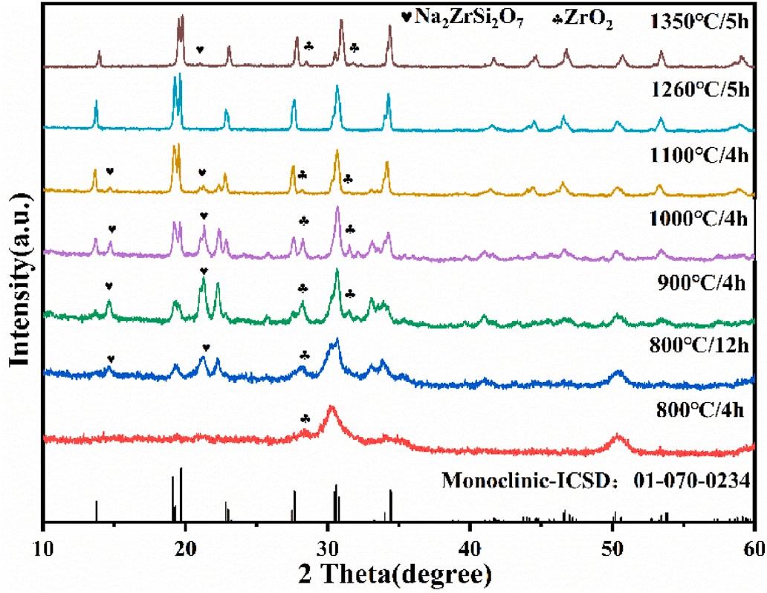

**Fig. 1.** XRD patterns showing the evolution of phase formation of Na3.4Zr2- Si2.4P0.6O12 with increasing sintering temperature.

(Aladdin, 99.5%), NH4NbO(C2O4)2 (Macklin, 99.99%), Si(OCH2CH3)4

(Macklin, 99.9%), and NH4H2PO4 (Macklin, 99.99%) were used as raw materials. Firstly, the stoichiometric amounts of ZrO(NO3)2 and NaNO3 were mixed and dissolved in of deionized water. When the solution was clarified, an appropriate amount of HNO3 solution was added and stirred for 1 h. When a clear solution was reached again, Si(OCH2CH3)4, and NH4H2PO4 were added. For the synthesis of NZNSPx, NH4NbO(C2O4)2 was added during this step. As a result, a white suspension was obtained after continuous stirring for 1 h. The obtained suspension was subse- quently dried in an oven at 80 ◦C for 24 h. The resulting powder was calcined in a muffle furnace at 800 ◦C for 3 h, wet ground in a planetary ball mill with ethanol for 48 h, and dried in an oven at 80 ◦C for 12 h. The resulted white color powder was finally pressed into discs at room temperature using a stainless steel cylindrical mold with a diameter of 15 mm under 100 MPa uniaxial pressure. NZSP or NZNSPx samples were

then sintered from 800 to 1350 ◦C to determine the best sintering temperature.

* 1. *Characterization of NASICON solid electrolytes*

The phase purity of the calcined and sintered powders was investi- gated by an XRD system with a PANalytical X’Pert PRO diffractometer using Cu Kα radiation. The microstructure of the samples was analyzed by SEM (HITACHI SU8010). Elemental analyses for the distribution of elements in the grains were examined by EDS (HORIBA EX250).

The prepared dense NZNSPx (x 0–0.4) samples were sputtered with Au on both sides. The ionic conductivity was measured by AC impedance analysis (Ametek PARSTAT-2273) in the fequency range from 1 MHz to 1 Hz with an amplitude of 5 mV and in the temperature range of 20–130 ◦C. In addition, the prepared dense Na3.3Zr2Si2.3P0.7O12 and NZNSP0.1 with same sodium content were measured at 25 ◦C using two electrochemical systems (Keysight E4991B and Biologic VMP-300), with an AC frequency range from 3 GHz to 1 MHz and from 10 MHz to 1 Hz, respectively.

=

The solid electrolyte was assembled with sodium metal (Na) as the working and counter electrodes. 5 μL of organic electrolyte (ethylene carbonate) was coated on the surface of the electrolyte before Na elec- trodes were attached. The constant current charging for 0.5 h and con-

stant current discharging for 0.5 h were alternately cycled, and the current density was set to 0.05 and 0.1 mA/cm2. After the constant current charging and discharging test of the Na|Na symmetric cell, the

stability between NZNSP0.1 and Na was judged by the stability of the voltage.

The ionic conductivity was calculated using the following equation:

*σ* = *h*

*R π*(*d*)2*total*

2

where h, d, and Rtotal represent the thickness, diameter and total impedance, respectively.

The ionic conductivity of the electrolyte was tested at different temperatures and the activation energy of sodium ion transport was

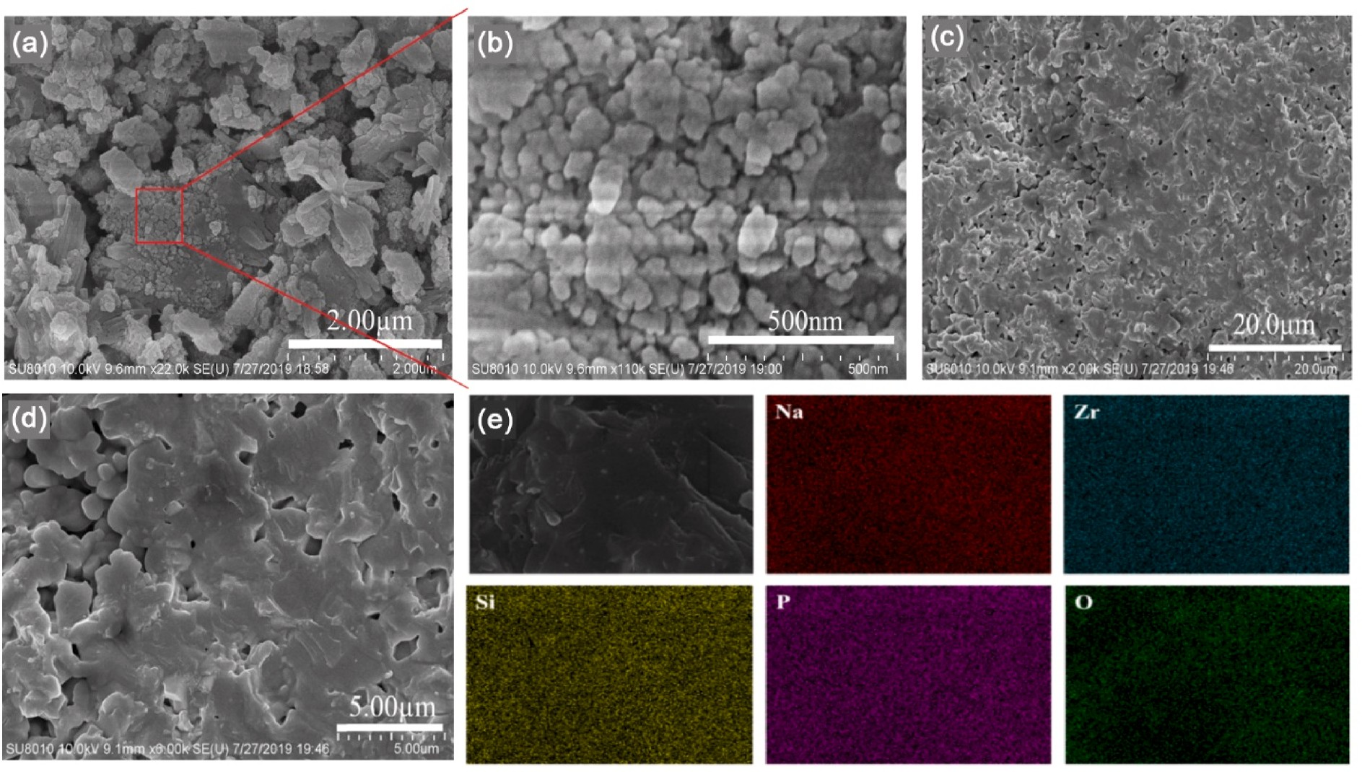

**Fig. 2.** Microstructure of the NZSP powder calcined at 800 ◦C for 4 h in air and ball milled for 48 h in different magnification (a) and (b). Cross-sections of NZSP after sintering at 1260 ◦C for 5 h, (c) and (d). (e) Corresponding EDS mappings of the prepared NZSP.

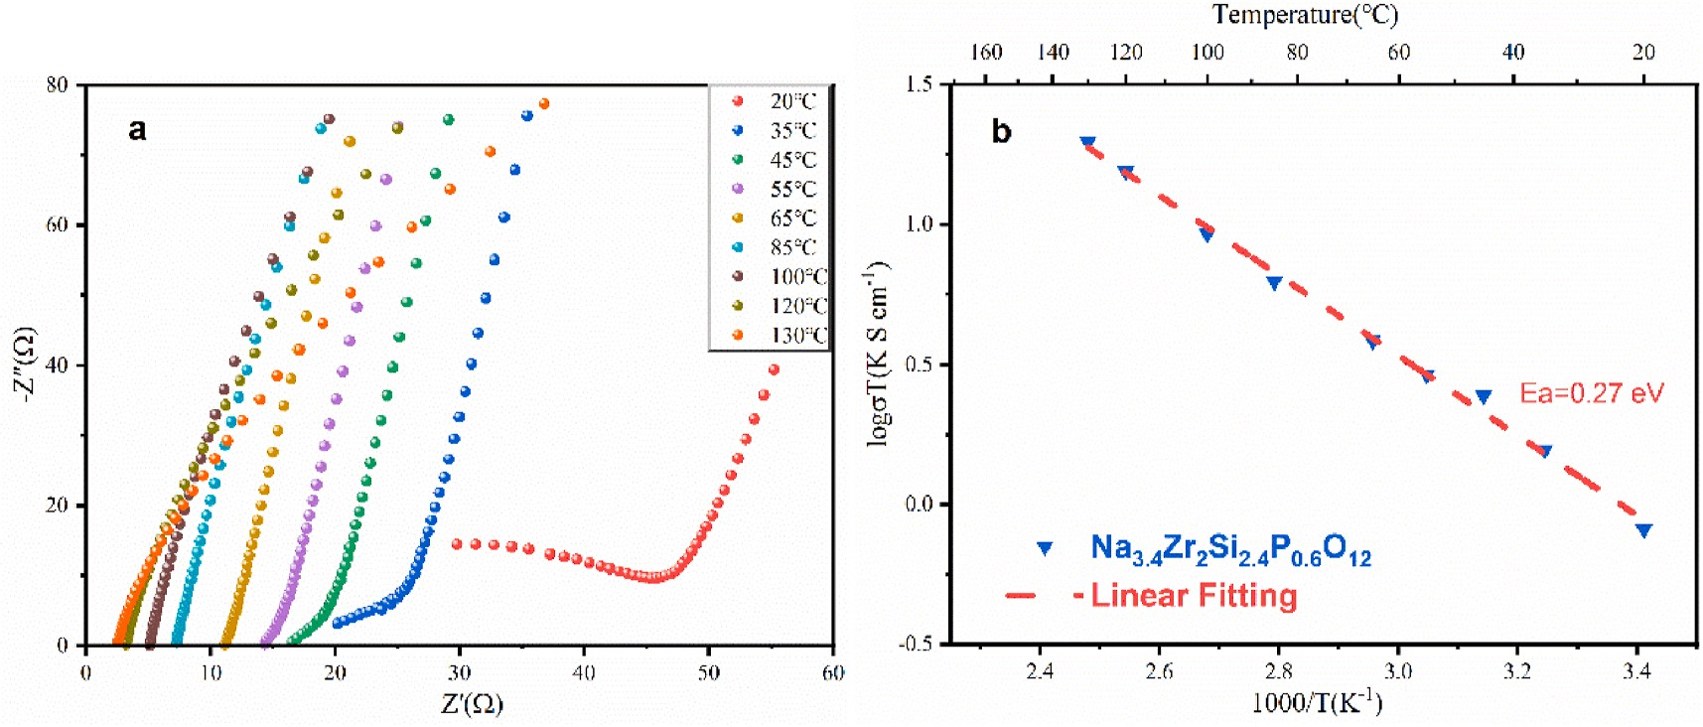

**Fig. 3.** (a) Impedance spectra of NZSP in the temperature range from 20 to 130 ◦C. (b) Arrhenius plot of conductivity data of NZSP sintered at 1260 ◦C.

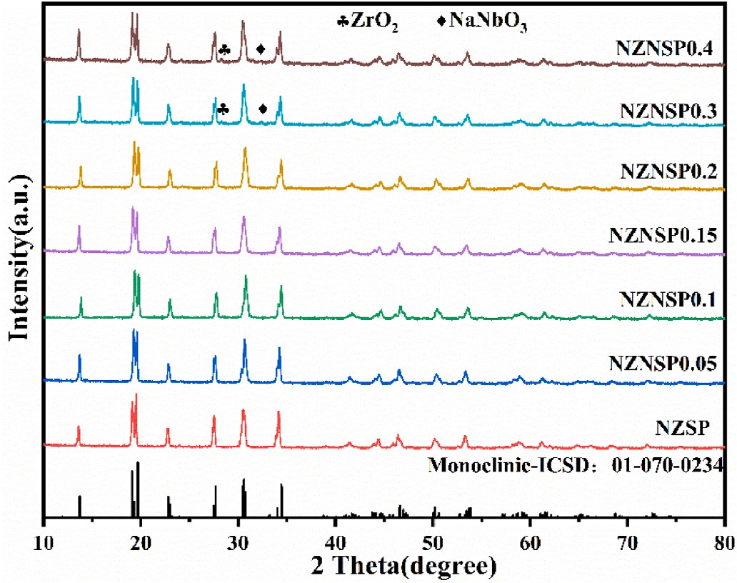calculated by the Arrhenius formula

***σT*** = ***Aexp***( — ***Ea*** / ***kT***)

where k, A, and T represent Boltzmann constant, pre-exponential factor, and absolute temperature, respectively.

# Results and discussion

For determination of the crystal type of the prepared NZSP material and the impact of the sintering temperature on its phase formation, the NZSP prepared after different heat treatments was characterized by XRD, as shown in Fig. 1. After 12 h of treatment at 800 ◦C, the NZSP powder started to form the desired NASICON structure, but substantial amounts of Na2ZrSi2O7 and ZrO2 as impurity phases were still present. The impurity phase contents gradually decreased with the increasing heat treatment temperature. After sintering at 1260 ◦C for 5 h, a well- crystallized monoclinic (or rhombohedral) phase was obtained. If the heat treatment temperature was increased further to 1350 ◦C, Na2Zr- Si2O7 and ZrO2 impurity phases were generated again due to excessive volatilization of sodium oxide at high temperature, and the peak posi-

tions of the main reflections shifted to a higher angles, indicating that the lattice of NZSP shrank. Besides, the intensity of the reflection near 19.6◦ was higher for NZSP heat-treated at 1260 ◦C compared with other temperatures indicating a higher purity of the monoclinic (or rhombo- hedral) phase. Therefore, the optimal sintering temperature of NZSP electrolyte material is 1260 ◦C. The negligible content of the impurity phases at this sintering temperature results in high purity NZSP elec- trolyte material.

The microstructure of the NZSP powder after calcination at 800 ◦C

for 4 h in air and ball milled for 48 h is shown in Fig. 2a and Fig. 2b. It can be seen from the figures that the powder is homogeneous, nearly spherical in shape, and consists of ultrafine particles (100–200 nm) on the surface of larger agglomerated particles, which is more favorable for the processing and sintering of the final ceramic product. Fig. 2c and d show the cross-sections of NZSP after sintering at 1260 ◦C for 5 h. There are still pores in the cross-section of the NZSP, which is the reason for the low density(89.9%). Since the density has a strong influence on the ionic conductivity of the ceramic solid electrolyte [35,36], it is necessary to further optimize the sintering processes to improve the density of the solid electrolyte in subsequent experiments to obtain a material with higher ionic conductivity. Fig. 2e shows the corresponding EDS mappings of the NZSP sample demonstrating the uniform distri- bution of the elements of Na, Zr, Si and P.

The ionic conductivities of NZSP were measured by impedance spectroscopy. As shown in Fig. 3a and Fig. 3b, the total ionic

**Fig. 4.** XRD patterns of NZNSPx（x = 0, 0.05, 0.1, 0.15, 0.2, 0.3 and 0.4） sintered at 1260 ◦C for 5 h.

conductivity of NZSP at room temperature can be calculated to be 2.77 mS cm—1, which is lower than previously reported [30] and related to

the insufficient density of the sample. The activation energy of sodium ion transport of NZSP obtained from the Arrhenius plot (Fig. 3b) is about

0.27 eV. The activation energy of Ga-substituted NASICON-type solid electrolyte is 0.36 eV [36], which shows that NZSP has a lower activa- tion energy and is more favorable for sodium ion transport.

In order to observe the changes in the crystal structure of NZNSPx lattice after substitution with different amounts of Nb, XRD measure- ments were performed for different NZNSPx, where x equals to 0.05, 0.1, 0.15, 0.2, 0.3, and 0.4. As shown in Fig. 4, the XRD results show well- crystallized NASICON phases for all samples after sintering at 1260 ◦C for 5 h. The high intensity of the reflection of NZSP near 19.6◦ indicates a high purity of the monoclinic phase, while with the increase of the amount of Nb, as can be seen from the peaks near 19.5◦, 31◦, and 34◦, the NASICON main phase underwent a weak phase change from monoclinic to rhombohedral. Research shows that the rhombohedral phase has a higher symmetry relative to the monoclinic phase, which may be more favorable for the conduction of sodium ions in the crystal structure [37]. However, the ratio of sodium ion concentration and vacancy concentration within the crystal structure changes with increasing substitution. Therefore, the influence of different substitution

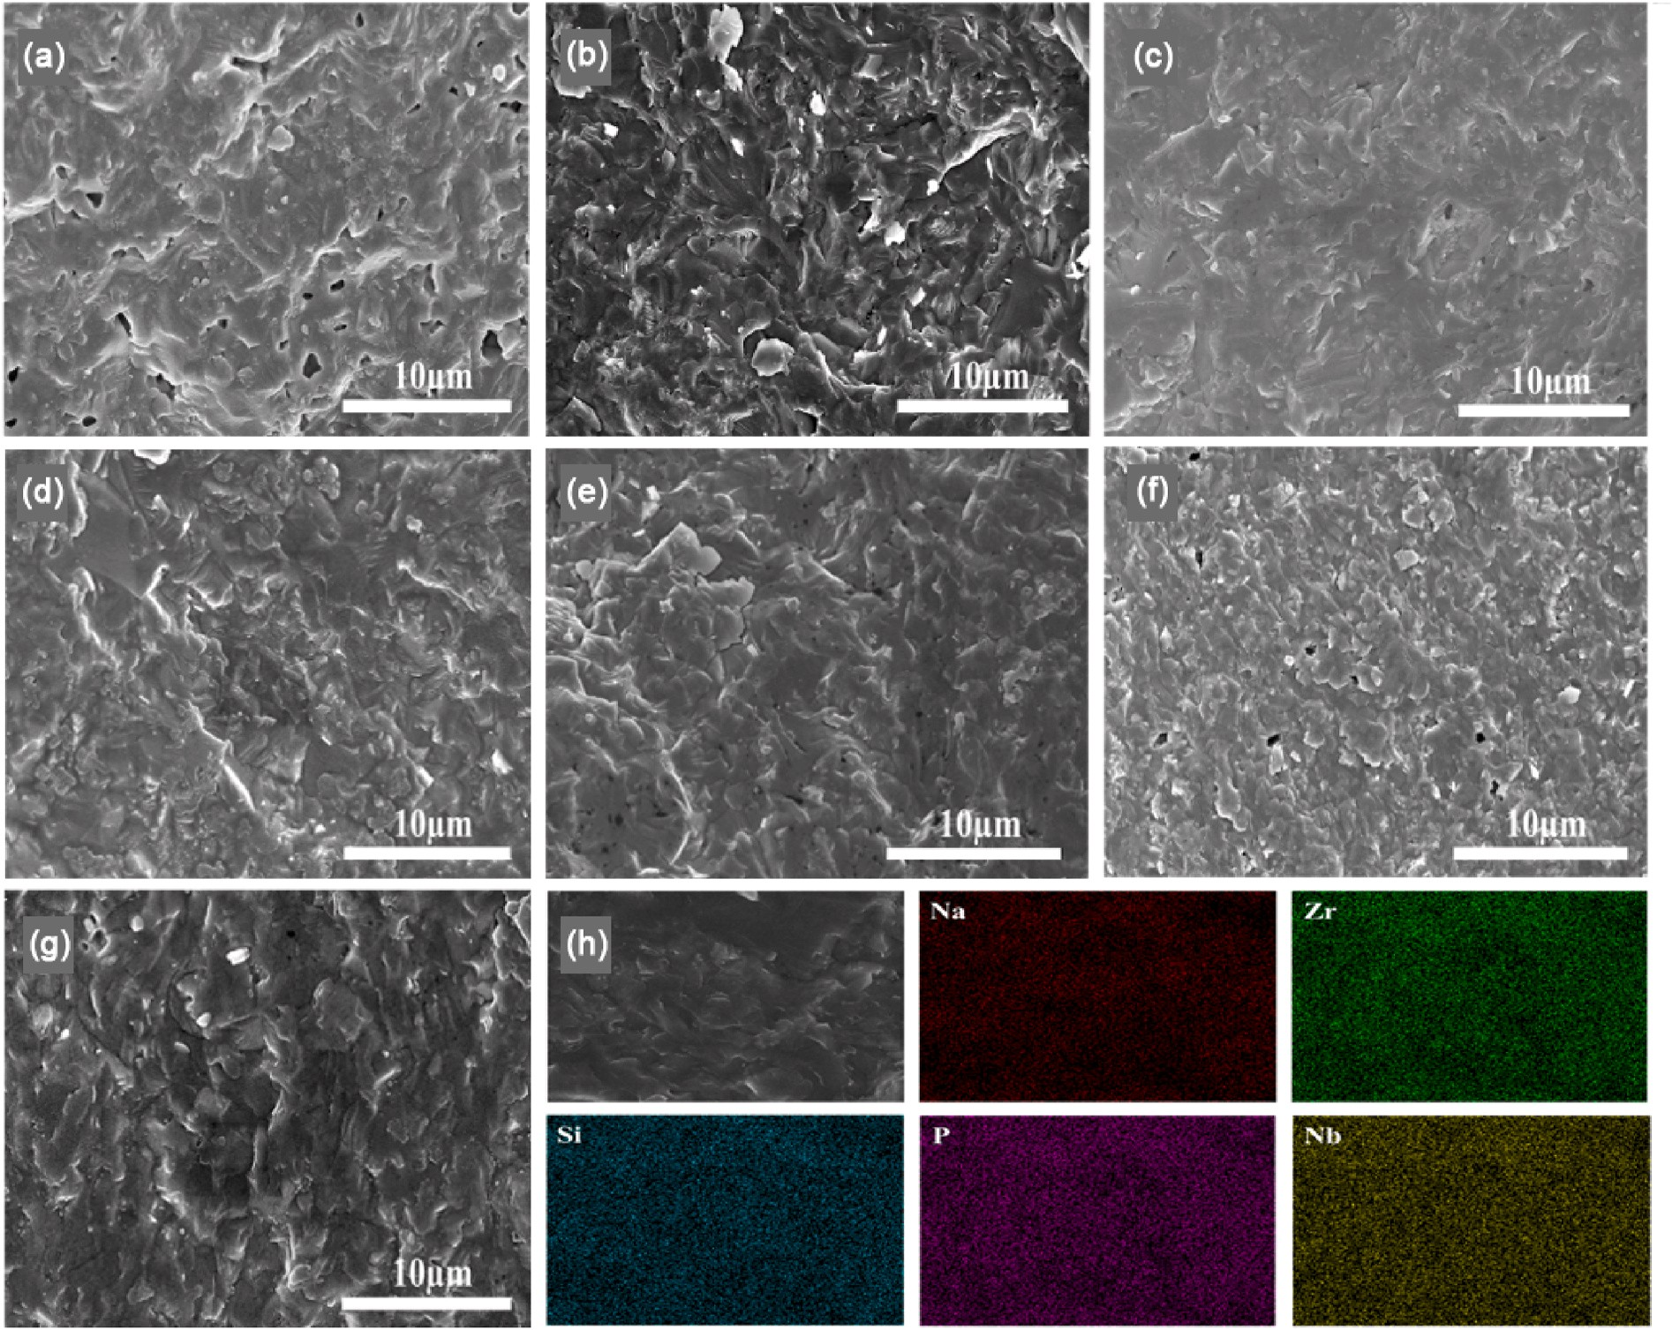

**Fig. 5.** Cross-sections of NZNSPx after sintering at 1260 ◦C for 5 h（a）x = 0（b）x = 0.05（c）x = 0.1（d）x = 0.15（e）x = 0.2（f）x = 0.3（g）x = 0.4. (h) Corresponding EDS mappings of the prepared Na3.3Zr1.9Nb0.1Si2.4P0.6O12.

levels will be analyzed and discussed later. In addition, when the Nb amount is x 0.05–0.2, only the crystalline NASICON phase was observed and no impurity phases were generated. However, when the Nb amount was further increased to 0.3 and 0.4, trace amounts of ZrO2 and NaNbO3 existed, of which ZrO2 is a very common secondary phase in the preparation of NASICON electrolytes and caused by the partial volatilization of Na2O during the high-temperature sintering process. The NaNbO3 impurity phase arises due to the solubility limit of Nb in the NASICON lattice.

=

Fig. 5a–g shows the cross-sectional images of NZNSPx. The Nb- substituted electrolyte materials have denser (95.5%) microstructures and higher crystallinity than the NZSP, and the grain size can be seen more obviously, thus indicating that the addition of Nb acts as a sin- tering aid. However, with the increase of Nb content, the electrolyte materials showed significant pore formation and cracks of different sizes. The cross-sectional morphology of NZNSP0.1 shows the closest contact between grains and almost no pores. In addition, the corre- sponding EDS mappings of the prepared Na3.3Zr1.9Nb0.1Si2.4P0.6O12 show that the elements of Na, Zr, Si, P, and Nb are uniformly distributed (Fig. 5h), which indicates that the Nb was successfully and homoge- neously incorporated into NZSP.

As shown in Fig. 6a and Fig. 6b, the ionic conductivity of the NZNSPx electrolytes increase and then decrease with increasing Nb content. The maximum of ionic conductivity of 5.51 mS cm—1 is reached at x 0.1.

=

Compared with all NASICON-type electrolyte materials reported so far with the highest ionic conductivity of 5.0 mS cm—1 [30], there is a good performance improvement. According to the charge conservation

principle, the substitution with cations having lower valence than Zr4+ is compensated with more mobile sodium ions in the crystal structure, while the substitution with higher valent cations creates more sodium vacancies [25,27,33]. This indicates that the concentration of vacancies available for sodium ions in the crystal structure gradually increases with the increase of Nb substitution, as shown in Fig. 6b. The intro- duction of too many vacancies reduces the concentration of mobile so- dium ions in the crystal structure to such a low level that the sodium ion transfer is inhibited [25,38]. Therefore, we assume that on the one hand there is a favorable ratio between the sodium ion concentration and vacancy concentration, at which the transfer of sodium ions is facilitated and the electroyte has the maximal ionic conductivity. On the other hand the increasing amount of Nb leads to significant changes in the Coulombic interaction with the oxygen ions along the sodium pathways leading to increasing electrostatic interferences of the ionic transport [38]. Fig. 6c and d show NZNSP0.1 electrolyte materials shows higher conductivities and lower activation energy (0.23 eV) than those of NZSP

and NZNSP0.1- NZNSP0.4. The above results indicate that the ionic conductivity can be improved both by replacing Zr4+ with Nb5+ and by

increasing the sodium vacancy concentration within a certain range. In addition, as shown in Fig. 6e, the σtotal of NZNSP0.1 is compared with other NASICON materials. Na3Zr2Si2PO12 has been playing an important role as a benchmark for many NASICON solid-state electrolyte materials

(σtotal > 10—4 S cm—1 at RT) [23]. Different methods have been tried to

enhance the ionic conductivity, such as substution with aliovalent cat- ions at the Zr site, changing the synthesis process, and adjusting the ratio of Si to P [39–41]. Among them, Na3.4Sc0.4Zr1.6Si2PO12,

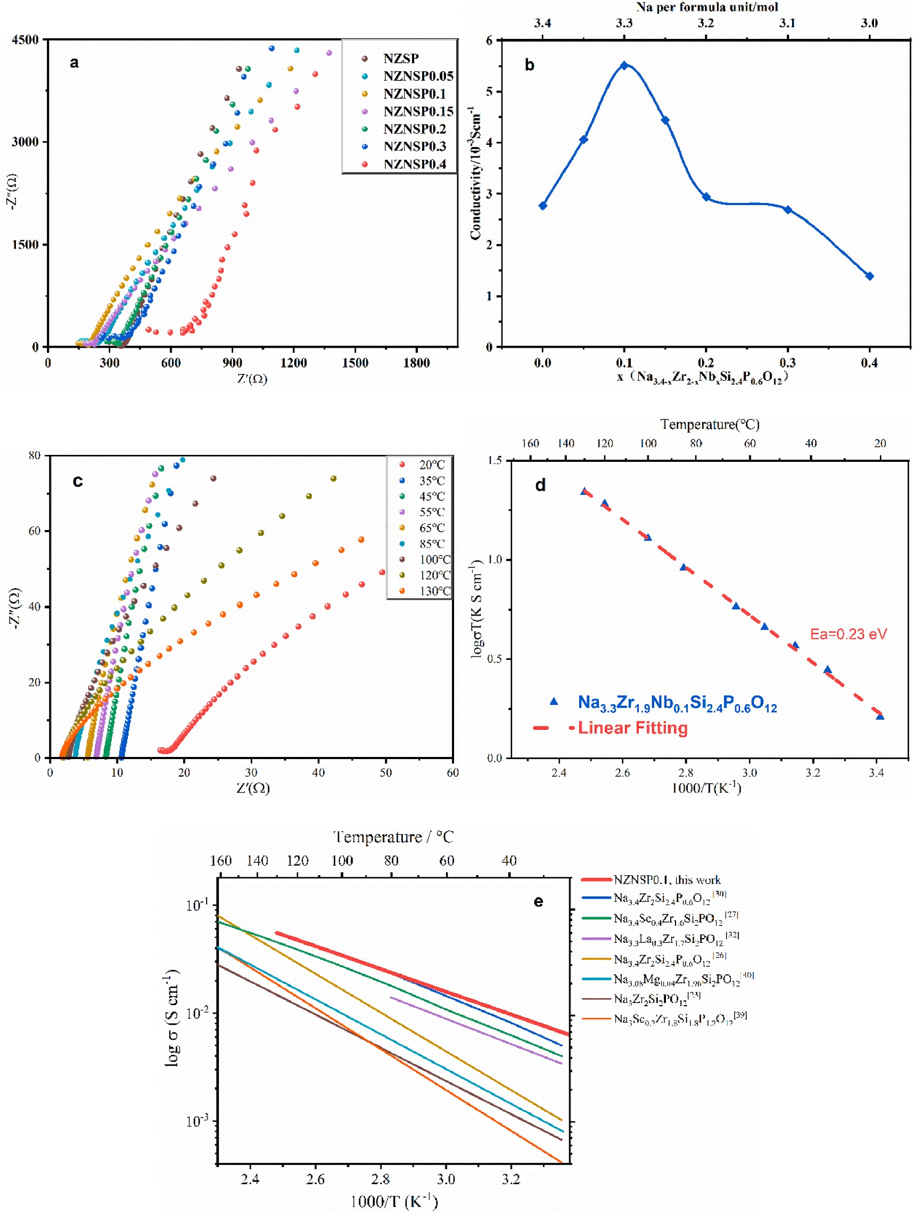

**Fig. 6.** (a) Impedance spectra and (b) plot of ionic conductivity versus niobium concentration of Na3.4-xZr2-xNbxSi2.4P0.6O12 at 25 ◦C, (c) Impedance spectra of Na3.3Zr1.9Nb0.1Si2.4P0.6O12 in the temperature range from 20 to 130 ◦C, (d) Arrhenius plot of Na3.3Zr1.9Nb0.1Si2.4P0.6O12 sintered at 1260 ◦C, (e) Temperature dependence of σtotal for NZNSP0.1 and comparison with other NASICON materials.

Na3.3La0.3Zr1.7Si2PO12, and Na3.4Zr2Si2.4P0.6O12 show reasonably good

σtotal of 4.0 mS cm—1, 3.4 mS cm—1 and 5.0 mS cm—1 at 25 ◦C, respec- tively [27,30,32]. In this work, the ionic conductivity as high as 5.51 mS cm—1 was obtained for NZNSP0.1. High ionic conductivity will help to

accelerate the practical application of NASICON electrolyte materials in the future.

In order to further unveil the reason for the increased conductivity after Nb doping, we separated the bulk impedance and grain boundary

impedance of NZNSP0.1 and Na3.3Zr2Si2.3P0.7O12 with the same sodium content of 3.3 mol per formula unit by applying a combined spectro- scopic system to analyze the reason for the increased conductivity after Nb substitution. It is common to use electrochemical impedance spec- troscopy to discuss the electrical conductivity of NASICON materials. However, conventional electrochemical impedance spectroscopy, due to its limited high-frequency range for investigations at room temperature, only yields one (or even half) semicircle, i.e., the total resistance Rtotal of

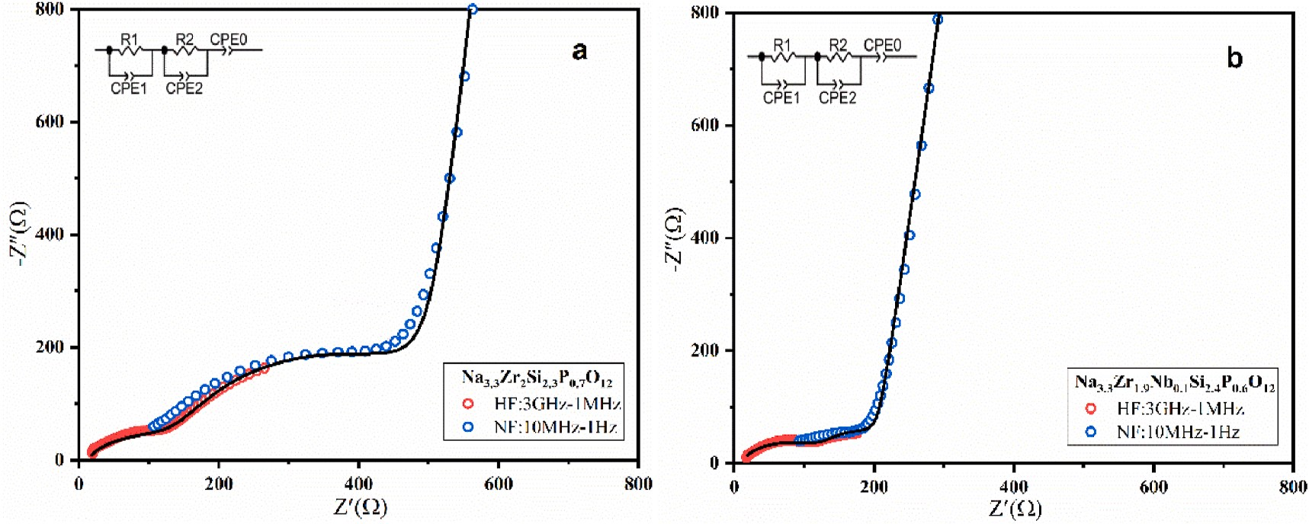

**Fig. 7.** Impedance spectra of Na3.3Zr2Si2.3P0.7O12 (a) and NZNSP0.1 (b) at 25 ◦C, in which the data of a high-frequency (HF) analyzer (red circles) and a normal- frequency (NF) analyzer (blue circles) and the simulated data (solid line) are combined. (For interpretation of the references to color in this figure legend, the reader is referred to the Web version of this article.)

**Table 1**

Bulk, grain boundary and total conductivity at 25 ◦C.

|  |  |  |  |  |  |
| --- | --- | --- | --- | --- | --- |
| Composition | Rb (Ω) | Rgb(Ω) | σb (mS cm—1) | Apparent σgb (mS cm—1) | σtotal(mS cm—1) |
| Na3.3Zr2Si2.3P0.7O12 | 145 | 322 | 6.89 | 3.11 | 2.14 |
| Na3.35Zr1.95Nb0.05Si2.4P0.6O12 | 153 | 93 | 6.53 | 10.7 | 4.06 |
| Na3.3Zr1.9Nb0.1Si2.4P0.6O12 | 119 | 62 | 8.39 | 16.1 | 5.51 |
| Na3.25Zr1.85Nb0.15Si2.4P0.6O12 | 161 | 64 | 6.20 | 15.6 | 4.44 |
| Na3.2Zr1.8Nb0.2Si2.4P0.6O12 | 259 | 81 | 3.86 | 12.3 | 2.94 |
| Na3.1Zr1.7Nb0.3Si2.4P0.6O12 | 269 | 103 | 3.72 | 9.7 | 2.69 |
| Na3Zr1.6Nb0.4Si2.4P0.6O12 | 463 | 256 | 2.16 | 3.9 | 1.39 |

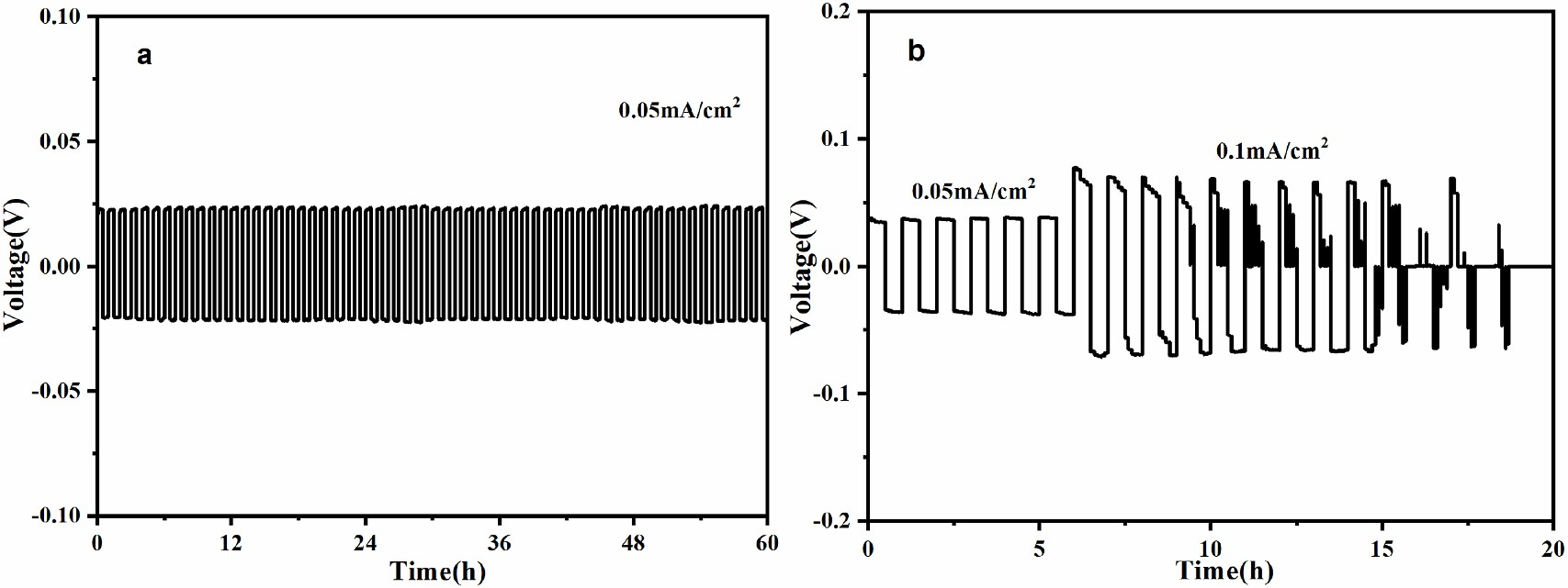

**Fig. 8.** Galvanostatic cycling of a Na/NZNSP0.1/Na symmetrical cell at (a) 0.05 mA/cm2 (b) 0.1 mA/cm2 at 25 ◦C.

the electrolyte material, while the bulk impedance Rb and the grain boundary impedance Rgb of the total impedance cannot be separated in the impedance spectrum. Therefore, a combination of two impedance spectroscopy systems were used, i.e. a high-frequency analyzer and a normal-frequency analyzer, as shown in Fig. 7. The inset shows the equivalent circuit used for data fitting, where R denotes a pure resis- tance and CPE denotes a constant phase element. The difference be- tween the bulk impedance and grain boundary impedance of NZNSP0.1 and Na3.3Zr2Si2.3P0.7O12 can be visually compared from the two distinct semicircles in the impedance spectra, as shown in Fig. 7 and Table 1. With the same sodium content of 3.3 mol per formula unit, the bulk impedance of NZNSP0.1 and Na3.3Zr2Si2.3P0.7O12 are approximately the

same. However, because the ionic radius of Nb5+ (0.63 Å) is smaller than

that of Zr4+ (0.72 Å) the transport channels of sodium ions in the crystal structure may slightly decreased in diameter and thus be more favorable

for the transport of sodium ions [26,42,43]. Therefore, the bulk impedance of Na3.3Zr1.9Nb0.1Si2.4P0.6O12 is slightly lower in comparison to Na3.3Zr2Si2.3P0.7O12. Secondly, it can be seen from Fig. 7 that the grain boundary impedance of NZNSP0.1 is significantly lower than that of Na3.3Zr2Si2.4P0.6O12, indicating that Nb can modify the grain boundaries resulting, in sum, in a higher total ionic conductivity of NZNSP0.1.

Whereas NASICON solid electrolytes have good ionic conductivity there are still issues to be solved in combination with electrode mate- rials. For example, most solid electrolyte materials suffer from relatively poor solid-solid contact with metal electrodes [44]. Thus, 5 μL of organic electrolyte (ethylene carbonate) was coated on the interface between electrode and electrolyte to improve the contact. The inhibition of so- dium dendrite growth and the stability between NZNSP0.1 and Na was tested by assembling Na|NZNSP0.1|Na symmetric cells for constant

current charge/discharge. As shown in Fig. 8a, the polarization voltage of the symmetric cell was stable for up to 60 cycles throughout the cyclic

operation at a current density of 0.05 mA/cm2 at 25 ◦C. The interface

between the electrode and the solid electrolyte was stable and no short-circuit occurred. However, when the current density was increased to 0.1 mA/cm2, the voltage showed significant fluctuations

(Fig. 8b), which may be due to dendrite formation through the elec- trolyte. Although the cycling performance of this cell is better than many solid-state lithium batteries [45], it is still slightly worse than the orig- inal NZSP [46], probably because Nb induces some electronic conduc- tivity, which may weaken the threshold of dendrite formation [47]. Further experiments are necessary for more detailed explanations.

# Conclusion

In summary, we successfully obtained a NASICON-type solid elec- trolyte Na3.4Zr2Si2.4P0.6O12 (NZSP) by a solution-assisted solid-state reaction method. On this basis, Nb5+ was incorporated into NZSP for the

first time, and it was found that the ionic conductivity initially increased

and then decreased with the increase of Nb concentration, and the ionic conductivity was as high as 5.51 mS cm—1 for NZNSP0.1. This is a sig-

nificant performance improvement compared with all NASICON-type electrolyte materials reported so far. The significant reduction of grain boundary impedance confirms that the substitution with Nb was helpful with respect to sintering of NZSP and the densities of the electrolyte materials increased in combination with higher phase purity and mini- mal presence of impurity phases such as ZrO2. The reduction of bulk

impedance is probably resulting from the sodium ion concentration and the impact of the Nb5+ ions on their local structure. The reasonable ratio of sodium ion concentration and vacancy concentration effectively

promotes the transfer of sodium ions. The high-frequency impedance analysis also confirms the reduction in both the bulk impedance and the grain boundary impedance of the Nb-containing materials. Na| NZNSP0.1|Na symmetrical cells were assembled, which can be cycled

stably for 60 cycles at a current density of 0.05 mA/cm2.

# CRediT authorship contribution statement

**Yujian Liu:** Conceptualization, Methodology, Writing – review & editing. **Limin Liu:** Conceptualization, Supervision, Writing – review & editing. **Jinsong Peng:** Investigation, Supervision, Writing – review & editing, Funding acquisition. **Xiaoliang Zhou:** Conceptualization, Su- pervision, Writing – review & editing, Funding acquisition. **Dongshi Liang:** Investigation. **Lei Zhao:** Software. **Jiawen Su:** Resources. **Bo Zhang:** Data curation. **Si Li:** Investigation. **Naiqing Zhang:** Data cura- tion. **Qianli Ma:** Conceptualization, Supervision, Writing – review & editing. **Frank Tietz:** Conceptualization, Supervision, Resources.

# Declaration of competing interest

The authors declare that they have no known competing financial interests or personal relationships that could have appeared to influence the work reported in this paper.

# Acknowledgements

This work was supported by the National Natural Science Foundation of China (No. 21875056 and No. 22075231) and the funding supported by Sichuan Science and Technology Program (No. 2020YFSY0026 and No. 2021YFSY0022). Limin Liu gratefully acknowledges the financial support of the Fundamental Research Funds for the Central Universities (2572018BC29), and the National Natural Science Foundation of Hei- longjiang Province (B2018002).

# Appendix A. Supplementary data

Supplementary data to this article can be found online at

# References

[1] [B. Obama, Science 355 (2017) 126–129](http://refhub.elsevier.com/S0378-7753(21)01257-X/sref1).

1. [A.M. Omer, Renew. Sustain. Energy Rev. 12 (2008) 2331–2357](http://refhub.elsevier.com/S0378-7753(21)01257-X/sref2).
2. [M. Asif, T. Muneer, Renew. Sustain. Energy Rev. 11 (2007) 1388–1413](http://refhub.elsevier.com/S0378-7753(21)01257-X/sref3).
3. [J.T. Lee, D.S. Callaway, Nature Energy 3 (2018) 960–968](http://refhub.elsevier.com/S0378-7753(21)01257-X/sref4). [5] [S. Chu, A. Majumdar, Nature 488 (2012) 294–303](http://refhub.elsevier.com/S0378-7753(21)01257-X/sref5).
4. [V. Palomares, P. Serras, I. Villaluenga, K.B. Hueso, J. Carretero-Gonz´alez, T. Rojo,](http://refhub.elsevier.com/S0378-7753(21)01257-X/sref6)

[Energy Environ. Sci. 5 (2012) 5884–5901](http://refhub.elsevier.com/S0378-7753(21)01257-X/sref6).

1. [H. Pan, Y.-S. Hu, L. Chen, Energy Environ. Sci. 6 (2013) 2338–2360](http://refhub.elsevier.com/S0378-7753(21)01257-X/sref7).
2. [C. Nithya, S. Gopukumar, Wiley Interdisciplinary Reviews: Energy Environ. 4](http://refhub.elsevier.com/S0378-7753(21)01257-X/sref8) [(2015) 253–278](http://refhub.elsevier.com/S0378-7753(21)01257-X/sref8).

[9] [X.-B. Cheng, R. Zhang, C.-Z. Zhao, Q. Zhang, Chem. Rev. 117 (2017) 10403–10473](http://refhub.elsevier.com/S0378-7753(21)01257-X/sref9).

1. [C. Zhao, L. Liu, X. Qi, Y. Lu, F. Wu, J. Zhao, Y. Yu, Y.S. Hu, L. Chen, Advanced](http://refhub.elsevier.com/S0378-7753(21)01257-X/sref10) [Energy Materials 8 (2018) 1703012](http://refhub.elsevier.com/S0378-7753(21)01257-X/sref10).
2. [Q. Zhang, K. Liu, F. Ding, X. Liu, Nano Research 10 (2017) 4139–4174](http://refhub.elsevier.com/S0378-7753(21)01257-X/sref11).
3. [Y. Tian, T. Shi, W.D. Richards, J. Li, J.C. Kim, S.H. Bo, G. Ceder, Energy Environ.](http://refhub.elsevier.com/S0378-7753(21)01257-X/sref12) [Sci. 10 (2017) 1150–1166](http://refhub.elsevier.com/S0378-7753(21)01257-X/sref12).
4. [Z. Zhang, E. Ramos, F. Lalere, A. Assoud, K. Kaup, Energy Environ. Sci.: EES](http://refhub.elsevier.com/S0378-7753(21)01257-X/sref13) [(Ecotoxicol. Environ. Saf.) 11 (2018) 87–93](http://refhub.elsevier.com/S0378-7753(21)01257-X/sref13).
5. [A. Hayashi, K. Noi, A. Sakuda, M. Tatsumisago, Nat. Commun. 3 (2011) 856](http://refhub.elsevier.com/S0378-7753(21)01257-X/sref14).
6. [L. Zhang, K. Yang, J. Mi, L. Lu, L. Zhao, L. Wang, Y. Li, H. Zeng, Advanced Energy](http://refhub.elsevier.com/S0378-7753(21)01257-X/sref15) [Materials 5 (2015) 1501294](http://refhub.elsevier.com/S0378-7753(21)01257-X/sref15).
7. [H. Oguchi, M. Matsuo, S. Kuromoto, H. Kuwano, S. Orimo, J. Appl. Phys. 111](http://refhub.elsevier.com/S0378-7753(21)01257-X/sref16) [(2012) 224103](http://refhub.elsevier.com/S0378-7753(21)01257-X/sref16).
8. [M. Matsuo, H. Oguchi, T. Sato, H. Takamura, E. Tsuchida, T. Ikeshoji, S.I. Orimo,](http://refhub.elsevier.com/S0378-7753(21)01257-X/sref17) [J. Alloys Compd. 580 (2013) S98–S101](http://refhub.elsevier.com/S0378-7753(21)01257-X/sref17).
9. [T.J. Udovic, M. Matsuo, A. Unemoto, N. Verdal, V. Stavila, A.V. Skripov, J.J. Rush,](http://refhub.elsevier.com/S0378-7753(21)01257-X/sref18)

[H. Takamura, S.I. Orimo, Chem. Commun. 50 (2014) 3750–3752](http://refhub.elsevier.com/S0378-7753(21)01257-X/sref18).

1. [T.J. Udovic, M. Matsuo, W.S. Tang, H. Wu, V. Stavila, A.V. Soloninin, R.](http://refhub.elsevier.com/S0378-7753(21)01257-X/sref19)

[V. Skoryunov, O.A. Babanova, A.V. Skripov, J.J. Rush, A. Unemoto, H. Takamura,](http://refhub.elsevier.com/S0378-7753(21)01257-X/sref19) [S.-i. Orimo, Adv. Mater. 26 (2014) 7622–7626](http://refhub.elsevier.com/S0378-7753(21)01257-X/sref19).

[20] [Y. Yao, J.T. Kummer, J. Inorg. Nucl. Chem. 29 (1967) 2453–2475](http://refhub.elsevier.com/S0378-7753(21)01257-X/sref20).

1. [G. Flor, A. Marini, V. Massarotti, M. Villa, Solid State Ionics 2 (1981) 195–204](http://refhub.elsevier.com/S0378-7753(21)01257-X/sref21).
2. [N. Baffier, J.C. Badot, P. Colomban, Mater. Res. Bull. 16 (1981) 259–265](http://refhub.elsevier.com/S0378-7753(21)01257-X/sref22).
3. [J.B. Goodenough, H.Y.P. Hong, J.A. Kafalas, Mater. Res. Bull. 11 (1976) 203–220](http://refhub.elsevier.com/S0378-7753(21)01257-X/sref23). [24] [H.Y.P. Hong, Mater. Res. Bull. 11 (1976) 173–182](http://refhub.elsevier.com/S0378-7753(21)01257-X/sref24).
4. [M. Guin, F. Tietz, J. Power Sources 273 (2015) 1056–1064](http://refhub.elsevier.com/S0378-7753(21)01257-X/sref25).
5. [N. Anantharamulu, K. Koteswara Rao, G. Rambabu, B. Vijaya Kumar, V. Radha,](http://refhub.elsevier.com/S0378-7753(21)01257-X/sref26) [M. Vithal, J. Mater. Sci. 46 (2011) 2821–2837](http://refhub.elsevier.com/S0378-7753(21)01257-X/sref26).
6. [Q. Ma, M. Guin, S. Naqash, C.-L. Tsai, F. Tietz, O. Guillon, Chem. Mater. 28 (2016)](http://refhub.elsevier.com/S0378-7753(21)01257-X/sref27) [4821–4828](http://refhub.elsevier.com/S0378-7753(21)01257-X/sref27).

[28] [Y. Lu, L. Li, Q. Zhang, Z. Niu, J. Chen, Joule 2 (2018) 1747–1770](http://refhub.elsevier.com/S0378-7753(21)01257-X/sref28).

1. [S. Naqash, Q. Ma, F. Tietz, O. Guillon, Solid State Ionics 302 (2017) 83–91](http://refhub.elsevier.com/S0378-7753(21)01257-X/sref29).
2. [Q. Ma, C.L. Tsai, X.K. Wei, M. Heggen, F. Tietz, J. Irvine, J. Mater. Chem. 7 (2019)](http://refhub.elsevier.com/S0378-7753(21)01257-X/sref30) [7766–7776](http://refhub.elsevier.com/S0378-7753(21)01257-X/sref30).
3. [J.F. Ihlefeld, E. Gurniak, B.H. Jones, D.R. Wheeler, M.A. Rodriguez, A.H. McDaniel,](http://refhub.elsevier.com/S0378-7753(21)01257-X/sref31) [J. Am. Ceram. Soc. 99 (2016) 2729–2736](http://refhub.elsevier.com/S0378-7753(21)01257-X/sref31).
4. [Z. Zhang, Q. Zhang, J. Shi, Y.S. Chu, X. Yu, K. Xu, M. Ge, H. Yan, W. Li, L. Gu,](http://refhub.elsevier.com/S0378-7753(21)01257-X/sref32) [Advanced Energy Materials 7 (2017) 1601196](http://refhub.elsevier.com/S0378-7753(21)01257-X/sref32).
5. [M. Samiee, B. Radhakrishnan, Z. Rice, Z. Deng, Y.S. Meng, S.P. Ong, J. Luo,](http://refhub.elsevier.com/S0378-7753(21)01257-X/sref33) [J. Power Sources 347 (2017) 229–237](http://refhub.elsevier.com/S0378-7753(21)01257-X/sref33).
6. [S. Song, H.M. Duong, A.M. Korsunsky, N. Hu, L. Lu, Sci. Rep. 6 (2016) 1–10](http://refhub.elsevier.com/S0378-7753(21)01257-X/sref34).
7. [R.O. Fuentes, F.M. Figueiredo, F.M.B. Marques, J.I. Franco, Solid State Ionics 140](http://refhub.elsevier.com/S0378-7753(21)01257-X/sref35) [(2001) 173–179](http://refhub.elsevier.com/S0378-7753(21)01257-X/sref35).
8. [C. Huang, G. Yang, W. Yu, C. Xue, Y. Zhai, W. Tang, N. Hu, Z. Wen, L. Lu, S. Song,](http://refhub.elsevier.com/S0378-7753(21)01257-X/sref36) [J. Alloys Compd. 855 (2021) 157501](http://refhub.elsevier.com/S0378-7753(21)01257-X/sref36).
9. [L. Ran, A. Baktash, M. Li, Y. Yin, B. Demir, T. Lin, M. Li, M. Rana, I. Gentle,](http://refhub.elsevier.com/S0378-7753(21)01257-X/sref37)

[L. Wang, D.J. Searles, R. Knibbe, Energy Storage Materials 40 (2021) 282–291](http://refhub.elsevier.com/S0378-7753(21)01257-X/sref37).

1. [S. Naqash, F. Tietz, O. Guillon, Solid State Ionics 319 (2018) 13–21](http://refhub.elsevier.com/S0378-7753(21)01257-X/sref38).
2. [M. Subramanian, P. Rudolf, A. Clearfield, J. Solid State Chem. 60 (1985) 172–181](http://refhub.elsevier.com/S0378-7753(21)01257-X/sref39).
3. [T. Takahashi, K. Kuwabara, M. Shibata, Solid State Ionics 1 (1980) 163–175](http://refhub.elsevier.com/S0378-7753(21)01257-X/sref40).
4. [U. Von Alpen, M. Bell, H. Ho¨fer, Solid State Ionics 3 (1981) 215–218](http://refhub.elsevier.com/S0378-7753(21)01257-X/sref41).
5. [D. Chen, F. Luo, W. Zhou, D. Zhu, J. Alloys Compd. 757 (2018) 348–355](http://refhub.elsevier.com/S0378-7753(21)01257-X/sref42).
6. [A.G. Jolley, D.D. Taylor, N.J. Schreiber, E.D. Wachsman, J. Am. Ceram. Soc. 98](http://refhub.elsevier.com/S0378-7753(21)01257-X/sref43) [(2015) 2902–2907](http://refhub.elsevier.com/S0378-7753(21)01257-X/sref43).
7. [S. Lou, F. Zhang, C. Fu, M. Chen, Y. Ma, G. Yin, J. Wang, Adv. Mater. 33 (2021)](http://refhub.elsevier.com/S0378-7753(21)01257-X/sref44) [2000721](http://refhub.elsevier.com/S0378-7753(21)01257-X/sref44).
8. [C.-L. Tsai, S. Yu, H. Tempel, H. Kungl, R.-A. Eichel, Mater. Technol. 35 (2020)](http://refhub.elsevier.com/S0378-7753(21)01257-X/sref45) [656–674](http://refhub.elsevier.com/S0378-7753(21)01257-X/sref45).
9. [C.-L. Tsai, T. Lan, C. Dellen, Y. Ling, Q. Ma, D. Fattakhova-Rohlfing, O. Guillon,](http://refhub.elsevier.com/S0378-7753(21)01257-X/sref46)

[F. Tietz, J. Power Sources 476 (2020) 228666](http://refhub.elsevier.com/S0378-7753(21)01257-X/sref46).

1. [X. Liu, R. Garcia-Mendez, A.R. Lupini, Y. Cheng, Z.D. Hood, F. Han, A. Sharafi, J.](http://refhub.elsevier.com/S0378-7753(21)01257-X/sref47)

[C. Idrobo, N.J. Dudney, C. Wang, Nat. Mater. (2021) 1–6](http://refhub.elsevier.com/S0378-7753(21)01257-X/sref47).