Infrared furnace for *in situ* neutron single crystal diffraction studies in controlled gas atmospheres at high temperatures

**Fernando Magroab, Monica Cerettia*, Martin Mevenb and Werner Paulusa**

aICGM , Univ. Montpellier, CNRS, ENSCM, Montpellier, France  
bInstitute of Crystallography, RWTH Aachen University and Jülich Centre for Neutron Science (JCNS) at Heinz Maier-Leibnitz Zentrum (MLZ), Garching, Germany

Correspondence email: monica.ceretti@umontpellier.fr

1. For the understanding of oxygen diffusion mechanisms in non-stoichiometric oxides, the possibility to explore structural changes as a function of the oxygen partial pressure with temperature and related oxygen bulk stoichiometry is mandatory. We report here on the realization of a high temperature furnace, suitable for single crystal neutron diffraction, working continuously at temperatures up to 1000°C at different and adjustable partial gas pressures up to 2 bars. This allows to explore the phase diagrams of non-stoichiometric oxides under *in operando* conditions under controlled oxygen partial pressure. As a pilot study we explored the structural changes of Pr2NiO4+δ at room temperature (δ ≈ 0.24), and at 900°C under 1 bar P(O2) (δ ≈ 0.13) as well as under secondary vacuum (approximately 10-5 mbar) condition yielding a δ close to zero. The strong anharmonic displacements of the apical oxygen atoms along the [110] shallow diffusion pathway, which were previously observed at RT and 400°C, clearly become more isotropic at 900°C. Our study evidences that the anisotropic oxygen displacements, here related to lattice instabilities, play a major role to understand oxygen diffusion pathways and related activation energies at moderate temperatures. This also shows the importance of the availability of such reaction cells for single crystal neutron diffraction to explore the phase diagram and associated structural changes of non-stoichiometric oxygen ion conductors and respective diffusion mechanisms.
2. Neutron Diffraction, IR furnace, non-stoichiometric oxides, *in situ* single crystal diffraction, Pr2NiO4+δ
3. Introduction

Chemical reactivity of solids is nowadays routinely investigated under *in situ* conditions on polycrystalline samples in dedicated reaction chambers. Cells for *in situ* X-rays/neutron diffraction studies, as a function of temperature and / or under controlled atmosphere or pressure are commonly available for different types of powder diffractometers (at both laboratory and large scale facilities) (Hansen *et al.*, 2015, Jensen *et al.*, 2010, Ahlburg *et al.*, 2019, Bianchini *et al.*, 2013). While this has become a standard characterization technique for many applications (batteries, catalysts, highly correlated compounds, to name a few) using powder diffraction methods, very little has been developed for the single crystal counterpart. However, following solid-state reactions using single crystals is in principle a more powerful tool, as it allows exploring the whole reciprocal lattice including its full spatial relationships. This provides valuable information on the diffuse scattering and weak reflections of superstructures, as well as indications of the volume fraction e.g. of different twin domains during the reaction, which are difficult or even impossible to access by powder diffraction. Despite these advantages, solid state reactivity followed using single crystals is almost unreported in the literature (Maity *et al.*, 2015). This is mainly due to the usually slow reaction kinetics, which, in addition may lead to non-homogeneous samples and structural complexity, often related to disorder states, twinning, stacking defects or domain effects, which consequently requires a more sophisticated and time-consuming data analysis. In this context, *in situ* single crystal neutron diffraction using a short wavelength presents a special interest, as neutrons are scattered at nuclei, i.e. point-like, resulting in constant atomic form factors. This consequently allows to deliver very precise information on thermal or static atomic displacements, especially from data sets up to high momentum transfers. Moreover, neutrons have the advantage to be transparent for most isotopes, which, together with the fact that the scattering amplitudes are roughly on the same scale, allows to easily explore scattering densities of light together with heavy elements simultaneously. All these arguments become decisive when exploring oxygen diffusion mechanisms in non-stoichiometric oxides, as precise structure analysis and oxygen stoichiometry can be analysed in parallel. Combined with a quantitative data analysis using the Maximum Entropy Method, this becomes a promising concept to explore oxygen diffusion pathways from elastic diffraction data directly from the scattering density maps.

For several oxide families, relevant oxygen diffusion is already present at quite moderate temperatures, i.e. around 400°C. The oxygen stoichiometry can be varied as a function of the temperature and the O2 partial pressure in a reasonable time window and related structural changes can be explored accordingly. Such kind of measurements requires, however, a gas tight reaction cell, which is transparent to neutrons and is resistant to high temperatures, allowing to control the oxygen stoichiometry. The classical heating devices for neutron diffractometers are thin vanadium sheets which are heated applying a current through them. As they are sensitive to oxidation at already moderate temperatures, they cannot be used at high temperatures in oxidizing atmospheres. An alternative reaction cell consisting of a quartz tube is presented below, where the temperature is achieved with the help of a mirror furnace.

Here, we report on the implementation of such kind of a furnace for *in-situ* structural studies by neutron diffraction on single crystals under different gas pressures and temperatures, which has so far not been reported for single crystal neutron diffractometers. This specific furnace is a modified version of the Infra-Red (IR) mirror furnace (Lorenz *et al.*, 1993) already available on the single crystal neutron diffractometer HEiDi at MLZ for high temperature measurements in vacuum. The main modification consists of inserting a tight quartz tube, in which the crystal is positioned in, and which is separated from the isolation vacuum. Such a reaction cell allows to apply any desired gas atmosphere (oxidizing or reducing) to the sample, thus avoiding damaging the mirrors inside the vacuum part of the furnace. Quartz is almost transparent to neutrons and has a small incoherent cross section, i.e. it yields a low background. As an example of application of this new equipment, we present structural changes of the oxygen ion conductor Pr2NiO4+ at 900°C at different P(O2) allowing to better explore oxygen diffusion mechanisms at high and moderate temperatures as a function of the oxygen stoichiometry.

1. Implementation of an IR furnace for *in situ* single crystal neutron diffraction in a controlled gas atmosphere

The existing IR mirror furnace available on the single crystal diffractometer HEiDi at the Heinz Maier-Leibnitz Zentrum (MLZ, Garching) (Meven & Sazanov, 2015) consists of a spherical central aluminium body, composed of a lower and upper cap, with an external diameter of 128 mm. Each cap has two mounts for water-cooled polished aluminium spherical reflectors. In total, four 150 W halogen lamps (Osram Xenophot 64633 HLX), arranged tetrahedrally, concentrate IR radiation into a common focal point at the sample position (Figure 1a). Light ray tracing calculations (Appendix 1) show that the homogeneous temperature region at the sample position is about 1 cm3, which is fully convenient for single crystal neutron diffraction studies. The sample holder itself consists of a height-adjustable steel tube, followed by a ceramic tube (Al2O3) in the direction of the sample position, at the end of which the crystal is glued with high-temperature cement and then adjusted to the center of the furnace. The sample temperature is controlled by a K-type thermocouple inside the sample holder, whose tip touches the sample. The compact design allows an easy installation into an Eulerian cradle, giving access to many possible sample orientations to explore the reciprocal space. Geometrically, the limits of (-91° ≤ χ ≤ 91° ,-179° ≤ ϕ ≤ 179°, -51° ≤ ω ≤ 51°, -5° ≤ 2θ ≤ 121°) are comparable to the situation without the furnace. A possible absorption of the incoming or reflected beam by the upper or lower cap of the furnace can largely be avoided by reaching many reflections not only in the bi-secting mode, but also with a Ψ-rotation. When a reflection cannot be measured in the standard bi-secting condition, due to a shading of the beam path, the data collection program on HEiDi automatically checks for accessibility by rotation around Ψ with a step size of 1°, in order to scan the full 360° rotation for possible matching. In this way most of the regions of reciprocal space are accessible. This of course also depends on the crystal orientation, which might need to be optimized before data collection, in order to have access to at least one symmetry equivalent reflection.

In its original configuration, the IR furnace was able to reach up to 1000°C under vacuum, while the application of most gas atmospheres leads to the deterioration of the mirrors and heat isolation problems (Figure 1a).

The guiding idea for the reaction cell conception was therefore to permit an easy control of the gas atmosphere inside the reaction cell, while maintaining the mirrors protected inside the isolation vacuum.

The existing furnace was thus modified in order to allow the installation of a quartz tube of about 10 mm diameter, tightly fixed inside and allowing to work under *operando* conditions between 10-5 mbar < P < 2 bar (above normal pressure). This implies a pressure difference of at least 3 bar between the pressures inside and outside the quartz tube, which has been successfully tested at 900°C. We experimentally verified the maximum operating temperature conditions to be 1100°C for 1 bar of Argon and 1050°C for 1 bar of Oxygen and air. The difference is essentially related to the higher specific heat capacity for 2-atomic gases as O2 (or N2) compared to monoatomic Ar and thus to their respective changes in the heat transport from the sample towards the walls of the quartz capillary.

To be able to pass the capillary through the furnace, the lower part has been rotated by 90° while the lower part of the reaction cell is connected to a vacuum pump (Figure 1b). The new sample holder fitting into the quartz capillary was equipped with valves allowing to inject any desired gas atmosphere. As in the original configuration, the sample temperature is controlled by a thermocouple inside the sample holder, touching the sample. To fix the modified furnace on the Eulerian cradle, the lower and upper bases of the furnace have been modified accordingly, still allowing an easy handling of positioning/rotation.

Heat transfer in the modified furnace was checked by performing thermal simulations using COMSOL Multiphysics® heat conduction and ray tracing modules (Appendix 1). To avoid overheating problems, an additional water-cooling system has been implemented (Figure 2) at one end of the quartz tube, at the gas injector. The heating zone at the center of the furnace has also been verified to ensure a homogeneous temperature profile of at least one centimeter around the sample, which is more than sufficient for neutron diffraction measurements.

~~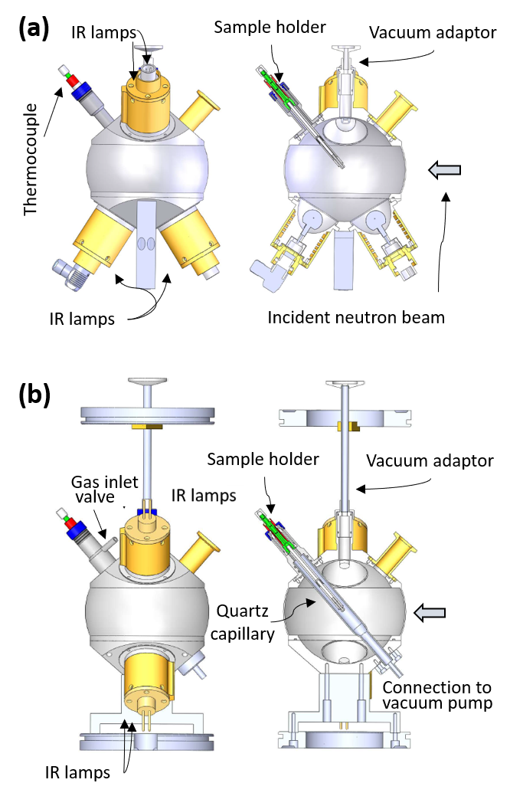~~

1. Drawings and front section of the furnace in its original configuration (a) and in the modified version (b). For the latter, the lower part has been rotated by 90° to pass the quartz tube through. Thus, any gas atmosphere can be injected in the cell without damaging the reflective wall of the furnace itself and the bulbs, being in vacuum. Gas inlet and outlet valves are outlined; this configuration allows also to work under constant gas flow conditions.

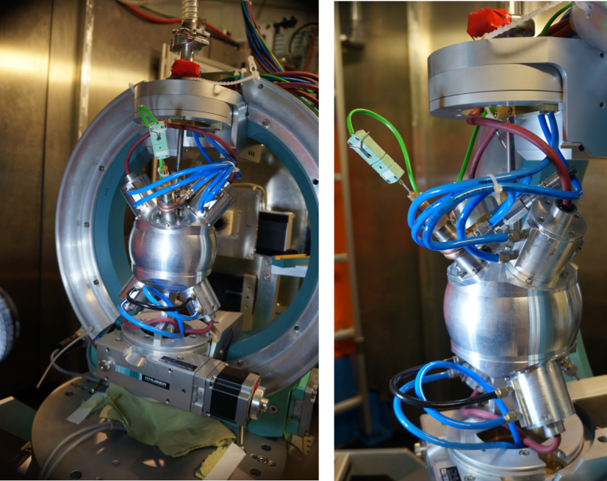

1. The new IR furnace mounted on the HEiDI diffractometer. On the right, a closer view to show the gas injector and the water-cooling system, introduced in order to avoid overheating problems at one end of the quartz cell.

In addition to the modification of the furnace, a gas handling system (Figure 3) was designed and built up in order to prepare and control the gas mixture to be injected into the quartz tube as an option. From the desired gas mixture, a precise amount of gas can be taken out using gas-tight syringes. Their termination incorporates an on/off syringe valve, where an adapter is mounted to connect the syringe to the gas chamber first and after filling to the reaction cell via an injection valve, which is situated on top of the quartz tube.

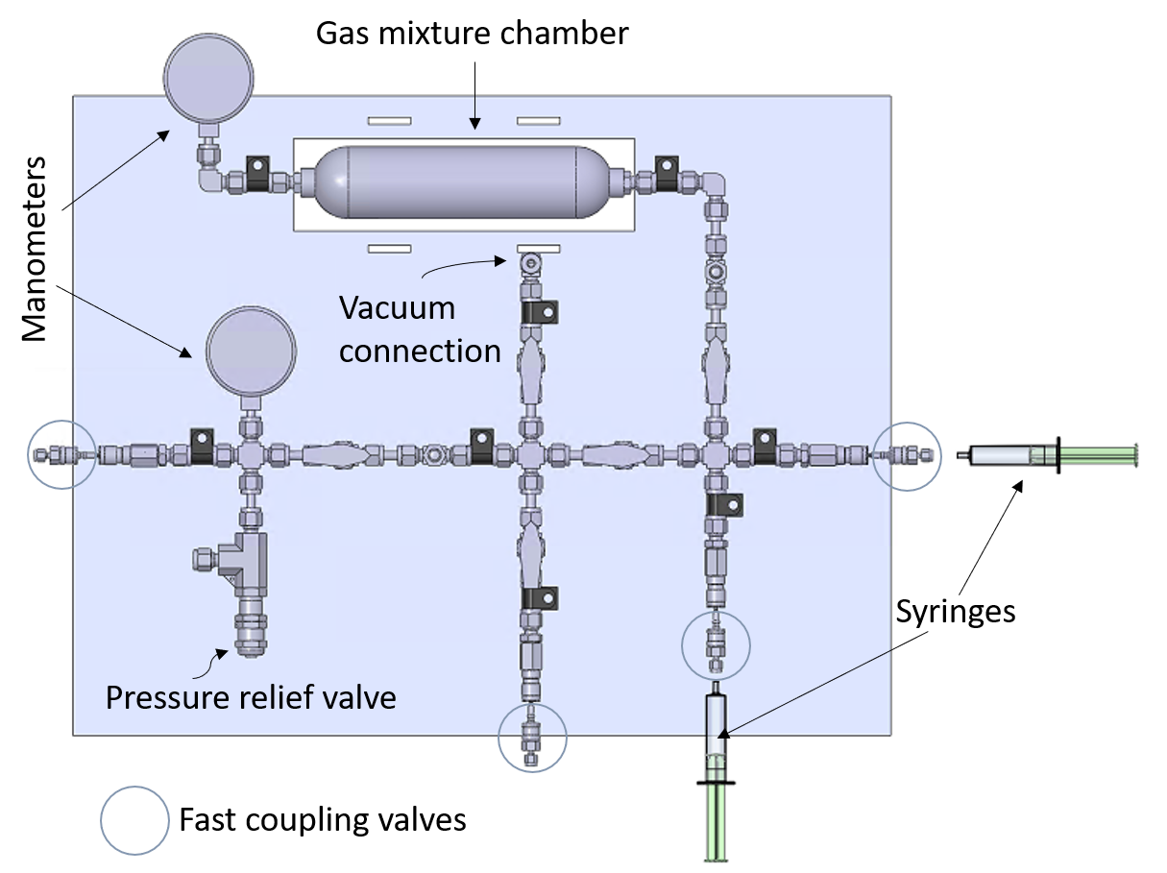

1. Gas handling system: different gas mixtures can be obtained up to 200 bars in the gas mixture chamber via two coupling valves to different gas bottles. Small quantities of the gas composition can be taken out via special syringe gas inlets or via a stainless-steel tube directly connected to the mirror furnace.
2. Diffraction measurements on oxygen stoichiometry controlled Pr2NiO4+ single crystals

Pr2NiO4+ (PNO in the following) belongs to the few known non-stoichiometric oxides of the K2NiF4 family with high oxygen ion conductivity already present at ambient temperature. It consequently figures among promising candidates for oxygen electrolytes/membranes in solid oxide fuel cells (Kovalevsky *et al.*, 2007, Takahashi *et al.*, 2010, Bassat *et al.*, 2013, Ishihara, 2014).

The Ruddlesden-Popper (RP) type framework with the general formula A2BO4 (A = rare earth, B = transition metal) consists of layers of the alternate stacking of rock-salt A2O2 and BO2 layers along the *c-*axis. For simplicity reasons the structure is generally presented as a sequence of octahedral perovskite type layers separated by AO units (Figure 4). Inside the Pr2O2 rock salt layers, extra oxygen atoms can be accommodated on interstitial lattice sites while interstitial oxygen atoms are coordinated tetrahedrally by 4 apical oxygen atoms (Oap) as well as 4 Pr atoms.

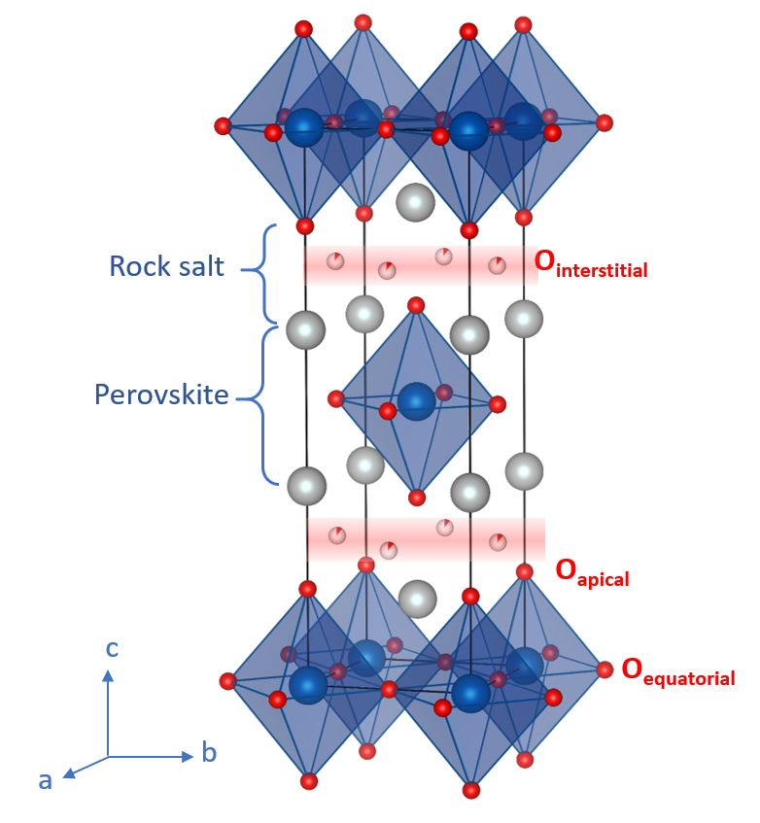

1. Crystal structure of Pr2NiO4+ in the tetrahedral symmetry *I4/mmm*, with alternating perovskite and rock salt layers. *NiO6* octahedra (blue polyhedra), *Pr* cations (grey spheres), and *O* anions (red spheres) as well as the interstitial (*Ointerstitial*), the apical (*Oapical*) and the equatorial (*Oequatorial*) oxygens, are also shown.

The non-stoichiometric region has been found to be 0 <  < 0.25, showing a rich and complex phase diagram as a function of the oxygen content (Sullivan *et al.*, 1991, Fernández-Díaz *et al.*, 1991, Fernández-Díaz *et al.*, 1993, Ceretti *et al.*, 2018). Stoichiometric Pr2NiO4.00 shows at ambient temperature the LTO (Low Temperature Orthorhombic) structure type (space group *Bmeb*), with a 3D ordered tilting scheme of the NiO6 octahedra, while at high temperatures its symmetry is tetragonal *I4/mmm* (High Temperature Tetragonal, HTT-phase). At room temperature the symmetry of oxygen doped Pr2NiO4+δ , with δ > 0.22, is monoclinic (space group *F112/m)*, the monoclinic angle 90.03° deviates, however, only slightly from 90° of the orthorhombic framework (Ceretti *et al.*, 2015).

Oxygen electrochemical intercalation into stoichiometric Pr2NiO4.0 yields then the formation of a non-stoichiometric tetragonal phase with 0.08 <  < 0.13, (space group *P42/ncm*), while for higher interstitial oxygen concentrations ( = 0.18-0.25) the symmetry lowers again to orthorhombic or monoclinic*,* showing complex oxygen ordering adapting a modulated structure (Dutta *et al.*, 2020). Upon heating in air Pr2NiO4+δ (δ ≈ 0.23) undergoes a monoclinic/tetragonal phase transition at around 365°C (space group *F4/mmm*), while the oxygen stoichiometry slightly increases towards δ ≈ 0.25. High temperature oxygen diffusion in Pr2NiO4+δ *has* been reported to proceed via a push pull mechanism between apical and interstitial oxygen atoms with a diffusion pathway along the [110] direction of the corresponding HTT phase in *F4/mmm (*Yashima *et al.,* 2008*,* Parfitt *et al.,* 2010*)*. Further single crystal neutron diffraction studies on Pr2NiO4.25 have evidenced a partially established overlap of the scattering density between apical and interstitial oxygen atoms already at 400°C (Ceretti *et al.*, 2015). This was indeed a surprising result which suggested that upon further heating, the anharmonic behavior further increases and progresses towards a complete overlap between the apical and interstitial oxygen atoms, as was reported experimentally and theoretically for RP-phases in *(*Yashima *et al.,* 2008*,* Parfitt *et al.,* 2010*)*.. Therefore, the scientific case of Pr2NiO4+δ presents the ideal test case for the as modified furnace presented above, in order to follow structural changes as a function of temperature and oxygen stoichiometry. Thereby the oxygen stoichiometry is adjusted by the combination of temperature and oxygen partial pressure, allowing to investigate its phase diagram under *in situ* conditions.

In this context, high quality PNO single crystals were investigated on HEiDi with the new device at 900°C in oxygen and secondary vacuum atmosphere, in order to compare to the results previously obtained at room temperature and 400°C (Ceretti *et al.*, 2015). Crystal growth by travelling solvent zone method is described in (Wahyudi *et al.*, 2015). For sake of comparison, data collection as well as data analysis, revealing nuclear density maps at different structural projections, were performed in the same way as reported in (Ceretti *et al.*, 2015).

Structure factors were collected by neutron diffraction up to high q-values, specifically up to sin = 0.87 Å-1 using a single crystal with a size of about 2.5 × 2.5 × 2.5 mm3*.* No absorption correction was applied due to the negligible neutron absorption coefficients of the compound. Refinements were carried using SHELXL (Sheldrick, 2015), with anisotropic individual Debye-Waller displacement factors for all atoms, except for the interstitial oxygen atoms which was refined isotropically, considering the weak occupation density. Isotropic extinction effects were corrected according to an empirical factor, as implemented in SHELXL. Occupations of Pr, Ni and equatorial oxygen atoms (Oeq) were fixed to be stoichiometric, while apical and interstitial oxygen occupancies were refined unconstrained. The resulting phased structure factors (*Fobs*)were subsequently used for Maximum Entropy reconstruction via PRIMA (Practice Iterative MEM Analysis) software (Izumi & Dilanian, 2002). This approach has the advantage to consider strong and weak reflections with equal importance, resulting in a much better-defined background compared to the classical Fourier-methods. This gives the possibility to better analyse atoms with low occupancies and/or anharmonic dynamics, as this is the case for the interstitial and apical oxygen atoms in PNO.

As reported in previous works, the single crystal structure of the PNO is rather complex (Ceretti *et al.*, 2015, Dutta *et al.*, 2020), with up to 16 monoclinic twin individuals by pseudo merohedry. At 900°C, twinning is no longer an issue as for both data collections in O2 atmosphere as well as in secondary vacuum, the symmetry was found to be tetragonal. As for the previously reported results, all refinements were carried out in the space group *F4/mmm*, relating the high temperature structure to the room temperature base vectors.

Measurements were carried out under the following conditions: firstly, the quartz capillary was flushed at ambient with oxygen gas and heated to 900°C, while maintaining 1 bar of oxygen partial pressure. After thermal equilibration, a first data collection was collected in 1 bar O2 atmosphere at 900°, followed by a 2nd data collection, after pumping the atmosphere inside the quartz tube down to 10-5 mbar for 1 hour. The vacuum conditions were maintained throughout the whole measurement in order to avoid any oxygen contamination related to possible leakage of the capillary and any uptake of oxygen by the sample. Refined structural parameters are reported in Table 1. The presence/absence of the interstitial oxygen as well the displacement factors of all atoms, becomes clearly visible from the nuclear density map obtained by MEM (Fig. 5c-d and Fig.5g-h). Further on we can recognize a more isotropic behavior of the apical oxygen atoms for both cases, and in particular the absence of any double potential as was observed at 400°C.

Despite this more harmonic displacement behaviour, the apical oxygen atoms still show a seemingly sub-stoichiometric oxygen occupancy of 1.80 and 1.86 under secondary dynamic vacuum conditions and 1 bar oxygen partial pressure respectively. The integer value 2 would have been expected here in case of a full site occupancy. As already outlined in (Ceretti *et al.*, 2015), this artefact is related to the still important anisotropic and anharmonic displacements of the apical oxygen atom, which cannot be corrected via a harmonic description of the respective thermal ellipsoids. The strong displacements inside the Pr2O2 layer are revealed by the strong anisotropy of the U11/U22 factor values of the Oap atoms, which are refined to be 4 times higher compared to the values of U33. Displacements of the Pr atoms were found to be merely isotropic for both measurements, which is in strong contrast to what is obtained at 400°C, where the Pr2O2 layer turned out to be anharmonic as well as a double potential for the apical oxygen positions, which suggest two distinct Ni-Oap distances.

1. Pr2NiO4+δ structure data obtained from single crystal neutron diffraction data, collected on diffractometer HEiDi with λ= 0.793 Å (monochromator: Ge (422) with Er filter), installed at the hot source of the FRM II reactor of MLZ. Refinements were carried out in space group *F4/mmm*; (Uii are given in Å2).

|  |  |  |  |
| --- | --- | --- | --- |
| **Atoms** | | **900°C in vacuum**  ** ≈ 0.00** | **900°C in oxygen**  ** ≈ 0.13** |
| **Pr (00z)** | z | 0.3607(6) | 0.3605(6) |
|  | Occ. | 2 | 2 |
|  | U11 =U22 | 0.0347(18) | 0.0343(18) |
|  | U33 | 0.0286(25) | 0.02953(25) |
| **Ni (000)** | Occ | 1 | 1 |
|  | U11=U22 | 0.0154(9) | 0.0147(9) |
|  | U33 | 0.0459(22) | 0.0457(22) |
| **Oap (00z)** | z | 0.1763(7) | 0.1764(7) |
|  | Occ | 1.80(6) | 1.85(7) |
|  | U11=U22 | 0.0939(69) | 0.0956(69) |
|  | U33 | 0.0247(34) | 0.0272(34) |
| **Oeq (**¼¼0) | Occ | 2.00 | 2.00 |
|  | U11=U22 | 0.0296(15) | 0.0312(18) |
|  | U33 | 0.0645(39) | 0.0639(40) |
| **Oint (**¼¼¼) | Occ |  | 0.126(7) |
|  | Uiso |  | 0.0415(88) |
| measured reflections  Rint(hkl)(%)  Rw (%)  GooF | | 335, 200 unique  5.8  7.04  1.84 | 334, 200 unique  6.2  6.23  1.78 |

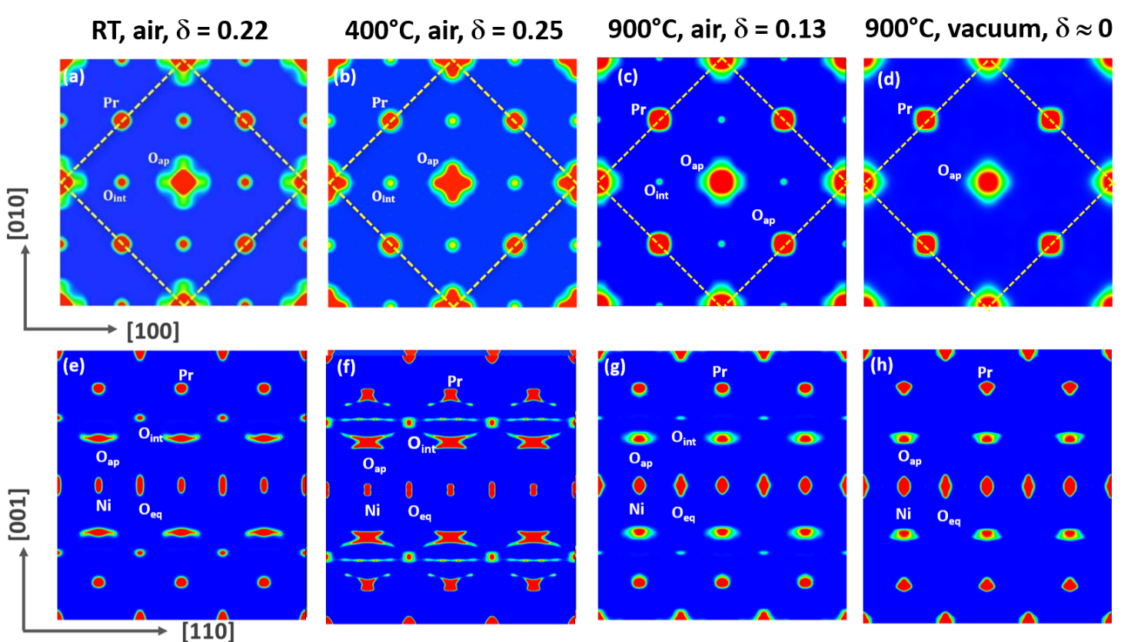

1. Representation of the nuclear scattering densities in Pr2NiO4+ obtained from Maximum Entropy reconstruction of single crystal neutron diffraction data (HEiDi) for different *T* and . In (a-d) the scattering densities in the 2a × 2a projection of the *I4/mmm* unit cell (the *F*-centred cell is outlined by the yellow dotted line) are shown from *z* = 0.12 to *z* = 0.28, thus showing half of the rock salt layer with positions of the Pr, Oap and Oint at *z* = 0.14, 0.17 and 0.25 respectively. In (e-h) 3*a* × *c* projections, from *y* = 0.45 to *y* = 0.55, in the *I*-cell are shown.

(Fig5a-b and Fig.5e-f) demonstrate strong anisotropic displacements of the apical oxygen atoms along the [110]-direction of the *F*-cell, becoming evident at RT and especially at 400°C from the Maximun Entropy reconstructions. For the measurements at 900°C in O2 atmosphere and in vacuum this is significantly changed and displacements of all atoms clearly indicate a more isotropic behaviour, especially through the absence of any double potential of the Oap (Fig5c-d and 5g-h). This is unexpected, as a more disordered and thus more fluid-like atomic distribution of the apical and interstitial oxygen atoms inside the Pr2O2 plane might have been expected. It is clear that the reduced Oint stoichiometry refined to δ = 0.13 at 900°C (at room temperature δ = 0.22) certainly contributes towards a reduction of the local Oap distortions, but it clearly does not explain completely the reduced distortions along [110].

Comparing the nuclear density maps of Pr2NiO4.13 and Pr2NiO4.00 at 900°C (see Fig. 5 c-d and 5g-h), they appear to be very close, despite their deviation in the Oint stoichiometry. This suggests that the interstitial oxygen, which at moderate temperatures decisively induces strong displacements of the Oap and subsequently promote a shallow anisotropic oxygen diffusion pathway along [110], has practically lost its function to trigger such kind of phonon activated diffusion mechanism (Villesuzanne *et al.*, 2011, Perrichon *et al.*, 2015). With increasing temperature, atomic displacements proceed steadily faster, thus averaging repulsive and attractive interatomic interactions with temperature. Consequently, the increase in temperature favours a more isotropic displacement behaviour, avoiding strong displacive anisotropies and double potentials. This further suggests that the anharmonic double potential, as observed for the apical oxygen atoms in Pr2NiO4.25 at 400°C, only prevails in a moderate temperature regime. In this case, lattice dynamics is able to contribute to an easier diffusion along [110], as is the case for the oxygen diffusion mechanism in Ruddlesden-Popper type oxides (Villesuzanne *et al.*, 2011; Piovano *et al.*, 2016). Such anisotropies seem to contradict the common perception of an isotropic diffusion regime activated at high temperatures, following the idealized Arrhenius behaviour. In this way, any anisotropic diffusion mechanism at moderate temperatures is essentially related to specific phonon modes, involving strong anisotropic displacements and consequently leads to more or less important deviations from an isotropic diffusion behaviour, as described by the Arrhenius formalism.

The availability of *in situ* measurements, allowing to vary simultaneously temperature and oxygen partial pressure, is thus a versatile concept to explore structural phase diagrams of non-stoichiometric oxides and its relevance for related diffusion mechanisms.

1. Conclusion

An IR furnace for *in situ* single crystal neutron diffraction in a controlled gas atmosphere and high temperatures has been successfully implemented on the four-circle neutron diffractometer HEiDi at MLZ, while preserving almost full access to reciprocal space. Its good performance has been successfully confirmed comparing structural changes in Pr2NiO4+δ single crystals at high temperature and in controlled oxygen partial pressure. These studies demonstrate the feasibility and reliability of such experiments and open the field to a wide range of investigations on non-stoichiometric oxide materials. In the particular studied case, it confirmed at first sight the surprising loss of anisotropic distortions of the apical oxygen atoms, which have been evidenced to trigger oxygen diffusion via specific phonon modes. This underlines the importance to access different temperatures and different oxygen partial pressures for the structural characterization of non-stoichiometric oxygen ion conductors, allowing to better conclude on respective diffusion mechanisms.

1. Neutron data were collected on the HEiDi single crystal diffractometer at MLZ jointly operated by RWTH Aachen and Forschungszentrum Jülich GmbH within JARA-Fit cooperation. We thank the TUM sample environment group of MLZ for their valuable support.

References

Ahlburg, J. V., Canevet, E. & Christensen, M. (2019). *J. Appl. Cryst.* **52**, 761-768.

Bassat, J.-M., Burriel, M., Wahyudi, O., Castaing, R., Ceretti, M., Veber, P., Weill, I., Villesuzanne, A., Grenier, J.-C., Paulus, W. & Kilner, J. A. (2013). *J. Phys. Chem. C* **117**, 26466-26472.

Bianchini, M., Leriche, J. B., Laborier, J. L., Gendrin, L., Suard, E., Croguennec, L. & Masquelier, C. (2013). *J. Electrochem. Soc.* **160**, A2176-A2183.

Ceretti, M., Wahyudi, O., André, G., Meven, M., Villesuzanne, A. & Paulus, W. (2018). *Inorg. Chem.* **57**, 4657-4666.

Ceretti, M., Wahyudi, O., Cousson, A., Villesuzanne, A., Meven, M., Pedersen, B., Bassat, J. M. & Paulus, W. (2015). *J. Mater. Chem. A* **3**, 21140-21148.

Dutta, R., Maity, A., Marsicano, A., Ceretti, M., Chernyshov, D., Bosak, A., Villesuzanne, A., Roth, G., Perversi, G. & Paulus, W. (2020). *J. Mater. Chem. A* **8**, 13987-13995.

Fernández-Díaz, M. T., Martínez, J. L. & Rodríguez-Carvajal, J. (1993). *Solid State Ionics* **63–65**, 902-906.

Fernández-Díaz, M. T., Rodríguez-Carvajal, J., Martínez, J. L., Fillion, G., Fernández, F. & Saez-Puche, R. (1991). *Z. Physik B - Condensed Matter* **82**, 275-282.

Hansen, B. R. S., Moller, K. T., Paskevicius, M., Dippel, A.-C., Walter, P., Webb, C. J., Pistidda, C., Bergemann, N., Dornheim, M., Klassen, T., Jorgensen, J.-E. & Jensen, T. R. (2015). *J. Appl. Cryst.* **48**, 1234-1241.

Ishihara, T. (2014). *J. Ceram. Soc. Jpn.* **122**, 179-186.

Izumi, F. & Dilanian, R. A. (2002). Report 81-7895-046-4*.*

Jensen, T. R., Nielsen, T. K., Filinchuk, Y., Jorgensen, J.-E., Cerenius, Y., Gray, E. M. & Webb, C. J. (2010). *J. Appl. Cryst.* **43**, 1456-1463.

Kovalevsky, A. V., Kharton, V. V., Yaremchenko, A. A., Pivak, Y. V., Tsipis, E. V., Yakovlev, S. O., Markov, A. A., Naumovich, E. N. & Frade, J. R. (2007). *J. Electroceram.* **18**, 205-218.

Lorenz, G., Neder, R. B., Marxreiter, J., Frey, F. & Schneider, J. (1993). *J. Appl. Cryst.* **26**, 632-635.

Maity, A., Dutta, R., Penkala, B., Ceretti, M., Letrouit-Lebranchu, A., Chernyshov, D., Perichon, A., Piovano, A., Bossak, A., Meven, M. & Paulus, W. (2015). *J. Phys. D: Appl. Phys.* **48**, 504004.

Meven, M. & Sazanov, A. (2015). *(Heinz Maier-Leibnitz Zentrum); Journal of large-scale research facilities* **1,** A7.

Parfitt, D., Chroneos, A., Kilner, J. A. & Grimes, R. W. (2010). *Phys. Chem. Chem. Phys.* **12**, 6834-6836.

Perrichon, A., Piovano, A., Boehm, M., Zbiri, M., Johnson, M., Schober, H., Ceretti, M. & Paulus, W. (2015). *J. Phys. Chem. C* **119**, 1557-1564.

Piovano, A., Perrichon, A., Boehm, M., Johnson, M. R. & Paulus, W. (2016). *Phys. Chem. Chem. Phys.* **18**, 17398-17403.

Sheldrick, G. (2015). *Acta Crystallographica Section C* **71**, 3-8.

Sullivan, J. D., Buttrey, D. J., Cox, D. E. & Hriljac, J. (1991). *Journal of Solid State Chemistry* **94**, 337-351.

Takahashi, S., Nishimoto, S., Matsuda, M. & Miyake, M. (2010). *J. Am. Ceram. Soc.* **93**, 2329-2333.

Villesuzanne, A., Paulus, W., Cousson, A., Hosoya, S., Le Dreau, L., Hernandez, O., Prestipino, C., Houchati, M. I. & Schefer, J. (2011). *J. Solid State Electrochem.* **15**, 357-366.

Wahyudi, O., Ceretti, M., Weill, I., Cousson, A., Weill, F., Meven, M., Guerre, M., Villesuzanne, A., Bassat, J. M. & Paulus, W. (2015). *CrystEngComm* **17**, 6278-6285.

Yashima, M., Enoki, M., Wakita, T., Ali, R., Matsushita, Y., Izumi, F. & Ishihara, T. (2008). *J. Am. Chem. Soc.* **130**, 2762-2763.

1. Thermal simulations

Heat transfer and flow inside the furnace and along the sample holder were simulated using the heat transfer module of COMSOL Multiphysics® software (version 5.2a, <https://www.comsol.com>). Simulations have done considering the whole furnace in vacuum, while the reaction cell is in a gas atmosphere (flowing and pressure). Results of these simulations are reported in Figure A1a-b in the case of oxygen pressure of 1 bar in the quartz tube.

Firstly, the ray simulation (obtained with Ray Optics Module of the COMSOL Multiphysics® package) showed that the energy emitted by the four lamps is transferred to the sample, in the focal point of the mirrors (Figure A1), even if some of it is lost by reflection from the quartz capillary.



Figure A1 (a) Ray tracing within the IR furnace and (b) heat transfer simulations within new the sample holder and quartz tube.

To verify that the energy reaching the sample is however enough to obtain a sufficiently high temperature, a heat transfer simulation of the whole device has been done. For these simulations, the energy transferred to the different materials from the ray tracing was considered. Figure A1(a) shows the light ray tracing concentrated in the focal point, at the sample position. Lamps are at the maximum of their power.

Figure A1(b) reports heat transfer simulation in the quartz capillary. It is clear that the heat is rapidly transferred to the sample holder while the quartz tube and gas remain at moderate temperatures: one end is at room temperature (300K), while the other end can reach quite high temperature (about 500K) when the heating lamps are at the maximum of their power. Thus, to avoid overheating effects, a new cooling system was installed at one end of the quartz tube. The homogeneous temperature region is about 1 cm at the sample position is evidenced, which is quite sufficient for neutron diffraction experiments.