**Tarnished silver-copper surfaces reduction using remote helium plasma at atmospheric pressure studied by means of high-resolution synchrotron x-ray photoelectron microscopy**

Olivier Schalma,b, Patrick Stormea, Amandine Crabbéc, Stefano Voltolinad, Alessandro Patellie, Vitaliy Feyerf, Herman Terrync

a. University of Antwerp, Conservation Studies, Blindestraat 9, B-2000 Antwerp, Belgium

b: Antwerp Maritime Academy, Noordkasteel Oost 6, B-2030 Antwerpen, Belgium

c. Vrije Universiteit Brussel (VUB), Research Group of Electrochemical and Surface Engineering, Pleinlaan 2, B-1050 Brussels, Belgium

d. Veneto Nanotech, Nano Fabrication Facility, Via delle Industrie 9, 30175 Venezia-Marghera, Italy

e. Padova University, Dept. Physics and Astronomy, Via Marzolo 8, 35131 Padova, Italy

f. Peter Grünberg Institute (PGI-6) and JARA-FIT, Research Center Jülich, 52425 Jülich, Germany

**Highlights**

* For tarnished silver, the corrosion layer contain polysulphide compounds
* For tarnished sterling silver, plasma treatment generated a pinkish Ag-Cu alloy
* For tarnished copper, only a surface layer is reduced into metallic copper

**Abstract**

Previous investigations suggested that sulphide layers on top of pure silver coupons could easily be removed with a reducing plasma afterglow at atmospheric pressure. However, similar sulphide layers on silver alloys with small admixtures of copper and on pure copper were much harder to remove. In order to understand the impact of a reducing afterglow on tarnished silver-copper surfaces, the surface of metallic and sulphidized silver, sterling silver and copper were characterized before and after plasma treatment using x-ray photoelectron spectroscopy at the NanoESCA beamline of the Elettra storage ring. With this technique, it became clear that sulphidized coupons of pure silver contained polysulphide compounds and that these compounds were decomposed after plasma treatment. After cleaning silver regained the metallic state, although the amount of chemisorbed sulphides increased. For sulphidized sterling silver, the afterglow resulted in a considerable drop in mono-sulphide compounds at the surface while an enhanced copper signal was observed. The metallic copper at the surface explained the pink colour. The afterglow was also able to transform the sulphide layer on top of copper into metallic copper because the mono-sulphide compounds almost completely disappeared from the surface. However, when this top layer was removed by ion sputtering, the sulphide layer reappeared. Therefore, only the surface of the sulphide layer was reduced by the plasma treatment. The measurements demonstrated that the impact of a reductive plasma afterglow was highly affected by the metal composition and the chemical compounds present in the corrosion layer.

**Keywords**

heritage; plasma afterglow cleaning; XPS; silver alloys; copper; sulphide

**1. Introduction**

It is well known that ppb-amounts of H2S in ambient air are sufficient to cover white and shiny silver alloy objects with a dark film [1]. Jewellery, liturgical attributes or photographic media are all prone to this kind of degradation. Such tarnish films are usually resulting in loss of readability of the object. To restore the original lustre, often silver dip, electrochemical reduction or polishing techniques are applied on the surface [2,3]. However, for mixed media objects such as silver threads in textile or silver foils on wooden statues, the traditional cleaning methods for silver can hardly be used due to the inevitable chemical damage or mechanical abrasion of the very sensitive organic materials that are in close contact with the tarnished silver. A dry, non-contact cleaning technique such as an afterglow generated by plasma at atmospheric pressure might be a solution for mixed media objects to reduce sulphide compounds [4-6].

To evaluate the cleaning performance of an afterglow plasma, the surface of 3 different artificially sulphidized metals was exposed to a dielectric barrier discharge plasma in remote configuration in He-H2 atmosphere. The 3 metals investigated were: (1) pure silver with at least 99.9 w% Ag (Ag999), (2) sterling silver with an amount of 7.5 w% of Cu (Ag925) and (3) pure copper containing at least 99.9 w% Cu (Cu999). In a previous investigation, we demonstrated that the effect of such an afterglow was substantially different for the 3 metal types at the sub µm-scale. All of them have their specific problems [7]:

* **Ag999:** The afterglow was able to reduce sulphide compounds into their metallic form in a matter of a few seconds, but the cleaning efficiency drops for corrosion layers thicker than 220 nm;
* **Ag925:** The corrosion layer of this silver alloy contains bot Ag-rich and Cu-rich corrosion products [8]. The afterglow was able to reduce a large fraction of the Ag-rich corrosion products while Cu-rich corrosion products were only partially reduced. Why the surface colour was sometimes pinkish remained to be clarified;
* **Cu999:** Plasma treatments had no substantial visual impact on corroded Cu999, but in our previous study we demonstrated that at the sub µm-scale the original corrosion products were covered with a new but unknown phase consisting of spheroidal particles [8].

To fully understand the impact of plasma treatments, the transformations of the first nm of the surface induced by the afterglow still need to be studied. For that reason, we present the chemical speciation of metallic and artificially sulphidized Ag999, Ag925 and Cu999 performed before and after plasma treatment with x-ray photoelectron spectroscopy using the NanoESCA beamline at Elettra Sincrotrone Trieste. This information is used in the discussion of the results to refine the previously published mechanistic information [7,8].

**2. Experimental**

**2.1. Sample preparation**

Three different metal substrates were considered in metallic and artificially sulphidized state: Ag999, Ag925 and Cu999. For each metal type, the metallic and sulphidized surface was analysed before and after plasma treatment, leading to 4 samples per metal type. The description of the metals used, the procedure to obtain artificially generated sulphide layers and the treatment of the samples with the reducing plasma afterglow with 5% hydrogen in helium at atmospheric pressure can be found in a previous work [7]. The samples were exposed to air before the XPS measurements. Therefore, the adventitious carbon on the surface, which was probably removed by plasma treatment, could be observed for all the plasma treated surfaces. In order to fit the samples in the sample holder of the XPS instrument, small squared samples of 10 mm × 10 mm were cut from the coupons. This was done with a jeweller’s saw, using nitrile gloves and removing saw dust from the surface with purified canned air. The squared samples were taken from the most homogeneous regions of the coupons. The surface states of the samples were denoted by the following abbreviations: BP (Before Plasma), APH (After Plasma Helium), SBP (Sulphide Before Plasma) and SAPH (Sulphide After Plasma Helium).

**2.2. Reference materials**

To facilitate the interpretation of the XPS analyses, a series of reference materials was analysed as well. Metallic surfaces of Ag999, Ag925 and Cu999 were considered as reference. Powders of respectively Ag2S (99.9%), Cu2S (99.5%) and CuS (99.8%) were purchased at Alfa Aesar and pressed into pellets. About 0.1 g of powder was transformed into a pellet of 8 mm diameter and about 1 mm thickness by means of a hand press using a pressure of 3 to 4.5 ton/cm2. The pellets could easily be transported and be manipulated without physical damage. Before the glossy surface of these pellets could be analysed with XPS, outgassing was needed. This was done in the preparation chamber of the XPS-instrument. Except for carbonaceous matter, no systematic surface contamination introduced during the sample preparation could be detected. Moreover, no disturbing surface charging occurred during the analyses of the pellets.

**2.3. NanoESCA beamline**

The instrument installed as an endstation at the NanoESCA beamline of the Elettra storage ring combines an electrostatic Photo Electron Emission Microscope (PEEM) with a double-hemispherical (‘IDEA’) analyser, allowing the collection of photoemission electron microscopy (PEEM) images, X-ray photo electron-energy-filtered images and XPS spectra as described in the list below. The NanoESCA beamline provides electromagnetic radiation with variable polarization (linear, circular) and energies up to 1000 eV [9]. For most analyses, no preceding cleaning procedure was needed to remove unwanted top layers. However, to visualize the Cu-inclusions in metallic Ag925 with XPS imaging, the surface needed to be cleaned in the preparation chamber of the XPS instrument by applying Ar+ ion sputtering (kinetic energy 2.0 keV, 13-15 µA on the sample, 10-20 minutes per cycle). For sulphidized Cu999 after plasma treatment (SAPH), the top layer was removed by 2 subsequent cycles.

* **Threshold PEEM images:** The sample was illuminated with UV-light using a high-pressure mercury arc lamp, while the kinetic energy of the secondary electrons leaving the sample surface was measured. The information depth is determined by the escape length of the secondary electrons, which was about 2 nm. In energy filtered PEEM imaging, an image stack was collected by scanning the kinetic energy of the secondary electrons. The PEEM images visualize chemical contrasts because every material has a different PEEM spectrum and a different onset (i.e., photoemission threshold or work function).
* **XPS energy-filtered image series:** The main application mode of the NanoESCA is the high lateral resolution (c. 50-100 nm) mapping of core-level photoemission signatures. Photoelectron energy-filtered image series was acquired for Cu3p, Cl2p, S2p, C1s, Ag3d using a soft-x-ray source of 450 eV. Images for O1s were collected at 600 eV while images for Cu2p were obtained at 1250 eV. The total energy resolution (analyser + beamline) was 0.2-0.3 eV. First, an energy scan was performed by collecting a series of images with an energy step of 0.1 eV within an energy range where the specific signal was located. From the image with the highest contrast, an average image was determined by collecting several images at the optimal energy.
* **XPS spectra:** The fast overview and high-resolution narrow spectra were collected under the same conditions as described for the energy-filtered image series. Energy calibration was performed by localizing the Fermi level position in the valence band spectra and setting that point to zero. For this, least-squares fitting was applied on the near-rectangular shape in the vicinity of the Fermi level using the CasaXPS software version 2.3.15 (CasaXPS Software Ltd. UK [CasaCookBook; www.casaxps.com]). However, for some surface states the expected near-rectangular shape in the vicinity of the Fermi level was too small for energy calibration. In such cases, the energy calibration was refined by using characteristic features in the shape of the valence band spectra [10]. This was done by comparing the shape of the complete valence band spectrum with valence band spectra of similar shape that could be calibrated with least square fitting. A detailed description of this method can be found in the Supplementary Material.

**4. Results**

**4.1. Impact of the plasma afterglow on Ag999**

The XPS spectra of the polished silver Ag999 samples presented the same features before (BP) and after (APH) the plasma treatments, with no changes in binding energy of the Ag3d peaks (Fig.1) and no change in shape. After all, the samples before and after the treatment maintained their shiny appearance. The only variation that could be detected was the intensity of the peaks which increased after the plasma treatment. This effect could not be fully explained by a partial removal of the carbonaceous film covering the surface since the sample was re-exposed to air before the XPS analyses. The carbon signal, indeed did not drop to zero (Fig. SM-1). Another contribution might be the removal of sulphides. However, the spectra presented in Fig. 1 showed only a faint bump in the range of S2p BE visible after the plasma treatment of the metal. The bump could not be related to the sulphur signal because it did not respect the expected shape of the doublet. Therefore, there was no presence of sulphur on metallic Ag999. Since no other effect could be detected, the difference in intensity was probably related to the removal of the surface contamination due to the afterglow interaction.

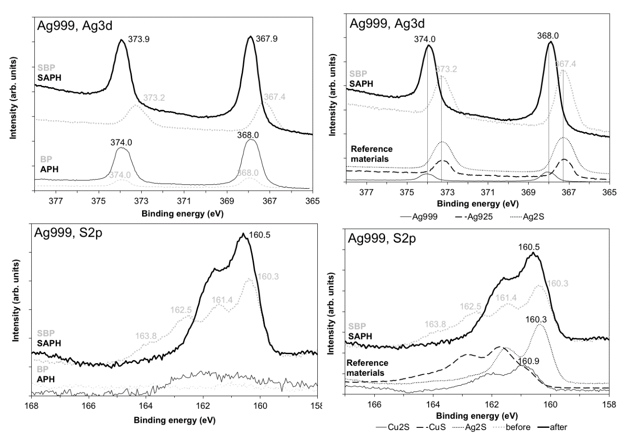

Fig. 1: High resolution spectra of Ag3d and S2p using a soft-x-ray excitation of 450 eV collected of Ag999 from a region of 90 µm diameter. The spectra at the left shows the metallic and sulphidized Ag999 before (grey spectra) and after (black spectra) plasma treatment. In the right column, XPS spectra of the sulphide layer before and after plasma treatment are compared with reference spectra of metal (Ag999, Ag925) and powders pressed in pellets (Ag2S, Cu2S, CuS).

To facilitate the selection of areas for analysis, the microstructure of sulphidized Ag999 was analysed with PEEM imaging (see Fig. 2). The sulphide surface (SBP) in Fig. 2a was characterised by an irregular surface. After the afterglow treatement (SAPH), the sulphide film was removed although black spots were visible in the PEEM image (see in Fig. 2b). Unfortunately, additional information from these spots could not be obtained by collecting XPS spectra because they were smaller than the x-ray beam. However, previous SEM-EDX analyses demonstrated that after a plasma treatment, isolated sulphide particles remained on the surface [7]. In the XPS spectra in Fig. 1-Ag3d, a shift of the Ag3d signal towards higher energies could be observed for sulphidized Ag999 after plasma treatment. For comparison, the Ag3d spectra of some reference materials were included in Fig. 2-Ag3d. Before the plasma treatment, the binding energy of the Ag3d peaks of the SBP sample corresponds to the Ag2S reference material, while after the treatment the silver signal overlaps with that of metallic Ag999 reference. Graedel et al. [1] reported that the Ag3d5/2 signal for Ag, Ag2S and sulphidized silver ranges between 367.8 eV and 368.0 eV (i.e., a difference of 0.2 eV), while for the silver signal in Fig. 2-Ag3d, the peak energies ranges between 367.4 eV and 367.9 eV (i.e., a difference of 0.5 eV). This was a substantial larger shift than the reported shifts. In any case, the data within our experimental set-up were self-consistent with our reference samples and supported the reduction of all corrosion products at the surface to metallic silver or at least the surface was covered by metallic silver. In addition, this interpretation was supported by the VB-spectrum shape of the sulphide layer after plasma treatment (Fig. SM1 – Ag999, SAPH). When looking at the S2p spectra, the presence of polysulphides on sulphidized Ag999 was the most remarkable observation. The polysulphide S-S compounds were characterized by a series of peaks from S2- (160.1 eV – 161.2 eV), S22- (162.1 eV- 162.6 eV), Sn2- (161.9 eV – 163.2 eV) to Sn0 (163.0 eV – 164.2 eV) [15]. The S2p spectrum did not contain signals of oxidized sulphur species such as SO3 (c. 167 eV) or SO4 (c. 169 eV). After plasma treatment, the surface appeared to consist of mono-sulphides with the main S2p peak at 160.5 eV. It must be stated that the transformation of Ag2S into metallic silver by means of reductive plasma at low pressure [11-14] or at atmospheric pressure [4] was observed previously also by other research groups. Also in this study, the plasma treatment had a clear effect on the surface of sulphidized Ag999: the sulphide layer before plasma treatment contained polysulphides while after plasma treatment silver was transformed in the metallic state, even if a substantial amount of mono-sulphides remained on the surface. Although the cleaning performance of the afterglow evaluated visually and at the sub µm-level was the best for this metal type (the surface turns from almost black to dull metal), the XPS-analyses suggested that the removal of sulphur was less effective than for Ag925 and Cu999. The silver mono-sulphide, which was detected on the surface, might be the result of a superficial monolayer of chemisorbed sulphides due to air exposure, because after the plasma process the silver surface was clean and highly reactive.

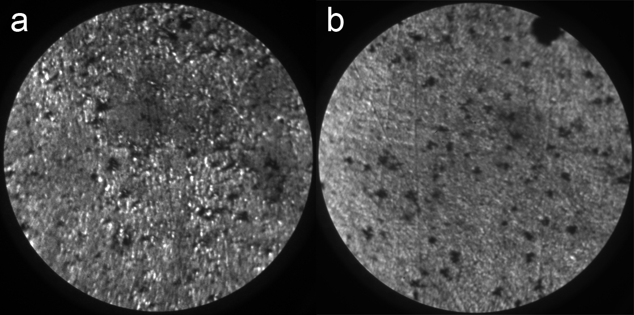

Fig. 2: PEEM images with a diameter of 90 µm of the sulphide layer on top of Ag999 before and after plasma treatment a) PEEM image of sulphidized Ag999 (Ekin = 4.2 eV); b) PEEM image of the sulphidized surface after plasma treatment (Ekin = 4.5 eV).

**4.3. Impact of the plasma afterglow on Ag925**

It is known that metallic Ag925 consists of an Ag-rich matrix containing small Cu-rich inclusions [16-19]. The PEEM images of Ag925 were able to visualize the Cu-rich inclusions in the alloy (images not shown here). XPS-imaging can only visualize these inclusions after the removal of the top layer, Ar ion sputtering was performed on the metallic Ag925. The XPS images of the surface after the ion sputtering are shown in Fig. 3. The brighter zones in Cu3p3/2 image (Fig. 3a) correspond to the darker regions in the Ag3d5/2Cu3p3/2 image (Fig. 3b). The Cu-rich inclusions had a size of 1 µm – 2 µm. The removal of the top layer resulted in a substantial drop of the carbon signal, while the copper and silver signals increased. The VB-spectrum (Fig. 3c) changed substantially as a consequence of the cleaning procedure: after cleaning the VB-spectrum was similar to that of metallic copper (see Fig. SM1-BP for Cu999). The Ag3d signals endured a small chemical shift of less than 0.2 eV (Fig. 3d). Although the cleaning procedure was useful to highlight the copper inclusions in the silver matrix, it was not used on the other Ag925 samples because it would distort the information about the corrosion layer.

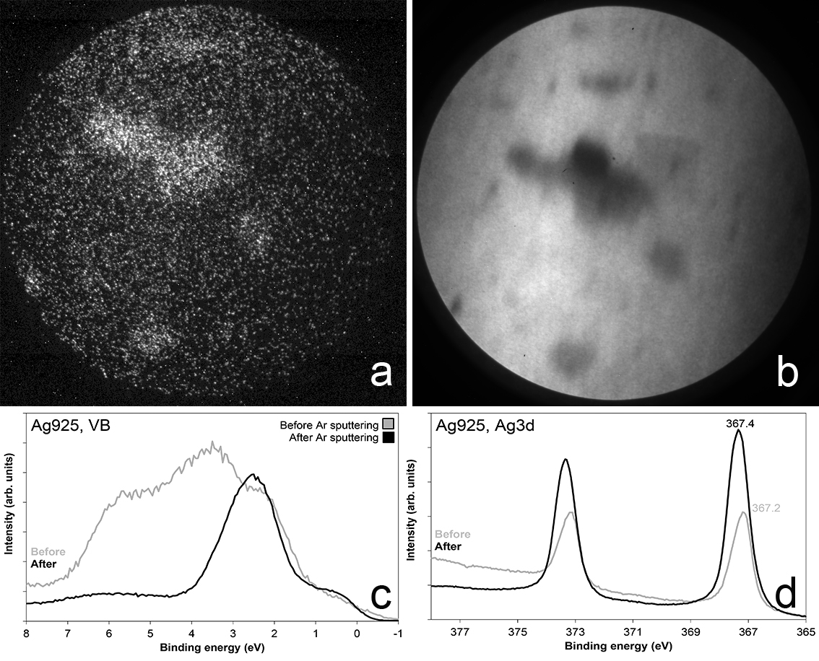

Fig. 3: XPS images collected of metallic Ag925 after cleaning by Ar sputtering for 20 minutes (field of view = 13 µm); a) average of 10 XPS images collected for Cu3p3/2 (x-ray excitation = 450 eV; Ekin = 374.3 eV); b) Average of 10 XPS images collected for Ag3d5/2 (x-ray excitation = 450 eV; Ekin emitted electrons = 81.0 eV); c) Valence band spectra before and after the sputtering procedure; d) High-resolution narrow spectra of Ag3d collected before and after the sputtering procedure.

For metallic Ag925 before plasma treatment, the Ag3d5/2 BE was located at 367.2 eV while the same signal for metallic Ag999 has a BE of 368.0 eV (see Fig. 4). This was a rather large difference in peak energy position which might be the result of small amounts of Cu dissolved in the Ag-rich matrix. The shift could not be explained by a different oxidation state of silver because the sulphur content for both surface states was low. For metallic Ag925 after plasma treatment, an enhanced signal for silver, sulphur and copper could be seen when compared to the situation before plasma treatment. The Ag3d5/2 peak underwent an energy shift of 0.2 eV towards higher energies. The Cu3p peaks for Ag925 and Cu999 for the 4 surface states did not endure any shift but differences in peak intensities were observed. In conclusion, the XPS-analyses showed that the plasma treatment induced a drop in the sulphur signal intensity and a shift of the Ag3d5/2 peak. In addition, also the VB-spectra of metallic Ag925 suggested that the plasma afterglow caused a transformation of the surface.

For sulphidized Ag925 before plasma treatment, the PEEM images were published elsewhere [8]. The images suggested the presence of a heterogeneous microstructure, which was in accordance with SEM-EDX analyses performed elsewhere [8]. These analyses suggested a Cu-enrichment at the surface during the corrosion process [20] and the presence of Cu-rich islands in the sulphide layer [21]. From an area between such islands and an area on top of such an island XPS spectra was collected. No substantial differences could be seen between the 2 areas. This means that the surface of the corrosion layer was homogeneous and characterised by a thin top layer rich in Ag and in S but poor in Cu. As can be seen in Fig. 4, the plasma treatment of sulphidized Ag925 resulted in a shift for the Ag3d5/2 signal from 367.2 eV (i.e., this is close to Ag2S) to 367.6 eV (i.e., this is between Ag999 and Ag925). This difference in the position of the Ag3d5/2 peak in the plasma treated sample suggested that the surface layer was reduced by plasma but the remaining metallic surface was different from that of Ag999. In addition, the high resolution spectra demonstrated that the monosulphide signal dropped and that the copper signal increased. Therefore, the plasma treatment of sulphidized Ag925 was able to decompose the sulphides at the surface while a top metal layer was formed. However, that metal layer was composed of an Ag-Cu alloy and could explain the pink surface colour after plasma treatment. After plasma treatment, the Ag925 surface contained less sulphur than the same state of Ag999.

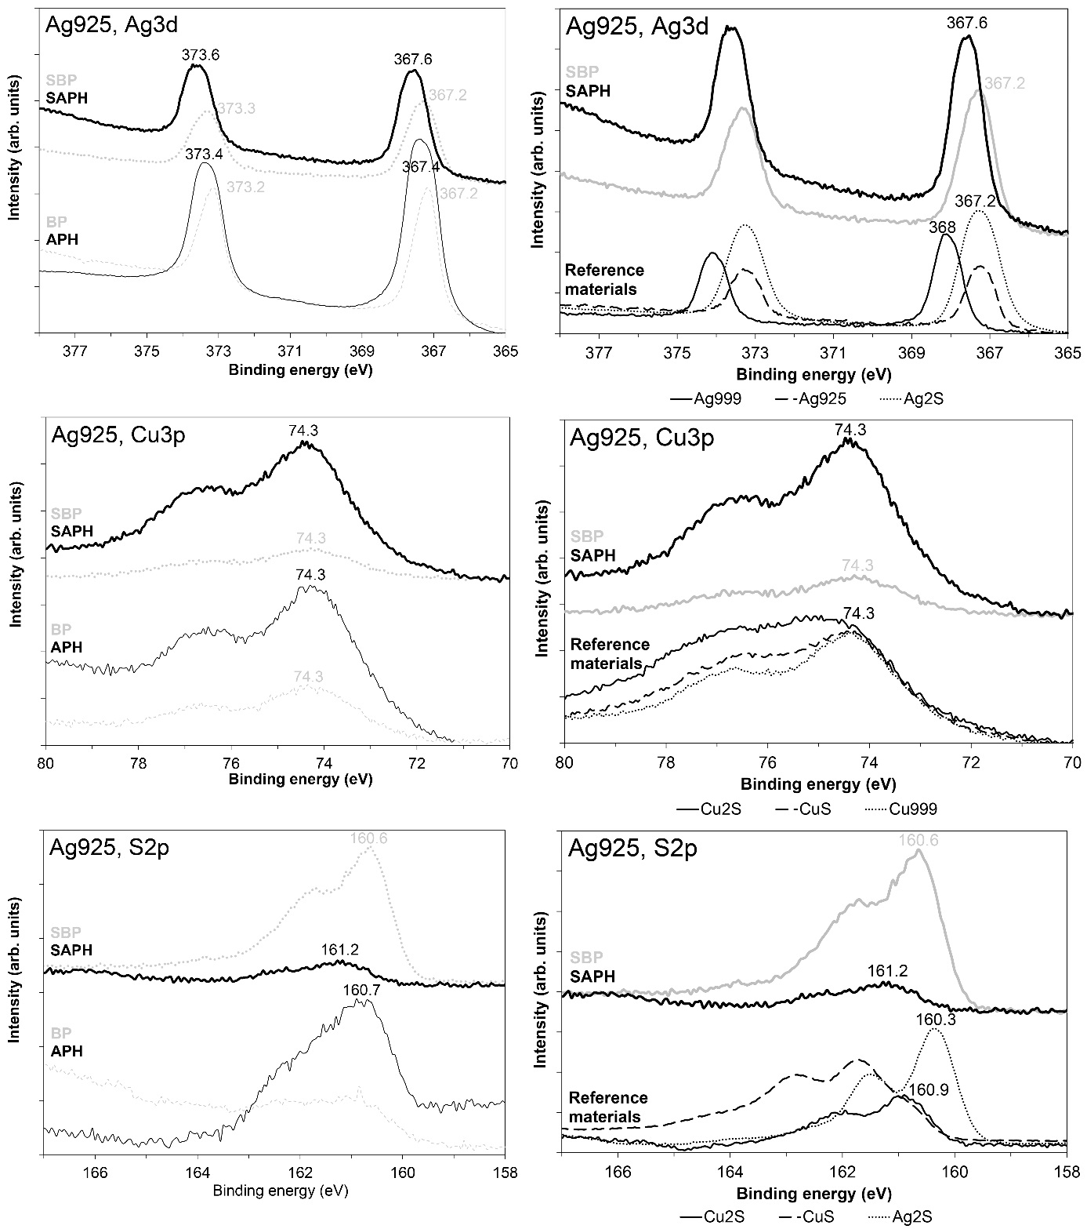

Fig. 4: High resolution spectra of Ag3d, Cu3p and S2p using a soft-x-ray excitation of 450 eV. Spectra were collected from metallic and sulphidized Ag925 before and after plasma treatment. In the right column, XPS spectra of the sulphide layer before and after plasma treatment are compared with some reference spectra.

**4.4. Impact of the plasma afterglow on Cu999**

For metallic Cu999 without corrosion layer, the plasma treatment had a limited effect. The clearest change induced by plasma was the increase of the copper signal and a higher VB-signal. The faint signal of sulphur suggested that almost no sulphides were present at the surface. For the 4 surface states, no energy shifts were observed for the copper signal. According to Fig. 5, the Cu3p signal of sulphidized Cu999 (SBP) resembles more that of metallic Cu999 (BP) than that of CuS or Cu2S. The S2p spectra of sulphidized Cu999 demonstrated that the sulphide compounds were substantially reduced during the plasma treatment. PEEM and visual inspection showed the presence of a black corrosion layer even after the plasma treatment [7].

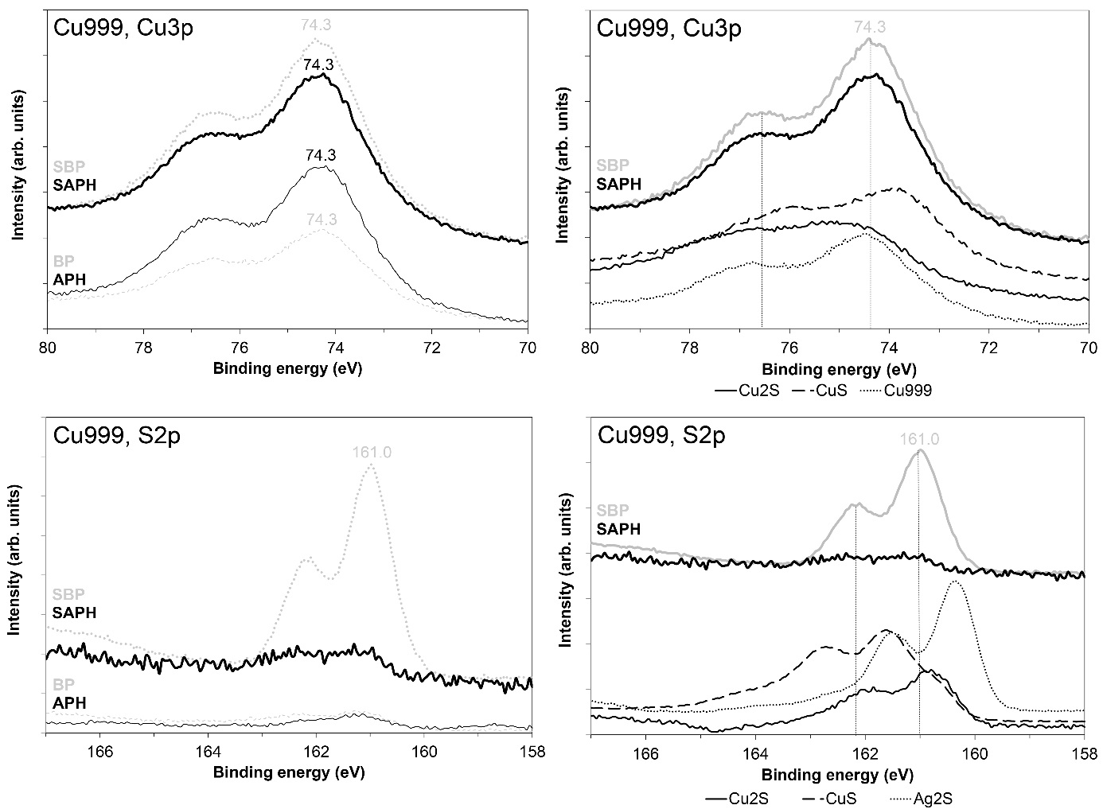



Fig. 5: High resolution spectra of Cu3p and S2p using a soft-x-ray excitation of 450 eV. Spectra were collected of metallic and sulphidized Cu999 before and after plasma treatment. In the right column, high resolution XPS spectra collected from sulphidized Cu999 before and after plasma treatment are compared with reference spectra.

A deeper investigation was performed by collecting XPS spectra of the plasma treated sulphidized Cu999 after two subsequent sputtering cycles of 10 minutes each. The spectra in Fig. 6 demonstrated that by removing the top layer, the sulphide signal became visible again. The depth profile demonstrated that the reducing plasma was able to form a thin metallic copper film covering the sulphide corrosion products. Therefore, the plasma treatments were able to reduce sulphide layers on Ag999 throughout the volume, while for Cu999 only the sulphides on the surface seemed to be decomposed. Factors which can limit the reduction process may be identified in a different diffusion of hydrogen in copper and silver corrosion layers, due to a different microstructure, roughness or porosity, or the absence of current through the sample due to the remote afterglow configuration. However, according to the XPS-analyses, the plasma treatment was able to remove almost all the sulphides from the surface. The absence of sulphide on the surface of copper after the cleaning may reflect the difference in reactivity of the two metals relative to the exposure to air after the plasma treatment.

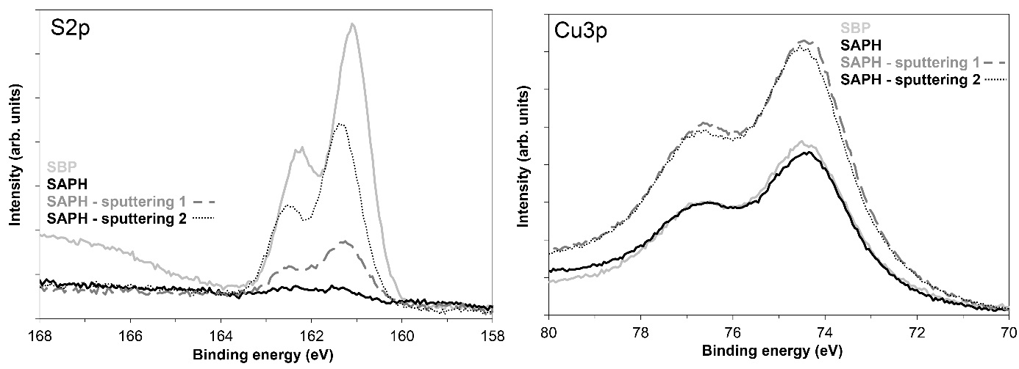

Fig. 6: High resolution XPS spectra collected of sulphidized Cu999 metal before and after H2/He plasma treatment. From the two subsequent sputtering cycles of the sulphide layer after plasma treatment, spectra are shown as well.

**5. Discussion**

Based on information at the sub-μm level, the transformation mechanism of the sulphidation of the metals Ag999, Ag925 and Cu999 and the transformation mechanism of plasma treatment of the sulphidized metals were reported earlier [7,8]. With the information supplied by the XPS investigation in this study, these mechanisms could be refined. The action of the reducing plasma was, therefore, summarised in the overview given in Fig. 7. Below, the most important results were discussed for the 3 metal types.

**5.1. Ag999**

The blackening of metallic Ag999 after immersion in a Na2S solution was usually considered to be the result of the formation of an Ag2S film [22]. The Ag2S corrosion layer was confirmed by the presence of sulphides [23] and of acanthite using several analytical techniques [24,25]. The dominating presence of the polysulphide species identified in sulphidized Ag999 suggested that they were present in abundant amounts at the surface of the sulphide layer. Polysulphides were not observed in sulphidized Ag925 and Cu999, although the same sulphidation process and the same chemical solutions were used. The only difference in the process was that Ag999 required a longer sulphidation process to develop the corrosion layer.

After plasma treatment, previous investigations at the sub µm level demonstrated that the sulphide layer was effectively reduced throughout the volume but that remnants of larger sulphide particles remained. Our XPS analyses showed that the signal of the polysulphides disappeared while substantial amounts of monosulphides became the dominating substance. The XPS analyses also highlighted the presence of metallic silver. The presence of monosulphides may be due to chemisorbed sulphide compounds at the surface formed after the treatment. Chemisorption and physisorption of a gas on clean metal surface cause only very small shifts and peak broadening of the metal peaks [26-28]. Chemisorption of sulphide compounds on the surface of metallic silver have been well studied such as (1) self-assembled monolayers of thiols [29], or (2) the adsorption of HS- ions at the metal surface in Na2S solutions as a first step in the explanation of the corrosion process [17,30]. For Ag999, the chemisorbed monosulphides was much more substantial than for Ag925 and Cu999.

**5.2. Ag925**

The analysis suggested that the surface of the sulphidised Ag925 was characterised by a top layer that was rich in silver with only a smaller amount of copper. A few nanometres below that top layer, the corrosion layer showed a heterogeneous structure containing islands of Cu-rich corrosion products as was reported elsewhere [7]. However, the sulphide compounds from that top layer did not match with the Ag2S reference compounds in Fig.4-S2p.

The most obvious change induced by the plasma treatment was a drastic drop of the sulphur signal and an increase of the copper signal, suggesting that the plasma treated sulphide layer resulted in a copper enrichment. The plasma treated sample showed a VB-spectrum similar to that of metallic copper, suggesting that metallic copper was present at the surface. The silver signals shifted to higher energies resulting in a BE between Ag999 and Ag925, suggesting the formation of a metallic alloy. In addition, the pinkish colour after plasma treatment, which could be observed visually, could be explained by the formation of an Ag-Cu alloy at the surface. The drastic drop of the S2p peak suggested that the surface was brought back to its metallic state although a small amount of sulphides remained. In the previous work [7], it was observed that sulphides were only partially reduced but that Cu-rich dendrites on top of the Cu,S-rich islands disappeared. Therefore, the Cu-rich corrosion products were partially reduced. This means that beneath a metallic top layer, sulphide products still remain. It should be noted that the pinkish colour was not observed for all cases. It is known that copper in Ag925 corrodes preferentially and that silver corrodes in a later stage [8]. Therefore, a more severe corrosion result in more Ag2S on the surface and after reduction a thicker and rougher grey silver layer can be formed covering sulphide corrosion products.

**5.3. Cu999**

Although there was no visual impact of the plasma treatment on sulphidized Cu999, at the sub µm-level the formation of a new phase could be seen with SEM-EDX [7]. The XPS analyses demonstrated that the plasma treatment of sulphidized Cu999 resulted in a metallic Cu film. However, that layer was rather thin because after ion sputtering, the sulphide signal reappeared. Therefore, the plasma treatment resulted in a thin metallic film on top of an unaltered sulphide layer. Why plasma treatment of sulphidized Cu999 was a surface treatment and why the same treatment of sulphidized Ag999 was a volume treatment (for layers smaller than 200 nm) remains an open question. However, it explains why the cleaning performance of plasma treatment on sulphidized Cu999 was rather poor.

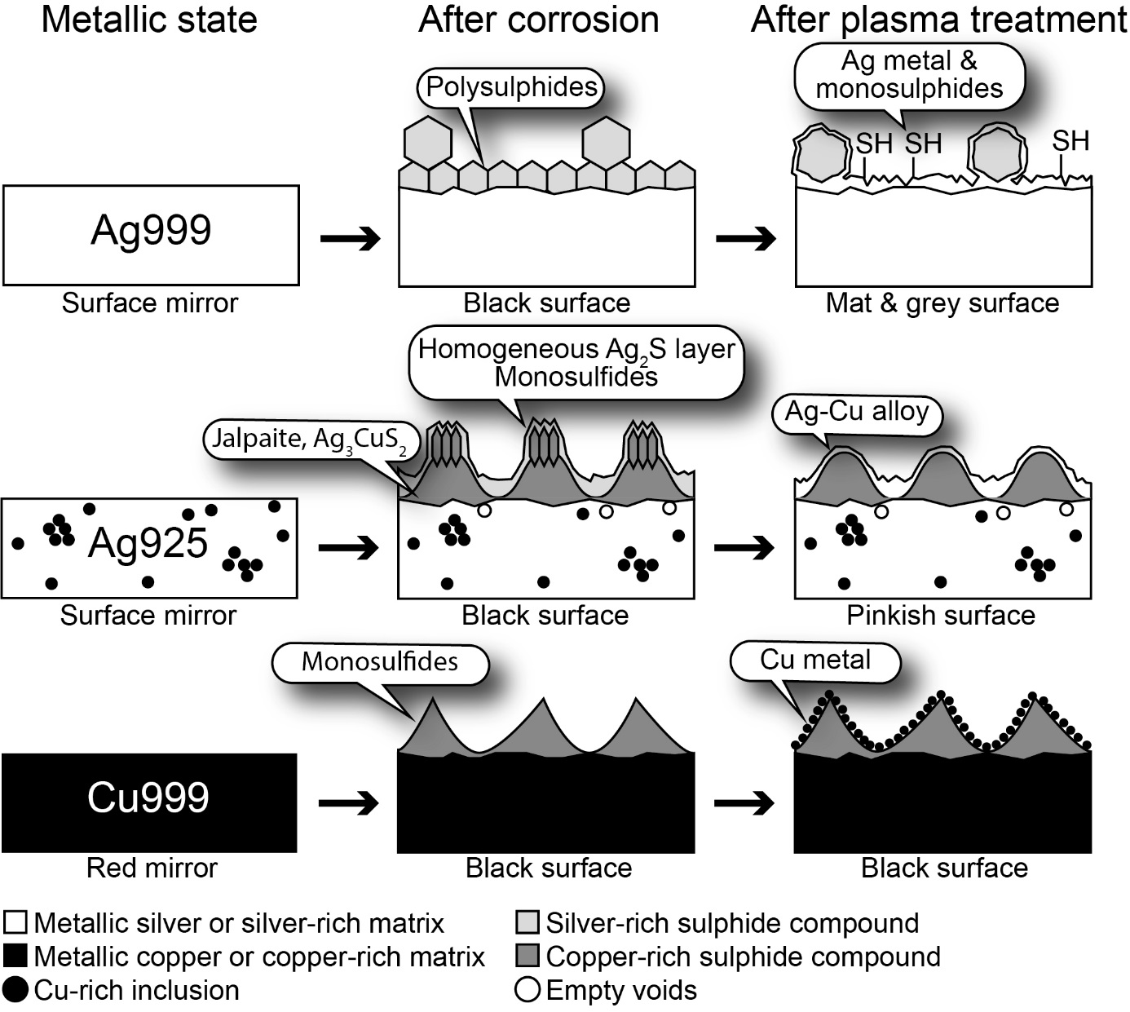

Fig. 7: Schematic representation of Ag999, Ag925 and Cu999 in cross-section in their metallic state characterized by a smooth surface, the surface state after corrosion in a Na2S solution and the corrosion layer after plasma treatment.

**6. Conclusions**

Sulphidized Ag999 was the only case where substantial amounts of polysulphides were found. Sulphites or sulphates were not encountered in sulphidized Ag999, Ag925 and Cu999. For all the sulphidized metal types, the atmospheric plasma treatments were able to reduce the surface of all sulphide layers into a metal. However, the visual and chemical impact were substantially different. For Ag999, a metallic surface with chemisorbed sulphides was formed. For Ag925, a pinkish Ag-Cu layer was formed, and for Cu999 metallic copper was formed, but corrosion products were still present below the top layer. This in depth non uniformity of the corrosion layer led to different information when applying different investigation techniques. XPS analyses highlighted the presence of a homogeneous top layer layers with low sulphur content, while SEM and PEEM showed the presence of a heterogeneous corrosion layer [7]. In addition, XPS suggested that the sulphur content after the atmospheric afterglow treatment was lower on Ag925 and Cu999 than on Ag999, while at the sub-µm level the information was the opposite. Therefore, the XPS analyses delivered valuable information to refine the existing description of the processes of sulphidation and plasma treatment of sulphide layers.

The plasma treatment of tarnished silver appeared to be limited by two phenomena. The first phenomenon was that the copper in silver alloys corrodes preferentially and that the corrosion layer was enriched in copper. When the corrosion layer was reduced back to its metallic state, a pinkish Ag-Cu alloy was formed. This change in colour is not desired in heritage. The other limiting phenomenon was that at least in this remote afterglow plasma configuration the Ag2S layers were decomposed throughout their volume, while Cu2S only endures a surface change. This means that the application of a reducing plasma afterglow at atmospheric pressure is limited to heritage objects that contain pure silver at the surface [6].

**Acknowledgements**

This work was supported by the EU-FP7 grant PANNA no. 282998. The SR-XPS measurements at the NanoESCA beamline of the Elettra storage ring were performed under the approval of the advisory Committee (Proposal No. 20135164).

**References**

[1] Graedel T.E., Franey J.P., Gualtieri G.J., Kammlott G.W., Malm D.L., On the mechanism of silver and copper sulfidation by atmospheric H2S and OCS, Corrosion Science, 1985, 25(12), 1163-1180

[2] Costa V., The deterioration of silver alloys and some aspects of their conservation, Reviews in Conservation, 2001, 2, 19-35

[3] Degrigny C., Jeanneret R., Witschard D., Local cleaning with the pleco electrolytic pencil of the tarnished saint candide reliquary head at the treasury of Saint-Maurice abbey, Valais (Switzerland), e-PS, 2015, 12, 20-27

[4] Patelli A., Favaro M., Simon S., Storme P., Scopece P., Kamenova V., Kamenarov Z., Lorenzon A., De Voeght F.- EU-Project PANNA: Plasma and nano for new age soft conservation: development of a full-life protocol for the conservation of cultural heritage, Lecture notes in computer science, 2012, 7617, 793-800

[5] Goossens O., Dekempeneer E., Vangeneugden D., Van de Leest R., Leys C., Application of atmospheric pressure dielectric barrier discharges in deposition, cleaning and activation, Surface and Coatings Technology, 2001, 142-144, 474-481

[6] Grieten, E., Schalm O., Tack P., Bauters S., Storme P., Gauquelin N., Caen J., Patelli A., Vincze L., Schryvers D., Reclaiming the image of daguerreotypes: characterization of the corroded surface before and after atmospheric plasma treatment, Journal of cultural Heritage, 2017, 28, 56-64

[7] Schalm O., Storme P., Gambirasi A., Favaro M., Patelli A., How effective were reducing plasma afterglows at atmospheric pressure in removing sulphide layers: application on tarnished silver, sterling silver and copper, Surface and Interface Analysis, 2018, 50(1), 32-42

[8] Schalm O., Crabbé A., Storme P., Wiesinger R., Gambirasi A., Grieten E., Tack P., Bauters S., Kleber Ch., Favaro M., Schryvers D., Vincze L., Terryn H., Patelli A., The corrosion process of sterling silver exposed to a Na2S solution: monitoring and characterizing the complex surface evolution using a multi-analytical approach, Applied Physics A, 2016, 122(10):903, doi:10.1007/s00339-016-0436-6

[9] Schneider C.M., Wiemann C., Patt M., Feyer V., Plucinski L., Krug I.P., Escher M., Weber N., Merkel M., Renault O., Barrett N., Expanding the view into complex material systems: From micro-ARPES to nanocale HAXPES, Journal of Electron Spectroscopy and Related Phenomena, 2012, 185, 330-339

[10] Miller A.C., Powell C.J., Gelius U., Anderson C.R., Energy calibration of x-ray photoelectron spectrometers. Part III: location of the zero point on the binding-energy scale, Surface and Interface Analysis, 1998, 26, 606-614

[11] Daniels V.D., Holland L., Pascoe M.W., Gas plasma reactions for the conservation of antiquities, Studies in Conservation, 1979, 24(2), 85-92

[12] Holland L., Samuel G., The reduction of Ag2S and treatment of paper in a magnetron glow discharge, Studies in Conservation, 1981, 14, 205-218A

[13] Daniels V., Plasma reduction of silver tarnish on Daguerreotypes, Studies in Conservation, 1981, 26(2), 45-49

[14] Schmidt-Ott, K., Plasma-Reduction: Its Potential for Use in the Conservation of Metals, in Proceedings of Metal 2004, Canberra, National Museum of Australia, 2004, p.235-246

[15] Smart R., Skinner, W. Gerson A., XPS of Sulphide Mineral Surfaces: Metal-deficient, Polysulphides, Defects and Elemental Sulphur, Surface and Interface Analysis, 1999, 28, 101-105

[16] Scott D.A., Metallography and microstructure of ancient and historic metals, The J. Paul Getty Trust, 1991

[17] Linke R., Schreiner M., Energy Dispersive X-Ray Fluorescence Analysis and X-Ray Microanalysis of Medieval Silver Coins: An Analytical Approach for Non-Destructive Investigation of Corroded Metallic Artifacts, Microchimica Acta, 2000, **133**, 165-170

[18] Beck L., Bosonnet S., Réveillon S., Eliot D., Pilon F., Silver surface enrichment of silver-copper alloys: A limitation for the analysis of ancient silver coins by surface techniques, Nuclear Instruments and Methods in Physics Research Section B Beam Interactions with Materials and Atoms 226(1-2), 153-162

[19] Northover S.M., Northover J.P., Microstructures of ancient and modern cast silver–copper alloys, Materials Characterization, 2014, **90**, 173-184

[20] Van Langh R., Ankersmit H.A., Joosten I., The delamination of silver sulphide layers, in Proceedings of Metal 2004, Canberra, Australia, 4–8 October 2004, p. 137-141

[21] Ingo G.M., Balbi S., De Caro T., Fragala I., Angelini E., Bultrini G., Combined use of SEM-EDS, OM and XRD for the characterization of corrosion products grown on silver roman coins, Applied Physics A, 2006, **83**, 493-497

[22] Bernard M.C., Dauvergne E., Evesque M., Keddam M., Takenouti H., Reduction of silver tarnishing and protection against subsequent corrosion, Corrosion Science, 2005, 47(3), 663-679

[23] Shams El Din A.M., Abd El Kader J.M., Abd El Wahab F.M., Saber T.M.H., El Azhari A.A., El Waraky A.A., An eletrochemical and ESCA study on the Tarnishing of Silver in Solutions of Different pS and pH Values, Electrochimica Acta, 1985, 30(4), 461-468

[24] Campbell G.D., Lincoln F.J., Power G.P., Ritchie I.M., The anodic oxidation of silver in sulphide solutions, Australian Journal of Chemistry, 1982, 35, 1079-1085

[25] Novakovic J., Vassilou P., Geogiza E., Electrochemical Cleaning of Artificially Tarnished Silver, International Journal of Electrochemical Science, 2013, 8, 7223-7232

[26] Fuggle J.C., Menzel D., The effect of chemisorption on substrate core levels observed by XPS, Chemical Physics Letters, 1975, 33(1), 37-40

[27] Barrie A., Bradshaw A.M., XPS shifts of substrate core levels upon chemisorption, Physics Letters, 1975, 55A(5), 306-308

[28] Buckley A.N., Woods A., Identifying chemisorption in the interaction of thiol collectors with sulphide minerals by XPS: adsorption of xanthate on silver and silver sulphide, Colloids and Surfaces A: Physicochemical and Engineering Aspects, 1995, 104, 295-305

[29] Ohgi T., Fujita D., Deng W., Dong Z.-C., Nejoh H., Scanning tunnelling microscopy and x-ray photoelectron spectroscopy of silver deposited octanethiol self-assembled monolayers, Surface Science, 2001, 493, 453-459

[30] Lee J.I., Howard S.M., Kellar J.J., Cross W., Han K.N., Electrochemical Interaction between Silver and Sulfur in Sodium Sulfide Solutions, Metallurgical and Materials Transactions B, 2001, 32B, 895-901

**Supplementary Material**

**Energy calibration of XPS spectra using the Fermi level and refinement of the calibration using the general shape of the valence band**

Olivier Schalma,b, Patrick Stormea, Amandine Crabbéc, Stefano Voltolinac, Alessandro Patellid, Vitaliy Feyere, Herman Terrync

a. University of Antwerp, Conservation Studies, Blindestraat 9, B-2000 Antwerp, Belgium

b: Antwerp Maritime Academy, Noordkasteel Oost 6, B-2030 Antwerpen, Belgium

c. Vrije Universiteit Brussel (VUB), Research Group of Electrochemical and Surface Engineering, Pleinlaan 2, B-1050 Brussels, Belgium

d. Veneto Nanotech, Nano Fabrication Facility, Via delle Industrie 9, 30175 Venezia-Marghera, Italy

e. Peter Grünberg Institute (PGI-6) and JARA-FIT, Research Center Jülich, 52425 Jülich, Germany

For the metallic samples Ag999, Ag925 and Cu999 after atmospheric plasma treatments, some carbonaceous compounds were still detected, although this might be the result of re-deposition after the plasma treatment. However, due to the plasma treatments and the resulting surface changes, the C1s peak changes in shape and in intensity among the samples, hindering the identification of a binding energy (BE). This means that the C1s peak could not be used as reference for energy calibration.

Instead, the spectra were calibrated in energy with respect to the Fermi level position. However, for some samples the near-rectangular shape in the vicinity of the Fermi level was not clear enough for accurate energy calibration. Therefore, an additional refinement of the energy calibration was performed using (specific features of) the overall shape of the valence band (VB) spectra. In the list below, the calibration method used for the collected spectra is described for the 3 metal types. Table I gives an overview of the methods used for each spectrum.

* **Ag999:** Of the 4 surface states, only 2 of them had a pronounced Fermi level: the sulphidized surface state (i.e., SBP) and the sulphide surface state that was transformed into the metallic surface state due to plasma treatment (i.e., SAPH). This means that energy calibration of both spectra could be performed by least-squares fitting using the CasaXPS software version 2.3.15. Due to a weak Fermi level of the other 2 surface states, the VB-spectra of metallic Ag999 before (BP) and after plasma treatment (APH) had to be calibrated in another way. The VB-spectra of the metallic surface states, (see Fig. SM-1: BP and APH vs. SAPH of Ag999) were very similar in shape and in agreement with the general shape of published VB spectra of metallic silver: a faint jump at the Fermi level, the energy of the VB band ranging from 4 eV to 8 eV, and a dip at about 6 eV [SM1, SM2, SM3]. Therefore, the energy calibration of these 2 spectra was obtained by shifting the spectrum until the shape coincide with that of the VB-spectrum of sulphidized Ag999 after plasma treatment (SAPH) which was previously calibrated by least-squares fitting. The peak at 4.3 eV of the SAPH spectrum was a useful feature to perform the energy calibration. After this refinement, the BE of Ag3d5/2 and Ag3d3/2 for the spectra collected of metallic silver were located at 367.9-368.0 eV and 373.9-374.0 eV, which were close to published BE obtained from high-resolution XPS: 368.0 eV and 374.3 eV respectively [SM4].

**Ag925:** The shape of the VB-spectra of the 4 surface states of Ag925 show substantial differences. Moreover, none of the spectra resembled the VB-spectra of Ag999. The differences between both alloys could be explained by the small copper amounts in Ag925 and by a different mixture of species in the corrosion layer. It is known that corrosion layers on top of Ag925 consist of a complex mixture of stromeyerite (AgCuS), acanthite (Ag2S), chlorargyrite (AgCl), cuprite (Cu2O) or covellite (CuS) [SM5,SM6]. From the 4 surface states, sulphidized Ag925 after plasma treatment (SAPH) has the best resolved Fermi level and was calibrated by least-squares fitting. The VB spectrum of that surface state was similar to that of metallic Cu999 (Fig. SM-1, BP). The peak maximum at 2.4 eV was chosen as reference since it was related to the metallic copper. That peak was used to refine the energy calibration of all the other Ag925 samples. As a result of this calibration procedure, the Cu3p signals for the 4 surface states coincided at 74.3 eV.

* **Cu999:** As can be seen in Fig. 1, the VB-spectra of Cu999 for the 4 different surface states were much more similar than the ones for Ag999 and Ag925. Published VB-spectra of metallic copper show a pronounced Fermi level while the peaks start at about 1 eV [SM1]. The clearly resolved Fermi level allowed an accurate calibration of the VB-spectra of all the 4 surface states using least-squares fitting. To evaluate the refining method based on the general shape of the spectrum, the VB-spectrum of metallic Cu999 before plasma treatment (BP) was calibrated by the Fermi level while the other ones were calibrated using the general shape of the spectra. Between the refining method and the least-squares fitting method, the average difference in energy shift was equal to 0.06 eV ± 0.04 eV, which was smaller than the energy shifts observed in the XPS-spectra. This strengthens our refined fitting method based on the general shape of the VB spectra.

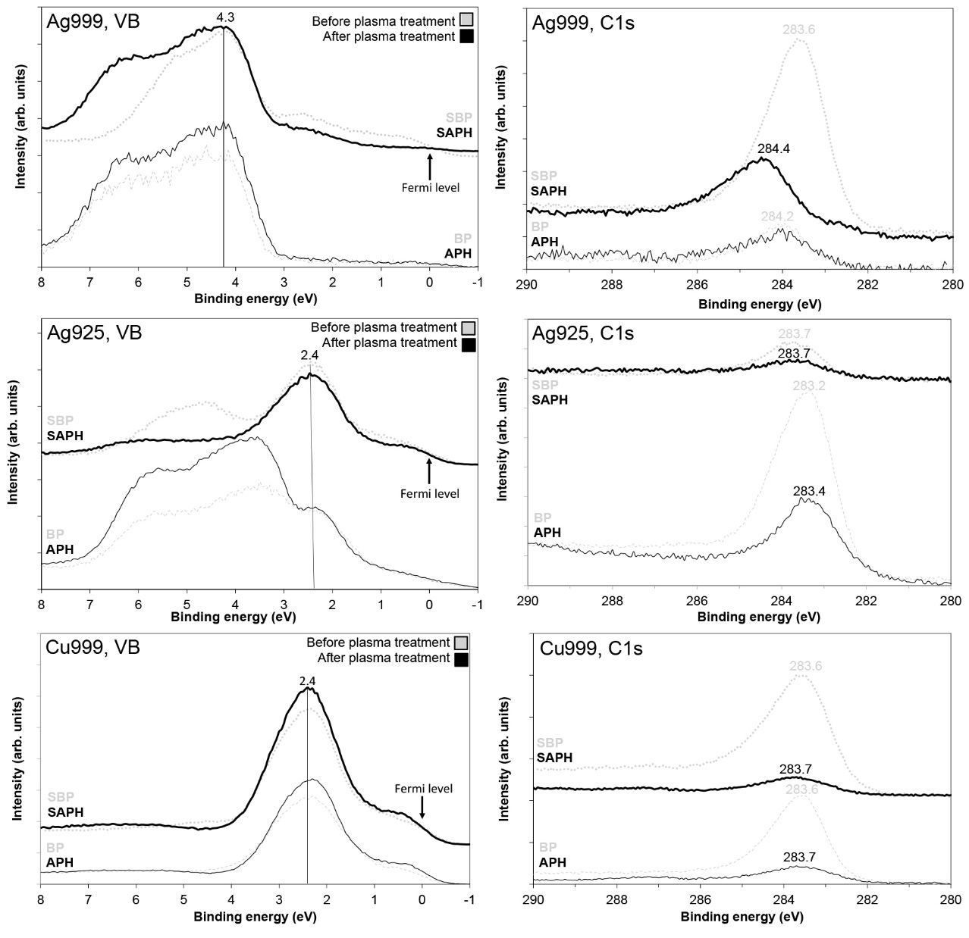

Fig. SM-1: High resolution spectra of the valence band of metallic and sulphidized Ag999, Ag925 and Cu999 before and after plasma treatment using a soft-x-ray excitation of 450 eV together with the high resolution spectra of C1s. The abbreviations BP, APH, SBP and SAPH stands for Before Plasma, After Plasma Helium, Sulphide Before Plasma and Sulphide After Plasma Helium respectively.

TABLE I: Features used to perform the energy calibration and the energy calibration method that was used.

|  |  |  |  |
| --- | --- | --- | --- |
| **Class** | **Surface treatment** | **Feature** | **Calibration method** |
| Ag999 | BP | Spectrum shape | Shift spectrum to match SAPH-spectrum & use the peak at 4.3 eV |
| APH | Spectrum shape | Shift spectrum to match SAPH-spectrum & use the peak at 4.3 eV |
| SBP | Fermi Level | Spectrum fitting using least-squares fitting |
| SAPH | Fermi Level | Spectrum fitting using least-squares fitting |
| Ag925 | BP | Peak at 2.4 eV | Shift spectrum to match peak in SAPH-spectrum |
| APH | Peak at 2.4 eV | Shift spectrum to match peak in SAPH-spectrum |
| SBP | Peak at 2.4 eV | Shift spectrum to match peak in SAPH-spectrum |
| SAPH | Fermi Level | Spectrum fitting using least-squares fitting |
| Cu999 | BP | Fermi Level | Spectrum fitting using least-squares fitting |
| APH | Fermi Level | Spectrum fitting using least-squares fitting |
| SBP | Fermi Level | Spectrum fitting using least-squares fitting |
| SAPH | Fermi Level | Spectrum fitting using least-squares fitting |
| Reference  products | Cu2S | Fermi Level | Spectrum fitting using least-squares fitting |
| CuS | Fermi Level | Spectrum fitting using least-squares fitting |
| Ag2S | Fermi Level | Spectrum fitting using least-squares fitting |

**References**

[SM1] Hüfner S., Wertheim G.K., Smith N.V., Traum M.M., XPS density of states of copper, silver and nickel, Solid State Communications, 1972, 11, 323-326

[SM2] Wertheim G.K., Buchanan D.N.E., Core-electron binding energies of adsorbed metallic monolayers: Au/Ag(111), Physical Review B, 1986, 33(2), 914-918

[SM3] Wertheim G.K., DiCenzo S.B., Buchanan D.N.E., Noble- and transition-metal clusters: the d bands of silver and palladium, Physical Review B, 1986, 33(8), 5384-5390

[SM4] Barrie A., Christensen N.E., High-resolution x-ray photoemission spectra of silver, Physical Review B, 1976, 14(6), 2442-2447

[SM5] Schalm O., Crabbé A., Storme P., Wiesinger R., Gambirasi A., Grieten E., Tack P., Bauters S., Kleber Ch., Favaro M., Schryvers D., Vincze L., Terryn H., Patelli A., The corrosion process of sterling silver exposed to a Na2S solution: monitoring and characterizing the complex surface evolution using a multi-analytical approach, Applied Physics A, 2016, 122(10):903, doi:10.1007/s00339-016-0436-6

[SM6] Angelini E., de Caro T., Mezzi A., Riccucci C., Faraldi F., Grassini S., Degradation mechanisms occurring in precious metallic artefacts, Surface and Interface Analysis, 2012, 44, 947-952