Insulation resistance in relation to distribution

of backsheet types in strings and inverters

Claudia Buerhop*, Tobias Pickel, Oleksandr Stroyuk, Jens Hauch, Marius Peters

High Throughput Methods in Photovoltaics, Forschungszentrum Jülich GmbH, Helmholtz Institute Erlangen-Nürnberg for Renewable Energy (HI ERN), Immerwahrstraße 2, 91058 Erlangen, Germany

Author for correspondence:
*Dr. Claudia Buerhop, e-mail: c.buerhop-lutz@fz-juelich.de; High Throughput Methods in Photovoltaics, Forschungszentrum Jülich GmbH, Helmholtz Institute Erlangen-Nürnberg for Renewable Energy (HI ERN), Immerwahrstraße 2, 91058 Erlangen, Germany

Abstract
Polymers are essential for long-term green energy production by photovoltaics (PV). We created a unique dataset that links electrical performance data of 28,030 PV modules, combined into 1,295 strings and 423 inverters with the identity of the backsheet (BS) materials of each of the tested modules. This dataset gives an insight into BS-versatility and resulting impact on the insulation resistance of strings and inverters. The BSs were analysed using near infrared spectroscopy (NIRA) plus visual inspection in the field. The insulation resistance (R_{iso}) of selected modules and strings was measured on-site. Furthermore, reported ground impedance (GI) values were evaluated with respect to an inverter-specific threshold below which the inverters do not start operation. We differentiated seven BS-types, the three most frequent being polyamide (PA), fluorinated coating (FC), and polyvinylidene fluoride (PVDF). Although modules with PA show often BS cracking, the insulation resistance was above the threshold. Similar, the GI of inverters with modules with PVDF-BSs was high. Modules with FC-BSs feature generally low R_{iso}–values on module-, string-, and on inverter level. Evaluating historic data reveals an increase in frequency of GI-values below the threshold for inverters connected to modules with exclusively FC-BSs. While inverters with modules having PA- or PVDF-BSs function as expected, inverters with modules having FC-BSs require maintenance to keep power yield on an acceptable level. The dataset collected in the present work highlights that the choice of BS-material of PV-modules is essential for reliable operation of PV power stations.

Introduction

Polymers are essential for long-term and reliable green energy production by photovoltaics (PV). The fact that polymers introduced as backsheets (BSs) can affect the operation of PV power stations is amazing at a first glance. This study highlights the importance of the selection of polymer components from appropriate and high quality materials for the expected functionality of PV modules by showing how the operation of inverters in PV power stations is related to the choice of BS-materials.
BSs are designed to shield the solar cells in modules against mechanical and environmental impacts and damages as well as to protect the environment against dangerous leakage current during regular energy production. Standards (VDE 0126-23 (DIN EN 62446), DIN EN 0126-1-1) [1, 2] demand an insulation resistance of R_{iso} > 40 MΩ m². For a regular 60 cell module (total area A = 1.6 m²) this translates to R_{iso} = 25 MΩ. For brand-new modules, R_{iso} can be in the range of GΩ, but for field-aged modules, R_{iso}-values with several hundred MΩ are reported in wet leakage tests in the lab [3-5].
Besides modules, inverters need to fullfill requirements for safe operation of PV power stations, as well. Regulations for the required insulation resistance for PV power stations can be found in refs. [1, 2]. For a system voltage above 500 V, the insulation resistance must be R_{iso} > 1 MΩ. PV-systems with galvanic isolation from the grid (by transformers) are excluded from this requirement. The threshold for starting operation varies among different inverter types, varying from 200 kΩ to 1 MΩ. The insulation resistance / ground impedance is measured by internal inverter routines always at starting and connecting to grid.
Leakage current is a severe safety issue also causing a reduction of the outcome. Possible reasons for high leakage currents are, e. g. inverter faults, too low insulation resistance of PV-strings, environmental humidity, dew on the modules, etc. Cueto [6] assigns the leakage current in modules to moisture ingress. Insulation resistance R_{iso} is described by Flicker et al. [7] by equation (1) as a function of module insulation R_{iso,mod}, inverter insulation R_{iso,inv}, fault resistance R_{iso,fault}, number of strings per inverter n and modules per string m, as well as resistance of the ground conductor R_{gc}.
$R_{iso}=\frac{1}{\frac{n∙m}{R_{iso,mod}} + \frac{1}{R_{iso,inv}} + \frac{1}{R_{iso,fault}}}+R_{gc}$ (1)
Flicker et al. [7] note that the measurable range of R_{iso} values is strongly affected by both module- and inverter technology. At very high values of R_{iso,fault} (> 100 kΩ as seen in healthy systems), R_{iso} is dominated by the insulation of the module and other balance-of-system (BOS) components to ground. The size of the array (n, m) and the specific insulation of these components (R_{iso,mod}, R_{iso,inv},) can have a significant impact on the fault’s detectability, in general, it is not possible to detect the presence of a fault with a larger resistance than the system itself. At very low fault resistances, the R_{iso} measurement is dominated by the series resistance R_{gc}.
At that, the knowledge if field-aged modules with field-aged BS with potentially reduced insulation resistance and leakage paths affect the operation and functionality of inverters is important. The most obvious consequences of BS resistance losses are alerts, inverter outages, late or complete failure to start of inverters (reduced uptime), neccessity of removing fault-initiating modules from the string, resulting in yield reduction.
With this study, we present first insights into BS-related differences in insulation resistance on module, string and inverter level from field data. Degradation of polymers (encapsulants, e.g. ethylene vinyl acetate (EVA), and BSs) at operating conditions has been reported for several years [8-11]. Water ingress is recognized as a major driving factor for the BS degradation [12-15]. The formation of macroscopic cracks in polyamide (PA) BSs has been studied [16-18]. The latter reports indicate that additives in the EVA, in particular UV-blocker, favour the crack formation in PA. Since field-suitable instruments for BS-analysis are not available, prevailingly single modules were analysed, usually in the labs. Most publications about polymer or BS-degradation concentrate on PA-BSs, while information on the electrical properties is rarely published [15, 19]. In addition, we are not aware of studies that include a statistally significant numbers of identified BSs of modules of one PV power station, e.g. for all modules in minimum one inverter. As a result, related impact on electrical performance, e.g. power, yield, insulation resistance, is rarely evaluated and published.
We present a first systematic study on differences in BS-related electrical performance data. Using visual inspection based on a previous spectral analysis with near-infrared absorption spectroscopy (NIRA), we were able to identify, to map, and to link BSs of all installed PV-modules to strings and inverters. The evaluated electrical data consist of reported ground impedance values from the inverter and measured insulation resistances of selected strings and modules. A combination of the BS-dataset and the R_{iso} dataset enabled us to capture and to extract changes and differences depending on the BS-type. All modules with different BS-types experienced the same history (identical operation conditions, weather conditions, installation period). Data visualization and statistical analysis clearly point out the significance of the different BSs on the inverter operation.

Experimental procedure

A 6.8 MWp PV power station, which includes PV-modules with several BS-types experiencing identical ambient conditions and operation period is analyzed. The station is located in Germany and was commissioned in 2012. There are 423 inverters connecting 1,295 strings and 28,030 PV-modules (23 modules per string). The modules are standard 60-cell devices from a well-known manufacturer.
The BS-materials of all modules were analyzed and identified on-site. We used non-destructive and field-suitable near infrared spectroscopy analysis (NIRA) [20, 21] for BS-identification. In parallel to BS-analysis from the rear side, the front side was visually inspected for indications of degradation, e. g. corrosion. BS-mapping was done by NIRA-supported visual inspection. At that, all avaliable BS types were first identified with NIRA and then specific BS structures were related to their specific appearance (light transmittance, BS reflectivity and internal structure, color and turbidity, etc.) which can be evaluated and identified visually by a trained observer. Periodically, random BSs were verified also with NIRA measurements across the entire PV field to make sure that the visual identification remains correct at different daytimes and natural illumination conditions and produces no artifacts. The BS mapping revealed the BS types of all modules electrically connected to strings / inverters.
Then, the electrical properties of the strings and inverters were analyzed, as will be described below. There are mostly 15 kWp transformerless inverters from a single manufacturer with three phases for maximum power point tracking of the strings. Before starting operation, the insulation resistance is checked internally by each inverter with a minimum threshold of GI_{th} = 400 kΩ [22]. GI-data of all 423 inverters measured due to regular starting procedure every morning is analyzed and evaluated for 3,375 days throughout eight years of operation.
In order to distinguish between insulation data of inverter and strings, we address inverter insulation data as ground impedance (GI).
For 373 strings (from 112 inverters), insulation resistance was measured consecutively on three mornings on-site with a PV Check setup from HT Instruments. The measurement range is limited to R_{iso} < 100 MΩ. For determining the insulation resistance of modules, a Benning SUN 2 PV multimeter was used with a measurement range up to R_{iso} < 200 MΩ.
Furthermore, measurement conditions, including ambient temperature T, relative humidity RH, and module temperature T_{m} during the insulation measurements of strings and modules, were recorded.
The PV power station is located in an area classified by humid and warm continental climate as (Dfb) according to Köppen-Geiger [23, 24]. Dfb decribes a cold and temperate climate with a siginificant rainfall, with considerable precipitation even in dry months. Using publicly available weather data of MERRA (NASA) [25], the weather at the site of installation can be described as follows averaged for one year: mean daily irradiance E ̅ = 3.62 ± 2.4 kWh/m², mean daily temperature T ̅ = 11.1 ± 8.2°C, range of daily relative humidity RH = 34% - 95%, and mean daily rainfall r ̅ = 0.01 ± 0.01 kg/m².

Results and discussion

Backsheet identification
Using NIRA-supported visual inspection we identified seven different BS-types, see Table 1. We found one non-fluoropolymer BS, polyamide (PA), and six multi-layered single-fluoropolymer BSs [26]. These single-fluoropolymers have a PET-core layer and various air and inner layers. Typically, BSs with a fluorinated coating (FC) air layer had a polypropylene (PP) inner layer, whereas BSs with polyvinyl fluoride (PVF) or polyvinylidene fluoride (PVDF) air layers featured an inner layer of polyethylene (PE). Inner and air layers are filled with microcrystalline rutile (titania) pigment. BS architectures with different layer thicknesses are indicated by a suffix 1 or 2. Throughout the study the BSs will be addressed by their air layer type, e. g. FC1-BS is a BS with a FC1 air layer, a PET core layer and a PP inner layer. Most BSs have a thickness of d > 300 µm, with one exception of FC1-BSs which were relatively thin, d ≈ 220 µm. The extremely thin fluorinated air layer (d = 5-10 µm) is more a coating than a layer and therefore is referred to as a fluorinated coating, FC, in line with other reports [10].
Most frequent BSs are PA (19%), FC1 (28%) and PVDF1 (30%), these three types account for 77% of all tested modules.

Table 1: summary of the identified BSs, PA: polyamide, PET: polyethylene terephthalate, PVF: polyvinyl fluoride, PVDF: polyvinylidene fluoride, PE: polyethylene, PP: polypropylene, FC: fluorinated coating, R: rutile TiO₂
The visual inspection revealed that many modules already showed signs of polymer degradation. In particular, we observed the so-called “chalking” of PA-BS (formation of rutile deposits on the air-side surface) and discoloration (“yellowing”) for PVF1- and PVDF2-BSs, see Table 1. Ca. 57% of the modules with PA-BSs had severe macroscopic cracks behind the cell interconnects / busbars, see Figure 1. Interestingly, mainly one-to-two thirds of the cell columns showed this crack pattern, but rarely all cell columns. For the time being, we can provide no explanation for this asymmetric BS crack formation in PA-BSs.
Also, crack patterns were observed for modules with FC1-BSs, see Figure 1. In transmission mode microcracks are visible in the cell gaps. All modules with FC1 show these microcracks which are located in the inner PP layer. Ca. 60% of the modules exhibit first signs for metal degradation / corrosion starting on the opposite side of the junction box. About 10% of the modules show colourful spots of severe corrosion of the metal interconnects, also opposite the junction box side. Other degradation features were also found, e. g. polymer ablation, delamination with water-filled bags, swelling, etc.

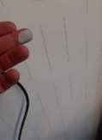  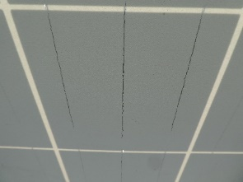  a) | 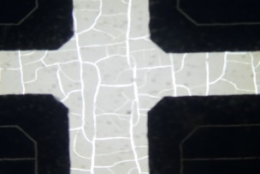  b)
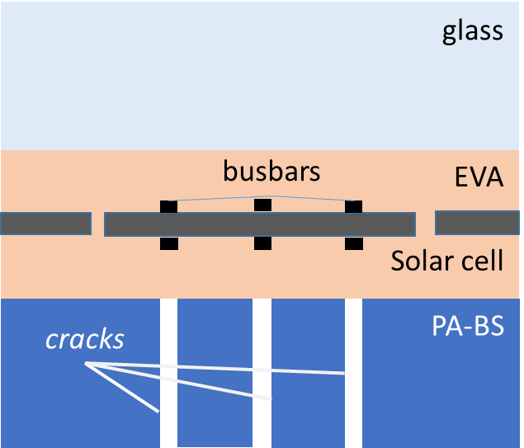  c) | 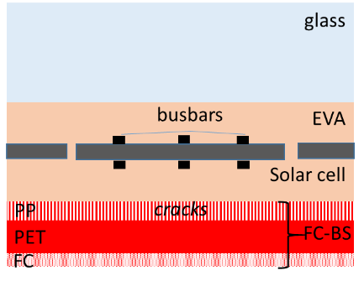  d)
Figure 1: Visualization of degradation patterns for modules with PA-BS (a) and FC1-BS (b), schematics of cross section of a module showing crack structures in PA-BS (c) and FC1-BS (d)
After identifying BSs of all present modules, they were mapped and their connection to specific strings and inverters was ascertained, see Table 2. Interestingly, only 74 out of 423 inverters have modules with only a single BS-type, which will be called the BS-pure (exclusively one BS) inverters. The majority of inverters (349 inverters) were connected to modules with multiple BS-types. Therefore, the summation of inverters with any BS-type does not equal the total number of inverters. At that, the versatility of BS-types per module type (same nameplate label) for strings and inverters can be surprisingly large. Up to six different BSs were identified for the same module type from the same manufacturer, as published elsewhere [26]. We note that at least nine data points should exist for a reliable statistical analysis. Because this condition is fullfilled for PA-, FC1-, and PVDF1-inverters, statistical evaluations will be presented only for these types. FC2-, PVF1-, PVF2-, and PVDF2-inverters with instances less than three are not considered.
For better readability, inverters and strings will be named according to the BS type of their modules, e. g. inverter with modules with PA will be then called “PA-inverter”. At that, 16% BS-pure inverters and 61% BS-pure strings remain for further evaluation.
As a further focus on PA-strings, we note that 69% of the PA-strings include modules with cracked BSs, for 30% of the PA-strings all modules have cracked BS, 31% of the PA-strings are free of cracked BSs.
Table 2: distribution of BSs to strings and inverters
level | subset | BS-purity | PA | FC1 | FC2 | PVF1 | PVF2 | PVDF1 | PVDF2 | Total number
Fraction of modules |  |  | 19% | 28% | 6% | 4% | 3% | 30% | 9% | 28,030
Number of strings | II)  Subset of strings with measured R_{iso,string} | A) any BS configuration | 92 | 160 | 16 | 57 | 29 | 183 | 67 | 373
Number of strings | II)  Subset of strings with measured R_{iso,string} | B) 1 BS-type / string | 75 | 61 | 3 | 4 | 3 | 71 | 11 | 228
Number of strings | I)  All strings | A) any BS configuration | 259 | 530 | 112 | 123 | 82 | 552 | 194 | 1,245
Number of strings | I)  All strings | B) 1 BS-type / string | 216 | 219 | 43 | 13 | 16 | 222 | 47 | 774
Number of inverters | II)  Subset of inverters with measured R_{iso,string} | A) any BS configuration | 51 | 71 | 10 | 30 | 18 | 79 | 30 | 112
Number of inverters | II)  Subset of inverters with measured R_{iso,string} | B) 1 BS-type / inverter | 7 | 6 | 0 | 2 | 0 | 8 | 0 | 21
Number of inverters | I)  All inverters | A) any BS configuration | 180 | 280 | 57 | 77 | 58 | 296 | 100 | 423
Number of inverters | I)  All inverters | B) 1 BS-type / inverter | 14 | 34 | 3 | 1 | 1 | 20 | 1 | 74

For exploring the impact of BS on GI and R_{iso} we use the subsets with BS-pure inverters and strings (PA, FC1, PVDF1). However, for a direct comparison of GI with R_{iso} we consider all data. Any BS in the strings is allowed with the assumption that at least one PA, FC1, or PVDF1 BS is included.

Ground impedance of inverters
Mapping the BS-material of the modules to inverters enabled the exploration of inverter readiness related to the BS type. Figure 2 exhibits the distribution of the GI for inverters classified by the BS-material for the same day in year nine of operation. The humidity is rather high due to rainfall during the previous night.
PA-inverters have GI between 2 and 5 MΩ, which is well above the threshold GI_{th}. There are inverters operating close to threshold. These are outliers in terms of the BS-study, as the comparison with string R_{iso} measurements below will confirm. Two PA-inverters show low, distinct GI-values due to inverter issues, e. g. defective fans. GI-values of FC1-inverters are below 3 MΩ. Many FC1-inverters operate close to threshold, many start already below the critical value. PVDF1-inverters operate well above threshold with the GI distribution ranging from 2.5 to 7 MΩ.
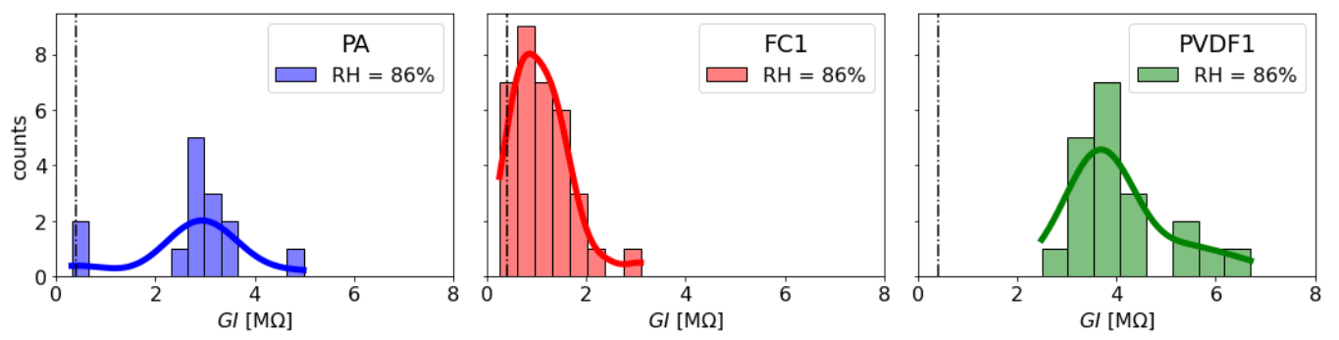
a)
c)
b)
Figure 2: distribution with density curve for ground impedances reported for one day in year nine of operation for inverters with different BS-types, a) 10 PA-inverter, b) 34 FC1-inverter, and c) 28 PVDF1-inverter. The dashed line marks the threshold GI = 400 kΩ.
The GI distributions for inverters and modules of the same age and operating at the same environmental conditions differ depending on the BS-material. The GI-distribution for PA-inverters is fairly broad and centered at 2.6 MΩ, see Figure 2 and Table 3. The majority of FC1-inverters starts with GI = 0.42 MΩ; their distribution is fairly narrow and close to the threshold. PVDF1-inverters show a broad distribution, too, with its maximum at GI = 3.5 MΩ.

Table 3: GI parameters for inverters with modules with different BS-types for one day in year nine of operation in autumn
inverter | GI_{mode} [MΩ] | GI_{mean} [MΩ] | GI_{std} [MΩ] | Standard error | Inverter  (GI< 400 kΩ) | Inverter  (GI< 1 MΩ)
PA | 2.6 | 2.73 | 1.15 | 0.31 | 1 | 2
FC1 | 0.42 | 1.09 | 0.6 | 0.1 | 3 | 17
PVDF1 | 3.5 | 4.08 | 1.04 | 0.23 | 0 | 0

The mean GIs differ significantly as evidenced by an analysis of variance (p = 3.5 e-14) because the calculated p-value is lower than the test-level of 0.05. A posteriori (post-hoc) analysis using Student’s t-test confirms significant differences in subset means for all subset pairs.
According to the GI-data, FC1-BS are correlated to the lowest GI-values and tend to be most critical for the inverter operation process.

Insulation resistance of strings
To gain deeper insights into BS-related insulation resistance, on-site R_{iso}-measurements of PV-strings were carried out. Here, one string data point accumulates the measurements made for 23 modules. Again, we focus on the BS-pure strings, mainly those with PA, FC1 and PVDF1. The R_{iso}-measurements were carried out on three consecutive mornings, each measurements performed for 3 hours, implying that during the course of the day temperature and relative humidity (RH) changed. Within the three measurement hours, temperature typically increased and humidity decreased.
Figure 3 shows the measured R_{iso}-values versus relative humidity and module temperature. There is a strong negative correlation of R_{iso} with humidity for PA-inverters (ρ = -0.89) and PVDF1-inverters (ρ = -0.74). This agrees with their statistically significant linear regression determined using Student’s t-test. With increasing module temperature, respectively decreasing humidity (temperature and humidity are strongly correlated), R_{iso} increases. This correlation and linear regression trend between RH and R_{iso} was not found for FC1-inverters, see Figure 3b. The measured R_{iso}-data for FC1-inverters were low, independent on RH or module temperature. R_{iso}-data do not indicate recovery with increasing temperature during the day. This is in agreement with “wet” leakage tests in the lab [15]. However, in the lab study all BS-types showed recovery of R_{iso} after one week in dry lab conditions, while there was no recovery observed for FC1-strings at field conditions in contrast to PA- and PVDF1 strings. A possible explanation involves differences in water ingress and drying, which might take a lot longer for these materials as compared to thinner FC BSs.
The data in Figure 3 shows that R_{iso} depends on the BS-type as well as on the measurement conditions. For data comparison and evaluation, therefore, we focus on the measurement conditions. For studying the expressiveness of GI-data (involving 69 modules), we combine the GI-inverter dataset with the R_{iso} string dataset (involving 23 modules). For statistically significant number of data points we include also inverters / strings with multiple BSs. GI-values for 112 inverters are linked to R_{iso}-data collected for the corresponding/connected 336 strings.

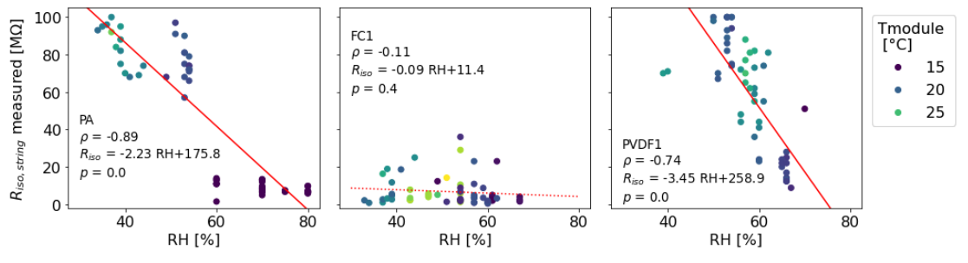
c)
b)
a)
Figure 3: measured insulation resistance for strings with various BS-types PA, FC1, and PVDF1, as a function of relative humidity and module temperature, a) 75 PA strings, b) 61 FC1 strings, and c) 71 PVDF1 strings. The linear regression line R_{iso} is shown in red, p-value for Student’s t-test p, Pearson’s correlation coefficient ρ.
In a PV-system, the insulation resistances of three strings connected to a single inverter are described as a parallel connection against earth (simplifying eq. (1)) and their reciprocal R_{iso}-values add up, see equation (2). Then, reciprocal GI can be set into relation to reciprocal R_{iso,total} plus potential contribution of inverter faults (3) for further analysis.
$\frac{1}{R_{iso,total}}=\sum_{1}^{3}{\frac{1}{R_{iso,i}}=\frac{1}{R_{iso, string1}}+\frac{1}{R_{iso, string2}}+\frac{1}{R_{iso, string3}}}$ (2)

$\frac{1}{GI}≈\frac{1}{R_{iso,total}}+ \frac{1}{R_{iso,inv}}$ (3)
The correlation between GI and R_{iso} for inverters with different BSs is depicted in Figure 4. Figure 4a represents all inverters including at least one module with PA, while the ones with only PA BSs are marked by bright blue dots. Inverters with FC1-BS are shown in Figure 4b, those with exclusively FC1 – marked with red symbols. PVDF1-inverters are collected in Figure 4c, with only PVDF1 ones marked by green dots. String and inverter data correlate well, low string R_{iso} corresponding to low GI. FC1-inverters show the lowest and therefore the most critical values.
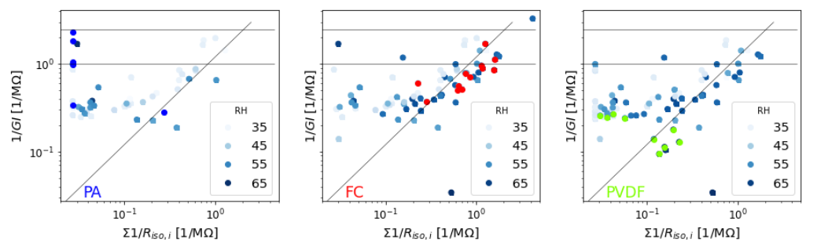
c)
b)
a)
Figure 4: comparison of reported ground impedance and sum of measured R_{iso,string} for inverters with different BS-types, a) inverters including modules with PA, b) inverters including modules with FC1, c) and inverters including modules with PVDF1. Bright dots mark inverters with exclusively one BS-type, a) PA: blue, b) FC1: red, and c) PVDF1: green. Increasing marker size indicates growing fraction of the specific BS per inverter. The horizontal lines indicate GI = 400 kΩ and GI = 1 MΩ. Inverter-related issues (low GI, high R_{iso,string}) are marked by dashed orange ellipses. Deviations due to time discrepancies of GI reported for one morning versus R_{iso,string} measured during time period of three mornings (stable GI by increasing R_{iso,string}) are marked by black ellipses.
Even though the overall correlation is strong for high reciprocal values, see Table 4, some deviations are still observed. First, some inverters have high 1/GI but low 1/R_{iso,string}, this low GI-value not being explainable by BS issues. The low value is probably due to inverter issues as mentioned previously. Second, GI seems to be limited to certain values of about 5 MΩ while R_{iso}, _{string} reaches up to values as high as 100 MΩ. We attribute this to the deviating time regime of data acquisition, GI in the morning starting the inverter, R_{iso,string} during the morning with increasing temperature, measuring one string after the other. Accordingly, while GI is rather low at the onset of inverter operation, R_{iso,string} tends to increase with increasing temperature, as shown above for PA and PVDF1.
Table 4: correlation coefficient ρ of reported GI and measured R_{iso,string} for inverters with different BS-types for one day in year nine of operation
inverter | ρ
PA | 0.61
FC1 | 0.78
PVDF1 | 0.72

In general, the correlation between GI and R_{iso,string} is high. It means that BS-issues are the predominant reason for low GI-values, which makes GI-analysis a suitable and reliable tool for the identification of BS-related issues. However, for comparing data collected at almost the same date, the time shift is of importance, while relevant measurement conditions may change.

Insulation resistance of modules
ρ = 0.72
All presented BS-related system/array data indicate on a BS-type-driven and BS-dependent performance of PV modules in the middle of the expected lifetime of 20 years. In the following discussion we present, therefore, the final data set providing insights into the insulation data on a module level. Typically, R_{iso,mod} is high for modules, several 100 MΩ for field-aged modules and in the GΩ-range for new modules [15]. According to a standard [27], a PV-module should exhibit an insulation resistance R_{iso} > 40 MΩ m², that gives R_{iso,mod} > 25 MΩ for a standard 60-cell module in order to meet the requirements. Therefore, a final experiment was done on module level for one inverter with three strings, each having the same BS-types but differing from each other: upper-string modules with PA-BS, middle-string modules with FC1-BS, and lower-string modules with PVDF1-BS, see Figure 5. All R_{iso} measurements were carried within ca. 30 min at stable ambient conditions.
Figure 5: measured module R_{iso} and string R_{iso} for one table / inverter with BS-material varying stringwise, upper string: modules with uncracked PA-BS (blue), middle string: modules with FC1-BS (red), and lower string: modules with PVDF1-BS (Green). The measured R_{iso,string} values are: R_{iso,string}(PA) = 21 MΩ, R_{iso,string}(FC1) = 0.36 MΩ, R_{iso,string}(PVDF1) = 26 MΩ. The ground impedance for the inverter was GI = 0.45 MΩ.
Modules with PA- and PVDF1-BSs had all R_{iso} > 200 MΩ. At the same time, measured R_{iso} values for modules with FC1-BS show a large spread, ranging from 0.4 MΩ to above 200 MΩ. Whether some of the modules with high R_{iso} are recently installed replacements, is unknown.
These module properties affect the R_{iso} of the strings. As expected, R_{iso,string} of the PA- ad PVDF1-strings are high, as shown in Table 5. For the FC1-string a fairly low R_{iso,string} = 0.36 MΩ was measured, which is probably caused by a module with the lowest R_{iso,mod} = 0.4 MΩ. As a consequence, the resulting GI for the inverter is critically low as well, GI = 0.45 MΩ. At that, four modules with R_{iso,mod} < 6 MΩ have been removed permanently from the string to ensure inverter start and operation.
Table 5: R_{iso} and GI-values for strings with PA, FC1, and PVDF1 strings, as illustrated in Figure 5
inverter | R_{iso,string} [MΩ] | GI_{inv} [MΩ]
PA | 21
FC1 | 0.36 |  | 0.45
PVDF1 | 26

After providing insights into point-wise BS-related insulation data, showing the differences for PA-, FC1-, PVDF1-modules, strings, and inverters, we discuss a time-dependent series in the next section.

Evaluation of time series of GI
Historic monitoring data enable exploring the temporal development of GI-values. We focus on instances of GI falling below the critical threshold GI-value, GI_{th} = 400 kΩ. We counted the instances f for GI < GI_{th} per year. To provide a numerical comparison of the impact of different BSs, summed instances f for inverters i are normalized to the number of inverters per subset. The number of instances I per subset of inverters falling below threshold GI_{th} is calculated as:
$I_{BS}=\frac{\sum{f_{BS,i}}}{n_{BS}}$ (4)
with counts f of inverter i with GI < GI_{th} summed per year, n number of inverters with BS-type PA or FC1 or PVDF1. Figure 6 illustrates frequency of breaching the GI threshold per BS type within the first eight years of operation. A value of I = 30 means, that, on average, GI of every inverter fell below threshold on 30 days throughout one year, I = 1 means respectively one breach per inverter and year. For PA-inverters, first individual cases were registered in 2019 and new single cases observed in 2020. FC1-inverters fell below GI_{th} as early as 2017. The threshold value was reached four times. In the following years the instances increased exponentially. PVDF1-inverters always started operation above the GI threshold.
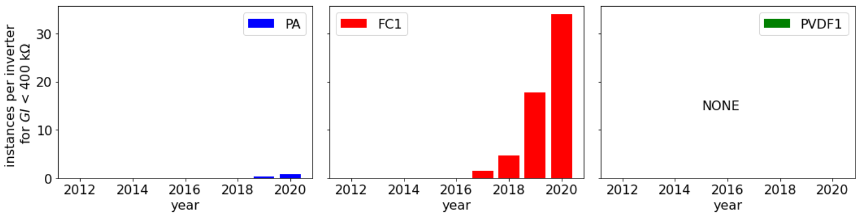
I_{BS}
c)
b)
a)
Figure 6: instances of GI < 400 kΩ per inverter calculated on an annual basis for an inverter with different BS-types, a) inverters including exclusively modules with PA BSs, b) inverters including exclusively modules with FC1 BSs, c) and inverters including exclusively modules with PVDF1 BSs.
This increase of instances for FC1-inverters is unique and statistcally significant. In case of randomness and independence on the BS type, the instances are expected to be equally distributed over all BS-related subsets of inverters. Since that is not the case, we take this fact as a strong indication for FC1-BSs causing insulation issues of modules, strings and inverters.

Discussion
After identifying, labelling and mapping 28,030 BSs of a 6.8 MWp PV-power station, we were able to create a suitable dataset for studying the impact of the BS type on the insulation resistance on the levels of modules, strings and inverters. Three main findings can be highlighted: 1) R_{iso} depends on the BS-material, the modules with FC1-BS reaching critical values especially frequently, 2) R_{iso} values vary throughout the day with changing temperature or humidity and, 3) GI-values of inverters are good indicators for BS-issues.
First, there are BS-related insulation issues. Our dataset for modules with different BSs installed at the same site for the same period shows them to perform differently. From the three most frequently identified BS types - PA, FC1, and PVDF1, FC1 shows an inferior performance on the module-, string- as well as on the inverter level. FC1-modules have the widest spread of R_{iso}-data, from 0.4 MΩ to above 200 MΩ. For PA- and PVDF1-modules the spread is unkown due to measurement limitations, but R_{iso} > 200 MΩ was registered for all modules. Important is, that only FC1-inverter fell below the critical value of GI_{th} = 400 kΩ, while PA- and PVDF1-inverters operated well above this threshold.
Beside this one-day analysis in year nine we evaluated the trend of instances for critical GI-data. For PVDF1-inverters, no critical values were reported, yet. For PA-inverter, rare instances in year seven and eight were identified. The opposite is observed for FC1-inverters with exponentially increasing frequency for days during which values fall below critical GI-values. Basing on these observations, we expect an increase in tripping alerts. For individual strings countermeasures taken by the operators, such as restart of inverters after warnings and shortening of the strings by removing modules with low R_{iso} have been reported [26]. Especially on days with increased humidity, FC1 inverters tend to fail and do not start operation [15, 19].
No plausible explanation for the early degradation of FC1-BSs can be found in the literature. Our working hypothesis is that polymers (EVA plus BS) degrade due to UV-radiation followed by subsequent water ingress as a major reason for the observed insulation issues [12, 28]. In particular, ref. [28] indicated the extent of degradation of EVA and resulting degradation products affecting the BS integrity, e.g. the EVA photodegradation being the dominant factor for PA-BSs. This results in chain scission predominating over cross-linkage as well as in the generation of free radicals initializing oxidation and other reactions (e.g. gradual consumption of additives [29]). Then, moisture ingress in the presence of other climatic stressors (e.g. UV-radiation) can cause all kinds of degradation modes,e.g. metal corrosion or leakage current [12].
For PA the physical-chemical degradation mechanisms are better understood. Published research work [16-18] confirms the presence of macroscopic cracks in PA-BSs and explains their formation, in particular, by the presence or absence of UV-additives in the EVA layers. Most probably, the sequence of events is the same for PA BSs as for the case of FC BSs, starting from the primary UV-induced degradation of EVA, damage of PA layers by the products of the encapsulant degradation followed by penetration of water from the environment with further deeper degradation of polymer components of the PV module. Our study provides new additional information about the impact of BSs (PA with and without cracks, or PVDF) on the insulation resistance of the modules. The present dataset points out that even though PA-BS are often cracked, the strings and inverter show less severe R_{iso} -issues than FC1-inverters.
Second, insulation resistance measurements capture the difference between BS-types as well as the distinct influence of temperature and humidity. In general, the insulation resistance increases with increasing temperature and decreasing humidity, as found for PA- and PVDF1-strings. For inverters with these strings, there is a negative correlation between R_{iso} and humidity which can be described by a linear correlation. In opposite, FC1-strings have constantly low R_{iso}, regardless of humidity and temperature, for longer time periods. Temporal evolution of R_{iso} during an extreme “wet” leakage test in the lab shows a loss of R_{iso} with time for all BS-types as well as subsequent recovery in a dry environment [15]. Therefore, reliable information on the measurement conditions (meteorological, configurational, and electrical) and history of modules, strings, inverters to be tested should be mandatory for comparison and evaluation purposes.
Third, reported GI values from the inverters correlate strongly with measured R_{iso,string}. Inverters with low R_{iso} can be identified and correlated with specific BS-types. In the critical range, 64% of the cases are due to BS-issues, while inverter issues are responsible for 36% of cases. Whether BS-issues also contribute and combine to the inverter issues is currently unknown. In general, inverter issues exist but are less often than BS-related issues. In most inverters with low GI, FC1-BSs are involved.
As a concluding note, we emphasize that the present study is ongoing and does not claim for completeness and representativeness of all variations of these polymers at the present moment.

Conclusion

We created a unique dataset which establishes the connections between the BS materials and the electrical performance data for 28,030 PV modules combined into 1,295 strings and 423 inverters. This dataset gives insight into BS-versatility and BS-related issues.
Due to BS-versatility, testing of single modules in the lab likely fails to be representative for typically installed field ensembles of ca. 10⁵ modules. Within almost 30,000 modules we measured at the investigated PV power station, totally seven BS-types were differentiated for modules of five power classes (1 to 6 different BS-types per power class). The three most frequent BS types are PA, FC1, and PVDF1, FC1-inverters generally showing low R_{iso}-values. Regardless of the ambient conditions, R_{iso}-values of FC1-inverters were close to the threshold. In contrast, even though modules with PA BSs often feature cracking, the insulation resistance was above the inverter specific threshold of GI_{th} = 400 kΩ. Similar, R_{iso} of PVDF1-inverters was well above the threshold.
Time-series of GI since commissioning disclosed that BS-related inverter issues gradually become more frequent, but only for inverters connected to modules with FC1-BSs. In year eight, FC1-inverters fell below threshold GI_{th} for more than 30 days per year on average. This trend had increased almost exponentially in previous years. These figures are calculated for a PV power station located in Germany in a temperate climate. In this case study, 28% of modules have a FC1-BS and are installed in 66% of the inverters. According to our study, 66% of the 423 inverters have the risk for outages, late start and connection to the grid, and shortening of strings to keep them running despite the BS-related issues.
The dataset collected in the present work demonstrates that the choice of BS-material of PV-modules is essential for the long-term reliable operation of PV power stations.

Acknowledgement
We gratefully thank the German Federal Ministry for Economic Affairs and Climatic Action (BMWK) for financial funding of the projects COSIMA (FKZ: 0324291A) and “dig4morE” (FKZ: 03EE1090B) as well as by the Bavarian State Government (project "PVTera—Reliable and cost-efficient photovoltaic power generation on the Terawatt scale," no. 44-6521a/20/5). We cordially thank Allianz Risk Consulting GmbH and Aquila Capital for access to PV power stations. We thank Andreas Bemm from ISB Consulting, Ingenieur- u. Sachverständigenbüro for fruitful discussions.

References

1 DIN EN 62446-1. 2019. Photovoltaik(PV)-Systeme - Anforderungen an Prüfung, Dokumentation und Instandhaltung, VDE 0126-23-1, Teil 1: Netzgekoppelte Systeme - Dokumentation, Inbetriebnahmeprüfung und Prüfanforderungen, Standard; 2019.
2 DIN/VDE V 0126-1-1:2013-08. 2013. Selbsttätige Schaltstelle zwischen einer netzparallelen Eigenerzeugungsanlage und dem öffentlichen Niederspannungsnetz, Standard; 2013.
3 Flicker J, Johnson J, Albers MJ, and Ball G. Recommendations for CSM and Riso ground fault detector trip thresholds. in 2014, IEEE 40th Photovoltaic Specialist Conference (PVSC). denver, CO, USA, pp. 3391-3397.
4 Stroyuk O, Buerhop C, Vetter A, Hepp J, Hauch J, Peters IM, and Brabec CJ. Distinguishing between different types of multi-layered PET-based backsheets of PV modules with near-infrared spectroscopy. Progress in Photovoltaics: Research and Applications 2021, 10.1002/pip.3465.
5 Hoffmann M, Hepp J, Doll B, Buerhop-Lutz C, Peters IM, Brabec CJ, Maier A, and Christlein V. Module Power Prediction from PL Measurements using Deep Learning. in 2021, IEEE, PVSC 47th.
6 del Cueto JA and McMahon TJ. Analysis of leakage currents in photovoltaic modules under high-voltage bias in the field. Progress in Photovoltaics: Research and Applications 2002; 10(1): 15-28, 10.1002/pip.401.
7 Flicker J, Johnson J, Albers M, and Ball G. Recommendations for isolation monitor ground fault detectors on residential and utility-scale PV systems. in 2015, 2015 IEEE 42nd Photovoltaic Specialist Conference (PVSC). pp. 1-6, 10.1109/PVSC.2015.7356429.
8 Dupont. DuPont global PV reliability, field analysis. 2019. https://www.dupont.com/content/dam/dupont/products-and-services/solar-photovoltaic-materials/solar-photovoltaic-materials-new/documents/DPVS_Field_Study_Analysis-1.pdf.
9 Oreski G, Rauschenbach A, Hirschl C, Kraft M, Eder GC, and Pinter G. Crosslinking and post-crosslinking of ethylene vinyl acetate in photovoltaic modules. Journal of Applied Polymer Science 2017; 134(23), https://doi.org/10.1002/app.44912.
10 Markert J, Kotterer S, Mansour DE, Philipp D, and Gebhardt P. ADVANCED ANALYSIS OF BACKSHEET FAILURES FROM 26 POWER PLANTS. in 2021, 38th European PV Solar Energy Conference and Exhibition. Lisboa, Portugal.
11 Buerhop-Lutz C, Stroyuk O, Pickel T, Hauch J, and Peters IM. Identification of solar module behaviour originating from backsheet failure - from lab studies to field tests. in 2021, IEEE, PVSC 48th.
12 Segbefia OK, Imenes AG, and Sætre TO. Moisture ingress in photovoltaic modules: A review. Solar Energy 2021; 224: 889-906, https://doi.org/10.1016/j.solener.2021.06.055.
13 Neumaier L, Mühleisen W, Hirschl C, Eder GC, Aichinger M, Plessing L, Martin A, and Zimmermann A. Monitoring of moisture ingress in PV module laminates during accelerated aging tests. in 2017, 33rd EU-PVSEC. Amsterdam, The Netherlands, pp. 1713 - 1715, https://10.4229/EUPVSEC20172017-5BV.4.73.
14 Ballif C, Li H-Y, Annigoni E, Galliano F, Escarre J, Meillaud F, and Perret L-E. Impact of moisture ingress in PV modules on long-term performance: the role of EVA formulation, module design and climate. 2014. https://www.tuv.com/media/germany/10_industrialservices/pv_modulworkshop/pv_modulworkshop_2014/23_Ballif_Impact_of_Moisture_Ingress_in_PV_Modules.pdf.
15 Buerhop C, Stroyuk O, Zöcklein J, Pickel T, Hauch J, and Peters IM. Wet leakage resistance development of modules with various backsheet types. Prog Photovolt Res Appl. 2021, https://doi.org/10.1002/pip.3481.
16 Eder G, Voronko Y, Mühleisen W, Hirschl C, Oreski G, Knöbl K, and Sonnleitner H. Aging induced cracking of polymeric backsheets: Analytical approach to identify the drivers. in 2019, IEEE PVSC-46. Chicago, IL, USA.
17 Lechner P, Wirth H, Schnepf J, Hummel S, Geyer D, Weinreich B, and Haas R. Analysis of Fielded PV-Modules with Backsheet Issues. in 2019, 36th EU-PVSEC. Marseille, France, pp. 930-934, 10.4229/EUPVSEC20192019-4CO.4.1.
18 Oreski G. Influence of Backsheet on PV Module Reliability. 2015. https://kipdf.com/influence-of-backsheet-on-pv-module-reliability_5ac90b2d1723ddd8e48a7342.html.
19 Buerhop C, Stroyuk O, Zöcklein J, Hauch J, and Peters IM. Studying time-series of wet leakage resistances for modules with various backsheet types in 2021, 38th European PV Solar Energy Conference and Exhibition. Lisboa, Portugal, pp. 646 - 649, 10.4229/EUPVSEC20212021-4CO.2.6.
20 Stroyuk O, Buerhop C, Vetter A, Hauch JA, and Brabec CJ. Nondestructive Characterization of Polymeric Components of Silicon Solar Modules by Near-Infrared Absorption Spectroscopy (NIRA). Solar Energy Materials and Solar Cells 2020; 216: 110702, 10.1016/j.solmat.2020.110702.
21 Stroyuk O, Pickel T, Winkler T, Buerhop C, Hauch JA, and Peters IM. Field Characterization of Silicon Solar Module Backsheets by Near-Infrared Absorption (NIRA) Spectroscopy. in 2021, EU-PVSEC. Lisboa, Portugal.
22 Danfoss. Inverter datasheet.
23 Ascencio-Vásquez J, Brecl K, and Topič M. Methodology of Köppen-Geiger-Photovoltaic climate classification and implications to worldwide mapping of PV system performance. Solar Energy 2019; 191: 672-685, https://doi.org/10.1016/j.solener.2019.08.072.
24 Beck HE, Zimmermann NE, McVicar TR, Vergopolan N, Berg A, and Wood EF. Present and future Köppen-Geiger climate classification maps at 1-km resolution. Scientific data 2018; 5(1): 1-12,
25 (GMAO) GMaAO. MERRA-2 tavg1_2d_slv_Nx: 2d,1-Hourly,Time-Averaged,Single-Level,Assimilation,Single-Level Diagnostics V5.12.4, Greenbelt, MD, USA, Goddard Earth Sciences Data and Information Services Center (GES DISC).
26 Buerhop C, Stroyuk O, Pickel T, Winkler T, Hauch J, and Peters IM. PV-Modules and their Backsheets - a case study of a multi-MW PV power station. SOLMAT 2021; 231, 10.1016/j.solmat.2021.111295.
27 IEC 61215-1. 2021. Crystalline silicon terrestrial photovoltaic (PV) modules - Design qualification and type approval- Part 1: Test requirements, Standard; 2021.
28 Fairbrother A, Phillips N, and Gu X, 7 - Degradation Processes and Mechanisms of Backsheets, in Durability and Reliability of Polymers and Other Materials in Photovoltaic Modules, H.E. Yang, R.H. French, and L.S. Bruckman, Editors. 2019, William Andrew Publishing. p. 153-174.
29 Mordvinkin A. Qualitative and Semi-Quantitative Analysis of Additives in Encapsulant Materials of PV modules. in 2022 siliconPV. Konstanz, Germany.

