**Reducing Energy Barrier** **of** **δ-to-α Phase Transition for Printed Formamidinium Lead Iodide Photovoltaic Devices**

*Zhenhua Xu1, Linxiang Zeng2, Jinlong Hu1,* *Zhen Wang1, Putao Zhang3, Christoph J. Brabec4,5, Karen Forberich,5, Yaohua Mai1*, and Fei Guo1,6\**

1Institute of New Energy Technology, College of Information Science and Technology, Jinan University, Guangzhou, 510632, China

2Department of Materials Science and Engineering, Zhejiang University, Hangzhou 310027, China

3Key Laboratory of Photovoltaic Materials, Henan University, Kaifeng, Henan, 475004, China

4Institute of Materials for Electronics and Energy Technology (i-MEET), Friedrich-Alexander University Erlangen-Nürnberg, Martensstrasse 7, 91058 Erlangen, Germany

5Forschungszentrum Jülich GmbH, Helmholtz-Institut Erlangen-Nürnberg for Renewable Energy (HI ERN), 91058 Erlangen, Germany

6College of Materials Science and Engineering, National Engineering Research Center for Advanced Polymer Processing Technology, Zhengzhou University, Zhengzhou, 450002, China

Correspondence: Y. M. (email: yaohuamai@jnu.edu.cn) and F. G. (email: fei.guo@jnu.edu.cn).

**Recent progress in perovskite photovoltaics has witnessed a growing interest in formamidinium lead iodide (FAPbI3)****, primarily due to its high efficiency potential and excellent stability. However, the high energy barrier of δ-to****-α phase transition presents a major hurdle to fabricate phase-pure α-FAPbI3 layers. Here, we report a two-step phase transition process to deposit high-quality photovoltaic α-FAPbI3 films by printing method. This is realized by judicious selection of a Lewis base N-methyl-2-pyrrolidone (NMP) and its counter Lewis acid, which enables the regulation of intermediary phase to reduce the energy barrier.** **With fine tuning the phase transition pathway, phase-pure and stable α-FAPbI3 perovskite films are obtained, which yield solar devices with a champion efficiency of 21.35%. The printed mini-modules with active areas of 12.32 cm2 and 55.44 cm2 are also fabricated, giving efficiencies of 17.07% and 14.17%, respectively. This work provides new insights of α-FAPbI3 crystallization for constructing efficient and stable printed photovoltaic devices.**

**1. Introduction**

Metal-halide perovskites are promising absorber materials for solar cell applications owning to their extraordinary optoelectronic properties1-3, such as high light absorption coefficient, long carrier diffusion length, and high tolerance to operational conditions. Thus far, perovskite solar cells (PSCs) have achieved power conversion efficiencies (*PCEs*) of 25.6% in lab-scale devices and 20.5% in large-area modules (active area 63.98 cm2)4-5, respectively. The perovskite possesses a formula of ABX3, where A denotes a cation (methylammonium (MA+), FA+, Cs+, etc.); B is a metal cation (Pb2+, Sn2+, etc.); and X is a halide (I–, Br–, or Cl–). The A cations occupy the space surrounded by four corner-shared [BX6]4– cages to form a three-dimensional perovskite structure6-8. In lead halide perovskite crystal, the overlap between the metal and halide orbitals dominates optoelectrical properties of perovskite; A-site cations contribute to the distortion of the [PbX6]4– octahedra and stabilize lattice structure9-10. Selection and alloy of A-site cations, such as FA+, MA+, and Cs+, are widely used strategy to address the efficiency and stability of perovskites11-15. Among them, the FAPbI3 allows the broadest solar absorption and highest stability4, which is of particular interest in delivering high device performance. However, it is challenging to employ the FAPbI3 in a solar cell directly, largely due to the presence of high energy barrier of cubic phase formation (α-phase) during thermal annealing16-22.

Typically, the thermodynamic and structure stability of perovskites are determined by the Goldschmidt tolerance factor(*t*). The perovskite can be stable when *t* locates within 0.8-1.0. However, the FAPbI3 with *t* factor near 1.0 indicates that the FA+ cation is slightly large for the voids among [PbI6]4– octahedra, which thereby requires more energy to fill in the voids (energy barrier) for the cubic phase29. The high energy barrier always causes the complexity of FAPbI3 crystallization, such as high annealing temperature, multiple intermediate species and phase transition pathways8, which represents one of the major hurdles for fabricating efficient FAPbI3 solar devices33. In pursuing efficient and stable FAPbI3-based perovskite solar cells, several strategies including compositional engineering23-26 and crystallization kinetics regulating27-30 have been reported to overcome the high energy barrier. For instance, in 2019, Min *et al.* reported the doping of FAPbI3 perovskite with methylenediammonium dichloride (DMACl2), resulting in a certified *PCE* of 23.7%31. The introduction of the A cation (DMACl2) to replace its counterpart FA+ in FAPbI3 perovskite lattice, which promoted the transformation of δ-to-α phase and stabilized the FAPbI3 crystal structure. On the other hand, Hui *et al.* demonstrated a two-step process to deposit α-FAPbI3 on a tailored PbI2 frame to manipulate the crystallization pathway of FAPbI3, achieving a *PCE* of 24.1%32. In addition, Seok’s group prepared FAPbI3 solar cells with an efficiency of 20.1% in 1 cm2 by a two-step crystallization13. The deposition of a PbI2-DMSO intermediate structure retained the inorganic PbI2 framework, allowing FAI interactions with PbI2 with lower energy barrier. Chen et. al. first demonstrated the possible phase transition pathway of FAPbI3 between the cubic and hexagonal structures during thermal quenching. One issue that has been highlighted in this context is the circumvention of high energy barrier, which is a key factor for the efficient FAPbI3 solar device33-40. Nevertheless, an in-depth investigation of phase transitions along with tailoring energy barrier are still outstanding.

Toward this end, we develop a two-step phase transitions with rationally designed intermediary phases by a functional couple. The NMP and its counter Lewis acid of protonated NMP (denoted as NMPH+), are incorporated into the intermediary phases to reduce the energy barrier of α-FAPbI3. The process of FAPbI­3 crystallization was evidenced by time dependent XRD and single-crystal analysis. It is discovered that the NMPH+, acting as large A-site cation, can distort the [PbI6]4– octahedra and produces FA+ and I– vacancies to offset Goldschmidt disorder in intermediary phase. As a result, the NMP-NMPH+ additive promotes the formation of α-FAPbI­3 with lower energy barrier, as well as fine-regulated crystallization, which yielding the FAPbI3 solar devices with improved *PCE*s of 21.35%, 17.07%, and 14.17% in lab-scale, 5 × 5 cm2,and 10 × 10 cm2 mini-modules, respectively.

**2. Results and Discussion**

**Solution chemistry of the FAPbI3 precursor**

Addition of hydroiodic acid (HI) into NMP solution41, the Lewis base NMP was neutralized by HI, which produces the NMPH+I– and residual NMP in Figure 1a. The NMP-NMPH+ couple was clearly evidenced by proton nuclear magnetic resonance (1H-NMR) and Fourier-transform infrared spectroscopy (FTIR) in Figure 1b and Figure S1a. The proton in NMPH+ is around 7.1 ppm and main peaks of NMPH+ shift to a higher ppm after amines’ reaction in 1H-NMR. Accordingly, the N-H stretch vibration peak is observed at 3495 cm-1 when HI has reacted with NMP, accompanied by solution color from colorless to yellow (Figure S1b). On the other hand, the NMPH+ could turn into NMP and HI in perovskite precursor as reviewer mentioned. The residual HI experience likewise reaction with DMF solvent to produce dimethylammonium DMA+, which is analogous to NMPH+ acting as large cations to tune the phase transition of FAPbI3. However, the residual HI content is marginal because the total concertation of HI is 0.5% and HI reacts with Lewis base NMP preceding addition to precursor. The function of HI is peripheral to affect the perovskite crystallization comparing with dominantNMP-NMPH+additive. It is well known that the Lewis base can cooperate with its counter acid, which is always applied to dissolve metal cations30, 34. The NMP-NMPH+ couple can efficiently increase the solubility of PbI2 cluster and hence promotes the nucleation of perovskite in precursor solution42, as illustrated by classical LaMer graph in Figure S2a. On the other hand, the functional couple strongly bonds with Pb2+ ions in Figure 1c, as Pb-O bond length of 2.42 Å (PbI2-NMPH+ cluster) and 2.4Å (PbI2-NMP cluster), which distorts the octahedral Pb-I fragments (~3.1 Å) and affects the process of perovskite crystal growth. These results suggest that the NMP-NMPH+ couple has a significant impact on the crystallization behavior of the FAPbI3 perovskite. Therefore, we manipulate the growth of FAPbI3 by precursor additive toward high-performance solar devices and mini-modules.

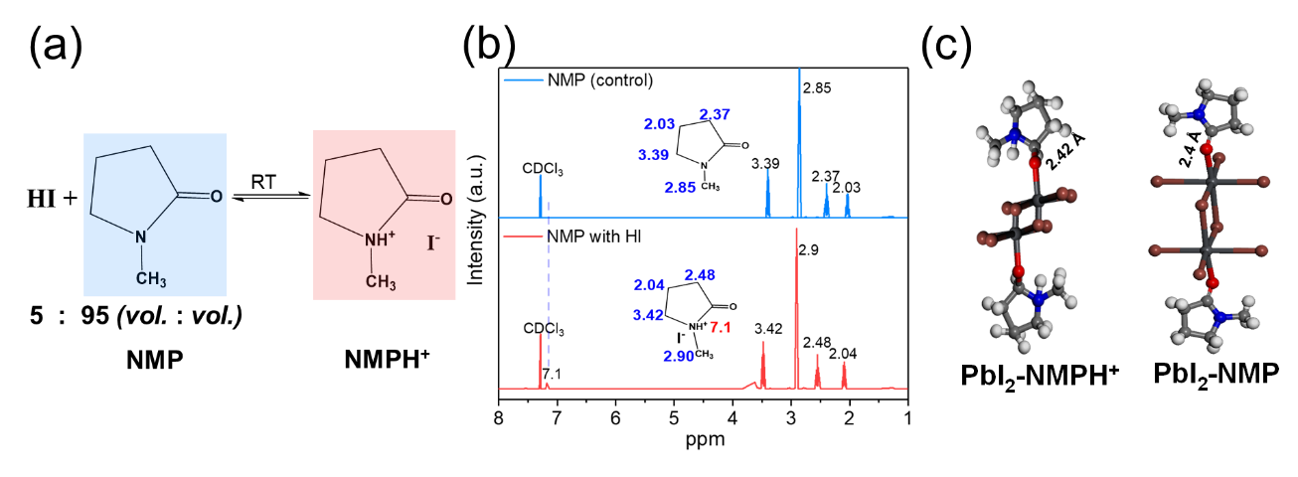

**Figure 1.** (a) NMP reacts with HI to produce NMPH+ at room temperature. (b) 1H-NMR spectra of the NMP and the NMP-NMPH+ in CDCl3. Dot-line guide for the eye. (c) Illustration of minimum clusters of PbI2-NMP and PbI2-NMPH+ in perovskite precursor. The NMP, Pb2+ and I– are shown with balls and sticks with carbon in grey, oxygen in red, nitrogen in blue, and iodide in brown color.

**Crystallization kinetics of the FAPbI3 perovskite film**

FAPbI3 perovskite films were prepared by vacuum-assisted one-step blade coating procedure18, 37, 38, as illustrated in Figure 2a. In brief, the perovskite film was coated by a blade at a constant speed. The freshly coated FAPbI3 precursor film was then subjected to a vacuum extraction to remove the excess solvent of the wet film. After the vacuum process, a homogenous intermediate film in yellow with shining appearance was obtained. The intermediate film obtained by vacuum extraction was confirmed to be δ-phase FAPbI3, independent of the solvent system. To obtain black α-phase perovskite, thermal annealing at a high temperature of 150 °C was applied to the intermediate film to complete the δ-to-α-phase transition. To reveal the crystallization mechanism of the printed FAPbI3 perovskite in detail, we monitored the real-time perovskite phase changes in blade-coating process by X-ray diffraction (XRD). As shown in Figure 2b, the fresh film (0 s) and vacuum treated film (60 s) present δ-FAPbI3 phases ­(2θ = 11.7°), as seen yellow perovskite films in optical images. Upon thermal annealing at 150 °C, the intermediary film with red color is captured as mixed δ- ­and α-phases, and subsequently transforms to a stable black α-FAPbI3 at 75 – 90 s. These three different growth stages in printed FAPbI3 films, i.e., yellow δ-phase, red intermediary phase, and black α-phase, show a unique two-step crystallization process comparing to conventional MAPbI3 and other perovskites with alloyed A cations.

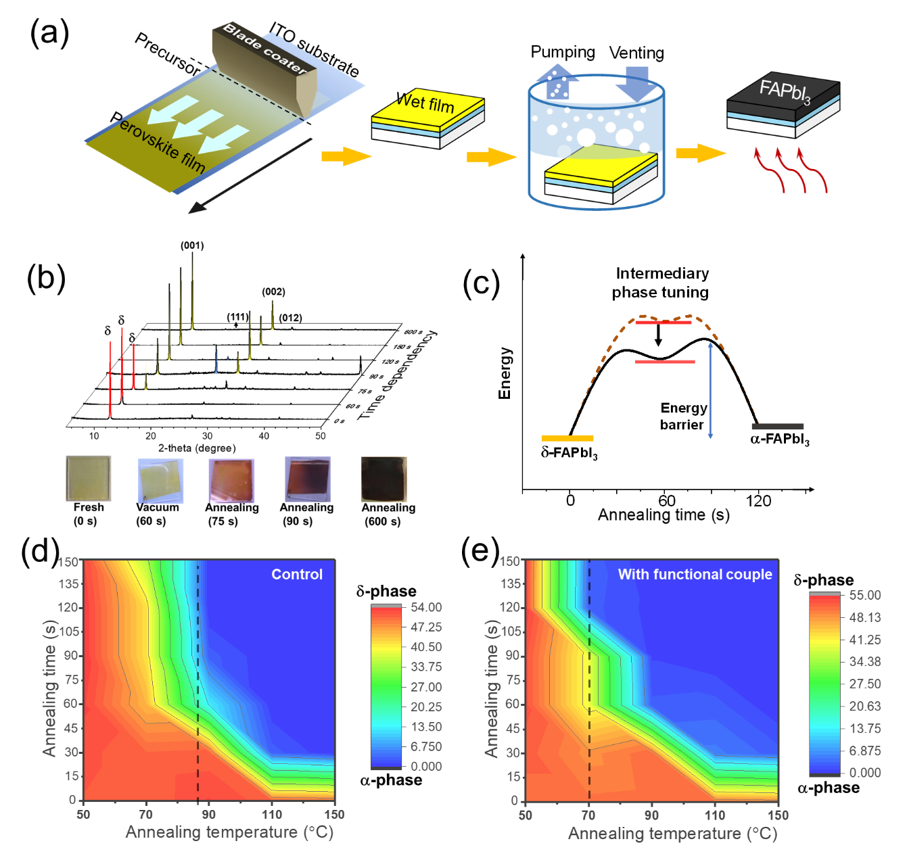

**Figure 2.** (a) The illustration of blade-coating procedure for FAPbI3 deposition. (b) XRD pattern of FAPbI3 perovskite films as a function of annealing time in blade-coating process. Bottom: the color evolution of perovskite films depends on annealing time. (c) Illustration of phase transition energy during FAPbI3 crystal growth. The time dependent XRD patterns of (d) the control film and (e) the optimized FAPbI3 thin film with the 5% NMPH+ at elevating temperature. The evolution of phase changes depends on peaks area ratio, where peaks area at 11.7° (δ-phase) versus that of 14.01° (α-phase) represent the phase transformation. The dot-line marks the phase transformation temperature in contour picture.

We further measured the thermal window of phase transitions to evaluate the required energy for α-FAPbI3. As seen in Figure 2d and 2e, the peak intensity ratios of δ-phase versus α-phase in FAPbI3 films are performed to distinguish the phase transitions, wherein the red region is indicative of δ-phase and the blue of α-phase in the contour picture. As shown in Figure 2d, it is found the phase transformation temperature for α-FAPbI3 in control film is ~ 87 °C, in agree with previous reports4, 32. By comparison, the temperature of δ-to-α phase transition shifts to a lower temperature below 70 °C in Figure 2e, which suggesting the functional couple promotes the growth of α-FAPbI3 with lower activation energy. The activation energy of phase transitions was also determined in quantitative by Arrhenius equation from Figure S2b. The energy barrier of α-FAPbI3 decreases from 59.63 kJ/mol (control) to 43.59 kJ/mol (the optimized FAPbI3 film). The NMP-NMPH+ couple is doped in FAPbI3 precursor, which is expected to regulate the intermediate phase to reduce the energy barrier of α-FAPbI3 (Figure 2c). Given this speculation, we extracted the intermediary films by controlling the NMP/NMPH+ ratio for a better understanding of perovskite growth.

As seen in Figure S3, a red-color film is observed with 20% NMPH+ additive in the FAPbI3 precursor (that is, 20 vol.% HI reaction with NMP to produce the functional couple). Interestingly, the intermediary film endures at the annealing over 200 °C without phase change and matches well with the XRD pattern of α-FAPbI3; however, the bandgap of the intermediary phase is calculated to be 2.03 eV from UV-vis absorption (Figure S3a). As aforementioned the inherent property of perovskite, the disorder of crystal lattice, such as A-site vacancies, induces the lattice shrinking and octahedral tilting, which resulting in the disruption of Pb-I orbital overlap and hence broadens the bandgap significantly19, 22, 23. We speculate that partial of FA+ and I– are expelled from FAPbI3 perovskite lattice to balance the mismatch of Goldschmidt tolerance, which producing a disrupted crystal lattice with obvious blue shift in absorption. It should be noted that both the FAPbI3 precursors experience the intermediate red-film stage with or without the NMP-NMPH+. As well, the intermediate red-films are metastable and can be only obtained with the heavy NMPH+ doping (e.g., over 20%), which suggests the functional couple assists the growth of FAPbI3 crystal, rather than completely changing the perovskite crystallization pathway (Figure 2c). Motivated by these considerations, we harvested the corresponding single crystals to verify the subtle conformation changes in FAPbI3 crystal growth.

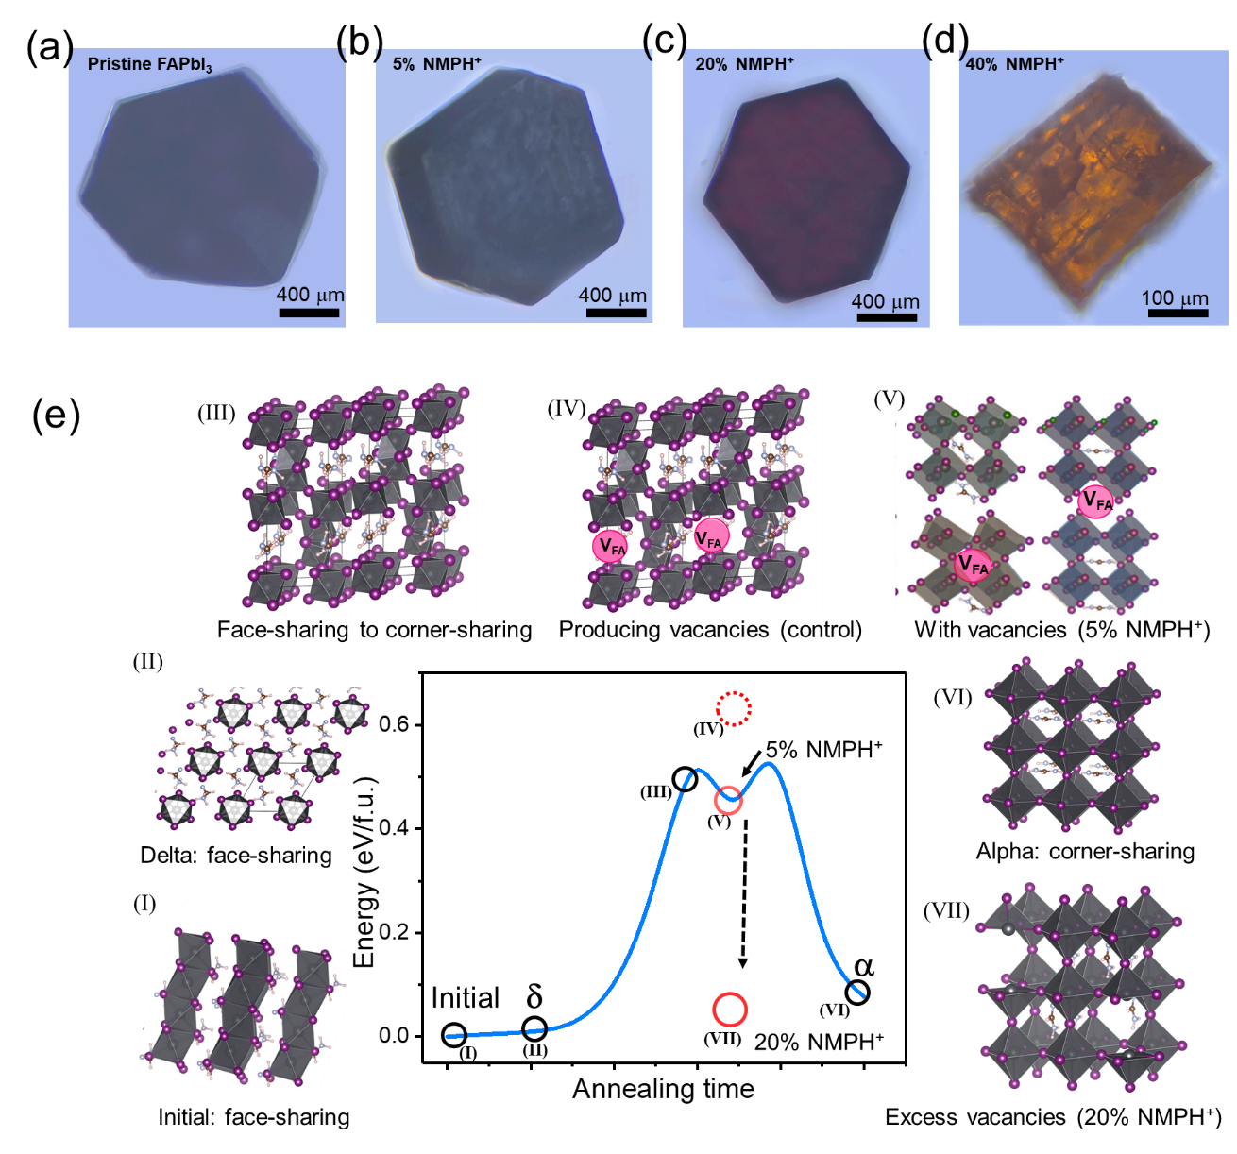

**Figure 3.** (a), (b), (c), and (d) Optical microscope images of FAPbI3 single crystals with assistance of the NMP-NMPH+ couple. (e) The FAPbI3 phase transition pathway along with activation energy from DFT and experimental data. Each circle represents the optimized perovskite structure and VFA and VI denote as FA+ and I– vacancies, respectively. A Gaussian fit of these circles outlines the energy barrier of FAPbI3 crystallization.

The families of FAPbI3 single crystals were cultured with the variant addition of NMP-NMPH+, which presented their morphology and color in optical images from Figure 3a to 3d. The pristine and 5% NMPH+ dopedsingle crystals adopt the typical α-FAPbI3 prototype with rhombic hexagonal dodecahedra geometry43, 44. However, the crystals with large amount of NMPH+ exhibit hexagonal and cubic geometry with red and orange color, respectively (Figure 3c and 3d). These morphic features in FAPbI3 single crystals deliver a direct evidence that the functional couple is incorporated into the intermediary phase to affect the FAPbI3 crystallization. As seen in Figure S4 and Table 1, the powder XRD patterns (p-XRD) of the single crystals are also calculated for comparison to the pristine powder and the ones with NMPH+ analogues, which give a gradual shrink in unit cell volume due to vacancies in perovskite lattice (Table 1). Additionally, the lattice parameters of the FAPbI3 perovskites with variant NMPH+ cations are listed in Table S3 from the single-crystal X-ray diffraction and the optimized structure, which also confirms the lattice to contract. These results are illustrated inFigure 3e to give a visualization of FAPbI3 crystallization pathway in combination with the density functional theory (DFT) calculation.

We discover a two-step crystallization process for the printed α-FAPbI3 perovskite. Step 1, the hexagonal δ-FAPbI3 is first transformed once precursor concentration reaches to the critical saturation. Upon thermal annealing, the δ-FAPbI3 subsequently rearranges into corner-sharing three dimensional [PbI6]4– octahedra with partial FA+ and I– vacancies to balance the Goldschmidt mismatch (intermediary phase). Step 2, the FA+ and I– vacancies are refilled by the growth of perovskite crystals with the arrangement of ions around the [PbI6]4– octahedra during continuously annealing, which indicates the α-FAPbI3 phase is formed. With assistance of the functional NMP-NMPH+, the lattice of intermediary phase tends to produce more FA+ and I– vacancies to compensate the geometric disorder, which significantly reducing the energy barrier. In quantitative, the total energy barrier of optimized FAPbI3 (5% NMPH+) is determined to be 50.65 kJ/mol, lower than that of 61.75 kJ/mol in the control perovskite from DFT calculation45, 46, which is in line with experimental results. When the vacancy density is too high (e.g., induced by 20% NMPH+ additive), the FAPbI3 crystal growth is caught in the trap of phase transition, which yields a more stable intermediary phase instead of α-FAPbI­3. Moreover, when we employ 5% NMPH+ in precursor for the FAPbI3 film deposition, there is no evidence that the NMPH+ cations still exist in FAPbI3 lattice after annealing, as binding energies of Pb 4f at 143.08 eV and 138.27 eV are consistent with those of the control film in Figure S7.

**Table 1.** Lattice parameters, lattice cell volumes, and bandgaps for the perovskite powder from the p-XRD refinement.

|  |  |  |  |  |
| --- | --- | --- | --- | --- |
| Material | a = b (Å) | c (Å) | Volume (Å3) | Bandgap (eV) |
| Control powder | 6.803 | 6.803 | 314.84 | 1.52 |
| 5% NMPH+ | 6.646 | 6.646 | 293.54 | 1.52 |
| 20% NMPH+ | 6.770 | 6.229 | 279.61 | 2.03 |
| 40% NMPH+ | 6.109 | 6.109 | 227.98 | 2.30 |

Bandgaps are determined by Tauc plot of the corresponding perovskite films.

**Characteristics of the FAPbI3 films and performance of working devices.**

Loading a small amount of the NMP-NMPH+ in precursor can realize the circumvention of high energy barrier and thus promotes the transformation of α-FAPbI3. As a result, the perovskite films with bandgap of 1.52 eV is obtained in Figure 4a and 4d. Steady-state PL intensity of the optimal FAPbI3 film on a quartz substrate is also higher than that of the control film, which is in line with the UV-vis absorption. On the other hand, the NMP-NMPH+ couple regulates the perovskite crystallization, which producing a uniform perovskite thin-film. The optimized perovskite film shows a fully compact surface with enlarged grain sizes around 600 nm in SEM image from Figure 4b and 4c. Besides, the additive involved film exhibits a much lower surface roughness of 8.7 nm compared to that of 25.4 nm for control film (atomic force microscopyin Figure S6). The homogeneoussurface offers a full contact between the interface layers, which mitigates the charge accumulation for efficient FAPbI3 solar device.

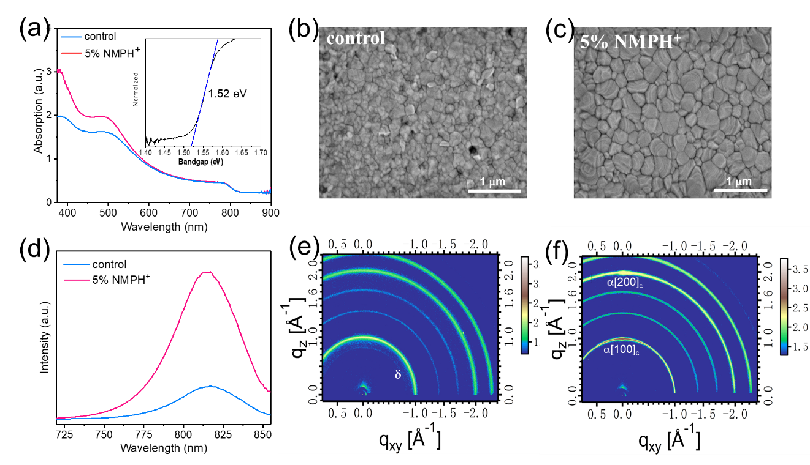

**Figure** 4. (a) UV-vis spectra of the control perovskite and the NMP-NMPH+ tailored films. Inset: the normalized Tauc plot of the FAPbI3 films. (b) and (c) Top-view SEM images of the control and the optimized FAPbI3 film, respectively. (d) Steady-state PL spectroscopy of the control and the NMP-NMPH+ mediated films. The GIWAXS characterization for two different perovskites: (e) the control and (f) the optimal perovskite film with the NMP-NMPH+ couple.

The FAPbI3 film was further characterized by grazing-incidence wide-angle X-ray scattering (GIWAXS). As seen in Figure 4e, the control FAPbI3 thin film has a slight δ-phase near q ≈ 8.5 nm−1 after annealing. By comparison, the optimized FAPbI3 thin film clearly shows a pure α-phase in Figure 4f, which is consistent with the XRD results (Figure S5f). Additionally, the scattering image recorded at the optimized perovskite film showing high intensities along the (100) ring (|q| = 0.98−1.05 Å−1) in Figure 4f, which suggests an orderly crystal lattice and better crystallinity via crystallization regulating. These results provide the impact of the tailoredcrystallization on the feature of morphology and crystallinity in the FAPbI3 perovskite—essential information to realize highly efficient photovoltaic devices.

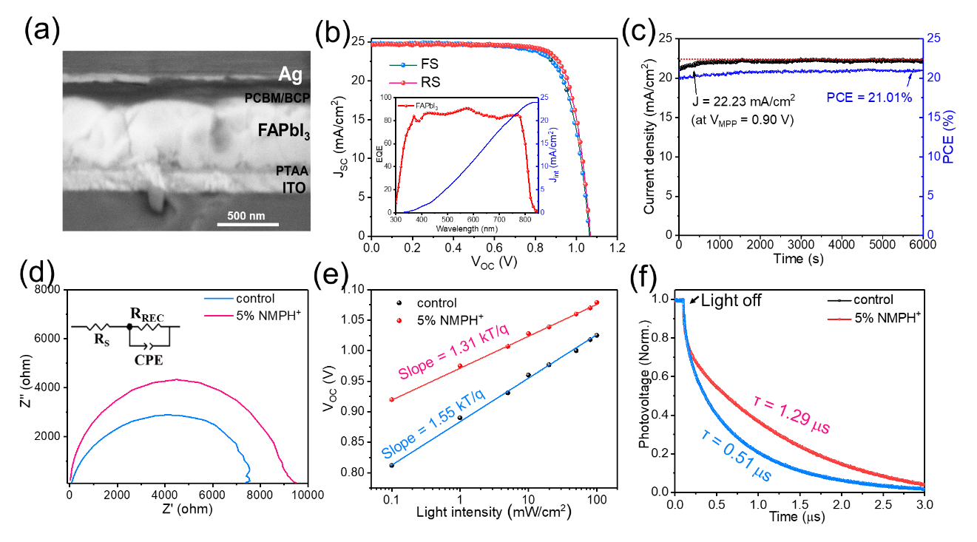

**Figure** 5. (a) Cross-section SEM image of a FAPbI3 solar cell device. (b) J-V curves of a typical blade-coated FAPbI3 solar cell under forward scan (FS, -0.1 V to 1.2 V) and reverse scan (RS, 1.2 V to -0.1 V). Inset: EQE spectra of the best-performance device with the NMP-NMPH+. (c) The maximum power output of a champion solar cell at the maximum power point under AM 1.5 G illumination with an intensity of 100 mW/cm2. (d) EIS spectra of the control and the NMP-NMPH+ regulated films, respectively. (e) Light intensity dependent *V*OC and (f) transient photovoltage decay (TPV) curves of the control and the optimized solar cells.

Consequently, the photovoltaic performance is improved in an inverted planar architecture (ITO / poly[bis(4-phenyl)(2,5,6-trimethylphenyl)amine (PTAA) / FAPbI3 / phenyl-C61-butyric acid methyl ester (PCBM) / bathocuproine (BCP) / Ag). A stack of layered perovskite device is visualized in a cross-section SEM image to guide for the eye (Figure 5a). The values extracted from J-V measurement are presented in Figure S12, wherein the control device shows a *PCE* of 15.42% with open-circuit voltage (*V*OC) of 0.97 V, short-circuit current (*J*SC) of 24.10 mA/cm2, and fill factor (FF) of 0.66. In contrast, the champion device with assistance of the NMP-NMPH+ shows an improved *V*OC of 1.08 V, *J*SC of 24.70 mA/cm2, and FF of 0.80, which contributing to a higher *PCE* of 21.35% with negligible hysteresis in Figure 5b. The average and champion photovoltaic parameters (50 cells) derived from J-V curves are listed in Table 2. The solar cells processed with NMP-NMPH+ additive exhibit noticeably higher photovoltaic performance compared to the control devices. With 5% NMP-NMPH+, the average PCE of the devices is increased compellingly from 12.21% to 19.44%. The reproducibility of the FAPbI3 solar cells is also demonstrated by the statistical distribution of photovoltaic parameters collected form 50 devices each (Figure SX). The integration of the external quantum efficiency (EQE) spectra with the AM 1.5G solar spectrum gives a *J*SC of 24.35 mA/cm2, close to the *J*SC value from *J*-*V* measurement.

**Table 2.** Photovoltaic Parameters from J-V curves of the FAPbI3 device with 50 cell under reverse scans

|  |  |  |  |  |
| --- | --- | --- | --- | --- |
| Device | JSC [mA/cm2]  (champion) | VOC [V]  (champion) | FF [%]  (champion) | PCE [%]  (champion) |
| Control | 22.51±1.46  (23.97) | 0.87±0.13 (1.01) | 0.62±0.02  (0.64) | 12.21±3.21  (15.42) |
| 5% additive | 23.83±0.87  (24.70) | 1.05±0.03  (1.08) | 0.74±0.06  (0.8) | 19.44±1.91  (21.35) |

It is acknowledged that a slight lattice disorder induced by crystal growth or additive governs the optoelectronic properties of high symmetric crystals, such as silicon and perovskite semiconductors3, 19, 36. By tuning the crystal growth, we scrutinized optoelectronic properties of the FAPbI3 perovskite film to reveal the reasons beneath performance enhancement. We first calculated the Nyquist plots from electrochemical impedance spectroscopy (EIS) in Figure 5d. The value of the series resistance (RS) decreases from 76.60 Ω to 23.02 Ω in optimized device, which is in favor of the extraction of photon-generated carriers. We also evaluated charge recombination of perovskite devices by examining the light intensity-dependent *J*–*V* and transient photovoltage (TPV). As seen in Figure 5e, the *V*OC versus the logarithm light intensity showing a slope of 1.31 kT/q, lower than the control device of 1.55 kT/q, which effectively suppressed charge recombination in optimized perovskite. Meantime, the device with the functional couple performs a longer carrier lifetime of 1.29 μs than that of 0.51 μs in control device. The longer carrier decay mitigates charge recombination, which is a main factor responsible for the enhanced *V*OC in optimal devices (detailed equations in Equation S1 and S2). Taken together, these results provide the merits of crystallization regulating toward the improvement of optoelectronic qualities and therefore can assess the efficiency and stability of the FAPbI3 solar cells.

We note that the α-FAPbI3 perovskite is kinetically stable; when the α-FAPbI3 is formed, its degradation to the δ-phase ­is suppressed by the energy barrier4, 29. As seen in Figure 5c and Figure S11, we performed long-time stability evaluation of the FAPbI3 working device. It is found that the efficiency of the optimized devices under light socking keeps constant without decrement for the entire measurement. The steady-state output of the best-performing device exhibits a stabilized current density of 22.23 mA/cm2 over 6000 s under illumination intensity of 100 mW/cm2. In addition, the performance of device can keep 91% of its initial efficiency over 600 h under ambient storage with a relative humidity of ~60% (Figure S10). We also evaluated the shelf stability of the perovskite films in ambient conditions without encapsulation. Owned to rationalization of crystal growth, the optimized FAPbI3 film ages over 4 months with negligible loss in UV-vis absorption, and the peaks in the XRD pattern do not exhibit shift from Figure S11d.

**Demonstration of FAPbI3 mini-modules**

The upscaling from lab-scale cells to large-size modules is required to develop perovskite solar cells toward future commercialization. we therefore fabricated the mini-modules with the designed pattern on 5 × 5 cm2 and 10 × 10 cm2 substrates. It is found that the FAPbI3 perovskite solar cells with the NMP-NMPH+ is smooth across the entire substrate in digital photograph (Figure 6a). The corresponding schematic mini-module pattern with etching line is depicted in Figure 6b and S14, where the series interconnecting lines of P1, P2 and P3 are etched by a fiber laser. The champion FAPbI3 solar device based on 5 × 5 cm2 module (7 sub-cells) achieves a *PCE* of 17.07% with high *FF* of 0.71. Achieving minimal interconnection resistance, i.e., high FF, is vital to fabricate high-efficiency perovskite modules considering their series-parallel connection to power grid. Combining with the regulation of perovskite crystallization and the optimized geometry design, a high FF of 0.71 is obtained in 5 × 5 cm2 mini-modules. Triple mini-modules (5 × 5 cm2) in series can easily power a mini-fan under daylight (Figure S13e). To verify the reproducibility of our method, we further prepared modules of FAPbI3 solar cell with 14 sub-cells in series on 10 × 10 cm2 substrate. The best *PCE* of 14.17%, as well as statistical *J-V* values in Table S2, indicate mini-modules are efficient and reliable, which holds promise for manufacturing production.

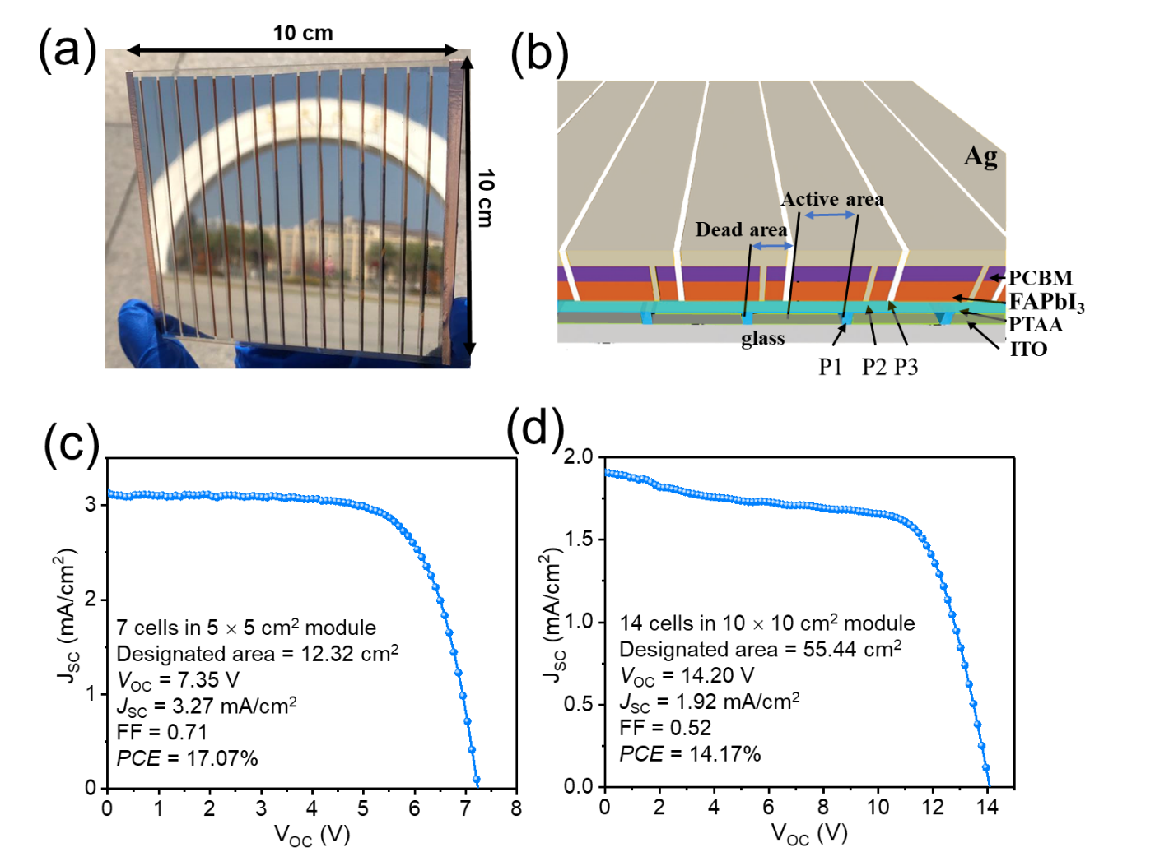

**Figure** 6. (a) Digital photograph showing mini-module with substrate area of 10 × 10 cm2. (b) Illustration of a pattern design and the structure of module perovskite device. (c) and (d) J-V curves of the best-performance mini-modules on 5 × 5 cm2 and 10 × 10 cm2 substrate, respectively.

**3. Conclusion**

In summary, we have demonstrated a facile and effective strategy to prepare α-FAPbI3 perovskite thin films by reducing the phase transition barrier, which was mediated by in-situ formation of a Lewis acid NMPH+. A comprehensive and in-depth analysis of the phase evolution during the crystallization underlines the critical role of the intermediate phase in facilitating the δ-to-α phase transition. The reduced energy barrier for FAPbI3 formation mitigates the electronic defects in perovskite bulk induced by lattice disorder, which leads to significantly enhanced morphological and optoelectronic properties of the FAPbI3 films. Accordingly, optimized FAPbI3 solar cells prepared by blade-coating exhibit improved photovoltaic performance, yielding perovskite devices with *PCE*s of 21.35%, 17.07%, and 14.17% for the active area of 0.09 cm2, 12.32 cm2, and 55.44 cm2, respectively.

**Supporting Information**

**Acknowledgements**

The work was supported by the National Natural Science Foundation of China (61705090), Natural Science Foundation of Guangdong Province (2020A1515010853), and by the Fundamental Research Funds for the Central Universities (21620441). F. G. acknowledges funding from the Opening Project of Key Laboratory of Materials Processing and Mold, Zhengzhou University. CJB and KF acknowledge funding from the Bavarian SolTech Iniative, the EET project within EnCN and the ELF project (StMWi Bavaria).

**Conflict of Interest**

The authors declare no conflict of interest.

**Keywords**

printed α-FAPbI3,two-step crystallization, energy barrier tuning, mini-modules

1. Almora, O.; Baran, D.; Bazan, G. C.; Berger, C.; Cabrera, C. I.; Catchpole, K. R.; Erten‐Ela, S.; Guo, F.; Hauch, J.; Ho‐Baillie, A. W. Y.; Jacobsson, T. J.; Janssen, R. A. J.; Kirchartz, T.; Kopidakis, N.; Li, Y.; Loi, M. A.; Lunt, R. R.; Mathew, X.; McGehee, M. D.; Min, J.; Mitzi, D. B.; Nazeeruddin, M. K.; Nelson, J.; Nogueira, A. F.; Paetzold, U. W.; Park, N. G.; Rand, B. P.; Rau, U.; Snaith, H. J.; Unger, E.; Vaillant‐Roca, L.; Yip, H. L.; Brabec, C. J., Device Performance of Emerging Photovoltaic Materials (Version 1). *Advanced Energy Materials* 2020, *11* (11), 2002774.

2. Ashworth, C., Reproducible, high-performance perovskite solar cells. *Nature Reviews Materials* 2021. 6, 239.

3. Bella, F.; Griffini, G.; Correa-Baena, J.-P.; Saracco, G.; Grätzel, M.; Hagfeldt, A.; Turri, S.; Gerbaldi, C., Improving efficiency and stability of perovskite solar cells with photocurable fluoropolymers. *Science* 2016, *354* (6309), 203-206.

4. Jeong, J.; Kim, M.; Seo, J.; Lu, H.; Ahlawat, P.; Mishra, A.; Yang, Y.; Hope, M. A.; Eickemeyer, F. T.; Kim, M.; Yoon, Y. J.; Choi, I. W.; Darwich, B. P.; Choi, S. J.; Jo, Y.; Lee, J. H.; Walker, B.; Zakeeruddin, S. M.; Emsley, L.; Rothlisberger, U.; Hagfeldt, A.; Kim, D. S.; Grätzel, M.; Kim, J. Y., Pseudo-halide anion engineering for α-FAPbI3 perovskite solar cells. *Nature* 2021. 592, 381–385.

5. Juarez-Perez, E. J.; Haro, M., Perovskite solar cells take a step forward. *Science* 2020, *368* (6497), 1309-1309.

6. Li, B.; Dai, Q.; Yun, S.; Tian, J., Insights into iodoplumbate complex evolution of precursor solutions for perovskite solar cells: from aging to degradation. *Journal of Materials Chemistry A* 2021, *9* (11), 6732-6748.

7. Liu, C.; Tu, J.; Hu, X.; Huang, Z.; Meng, X.; Yang, J.; Duan, X.; Tan, L.; Li, Z.; Chen, Y., Enhanced hole transportation for inverted tin‐based perovskite solar cells with high performance and stability. *Advanced Functional Materials* 2019, *29* (18), 1808059.

8. Tailor, N. K.; Abdi-Jalebi, M.; Gupta, V.; Hu, H.; Dar, M. I.; Li, G.; Satapathi, S., Recent progress in morphology optimization in perovskite solar cell. *Journal of Materials Chemistry A* 2020, *8* (41), 21356-21386.

9. Taylor, A. D.; Sun, Q.; Goetz, K. P.; An, Q.; Schramm, T.; Hofstetter, Y.; Litterst, M.; Paulus, F.; Vaynzof, Y., A general approach to high-efficiency perovskite solar cells by any antisolvent. *Nat Commun* 2021, *12* (1), 1878.

10. Vaynzof, Y., The Future of Perovskite Photovoltaics—Thermal Evaporation or Solution Processing? *Advanced Energy Materials* 2020, *10* (48), 2003073.

11. Wang, X.; Rakstys, K.; Jack, K.; Jin, H.; Lai, J.; Li, H.; Ranasinghe, C. S. K.; Saghaei, J.; Zhang, G.; Burn, P. L.; Gentle, I. R.; Shaw, P. E., Engineering fluorinated-cation containing inverted perovskite solar cells with an efficiency of >21% and improved stability towards humidity. *Nat Commun* 2021, *12* (1), 52.

12. Wang, Z.; Zeng, L.; Zhang, C.; Lu, Y.; Qiu, S.; Wang, C.; Liu, C.; Pan, L.; Wu, S.; Hu, J.; Liang, G.; Fan, P.; Egelhaaf, H. J.; Brabec, C. J.; Guo, F.; Mai, Y., Rational Interface Design and Morphology Control for Blade‐Coating Efficient Flexible Perovskite Solar Cells with a Record Fill Factor of 81%. *Advanced Functional Materials* 2020, *30* (32), 2001240.

13. Yang, W. S.; Noh, J. H.; Jeon, N. J.; Kim, Y. C.; Ryu, S.; Seo, J.; Seok, S. I., High-performance photovoltaic perovskite layers fabricated through intramolecular exchange. *Science* 2015, *348* (6240), 1234-1237.

14. Yang, Y.; Wu, J.; Wang, X.; Guo, Q.; Liu, X.; Sun, W.; Wei, Y.; Huang, Y.; Lan, Z.; Huang, M.; Lin, J.; Chen, H.; Wei, Z., Suppressing Vacancy Defects and Grain Boundaries via Ostwald Ripening for High-Performance and Stable Perovskite Solar Cells. *Adv Mater* 2020, *32* (7), e1904347.

15. Zhang, S.; Liu, Z.; Zhang, W.; Jiang, Z.; Chen, W.; Chen, R.; Huang, Y.; Yang, Z.; Zhang, Y.; Han, L.; Chen, W., Barrier Designs in Perovskite Solar Cells for Long‐Term Stability. *Advanced Energy Materials* 2020, *10* (35), 2001610.

16. Daboczi, M.; Kim, J.; Lee, J.; Kang, H.; Hamilton, I.; Lin, C. T.; Dimitrov, S. D.; McLachlan, M. A.; Lee, K.; Durrant, J. R.; Kim, J. S., Towards Efficient Integrated Perovskite/Organic Bulk Heterojunction Solar Cells: Interfacial Energetic Requirement to Reduce Charge Carrier Recombination Losses. *Advanced Functional Materials* 2020, *30* (25), 2001482.

17. Gutierrez-Partida, E.; Hempel, H.; Caicedo-Dávila, S.; Raoufi, M.; Peña-Camargo, F.; Grischek, M.; Gunder, R.; Diekmann, J.; Caprioglio, P.; Brinkmann, K. O.; Köbler, H.; Albrecht, S.; Riedl, T.; Abate, A.; Abou-Ras, D.; Unold, T.; Neher, D.; Stolterfoht, M., Large-Grain Double Cation Perovskites with 18 μs Lifetime and High Luminescence Yield for Efficient Inverted Perovskite Solar Cells. *ACS Energy Letters* 2021, *6* (3), 1045-1054.

18. Hu, J.; Wang, C.; Qiu, S.; Zhao, Y.; Gu, E.; Zeng, L.; Yang, Y.; Li, C.; Liu, X.; Forberich, K., Spontaneously Self‐Assembly of a 2D/3D Heterostructure Enhances the Efficiency and Stability in Printed Perovskite Solar Cells. *Advanced Energy Materials* 2020, *10* (17), 2000173.

19. Huang, J.; Yuan, Y.; Shao, Y.; Yan, Y., Understanding the physical properties of hybrid perovskites for photovoltaic applications. *Nature Reviews Materials* 2017, *2* (7), 1-19.

20. Kim, J.; Park, B. W.; Baek, J.; Yun, J. S.; Kwon, H. W.; Seidel, J.; Min, H.; Coelho, S.; Lim, S.; Huang, S.; Gaus, K.; Green, M. A.; Shin, T. J.; Ho-Baillie, A. W. Y.; Kim, M. G.; Seok, S. I., Unveiling the Relationship between the Perovskite Precursor Solution and the Resulting Device Performance. *J Am Chem Soc* 2020, *142* (13), 6251-6260.

21. Yoon, J.; Kim, U.; Yoo, Y.; Byeon, J.; Lee, S. K.; Nam, J. S.; Kim, K.; Zhang, Q.; Kauppinen, E. I.; Maruyama, S.; Lee, P.; Jeon, I., Foldable Perovskite Solar Cells Using Carbon Nanotube‐Embedded Ultrathin Polyimide Conductor. *Advanced Science* 2021, 2004092.

22. Zeng, L.; Chen, S.; Forberich, K.; Brabec, C. J.; Mai, Y.; Guo, F., Controlling the crystallization dynamics of photovoltaic perovskite layers on larger-area coatings. *Energy & Environmental Science* 2020, *13* (12), 4666-4690.

23. Chen, S.; Xiao, X.; Chen, B.; Kelly, L. L.; Zhao, J.; Lin, Y.; Toney, M. F.; Huang, J., Crystallization in one-step solution deposition of perovskite films: Upward or downward? *Science Advances* 2021, *7* (4), eabb2412.

24. Chen, S.; Xiao, X.; Gu, H.; Huang, J., Iodine reduction for reproducible and high-performance perovskite solar cells and modules. *Science Advances* 2021, *7* (10), eabe8130.

25. Chung, J.; Shin, S. S.; Hwang, K.; Kim, G.; Kim, K. W.; Lee, D. S.; Kim, W.; Ma, B. S.; Kim, Y.-K.; Kim, T.-S.; Seo, J., Record-efficiency flexible perovskite solar cell and module enabled by a porous-planar structure as an electron transport layer. *Energy & Environmental Science* 2020, *13* (12), 4854-4861.

26. Dong, Q.; Zhu, C.; Chen, M.; Jiang, C.; Guo, J.; Feng, Y.; Dai, Z.; Yadavalli, S. K.; Hu, M.; Cao, X.; Li, Y.; Huang, Y.; Liu, Z.; Shi, Y.; Wang, L.; Padture, N. P.; Zhou, Y., Interpenetrating interfaces for efficient perovskite solar cells with high operational stability and mechanical robustness. *Nat Commun* 2021, *12* (1), 973.

27. Feng, J.; Jiao, Y.; Wang, H.; Zhu, X.; Sun, Y.; Du, M.; Cao, Y.; Yang, D.; Liu, S. F., High-Throughput Large-Area Vacuum Deposition for High-Performance Formamidine-based Perovskite Solar Cells. *Energy & Environmental Science* 2021. 14, 3035-3043.

28. Fong, P. W.; Hu, H.; Ren, Z.; Liu, K.; Cui, L.; Bi, T.; Liang, Q.; Wu, Z.; Hao, J.; Li, G., Printing High-Efficiency Perovskite Solar Cells in High-Humidity Ambient Environment-An In Situ Guided Investigation. *Adv Sci (Weinh)* 2021, *8* (6), 2003359.

29. Jeong, M.; Choi, I. W.; Go, E. M.; Cho, Y.; Kim, M.; Lee, B.; Jeong, S.; Jo, Y.; Choi, H. W.; Lee, J., Stable perovskite solar cells with efficiency exceeding 24.8% and 0.3-V voltage loss. *Science* 2020, *369* (6511), 1615-1620.

30. Goodenough, J.; Raccah, P., Complex vs band formation in perovskite oxides. *Journal of Applied Physics* 1965, *36* (3), 1031-1032.

31. Min, H.; Kim, M.; Lee, S.-U.; Kim, H.; Kim, G.; Choi, K.; Lee, J. H.; Seok, S. I., Efficient, stable solar cells by using inherent bandgap of α-phase formamidinium lead iodide. *Science* 2019, *366* (6466), 749-753.

32. Hui, W.; Chao, L.; Lu, H.; Xia, F.; Wei, Q.; Su, Z.; Niu, T.; Tao, L.; Du, B.; Li, D., Stabilizing black-phase formamidinium perovskite formation at room temperature and high humidity. *Science* 2021, *371* (6536), 1359-1364.

33. Wu, S.; Chen, R.; Zhang, S.; Babu, B. H.; Yue, Y.; Zhu, H.; Yang, Z.; Chen, C.; Chen, W.; Huang, Y.; Fang, S.; Liu, T.; Han, L.; Chen, W., A chemically inert bismuth interlayer enhances long-term stability of inverted perovskite solar cells. *Nat Commun* 2019, *10* (1), 1161.

34. Li, F.; Deng, X.; Qi, F.; Li, Z.; Liu, D.; Shen, D.; Qin, M.; Wu, S.; Lin, F.; Jang, S.-H., Regulating surface termination for efficient inverted perovskite solar cells with greater than 23% efficiency. *Journal of the American Chemical Society* 2020, *142* (47), 20134-20142.

35. Wang, H.; Huang, Z.; Xiao, S.; Meng, X.; Xing, Z.; Rao, L.; Gong, C.; Wu, R.; Hu, T.; Tan, L.; Hu, X.; Zhang, S.; Chen, Y., An in situ bifacial passivation strategy for flexible perovskite solar module with mechanical robustness by roll-to-roll fabrication. *Journal of Materials Chemistry A* 2021, *9* (9), 5759-5768.

36. Noel, N. K.; Congiu, M.; Ramadan, A. J.; Fearn, S.; McMeekin, D. P.; Patel, J. B.; Johnston, M. B.; Wenger, B.; Snaith, H. J., Unveiling the Influence of pH on the Crystallization of Hybrid Perovskites, Delivering Low Voltage Loss Photovoltaics. *Joule* 2017, *1* (2), 328-343.

37. Guo, F.; Qiu, S.; Hu, J.; Wang, H.; Cai, B.; Li, J.; Yuan, X.; Liu, X.; Forberich, K.; Brabec, C. J., A Generalized Crystallization Protocol for Scalable Deposition of High‐Quality Perovskite Thin Films for Photovoltaic Applications. *Advanced Science* 2019, *6* (17), 1901067.

38. Guo, F.; He, W.; Qiu, S.; Wang, C.; Liu, X.; Forberich, K.; Brabec, C. J.; Mai, Y., Sequential Deposition of High‐Quality Photovoltaic Perovskite Layers via Scalable Printing Methods. *Advanced Functional Materials* 2019, *29* (24), 1900964.

39. Li, J.; Dagar, J.; Shargaieva, O.; Flatken, M. A.; Köbler, H.; Fenske, M.; Schultz, C.; Stegemann, B.; Just, J.; Többens, D. M.; Abate, A.; Munir, R.; Unger, E., 20.8% Slot‐Die Coated MAPbI3 Perovskite Solar Cells by Optimal DMSO‐Content and Age of 2‐ME Based Precursor Inks. *Advanced Energy Materials* 2021, *11* (10), 2003460.

40. Tong, G.; Son, D. Y.; Ono, L. K.; Liu, Y.; Hu, Y.; Zhang, H.; Jamshaid, A.; Qiu, L.; Liu, Z.; Qi, Y., Scalable Fabrication of >90 cm2 Perovskite Solar Modules with >1000 h Operational Stability Based on the Intermediate Phase Strategy. *Advanced Energy Materials* 2021, *11* (10), 2003712.

41. Zhang, W.; Zhong, J.; Shi, Q.; Gao, L.; Ji, Y.; Li, G.; An, T.; Francisco, J. S., Mechanism for Rapid Conversion of Amines to Ammonium Salts at the Air-Particle Interface. *J Am Chem Soc* 2021, *143* (2), 1171-1178.

42. Chao, L.; Niu, T.; Gao, W.; Ran, C.; Song, L.; Chen, Y.; Huang, W., Solvent Engineering of the Precursor Solution toward Large-Area Production of Perovskite Solar Cells. *Adv Mater* 2021, e2005410.

43. Liu, Y.; Sun, J.; Yang, Z.; Yang, D.; Ren, X.; Xu, H.; Yang, Z.; Liu, S. F., 20-mm-Large Single-Crystalline Formamidinium-Perovskite Wafer for Mass Production of Integrated Photodetectors. *Advanced Optical Materials* 2016, *4* (11), 1829-1837.

44. Chaminade, J.; Garcia, A.; Pouchard, M.; Fouassier, C.; Jacquier, B.; Perret-Gallix, D.; Gonzalez-Mestres, L., Crystal growth and characterization of InBO3: Tb3+. *Journal of crystal growth* 1990, *99* (1-4), 799-804.

45. Lu, H.; Liu, Y.; Ahlawat, P.; Mishra, A.; Tress, W.; Eickemeyer, F.; Yang, Y., Fu, F.; Wang, Z.; Evalos, C.; Carlsen, B.; Eickemeyer, F.; Agarwalla, A.; Zhang, X.; Li, X.; Zhan, Y.; Zakeeruddin, S.; Emsley, L.; Rothlisberger, U.; Zheng, Li.; Hagfeldt, A.; Gratzel, M., Vapor-assisted deposition of highly efficient, stable black-phase FAPbI3 perovskite solar cells *Science* 2020, *370* (6512), eabb8985.

46. Ahlawat, P.; Hinderhofer, A.; Alharbi, E. A.; Lu, H.; Ummadisingu, A.; Niu, H.; Invernizzi, M.; Zakeeruddin, S. M.; Dar, M. I.; Schreiber, F., A combined molecular dynamics and experimental study of two-step process enabling low-temperature formation of phase-pure α-FAPbI3. Science Advances 2021, 7 (17), eabe3326.