Supporting Information

Table of contents:

*Supplementary References.* Published articles included in the systematic review **2**

*Wei et al., 2014:* Decision process for inclusion **4**

*Table S1.* Raw count of foci falling in each brain region for each subgroup **5**

*Table S2.* Details about the tasks of the original studies in each subgroup **8**

***Search queries* 10**

*Figure S1.* Barplot with the results of the label-based review (percentages of studies out of total studies) **11**

*Figure S2.* Foci from the original studies projected on a 3D brain template (node size proportional to the percentage of studies) **12**

*Table S3.* Results of the Activation Likelihood Estimation meta-analysis13

***Figure S3.*** Foci from the original studies projected on a 3D brain template (node size is fixed, colour-blind friendly colour scale)**14**

*Table S4.* Results of the outlier detection analysis in the African and Caucasian subgroups **15**

***Figure S3*:** Barplot including studies reporting non-significant findings 16

***Differences between label-based and coordinate-based approaches in our work*** 18

Supplementary References

1. Brown, T. I., Uncapher, M. R., Chow, T. E., Eberhardt, J. L., & Wagner, A. D. (2017). Cognitive control, attention, and the other race effect in memory. PloS one,12(3), e0173579.***

2. Cassidy, B. S., Hughes, C., & Krendl, A. C. (2021). Age differences in neural activity related to mentalizing during person perception. Aging, Neuropsychology, and Cognition, 1-18.***

3. Cloutier, J., Li, T., & Correll, J. (2014). The impact of childhood experience on amygdala response to perceptually familiar black and white faces. Journal of Cognitive Neuroscience,26(9), 1992-2004.

4. Contreras, J. M., Banaji, M. R., & Mitchell, J. P. (2013). Multivoxel patterns in fusiform face area differentiate faces by sex and race. PloS one,8(7), e69684.

5. Cunningham, W. A., Johnson, M. K., Raye, C. L., Gatenby, J. C., Gore, J. C., & Banaji, M. R. (2004). Separable neural components in the processing of black and white faces. Psychological science,15(12), 806-813.

6. Engell, A. D., Kim, N. Y., & McCarthy, G. (2018). Sensitivity to faces with typical and atypical part configurations within regions of the face-processing network: An fMRI study. Journal of cognitive neuroscience,30(7), 963-972.***

7. Gilbert, S. J., Swencionis, J. K., & Amodio, D. M. (2012). Evaluative vs. trait representation in intergroup social judgments: Distinct roles of anterior temporal lobe and prefrontal cortex.Neuropsychologia,50(14), 3600-3611. ***

8. Hughes, C., Babbitt, L. G.,& Krendl, A. C. (2019). Culture impacts the neural response to perceiving outgroups among black and white faces. Frontiers in human neuroscience,13, 143.

9. Kim, J. S., Yoon, H. W., Kim, B. S., Jeun, S. S., Jung, S. L., & Choe, B. Y. (2006). Racial distinction of the unknown facial identity recognition mechanism by event-related fMRI. Neuroscience Letters,397(3), 279-284.

10. Krosch, A. R., & Amodio, D. M. (2019). Scarcity disrupts the neural encoding of Black faces: A socioperceptual pathway to discrimination. Journal of personality and social psychology,117(5), 859.

11. Lee, K. U., Khang, H. S., Kim, K. T., Kim, Y. J., Kweon, Y. S., Shin, Y. W., ... & Liberzon, I. (2008). Distinct processing of facial emotion of own-race versus other-race.Neuroreport,19(10), 1021-1025.

12. Lieberman, M. D., Hariri, A., Jarcho, J. M., Eisenberger, N. I., & Bookheimer, S. Y. (2005). An fMRI investigation of race-related amygdala activity in African-American and Caucasian-American individuals. Nature neuroscience,8(6), 720-722.

13. Liu, Y., Lin, W., Xu, P., Zhang, D., & Luo, Y. (2015). Neural basis of disgust perception in racial prejudice. Human brain mapping,36(12), 5275-5286.

14. Mattan, B. D., Kubota, J. T., Dang, T. P., & Cloutier, J. (2018). External motivation to avoid prejudice alters neural responses to targets varying in race and status.Social cognitive and affective neuroscience,13(1), 22-31.

15. McCutcheon, R., Bloomfield, M. A., Dahoun, T., Quinlan, M., Terbeck, S., Mehta, M., & Howes, O. (2018). Amygdala reactivity in ethnic minorities and its relationship to the social environment: an fMRI study. Psychological medicine,48(12), 1985-1992.

16. Molapour, T., Golkar, A., Navarrete, C. D., Haaker, J., & Olsson, A. (2015). Neural correlates of biased social fear learning and interaction in an intergroup context.NeuroImage,121, 171-183.

17. Muscatell, K. A., McCormick, E., & Telzer, E. H. (2018). Subjective social status and neural processing of race in Mexican American adolescents. Development and psychopathology,30(5), 1837.***

18. Park, B., Tsai, J. L., Chim, L., Blevins, E., & Knutson, B. (2016). Neural evidence for cultural differences in the valuation of positive facial expressions. Social Cognitive and Affective Neuroscience,11(2), 243-252.***

19. Park, B., Blevins, E., Knutson, B., & Tsai, J. L. (2017). Neurocultural evidence that ideal affect match promotes giving.Social Cognitive and Affective Neuroscience,12(7), 1083-1096.***

20. Reggev, N., Brodie, K., Cikara, M., & Mitchell, J. P. (2020). Human face-selective cortex does not distinguish between members of a racial outgroup.Eneuro,7(3).***

21. Richeson, J. A., Baird, A. A., Gordon, H. L., Heatherton, T. F., Wyland, C. L., Trawalter, S., & Shelton, J. N. (2003). An fMRI investigation of the impact of interracial contact on executive function. Nature neuroscience,6(12), 1323-1328.

22. Rigo, P., Ragunath, B. L., Bornstein, M. H., & Esposito, G. (2020). Enlarged Ingroup Effect: How a Shared Culture Shapes In-Group Perception. bioRxiv. ***

23. Ronquillo, J., Denson, T. F., Lickel, B., Lu, Z. L., Nandy, A., & Maddox, K. B. (2007). The effects of skin tone on race-related amygdala activity: An fMRI investigation. Social cognitive and affective neuroscience,2(1), 39-44.

24. Van Bavel, J. J., Packer, D. J., & Cunningham, W. A. (2008). The neural substrates of in-group bias: a functional magnetic resonance imaging investigation. Psychological science,19(11), 1131-1139.

25. Wang, C., Wu, B., Liu, Y., Wu, X., & Han, S. (2015). Challenging emotional prejudice by changing self-concept: priming independent self-construal reduces racial in-group bias in neural responses to other’s pain. Social cognitive and affective neuroscience,10(9), 1195-1201.***

26. Wei, W., Liu, J., Dai, R., Feng, L., Li, L., & Tian, J. (2014, March). Different brain activations between own-and other-race face categorization: an fMRI study using group independent component analysis. In Medical Imaging 2014: Biomedical Applications in Molecular, Structural, and Functional Imaging(Vol. 9038, p. 903807). International Society for Optics and Photonics.

27. Wheeler, M. E., & Fiske, S. T. (2005). Controlling racial prejudice: Social-cognitive goals affect amygdala and stereotype activation. Psychological Science,16(1), 56-63.

28. Yan, Z., Schmidt, S. N., Saur, S., Kirsch, P., & Mier, D. (2019). The effect of ethnicity and team membership on face processing: a cultural neuroscience perspective. Social cognitive and affective neuroscience,14(9), 1017-1025.***

29. Zhou, Y., Gao, T., Zhang, T., Li, W., Wu, T., Han, X., & Han, S. (2020). Neural dynamics of racial categorization predicts racial bias in face recognition and altruism. Nature human behaviour,4(1), 69-87.

**\*\*\*: Articles for which additional data was requested and obtained from the authors.**

Wei et al., 2014: decision process for inclusion

In all the other studies we include, the effect of the other-"race" face is achieved via the subtractive logic of the contrasts. We decided to include the work by Wei at al. even though they use an independent component analysis (ICA) approach because they investigate a comparable effect. In short, they reduce the signal with ICA, so as to obtain which regions show the higher signal correlation, regardless of the task. This is first done at the subject level and then at the group level. Then, the authors use the SPM paradigm matrix to see which components are related to task conditions. Both steps are performed considering the whole-brain. Therefore, first they obtained which regions are more synchronized, and then they tested where this synchronization is explained (regression) by perceiving Asian > white faces, and vice-versa.

Considering that i) we target those regions showing an effect related to the perception of OR faces, and that ii) it is expected that regions involved in a condition to somewhat work in coordination and that iii) other label-based reviews similarly include a variety of imaging methods [1], we decided to include the coordinates reported in this work.

[1] Lamsma, J., Mackay, C., & Fazel, S. (2017). Structural brain correlates of interpersonal violence: systematic review and voxel-based meta-analysis of neuroimaging studies. *Psychiatry Research: Neuroimaging*, *267*, 69-73.

Table S1. **Raw count of foci falling in each brain region for each subgroup**

|  |  |  |  |  |  |  |  |  |
| --- | --- | --- | --- | --- | --- | --- | --- | --- |
| **Left** | **Right** | **Brain region** | **Brain structure** | **Subgroup** | **N of foci** | **N of studies** | **Participants studies** | **Total N participants** |
| 1 | 0 | Claustrum | Sublobar structures | African | 1 | 1 | 11 | 11 |
| 1 | 2 | Inferior Parietal Lobule | Parietal lobe | African | 3 | 1 | 16 | 16 |
| 0 | 1 | Postcentral Gyrus | Parietal lobe | African | 1 | 1 | 16 | 16 |
| 0 | 1 | Declive | Cerebellum | African | 1 | 1 | 32 | 32 |
| 1 | 1 | Parahippocampal Gyrus | Limbic system | African | 2 | 2 | 11 | 11 |
| 3 | 2 | Culmen | Cerebellum | African | 5 | 2 | 16 + 11 | 27 |
| 6 | 0 | Posterior Cingulate | Limbic system | African | 6 | 3 | 30 + 20 + 26 | 76 |
| 0 | 1 | Subcallosal Gyrus | Sublobar structures | African | 1 | 1 | 75 | 75 |
| 1 | 1 | Thalamus | Limbic system | African | 2 | 2 | 16 + 8 | 24 |
| 6 | 1 | Caudate Nucleus | Basal ganglia | African | 7 | 2 | 20 + 8 | 28 |
| 3 | 2 | Lingual gyrus | Occipital lobe | African | 5 | 3 | 17 + 16 + 8 | 41 |
| 0 | 5 | Superior Frontal Gyrus | Frontal lobe | African | 5 | 3 | 13 + 15 + 16 | 44 |
| 1 | 1 | Middle Temporal Gyrus | Temporal lobe | African | 2 | 2 | 11 + 17 | 28 |
| 1 | 2 | Anterior Cingulate | Limbic system | African | 3 | 3 | 15 + 16 + 26 | 57 |
| 0 | 2 | Cuneus | Occipital lobe | African | 2 | 2 | 75 + 23 | 98 |
| 0 | 5 | Superior Temporal Gyrus | Temporal lobe | African | 5 | 3 | 16 + 17 + 32 | 65 |
| 4 | 3 | Middle Occipital Gyrus | Occipital lobe | African | 7 | 3 | 17 + 23 + 20 | 60 |
| 8 | 4 | Cingulate Gyrus | Limbic system | African | 12 | 4 | 15 + 16 + 13 + 20 | 64 |
| 4 | 0 | Fusiform Gyrus | Temporal lobe | African | 4 | 3 | 32 + 45 + 11 | 88 |
| 2 | 2 | Lentiform Nucleus | Basal ganglia | African | 4 | 4 | 11 +11 + 26 + 20 | 68 |
| 2 | 3 | Inferior Occipital Gyrus | Occipital lobe | African | 5 | 3 | 60 + 17 + 20 | 97 |
| 2 | 3 | Inferior Frontal Gyrus | Frontal lobe | African | 5 | 4 | 11 +13 + 16 + 26 | 66 |
| 2 | 5 | Insula | Insular cortex | African | 7 | 6 | 11 + 15 + 11 + 32 + 26 + 20 | 115 |
| 4 | 6 | Middle Frontal Gyrus | Frontal lobe | African | 10 | 6 | 15 + 13 +32 + 16 + 23 + 30 | 129 |
| 3 | 5 | Medial Frontal Gyrus | Frontal lobe | African | 8 | 6 | 60 + 15 + 13 + 75 + 16 | 179 |
| 1 | 0 | Lentiform Nucleus | Basal ganglia | Caucasian | 1 | 1 | 9 | 9 |
| 0 | 1 | Fusiform Gyrus | Temporal lobe | Caucasian | 1 | 1 | 12 | 12 |
| 0 | 1 | Cingulate Gyrus | Limbic system | Caucasian | 1 | 1 | 12 | 12 |
| 0 | 4 | Inferior Frontal Gyrus | Frontal lobe | Caucasian | 4 | 1 | 17 | 17 |
| 1 | 4 | Inferior Parietal Lobule | Parietal lobe | Caucasian | 5 | 3 | 17 + 12 + 13 | 32 |
| 0 | 1 | Caudate Nucleus | Basal ganglia | Caucasian | 1 | 1 | 17 | 17 |
| 0 | 1 | Middle Temporal Gyrus | Temporal lobe | Caucasian | 1 | 1 | 20 | 20 |
| 0 | 2 | Insula | Insular cortex | Caucasian | 2 | 2 | 17 + 9 | 26 |
| 0 | 2 | Paracentral Lobule | Frontal lobe | Caucasian | 2 | 1 | 20 | 20 |
| 2 | 0 | Postcentral Gyrus | Parietal lobe | Caucasian | 2 | 2 | 20 + 4 | 24 |
| 1 | 1 | Parahippocampal Gyrus | Basal ganglia | Caucasian | 2 | 1 | 20 | 20 |
| 1 | 0 | Superior Parietal Lobule | Parietal lobe | Caucasian | 1 | 1 | 20 | 20 |
| 1 | 0 | Middle Occipital Gyrus | Occipital lobe | Caucasian | 1 | 1 | 20 | 20 |
| 1 | 1 | Lingual Gyrus | Occipital lobe | Caucasian | 2 | 1 | 30 | 30 |
| 1 | 0 | Anterior Cingulate | Limbic system | Caucasian | 1 | 1 | 48 | 48 |
| 1 | 1 | Claustrum | Sublobar structures | Caucasian | 2 | 2 | 17 + 13 | 30 |
| 4 | 2 | Precentral Gyrus | Parietal lobe | Caucasian | 6 | 2 | 20 + 13 | 33 |
| 2 | 3 | Culmen | Cerebellum | Caucasian | 5 | 3 | 12 + 20 + 20 | 52 |
| 0 | 3 | Cuneus | Occipital lobe | Caucasian | 3 | 2 | 20 + 30 | 50 |
| 1 | 2 | Superior Frontal Gyrus | Frontal lobe | Caucasian | 3 | 2 | 17 | 17 |
| 2 | 1 | Declive | Cerebellum | Caucasian | 3 | 3 | 12 + 13 + 30 | 55 |
| 1 | 4 | Middle Frontal Gyrus | Frontal lobe | Caucasian | 5 | 4 | 17 + 13 + 48 + 30 | 108 |
| 2 | 1 | Medial Frontal Gyrus | Frontal lobe | Caucasian | 3 | 3 | 12 + 20 + 30 | 52 |
| 5 | 2 | Precuneus | Parietal lobe | Caucasian | 7 | 5 | 20 + 31 + 48 + 30 | 129 |
| 0 | 1 | Precuneus | Parietal lobe | Asian | 1 | 1 | 18 | 18 |
| 1 | 0 | Paracentral Lobule | Frontal lobe | Asian | 1 | 1 | 18 | 18 |
| 0 | 1 | Superior Temporal Gyrus | Temporal lobe | Asian | 1 | 1 | 18 | 18 |
| 0 | 1 | Fusiform Gyrus | Temporal lobe | Asian | 1 | 1 | 24 | 24 |
| 1 | 1 | Middle Occipital Gyrus | Occipital lobe | Asian | 2 | 1 | 24 | 24 |
| 0 | 1 | Thalamus | Limbic system | Asian | 1 | 1 | 75 | 75 |
| 1 | 2 | Declive | Cerebellum | Asian | 3 | 2 | 24 + 19 | 43 |
| 0 | 2 | Cingulate Gyrus | Limbic system | Asian | 2 | 2 | 75 + 18 | 93 |
| 5 | 1 | Caudate Nucleus | Basal ganglia | Asian | 6 | 2 | 75 + 24 | 99 |

Table S2. **Details about the tasks of the original studies in each subgroup**

Task characteristics for each neuroimaging contrast evaluated in the review. For each contrast, we report the following information, from left to right: i) the original publication, ii) the other-“race” that participants perceived, iii) the number of participants included in the analysis, iv) the task type, v) the type of cognitive process the tasks were tapping into, vi) the explicit relevance of the concept of “race” during the task and vii) some additional information about the task instructions. Note that, although some studies are reported twice because the authors reported activation for two other-“races”, these were derived from different participants (except that in Zhou et al., 2019, where the same Asian participants perceived both African and Caucasian faces, and Cassidy, Hughes and Krendl (2020), where Caucasian participants observed African and Asian faces). N.A. = not assessed;

|  |  |  |  |  |  |  |  |
| --- | --- | --- | --- | --- | --- | --- | --- |
| **Study** | **Subgroup** | **Sample size** | **Task Type** | **Process Type** | **Task relevance of „race“** | **Observers self-reported “race”, provenance /**  **Socio-economic status (related proxies)** | **Notes** |
| Liebermann et al., 2005 | African > own | 11 | Categorization | Matching | No | Caucasian, American / N.A. | Matching faces based on similarity/relevance to racial categories |
| Mattan et al., 2018 | African > own | 60 | Categorization | Judgement | No | White, Chicago / mixed socioeconomic status | Pressing when forming an impression, based on prior status-colour associations |
| Richeson et al., 2003 | African > own | 15 | Observation | Perception | No | White, American / N.A. (college students) | Spatial location task |
| Ronquillo et al., 2007 | African > own | 11 | Categorization | Judgement | No | Caucasian, American / N.A. | Age discrimination (more or less than 24 years old) |
| VanBavel, Partker, & Cunningham, 2008 | African > own | 17 | Categorization | Judgement | No | White, N.R. / N.A. | Merged task 1 and 2 (1 = team membership, 2 = skin colour) |
| Contreras, Banaji, & Mitchell, 2013 | African > own | 17 | Categorization | Judgement | Yes | White UK / N.A. (college students) | Categorization of sex and race |
| Cunningham et al., 2004 | African > own | 13 | Observation | Perception | No | White / N.A. | Passive viewing, indicate side (only long duration included) |
| Cloutier, Li, & Correll, 2014 | African > own | 45 | Memory | Judgement | No | White, Chicago / N.A. | Familiarity rating (unfamiliar or not?), classified as memory |
| Molapour et al., 2015 | African > own | 20 | Observation | Perception | No | European descent / N.A. | Acquisition (fear conditioning) |
| Cassidy, Hughes, & Krendl, 2020 | African > own | 75 | Mentalizing | Inference | No | White, Indiana / N.A. (> 15 years of education) | Reading Mind in the Eyes, emotion categorization |
| Reggev et al., 2020 | African > own | 32 | Categorization | Matching | No | White, American / N.A. (college students) | Same-different task |
| Gilbert, Swencionis, & Amodio, 2012 | African > own | 16 | Categorization | Judgement | Yes | White, American / N.A. | Categorization of social features or stereotypical features |
| Liu et al., 2015 | African > own | 26 | Observation | Perception | No | Chinese, China / N.A. (college students, no severe emotional or physical trauma) | Passive viewing |
| Brown et al., 2017 | African > own | 8 | Memory | Judgement | No | White, European American / N.A. (college students) | Collapsed across remembered/forgotten faces |
| Muscatell, McCormick, & Telzer, 2018 | African > own | 23 | Categorization | Judgement | No | Mexican, Los Angeles / low- to middle-income | Categorization of gender or name assignment |
| Engell, Kim, McCarthy, 2018 | African > own | 20 | Observation | Perception | No | White and Asian / N.A. | Passive viewing |
| Krosch & Amodio, 2019 | African > own | 30 | Categorization | Judgement | No | White, Asian and Latino, New York / N.A. (college students) | Asked to donate money based on deservedness |
| Cassidy, Hughes, & Krendl, 2020 | Asian > own | 75 | Mentalizing | Inference | No | White, Indiana / N.A. (> 15 years of education) | Reading Mind in the Eyes, emotion categorization |
| Park et al., 2016 | Asian > own | 19 | Rating | Judgement | No | European-American / N.A. (college students) | Rating of social features |
| Park, Belvis, Knuston, & Tsai, 2017 | Asian > own | 18 | Mentalizing | Inference | No | European-American / mostly middle- to high-income | Dictator game (decide how much money to give to avatars) |
| Yan et al., 2019 | Asian > own | 24 | Categorization | Judgement | Yes | Germans / N.A. (at least a secondary school certificate) | Categorizing according to race and team membership |
| Hughes, Babbitt, & Krendl, 2019 | Caucasian > own | 17 | Observation | Perception | No | Chinese, China and America / N.A. (Chinese American participants were college students) | Passive viewing |
| Kim et al., 2006 | Caucasian > own | 12 | Memory | Judgement | No | Korean / N.A. | Familiarity rating (unfamiliar or not?), classified as memory |
| Lee et al., 2008 | Caucasian > own | 13 | Categorization | Judgement | No | Korean / N.A. | Sex discrimination |
| Liebermann et al., 2005 | Caucasian > own | 9 | Categorization | Matching | No | African American / N.A. | Matching faces based on similarity/relevance to racial categories |
| McCutcheon et al., 2018 | Caucasian > own | 20 | Observation | Perception | No | Black, Caribbean or African / minority (migrants) | Pressing when a face is presented in different parts of the screen |
| Yan et al., 2019 | Caucasian > own | 20 | Categorization | Judgement | Yes | Chinese / N.A. (at least a secondary school certificate) | Categorizing according to race and team membership |
| Wei et al., 2014 | Caucasian > own | 31 | Categorization | Judgement | Yes | Chinese / N.A. | Categorizing based on race |
| Rigo et al., 2020 | Caucasian > own | 48 | Observation | Perception | No | Chinese, Singapore / N.A. | Observation of faces and contextual cues |
| Brown et al., 2017 | Caucasian > own | 4 | Memory | Judgement | No | Black, African American / N.A. (mostly college students) | Collapsed across remembered/forgotten faces |
| Wang et al., 2015 | Caucasian > own | 30 | Rating | Inference | No | Chinese / N.A. (college students) | Rating how much a person is suffering |

Search queries

i) on Pubmed: *("race"[Title/Abstract] OR "racial bias" [Title/Abstract] OR "racial categorization" [Title/Abstract] OR "other-race effect" [Title/Abstract] OR "own-race bias" [Title/Abstract] OR "ethnicity" [Title/Abstract]) AND ("functional MRI" [Title/Abstract] OR "fMRI" [Title/Abstract] OR "positron emission tomography" [Title/Abstract] OR "PET" [Title/Abstract])*;

ii) on Web of Science: *(race OR racial bias OR own-race bias OR ethnicity OR other-race effect OR racial categorization) AND (fMRI OR functional MRI OR PET OR positron emission tomography imaging)[TOPIC]*;

iii) on Google Scholar: *race, fMRI racial bias, OR other-race effect, OR own-race bias, OR ethnicity, AND functional MRI, OR PET, OR positron emission tomography*.

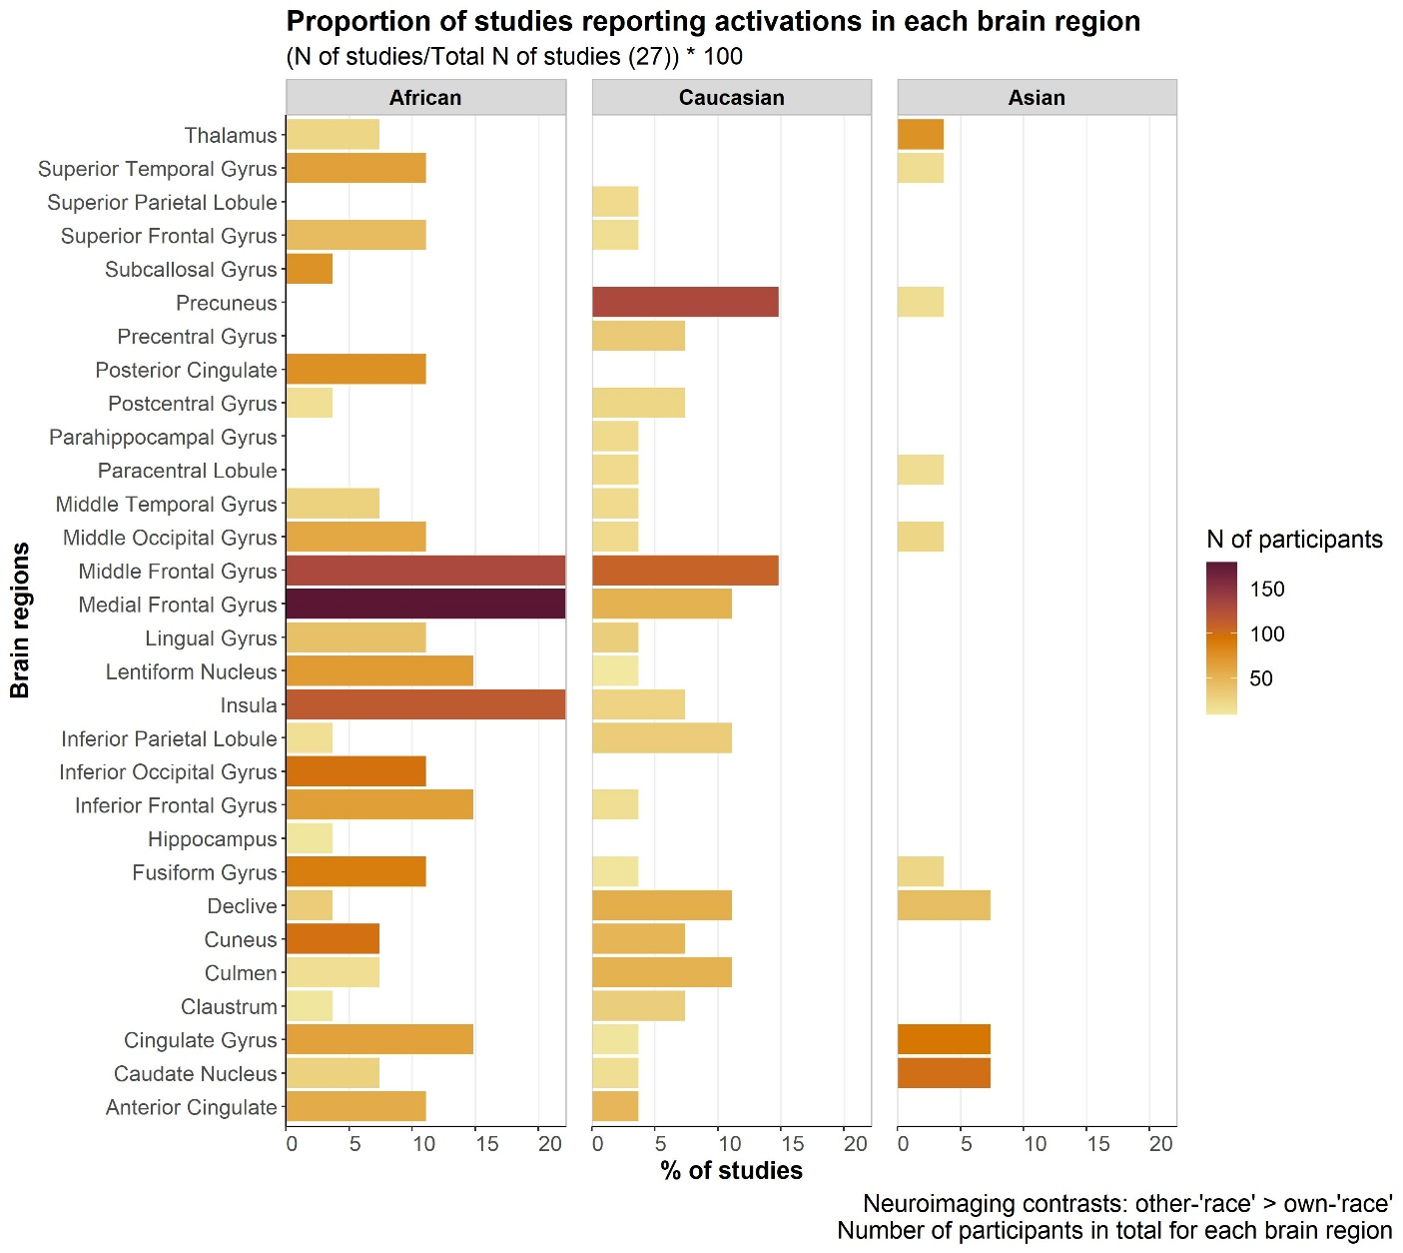Figure S1. **Barplot with the results of the label-based review (percentages of studies out of total studies)**

Figure S1. Overview of the percentages of studies reporting activation foci for each brain region, in the three subgroups separately. Y axis: brain region labels; X axis: percentage of studies out of 27. See Figures 3 to for percentages scaled within each subgroup. Colour intensity visually conveys the number of participants representing each brain region.

Figure S2. **Foci from the original studies projected on a 3D brain template (node size proportional to the percentage of studies)**

Figure S2. Activation foci in response to the different OR subgroups plotted on a 3D brain template (BrainNet Viewer, cf. Figure 4). Node size is arbitrary, but it represents the proportion of studies out of 29 which report activations in that label (cf. Figure S1). Note: Image is shown in a colour-blind friendly colour scale.

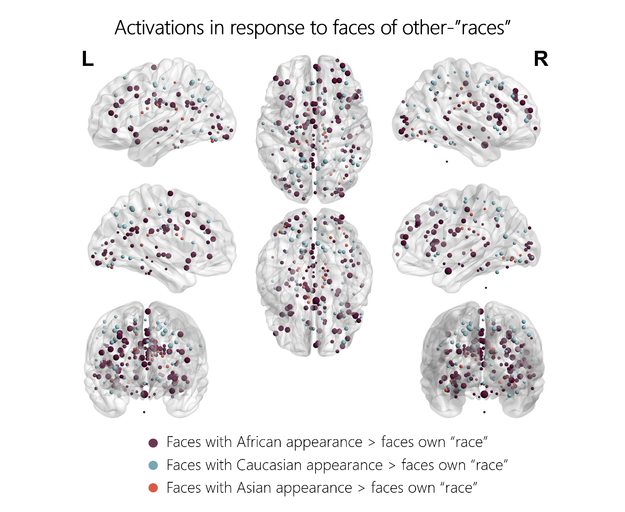

*Table S3.* Results of the Activation Likelihood Estimation meta-analysis

Meta-analyses were performed using the Activation likelihood Estimation algorithm, with the software GingerALE, version 3.0.2 (Eickhoff et al., 2009, Turkeltaub et al., 2012, Eickhoff et al., 2012).

*Table S3: Results of the Activation Likelihood Estimation meta-analysis. Note that the number of total contrasts in this case is 30 and not 31 because one study reported two contrasts on the same participants who observed two types of OR faces (Cassidy et al., 2021). We therefore merged these two contrasts to calculate the convergence.*

|  |  |  |
| --- | --- | --- |
| **Articles included** | **MNI coordinates (x,y,z)** | **Anatomical location (Brodmann area)** |
| **All contrasts (N=30, 196 foci)**  **Cluster-level FWE, p < 0.05** | | |
|  | No clusters found | - |
| **All contrasts (N=30, 196 foci)**  **Uncorrected, p < 0.0005** | | |
|  | -10,-8,26 | Left Caudate |
| **African + Caucasian (N=27, 178 foci)**  **Cluster-level FWE, p < 0.05** | | |
|  | No clusters found | - |
| **African + Caucasian (N=27, 178 foci)**  **Uncorrected, p < 0.0005** | | |
|  | -14,-54,10 | Left Posterior Cingulate (BA 30) |
|  | 34,24,-4 | Right Claustrum, Insula (BA 13) |
| **African (N=17, 115 foci)**  **Cluster-level FWE, p < 0.05** | | |
|  | No clusters found | - |
| **African (N=17, 115 foci)**  **Uncorrected, p< 0.0005** | | |
|  | -14,-54,10 | Left Posterior Cingulate Gyrus (BA 30, BA 18) |
|  | 38,-46,-16 | Right Fusiform Gyrus (BA 20) |
|  | 52,24,4 | Right Inferior Frontal Gyrus (BA 45) |

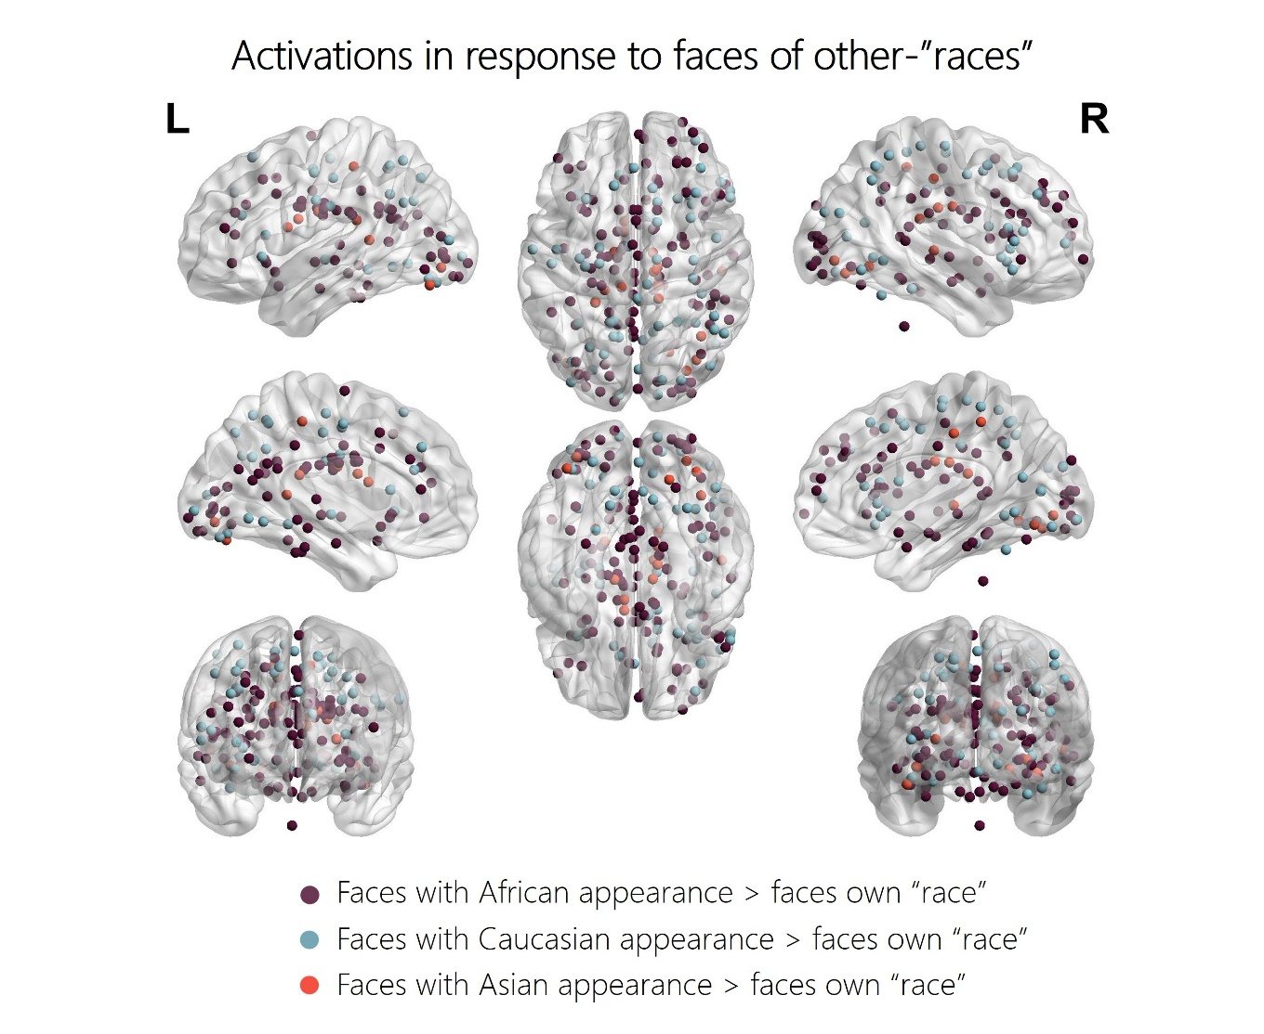Figure S3. **Foci from the original studies projected on a 3D brain template (node size is fixed, colour-blind friendly colour scale)**

*Figure S3: Activation foci from the original studies or the authors’ data plotted on a 3D brain mesh. Different colours represent different OR subgroups (African OR in purple, Caucasian OR in blue, and Asian OR in red). Foci falling outside the cerebrum are also shown (cerebellum and brain stem). See Figure S2 for a similar figure which visually incorporates the proportions of studies reporting activations in each region.* Note: Im*age* is *shown in a colour-blind friendly colour scale.*

*Table S4:* Results of the outlier detection analysis in the African and Caucasian subgroups

Table S4: This analysis has been performed to provide the reader with a quantitative way of selecting which brain regions are disproportionately reported within the two most numerous subgroups, and should therefore be discussed in more detail. The analysis on frequencies were performed in R using the function rstatix::identify_outliers(). This function considers outliers those values which are reported above the . This analysis was performed on each subgroup separately, and on all the regions that appeared in Figure 3 within each subgroup. Regions not mentioned in Table S4 were not classified as outliers. Note also that Chi-square tests would not be feasible because our proportions database violates one of the main assumptions of this test (that frequencies of brain labels are independent – in our dataset some brain regions have been reported in the same studies). Note that introducing studies reporting non-significant findings for the contrast OR > SR in the two subgroups did not change these results (cf. Figure S3).

|  |  |
| --- | --- |
| Brain region | Is.outlier |
| **African** |  |
| Insula | TRUE |
| Middle Frontal Gyrus | TRUE |
| Medial Frontal Gyrus | TRUE |
| **Caucasian** |  |
| Middle Frontal Gyrus | TRUE |
| Precuneus | TRUE |
|  |  |

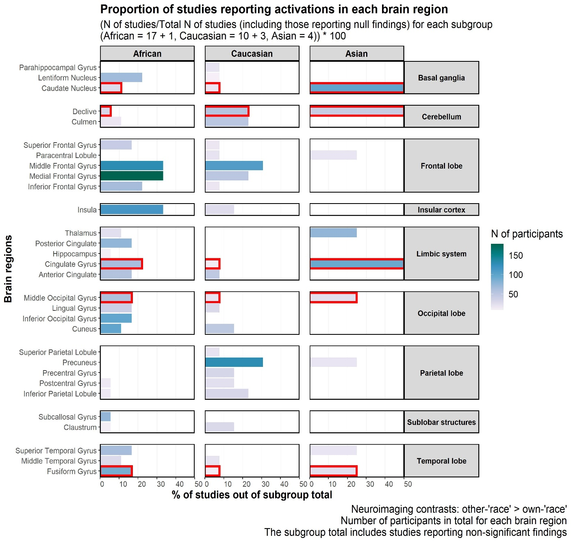Figure S3. **Barplot including studies reporting non-significant findings**

Figure S3. Overview of the percentages of studies reporting activation foci for each brain region, in the three subgroups separately. Y axis: brain region labels; X axis: percentage of studies out of the subgroup total. Colour intensity visually conveys the number of participants representing each brain region. Note that here the subgroup total includes studies reporting non-significant results for the contrast OR > SR in each subgroup. For the African subgroup, Van Bavel et al., 2011 is now included, whereas for the Caucasian subgroup Feng et al., 2011, Iidaka et al., 2008 and Zhou et al., 2018 are now included. For the respective references, please see the main text.

*We initially excluded studies reporting non-significant findings (i.e. no significant activations for the contrasts of interest) because these could not contribute to our main analysis. Since in this analysis we consider which labels are present in all subgroups (see bins with red contour in Figure S3), studies reporting no labels could not be included. Moreover, these studies cannot be included in our ALE convergence analysis, because no peaks are provided. However, we could include them in our secondary analysis, which considers which regions are reported most often in each subgroup. We did so by including these studies in the number of total studies in each subgroup (see above section of this caption)*

***Differences between label-based and coordinate-based approaches in our work***

We were interested in the effect of observing OR faces vs. SR faces across studies. This effect can be analyzed using two approaches: a label-based systematic review and a coordinate-based meta-analysis. The first allows to check which brain regions are reported across studies investigating different OR > SR faces contrasts, whereas the second allows to calculate the spatial convergence across the foci reported for all these contrasts with a coordinate-based meta-analytic algorithm, e.g. the ALE.

The main difference between the two is that the label-based review allows to see which regions are reported across studies based on automatically produced brain regions labels, both in terms of which labels are “in common” across groups of articles, and which are “predominantly reported” in a particular group. Instead, the conventional coordinate-based meta-analysis allows to see whether and in which regions the foci associated to these labels spatially converge to a larger extent than chance. This convergence is influenced by the relative closeness of activation foci in the original studies, by the sample size of these studies and by the sheer number of foci included in each analysis.

In our study, we chose to prioritize the label-based approach over the coordinate-based meta-analysis for three main reasons.

First, the fact that the ALE approach returns no significant convergence can be merely due to activation foci being located too far from each other, despite falling within the same region. In this sense, the label-based approach is more sensitive, as it allowed us to obtain an overview of the activation foci recurring in the three subgroups, despite the absence of significant convergence. However, we note that the lack of ALE convergence still gives us an important piece of information: the perception of OR faces is associated to a rather distributed activation pattern. As we stress in the main text, this spatial heterogeneity needs to be more investigated with studies examining brain responses to different OR faces systematically.

Second, because we examine subgroups of studies which report a different number of activation foci, applying the ALE approach across the three subgroups of studies would have produced a result that is biased towards the subgroup with the highest number of foci, i.e. the African OR faces subgroup.

Third, our secondary aim then was to test which regions respond preferentially to each OR face subgroup. In such case we would not have had sufficient power to run an ALE meta-analysis in only 1 out of 3 subgroups. Therefore, we preferred to simply see which labels are more often reported, in proportion to the total number of studies in each subgroup.