Chemical reactions and phase stabilities in the Si-Te system at high pressures and high temperatures

Andrzej Grzechnik 1,*, Wilson A. Crichton 2, Dmitrii Druzhbin 2, Michal Fečík 3, Ralf P. Stoffel 3, Sophia Brauksiepe 3, Simon Steinberg 3, Richard Dronskowski 3,4,5, B. Viliam Hakala 6, Karen Friese 1,6

1Institute of Crystallography, RWTH Aachen University, 52056 Aachen, Germany; 2European Synchrotron Radiation Facility, Grenoble, France; 3Institute of Inorganic Chemistry, RWTH Aachen University, 52056 Aachen, Germany; 4Jülich-Aachen Research Alliance (JARA-FIT and JARA–HPC), RWTH Aachen University, 52056 Aachen, Germany; 5Hoffmann Institute of Advanced Materials, Shenzhen Polytechnic, 7098 Liuxian Blvd, Nanshan District, Shenzhen 518055, China; 6Jülich Centre for Neutron Science, Forschungszentrum Jülich, Germany

* grzechnik@ifk.rwth-aachen.de

Abstract

Chemical reactions and phase stabilities in the Si-Te system at high pressures were explored using *in situ* angle-dispersive synchrotron powder diffraction in a large-volume multi-anvil press together with density-functional theory-based calculations. Cubic and rhombohedrally distorted clathrates, with the general formula Te8@(Si38Te8) and wide compositional range, preceded by a hexagonal phase with the composition Si0.14Te, are formed for different mixtures of Si and Te as starting materials. Si0.14Te, with the structural formula Te2(Te0.74Si0.26)3(Te0.94Si0.06)3, is the very first chalcogenide with the Mn5Si3 type structure. Silicon sesquitelluride -Si2Te3 decomposes into a mixture of phases that includes the clathrate and hexagonal phases at high pressures and temperatures. The higher the pressure the lower the temperature for the two phases to occur. Regardless of the starting compositions, only the clathrate is quenched to atmospheric conditions while the hexagonal phase amorphizes on decompression. The rhombohedral clathrates Te8@(Si38Te8) form on quenching of the cubic phases to ambient conditions. There is a high degree of interchangeability of Si and Te not only in the clathrates but also in the Mn5Si3 type structure. The theoretical calculations of enthalpies indicate that the reported decomposition of -Si2Te3 is energetically favourable over its transformation to another polymorph of the A2X3 type at extreme conditions.

Keywords: Si-Te system, high-pressure high-temperature synthesis, phase transitions, synchrotron radiation

Introduction

The interest in the Si-Te system arises from the possibility of synthesizing silicon monotelluride SiTe that, like GeTe, SnTe, and PbTe, is expected to have applications in data storage or thermoelectric energy conversion but with a much cheaper element (Si instead of Ge). In the Si-Te phase diagram at ambient pressure, only one stable compound Si2Te3 is known, which is trigonal below 673 K (the  polymorph, *P*1*c*, *Z* = 4).1,2 The structure can be regarded as a derivative of the CdI2 type in which Te atoms form an *hcp* lattice with Si dumbbells occupying 2/3 of the octahedral voids of every second layer enclosed by the Te atoms. At 673 K, diffuse scattering in the shape of a honeycomb is observed, attributed to the break-up of the Si–Si units and to a reordering of the Si atoms, which start to occupy part of the neighbouring voids in the structure. Above 723 K, a superstructure develops, in which the Te-sublattice remains unaltered while all Si–Si dumbbells dissociate. The Si atoms then occupy 1/4 of the tetrahedral voids in an ordered way.1 At temperatures above 823 K, the superlattice reflections disappear indicating a completely disordered distribution of Si in the Te-sublattice.

The reports on the (hypothetic) existence of thermodynamically stable SiTe and SiTe2 are contested since they are similar to Si2Te3 with some deviations from its stoichiometric composition (2:3), due to the excess of either Si or Te.1,3,4 These deviations do not affect the structure of Si2Te3 that is discussed to be a non-stoichiometric compound with a large compositional range.3,4 The Te-sublattice is not substantially affected by the compositional flexibility. According to theoretical calculations,4,5 -Si2Te3 is thermodynamically more stable than SiTe2 with the CdI2-type structure (*Pm*1, *Z* = 1), in which the Si atoms reside in all octahedral voids of every second layer.6 A new layered polymorph of SiTe2 (space group *P*1) even more stable than the CdI2-type polymorph was predicted with the Si atoms in a distorted tetrahedral coordination to the Te atoms.7

The eutectic between Te and Si2Te3 at ambient pressure exhibits a relatively low melting temperature (682 K) and corresponds to the composition of less than 20 at. % of Si.1,2 Within this compositional domain, it is possible to quench the melt and obtain silicon telluride glasses Si*x*Te1−*x*, 0.02 ≤ *x*≤ 0.25.1,8,9

The existence of -SiTe and -SiTe monolayer analogues of black and blue phosphorene, respectively, was predicted by Chen *et al*.10 In their bulk forms, they are argued to be orthorhombic and triclinic, respectively.11 Altogether, the bulk IV–VI compounds have structures derived from a black phosphorene, which is a distorted variant of the NaCl structure.12 Quantum-chemical calculations suggested a plausible synthetic approach to a silicon monotelluride since silicon can be incorporated into the crystal structure of Si2Te3 to yield SiTe at pressures of about 7 GPa.5 Several candidates for the hypothetical high pressure phase of SiTe were proposed and their formation enthalpies were obtained from DFT calculations. The most favorable SiTe polymorph was predicted to have the -GeTe structure (*R*3*m*, *Z* = 1), which can be described as a distorted variant of a face-centred cubic lattice. A further indirect evidence for a possible formation of SiTe under pressure could be inferred from the high-pressure behaviour of Si2Te3.13 During compression of -Si2Te3, a colour change from transparent red to opaque black was observed in addition to a reversible phase transition occuring at 9.5 GPa as detected using Raman spectroscopy. Furthermore, -Si2Te3 could be intercalated with up to 1% of elemental manganese at high pressures. This intercalation leads to a lowering of the pressure of the phase transition to 7.5 GPa. All these observations would suggest that the formation of SiTe from Si and -Si2Te3 could be facilitated by the structural instability of the latter at pressures below 10 GPa. Two metallic layered phases (triclinic and hexagonal) were proposed as candidates for the high-pressure polymorph of Si2Te3.14 The Si2 dumbbells are absent in both of them.

The first experimental studies of the Si-Te system at high pressures were performed by Jaussaud *et al*.15-17 A clathrate Te7+*x*Si20−*x* (*Fdc*, *Z* = 16) with the Si/Te molar ratios 1.58 to 1.88. was prepared between 3–7 GPa in the temperature range 973–1223 K. Two other clathrates Te16Si38 were synthesized at 5 GPa and 1473 K and their crystal structures were determined from single-crystal X-ray diffraction data. One is cubic (*P*3*n*, *Z* = 1) and the other is rhombohedral (*R*3*c*, *Z* = 1), both having the Si/Te molar ratio of 2.4. They are distorted variants of the clathrate aristotype G8@Si46 (*Pmn*, *Z* = 1) with Te occupying the G position and substituting half of Si at the 16*i* site of the *Pmn* structure, which results to Te8@(Si38Te8). It is not clear from the work by Jaussaud *et al*. 15-17 whether the *P*3*n* (c*P*) and *R*3*c* (r*R*) clathrates transform into each other as a function of pressure and/or temperature, though.

The present study was undertaken considering the large interest in the stabilities and properties of various phases in the Si-Te system. Using high-pressure synthesis in a large-volume multi-anvil press followed *in situ* with angle-dispersive synchrotron powder diffraction, we aimed to obtain bulk SiTe and to determine the high-pressure polymorph of Si2Te3, both being theoretically predicted to form at extreme conditions. The exploratory data reported here could be used to characterize the pressure-temperature phase diagram of the Si-Te system.

Experimental methods

Prior to the high-temperature high-pressure experiments, we first synthesized Si2Te3 that was later employed as a starting material for the high-pressure high-temperature experiments. Because Si2Te3 is extremely sensitive against air and moisture,4 all sample preparation had to be carried under a dry argon atmosphere using a glove box (MBraun, Garching, Germany; O2, H2O < 0.1 ppm by volume) or Schlenk techniques. The synthesis of silicon telluride Si2Te3 was carried out from mixtures of silicon (North Chemical, > 99.8%) and tellurium (Merck, > 99%) that were loaded into one-side sealed silica tubes, whose open ends were closed with quick-fit adapters inside the aforementioned glove box. The adapters were connected to a vacuum and an inert gas manifold so that the silica tubes could be flame-sealed under an inert atmosphere. The samples were heated using a computer-controlled tube furnace with the following temperature program: heating to 1273 K at a rate of 80 K/h, keeping this temperature for 48 h, cooling to 473 K in 670 h, and finally lowering the temperature to room conditions in 2 h. The product appeared as a red powder and the purity of the obtained silicon telluride was checked with powder X-ray diffraction using a Stadi P diffractometer at room temperature (Stoe & Cie GmbH, Darmstadt, Germany; area detector; Cu-K).

*In situ* angle-dispersivex-ray powder diffraction experiments at high pressures and high temperatures were performed using the Voggenreiter multi-anvil press in the beamline ID06-LVP at the European Synchrotron Radiation Facility (Grenoble, France). The powder patterns were continuously measured on changing pressure and temperature. In all the experimental runs, the high-resolution 2D detector Pilatus3X-900kW CdTe was used. Sample-detector distance and offset calibrations were carried out using LaB6 as a standard. The collected diffraction patterns were analysed using Fit2d software.18

Various mixtures of elementary Si and Te were prepared in the air for the multi-anvil synthesis runs at about 10 GPa ( = 0.23437 Å or  = 0.23393 Å). The starting materials had the Si:Te ratios of 1:1, 2:3, 1:8, and 38:16. The samples (0.7 mm in diameter and 2.0 mm in height) were surrounded by capsules made of hexagonal BN (2.4 mm in diameter and 2.0 mm in height). hBN discs (0.5 mm in thickness) were used to close the capsules that were placed inside graphite heaters (2.9 mm in diameter) together with two MgO plugs (each 2.4 mm in diameter and 2.7 mm in height). Cylindrical diamond epoxy windows in the MgO/Cr2O3 octahedra and boron epoxy gaskets were used to complete the sample assemblies that were heated up to about 1000 K by passing the current through graphite. The *P*-*T* conditions were determined from the equations of state and phase diagram of Te to reach its different phases.19,20

Sample assemblies for the multi-anvil runs on Si2Te3 ( = 0.23482 Å) up to 14 GPa and 1250 K were prepared and sealed under a dry argon atmosphere in the aforementioned glove box. The samples were placed in capsules (2 mm in diameter) made of NaCl mixed with Au (the weight ratio 5:1) with a drilled hole of 1.0–1.2 mm in diameter. The capsules were tightly sealed with pellets of pure NaCl. Graphite furnaces thermally isolated by MgO plugs and sleeves made of the ZrO2 were used. The diamond epoxy windows were mounted into the octahedra and pyrophyllite gaskets. Pressures and temperatures were estimated from experimental unit-cell volumes by a cross-calibration of the equations of state of both Au and NaCl.21

Small parts of the recovered samples with the starting compositions Si1:Te1 and Si38:Te16 of the Si/Te mixtures were mounted on glass pins to collect Gandolfi patterns at room temperature on a laboratory single-crystal diffractometer IPDS-II (Stoe & Cie GmbH, Darmstadt, Germany;  = 0.71073 Å). The patterns were integrated using the software *X-Area*.22 EDX investigations were conducted with a Zeiss LEO 1530 SEM system (Zeiss, Jena, Germany), equipped with Oxford Lynx Silicon Drift EDS Detector (Oxford Instruments, Abingdon, UK).

Theoretical methods

Theoretical investigations of two Te8@(Si38Te8) clathrate phases c*P* and r*R* were performed via periodic density functional theory (DFT) calculations using the projector-augmented-wave (PAW) method 23 with the PBE-D3 24-27 functional as implemented in the Vienna Ab-initio Simulation Package (VASP).28-30 The D3 dispersion correction was included using Becke-Johnson damping.31-33 The plane-wave kinetic energy cutoff was set to 500 eV. The Brillouin zone (BZ) was sampled on a dense mesh of reciprocal space points, namely, 3×3×2 for r*R* containing three formula units in a unit cell and 9×9×9 for c*P* having one formula unit per cell.

Structural optimizations of the rhombohedral phase r*R* were carried out based on the experimental structure published by Jaussaud *et al*.16 First, the optimization at 0 GPa was conducted by keeping the symmetry locked. After arriving at a well optimized structure, the volume was kept fixed and optimizations of cells with scaled lattice parameters were carried out to about 25 GPa. The structure of the cubic phase c*P* was taken from the experimental data obtained in this study (Table S1). Initial calculations suggested the equilibrium cell being smaller than the experimental one. The structure was optimized for different fixed volumes corresponding to pressures up to 50 GPa. Thus, the energy dependence on the cell volume was fitted using the Birch-Murnaghan equation of state yielding the theoretical equilibrium volume. To ensure that the equilibrium structure reached its energy minimum, the structure was re-optimized for a strict set of convergence criteria, that is, 10–8 eV/Å for the atomic forces and 10–10 eV for the electronic wave function. All phonon computations were performed by the Phonopy code 34 using a finite displacement of ±0.01 Å to obtain force constants from supercell calculations with VASP.

Results and Discussion

The first synthetic runs were carried out on mixtures of elemental Si and Te with the starting molar Si:Te ratios of 1:1 and 2:3. Upon compression at room temperature, the sequence of phase transitions Te-I → Te-II → Te-III in tellurium was observed. During heating at about 10 GPa, a mixture of new phases formed in both runs (Figures 1 and S1). One of the phases was the Te-IV polymorph. The reflections of the other phase could be indexed with a hexagonal lattice, *a* ≈ 8.95 Å and *c* ≈ 6.56 Å (the phase *hex1*). Upon further heating, this hexagonal phase started to vanish and Te-IV melted, while another phase, which was indexed with a primitive cubic lattice (*a* ≈ 10.44 Å), formed. It corresponded to the clathrate Te8@(Si38Te8) in space group *P*4*n* (the clathrate c*P*) reported by Jaussaud *et al*.15-17 On cooling and decompressing, the crystallization of Te-IV and the sequence of phase transitions Te-IV → Te-III → Te-II → Te-I were observed. The phase *hex1* could be cooled down to room temperature at high pressures but it amorphized on decompression. The phase c*P* was recovered at ambient conditions as a powder in both runs with the starting compositions Si1:Te1 and Si2:Te3. The Te8@(Si38Te8)-type clathrate was also obtained and quenched to atmospheric pressure from the starting Si:Te composition 38:16. We found no evidence for the formation of any phases of SiTe and Si2Te3 reported earlier from theoretical predictions.5,10-12,14

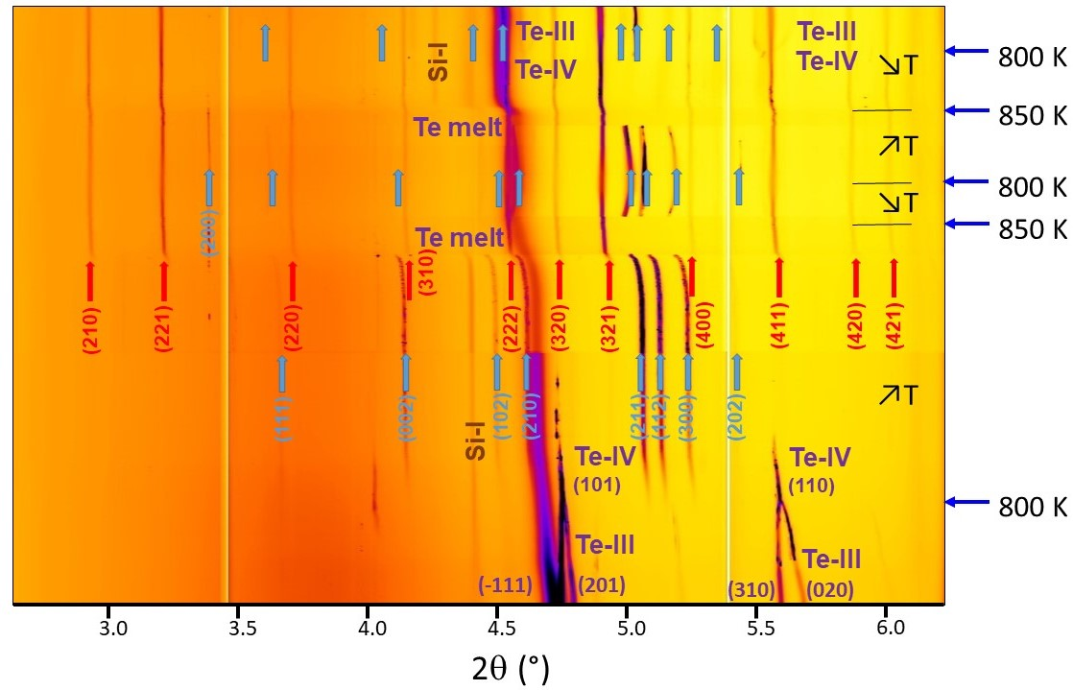

Figure 1: Measured powder patterns in the run with the starting composition Si1:Te1 at about 10 GPa ( = 0.23437 Å). The blue and red arrows indicate the reflections due to the phase *hex1* and Te8@(Si38Te8) clathrate (c*P*), respectively. The black up and down arrows indicate the increase and decrease of temperature (T), respectively.

The *F*-centered clathrate Te7+xSi20-x (c*F*) was identified for the compositional mix of Si38:Te16, where it formed simultaneously with the Te8@(Si38Te8) type clathrate after the hexagonal phase disappeared (Figure S2). At higher temperatures, the Te8@(Si38Te8) type clathrate is favoured and is retained on cooling. The two cubic clathrates c*F* and c*P* appear when Te-IV is melted. The lattice doubling and *F*-centring can be distinguished from the c*P* lattice by the presence of the (731) and (11.31) reflections, for which the smaller (equivalent) lattice has no corresponding reflections. Traces of the *F*-centered clathrate Te7+xSi20-x were also identified in the run with the Si2:Te3 composition. This phase was not observed in the Si1:Te1 run (Figure 1) because either its diffraction peaks were just too weak or this phase is not formed for this starting composition.

The recovered sample from the run with the starting Si:Te ratio 2:3 is a mixture of two phases (Figure S3) with the compositions Si38Te18.7 and Si0.14Te. The recovered phase in the run with the starting Si:Te ratio 1:1 has the composition Si38Te14.9. The compositions of both silicon-rich phases are related to that of the Te8@(Si38Te8) clathrate.15-17 For the 1:1 starting composition, the tellurium-rich phase does not seem to be intergrown with Si38Te14.9 due to a melt separation. It is noteworthy that Si0.14Te has the composition corresponding to that of the telluride glasses Si*x*Te1−*x*, 0.02 ≤ *x*≤ 0.25 obtained by melt quenching at ambient pressure.1,8,9 This phase represents the composition of the hexagonal phase, which amorphizes on decompresion.

The silicon-rich phases could easily be extracted from the recovered samples under an optical microscope. Their Gandolfi powder X-ray diagrams (Figure 2) were refined with the Rietveld method using the program JANA2020.35 The structure of the clathrates was solved with the program SUPERFLIP 36 that confirmed symmetry *P*3*n* (c*P*) and yielded the structural model analogous to the one by Jaussaud *et al*. 16,17 The resolution of the laboratory powder data is too low to observe any rhombohedral distortion of the lattice.

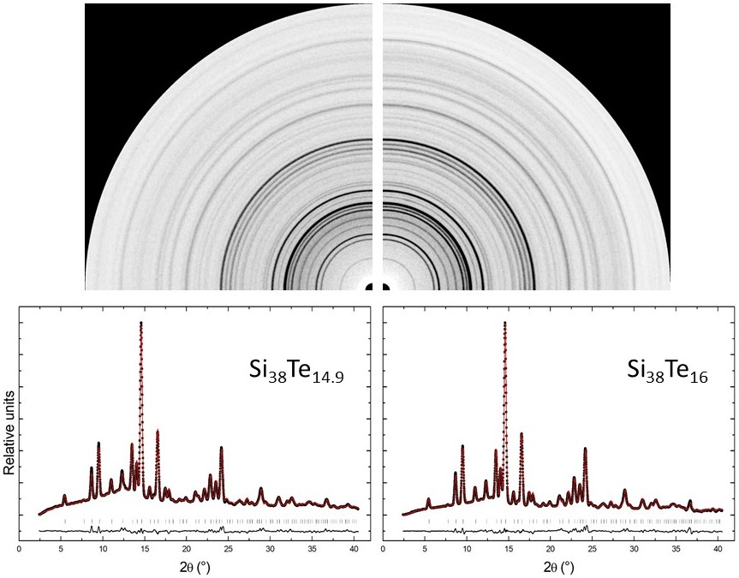

Figure 2: Measured Gandolfi diffraction patterns and integrated diagrams (black circles) compared with the calculated (red lines) and difference (black lines) diagrams obtained using the Rietveld method for the samples with the starting compositions Si1:Te1 (left) and Si38:Te16 (right),  = 0.71073 Å. Vertical markers indicate the positions of the calculated Bragg reflections. Si38Te14.9: R(F)obs = 8.51%, Rp = 3.40%, wRp = 4.61%. Si38Te16: R(F)obs = 7.70%, Rp = 4.04%, wRp = 5.95%.

Two different models were refined. In the first one, the overall composition was set to Si38Te16 and the isotropic displacement parameters for all the atoms were refined independently (Table S1). In the second model, the occupancies of Te were constrained to yield the bulk composition Si38Te14.9 obtained from the chemical analysis. The isotropic thermal displacement parameters were restricted to be equal for Te and Si (Table S2). The deviations from the Si38Te16 composition do not seem to have any effect on the lattice parameters and atomic positions when the results in Tables S1 and S2 are compared with those by Jaussaud *et al*. 16 The compositional range Si38Te16±*x*is quite broad, with 0 ≤ *x*< 3 according to our chemical analysis of the recovered products. It could be explained by the fact that Si and Te could substitute each other in the clathrate structure.15-17

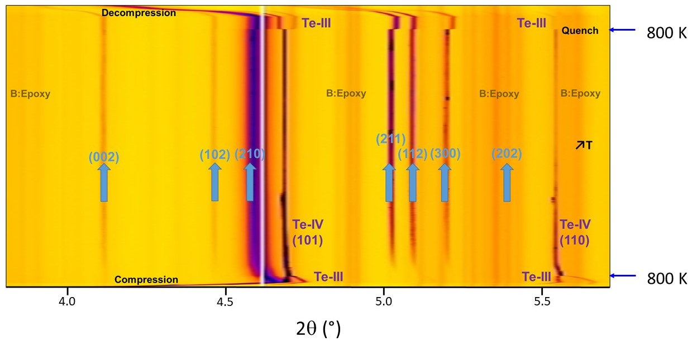

Figure 3: Measured powder patterns in the run with the starting composition Si1:Te8 at 10 GPa ( = 0.23437 Å). Reflections due to the phase *hex1* are marked in blue. The black arrow indicates the increase of temperature (T).

Since the phase *hex1* was formed together with Te-IV, the question arose whether it could be either another polymorph of tellurium not found in earlier studies 20 or a new phase in the system Si-Te. To clarify this issue, we performed two additional runs. The first one was on pure Te at the *P*-*T* conditions, at which the hexagonal phase was detected. It turned out that only Te-IV and then the Te melt were observed. This confirms that the phase *hex1* is indeed a novel binary silicon telluride. The second run was on the starting Si:Te composition 1:8 approximating the Si0.14Te telluride in the recovered product in the Si2:Te3 run and the telluride glasses from melt quenching at ambient conditions.1,8,9 The sample was heated at 10 GPa (Figure 3) to the temperatures just below the melting point of tellurium at about 850 K.19 The hexagonal phase forms after the transformation Te-III -> Te-IV. Kept at constant temperature, there is no significant further variation of the pattern of this phase, which retains an excess Te. Upon quenching Te back-transforms to Te-III. The phase *hex1* survives decompression until the press is opened, whereupon it amorphises.

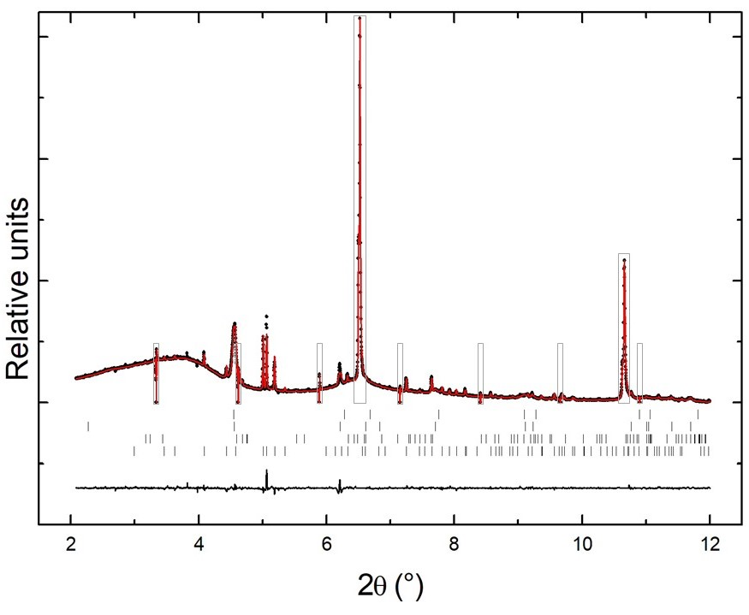

Figure 4: Observed diagram (black circles) compared with the calculated (red lines) and difference (black lines) diagrams for the phase *hex1* at 10 GPa and room temperature in the run with the starting composition Si1:Te8,  = 0.23393 Å. Vertical markers indicate the positions of the calculated Bragg reflections for (from bottom to top) the phase *hex1*, Te-III, hBN, and graphite. The grey contours indicate the parts of the observed diagram excluded from the refinement. R(F)obs = 7.77%, Rp = 2.50%, wRp = 4.62%.

Indexing of the powder patterns of the phase *hex1* indicated the space group *P*63/*mcm*. The symmetry was confirmed and the structure was solved with the program SUPERFLIP.36 The obtained structural model was refined from the pattern measured at 10 GPa and room temperature (Figure 4) with the Rietveld method using the program JANA2020.35 The isotropic displacement parameters were refined separately for each site. The occupancies of Si and Te were refined with a constraint to the bulk composition obtained from the chemical analysis of the amorphous phase, Si0.14Te. Different occupational schemes were tried. The refined structure is of the Mn5Si3 type (Figure 5), in which three different Wyckoff positions are occupied: the 4*d* site (⅓,⅔,0) and two 6*g* sites (*x*,0,¼ with *x* ≈ 0.24 and *x* ≈ 0.62).37,38 The refinement converged best for a model (Table S3), in which the 4*d* site is exclusively occupied by Te. This Te1 site is octahedrally coordinated by Te3/Si2 (0.94:0.06). The Te-centered octahedra share common faces and form columns along the *c*-axis. Neighbouring columns are interconnected via common edges. The Te2/Si1 (0.75:0.25) atoms on the other 6*g* site are interconnected to form chains of face-sharing distorted empty octahedra along the *c* direction. Like in the clathrates,15-17 the Te and Si atoms are interchangeable in the phase *hex1*. Regarding the element distribution on the three Wyckoff positions in the Mn5Si3 structure, its formula could be written as Mn2Mn3Si3. Accordingly, the phase *hex1* with the Si0.14Te composition would be written as Te2(Te0.74Si0.26)3(Te0.94Si0.06)3. The Si atoms clearly tend to occupy the site at which they are octahedrally coordinated to the Te atoms.

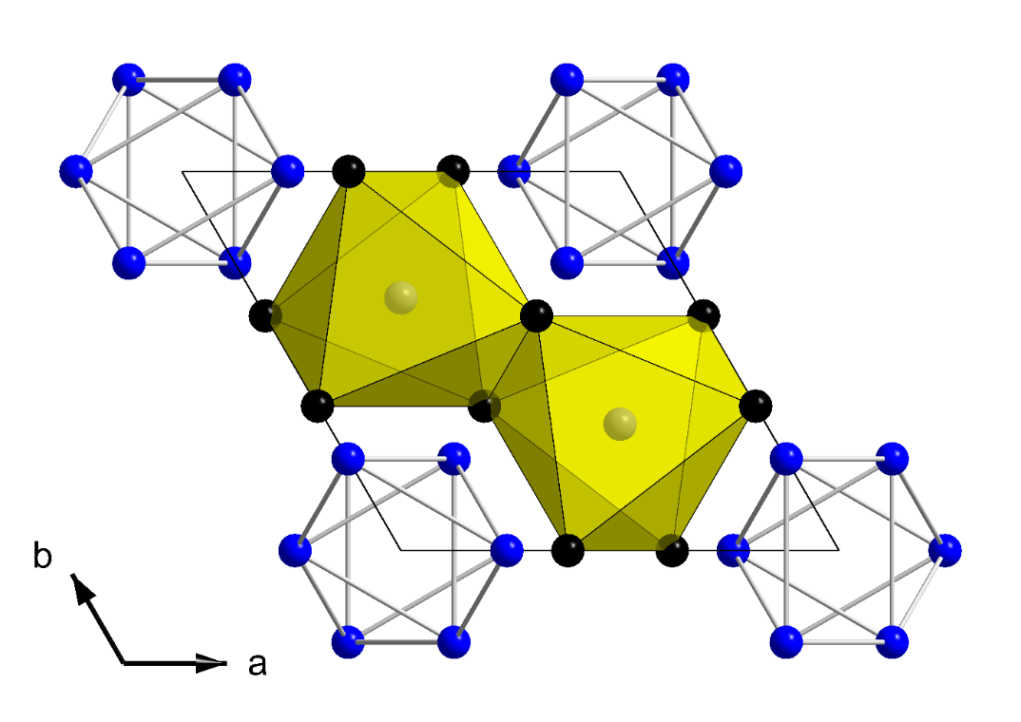

Figure 5: Crystal structure of the phase *hex1*. The Te1, Te2/Si1, and Te3/Si2 atoms are drawn as grey, blue, and black symbols, respectively.

The Mn5Si3 type is found in aluminides, gallides, silicides, germanides, rare-earth-metal-transition-metal alloys, etc., and it is the aristotype of the Nowotny intermetallic phases.37 The interstices in the empty octahedral, the site 2*b* (0,0,0), could be partially or completely filled in stuffed Mn5Si3 structures. The non-stoichiometry, chemical substitution, presence of small interstitial atoms, and/or structural distortions could lead to various superstructures.38-41 The phase *hex1* synthesized in this study is the very first chalcogenide of the Mn5Si3 type. Our multi-phase powder data, however, do not allow for a meaningful refinement of the interstitial occupancies for either Si or Te due to correlations with atomic displacement parameters.

The distances between the double columns of face-sharing octahedra around the Te1 atoms and empty 2*b* sites are within the range of about 3.0–3.5 Å (Table S4). On the other hand, the distance between the 2*b* site and the Te2/Si1 atoms is 2.7 Å and is the shortest in the phase *hex1*. In comparison, the Te–Te distances in the high-pressure polymorphs of tellurium, Te-III and Te-IV, are above about 2.9 Å.20,42-44 The shortest Te–Te distance in Te-I occurring at ambient pressure is about 2.8 Å.45

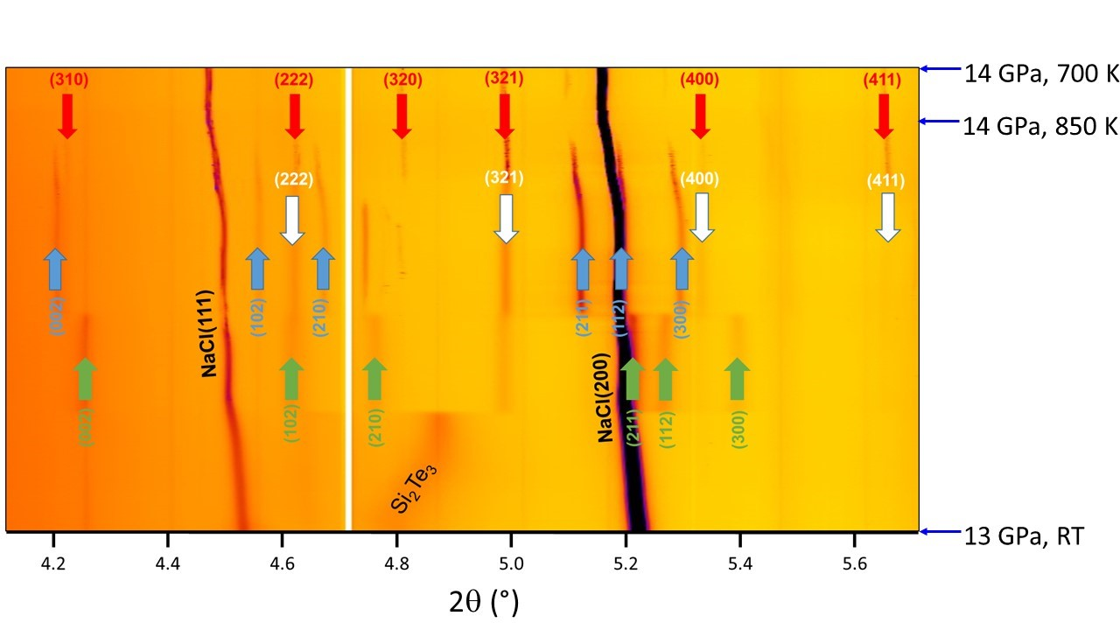

Figure 6: Measured powder patterns in the run with the starting composition -Si2Te3 ( = 0.23482 Å). Reflections due to the phase *hex1*, *cP* and *cI* clathrates are marked in blue, red and white, respectively. The reflections marked in green are due to another hexagonal phase (*hex2*).

Four separate experimental runs were performed on -Si2Te3 (*P*1*c*) at high pressures and temperatures. Upon compression at room temperature, the phase’s reflections broaden and become poorly resolved (Figure 6). Si2Te3 becomes amorphous at about 12.9 GPa and room temperature. Our powder data at room temperature data do not provide any clear evidence for the phase transition at about 9.5 GPa reported earlier by Johnson *et al*. 13

On heating at various pressures, Si2Te3 starts to decompose at about 6 GPa and 700 K, 7.5 GPa and 650 K, 11.5 GPa and 500 K. The formation of the Mn5Si3 type phase (*hex1*) is preceded by the occurrence of a denser hexagonal phase (*hex2*) that could be indexed with *a* ≈ 8.82 Å and *c* ≈ 6.32 Å (Figures 6 and S4). Although, the lattice parameters and *c/a* ratio in *hex2* are close to those for the Mn5Si3 type, the relationship between the two phases is not clear at present. Our data do not allow to solve the structure of this new phase. Upon further temperature increase, the clathrate of the Te8@(Si38Te8) type starts to synthesize. It can initially be indexed with the *I*-centered cubic lattice (c*I*). As the crystallization progresses, the reflections violating the body-centered lattice appear and the patterns could be indexed with the c*P* lattice. We do not find any evidence for the formation of the reported phases of SiTe2 6,7 that could be considered as decomposition products of stoichiometric Si2Te3 1,3,4 or of the Te7+xSi20-x type clathrate. At higher temperatures, the phase *hex1* disappears at the conditions for the occurrence of the Te melt 20 and only the Te8@(Si38Te8) type clathrate is present. When the temperature is lowered, the phase *hex1* re-crystallizes in the presence of the clathrate. Temperature cycling at high pressures shows that the melting and crystallization of the phase *hex1* are reversible. Upon quenching to ambient conditions and room temperature, a mixture of crystalline and amorphous phases, including the Te8@(Si38Te8) clathrate, is recovered. The phase *hex1* of the Mn5Si3 type is not among them. Several reflections that are singlets in the c*I* and c*P* clathrate phases split on cooling indicating the presence of the rhombohedral distortion (Figure S4). This cannot be clearly observed at the runs on Si:Te mixtures performed at much higher pressures (Figure 1).

Additional insight on the stability of the clathrate phases is provided by theoretical calculations on the stoichiometric clathrate composition Si38Te16. The rhombohedral structure r*R* was optimized at several fixed volumes obtained by scaling of the lattice parameters (Table S5). The symmetry (space group *R*3*c*) did not change for the entire pressure range under investigation. Single-point calculations of the experimental cubic phase c*P* showed that the structure is subject to about 0.9 GPa of internal pressure suggesting that the cell is slightly larger than its theoretical equilibrium value. When compared to the rhombohedral structures at 0 GPa and 2.49 GPa, this un-optimized cubic phase shows lower stability with the difference of about 1.2 eV. To obtain the theoretical equilibrium volume, the structure was optimized at different fixed volumes in a similar manner to the rhombohedral phase r*R* (Table S6). The energy-volume (*E*-*V*) curve was fitted by the Birch-Murnaghan equation of state to obtain the equilibrium volume *V*0 that corresponds to the structure at 0 GPa. The optimized structure was found to be subject to pressure of 0.006 GPa and still to be less stable when compared to the rhombohedral one r*R* by about 1.2 eV. Similar to r*R*, the symmetry of c*P* (space group *P*3*n*) did not change for the entire pressure range. The enthalpies of the c*P* and r*R* phases were calculated at different pressures. Figure 7 shows the enthalpy difference (H) between the two phases as a function of the pressure. The estimated pressure at which c*P* would become more stable than r*R* is about 21 GPa at 0 K. The r*R* clathrate has an anisotropic compressibility and is altogether more compressible than the c*P* clathrate (Tables S5 and S6, Figure S5).

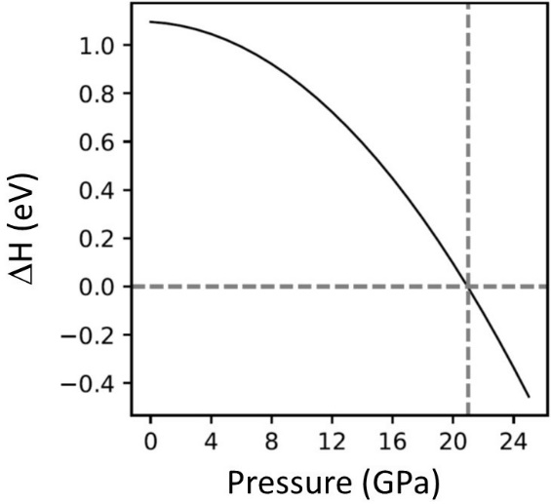

Figure 7: Enthalpy difference H between the c*P* and r*R* phases as a function of the pressure at 0 K.

The density of phonon states (DPS) of r*R* was calculated for zero pressure, yielding no imaginary modes that would hint towards an unstable structure. The corresponding DPS of c*P* obtained for 0 GPa, however, shows several imaginary modes indicating its instability at ambient conditions. The observed imaginary frequencies persist up to at least 50 GPa (Figure 8). Additionally, the imaginary modes are increasing in magnitude and numbers (up to ca. 15 % of the total phononic population) further highlighting the instability of this phase. The telluride deficient counterpart Si38Te14.9 is currently being investigated.

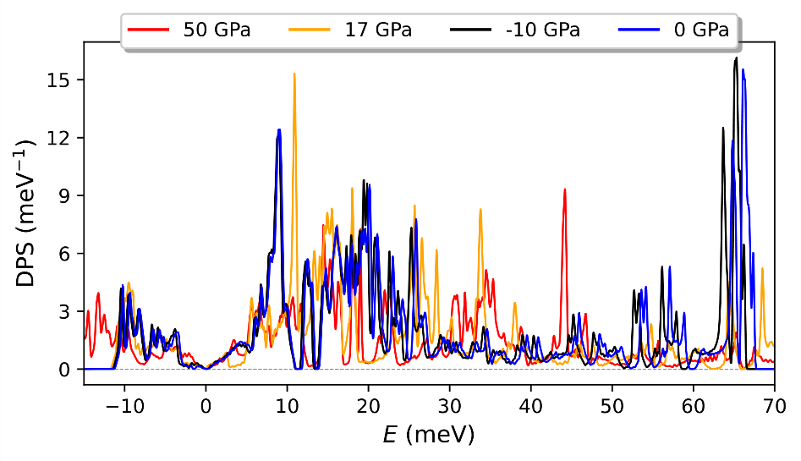

Figure 8: Density of phononic states of the c*P* phase as a function of energy at different pressures.

To compare the stability of the Si38Te16 clathrates with respect to Si2Te3 at 0 GPa, Si2Te3 was examined in different structures of the A2X3 type available in the Inorganic Crystal Structure Database. 46 We do not find any A2X3 structure in this database for which Si2Te3 would be more stable than its  polymorph (*P*1*c*, *Z* = 4). 4,5 Additionally, the structure of Te-I in addition to the corresponding energetics was then calculated for the chemical reaction:

|  |  |
| --- | --- |
| Si38Te16 + 41 Te 19 Si2Te3 | (Eq. 1) |

Hence, in terms of enthalpy at 0 K the phase Si38Te16 together with Te is more stable than -Si2Te3 by about 208 kJ/mol and 102 kJ/mol for r*R* and c*P*, respectively. At 300 K, the clathrates together with Te are still more stable than -Si2Te3 by about 231 kJ/mol and 148 kJ/mol for r*R* and c*P*, respectively.

A thorough theoretical study of the observed phase *hex1* is not reported here due to its high computational complexity but the system is currently being investigated and the corresponding calculations are ongoing.

Conclusions

Contrary to our expectations, the results of exploratory high-pressure high-temperature experiments on various mixtures of elemental Si and Te show that no silicon telluride SiTe is formed in the conditions up to 10 GPa reached in this study. Instead, the clathrates, with the general formula Te8@(Si38Te8), preceded by a tellurium-rich hexagonal phase containing essential silicon, are formed. The clathrates Si38Te16±*x* have a wide compositional range with 0 ≤ *x*< 3. The phase *hex1* synthesized in this study is the very first chalcogenide of the Mn5Si3 type.

Silicon sesquitelluride Si2Te3 amorphizes above about 12 GPa and room temperature. At high pressures and high temperatures, it decomposes into a mixture of various phases from which the Te8@(Si38Te8) type clathrate and phase *hex1* are eventually formed. An increase in pressure corresponds to a lowering of the temperature for the two phases to occur, suggesting that the amorphization of Si2Te3 is due to its decomposition at extreme conditions. The phase *hex1* of the Mn5Si3 type could be reversibly melted and crystallized in the presence of the clathrate at non-ambient pressure.

Both in the synthesis runs on the Si:Te mixtures and on stoichiometric Si2Te3 as starting compositions, only the Te8@(Si38Te8) type clathrate is quenched to atmospheric conditions while the phase *hex1* amorphizes on decompression. It remains to be seen whether this telluride could be stabilized with small interstitial atoms and whether other chalcogenides with this structure could be obtained at high pressures and temperatures. The surprising result of our study is the high degree of interchangeability of Si and Te not only in the clathrates 15-17 but also in the Mn5Si3 type structure (*hex1*).

The experimental work presented here does not yield any result that would confirm previous theoretical studies on the existence and stability of various phases of SiTe, Si2Te3, and SiTe2 at extreme conditions. Our experimental results on the Si-Te system clearly show that the formation of the clathrate and Mn5Si3 type structures occurs at extreme conditions. The theoretical calculations of enthalpies indicate that the decomposition of -Si2Te3 is energetically favourable over its transformation to another polymorph at high pressures and high temperatures.

Acknowledgements

The authors wish to thank Tobias Storp for collecting the PXRD data on Si2Te3 and the Jülich-Aachen Research Alliance (JARA) as well as the IT Center of RWTH Aachen University for providing the computational resources (JARA-HPC project “jara0033”).

ASSOCIATED CONTENT

Supplementary material contains refined structural models and interatomic distances as well as theoretically obtained P-V data, enthalpies, and total energies. The reported crystal structures are deposited in the joint CCDC/FIZ Karlsruhe deposition service with the numbers CSD 2144705 for Si38Te14.9, CSD 2144706 for Si38Te16, and CSD 2144707 for Si0.14Te.

AUTHOR INFORMATION

Corresponding Author

* Andrzej Grzechnik; Institute of Crystallography, RWTH Aachen University, 52056 Aachen, Germany; e-mail address: grzechnik@ifk.rwth-aachen.de.

Author Contributions

The manuscript was written through contributions of all authors. All authors have given approval to the final version of the manuscript.

Funding Sources

This work was supported by the German Research Foundation (DFG, Bonn, Germany; SFB 917 “Nanoswitches”; S.B., B.V.H., R.D. and K.F.) as well as the Verband der Chemischen Industrie (FCI, Frankfurt a.M., Germany; “Liebig Stipend”, S.S.).

References

(1) Bletskan, D.I. Phase equilibrium in the binary systems AIVBIV. *J. Ovonic Res*. 2005, 1(5), 47-52.

(2) Okamoto, H. Supplemental literature review of binary phase diagrams: Au-La, Ce-Pt, Co-Pt, Cr-S, Fe-Ni, Lu-Pd, Ni-S, Pd-Ti, Si-Te, Ta-V, and V-Zn. *J. Phase Equilib. Diffus*. 2019, 49, 743-756.

(3) Gregoriades, P.E.; Bleris, G.L.; Stoemenos, J. Electron diffraction study of the Si2Te3 structural transformation. *Acta Cryst*. *B* 1983, 39, 421-426.

(4) Göbgen, K.C.; Steinberg, S.; Dronskowski, R. Revisiting the Si-Te system: SiTe2 finally found by means of experimental and quantum-chemical techniques. *Inorg. Chem*. 2017, 56, 11398-11405.

(5) Steinberg, S.; Stoffel, R.P.; Dronskowski, R. Search for the mysterious SiTe - and examination of the binary Si-Te system using first-principles-based methods. *Cryst. Growth Des*. 2016, 16, 6752-6755.

(6) Mishra, R.; Mishra, P.K.; Phapale, S.; Babu, P.D.; Sastry, P.U.; Ravikumar, G. Evidences of the existence of SiTe2 crystalline phase and a proposed new Si-Te phase diagram. *J. Solid State Chem*. 2016, 237, 234-241.

(7) Bhattarai, R.; Shen, X. Predicting a novel phase of SiTe2. *ACS Omega* 2020, 5, 16848-16855.

(8) Petersen, K.E.; Birkholz, U.; Adler, D. Properties of crystalline and amorphous silicon telluride. *Phys. Rev. B* 1973, 8, 1453-1461.

(9) Moharram, A.H.; Abu El-Oyoun, M. Glass transition kinetics of the binary Si12.5Te8.75 alloy. *Appl. Phys. A* 2014, 116, 311-317.

(10) Chen, Y.; Sun, Q.; Jena, P. SiTe monolayers: Si-based analogues of phosphorene. *J. Mater. Chem. C* 2016, 4, 6353–6361.

(11) Bhattarai, R.; Shen, X. Optical and electronic properties of SiTex (x = 1, 2). *J. Appl. Phys*. 2021, 129, 224305.

(12) Wang, Q.; Wu, L.; Urban, A.; Cao, H.; Lu, P. Anisotropic to isotropic transition in monolayer group-IV tellurides. *Materials* 2021, 14, 4495.

(13) Johnson, V.L.; Anilao, A.; Koski, K. Pressure-dependent phase transition of 2D layered silicon telluride (Si2Te3) and manganese intercalated silicon telluride. *Nanoresearch* 2019, 12(9), 2373-2377.

(14) Bhattarai, R.; Shen, X. Pressure-induced insulator-metal transition in silicon telluride from first-principles calculations. *J. Phys. Chem*. *C* 2021, 125, 11532-11539.

(15) Jaussaud, N; Pouchard, M.; Goglio, G.; Cros, C.; Ammar, A.; Weill, F.; Gravereau, P. High pressure synthesis and structure of a novel clathrate-type compound: Te7+xSi20-x (x ~ 2.5). *Solid State Sci.* 2003, 5, 1193-1200.

(16) Jaussaud, N.; Toulemonde, P.; Pouchard, M., San Miguel, A.; Gravereau, P.; Pechev, S.; Goglio, G.; Cros, C. High pressure synthesis and crystal structure of two forms of a new tellurium-silicon clathrate related to the classical type I. *Solid State Sci.* 2004, 6, 401-411.

(17) Jaussaud, N.; Pouchard, M.; Gravereau, P.; Pechev, S.; Goglio, G.; Cros, C. Structural trends and chemical bonding in Te-doped silicon clathrates. *Inorg. Chem*. 2005, 44(7), 2210-2214.

(18) Hammersley, A.P. FIT2D: a multi-purpose data reduction, analysis and visualization program. *J. Appl. Cryst*. 2016, 49, 646-652.

(19) Brazhkin, V.V.; Voloshin, R.N.; Popova, S.V.; Umnov, A.G. Pressure-temperature phase diagram of solid and liquid Te under pressures up to 10 GPa. *J. Phys.: Condens. Matter* 1992, 4, 1419-1425.

(20) Hejny, C.; Falconi, S.; Lundegaard, L.F.; McMahon, M.I. Phase transitions in tellurium at high pressure and temperature. *Phys. Rev. B* 2006, 74, 174119.

(21) Sokolova, T.S.; Dorogokupets, P.I.; Dymshits, A.M.; Danilov, B.S.; Litasov, K.D. Microsoft excel spreadsheets for calculation of P-V-T relations and thermodynamic properties from equations of state of MgO, diamond and nine metals as pressure markers in high-pressure and high-temperature experiments. *Comput. Geosci*. 2016, 94, 162-169.

(22) Stoe & Cie (1998). *X-AREA*. Stoe & Cie, Darmstadt, Germany.

(23) Blöchl, P. E. Projector augmented wave method. *Phys. Rev. B* 1994, 50, 17953–17979.

(24) Perdew, J. P.; Burke, K.; Ernzerhof, M. Generalized gradient approximation made simple. *Phys.* *Rev. Lett*. 1996, 77, 3865-3868.

(25) Perdew, J. P.; Burke, K.; Ernzerhof, M. Generalized gradient approximation made simple. *Phys. Rev. Lett.* 1997, 78, 1396-1396.

(26) Grimme, S.; Antony, J.; Ehrlich, S.; Krieg, S. A consistent and accurate ab initio parametrization of density functional dispersion correction (DFT-D) for the 94 elements H-Pu. *J. Chem. Phys.* 2010, 132, 154104.

(27) Grimme, S.; Ehrlich, S.; Goerigk, L. Effect of the damping function in dispersion corrected density functional theory. *J. Comp. Chem.* 2011, 32, 1456-1465.

(28) Kresse, G.; Furthmüller, J. Efficiency of ab-initio total energy calculations for metals and semiconductors using plane-wave basis set. *Comput. Mater. Sci*. 1996, 6, 15-50.

(29) Kresse, G.; Furthmüller, J. Efficient iterative schemes for ab initio total-energy calculations using a plane-wave basis set. *Phys. Rev. B* 1996, 54, 11169-11186.

(30) Kresse, G.; Joubert D. From ultrasoft pseudopotentials to the projector augmented-wave method. *Phys. Rev. B* 1999, 59, 1758-1775.

(31) Becke, A. D.; Johnson, E. R. A density-functional model of the dispersion interaction. *J. Chem. Phys.* 2005, 122, 154101.

(32) Johnson, E. R.; Becke, A. D. A post-Hartree-Fock model of intermolecular interactions. *J. Chem. Phys.* 2005, 123, 024101.

(33) Johnson, E. R.; Becke, A. D. A post-Hartree-Fock model of intermolecular interactions: Inclusion of higher-order corrections. *J. Chem. Phys.* 2006, 124, 174104.

(34) Togo, A.; Tanaka, I. First principles phonon calculations in material science. *Scr. Mater.* 2015, 108, 1-5.

(35) Petricek, V.; Dusek, M.; Palatinus, L. (2020) JANA2020. Institute of Physics, Prague, Czech Republic.

(36) Palatinus, L.; Chapuis, G. SUPERFLIP – a computer program for the solution of crystal structures by charge flipping in arbitrary dimensions. *J. Appl. Cryst*. 2007, 40, 786-790.

(37) H. Nowotny (1963), *Electronic Structure and Alloy Chemistry of the Transition Elements* (P.A. Beck, editor) John Wiley, New York.

(38) Hering, P.; Friese, K.; Voigt, J.; Persson, J.; Aliouane, N.; Grzechnik, A.; Senyshyn, A.; Brückel, T. Structure, magnetism, and the magnetocaloric effect of MnFe4Si3 single crystals and powder samples. *Chem. Mater*. 2015, 27(20), 7128-7136.

(39) Guloy, A.M.; Mudring, A.V.; Corbett, J.D. Nine hexagonal Ca5Pb3Z phases in stuffed Mn5Si3-type structures with transition metal interstitial atoms Z. Problems with classical valence states in possible Zintl phases. *Inorg. Chem*. 2003, 42, 6673-6681.

(40) Yusupov, R.G.; Stanley, C.J.; Welch, M.D.; Spratt, J.; Cressey. G.; Rumsey, M.S.; Seltmann, R.; Igamberdiev, E. Mavlyanovite, Mn5Si3: a new mineral species from a lamproite diatreme, Chatkal Ridge, Uzbekistan. *Mineral. Mag.* 2009, 73(1), 43-50.

(41) Bławat, J.; Roman, M.; Xie, W.; Cava, R.J.; Klimczuk, T. La15NbxGe9: a superstructure of the Mn5Si3 structure type with interstitial Nb atoms. *Solid State Chem*. 2018, 265, 50-54.

(42) Takumi, M.; Masamitsu, T.; Nagata, K. X-ray structural analysis of the high-pressure phase III of tellurium. *J. Phys.: Condens. Matter* 2002, 14, 10609-10613.

(43) Hejny, C.; McMahon, M.I. Large structural modulations in incommensurate Te-III and Se-IV. *Phys. Rev. Lett*. 2003, 91(21), 215502.

(44) Hejny, C.; McMahon, M.I. Complex crystal structures of Te-II and Se-III at high pressure. *Phys. Rev. B* 2004, 70, 184109.

(45) Adenis, C.; Langer, V.; Lindqvist, O. Reinvestigation of the structure of tellurium. *Acta Cryst*. C 1989, 45, 1-4.

(46) Inorganic Crystal Structure Database, FIZ Karlsruhe – Leibniz Institute for Information Infrastructure (2022).

**Graphic for Table of Contents and Abstract**

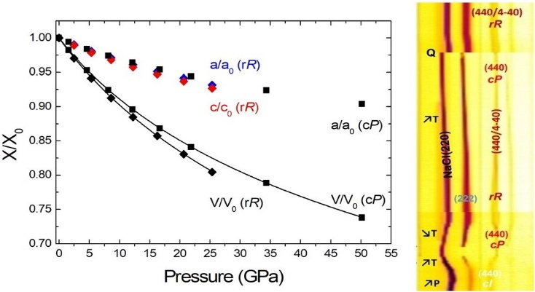

Chemical reactions and phase stabilities in the Si-Te system at high pressures are explored using *in situ* angle-dispersive synchrotron powder diffraction and density-functional theory-based calculations. Clathrates Te8@(Si38Te8), preceded by a hexagonal phase with the composition Si0.14Te and structural formula Te2(Te0.74Si0.26)3(Te0.94Si0.06)3, are formed for mixtures of Si and Te as starting materials. -Si2Te3 decomposes into the clathrates and hexagonal phase. Only the clathrates are quenched to atmospheric conditions while the hexagonal phase amorphizes on decompression.