**Chemical reactions and phase stabilities in the Si-Te system at high pressures**

**and high temperatures**

Andrzej Grzechnik 1,*, Wilson Crichton 2, Dmitrii Druzhbin 2, Michal Fečík 3, Ralf P. Stoffel 3, Sophia Brauksiepe 3, Simon Steinberg 3, Richard Dronskowski 3,4,5, B. Viliam Hakala 6,

Karen Friese 1,6

1Institute of Crystallography, RWTH Aachen University, 52056 Aachen, Germany; 2European Synchrotron Radiation Facility, Grenoble, France; 3Institute of Inorganic Chemistry, RWTH Aachen University, 52056 Aachen, Germany; 4Jülich-Aachen Research Alliance (JARA-FIT and JARA–HPC), RWTH Aachen University, 52056 Aachen, Germany; 5Hoffmann Institute of Advanced Materials, Shenzhen Polytechnic, 7098 Liuxian Blvd, Nanshan District, Shenzhen 518055, China; 6Jülich Centre for Neutron Science, Forschungszentrum Jülich, Germany

*Corresponding author: grzechnik@ifk.rwth-aachen.de

**Abstract**

Chemical reactions and phase stabilities in the Si-Te system at high pressures were explored using *in situ* angle-dispersive synchrotron powder diffraction in a large-volume multi-anvil press together with density-functional theory-based calculations. Cubic and rhombohedrally distorted clathrates, with the general formula Te8@(Si38Te8) and wide compositional range, preceded by a hexagonal phase with the composition Si0.14Te, are formed for different mixtures of Si and Te as starting materials. Si0.14Te, with the structural formula Te2(Te0.74Si0.26)3(Te0.94Si0.06)3, is the very first chalcogenide with the Mn5Si3 type structure. Silicon sesquitelluride -Si2Te3 decomposes into a mixture of phases that includes the clathrate and hexagonal phases at high pressures and temperatures. The higher the pressure the lower the temperature for the two phases to occur. Regardless of the starting compositions, only the clathrate is quenched to atmospheric conditions while the hexagonal phase amorphizes on decompression. The rhombohedral clathrates Te8@(Si38Te8) form on quenching of the cubic phases to ambient conditions. There is a high degree of interchangeability of Si and Te not only in the clathrates but also in the Mn5Si3 type structure. The theoretical calculations of enthalpies indicate that the reported decomposition of -Si2Te3 is energetically favourable over its transformation to another polymorph of the A2X3 type at extreme conditions.

**Table S1**

Refined structural model for Si38Te16: *P*3*n*, *Z* = 1, *a* = 10.436(3) Å, R(F)obs = 7.70%, Rp = 4.04%, wRp = 5.95%.

----------------------------------------------------------------------------------------------

Atom x y z Uiso (in Å2) Occup.

----------------------------------------------------------------------------------------------

Te1 0 0 0 0.038(8) 1

Te2 ½ ¼ 0 0.044(4) 1

Te3 0.8140(8) 0.1860(8) 0.1860(8) 0.047(4) 1

Si1 ½ 0 ¼ 0.05(2) 1

Si2 0.662(3) 0.338(3) 0.338(3) 0.04(2) 1

Si3 0.535(4) 0.168(3) 0.392(3) 0.09(2) 1

----------------------------------------------------------------------------------------------

**Table S2**

Refined structural model for Si38Te14.9: *P*3*n*, *Z* = 1, *a* = 10.430(4) Å, R(F)obs = 8.51%, Rp = 3.40%, wRp = 4.61%.

----------------------------------------------------------------------------------------------

Atom x y z Uiso (in Å2) Occup.

----------------------------------------------------------------------------------------------

Te1 0 0 0 0.044(2) 0.93(1)

Te2 ½ ¼ 0 0.93(1)

Te3 0.8142(8) 0.1858(8) 0.1858(8) 0.93(3)

Si1 ½ 0 ¼ 0.09(1) 1

Si2 0.663(3) 0.337(3) 0.337(3) 1

Si3 0.536(4) 0.170(3) 0.390(3) 1

----------------------------------------------------------------------------------------------

**Table S3**

Refined structural model for Si0.984Te7.016 (Si0.14Te): *P*63*/mcm*, *Z* = 2, *a* = 8.9523(6) Å, *c* = 6.5662(5) Å, R(F)obs = 7.77%, Rp = 2.50%, wRp = 4.62%.

----------------------------------------------------------------------------------------------

Atom x y z Uiso (in Å2) Occup.

----------------------------------------------------------------------------------------------

Te1 ⅔ ⅓ 0 0.037(3) 1

Te2 0.2419(9) 0 ¼ 0.019(3) 0.74

Si1 0.26

Te3 0 0.619(1) ¼ 0.054(4) 0.93

Si2 0.07

----------------------------------------------------------------------------------------------

**Table S4**

Interatomic distances in Si0.14Te (in Å) less than 4 Å.

--------------------------------------------------------

Te1-Te1 2x 3.2831(5)

Te1-Te2/Si1 6x 3.84(1)

Te1-Te3/Si2 6x 3.24(1)

Te2/Si1-Te2/Si1 2x 3.75(1)

4x 3.933(3)

Te2/Si1-Te3/Si2 2x 2.99(1)

1x 3.38(1)

2x 3.511(4)

Te3/Si2-Te3/Si2 2x 3.914(7)

--------------------------------------------------------

**Table S5**

Pressure P, unit-cell volume V, molar volume Vm and lattice parameters *a* and *c* of the rhombohedral Si38Te16 phase (space group *R*3*c*). Only values for positive external pressure are shown.

|  |  |  |  |  |
| --- | --- | --- | --- | --- |
| P (GPa) | V (Å3) | Vm (cm3/mol) | *a* (Å) | *c* (Å) |
| 0.00 | 1129.92 | 680.45 | 14.6925 | 18.1320 |
| 2.49 | 1096.36 | 660.24 | 14.5516 | 17.9358 |
| 5.34 | 1063.47 | 640.44 | 14.4096 | 17.7425 |
| 8.59 | 1031.25 | 621.03 | 14.2664 | 17.5520 |
| 12.24 | 999.68 | 602.02 | 14.1225 | 17.3631 |
| 16.26 | 968.77 | 583.40 | 13.9780 | 17.1759 |
| 20.65 | 938.49 | 565.17 | 13.8332 | 16.9893 |
| 25.37 | 908.86 | 547.34 | 13.6884 | 16.8031 |

**Table S6**

Pressure P, cell volume V, molar volume Vm and the lattice parameters *a* of the cubic Si38Te16 phase (space group *P*3*n*). Only values for positive external pressure are shown.

|  |  |  |  |
| --- | --- | --- | --- |
| P (GPa) | V (Å3) | Vm (cm3/mol) | *a* (Å) |
| 0.00  1.61 | 1122.61  1102.83 | 676.05  664.14 | 10.3930  10.3316 |
| 4.65 | 1069.75 | 644.22 | 10.2273 |
| 8.15 | 1037.33 | 624.69 | 10.1229 |
| 12.15 | 1005.58 | 605.57 | 10.0186 |
| 16.71 | 974.48 | 586.85 | 9.9142 |
| 21.89 | 944.03 | 568.51 | 9.8098 |
| 34.38 | 885.05 | 532.99 | 9.6011 |
| 50.19 | 828.57 | 498.98 | 9.3924 |

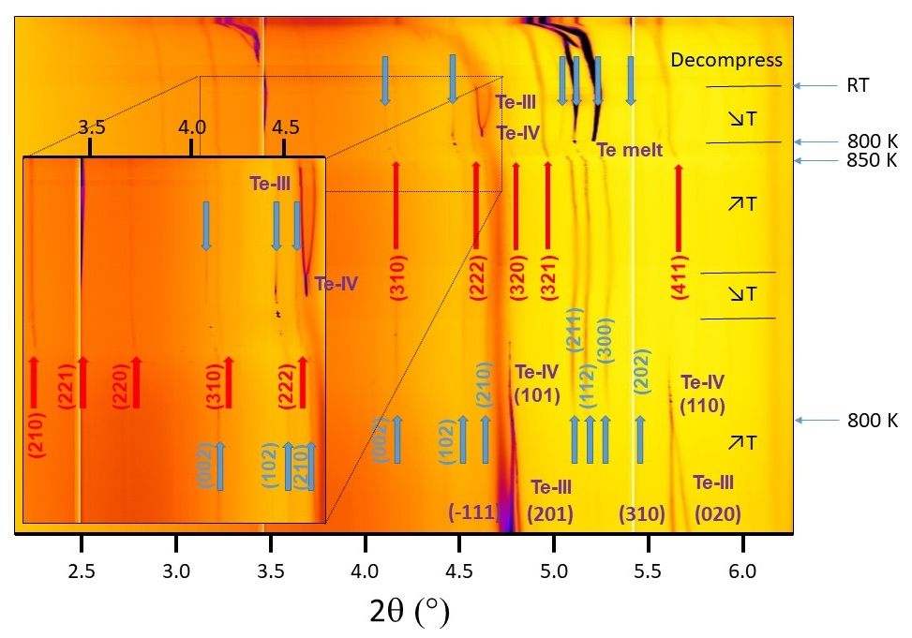

**Figure S1** Measured powder patterns in the run with the starting composition Si2:Te3 at 10 GPa ( = 0.23437 Å). The blue and red arrows indicate the reflections due to the phase *hex1* and Te8@(Si38Te8) clathrate (c*P*), respectively.

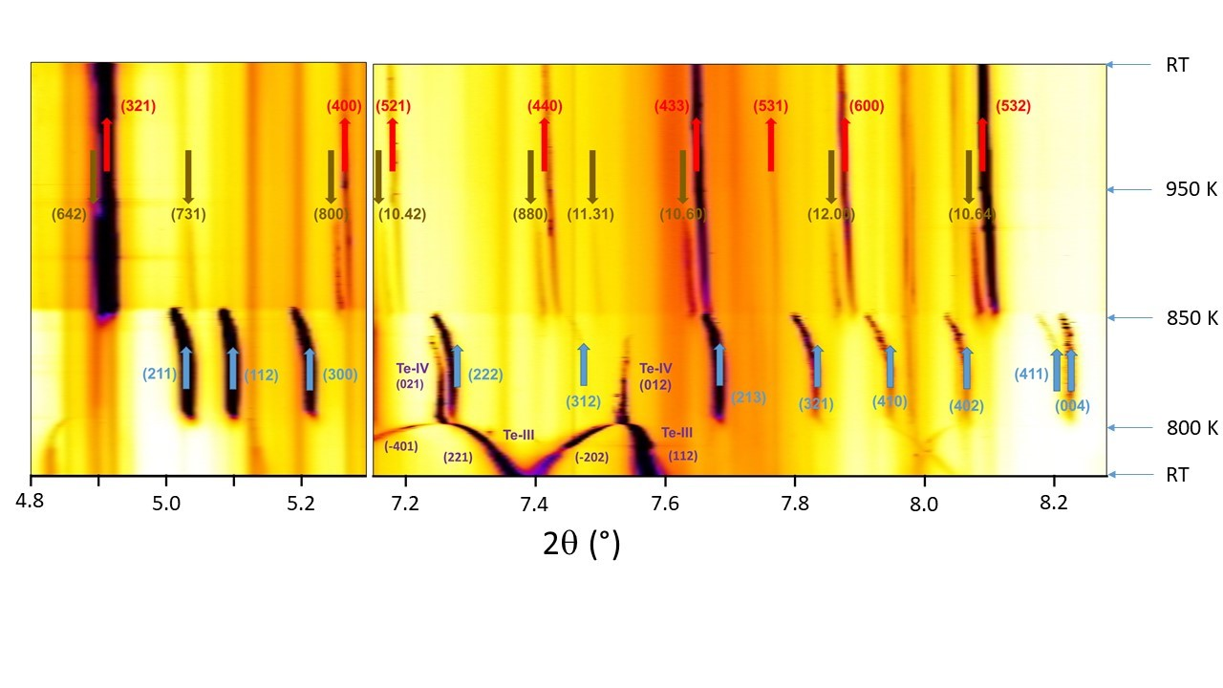

**Figure S2** Measured powder patterns in the run with the starting composition Si38:Te16 at 10 GPa ( = 0.23437 Å). The blue, brown, and red arrows indicate the reflections due to the phase *hex1*, Te7+xSi20-x (c*F*) and Te8@(Si38Te8) (c*P*) clathrates, respectively.

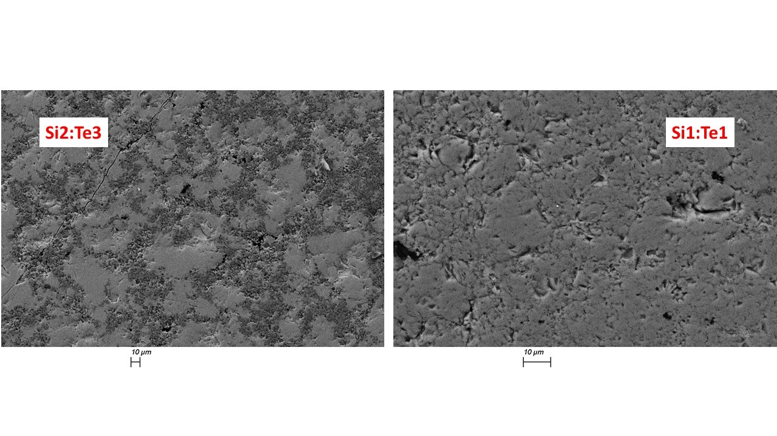

**Figure S3** SEM images showing the recovered samples with different starting compositions. In the run Si2:Te3, the light grey phase has the composition Si38Te18.7 while the dark grey one is Si0.14Te. The recovered light grey phase in the run with the starting Si:Te ratio 1:1 has the composition Si38Te14.9.

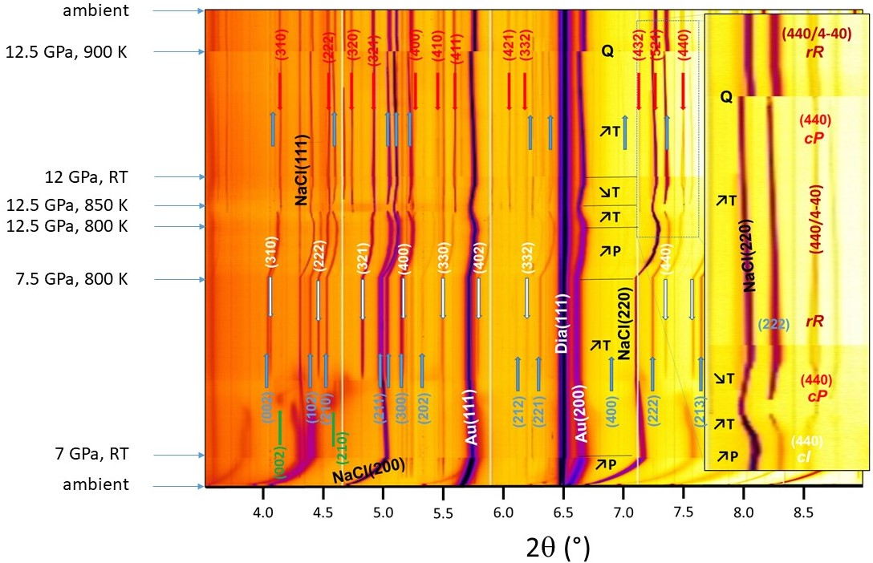

**Figure S4** Measured powder patterns in the run with the starting composition -Si2Te3 ( = 0.23482 Å). Reflections due to the phase *hex1*, c*I* and c*P* clathrates are marked in blue, white and red, respectively. The reflections marked in green are due to another hexagonal phase (*hex2*). The insert shows the evolution of the (222) and (440) reflections in the cubic clathrates at different *P*-*T* conditions, highlighting the reversible splitting to rhombohedral clathrate (r*R*).

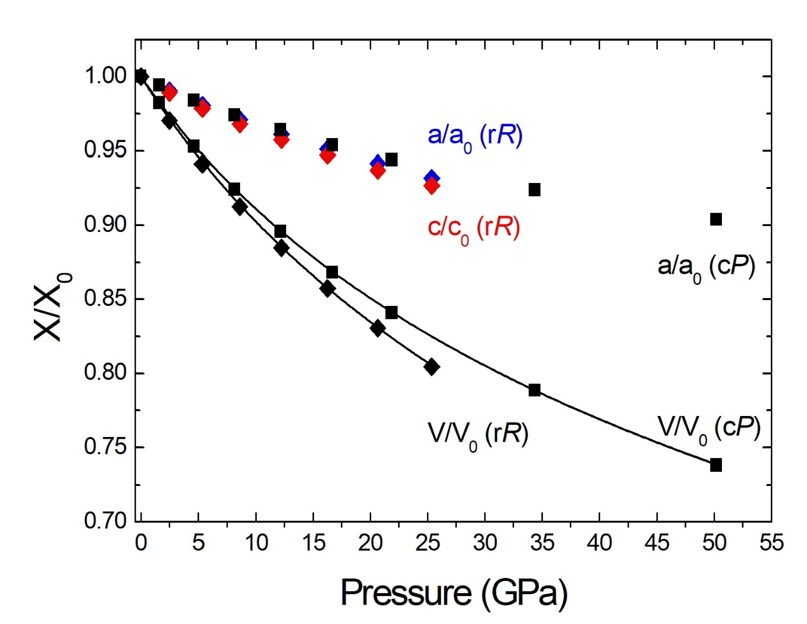

**Figure S5** Normalized lattice parameters and unit-cell volumes from theoretical predictions for the clathrates r*R* (diamonds) and c*P* (squares) taken from Tables S5 and S6. The solid lines are fits of the Birch-Murnaghan equations of state – r*R*: *V*0 = 1128.8(8) Å3, *B*0 = 82(1) GPa, *B*0’ = 3.4(1); c*P*: *V*0 = 1122.1(4) Å3, *B*0 = 88.8(5) GPa, *B*0’ = 4.09(3).