Enter the total surface area of the material and the percentage of Pt present at the unknown cathode

Execute the SVM-cubic classification program

{Level 1}-------------

Selecting cathode class

1. Pure Pt

2. rGO-CB-Pt

3. CB-Pt

4. GNP-CB-Pt

{Level 1}--------------

Achieve cyclic voltammetry diagrams

Achieve current density-voltage-power density diagrams

{Level 2}----

ECSA calculation

{Level 3}----

**Figure 1.**

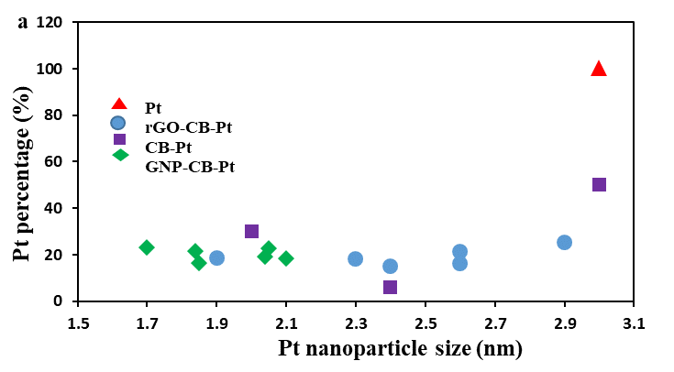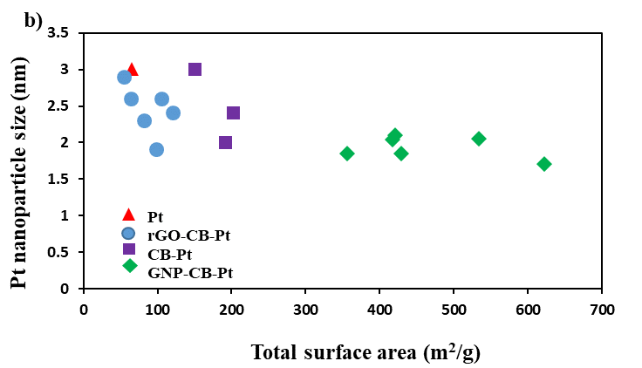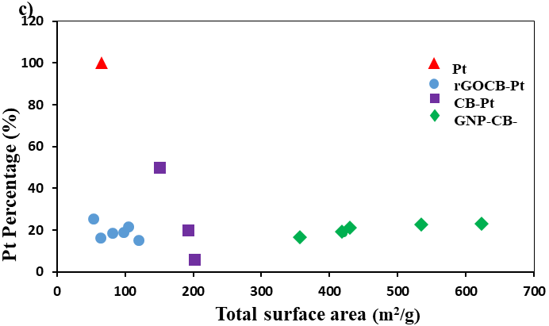

**Figure 2.**

**b)**

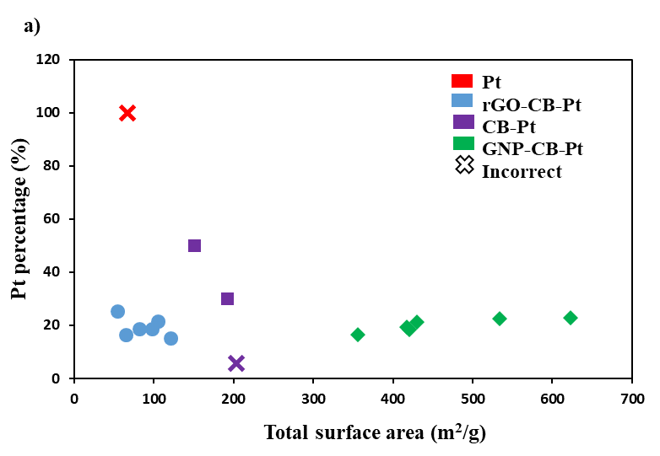

**Figure 3.**

**(b)**

**(a)**

**Figure 4. Cyclic voltammetry diagrams with test data for a) rGO-CB (H90-H60) and (b) GNP-CB (H90-H70) cathodes.**

**(a)**

**(b)**

**Figure 5. Current density-voltage-power density diagrams with test data for (a) rGO-CB (H90-H60) and (b) GNP-CB(H90-H70) cathodes.**