**Tape-cast Ce-substituted Li7La3Zr2O12 Electrolyte for Improving Electrochemical Performance of Solid-State Lithium Batteries**

Purna Chandra Rath, Yu-Syuan Jheng, Cheng-Chia Chen, Chih-Long Tsai, Yu-Sheng Su, Chun-Chen Yang, Rüdiger-A. Eichel, Chien-Te Hsieh, Tai-Chou Lee, Jeng-Kuei Chang

**Table S1.** Chemical composition of LLZO, LGLZO, and various LLZCO samples examined using ICP-MS.

|  |  |  |  |  |  |  |
| --- | --- | --- | --- | --- | --- | --- |
| Sample | Chemical formula | Li | La | Zr | Ce | Ga |
| LLZO | Li7La3Zr2O12 | 5.16 | 3.000 | 1.97 | NA | NA |
| LGLZO | Li6.25Ga0.25La3Zr2O12 | 4.18 | 3.000 | 2.00 | NA | 0.28 |
| LLZCO-0.05 | Li7La3Zr1.95Ce0.05O12 | 4.99 | 3.000 | 1.96 | 0.050 | NA |
| LLZCO-0.10 | Li7La3Zr1.90Ce0.10O12 | 5.02 | 3.000 | 1.90 | 0.095 | NA |
| LLZCO-0.15 | Li7La3Zr1.85Ce0.15O12 | 5.02 | 3.000 | 1.84 | 0.145 | NA |

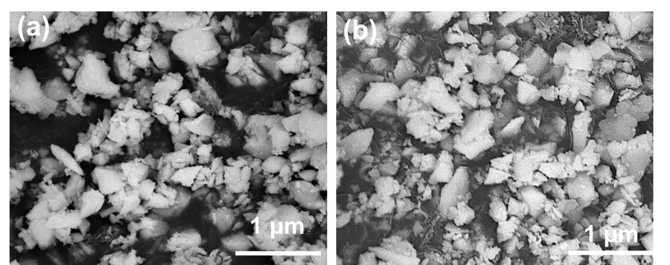

**Fig. S1.** SEM images of (a) LLZCO-0.05 and (b) LLZCO-0.15 samples.



**Fig. S2.** DLS data of LLZO, LGLZO, and various LLZCO samples.



**@0.1 C**

**Fig. S3.** Charge-discharge curves of Li//CSE//LFP cell with 25 wt.% LGLZO and EO/Li+ molar ratio of 5 in CSE.

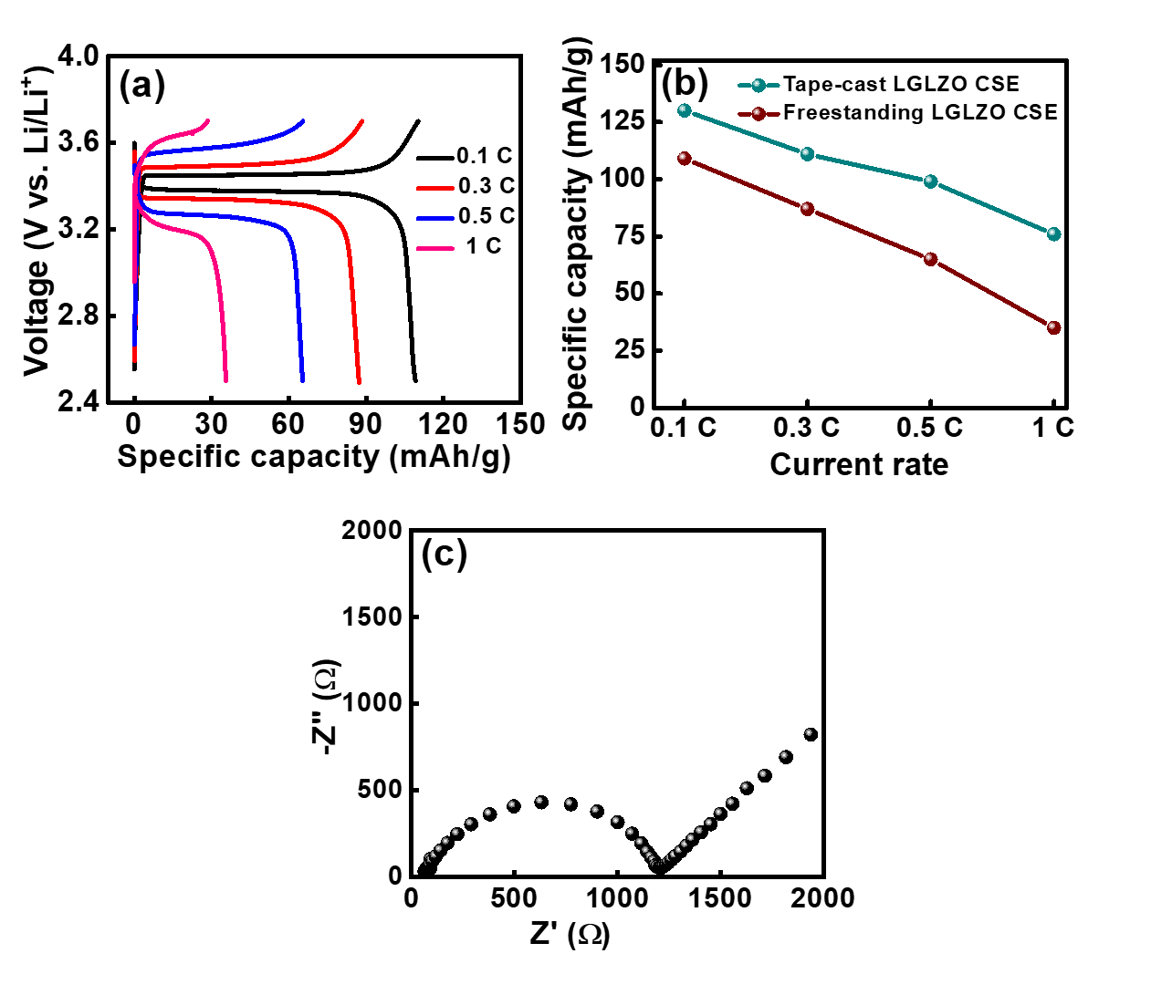

**Fig. S4.** (a) Charge-discharge curves of Li//LFP cell assembled with freestanding CSE. (b) Comparative rate performance of Li//LFP cells with freestanding and tape-cast CSE layers. (c) EIS spectra of Li//LFP cell assembled with freestanding CSE.

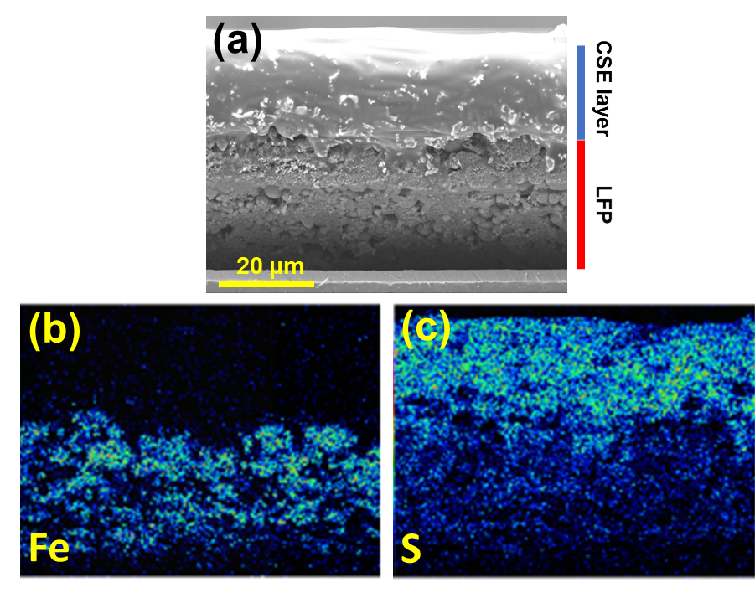

**Fig. S5.** (a) Cross-sectional SEM image of tape-cast CSE on LFP cathode. (b) The corresponding EDS Fe and S mapping in the same region.

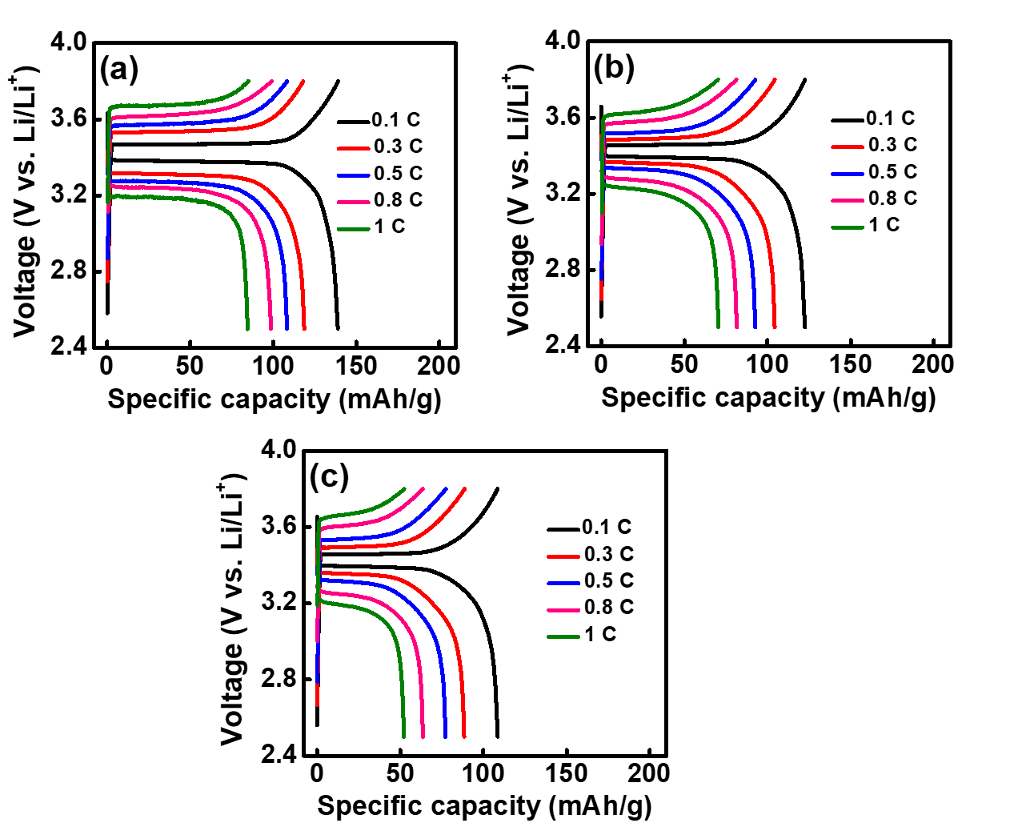

**Fig. S6.** Charge-discharge curves of Li//CSE (with EO/Li+ = 10 and 35 wt.% LGLZO)//LFP cell with CSE thickness of (a) 20, (b) 50, and (c) 80 µm.



**Fig. S7.** Overpotential derived from charge-discharge curves (in **Fig. 7**) of Li//CSE//LFP cells with various CSEs.

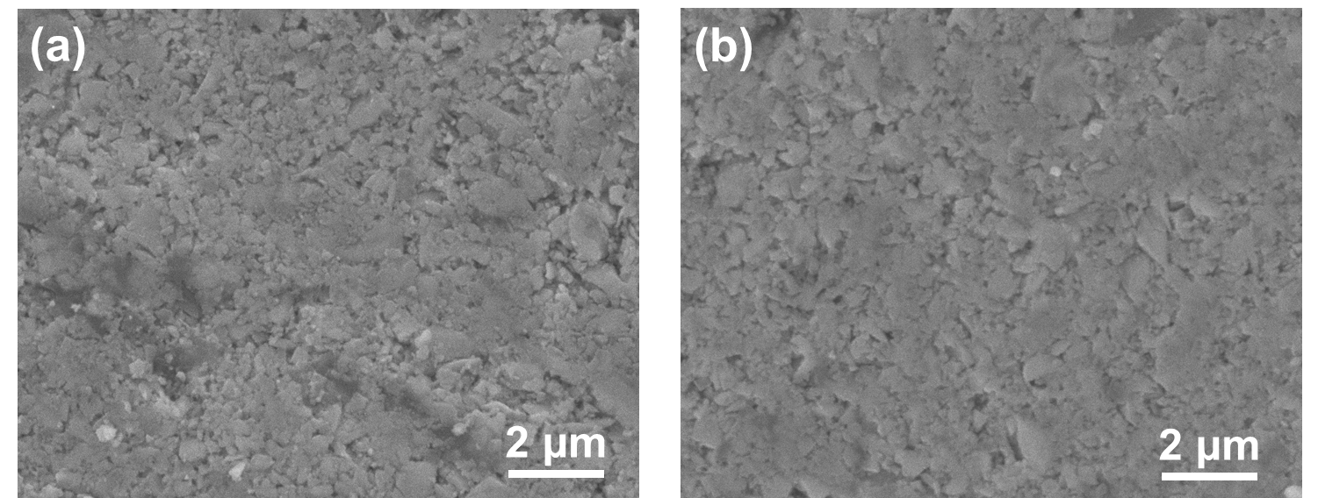

**Fig. S8.** SEM images of (a) LLZO (b) LLZCO-0.10 pellets after Li contact for 48 hours at 70 °C.

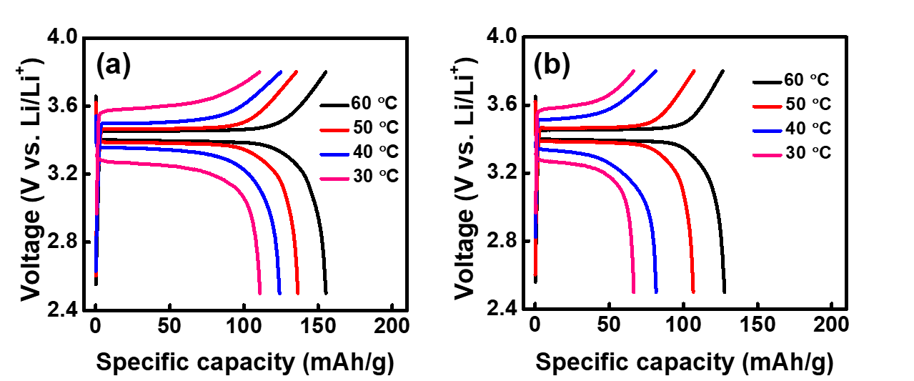

**Fig. S9.** Charge-discharge curves of Li//LLZCO-0.10 CSE//LFP cell measured at (a) 0.1 C and (b) 0.5 C at various temperatures.