**Tape-cast Ce-substituted Li7La3Zr2O12 Electrolyte for Improving Electrochemical Performance of Solid-State Lithium Batteries**

Purna Chandra Rath a‡, Yu-Syuan Jheng b‡, Cheng-Chia Chen a, Chih-Long Tsai c, Yu-Sheng Su d, Chun-Chen Yang e, Rüdiger-A. Eichel c,f, Chien-Te Hsieh g,*, Tai-Chou Lee b,*, Jeng-Kuei Chang a,h,*

a Department of Materials Science and Engineering, National Yang-Ming Chiao Tung University, 1001 University Road, Hsinchu 30010, Taiwan

b Department of Chemical and Materials Engineering, National Central University, 300 Jhong-Da Road, Taoyuan 32001, Taiwan

c Institut für Energie– und Klimaforschung (IEK–9: Grundlagen der Elektrochemie), Forschungszentrum Jülich, D–52425 Jülich, Germany

d International College of Semiconductor Technology, National Yang Ming Chiao Tung University, 1001 University Road, Hsinchu 30010, Taiwan

e Battery Research Center of Green Energy, Ming Chi University of Technology, New Taipei City 243, Taiwan

f Institut für Materialien und Prozesse für elektrochemische Energiespeicher– und wandler, RWTH Aachen University, D–52074 Aachen, Germany

g Department of Chemical Engineering and Materials Science, Yuan Ze University, Taoyuan 32003, Taiwan

h Department of Chemical Engineering, Chung Yuan Christian University, 200 Chung Pei Road, Taoyuan 32023, Taiwan

‡ PCR and YSJ contributed equally to this work.

* Corresponding authors:

Chien-Te Hsieh; Email: cthsieh@saturn.yzu.edu.tw

Tai-Chou Lee; Email: taichoulee@ncu.edu.tw

Jeng-Kuei Chang; E-mail: jkchang@nctu.edu.tw

**Abstract**

Solid-state lithium-metal batteries (SSLMBs) with a composite solid electrolyte (CSE) have great potential for achieving both high energy density and high safety and are thus promising next-generation energy storage devices. The current bottlenecks are a high electrode/electrolyte interface resistance and the limited Li+ conductivity of the solid electrolyte layer. To reduce the interface resistance, a tape casting method is used to directly deposit a CSE layer (~20 μm) onto a model LiFePO4 cathode. The CSE slurry infiltrates the cathode layer, forming a Li+ conduction network and ensuring intimate contact between the CSE and the cathode. The tape casting parameters, such as the polymer/Li salt ratio, inorganic filler fraction, and casting thickness, for the CSE layer are investigated. To increase Li+ conductivity, Ce substitution is conducted for Li7La3Zr2-*x*Ce*x*O12, *x* = 0−0.15. The effects of Ce content on the specific capacity, rate capability, and cycling stability of Li//CSE//LiFePO4 cells are systematically studied. Li7La3Zr1.9Ce0.1O12 (i.e., *x* = 0.1) is found to be the optimal composition; it outperforms Li7La3Zr2O12 and Li6.25Ga0.25La3Zr2O12 in terms of CSE conductivity and SSLMB charge-discharge performance.

**Keywords**: zirconium substitution, tape casting, composite solid electrolyte, Ce concentration, interface resistance

**1. Introduction**

The increasing demand for electric vehicles and grid-scale energy modulation has led to a need for energy storage devices with high energy/power densities, long cycle life, and high safety.1,2 Lithium-ion batteries (LIBs) currently play an important role in energy storage.3 However, the requirement for cells with higher energy density has prompted the utilization of a metallic Li anode owing to its high theoretical capacity (3860 mAh g−1) and low redox potential (−3.04 V vs. standard hydrogen electrode).4 The development of Li-metal batteries with a conventional liquid electrolyte has been hindered by Li dendrite formation, which leads to the safety concerns.5,6 A solid-state electrolyte (SSE) has great potential to overcome these limitations.7,8 Solid-state Li-metal batteries (SSLMBs) may thus achieve both high energy density and high safety. SSEs include solid polymer electrolytes (SPEs), such as those based on polyethylene oxide (PEO), poly(acrylonitrile), poly(vinylidene fluoride) (PVDF), and poly(vinylidene fluoride−hexafluoropropylene), and inorganic solid electrolytes (ISEs), such as sulfides, oxynitrides, NASICON compounds, perovskite oxides, and garnet oxides.9-10 However, an SPE or ISE alone may not be an optimal SSE. The low ionic conductivity, unsatisfactory mechanical properties, and insufficient oxidation stability restrict the use of SPEs,9 while ISEs are usually fragile and difficult to fabricate and are thus unfavorable for practical applications.10 Accordingly, composite solid electrolytes (CSEs), composed of a polymer phase, Li salt, and Li+-conducting inorganic filler, have become a promising alternative.11-12 The polymer phase has good flexibility, plasticity, and wettability toward electrodes.13 The ceramic filler provides high Li+ conductivity and enhances the mechanical strength of the CSE to suppress Li dendrite propagation.14-15 A CSE thus combines the merits of SPEs and ISEs, endowing SSLMBs with desirable charge-discharge properties. Nevertheless, the poor interfacial contact between a CSE and electrodes must be overcome.16 The unsatisfactory interfacial compatibility hinders Li+ transport across the substances, limiting battery performance. In addition, the CSE thickness must be reduced because a CSE with a thickness of dozens of micrometers, a commonly reported value, can lead to high electrolyte resistance. These issues are addressed in this work.

Several approaches for improving the cathode/solid electrolyte contact have been proposed.17-19 Simple low-temperature heating and hot-pressed stacking are not sufficient for attaining an intimate contact at the interface.20,21 Some studies used high-temperature (> 700 °C) sintering to improve the contact between an oxide electrolyte and LiCoO2.18,22,23 However, high-temperature annealing can cause inter-diffusion, secondary phase formation, and cathode decomposition,18,24  which are detrimental to cell performance. The spin coating of a CSE onto a cathode electrode has been examined;25,26 unfortunately, this process is not easily scalable. Several research groups have adopted various liquids, gels, and polymers to mitigate the interface problems.27-29 However, a more facile, cost-effective, and scalable method for improving the electrode/solid electrolyte contact is highly desirable.

An inorganic filler material is also important for CSEs. Among various Li+-conducting fillers, garnet-structure Li7La3Zr2O12 (LLZO) has received a lot of research attention due to its adequate Li+ conductivity, excellent chemical stability with metallic Li, and wide electrochemical stability window (> 5 V vs. Li+/Li).15,23 LLZO has two kinds of polymorph, namely a tetragonal polymorph (*I*41*/acd*) and a cubic polymorph (*Ia* or *I*3*d*, depending on synthesis conditions).30 The latter polymorph has a Li+ conductivity that is about two orders of magnitude higher than that of the former one.30 Accordingly, many efforts have been made to produce the cubic phase and promote Li+ conduction, which can be achieved by incorporating various substituents.15,31 For example, the substitution of Al3+ and Ga3+ at the Li+ site has been conducted to stabilize the cubic structure and lower the calcination temperature.31-33 However, a high degree of substitution at the Li+ site can lead to the blockage of Li+ transport pathways.34 Hence, substitution at the Zr4+ site is favorable for increasing the Li+ conductivity of LLZO.31,35-38 It has been reported that the substitution of an element with a larger ionic radius can enlarge the channel size for Li+ migration and thus increase Li+ mobility.36-38 Chen *et al*. used molecular dynamic simulation to compare the bottleneck size for Li+ diffusion in LLZO crystals with various substitutions.39 They found that Ce4+ substitution is particularly promising; Li7La3Ce2O12 showed the largest bottleneck size and the lowest activation energy for Li+ migration.39 Only two experimental works have examined Ce-substituted LLZO.38,40 Rangaswamy *et al*. considered the Ce4+ substitution at the La3+ site.40 However, no pure garnet phase was found. Due to the solubility limit, a CeO2 impurity phase was observed. The ionic conductivity of the Ce-substituted LLZO was as low as 0.014 mS cm−1. In contrast, Dong *et al*. showed that Ce4+ can be substituted at the Zr4+ site to stabilize the cubic phase.38 The Li7La3Zr1.75Ce0.25O12 sample showed a promising ionic conductivity of 1.2 × 10−4 S cm−1 at 50 °C, which is ~1.5 orders of magnitude more than that of pristine LLZO. Moreover, the great cycling stability of a Li//Li7La3Zr1.75Ce0.25O12//Li symmetric cell was demonstrated. The inconsistent results reported in the literature indicate that further investigation is needed. Importantly, neither cathode compatibility nor Li-metal full-cell performance using a Ce-substituted LLZO electrolyte has been examined. These topics are worthy of examination.

In the present work, we use a tape casting method to directly deposit a CSE layer onto a model cathode, namely a lithium iron phosphate (LFP) cathode. During the tape casting, the CSE slurry infiltrates the cathode layer, achieving an intimate interfacial contact and creating a Li+-conducting network within the cathode. In the first part of this paper, the tape casting parameters, namely the polymer/Li salt ratio, inorganic filler fraction, and casting thickness of the CSE layer, are optimized. Tape casting is cost-effective and suitable for mass production. Moreover, the coating thickness can be easily controlled. In the second part of this paper, various Li7La3Zr2-*x*Ce*x*O12 samples (*x* = 0−0.15) are synthesized. The effects of Ce content on the specific capacity, rate capability, and cycling stability of Li//CSE//LFP cells are investigated in detail.

**2. Experimental procedures**

*Synthesis of Ga-substituted and Ce-substituted LLZO samples*

LLZO-based samples were synthesized using a solid-state reaction method. Li2CO3, La2O3, and ZrO2 precursorswere used, with a 10% excess of Li2CO3 in the stoichiometric ratio to compensate for Li loss during calcination. Ga2O3 and CeO2 were employed for Ga- and Ce-substitutions, respectively. All the ingredients were mixed thoroughly via ball milling for 12 h in ethanol solution. The resulting materials were dried at 80 °C and then calcined under air at 900 °C for 10 h to produce powdery samples with various chemical compositions. The Li7La3Zr2O12, Li6.25Ga0.25La3Zr2O12, Li7La3Zr1.95Ce0.05O12, Li7La3Zr1.90Ce0.10O12, and Li7La3Zr1.85Ce0.15O12 samples are denoted as LLZO, LGLZO, LLZCO-0.05, LLZCO-0.10, and LLZCO-0.15, respectively.

*Fabrication of CSE layers and cell assembly*

A cathode slurry was prepared by mixing 80 wt.% LFP powder, 10 wt.% carbon black, and 10 wt.% PVDF in *N*-methyl-*2*-pyrrolidone solution. This slurry was pasted onto Al foil and vacuum-dried at 110 °C for 12 h. The LFP mass loading and density were ~6 mg cm−2 and ~2 g cm−3, respectively. To fabricate the CSE layer, PEO (Mw: ~1000000) and lithium bis(trifluorosulfonyl)imide (LiTFSI) at various molar ratios (EO/Li+ = 5, 10, or 15; PEO+LiTFSI = 2.5 g) were dissolved in 25 g of acetonitrile solvent with continuous stirring at 60 °C for 2 h to obtain a uniform solution. Then, various amounts of oxide powder (i.e., 25 wt.%, 35 wt.%, 45 wt.%, and 55 wt.% of solid content) were added into the above solution, which was stirred for another 1 h. This CSE slurry was tape-cast onto the LFP cathode. Briefly, the slurry was dispensed on the LFP layer and the height is controlled by an adjustable doctor blade. Unless otherwise specified, a doctor blade gap of 1000 µm was used to produce a CSE thickness of ~20 µm. The obtained sample was then dried in a vacuum oven at 65 °C for 12 h to vaporize the solvent. A conventional freestanding CSE was also fabricated for comparison. The preparation procedures are the same as mentioned above, except that a glass (rather than LFP) substrate was used. This CSE was then separated from the glass substrate after drying, forming a freestanding layer. The electrode/electrolyte combined lamella was pressed and punched to match the required dimensions of a CR2032 coin cell. A thin Li metal foil was used as the negative electrode. The coin cell was assembled in an argon-filled glove box (Innovation Technology Co. Ltd.), where both the moisture and oxygen content levels were maintained at ~0.1 ppm.

*Material and electrochemical characterization*

X-ray diffraction (XRD) was conducted using a Bruker D2 Phaser diffractometer. Cu Kα radiation was used as the X-ray source. The sample microstructures were examined with scanning electron microscopy (SEM, FEI Inspect F50) and transmission electron microscopy (TEM, JEOL 2100F). To evaluate the particle size, a dynamic light scattering (DLS) measurement was performed using a Beckman Coulter analyzer. The chemical compositions of the samples were quantitatively determined using inductively coupled plasma-mass spectroscopy (ICP-MS). X-ray photoelectron spectroscopy (XPS, Thermo Fisher Scientific ESCALAB Xi+) was used to examine the surface chemistry of various samples. Al K*α* radiation (1486.6 eV) was employed as the X-ray source. The data fitting was conducted using the XPSPEAK 4.1 software. Electrochemical impedance spectroscopy (EIS) analyses of the cells were conducted using a Biologic VSP-300 workstation within a frequency range of 106–10−2 Hz at a full discharge state; the voltage perturbation amplitude was 10 mV. The electrochemical properties, such as charge-discharge capacity, rate capability, and cycling stability, of the cells were evaluated using an Arbin BT-2043 battery tester. The electrochemical measurements were conducted at 60 °C unless otherwise specified. For each kind of cell, at least five coin cells were measured. The capacity deviation was typically within 5%. The reported data are the median values.

**3. Results and discussion**

**Fig. 1(a)−(c)** show SEM images of LLZO, LGLZO, and LLZCO-0.10 powders, respectively. The SEM micrographs for LLZCO-0.05 and LLZCO-0.15 are shown in **Fig. S1**. Granular oxide particles were observed in samples calcined at 900 °C. No significant difference between the various samples was observed, indicating that the Ga and Ce dopants did not alter morphology. The DLS data in **Fig. S2** reveal that the particle size of the various samples is mainly around 1 µm. The ICP-MS data in **Table S1** show that the chemical compositions of the LLZCO samples well match the designed Ce/Zr stoichiometric ratios. **Fig. 1(d)** shows the XRD patterns of the various synthesized powders. All the diffraction peaks belong to the cubic garnet phase (JCPDS 00-063-1074); no impurity signals were found. The lattice constants of LLZO, LGLZO, LLZCO-0.05, LLZCO-0.10, and LLZCO-0.15 are 13.035(4), 13.018(2), 13.048(3), 13.073(2), and 13.097(3) Å, respectively. Ga substitution reduced the lattice size, which is associated with Ga3+ having a smaller ionic radius than that of the substituted Li+. With increasing Ce content, the lattice constant increased because the radius of Ce4+ (0.94 Å) is larger than that of Zr4+ (0.72 Å). These results confirm the successful substitution of Ce into the LLZO lattice.

**Fig. 2(a)** shows a TEM bright-field image of the LLZCO-0.10 sample. Its cubic garnet structure is confirmed by the electron diffraction pattern shown in **Fig. 2(b)**. **Fig. 2(c)** shows a high-resolution lattice image of LLZCO-0.10; the lattice fringe with a spacing of 0.65 nm is associated with the (002) plane distance of the garnet crystal. **Fig. 2(d)** shows the fast Fourier transform (FFT) pattern along the [120] zone, which is consistent with the above phase identification results. A high-angle annular dark-field (HAADF) image and the corresponding EDS mapping data are shown in **Fig. 2(e)−(i)**. The results indicate a homogeneous distribution of La, Zr, Ce, and O among the sample.

The optimal CSE tape casting conditions (i.e., the polymer/Li salt ratio, ceramic filler fraction, and casting thickness) on the LFP cathode were first determined. In this section, the LGLZO filler was used, because LGLZO is a benchmark material of garnet-type Li+ conductor. **Fig. 3(a)** and **(b)** show the electrochemical performance of the cells with EO/Li+ molar ratios of 10 and 15, respectively, in the CSE (with 25 wt.% LGLZO). When the EO/Li+ ratio was 5, the mechanical strength of this CSE was insufficient, leading to abnormal charge-discharge curves (see **Fig. S3**). The potential fluctuation indicates a partially internal short circuit of the cell. An EO/Li+ ratio of 10 led to the best cell performance; a further increase of the EO/Li+ ratio to 15 decreased the LFP capacities, especially at high rates (**Fig. 3(a)** and **(b)**). An optimal polymer-to-Li salt ratio ensures adequate mechanical strength and ionic conductivity of the CSE. The incorporation of a proper amount of LiTFSI decreases the crystallinity of PEO, increasing the segmental motion of the polymer chains and thus enhancing Li+ mobility.41 EIS was used to examine the impedance characteristics of the two cells. The obtained spectra and the equivalent circuit used to fit the EIS data are shown in **Fig. 3(c)**. The *R*e, *R*ct, *CPE*, and *W* in the circuit are the electrolyte resistance, interfacial charge transfer resistance, interfacial constant-phase element, and Warburg impedance associated with Li+ diffusion within the electrode, respectively.42 The *CPE* component that considers surface inhomogeneity and non-ideal interfacial double-layers can involve ion transfer (the *CPE* *n* values are shown in **Table 1**). In addition, the charge transfer reaction (related to *R*ct) requires ion conduction to proceed. As shown in **Table 1**, the *R*e and *R*ct values of the cells increased when the EO/Li+ ratio was increased from 10 to 15. The reduced concentration of the charge carrier, Li+, decreased the CSE ionic conductivity. In addition, the excessive PEO may increase the crystallinity and rigidity of the polymer phase, which is detrimental to the electrolyte/electrode interface contact,43 and thus increases *R*ct. Moreover, a high PEO content increased viscosity of the slurry, making it more difficult to infiltrate the cathode layer. The EIS data explain the superior charge-discharge performance of the cell with an EO/Li+ ratio of 10.

To verify the advantages of the tape casting method over a conventional CSE preparation method (i.e., the CSE layer is fabricated separately from the cathode layer), a freestanding CSE (with the same EO/Li+ ratio of 10 and 25 wt.% LGLZO; ~100 μm in thickness) was prepared. **Fig. S4(a)** shows the charge-discharge curves of a Li//LFP cell with this freestanding CSE. As compared in **Fig. S4(b)**, the specific capacities and rate capability of the Li//CSE//LFP fabricated using the proposed tape casting method are substantially higher than those of the cell with the freestanding CSE. As schemed in **Fig. 4**, the tape-cast CSE (but not the freestanding counterpart) can effectively percolate through the cathode layer, establishing Li+ conduction pathways therein. This improves LFP utilization and thus results in the superior battery performance. Moreover, the tape casting method ensures intimate contact between the CSE and the cathode. The tight interface minimizes the contact resistance and enhances Li+ transport across the interface.As shown in the cross-sectional SEM image in **Fig. S5(a)**, the tape-cast CSE thickness is approximately 20 μm and well connects to the LFP cathode. The EDS Fe and S (presenting the existence of CSE) mapping results in **Fig. S5(b)** and **(c)**) confirms that the CSE indeed infiltrates the cathode layer. **Fig. S4(c)** shows that the *R*ct value of the Li//freestanding CSE//LFP cell is ~1200 Ω, which is significantly higher than that (380 Ω) of the Li//tape-cast CSE//LFP cell (see **Fig. 3 (c)**). This explains the clearly better rate capability of the latter cell. Of note, the tape casting technique is facile and cost-effective, making it promising for SSLMB fabrication.

**Fig. 5(a)−(d)** show the charge-discharge curves of the cells with CSEs with 25 wt.%, 35 wt.%, 45 wt.%, and 55 wt.% LGLZO, respectively (an EO/Li+ ratio of 10 was used). The reversible capacities measured at various rates are compared in **Fig. 5(e)**. An insufficient LGLZO fraction (**Fig. 5(a)**) results in inferior reversible capacities. Because LGLZO facilitates the transport of Li+ ions,33 increasing the LGLZO fraction leads to the formation of more effective Li+ conduction pathways. Moreover, an increase in the number of LGLZO particles decreases the crystallinity of PEO, promoting Li+ mobility in the polymer domain.44 As a consequence, the optimal cell performance is achieved with 35 wt.% LGLZO in the CSE (**Fig. 5(b)**). Further addition of LGLZO led to deterioration of the charge-discharge properties (**Fig. 5(c)** and **(d)**). As shown in the optical microscopy and SEM images in **Fig. 6**, excessive amounts (i.e., 45 wt.% and 55 wt.%) of LGLZO caused oxide agglomeration and roughening of the CSEs. The inhomogeneous distribution of oxide particles does not effectively decrease PEO crystallinity and thus is detrimental to Li+ conductivity. In addition, a rough and non-uniform CSE deteriorates the interface contact with the electrodes. These arguments are well supported by the EIS data (**Fig. 5(f)** and **Table 1**), which show that the *R*e and *R*ct values both increase when the LGLZO fraction is 45 wt.% or 55 wt.%. This explains the inferior charge-discharge performance for these fractions compared to that for the cell with 35 wt.% LGLZO in the CSE.

The effects of the CSE thickness were investigated (with EO/Li+ = 10 and 35 wt.% LGLZO). **Fig. S6** shows the obtained charge-discharge curves measured at various rates. Doctor blade gaps of 1000, 1500, and 2000 µm were employed to produce final CSE thicknesses (after drying) of 20, 50, and 80 µm, respectively. It is noted that the final CSE thicknesses are not proportional to the doctor-blade gaps. This is associated with the fact that the initial CSE slurry infiltrated the cathode layer. Further reduction of the doctor blade gap did not yield a uniform coating, and thus the corresponding CSE was unable to electronically separate the positive and negative electrodes. The cell with a 20-µm CSE exhibited the best performance; the reversible capacities of LFP at 0.1 and 1 C were 139 and 84 mAh g−1, respectively. An increase in CSE thickness led to an increase in the electrolyte resistance and thus degraded the charge-discharge capacities. The SSE thickness of 20 µm is among the lowest values reported in the literature.45-48 A thin electrolyte is favorable for shortening the Li+ transport distance and is beneficial for achieving a high energy density of the cell (since electrolyte weight and volume are reduced).46,48 Importantly, the proposed tape casting method for fabricating CSEs is reliable and can be easily scaled up for mass production. The optimized tape casting parameters (i.e., an EO/Li+ ratioof 10, 35 wt.% oxide filler, and a doctor blade gap of 1000 µm) were used for further LLZCO investigation.

The effects of Ce doping on the Li//CSE//LFP cell performance were examined. **Fig. 7(a)−(e)** show the obtained charge-discharge profiles of various cells with CSEs that consist of different chemical compositions of the oxide fillers. At 0.1 C, the reversible LFP capacities of the LLZO, LGLZO, LLZCO-0.05, LLZCO-0.10, and LLZCO-0.15 cells are 118, 139, 142, 155, and 149 mAh g−1, respectively. As shown in **Fig. 7(f)**, the specific capacities decrease with increasing C rate due to the kinetic limitations and internal cell resistance. The capacities decreased to 60, 84, 89, 105, and 95 mAh g−1 at 1 C, respectively, corresponding to 51%, 60%, 62%, 68%, and 64% retention compared to the values measured at 0.1 C. **Fig. S7** shows a histogram that compares the overpotential at various charge-discharge rates for different cells. A proper Ce substitution concentration clearly benefits the cell charge-discharge performance. Of note, the LLZCO-0.10 filler outperforms not only LLZO but also LGLZO, which is known to be a promising garnet material with high Li+ conductivity.33 EIS was used to examine the impedance characteristics of various cells; the obtained spectra and the fitting results are shown in **Fig. 7(g)** and **Table 1**, respectively. As summarized in **Table 1**, the LLZCO-0.10 CSE exhibits the highest ionic conductivity (5.5 × 10−4 S cm−1) among the electrolytes studied. The Ce4+ substitution at the Zr4+ site increases the lattice size and the Li+ diffusion channel size.39 Thus, Li+ mobility and conductivity are improved. However, we found that an excessive Ce concentration (i.e., that in LLZCO-0.15) decreased ionic conductivity. A high substitution concentration can cause a large structural distortion of the garnet crystal, which may hinder Li+ transport along the octahedral sites.36,37 **Table 1** also indicates that the *R*ct values are affected by the substitution type and concentration. The cells with Ce-substituted LLZO CSEs show clearly lower *R*ct values than those of cells with LLZO and LGLZO CSEs. According to Dong *et al*.,38 the Ce dopant can reduce the interfacial resistance toward the Li metal electrode, which is associated with the formation of a Ce4O7 interlayer that improves lithophilicity and enhances Li+ transport across the substances. The lowest *R*ct value was found for the cell with an LLZCO-0.10 CSE. Further increasing the Ce concentration may lead to redundant Ce4O7, which could impede Li+ conduction, increasing *R*ct. The rate capability of the Li//LLZCO-0.10 CSE//LFP cell, which had the lowest *R*e and *R*ct values, is thus among the best reported in the literature.42,49-53 These data reveal the great potential of the Ce-doped LLZO for SSLMB applications.

**Fig. 7(h)** shows that the Li//CSE//LFP cells with LLZO, LGLZO, LLZCO-0.05, LLZCO-0.10, and LLZCO-0.15 electrolyte fillers, respectively, exhibit 65%, 62%, 71%, 79% and 80%, capacity retention after 300 cycles. The chemical composition of the filler substantially affects cell cyclability. The root causes for the capacity deterioration were examined using EIS; the variation of the *R*e and *R*ct values versus the cycle number is shown in **Fig. 7(i)**. The undesirable interactions between the Li metal electrode and the CSE could consume Li+ in the polymer phase 54 and deteriorate the oxide filler, increasing the *R*e value. In addition, the side reaction products could accumulate at the interface, increasing *R*ct. It was reported that the highly oxophilic Li metal can drive the reduction of the oxide filler; the formed oxygen-deficient interphase layer is charge-compensated by Zr4+ reduction.55 It was also reported that doped Ga3+ at the Li+ site is remarkably reduced at the Li/oxide interface.56 The LGLZO cell thus showed the largest increase in *R*e and *R*ct during cycling, which led to it having the worst capacity retention. To examine the Zr4+ reduction, the LLZO and LLZCO-0.10 powders were pressed to become pellets, which were contacted with Li metal foil at 70 °C under argon. After 48 hours, the Li foil was carefully peeled off and the pellets were analyzed using SEM and XPS. **Fig. S8** showsthatthe morphologies of the two pellets after Li contact have no significant difference. However, **Fig. 8(a)** and **(b)** reveal a clear reduction of Zr4+ to Zr3+ for the LLZO sample. In contrast, a much less extent of Zr4+ reduction was found for the LLZCO-0.10 (**Fig. 8(c)** and **(d)**). These experimental data explain the stable *R*e and *R*ct values and the improved cell durability.

**Fig. S9** shows the effects of temperature on the charge-discharge properties of the Li// LLZCO-0.10 CSE//LFP cell. Usually, thick freestanding PEO-based electrolytes perform well only at an elevated temperature (~60 °C) due to high resistance at lower temperatures.12,13 With the tape casting method, a thin CSE and an intimate contact of CSE//LFP can be achieved. Moreover, the Ce-doped LLZO filler provides high Li+ conductivity (both *R*e and *R*ct are reduced). Thus, great charge-discharge performance even at relatively low temperature was observed for our cell. For instance, the measured specific capacity of LFP at 30 °C was ~110 mAh g−1, which is considerably higher than the values reported in the literature.57-59 The proposed CSE fabrication and Ce doping strategies are promising for practical SSLMBs. If the Li+ conductivity of the polymer phase can be improved, higher battery performance can be expected.

**4. Conclusions**

A facile and cost-effective tape casting method was used to coat a 20-μm-thick CSE directly onto an LFP cathode. The effects of the EO/Li+ ratio and the oxide filler fraction on battery performance were examined. The advantages of a tape-cast CSE over a freestanding CSE in terms of reducing the interface resistanceand increasing the specific capacity of LFP were clearly revealed. We synthesized Li7La3Zr2-*x*Ce*x*O12 (*x* = 0−0.15) with various Ce concentrations and used the resulting CSEs for a full-cell study. LLZCO-0.10 is the optimal composition among the Ce-doped samples in terms of the *R*e, *R*ct, charge-discharge capacities, and rate capability of the cell. It was found that the LLZCO-0.10 filler outperformed LLZO and LGLZO. The Ce doping also improved cell cycling stability, suggesting that Ce4+ at the Zr4+ site can mitigate the Zr4+ reductive decomposition upon contact with the Li metal electrode. We believe that the proposed interface enhancement and Ce doping approach are feasible and cost-effective for greatly increasing SSLMB performance.

**CRedit authorship contribution statement**

Purna Chandra Rath: Investigation, Data curation, Formal analysis, Writing - original draft

Yu-Syuan Jheng: Methodology, Investigation, Formal analysis, Data curation

Cheng-Chia Chen: Investigation, Formal analysis, Data curation

Chih-Long Tsai: Formal analysis, Writing- review & editing

Yu-Sheng Su: Investigation, Formal analysis

Chun-Chen Yang: Investigation, Formal analysis

Rüdiger-A. Eichel: Writing- review & editing

Chien-Te Hsieh: Formal analysis, Writing- review & editing

Tai-Chou Lee: Conceptualization, Writing- review & editing, Supervision, Funding, Resource

Jeng-Kuei Chang: Conceptualization, Data curation, Writing- review & editing, Supervision, Funding, Resource

**Acknowledgements**

The financial support provided for this work by the National Science and Technology Council (NSTC) of Taiwan is gratefully appreciated.

**Declaration of interests**

The authors declare no competing financial interests.

**References**

1. C. Liu, F. Li, L. P. Ma and H. M. Cheng, *Adv. Mater.*, 2010, **22**, E28–62.
2. H. D. Yoo, E. Markevich, G. Salitra, D. Sharon and D. Aurbach, *Mat. Today*, 2014, **17**, 110–121.
3. M. Li, J. Lu, Z. Chen and K. Amine, *Adv. Mater.*, 2018, 30,1800561.
4. J. Lang, L. Qi, Y. Luo and H. Wu, *Energy Storage Mater.*, 2017, **7**, 115–129.
5. D. Cao, X. Sun, Q. Li, A. Natan, P. Xiang and H. Zhu, *Matter*, 2020, **3**, 57–94.
6. Y. Chen, Y. Luo, H. Zhang, C. Qu, H. Zhang and X. Li, *Small Methods*, 2019, **3**,1800551.
7. Q. Zhao, S. Stalin, C. Z. Zhao and L. A. Archer, *Nat. Rev. Mater.*, 2020, **5**, 229–252.
8. O. Sheng, C. Jin, X. Ding, T. Liu, Y. Wan, Y. Liu, J. Nai, Y. Wang, C. Liu and X. Tao, *Adv. Funct. Mater.*, 2021, **31**, 2100891.
9. H. Wang, L. Sheng, G. Yasin, L. Wang, H. Xu and X. He, *Energy Storage Mater.*, 2020, **33**, 188–215.
10. J. C. Bachman, S. Muy, A. Grimaud, H. H. Chang, N. Pour, S. F. Lux, O. Paschos, F. Maglia, S. Lupart, P. Lamp, L. Giordano and Y. S. Horn, *Chem. Rev.*, 2016, **116**, 140–162.
11. S. Li, S. Q. Zhang, L. Shen, Q. Liu, J. B. Ma, W. Lv, Y. B. He and Q. H. Yang, *Adv. Sci.*, 2020, **7**, 1903088.
12. Y. Zheng, Y. Yao, J. Ou, M. Li, D. Luo, H. Dou, Z. Li, K. Amine, A. Yu and Z. Chen, *Chem. Soc. Rev.*, 2020, **49**, 8790–8839.
13. W. Q. Ding, F. Lv, N. Xu, M. T. Wu, J. Liu and X. P. Gao, *ACS Appl. Energy Mater.*, 2021, **4**, 4581–4601.
14. F. Croce, L. Persi, B. Scrosati, F. S. Fiory, E. Plichta, M. A. Hendrickson, *Electrochim. Acta* 2001,**46,** 2457–2461
15. A. J. Samson, K. Hofstetter, S. Bag and V. Thangadurai, *Energy. Environ. Sci.*, 2019, **12**, 2957–2975.
16. F. Lv, Z. Wang, L. Shi, J. Zhu, K. Edström, J. Mindemark and S. Yuan, *J. Power Sources*, 2019, **441**, 227175.
17. J. Sastre, X. Chen, A. Aribia, A. N. Tiwari and Y. E. Romanyuk, *ACS Appl. Mater. Interfaces*, 2020, **12**, 36196–36207.
18. G. Vardar, W. J. Bowman, Q. Lu, J. Wang, R. J. Chater, A. Aguadero, R. Seibert, J. Terry, A. Hunt, I. Waluyo, D. D. Fong, A. Jarry, E. J. Crumlin, S. L. Hellstrom, Y. M. Chiang and B. Yildiz, *Chem. Mater.*, 2018, **30**, 6259–6276.
19. J. Sastre, T. Y. Lin, A. N. Filippin, A. Priebe, E. Avancini, J. Michler, A. N. Tiwari, Y. E. Romanyuk and S. Buecheler, *ACS Appl. Energy Mater.*, 2019, **2**, 8511–8524.
20. J. H. Seo, Z. Fan, H. Nakaya, R. Rajagopalan, E. D. Gomez, M. Iwasaki and C. A. Randall, *Jap. J. Appl. Phy.*, 2021, **60**,37001.
21. R. J. Chen, Y. B. Zhang, T. Liu, B. Q. Xu, Y. H. Lin, C. W. Nan and Y. Shen, *ACS Appl. Mater. Interfaces*, 2017, **9**, 9654–9661.
22. T. Kato, T. Hamanaka, K. Yamamoto, T. Hirayama, F. Sagane, M. Motoyama and Y. Iriyama, *J. Power Sources*, 2014, **260**, 292–298.
23. C. L. Tsai, S. Yu, H. Tempel, H. Kungl, and R. A. Eichel, *Mater. Technol.* 2020, **35**, 656-674.
24. L. Miara, A. Windmuller, C. L. Tsai, W. D. Richards, Q. Ma, S. Uhlenbruck,; O. Guillon, and G. Ceder, *ACS Appl. Mater. Interfaces* 2016**,** **8**, 26842-26850.
25. T. A. Zegeye, W. N. Su, F. W. Fenta, T. S. Zeleke, S. K. Jiang and B. J. Hwang, *ACS Appl. Energy Mater.*, 2020, **3**, 11713–11723.
26. Q. Pang, L. Zhou and L. F. Nazar, *Proc Natl Acad Sci USA*, 2018, **115**, 12389–12394.
27. C. Wang, Q. Sun, Y. Liu, Y. Zhao, X. Li, X. Lin, M. N. Banis, M. Li, W. Li, K. R. Adair, D. Wang, J. Liang, R. Li, L. Zhang, R. Yang, S. Lu and X. Sun, *Nano Energy*, 2018, **48**, 35–43.
28. B. Liu, Y. Gong, K. Fu, X. Han, Y. Yao, G. Pastel, C. Yang, H. Xie, E. D. Wachsman and L. Hu, *ACS Appl. Mater. Interfaces*, 2017, **9**, 18809–18815.
29. D. Cai, X. Wu, J. Xiang, M. Li, H. Su, X. Qi, X. Wang, X. Xia, C. Gu and J. Tu, *Chem. Eng. J.*, 2021, **424**,130622.
30. D. Rettenwander, G. Redhammer, F. P. Pflugl, L. Cheng, L. Miara, R. Wagner, A. Welzl, E. Suard, M. M. Doeff, M. Wilkening, J. Fleig and G. Amthauer, *Chem. Mater.*, 2016, **28**, 2384–2392.
31. Y. Wang, Y. Wu, Z. Wang, L. Chen, H. Li and F. Wu, *J. Mater. Chem. A*, 2022, **10**, 4517–4532.
32. C. Im, D. Park, H. Kim and J. Lee, *J. Energy Chem.*, 2018, **27**, 1501–1508.
33. J. F. Wu, E. Y. Chen, Y. Yu, L. Liu, Y. Wu, W. K. Pang, V. K. Peterson and X. Guo, *ACS Appl. Mater. Interfaces*, 2017, **9**, 1542–1552.
34. N. Birkner, C. Li, S. L. Estes and K. S. Brinkman, *ChemSusChem*, 2021, **14**, 2621–2630.
35. X. Liang, S. Li, G. Yang, X. Wu, D. Huang, Y. Ning, J. Luo and Z. Fang, *Appl. Phy. A*, 2021, **128**, 4.
36. S. Song, B. Chen, Y. Ruan, J. Sun, L. Yu, Y. Wang and J. Thokchom, *Electrochim. Acta*, 2018, **270**, 501–508.
37. X. Wang, J. Liu, R. Yin, Y. Xu, Y. Cui, L. Zhao and X. Yu, *Mater. Lett.*, 2018, **231**, 43–46.
38. B. Dong, S. R. Yeandel, P. Goddard and P. R. Slater, *Chem. Mater.*, 2019, **32**, 215–223.
39. F. Chen, L. Xu, J. Li, Y. Yang and Q. Shen, *Ionics*, 2020, **26**, 3193–3198.
40. E. Rangasamy, J. Wolfenstine, J. Allen and J. Sakamoto, *J. Power Sources*, 2013, **230**, 261–266.
41. N. Molinari, J. P. Mailoa, and B. Kozinsky, *Chem. Mater.* 2018, **30**, 6298−6306.
42. M. Mishra, C. W. Hsu, P. C. Rath, J. Patra, H. Z. Lai, T. L. Chang, C.-Y. Wang, T. Y. Wu, T. C. Lee and J. K. Chang, *Electrochim. Acta*, 2020, **353**,136536.
43. M. Marzantowicz, J. R. Dygas and F. Krok, *Electrochim. Acta*, 2008, **53**, 7417–7425.
44. Z. Li, H. M. Huang, J. K. Zhu, J. F. Wu, H. Yang, L. Wei and X. Guo, *ACS Appl. Mater. Interfaces*, 2019, **11**, 784–791.
45. W. Lu, M. Xue and C. Zhang, *Energy Storage Mater.*, 2021, **39**, 108–129.
46. J. Wu, L. Yuan, W. Zhang, Z. Li, X. Xie and Y. Huang, *Energy Environ. Sci.*, 2021, **14**, 12–36.
47. J. Guo, J. Zheng, W. Zhang and Y. Lu, *Energy Fuels*, 2021, **35**, 11118–11140.
48. M. Balaish, J. C. G. Rosillo, K. J. Kim, Y. Zhu, Z. D. Hood and J. L. M. Rupp, *Nat. Energy*, 2021, **6**, 227–239.
49. F. Chen, D. Yang, W. Zha, B. Zhu, Y. Zhang, J. Li, Y. Gu, Q. Shen, L. Zhang and D. R. Sadoway, *Electrochim. Acta*, 2017, **258**, 1106–1114.
50. J. Huang, Y. Huang, Z. Zhang, H. Gao and C. Li, *Energy Fuels*, 2020, **34**, 15011-15018.
51. Z. Xie, Z. Wu, X. An, A. Yoshida, Z. Wang, X. Hao, A. Abudula and G. Guan, *J. Membr. Sci.*, 2019, **586**, 122–129.
52. J. Zagórski, B. Silván, D. Saurel, F. Aguesse and A. Llordés, *ACS Appl. Energy Mater.*, 2020, **3**, 8344–8355.
53. X. Yan, Z. Li, Z. Wen and W. Han, *J. Phy. Chem. C*, 2017, **121**, 1431–1435.
54. L. Wu, Y. Wang, X. Guo, P. Ding, Z. Lin, and H. Yu,  *SusMat*, 2022, **2**, 264–292.
55. Y. Zhu, J. G. Connell, S. Tepavcevic, P. Zapol, R. G. Mendez, N. J. Taylor, J. Sakamoto, B. J. Ingram, L. A. Curtiss, J. W. Freeland, D. D. Fong and N. M. Markovic, *Adv. Energy Mater.*, 2019, **9**,1803440.
56. W. Manalastas, J. Rikarte, R. J. Chater, R. Brugge, A. Aguadero, L. Buannic, A. Llordés, F. Aguesse and J. Kilner, *J. Power Sources*, 2019, **412**, 287293.
57. F. Ma, Z. Zhang, W. Yan, X. Ma, D. Sun, Y. Jin, X. Chen and K. He, *ACS Sustain. Chem. Eng.*, 2019, **7**, 4675–4683.
58. S. H.-S. Cheng, K. Q. He, Y. Liu, J. W. Zha, M. Kamruzzaman, R. L. W. Ma, Z. M. Dang, R. K. Y. Li and C. Y. Chung, *Electrochim. Acta*, 2017, **253**, 430–438.
59. S. Song, Y. Wu, W. Tang, F. Deng, J. Yao, Z. Liu, R. Hu, Alamusi, Z. Wen, L. Lu and N. Hu, *ACS Sustain. Chem. Eng.*, 2019, **7**, 7163–7170.

|  |  |  |  |  |
| --- | --- | --- | --- | --- |
| Electrolyte | *R*e (ohm) | *R*ct (ohm) | *n* | Conductivity (S/cm) |
| 25 wt.% LGLZO (EO/Li+=15) | 6.5 | 560 | 0.85 | 2.3 × 10−4 |
| 25 wt.% LGLZO (EO/Li+=10) | 4.9 | 380 | 0.89 | 3.1 × 10−4 |
| 35 wt.% LGLZO | 4.5 | 351 | 0.89 | 3.4 × 10−4 |
| 45 wt.% LGLZO | 5.6 | 395 | 0.91 | 2.7 × 10−4 |
| 55 wt.% LGLZO | 6.5 | 560 | 0.86 | 2.3 × 10−4 |
| LLZO | 6.5 | 565 | 0.86 | 2.3 × 10−4 |
| LLZCO-0.05 | 3.5 | 315 | 0.87 | 4.3 × 10−4 |
| LLZCO-0.10 | 2.7 | 271 | 0.91 | 5.5 × 10−4 |
| LLZCO-0.15 | 3.2 | 290 | 0.89 | 4.7 × 10−4 |

**Table 1.** *R*e, *R*ct, and *CPE* *n* values for various cells measured using EIS.

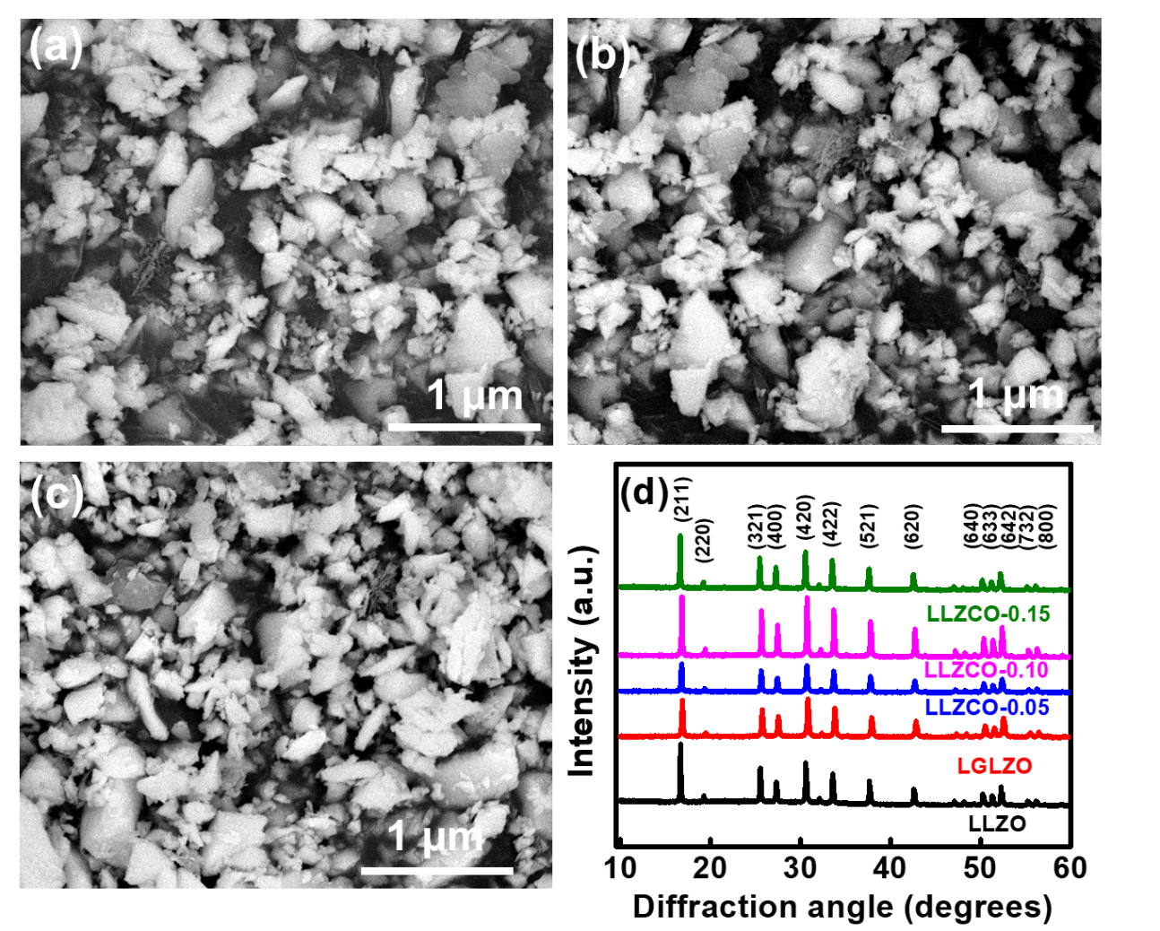

**Fig. 1.** SEM images of (a) LLZO, (b) LGLZO, and (c) LLZCO-0.10. (d) XRD patterns of LLZO, LGLZO, and various LLZCO samples.

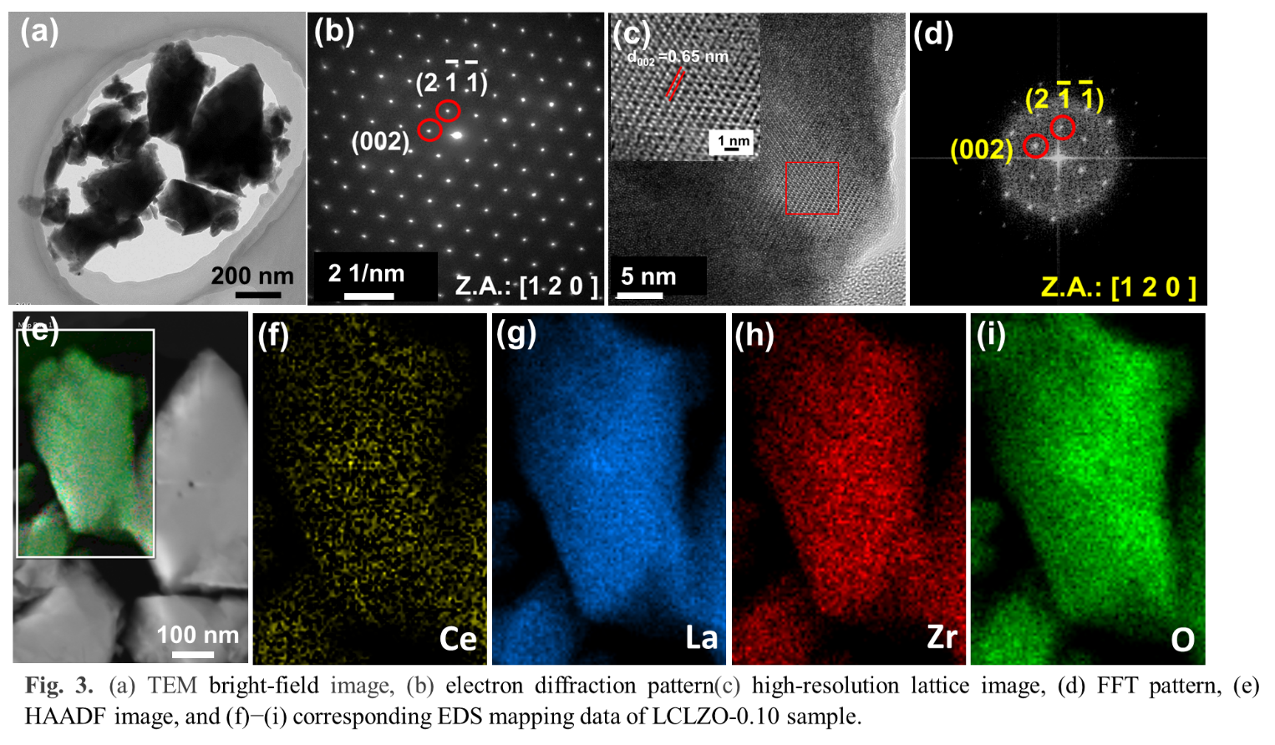

**Fig. 2.** (a) TEM bright-field image, (b) electron diffraction pattern, (c) high-resolution lattice image, (d) FFT pattern, (e) HAADF image, and (f)−(i) corresponding EDS mapping data of LLZCO-0.10 sample.

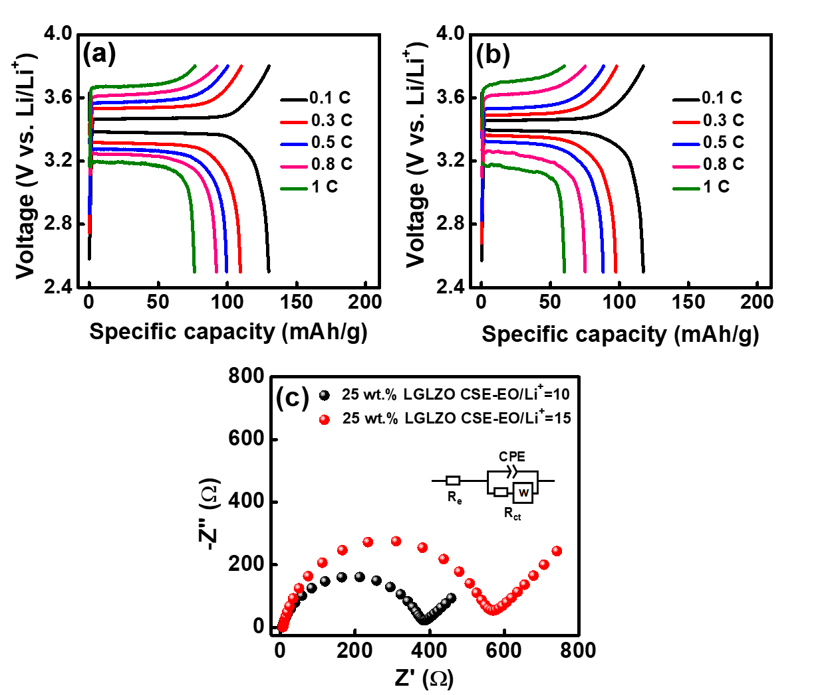

**Fig. 3.** Charge-discharge curves of Li//CSE//LFP cells with 25 wt.% LGLZO and EO/Li+  molar ratios of (a) 10 and (b) 15 in CSEs. (c) EIS spectra of both cells.

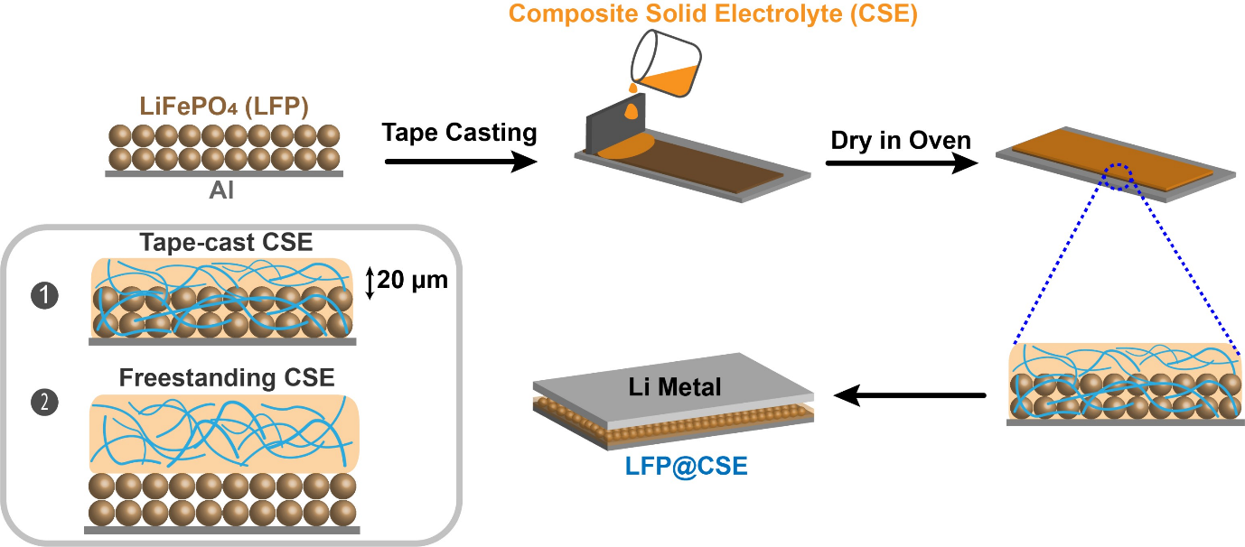

**Fig. 4.** Scheme of proposed CSE/cathode combined lamella fabrication method done by tape casting.

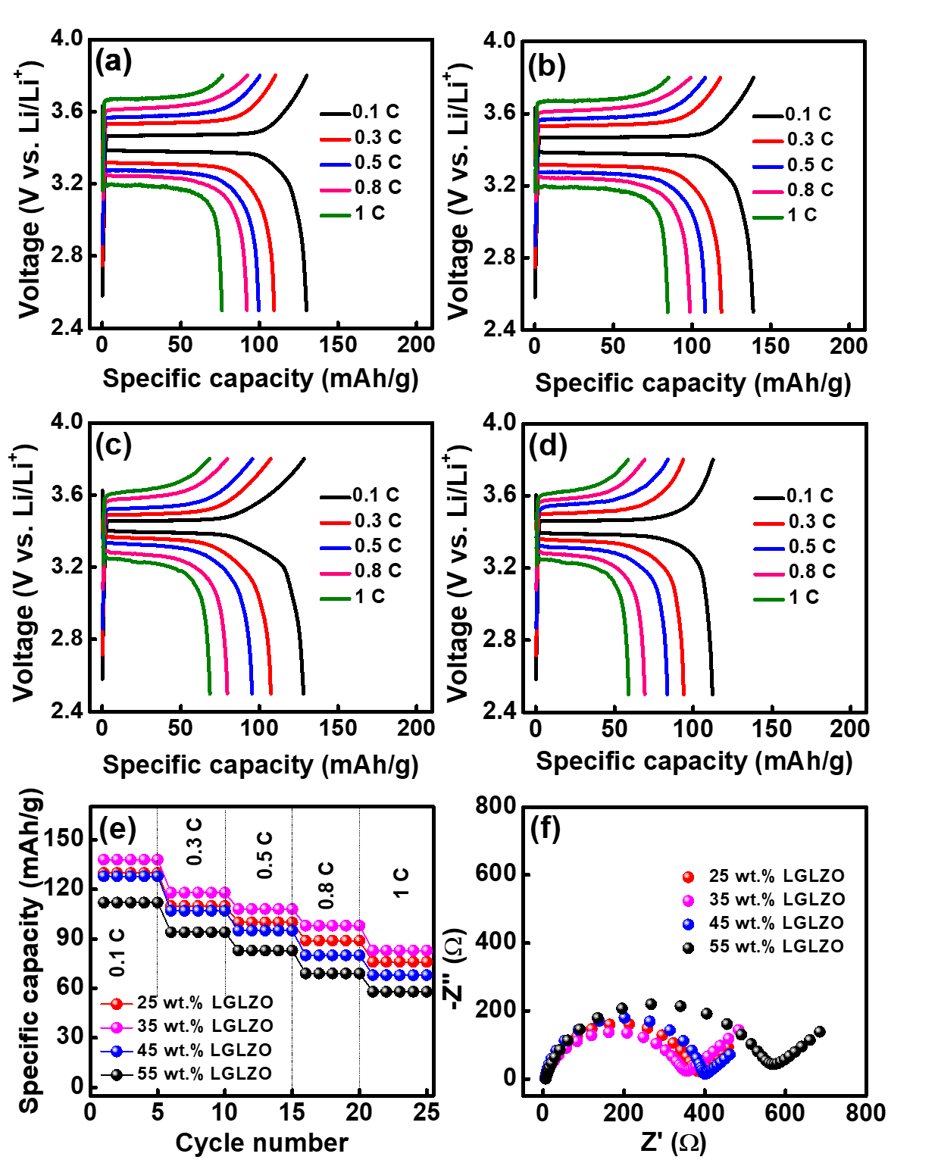

**Fig. 5.** Charge-discharge curves of Li//CSE//LFP cells with (a) 25 wt.% LGLZO, (b) 35 wt.% LGLZO-0.35, (c) 45 wt.% LGLZO, and (d) 55 wt.% LGLZO in CSEs. (e) Comparative rate performance and (f) EIS spectra of various cells.

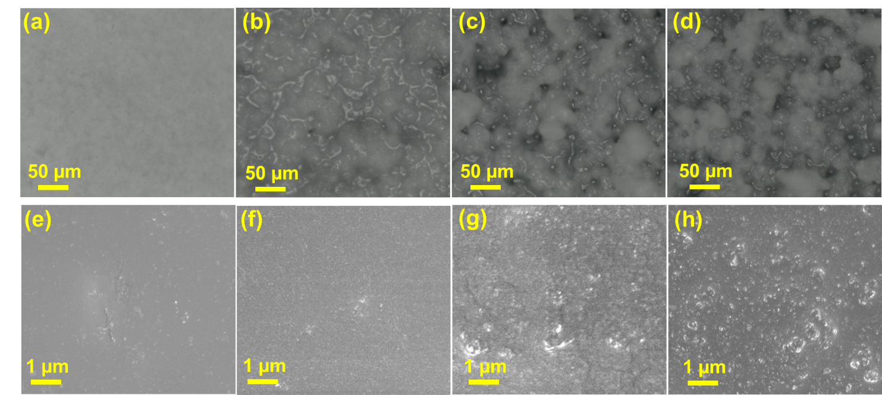

**Fig. 6.** (a-d) Optical microscopy images and (e-h) SEM Images of CSEs with 25 wt.% LGLZO (a and e), 35 wt.% LGLZO (b and f), 45 wt.% LGLZO (c and g), and 55 wt.% LGLZO (d and h).

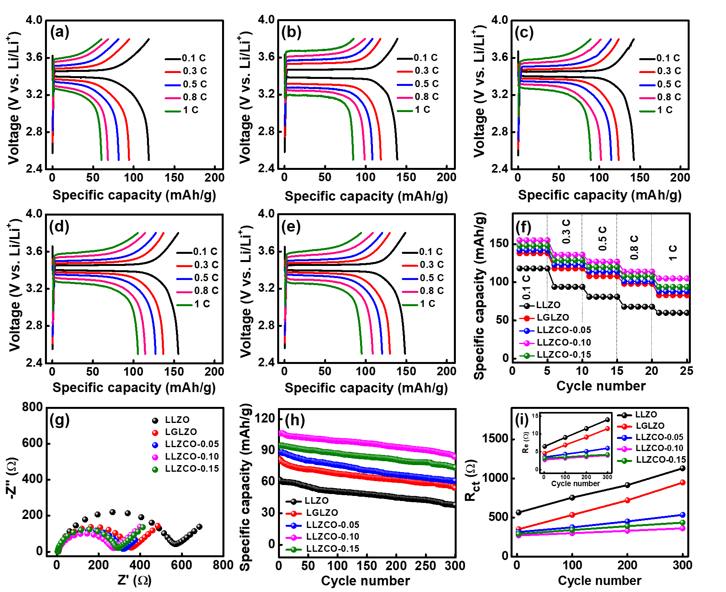

**Fig. 7.** Charge-discharge curves of Li//CSE//LFP cells with (a) LLZO, (b) LGLZO, (c) LLZCO-0.05, (d) LLZCO-0.10, and (e) LLZCO-0.15 fillers in CSEs. (f) Comparative rate performance and (g) EIS spectra of various cells. (h) Cycling stability of various cells measured at 1 C and (i) corresponding variation of *R*e and *R*ct values versus cycle number.

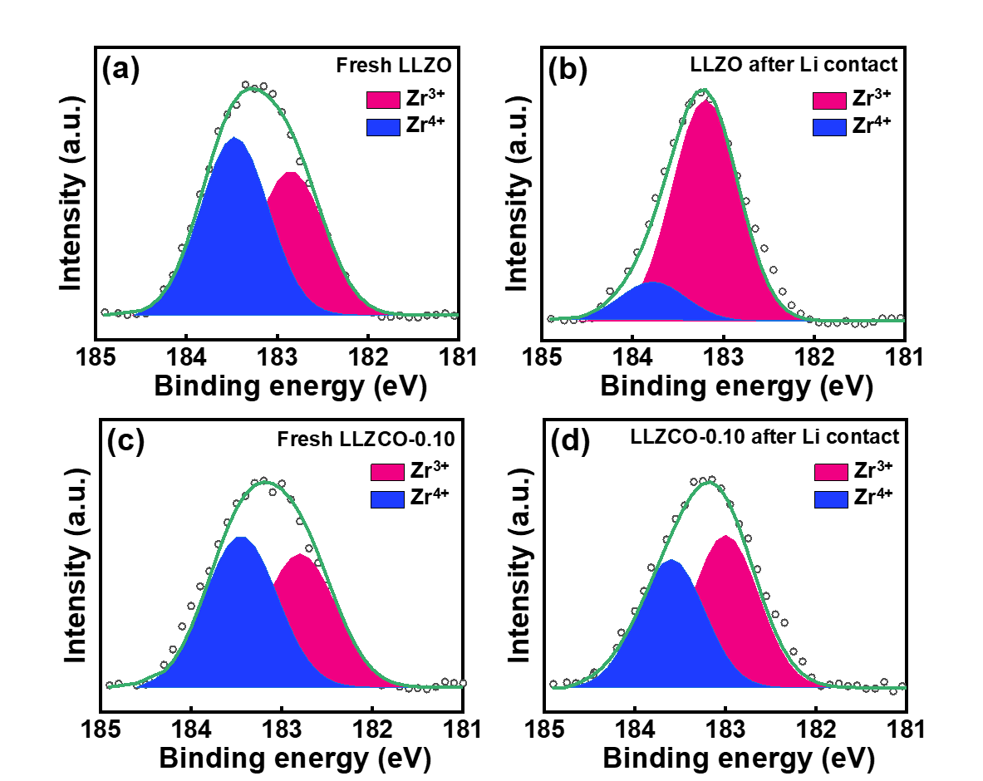

**Fig. 8.**  XPS Zr 3d5/2 spectra of (a, b) LLZO and (c, d) LLZCO-0.10 pellets before (a, c) and after (b, d) Li contact for 48 hours at 70 °C.