Stable Ce0.8Gd0.2O2-δ oxygen transport membrane reactor for hydrogen production

*Wenyuan Liang a, b, Andreas Kaiser c, Armin Feldhoff a, Stefan Baumann d, Wilhelm A. Meulenberg d*, *Tianmiao Hu b, Jian Xue a, e, Heqing Jiang b,*

*Zhengwen Cao a, b, *, Jürgen Caro a, e,*

[a]

Institute of Physical Chemistry and Electrochemistry

Leibniz University of Hannover

Callinstr.3a, 30167 Hannover (Germany)

[b]

Qingdao Key Laboratory of Functional Membrane Material and Membrane Technology, Qingdao Institute of Bioenergy and Bioprocess Technology

Chinese Academy of Sciences, 266101 Qingdao (China)

[c]

Technical University of Denmark, Department of Energy Conversion and Storage,

Risø Campus, P.O. Box 49, 4000 Roskilde (Denmark)

[d]

Forschungszentrum Jülich GmbH, Institute of Energy and Climate Research,

Leo-Brandt-Str, 52425 Jülich (Germany)

[e]

School of Chemistry and Chemical Engineering, South China University of Technology, 510640, Guangzhou (China)

* Corresponding author:[caozw@qibebt.ac.cn](mailto:caozw@qibebt.ac.cn)

**Abstract**

Hydrogen production using oxygen transport membrane reactors has attracted widespread attention. However, the structural stability of membrane materials under harsh reducing atmospheres is still a significant challenge. Gadolinium doped cerium oxide (CGO) presents high ionic conductivity and good reducing resistance but is limited by its poor electronic conductivity. Herein, a two mol.% cobalt-doped Ce0.8Gd0.2O2-δ (CoCGO) ultrathin membrane was manufactured by thin-film technology and applied to hydrogen production from water splitting (WS) with simultaneous syngas production through partial oxidation of methane (POM). Hydrogen production rate above 1.8 mL·min-1·cm-2 and methane conversion of around 80 % were achieved, and no noticeable degradation was detected during 100 h operation, suggesting its prospective stability advantages as a membrane reactor for clean energy generation.

**Keywords**

Oxygen Transport Membrane, Stability, Hydrogen Production, Partial Oxidation of Methane

1. **Introduction**

Fundamental studies have been mainly focused on the development of oxygen transport membranes possessing high permeability and excellent chemical stability,[1-3] because the implications of these properties could be significant for various applications including economic pure oxygen production,[4, 5] highly selective oxidation of hydrocarbons[6] and carbon dioxide decomposition.[7, 8] Compared to the simple coupling reaction and oxygen generation from air,[9] recently the coupling of two chemical reactions in a single membrane reactor has attracted growing interest because of its great potential in hydrogen generation and process intensification.[10-15] From the technical implication point of view, membrane reactors based on current oxygen transport membranes suffer from their poor chemical stability and low permeability under harsh atmospheres such as CO2 or reducing atmospheres.[16, 17] More importantly, integrating two different reactions into a single membrane reactor requires a stable membrane under reducing atmospheres on both sides (e.g. H2, H2O / CO, CO2, CH4) while retaining good oxygen permeability.[18, 19]

Gadolinium doped cerium oxide (CGO) is of considerable interest for the use in solid oxide fuel cells due to its high oxygen ionic conductivity and good chemical stability towards CO2 and reducing gases,[20-22]. In contrast, the use of the CGO as an effective oxygen permeation membrane is limited by its poor electronic conductivity. One approach to overcome this critical limitation is to increase the electronic conductivity through the minor addition of variable-valence metal oxides.[23] Previous studies revealed that the introduction of small amounts of cobalt oxides in the fluorite-type oxides is beneficial to both electronic conductivity and overall conductivity without affecting the structure.[24, 25] According to a recent report, an elevated electronic conductivity of around the factor two to three is expected to enhance the ambipolar transport of the electrons and oxygen ions through the membrane and improve the oxygen permeability of the CGO membrane.[26] Moreover, reducing the thickness of the membrane as thin as possible through thin-film technology is also an effective method to improve the performance of the membrane.[27, 28] For example, the oxygen permeability of a NiO-YSZ supported Ce0.9Gd0.1O2-δ membrane fabricated by tape casting and lamination methods can reach an oxygen flux as high as 16 mL min-1 cm-2 at 900 oC.[29] To sum up, it is reasonable to expect that a thin cobalt-doped CGO membrane has the potential to give an enhanced performance on high oxygen permeability and excellent stability under harsh conditions (low pO2 and in CO2 atmospheres).

In this work, an ultrathin 2 mol.% cobalt-doped Ce0.8Gd0.2O2-δ (CoCGO) membrane was manufactured by tape-casting and lamination technology. The coupling of hydrogen production through water splitting (WS) and partial oxidation of methane (POM) was employed to evaluate the oxygen permeability and stability performance. Desired hydrogen and syngas production rates are expected owing to the elevated electronic conductivity and stability of the CoCGO membrane under low oxygen partial pressures.

1. **Experimental**

2.1 Membrane preparation and membrane reactor evaluation: The ultrathin CoCGO was manufactured by tape casting and lamination,[30] La0.4Sr0.6CoO3-δ (LSC) was infiltrated onto the porous side by the impregnation method.[31] The oxygen permeation test and the coupling measurements of different membranes were conducted in a self-made high-temperature oxygen permeator, as described previously (Figure 1). [10, 11,] 0.2 g Ni-based catalyst (Süd Chemie AG) was packed on the surface of the membrane to obtain a highly effective POM. The gas or liquid mass-flow controller (Bronkhorst) was employed to control the flow of gases or liquids, respectively. All gas pipes were heated to 180 oC to ensure the complete evaporation of the water. An online gas chromatorgraph (Agilent 6890) was used to determine the concentrations of the gases. More details can be found in our previous works.[16, 32]

2.2 Characterization: The morphology of membranes was analyzed by a JEOL JSM-6700F filed-emission scanning electron microscope (SEM). XRD experiments were performed using a Bruker D8 instrument with CuKa radiation. Scanning TEM (STEM) in high-angle annular dark-field (HAADF) mode, EDXS were conducted at 200 kV primary electron energy in a JEOL JEM-2100F.

In the He/air and CO2/air oxygen partial pressure gradient experiments, the oxygen permeation rate JO2 was calculated according to the following equation (1):

 ------------(1)

where, C(O2) and C(N2) are the concentrations of oxygen and nitrogen on the sweep side. F is the total flow rate of the outlet, and A is the membrane area. ‘4.02’ is the Knudsen diffusion factor of nitrogen and oxygen.

In the WS/POM oxygen partial pressure gradient experiments, conversion of CH4, selectivity of CO, H2 production rate, and O2 flux were calculated according to the following equations (2-5),

 --------(2)  
 --------(3)

 ------- (4)

 ------- (5)

1. **Results and Discussion**

The ultrathin CoCGO membrane supported on a porous CoCGO substrate was manufactured by tape casting and lamination, and LSC was infiltrated onto the porous side to obtain a higher surface exchange rate. SEM (Figure 2) clearly shows the dual-layer structure of the fresh CoCGO membrane. A dense layer of ~ 30 µm thickness is well sintered on top of a 300 µm support layer (Figure 2a, b). Despite some tiny closed pores (Figure 2c), a fully-sintering dense membrane is observed (Figure 2d), ensuring sufficient gas-tightness. According to Figure S1, stable oxygen permeation fluxes of 0.25 and 0.18 mL min-1 cm-2 are achieved under He/air, CO2/air oxygen partial pressure gradients, respectively, suggesting its favourable structure stability and CO2 resistance.

The coupling of WS and POM was carried out after the oxygen permeation test. The porous side of the CoCGO membrane is exposed to the water side, and the dense to methane. Surprisingly, continuous hydrogen production from WS and syngas from POM was achieved, as shown in Figure 3, 4. It is observed that the hydrogen production rate and the conversion of methane decrease with time during the first 50 h, stable hydrogen production rate of 1.8 mL·min-1·cm-2 and methane conversion of 80 % are achieved in the following 50 h. For comparison, Ba0.5Sr0.5Co0.8Fe0.2O3-δ (BSCF) membrane[33] with a similar structure was employed as a reference for the oxygen permeation and reaction measurements. The oxygen permeation fluxes of the membranes under different atmospheres were compared and presented in Figure 5. Although the BSCF exhibits a higher oxygen permeability than CoCGO under He/Air gradient, the CoCGO demonstrates a three times higher oxygen permeation flux under POM/WS gradient than BSCF, leading to an improved hydrogen production rate as well as a higher methane conversion. Indeed, the hydrogen production rate can be further enhanced by increasing the methane concentration and temperature, as shown in Figures S2 and S3. Several factors are responsible for the excellent performance of the catalytic membrane reactor based on CoCGO: i) the CoCGO membrane is more stable than perovskite membranes under harsh atmospheres; ii) an appropriate permeability can be achieved under low oxygen partial pressures (both sides < 10-4 atm), owing to improved electronic conductivity by the 2 mol% Co-doping and the reducible Ce4+ to Ce3+; [34, 35] iii) the LSC infiltrated in the porous structure increases the surface exchange rate on the WS side and may play the role of an effective catalyst. As a result, a high hydrogen production rate above 2.5 mL·min-1·cm-2 and a methane conversion of ~90 % are observed in the first 10 h.

However, the infiltrated LSC catalyst is not chemically stable under such harsh reducing atmospheres (H2, H2O). A gradual decomposition of the LSC is therefore expected, causing a gradual performance decrease in the initial 50 h. The decay of LSC is confirmed by XRD as shown in Figure 7 III, IV. The presence of cobalt oxides reveals the extraction of Co from LSC catalyst after reduction, which is also the main reason for the failure of the other cobalt-containing membranes in reducing atmospheres.

Nevertheless, the bulk CoCGO membrane exhibits significant stability despite the harsh atmospheres on both sides. After long-term exposure to the reducing atmospheres of hydrogen production from WS (H2, H2O) and syngas production from POM (CH4, CO, CO2, H2), the structure of the dense CoCGO layer turned out to be almost unchangeable (Figure 6). The SEM (Figure 6a) analysis of the spent membrane suggests that the structure of the membrane remains the same, and the dense layer is still well attached to the supporting layer (Figure 6b, e, f). Despite exposure to the low oxygen partial pressure side (CH4, CO, CO2, H2) for 100 h, no failure or erosion is found on the dense side of the membrane (Figure 6 b, e). The XRD (Figure 7I, II) also confirms that the only identifiable foreign phase in the spent sample is the gold from the sealing. This provides direct evidence that the CoCGO membrane is chemically stable for application in such reducing atmospheres. Usually, cobalt is expected to be extracted due to the reduction of cobalt cation from perovskite structures at the surface, especially under reducing atmospheres.[36] To further verify the stability of the CoCGO membrane, it is essential to check the existing state of fluorite structure. With the help of STEM high-angle annular dark field micrograph and EDXS elemental distributions (Figure S4), it is found that the cobalt particles of nano or micrometre size segregate mainly at multiple grains of CGO. The segregation of the cobalt is probably because of the relatively lower solubility of the cobalt in CGO.[37, 38] Nevertheless, no extraction and segregation of cobalt particles on the surface are found after the measurement, suggesting the excellent chemical stability of the CoCGO membrane for clean energy generation through coupling reactions.

1. Conclusions

A newly developed oxygen transporting membrane based on CoCGO is reported for long-term hydrogen and syngas production from coupling water splitting (WS) and partial oxidation of methane (POM). Compared to the reactor based on BSCF membrane, higher oxygen permeability is obtained owing to the stability of the CoCGO membrane in the presence of reducing gases. As a result, a hydrogen production rate above 1.8 mL·min-1·cm-2 and a methane conversion of ~80 % were achieved during 100 h operation. The XRD, SEM, and STEM analysis data indicate that the spent membrane for 100 h measurement retained its crystalline structure, which suggests that the CoCGO membrane is chemically stable and highly suitable for hydrogen generation through WS-POM.

**Declaration of Competing Interest**

The authors declare that they have no known competing financial interests or personal relationships that could have appeared to influence the work reported in this paper.

**Acknowledgements**

We kindly thank the European Union through the FP7 NASA-OTM project (grant agreement no. 228701) for financial support. We also thank National Natural Science Foundation of China (22008250, 22108286), the Innovation Funds of Shandong Energy Institute (SEI I202146).

**Reference**

[1] Y. Liu, X. Zhu, M. Li, H. Liu, Y. Cong, W. Yang, Stabilization of low-temperature degradation in mixed ionic and electronic conducting perovskite oxygen permeation membranes, Angewandte Chemie International Edition, 52 (2013) 3232-3236.

[2] L. Jia, G. He, Y. Zhang, J. Caro, H. Jiang, Hydrogen purification through a highly stable dual-phase oxygen-permeable membrane, Angewandte Chemie International Edition, 60 (2021) 5204-5208.

[3] W. Bai, J. Feng, C. Luo, P. Zhang, H. Wang, Y. Yang, Y. Zhao, H. Fan, A comprehensive review on oxygen transport membranes: Development history, current status, and future directions, International Journal of Hydrogen Energy, 46 (2021) 36257-36290.

[4] X. Zhu, W. Yang, Microstructural and interfacial designs of oxygen-permeable membranes for oxygen separation and reaction-separation coupling, Advanced Materials, 31 (2019) 1902547.

[5] H. Wang, S. Werth, T. Schiestel, J. Caro, Perovskite hollow-fiber membranes for the production of oxygen-enriched air, Angewandte Chemie International Edition, 44 (2005) 6906-6909.

[6] M. Ikeguchi, T. Mimura, Y. Sekine, E. Kikuchi, M. Matsukata, Reaction and oxygen permeation studies in Sm0.4Ba0.6Fe0.8Co0.2O3-δ membrane reactor for partial oxidation of methane to syngas, Applied Catalysis A: General, 290 (2005) 212-220.

[7] X. Dong, W. Jin, N. Xu, K. Li, Dense ceramic catalytic membranes and membrane reactors for energy and environmental applications, Chemical Communications, 47 (2011) 10886-10902.

[8] A. Mustafa, B.G. Lougou, Y. Shuai, Z. Wang, H. Tan, Current technology development for CO2 utilization into solar fuels and chemicals: A review, Journal of Energy Chemistry, 49 (2020) 96-123.

[9] C.S. Chen, S.J. Feng, S. Ran, D.C. Zhu, W. Liu, H.J.M. Bouwmeester, Conversion of methane to syngas by a membrane-based oxidation-reforming process, Angew. Chem.-Int. Edit., 42 (2003) 5196-5198.

[10] H.Q. Jiang, H.H. Wang, S. Werth, T. Schiestel, J. Caro, Simultaneous production of hydrogen and synthesis gas by combining water splitting with partial oxidation of methane in a hollow-fiber membrane reactor, Angew. Chem.-Int. Edit., 47 (2008) 9341-9344.

[11] H.Q. Jiang, H.H. Wang, F.Y. Liang, S. Werth, T. Schiestel, J. Caro, Direct decomposition of nitrous oxide to nitrogen by in situ oxygen removal with a perovskite membrane, Angew. Chem.-Int. Edit., 48 (2009) 2983-2986.

[12] H.Q. Jiang, F.Y. Liang, O. Czuprat, K. Efimov, A. Feldhoff, S. Schirrmeister, T. Schiestel, H.H. Wang, J. Caro, Hydrogen production by water dissociation in surface-modified BaCoxFeyZr1-x-yO3-δ hollow-fiber membrane reactor with improved oxygen permeation, Chemistry-a European Journal, 16 (2010) 7898-7903.

[13] C.Y. Park, T.H. Lee, S.E. Dorris, U. Balachandran, A cobalt-free oxygen transport membrane, BaFe0.9Zr0.1O3-δ, and its application for producing hydrogen, International Journal of Hydrogen Energy, 38 (2013) 6450-6459.

[14] N. Zhu, X. Dong, Z. Liu, G. Zhang, W. Jin, N. Xu, Toward highly-effective and sustainable hydrogen production: bio-ethanol oxidative steam reforming coupled with water splitting in a thin tubular membrane reactor, Chemical Communications, 48 (2012) 7137-7139.

[15] W. Li, X. Zhu, S. Chen, W. Yang, Integration of nine steps into one membrane reactor to produce synthesis gases for ammonia and liquid fuel, Angewandte Chemie International Edition, 55 (2016) 8566-8570.

[16] H.Q. Jiang, Z.W. Cao, S. Schirrmeister, T. Schiestel, J. Caro, A coupling strategy to produce hydrogen and ethylene in a membrane reactor, Angew. Chem.-Int. Edit., 49 (2010) 5656-5660.

[17] M. Arnold, H. Wang, A. Feldhoff, Influence of CO2 on the oxygen permeation performance and the microstructure of perovskite-type (Ba0.5Sr0.5)(Co0.8Fe0.2)O3-δ membranes, Journal of Membrane Science, 293 (2007) 44-52.

[18] G. He, W. Liang, C.-L. Tsai, X. Xia, S. Baumann, H. Jiang, W.A. Meulenberg, Chemical environment-induced mixed conductivity of titanate as a highly stable oxygen transport membrane, iScience, 19 (2019) 955-964.

[19] G. He, Y. Ling, H. Jiang, A. Toghan, Barium titanate as a highly stable oxygen permeable membrane reactor for hydrogen production from thermal water splitting, ACS Sustainable Chemistry & Engineering, 9 (2021) 11147-11154.

[20] B.C.H. Steele, A. Heinzel, Materials for fuel-cell technologies, Nature, 414 (2001) 345-352.

[21] B.C.H. Steele, Appraisal of Ce1-yGdyO2-y/2 electrolytes for IT-SOFC operation at 500°C, Solid State Ionics, 129 (2000) 95-110.

[22] V.V. Kharton, F.M. Figueiredo, L. Navarro, E.N. Naumovich, A.V. Kovalevsky, A.A. Yaremchenko, A.P. Viskup, A. Carneiro, F.M.B. Marques, J.R. Frade, Ceria-based materials for solid oxide fuel cells, Journal of Materials Science, 36 (2001) 1105-1117.

[23] F. Zeng, S. Baumann, J. Malzbender, A. Nijmeijer, L. Winnubst, O. Guillon, R. Schwaiger, W.A. Meulenberg, Enhancing oxygen permeation of solid-state reactive sintered Ce0.8Gd0.2O2-δ-FeCo2O4 composite by optimizing the powder preparation method, Journal of Membrane Science, 628 (2021) 119248.

[24] D.P. Fagg, J.C.C. Abrantes, D. Pérez-Coll, P. Núñez, V.V. Kharton, J.R. Frade, The effect of cobalt oxide sintering aid on electronic transport in Ce0.80Gd0.20O2-δ electrolyte, Electrochimica Acta, 48 (2003) 1023-1029.

[25] K. Neuhaus, R. Dolle, H.-D. Wiemhöfer, The effect of transition metal oxide addition on the conductivity of commercially available Gd-doped ceria, Journal of The Electrochemical Society, 167 (2020) 044507.

[26] D.P. Fagg, A.L. Shaula, V.V. Kharton, J.R. Frade, High oxygen permeability in fluorite-type Ce0.8Pr0.2O2-δ via the use of sintering aids, Journal of Membrane Science, 299 (2007) 1-7.

[27] N.F. Himma, A.K. Wardani, N. Prasetya, P.T.P. Aryanti, I.G. Wenten, Recent progress and challenges in membrane-based O2/N2 separation, Reviews in Chemical Engineering, 35 (2019) 591-625.

[28] S. Baumann, J.M. Serra, M.P. Lobera, S. Escolástico, F. Schulze-Küppers, W.A. Meulenberg, Ultrahigh oxygen permeation flux through supported Ba0.5Sr0.5Co0.8Fe0.2O3-δ membranes, Journal of Membrane Science, 377 (2011) 198-205.

[29] A. Kaiser, S. Foghmoes, C. Chatzichristodoulou, M. Søgaard, J.A. Glasscock, H.L. Frandsen, P.V. Hendriksen, Evaluation of thin film ceria membranes for syngas membrane reactors-Preparation, characterization and testing, Journal of Membrane Science, 378 (2011) 51-60.

[30] A. Kaiser, S.P. Foghmoes, G. Pećanac, J. Malzbender, C. Chatzichristodoulou, J.A. Glasscock, D. Ramachandran, D.W. Ni, V. Esposito, M. Søgaard, P.V. Hendriksen, Design and optimization of porous ceramic supports for asymmetric ceria-based oxygen transport membranes, Journal of Membrane Science, 513 (2016) 85-94.

[31] W. Fang, F. Steinbach, Z. Cao, X. Zhu, A. Feldhoff, A highly efficient sandwich-like symmetrical dual-phase oxygen-transporting membrane reactor for hydrogen production by water splitting, Angewandte Chemie International Edition, 55 (2016) 8648-8651.

[31] W. Liang, Z. Cao, G. He, J. Caro, H. Jiang, Oxygen transport membrane for thermochemical conversion of water and carbon dioxide into synthesis gas, ACS Sustainable Chemistry Engineering, 5 (2017) 8657-8662.

[33] Z. Cao, H. Jiang, H. Luo, S. Baumann, W.A. Meulenberg, H. Voss, J. Caro, Simultaneous overcome of the equilibrium limitations in BSCF oxygen-permeable membrane reactors: Water splitting and methane coupling, Catalysis Today, 193 (2012) 2-7.

[34] K. Zhang, F. Chu, Y. Hu, X. Huang, G. Zhao, G. Wang, Ce-doped MIL-125-NH2 coupled Ce4+/Ce3+ and Ti4+/Ti3+ redox mediators for thermo-enhanced photocatalytic oxidative desulfurization, Chinese Chemical Letters, (2022) 107766.

[35] I. García-Torregrosa, M.P. Lobera, C. Solís, P. Atienzar, J.M. Serra, Development of CO2 protective layers by spray pyrolysis for ceramic oxygen transport membranes, Advanced Energy Materials, 1 (2011) 618-625.

[36] L. Bedel, A.C. Roger, C. Estournes, A. Kiennemann, Co0 from partial reduction of La(Co,Fe)O3 perovskites for Fischer–Tropsch synthesis, Catalysis Today, 85 (2003) 207-218.

[37] A.V. Kotkondawar, S. Rayalu, Enhanced H2 production from dehydrogenation of sodium borohydride over the ternary Co0.97Pt0.03/CeOx nanocomposite grown on CGO catalytic support, RSC Advances, 10 (2020) 38184-38195.

[38] G.S. Lewis, A. Atkinson, B.C.H. Steele, J. Drennan, Effect of Co addition on the lattice parameter, electrical conductivity and sintering of gadolinia-doped ceria, Solid State Ionics, 152–153 (2002) 567-573.

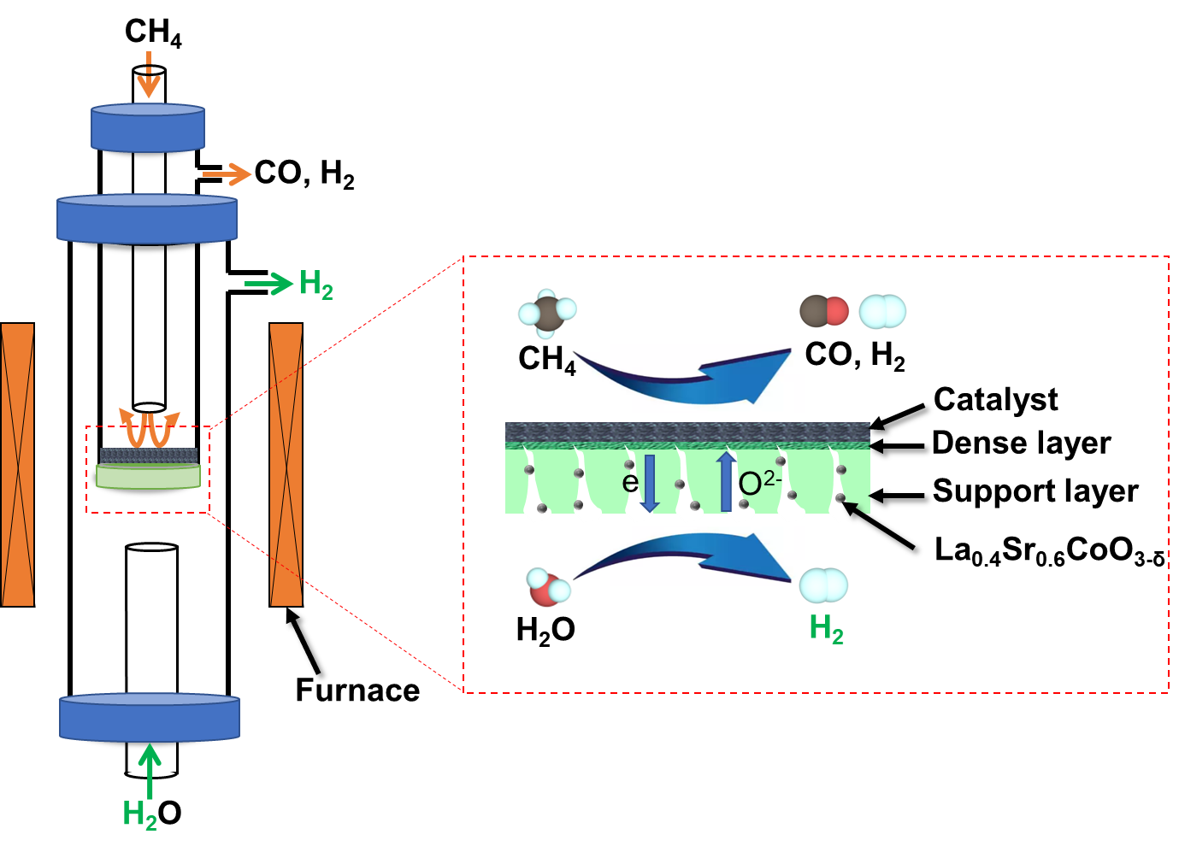

Figure 1. Schematic diagram of the CoCGO membrane reactor for hydrogen production from WS and syngas production from POM.

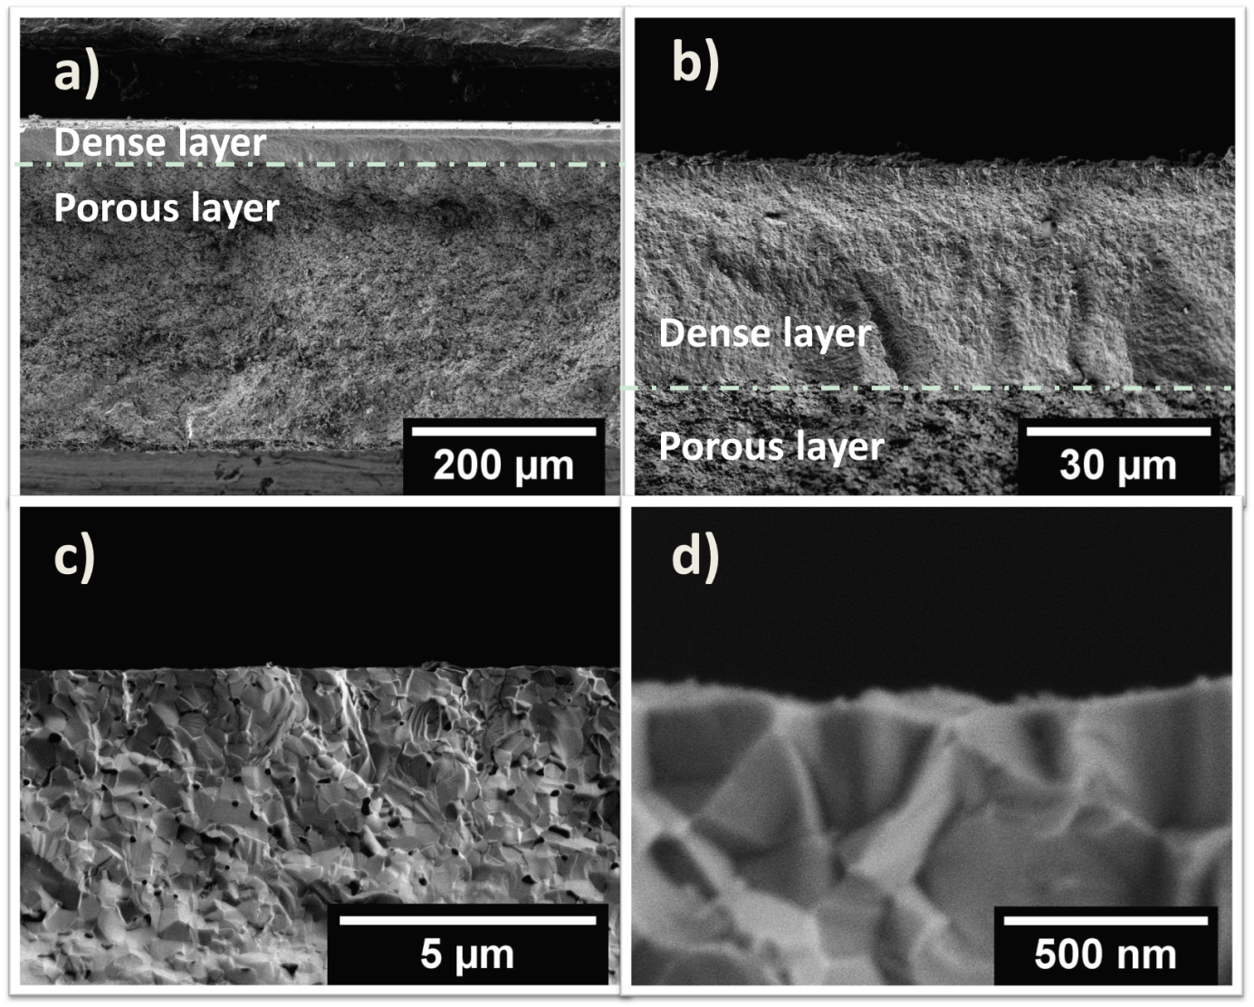

Figure 2. SEM micrographs of the fresh CoCGO membrane: (a) Overview of the membrane, (b) cross section of the dense layer, (c) and (d) top cross sections of the dense layer.



Figure 3. JH2 as a function of time for the CoCGO membrane reactor. WS side: FH2O = 30 mL min-1 and FHe = 10 mL min-1, POM side: FNe = 1 mL min-1 , FCH4 = 3 mL min-1 and FHe = 16 mL min-1, T = 930 oC.



Figure 4. X(CH4) and S(CO) as a function of time for the CGO membrane reactor. WS side: FH2O = 30 mL min-1 and FHe = 10 mL min-1, POM side: FNe = 1 mL min-1 , FCH4 = 3 mL min-1 and FHe = 16 mL min-1, T = 930 oC.



Figure 5. JO2 of BSCF and CoCGO membranes under different sweep/feed atmospheres at T = 930 oC. He/Air oxygen partial pressure gradient, He/Ne sweep side: FHe = 29 mL min-1, FNe = 1 mL min-1, Air side: FAir = 100 mL min-1; POM/WS oxygen partial pressure gradient, POM side: FNe = 1 mL min-1, FCH4 = 3 mL min-1 and FHe = 16 mL min-1, WS side: FH2O = 30 mL min-1 and FHe = 10 mL min-1.

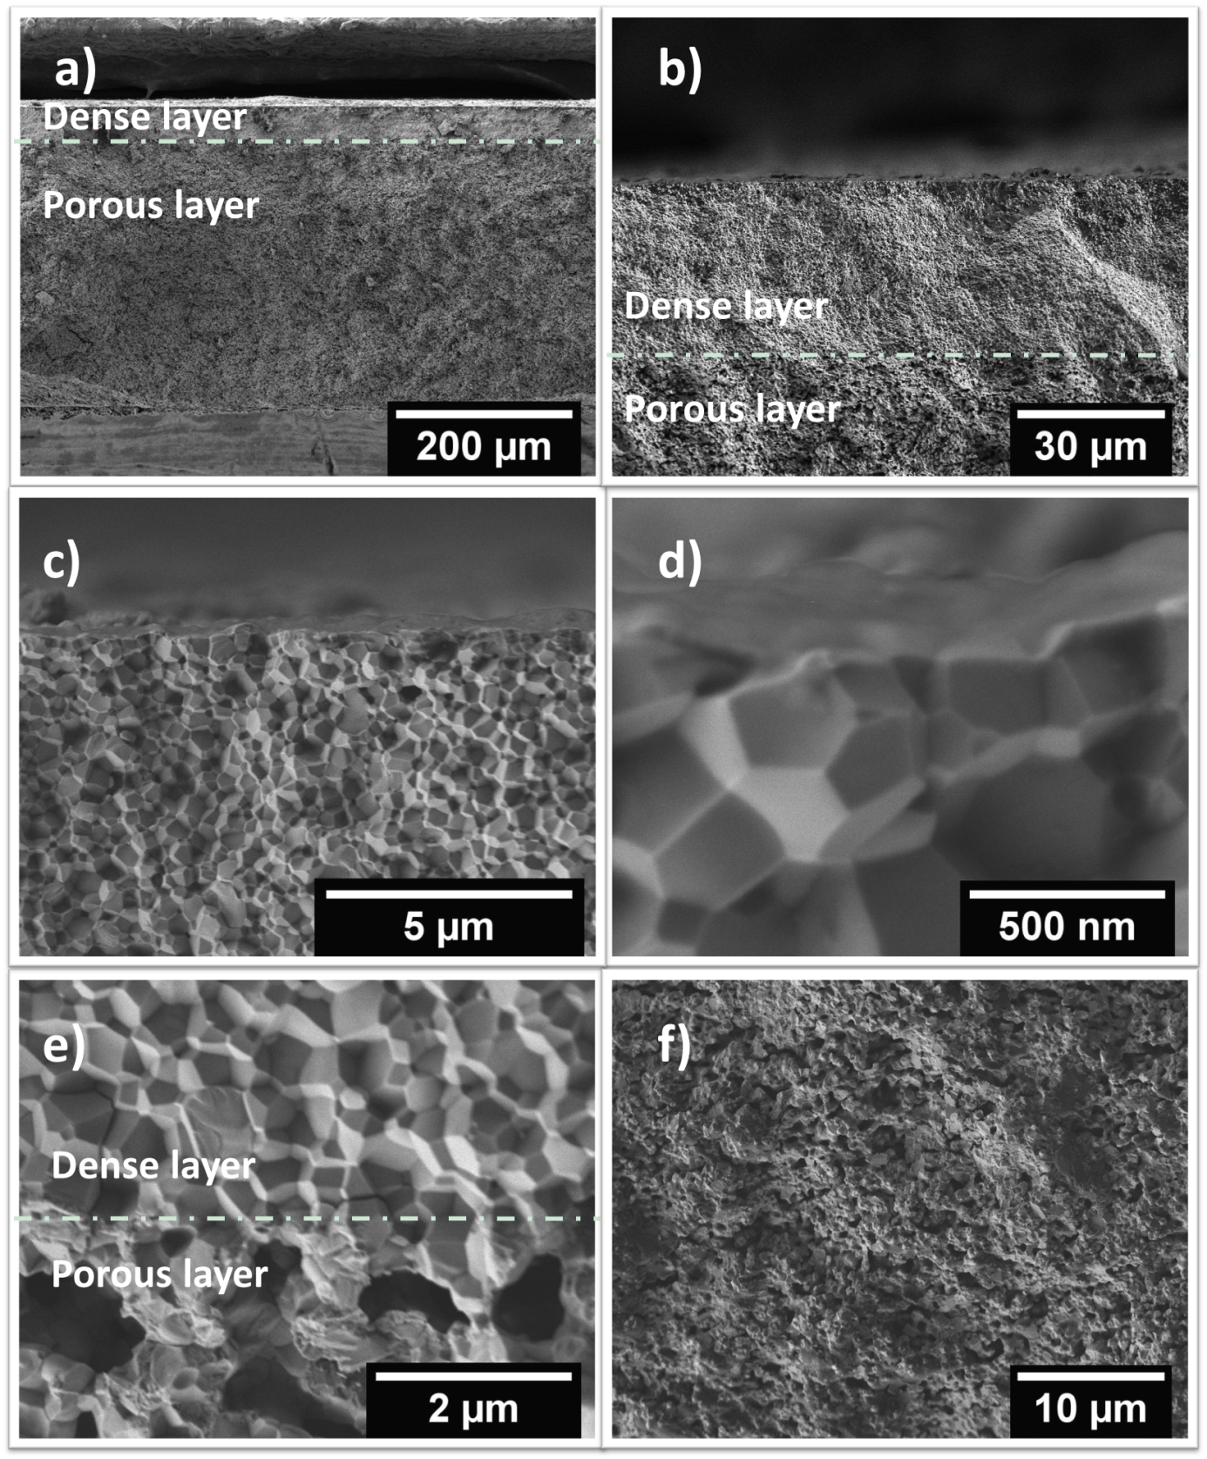

Figure 6. SEM micrographs of the spent CoCGO membrane: (a) Overview of the membrane, (b) cross section of the dense layer, (c) and (d) top cross sections of the dense layer, (e) boundary layer between the dense and porous layers, (f) cross section of the porous layer.



Figure 7. XRD patterns of fresh and spent CoCGO (after 100 hours operation in the POM/WS at 930°C) CoCGO membrane.