Graphs of Hydrogen-Bond Networks
to Dissect Protein Conformational Dynamics

Ana-Nicoleta Bondar^{1,2,*}

¹University of Bucharest, Faculty of Physics, Str. Atomiştilor 405, 077125 Bucharest-Măgurele, Romania
²Institute for Neuroscience and Medicine and Institute for Advanced Simulations (IAS-5/INM-9), Computational Biomedicine, Forschungszentrum Jülich, 52425 Jülich, Germany

Correspondence to nbondar@fizica.unibuc.ro, a.bondar@fz-juelich.de

Abstract
Dynamic hydrogen bonds and hydrogen-bond networks are ubiquitous in proteins and protein complexes. Functional roles that have been assigned to hydrogen-bond networks include structural plasticity for protein function, allosteric conformational coupling, long-distance proton transfers, and transient storage of protons. Advances in structural biology provide invaluable insights into architectures of large proteins and protein complexes of direct interest to human physiology and disease, including G Protein Coupled Receptors (GPCRs) and the SARS-Covid-19 spike protein S, and bring about the challenge of how to identify those interactions more likely to govern protein dynamics. This perspective article discusses applications of graph-based algorithms to dissect dynamical hydrogen-bond networks of complex protein complexes, with illustrations for GPCRs and spike protein S. H-bond graphs provide an overview of sites in GPCR structures where hydrogen-bond dynamics would be required to assemble longer-distance networks between functionally important motifs. In the case of spike protein S, graphs identify regions of the protein where hydrogen bonds rearrange during the reaction cycle, and where local hydrogen-bond networks likely change in a virus variant of concern.

Introduction
The role of hydrogen(H) bonds in protein structure, folding and function, has been studied for many decades,¹⁻⁵ with early works recognizing H bonds as key determinants of the native protein structure.¹ Experiments on both globular and membrane proteins indicated each H-bond contributes about 1kcal/mol to protein stability,^{6, 7} with larger contributions identified for salt bridges between sidechains.⁸ Weak H-bonds, i.e., H-bonds that break without a significant energetic penalty, are essential for the structural plasticity needed for protein function,⁷ and networks of H-bonds observed in static protein structures are often central to hypotheses about protein reaction mechanisms. Large proteins and protein complexes that become amenable to structural biology bring about the challenge of very large numbers of interactions of potential interest –for example, a single coordinate snapshot of the ectodomain of the spike protein S trimer of SARS-Covid-19 has hundreds of H-bonds,⁹ and one coordinate snapshot of complex I has >2000 H-bonds.¹⁰ As H-bonds are relatively weak interactions that can break at physiological temperatures,¹¹ and H-bonds within networks may have distinct conformational modes¹² and contribute to network co-operativity,¹³ studying H-bonds networks of such large proteins can become a daunting task. This perspective article addresses the usefulness of recently developed graph-based algorithms to compute and visualize H-bond networks from static protein structures and simulations. Examples that illustrate the usefulness of graph-based algorithms focus on G Protein Coupled Receptors (GPCRs), which use dynamic H-bond networks for long-distance conformational couplings, and spike protein S of SARS-Covid-2, which uses H-bonds to bind to the membrane receptor protein of the host cell.

H-bonds and H-bond networks in proteins
A 2011 IUPC technical report defines the H-bond as ‘an attractive interaction between a hydrogen atom from a molecule or molecular fragment X-H in which X is more electronegative than H, and an atom or group of atoms in the same or a different molecule, in which there is evidence of bond formation’.^{13, 14} Criteria used as evidence for H-bonding include geometry,¹³ and indeed most often H-bonds are identified according to distance and angle criteria. Typical H-bond distances measured between the H atom and the nitrogen or oxygen acceptor atoms from X-ray and neutron scattering data on organic compounds range from ~1.6-1.7 to ~2.5-2.6Å.¹⁵ For comparison, the H-bond distance in ice is ~1.75Å, and the distance between oxygen atoms, ~2.75Å.^{11, 16}
In proteins, H-bonds involve backbone groups and sidechains –which can also H-bond to water, lipid, or ligand molecules (Figure 1). A distance within 3.5Å between the donor and acceptor heavy atoms, and angles >90º at the donor and acceptor atoms, are typically used as indication for H-bonding in static protein structures that lack coordinates for H atoms.¹⁷ For atomistic protein simulations whose coordinate sets include all H atoms, a criterion often used combines a ≤3.5Å donor-acceptor distance with an ≤60º H-bond angle; this latter combined criterion gives results very similar to those obtained with a single criterion of an ≤2.5 Å H-acceptor distance.⁹

H-bond graphs for protein-water H-bond networks: Bridge and C-Graphs
An H-bond graph consists of nodes (vertices) –which are H-bonding groups, inter-connected by edges that represent H-bonds between these groups (Scheme 1A). H-bond graphs are computed from coordinates of the protein atoms, and may include water, lipids and ligand molecules. These atomic coordinates may be taken from experimental static protein structures, or from numerical simulation trajectories. All H-bond networks discussed here were derived with the recently developed packages Bridge¹⁸ and Bridge2,¹⁹ and with C-Graphs.²⁰
Bridge consists of graph-based algorithms designed for analyses of dynamic protein-water H-bond networks. H-bonds are identified according to distance criteria chosen by the user. When H-bond angles are also included as the H-bond criterion, they are computed with an efficient implementation of the Einstein sum convention based on the positional vectors for the H-bond donor and acceptor heavy atoms, and for the H atom.^{18, 19} H-bonded water chains between protein sidechains pertain to the nearest neighbors problem, and are computed using k-d tress –by contrast to the naïve solution of computing all pairwise distances, which scales with N², k-d trees account for the distribution of data points and scale with N.logN.¹⁹
The efficiency of Bridge computations for protein-water H-bond networks was tested by comparing the times needed for the same H-bond computation using Bridge¹⁸ vs. MDAnalysis.²¹ In the case of the channelrhodopsin chimeric ion channel C1C2, Bridge was one order of magnitude faster for computations of direct protein-protein H-bonds, two orders of magnitude faster, for H-bonds including a water selection.¹⁸ In the case of the spike protein S of SARS-Covid-2, computing 596 H-bonds between protein sidechains took less than one second/coordinate snapshot, and computing 12,368 water bridges between protein sidechains, with up to five waters in the bridge, took ~3 seconds/snapshot.¹⁹
In the case of complex proteins with large numbers of H-bonds, it is of interest to identify local H-bond clusters – which are subsets of graph nodes and edges that are all interconnected to each other (see color-coded H-bond clusters in Scheme 1A). A rather typical example here is the question of the local H-bond network of an amino acid residue known to be important for function, or of interest for site-directed mutagenesis experiments. Bridge provides a solution to this problem: All H-bond paths starting from a node of interest, denoted as root node, can be identified using Connected Components^{18, 22} (Scheme 1A).
Scheme 1. Illustration of H-bond graph computations. (A) The H-bond graph of protein-1 is computed based on a coordinate snapshot from structural biology, or from an ensemble of coordinate sets from molecular dynamics simulations. Here, nodes and edges are colored according to H-bond clusters that can be identified using Connected Component Analyses in Bridge.^{18, 19} Node i of the cluster colored orange has high centrality, and the shortest distance path that connects nodes i and j is shown with dotted lines. (B) Linear length of H-bond clusters. C-Graphs²⁰ projects onto the z-axis the coordinates of the Cα atoms of the H-bonding groups; linear lengths of each cluster are estimated based on the minimum and maximum values of these z-coordinates. (C) The H-bond graph of protein-1 is compared to the conserved graph of nodes and edges present in both proteins-1 and -2. Nodes/edges colored grey vs. cyan are present in H-bond graphs of both proteins vs. protein-1 only. Panels are based on schemes from ref.²⁰

H-bond graphs with hundreds of nodes bring about the challenge of finding out which H-bonding groups might be particularly important for the network. Graph theory uses a number centrality measures to rank graph nodes (see, e.g., refs.²³), and analyses of protein structures using centrality measures underline their usefulness: it was found, for example, that high-centrality groups tend to locate at conserved and/or functionally important protein sites,^{24, 25} and that high centrality values may have strong negative correlation with the evolutionary rate.²⁶ Bridge^{18, 19} uses two centrality measures: Betweenness Centrality, BC, and Degree Centrality, DC. The BC evaluates the communication flow between nodes of the graph based on shortest paths between nodes;^{25, 27, 28} the DC of a graph node quantifies the number of direct edges of a node^{25, 29} DC and BC values may be averaged according to the number of coordinate sets used for analyses, or normalized – the DC, according to the maximum number of edges possible in the graph, and the BC of node i, according to the total number of node pairs excluding i.^{19, 25}
Bridge2¹⁹ is the graphical user interface of Bridge. Once an H-bond graph is computed, Bridge2 can extract automatically H-bonds that are of particular interest because they appear rather frequently at functionally important sites, such as Asp/Glu-Ser-Thr H-bonds observed in a number of proton-transfer proteins.³⁰⁻³² Importantly, Bridge2 is fully interactive and it allows re-arrangement of graph nodes for optimal display of protein H-bond graphs with large numbers of H-bonds.
A limitation of Bridge and Bridge2 is that H-bond graphs can be computed for only one protein structure, or one numerical simulation, at a time, such that comparing the H-bond networks of two distinct proteins or simulations requires further manual inspection. The Conserved (C)-Graphs tool²⁰ solves this problem: An entire set of distinct static protein structures can be subjected to computations of H-bond graphs; from the individual protein H-bond graphs, C-Graphs computes a conserved H-bond graph whose nodes and edges are H-bonding groups and H-bonds present in all individual structures, or in a subset of structures according to a conservation criterion; the conserved H-bond graph can be used as a reference to inspect H-bond unique to a particular structure of the dataset (Scheme 1C).²⁰
In the case of membrane transporters and receptors, the projection of internal H-bond clusters along the membrane normal may be used to identify regions where, e.g., internal H-bond networks are interrupted. Let us consider as an example a membrane protein inserted in the membrane with its principal axis along the membrane normal, which corresponds to the z-axis of the Cartesian coordinate system. C-Graphs projects the z-coordinates of the Cα atoms of the H-bonding groups along the z-axis and reports the number of nodes in each of the projected H-bond clusters (Scheme 1C). The linear length of an H-bond cluster is given by the distance between the z-coordinates of the Cα atoms with the minimum vs. maximum z-coordinate values. Once local H-bond clusters are identified in a protein structure (Scheme 1A), they can be used, e.g., to characterize the protein H-bond environment, and to identify sites where conformational changes occur.⁹
Graphs of hydrophobic interactions can be detected with Bridge2 using distance-based criteria, and subjected to analyses of hydrophobic clusters as summarized above for H-bond graphs.¹⁹

H-bond networks computed from static structures
According to the statistics available in the Protein Data Bank (PDB),³³ the numbers of new PDB structures released in 2020 was 11.231 for X-ray crystallography, and 2389 for cryo-Electron Microscopy (cryo-EM). Structures of proteins central to biomedical applications are being solved at a rapid pace: GPCRs, which mediate essential cell signaling paths and are major drug targets,^{34, 35} are studied intensively with structural biology, such that the repository for experimental structures of GPCRs, GPCR-EXP, contains >360 entries;³⁶ for SARS-Covid-2 proteins, the PDB accessed on December 9, 2021, reported five new entries just for that week. Time Resolved Serial Femtosecond Crystallography (TR-SFX) has revolutionized structural biology, as it can solve entire molecular movies of protein in action:³⁷ For bacteriorhodopsin, for example, just one set of coordinate sets solved with TR-SFX captured the pump at 14 time moments, from the resting state to nanoseconds, microseconds, and milliseconds after the start of the reaction cycle.³⁸
Such a wealth of structural data that becomes available provides valuable opportunities to use graph-based algorithms to dissect the role of dynamic H-bonds and H-bond networks along reaction paths of protein function based on datasets of static protein structures. In general, the better the resolution and R-free factors, the lower the number of buried main-chain groups with unsatisfied H-bonding; ³⁹ that is, as one would anticipate, only structures solved with sufficiently high resolution ought to be included in computations of accurate H-bond graphs. What is somewhat unclear, however, is which resolution threshold shall be set, and how to account for those differences in H-bond networks that could be due to differences in the protocol used to solve the structure. For protein-water H-bond networks, additional challenges arise from observations that even protein-bound waters that are ordered in the crystal can have short residence times,^{40, 41} the equilibrium water occupancy for internal protein cavities can be different at cryogenic vs. room temperature,^{42, 43} and information reported for crystallographic waters may be influenced by artefactual electron density from atoms that delineate the protein cavity.⁴⁴
The large dataset of experimental structures available for GPCRs allowed relationships between resolution and the number of internal waters to be tested.³⁶ Most of the structures solved at resolutions of 2.0Å or better have 30 internal waters, most of the 65 structures solved at resolutions of at least 2.5Å had at least 10 internal waters; at least 25 internal waters were present in structures solved at 2.3Å, and the largest number of internal waters was identified in the highest resolution structure of the dataset. A significant part of GPCR structures solved at resolutions below 2.5Å (139 out of 255 structures) lacked internal waters.³⁶ Of the >360 structures considered in the starting dataset, only 25 GPCR structures were solved at resolutions of 2.3Å or better, and had at least 25 internal waters; these proteins share an extensive core protein-water H-bond network that interconnects functionally important regions of Class-A GPCRs, and several other local clusters of H-bonds.³⁶ By contrast, H-bond graph analyses indicated that GPCR structures solved at lower resolution, and/or with fewer internal waters, have fewer conserved H-bonds,³⁶ suggesting that both the resolution and the internal number of water molecules need to be considered when assembling datasets of static structures.
An example of a GPCR structure with well resolved internal protein-water H-bond network is that of the dark, resting-state of squid rhodopsin bound to the inverse agonist 11-cis retinal.⁴⁵ The protein-water H-bond graph (Figures 1A,B) has 68 nodes (H-bonding protein sidechains and water molecules) and 53 edges (H-bonds between them). The largest internal H-bond cluster of squid rhodopsin is located at the center of the protein: here, 10 protein sidechains and 5 waters establish a cluster with linear length of ~15Å; this cluster includes D80 and Y315 (2.50 and 7.53 in the standard Ballesteros-Weinstein scheme,⁴⁶ BW, Figure 1B), which are part of functional motifs involved in structural dynamics of Class-A GPCRs.²⁰ Two other H-bond clusters, with 6-7 partners, include 1-2 waters each (Figures 1A-C). There are four smaller H-bond clusters of 3-4 groups each, and the remaining of the H-bond graph corresponds to singular H-bonds –between sidechains, or between a sidechain and a water molecule (Figure 1C).
When computed without waters, the H-bond graph of the sidechains of squid rhodopsin is reduced to 45 H-bonding groups and 29 H-bonds, the largest H-bond cluster consisting of 6 nodes and has a linear length of ~10Å, that is, water-mediated H-bonds constitute a significant percentage of the total number of H-bonds of the GPCR, and are required for internal long-distance H-bond networks. Importantly, H-bond graph analyses combined with clustering of crystallographic waters revealed some of the internal waters of squid rhodopsin, and the core H-bond network they help mediate at D80 (Figures 1A-C), are conserved in the structure of adenosine A2A receptor and in jumping-spider rhodopsin-1, JSR-1.²⁰
H-bond graphs with relatively few H-bonds, as obtained for GPCRs whose structures lack internal waters,^{20, 36} are illustrated in Figures 1D-I for the cannabinoid CB and the for the CC chemokine receptor 5, CCR5. Both the CB2⁴⁷ and CCR5 structures⁴⁸ have been solved by cryo-EM in the presence of cytoplasmatic G protein partners, i.e., they represent coordinate snapshots at late steps along the activation path of these receptors. Nevertheless, their H-bond graphs consist mostly of localized H-bonds, with just a handful of small local H-bond clusters of 3-4 protein sidechains (Figures 1E,H) and linear lengths within ~10Å (Figures 1F,I).
Given the localized nature of H-bonds in the H-bond graphs of CB2 and CCR5, it is unclear whether persistent long-distance H-bond paths could be established without further structural change. The schematic representation of the H-bonding graph of the receptor projected along the membrane normal (Figures 1B, 1E, 1H) directly indicates where the network is interrupted, and provides an estimate of local structural rearrangements and/or H-bonding waters that would be needed to establish a continuous H-bond path of potential interest for GPCR activation.
Alternatively, presence of an extended H-bond network in an inactive receptor (see the D80-Y315 network in Figure 1B), but not in G-protein bound receptors (Figures 1D,F), could be interpreted to suggest that a pre-existing core network that inter-connects functionally important groups in the resting, inactive state of the receptor could be advantageous for rapid relay of changes in structure and dynamics upon ligand binding. The pre-assembled core H-bond network may recruit additional, transient H-bonds during conformational dynamics.³⁶
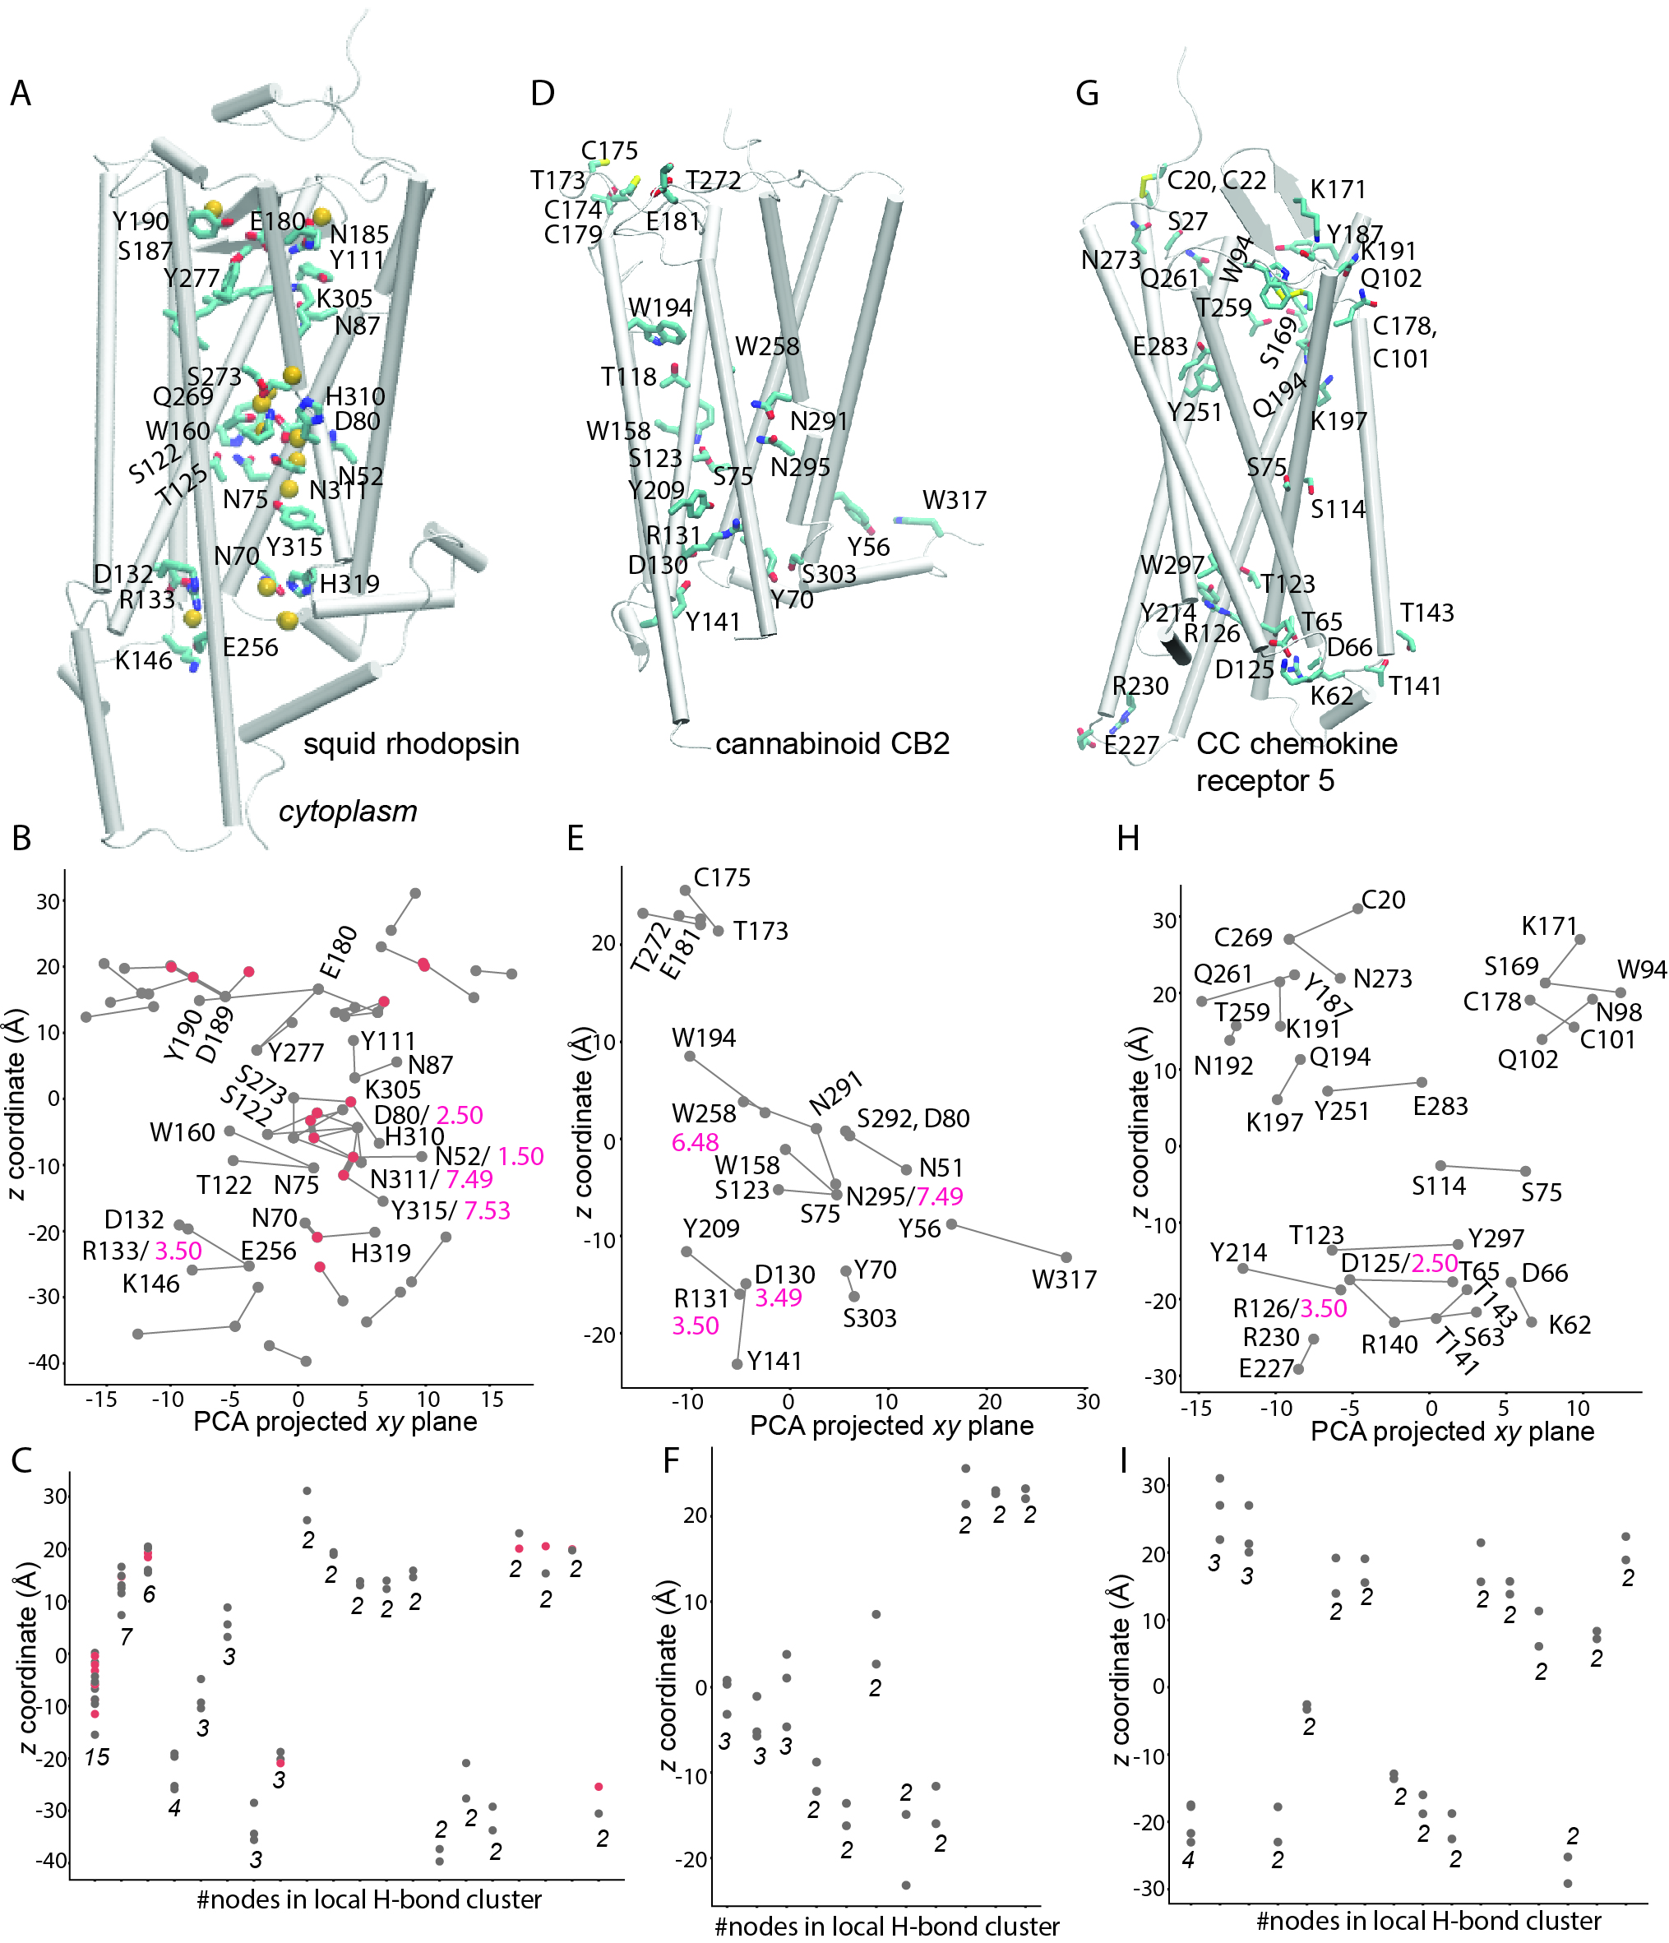
Figure 1. Illustration of H-bond graphs and local H-bond clusters identified in static structures of three GPCRs. (A) Molecular graphics of squid rhodopsin. The protein is shown as white ribbons; selected sidechains are shown as bonds with carbon atoms colored cyan, nitrogen, blue, and oxygen, red. The protein structure (PDB 2Z73, chain A, 2.5Å resolution) was taken from the Orientations of Proteins in Membranes (OPM) database.⁴⁹ (B) C-Graphs²⁰ H-bond graph of squid rhodopsin. Gray dots represent a protein sidechain, red dots, water oxygen atoms, and edges, distances within 3.5Å between the nodes. For clarity, only selected nodes are labeled. For selected graph nodes, numbers in pink indicate the standard BW scheme.⁴⁶ (C) Linear projections²⁰ of H-bond networks. Numbers in italics give the number of nodes of each cluster. (D) Molecular graphics of the cannabinoid receptor CB2 based on chain R of PDB ID:6KPF, 2.9Å resolution.⁴⁷ (E, F) H-bond graph (panel E) and linear projection of H-bond clusters of CB2 (panel E). (G) Molecular graphics of CCR5 based on PDB ID:7O7F, chain C, 3.15Å resolution⁴⁸. Visual Molecular Dynamics (VMD)⁵⁰ was used to orient and center CB2 and CCR5, and for all molecular graphics.

A similar observation was made for the closed state of the unrelated SecY protein translocon, where an extensive H-bond network includes a local H-bond cluster at a site essential for structural dynamics.^{12, 51} Alternatively, the cryo-EM structures might have captured the two receptors in late intermediates in which any continuous H-bond networks within the transmembrane domain have already disassembled.

H-bond networks of the SARS-Covid-19 spike protein S
Spike protein S of SARS-Covid-2 is a homo-trimer of a heavily glycosylated type-I protein (Figure 2A). The N-terminal, S1 region of the ectodomain contains the Receptor Binding Domain, RBD, which binds to the Angiotensin Converting Enzyme 2 receptor (ACE2) of the host cell;^{52, 53} the proteolyic cleavage sites are S1/S2 at R655, and S2’ at R815⁵⁴ (Figure 2A). Before binding to ACE2, protein S samples conformations largely distinguished by the orientation of the RBDs: The closed, receptor-inaccessible conformation⁵⁵ has all three RBDs down, in the same plane on the surface of the protein⁵⁶ (Figure 2A), whereas the receptor-accessible⁵⁵ open⁵⁶ and pre-fusion conformations⁵⁷ have one RBD up. Similar structural dynamics, with a symmetrical, all three RBDs down when inactive, vs. one RBD up when active, was noted for spike S of SARS-Covid.⁵⁸ The up conformation of the ACE-2 bound RBD and structural plasticity could be important to expose site S2’.⁵⁵
Since the three RBDs of protein S have the same sequence, the fact that structures captured by structural biology suggest the three protomers can sample distinct conformations with asymmetric orientations of the RBDs is intriguing. Exhaustive analyses of the H-bond networks in three static cryo-EM structures of the ectodomain of protein S identified H-bond clusters that are located at important functional sites of protein S, including near the proteolytic cleavage site and at the RBD of each protomer, and which have markedly different compositions and arrangements in the closed vs. open and pre-fusion conformation.⁹ Atomistic MD simulations of the closed conformation of protein S indicated that H-bond networks of protein S tend to be dynamic, and that just three H-bonds of the RBDs are sampled persistently in each of the three protomers.¹⁹
Figure 2. Architecture and H-bonding of the SARS-Covid-2 protein S ectodomain. (A) Molecular graphics of the closed conformation; the coordinate snapshot used is from a molecular dynamics simulation.¹⁹ The three RBD domains are colored green, red, and blue; for clarity, the remaining of each protomer is colored light grey, and only selected amino acid residues are labeled. Black, magenta, and pink spheres indicate Cα atoms at the S1/S2 and S2’ cleavage sites, and at Omicron mutation sites⁵⁹ where H-bond properties of the sidechain are altered. Amino acid residues mutated in Omicron are shown for protomer A. (B) Sidechain H-bonds sampled during MD simulations of the closed ectodomain.¹⁹ Each circle represents an H-bonding sidechain, colored according to the protomer to which it belongs; for clarity, only H-bonds sampled during at least 30% of the time are included. (C-E) Illustration of H-bonds between pairs of protomers; lines (graph edges) between H-bonding sidechains (graph nodes) indicate the H-bond occupancy, i.e., the percentage of time during which H-bond criteria are met. Nodes filled with yellow indicate RBD amino acid residues. D571, E702, and N703 H-bond in each protomer pair, and D614 and N969 are mutated in Omicron. ‘c,p’ indicate H-bonds common to the closed and pre-fusion structures, and ‘c,o’ or ‘c,p,o’, H-bonds common to the closed and omicron structures. H-bonds presented in panels B-E were identified with Bridge2 based on 6179 equally-spaced coordinate snapshots from the last 61.8ns segment of an atomistic MD simulation of the closed protein S in a water box as reported in ref.¹⁹ an H-bond distance ≤3.5Å and H-bond angle ≤60º were used as H-bond criteria, and H-bonds computed per amino acid residue. Panels C-E use H-bonds from H-bond graphs presented in ref.¹⁹

Given the size of protein S, it is perhaps not surprising that the graph of H-bonds between sidechains is large: there are >360 sidechain-sidechain H-bonds and disulfide bridges in the cryo-EM coordinate snapshot of the closed structure (Figure 3A). The number of sidechain H-bonds and disulfide bridges in the pre-fusion conformation is significantly smaller, 286 (Figure 3B); of these sidechain interactions, less than half are present in the conserved graph computed for both structures (Figures 3A-C). H-bond differences between the closed vs. pre-fusion structures are distributed throughout the entire protein, from the vicinity of S1055, which is close to the S1/S2 cleavage site, to the RBDs (Figures 2A, 3A-C).
The linear projection of H-bond networks suggests that conserved H-bonds tend to be located in roughly four regions of the protein (Figures 3A,C): the regions of Q895/Q1106, R816, Q644/Q954, and E748 (Figure 3C). By contrast, there are very few conserved H-bonds in the RBDs (Figure 3C), suggesting H-bond interactions of the RBDs are overall distinct in the closed vs. prefusion conformations. Such structural dynamics of the RBDs appears compatible with the finding that, during molecular dynamics (MD) simulations of the closed conformation of protein S, only a relatively small number of inter-protomer H-bonds involved RBD groups, and most of the these RBD H-bonds had low occupancies (Figures 2C-E).¹⁹
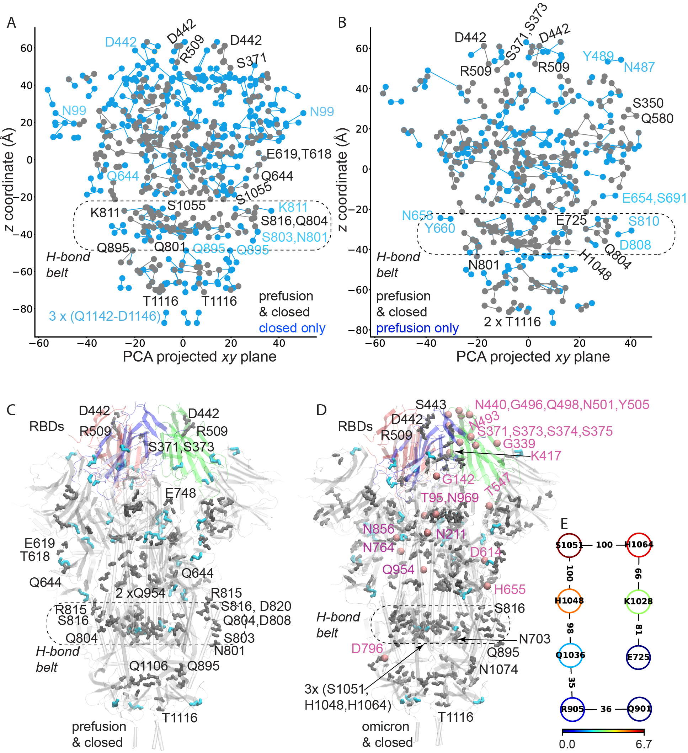

Figure 3. Conserved H-bond graphs of spike protein S. (A-B) C-Graphs²⁰ sidechain H-bond graphs of the closed vs. prefusion conformations (PDB 6vxx⁵⁶ and 6vsb,⁵⁷ respectively). Nodes and edges colored grey indicate H-bonding sidechains and H-bonds present in both structures, and cyan, those present in only one structure; disulfide and salt-bridges bridges are included. (A,B) H-bonds present only in the closed (panel A) or prefusion structures (panel B) are compared to the conserved H-bond graph. (C,D) Molecular graphics of the closed protein S showing interactions conserved in the closed vs. prefusion structures (panel C), and in the closed vs. the Omicron structure 7t9j⁵⁹ (panel D). H-bonding sidechains are shown as black bonds, and cysteine sidechains, cyan. The structure of the Omicron protein S, solved at a resolution of 2.8Å,⁵⁹ has 388 H-bonds and disulfide bridges, of which 179 are also present in the reference closed structure. Sites of amino acid residues mutated in Omicron⁵⁹ are shown as pink spheres for protomer A. (E) Local H-bond network of the high-centrality groups S1051, as identified in ref.¹⁹ Panel E is modified from ref.¹⁹ The closed protein structure used as a reference was oriented and centered using VMD. All structures were analyzed using coordinates for residues solved in these structures.

A caveat of the H-bond graph computation above is that the pre-fusion structure was solved at a resolution of 3.46Å,⁵⁷ as compared to the 2.8Å resolution of the closed structure.⁵⁶ As the discussion above on GPCRs suggests, structures solved at lower resolution may underestimate H-bonding – and, indeed, as noted above, there are fewer H-bonds in the pre-fusion than in the closed structure. Moreover, H-bonds between protein sidechains can be dynamic.¹² In what follows, the usefulness of H-bond graph computations to evaluate dynamic H-bond networks sampled during MD is summarized briefly, with examples that are focused on own work including dynamic H-bonds sampled during MD of the ectodomain of the closed protein S in aqueous solution.¹⁹

Graph-based analyses of dynamic H-bond networks from MD simulations
Classical MD simulation trajectories contain the time evolution of the Cartesian coordinates of all atoms of the system for a finite length of time.¹² Coordinate sets from the MD trajectory can be subjected to graph analyses to dissect H-bond networks; the frequency with which an H-bond is sampled, or its occupancy, is given by the percentage of the simulation length during which the H-bond criteria are met.
Recent works on two unrelated proteins, the Antarctic rhodopsin (AntR) inward proton pump, and the bacterial SecA motor protein, illustrate the usefulness of H-bond graphs to dissect protein dynamics: for AntR, graph-based analyses of internal H-bond networks sampled during MD helped guide the choice of amino acid residues for site-directed mutagenesis to identify groups essential for the functioning of AntR.⁶⁰ For SecA, H-bond graph analyses augmented experiments to identify multiple local flexible regions enabled by dynamical H-bond networks.^{61, 62} Dynamic H-bond networks are illustrated below for protein S based on coordinate snapshots from MD simulations of the closed spike protein S in a water box.¹⁹

H-bond networks of groups mutated in the Omicron spike protein S
Mutations of Spike protein S are of direct interest as they might alter the strength of spike protein-ACE2 interactions, e.g., the N501Y spike protein of the B1.1.7 (UK) variant has an increased ACE2 binding affinity that associates with altered local interactions of Y501.⁶³ Spike protein S of the Omicron virus variant has 37 mutations,⁵⁹ of which 23 alter polar or charged sidechains (Figures 2A, 4A) such that 5 polar/charged sidechains (T95, N211, S371, S373, E488) become Ile, Leu, Phe, or Ala, and 9 polar sidechains (N440, T478, Q493, Q498, T547, N679, N764, N856, and N969) become Lys or Arg.
In the structure of the Omicron spike protein-ACEs complex, R493 and R498 make direct interactions with ACE2 groups, being thought that they contribute to the stronger binding affinity of the Omicron spike protein S.⁵⁹ But the large number of mutations that impact H-bonding groups, and the fact that these mutations are spread throughout much of the protein (Figures 2A, 4A) raise the important question of whether Omicron mutations might impact H-bonds and H-bond networks at sites that could be otherwise relevant for conformational couplings of protein S.
Given that >150 H-bonds are shared between the Omicron and reference closed structures (Figure 3D), we are largely in uncharted territory about the role of specific H-bonds other than those that mediate contacts between protein S and ACE2.^{9, 59, 64} The summary of H-bonds and H-bond networks presented in Figure 4 suggest that at least 10 of the H-bonding sidechains that are mutated in Omicron participate in dynamic sidechain H-bonds, or bridge to another sidechain via an H-bonding water molecule. RBD K417 –which is mutated to Asn in Omicron⁵⁹ and in the earlier 501Y.V2 virus variant,⁶⁵ connects directly to E406 or D420 (Figures 4A,4B), and can also be part of a local water-mediated cluster with water-bridges (Figure 4C).
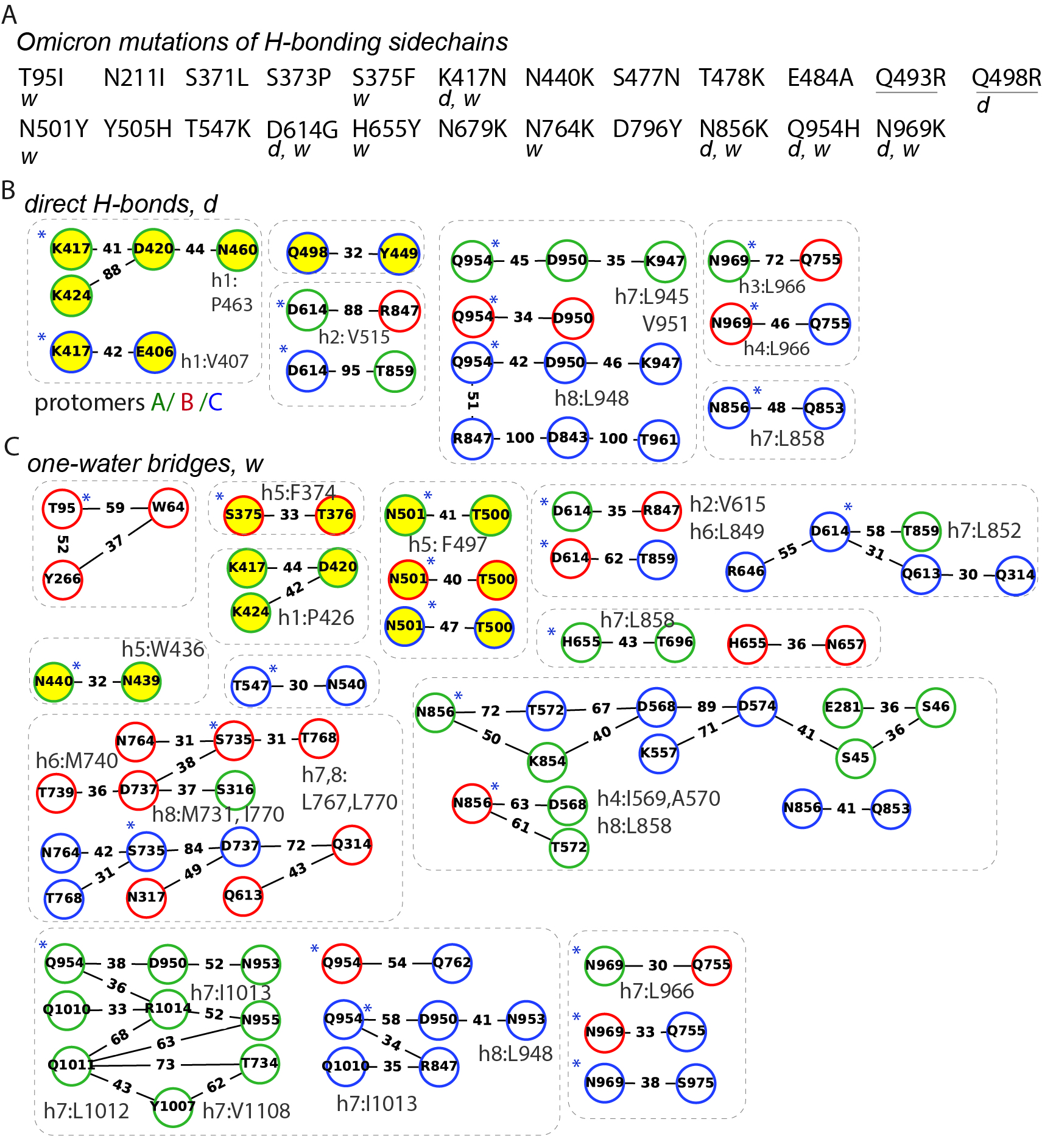
Figure 4. Dynamic H-bonds and H-bond networks of sidechains mutated in the Omicron virus variant. (A) H-bonding sidechains that are mutated in the Omicron variant.⁵⁹ R493 and R498 of the mutated protein S H-bond to ACE2. d and w indicate direct sidechain H-bonds and, respectively, water-mediated bridges sampled during MD.¹⁹ (B, C) Direct (panel B) vs. one water-mediated H-bonds (panel C) of groups mutated in Omicron. Nodes shown with yellow belong to the RBD, and ‘*’ indicates Omicron-mutated residues. Thin dashes indicate H-bonds as present in the three protomers. Numbers along the edges indicate H-bond occupancies computed from MD.¹⁹ h indicates a nearby hydrophobic cluster as illustrated in Figure 5. H-bonds were extracted from H-bond graphs computed in ref.¹⁹. All computations for graphs of H-bonds and hydrophobic interactions were performed with Bridge2, and graph nodes were arranged manually in for optimal display. Panels B and C use H-bonds from H-bond graphs presented in ref.¹⁹

Water-mediated bridges of RBD groups are present at S375, N440, and N501 (Figure 4C); Q498 can directly H-bond to Y449 (Figure 4C). D614 of two protomers has direct inter-protomer H-bonds (Figure 4B), and can be part of a local water-mediated H-bond cluster that includes R646 (Figure 4C), a group where inter-protomer salt bridging can be present (Figure 2C); the D614G mutation in Omicron and Delta variants would abolish or otherwise alter these H-bonds.
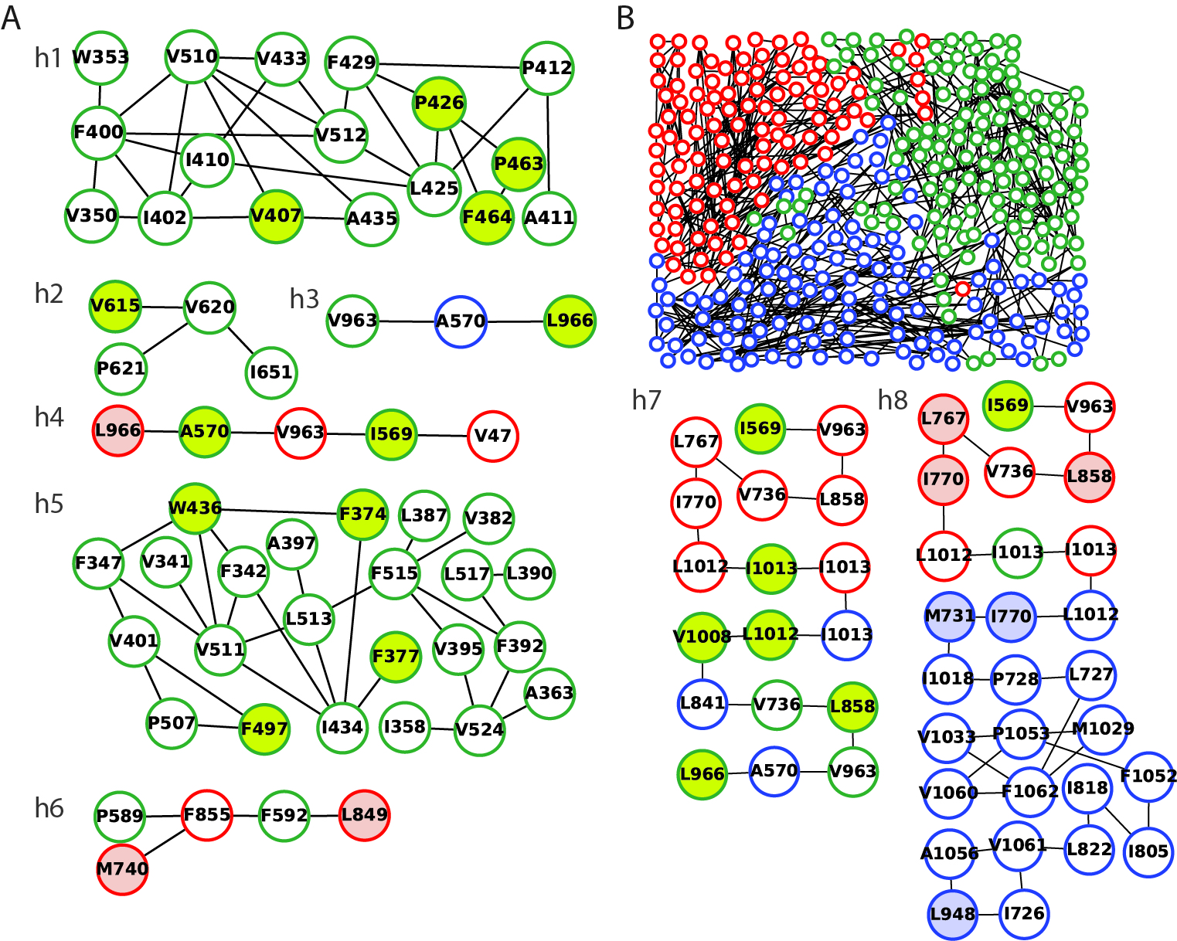
Figure 5. (D-F) Illustration of hydrophobic clusters extracted from hydrophobic interaction graphs computed from MD simulations of spike protein S in ref.¹⁹. Hydrophobic contacts were detected using a distance criterion of 5Å between heavy atoms; for clarity, only hydrophobic contacts with occupancies ≥90% are shown. (A) Illustration of local selected hydrophobic interactions h₁-h₆ that include at least one group (see lime-filled dots) close in sequence to an H-bonding sidechain from Figures 4B, 4C. (B) Hydrophobic cluster found with Connected Components in Bridge2¹⁹ using protomer-A I569 as a root node. Shortest-distance hydrophobic paths h7 and h8 extracted from this cluster; connect I569 connects to L966 in h7, and to L948 of protomer C in h8. Figure 5 uses hydrophobic interactions and hydrophobic clusters from graphs presented in ref.¹⁹

N856 has water-mediated bridging in all three protomers, and can be part of an extended H-bond cluster with 8 other protein sidechains; this extended cluster includes D568 and D574, sites where inter-protomer interactions with K854 are sampled (Figures 2C, 2E) – and K854 is just two positions downstream from N856, another Omicron mutation (Figure 4A). Q954 directly H-bonds to D950 in all three protomers; in one of the protomers, Q954 is part of an H-bond cluster with D843, which was implicated in a pH-dependent switch thought important for conformational dynamics upon endosome entry;⁵³ in two protomers, Q954 is part of water-mediated clusters with N953 (Figure 4C). The most C-terminal Omicron mutation group, N969, can bridge two protomer pairs via H-bonding to Q755 (Figures 2C, 4B); close in sequence to N969, Q965 H-bonds to S758 in two protomer pairs; one of the Q965-S758 inter-protomer H-bonds is conserved in static structures of the reference closed, prefusion, and Omicron spike proteins (Figure 2E).
The finding here that a number of the sidechains mutated in Omicron can participate in local H-bond clusters (Figures 4B, 4C) raises the possibility that the local conformational dynamics of the Omicron spike protein might be somewhat distinct from that of the reference closed conformation.
The presence of multiple H-bonds in the vicinity of the S2’ proteolytic site (Figure 3) is intriguing, and raises the question as to whether H-bond networks in this protein region could be relevant to protein conformational coupling. Couplings via H-bonds have been identified experimentally e.g., for the ketosteroid isomerase, which has coupling between two adjoining H-bonds at its active site,⁶⁶ and for the Pseudomonas aeruginosa heme oxygenase, which uses a H-bond network to control its conformational dynamics.⁶⁷ Future experiments and computation would be required to evaluate whether H-bonds of the belt region could be involved in a relay of structural changes upon proteolytic activation of protein S.
The discussion here was focused on H-bonds and H-bond networks. To decipher molecular interactions that govern local dynamics of H-bonds networks, hydrophobic interactions might need to be considered, since the local hydrophobic environment can restrict H-bond dynamics.³⁰ Compatible with this notion, graph analyses of hydrophobic interactions performed with Bridge2 for the ectodomain of protein S indicated that each of the three RBD H-bonds sampled persistently during MD is close to a conserved hydrophobic group engaged in local hydrophobic contacts.¹⁹ Hydrophobic clusters that neighbor H-bonds and H-bond networks of Omicron-mutated groups include V407 and P463, which are close in sequence to groups of the E417 network (Figures 4A, 4B, 5A); V615 –adjacent to D614 (Figures 4C, 5B); L966 –close to N969 (Figures 4, 5B); L948 – close to D950-Q948 (Figure 4B), and also part of a hydrophobic cluster with L805 (Figure 5B), which is adjacent to Q804 of the H-bond belt (Figure 3D). In the future, the interplay between hydrophobic contacts and H-bond networks during the reaction coordinate of protein S could be dissected with the Bridge^{18, 19} and C-Graphs²⁰ algorithms presented here and, e.g., with algorithms for rigidity-based approaches.^{26, 68}

Conclusions
Advances in structural biology and computation provide us with a wealth of data on the structures and conformational dynamics of large proteins and protein complexes, and bring about the challenge of how to efficiently analyze data sets of protein structures to identify interactions of interest for protein function. The usefulness of graph-based analyses for efficient analyses of protein structure has led to the development of dedicated algorithms and applications of network analyses to study protein function (see, e.g., refs. ^{68, 69}). This perspective focused on the applicability of the recently developed Bridge,¹⁸ Bridge2,¹⁹ and C-Graphs²⁰ algorithms and graphical user interfaces for efficient analyses of dynamic protein and protein-water H-bond networks. Features of Bridge and C-Graphs that are particularly valuable for analyses of complex proteins include Connected Components Analyses to extract local H-bond clusters from the complete H-bond graph (Figures 4B, 4C),¹⁸ interactive rearrangement of graph nodes for optimal visualization of H-bonds and H-bond networks¹⁹ (Figures 2, 4B, 4C), and computations of conserved and comparison H-bond graphs to map H-bonds that are conserved, vs. distinct, in data sets²⁰ (Figures 3A, 3B).
GPCRs and the SARS-Covid-19 spike protein S are among proteins for which static structures are being solved at a rapid pace, and H-bonds have been implicated in function – in the case of GPCRs, internal H-bond dynamics are part of the reaction coordinate for receptor activation and, in the case of the spike protein, for the binding to the ACE2 receptor of the host cell. H-bond graphs provide an overview of all H-bonds present in distinct protein structures (Figures 1, 2, 3).
Graph-based analyses of H-bonds in data sets of static protein structures have the advantage that they can be performed directly on the structure resulting from experimental biology (Figures 1,3). Moreover, as static structures might be solved for distinct conformational intermediates of the same protein, and in different experimental conditions, or for distinct proteins of the same family, data sets of experimental static structures provide invaluable input about the protein conformational space. A caveat of graph-based analyses of H-bond networks based on static protein structures is that H-bonds and H-bond networks can be rather dynamic, particularly when water bridging is involved, and H-bond dynamics can be difficult to predict based on static structures¹² which typically lack coordinates for H atoms. Moreover, resolution can impact results of graph-based H-bond analyses. For example, GPCRs structures solved at higher resolution tend to contain coordinates for more internal water molecules.³⁶ The GPCR structures solved at resolutions of 2.5Å or higher, and with at least 10 internal waters, have a conserved protein-water H-bond network that contains amino acid residue sidechains known to be essential for function, additional local H-bond clusters being present in the higher-resolution structures.³⁶ An overview of how frequently ten selected H-bond motifs are present in static structures of membrane proteins from distinct families was found to be qualitatively similar when analyzing 200 structures solved at a resolution of 2.5Å or higher, vs. 483 structures solved at resolutions of 2.5-3.5Å.⁷⁰ For the soluble protein SecA, an H-bond network at the nucleotide-binding site was qualitatively similar when computed from 4 static structures solved at resolutions of 2.5-3.2Å, or from MD simulations started from one of those structures –however, additional H-bonds were sampled transiently at room temperature during MD.⁷¹ In rigidity analyses of biological assemblies, it was found that certain H-bonds can alter profoundly the rigidity of a protein complex.⁷² These considerations suggest that both the resolution and the number of internal waters need to be accounted for when selecting datasets of static protein structures for H-bond network analyses.
MD simulations are valuable here, as they allow us to explore dynamic H-bonds and H-bond networks in fluid environments, including transient H-bonds that could be difficult to anticipate based on static structures.¹² The dynamic protein-water H-bond networks would need to be considered when interpreting centrality values: Work on a membrane-embedded GPCR indicated that high centrality values might be obtained for bulk-exposed sidechains involved in dynamic water bridges;³⁶ yet, when H-bond graphs computed from MD simulations included only the persistent interactions, high-centrality values were obtained for groups with highest centrality in static structures.³⁶
Both GPCRs and the spike S are dynamic proteins whose reaction cycles are thought to involve protonation change. In the future, pH-dependent computations would be required to evaluate mechanisms by which protonation change at discrete protein sites couple to protein conformational change, and to map protonation-dependent dynamics onto H-bond graphs.

Acknowledgement. Research reviewed here was supported in part by the Collaborative Research Center SFB 1078 of the German Research Foundation, and by allocations of computing time from the HLRN, the North-German Supercomputing Center.

References
1. Mirsky, A. E.; Pauling, L., On the Structure of Native, Denatured, and Coagulated Proteins. Proc. Natl. Acad. Sci. 1936, 22, 439-447.
2. Bragg, W. L.; Kendrew, J. C.; Perutz, M. F., Polypeptide Chain Configurations in Crystalline Proteins. Proc. Royal Soc. A 1950, 21, 321-357.
3. Pauling, L.; Corey, R. B.; Branson, H. R., The Structure of Proteins: Two Hydrogen-Bonded Helical Configurations of the Polypeptide Chain. Proc. Natl. Acad. Sci. 1951, 37, 205-211.
4. Huggins, M. L., The Structure of Fibrous Proteins. Chem. Rev. 1942, 32, 195-218.
5. Fersht, A. R.; Shi, J.-P.; Knill-Jones, J.; Lowe, D. M.; Wilkison, A. J.; Blow, D. M.; Brick, P.; Carter, P.; Waye, M. M. Y.; Winter, G., Hydrogen Bonding and Biological Specificity Analysed by Protein Engineering. Nature 1985, 314, 235-238.
6. Pace, C. N.; Fu, H.; Fryar, K. L.; Landua, J.; Trevino, S. R.; Schell, D.; Thurkill, R. L.; Imura, S.; Scholtz, J. M.; Gajiwala, K.; Sevcik, J.; Urbanikova, L.; Myers, J. K.; Takano, K.; Hebert, E. J.; Shirley, B. A.; Grimsley, G. R., Contribution of Hydrogen Bonds to Protein Stability. Prot. Sci. 2014, 23652-661.
7. Joh, N. H.; Min, A.; Faham, S.; Whitelegge, J. P.; Yang, D.; Woods Jr., V. L.; Bowie, J. U., Modest Stabilization by Most Hydrogen-Bonded Side-Chain Interactions in Membrane Proteins Nature 2008, 453, 1266-1270.
8. Hong, H.; Szabo, G.; Tamm, L. K., Electrostatic Couplings in OmpA Ion-Channel Gating Suggest a Mechanism for Pore Opening. Nature Chem. Biol. 2006, 2, 627-633.
9. Karathanou, K.; Lazaratos, M.; Bertalan, E.; Siemers, M.; Buzar, K.; Schertler, G. F. X.; del Val, C.; Bondar, A.-N., A Graph-Based Approach Identifies Dynamic H-Bond Communication Networks in Spike Protein S of SARS-CoV-2. J. Struct. Biol. 2020, 212, 107617.
10. Lazaratos, M.; Karathanou, K.; Bondar, A.-N., Graphs of Dynamic H-Bond Networks: from Model Proteins to Protein Complexes in Cell Signaling. Current Opinion Struct. Biol. 2020, 64, 79-87.
11. Martin, T. W.; Derewenda, Z. S., The Name isBond - H Bond. Nature Struct. Biol. 1999, 6, 403-406.
12. Bondar, A.-N.; White, S. H., Hydrogen Bond Dynamics in Membrane Protein Function. Biochim. Biophys. Acta 2012, 1818, 942-950.
13. Arunan, E.; Desiraju, G. R.; Klein, R. A.; Sadlej, J.; Scheiner, S.; Akorta, I.; Clary, D. C.; Crabtree, R. H.; Dannenberg, J. J.; Hobza, P.; Kjaergaard, H. G.; Legon, A. C.; Mennucci, B.; Nesbitt, D. J., Definition of the Hydrogen Bond (IUPAC Recommendations 2011). Pure Appl. Chem. 2011, 83, 1637-1641.
14. Arunan, E.; Desiraju, G. R.; Klein, R. A.; Sadlej, J.; Scheiner, S.; Alkorta, I.; Clary, D. C.; Crabtree, R. H.; Dannenberg, J. J.; Hobza, P.; Kjaergaard, H. G.; Legon, A. C.; Mennucci, B.; Nesbitt, D. J., Defining the Hydrogen Nond: An Account (IUPAC technical report). Pure Appl. Chem. 2011, 83, 1619-1636.
15. Espinosa, E.; Souhassou, M.; Lachekar, H.; Lecomte, C., Topological Analysis of the Electron Density in Hydrogen Bonds. Acta Cryst. 1999, B55, 563-572.
16. Isaacs, E. D.; Shukla, A.; Platzman, P. M.; Hamann, D. R.; Barbiellini, B.; Tulk, C. A., Covalency of the Hydrogen Bond in Ice: A Direct X-ray Measurement. Phys. Rev. Lett. 1999, 82, 600-603.
17. Hubbard, R. E.; Haider, M. K. Hydrogen Bonds in Proteins: Roles and Strength. In Enciclopedia of Life Sciences; John Wiley & Sons, Ltd: Chichester: 2010.
18. Siemers, M.; Lazaratos, M.; Karathanou, K.; Guerra, F.; Brown, L. S.; Bondar, A.-N., Bridge: A Graph-Based Algorithm to Analyze Dynamic H-Bond Networks in Membrane Proteins. J. Chem. Theory Comput. 2019, 15, 6781-6798.
19. Siemers, M.; Bondar, A.-N., Interactive Interface for Graph-Based Analyses of Dynamic H-Bond Networks: Application to Spike Protein S. J. Chem. Inf. Model. 2021, 61, 2998-3014.
20. Bertalan, E.; Lesca, E.; Schertler, G. F. X.; Bondar, A.-N., C-Graphs Tool with Graphical User Interface to Dissect Conserved Hydrogen-Bond Networks: Applications to Visual Rhodopsins. J. Chem. Inf. Model. 2021, 61, 5692-5707.
21. Gowers, R. J.; Linke, M.; Barnoud, J.; Reddy, T. J. E.; Melo, M. N.; Seyler, S. L.; Dotson, D. L.; Domanski, J.; Buchoux, S.; Kenney, I. M.; Beckstein, O., MDAnalysis: A Python Package for the Rapid Analysis of Molecular Dynamics Simulations. S. Benthall and S. Rostrup, Editors, Proc. 15th Phyton in Science Conference, Austin, TX, 2016 SciPy 2016, 102-109.
22. Cormen, T. H.; Leiserson, C. E.; Rivest, R. L.; Sten, C., Introduction to Algorithms, Third Edition. Massachusetts Institute of Technology 2009.
23. Valente, T. W.; Coronges, K.; Lakon, C.; Costenbader, E., How Correlated are Network Centrality Measures? Connect (Tor) 2008, 28, 16-26.
24. Amitai, G.; Shemesh, A.; E., S.; Shklar, M.; Netanely, D.; Venger, I.; Pietrovski, S., Network Analysis of Protein Structures Identifies Functional Residues. J. Mol. Biol. 2004, 344, 1135-1146.
25. Karathanou, K.; Bondar, A.-N., Using Graphs of Dynamic Hydrogen-Bond Networks to Dissect Conformational Coupling in a Protein Motor. J. Chem. Inf. Model. 2019, 59, 1882-1896.
26. Fokas, A. S.; Cole, D. J.; Ahnert, S. E.; Chin, A. W., Residue Geometry Networks: A RIgidity-Based Approach to the Amino Acid Network and Evolutionary Rate. Sci. Rep. 2016, 6, 33213.
27. Freeman, L. C., A Set of Measures of Centrality Based on Betweenness. Sociometry 1977, 40, 35-41.
28. Freeman, L. C., Centrality in Cocial Networks. Conceptual Clarification. Social Networks 1979, 1, 215-239.
29. Brandes, U., A Faster Algorithm for Betweenness Centrality. J. Math. Sociol. 2001, 25, 163-177.
30. del Val, C.; Bondar, L.; Bondar, A.-N., Coupling Between Inter-Helical Hydrogen Bonding and Water Dynamics in a Proton Tansporter. J. Struct. Biol. 2014, 186, 95-111.
31. Bondar, A.-N.; Lemieux, H. J., Reactions at Membrane Interfaces. Chem. Rev. 2019, 119, 6162-6183.
32. Bondar, A.-N.; Smith, J. C., Protonation-State Coupled Conformational Dynamics in Reaction Mechanisms of Channel and Pump Rhodopsins. Photochem. Photobiol. 2017, 93, 1336-1344.
33. Berman, H. M.; Westbrook, J.; Feng, G.; Gilliland, G.; Bhat, T. N.; Weissig, H.; Shindyalov, I. N.; Bourne, P. E., The Protein Data Bank. Nucleic Acid Res. 2000, 28, 235-242.
34. Lappano, R.; Maggiolini, M., G Protein-Coupled Receptors: Novel Targets for Drug Discovery in Cancer. Nature Rev. Drug Discov. 2011, 10, 47-60.
35. Hauser, A.; Attwood, M. M.; Rask-Andersen, M.; Schiöth, H. B.; Gloriam, D. E., Trends in GPCR DrugDiscovery: New Agents,Targets and Indications. Nature Rev. Drug Discov. 2017, 16, 829-842.
36. Bertalan, É.; Lešnik, S.; Bren, U.; Bondar, A.-N., Protein-Water Hydrogen-Bond Networks of G Protein-Coupled Receptors: Graph-Based Analyses of Static Structures and Molecular Dynamics. J. Struct. Biol. 2020, 212, 107634.
37. Martin-Grecia, J. M.; Conrad, C. E.; Cose, J.; Roy-Chowdhury, S.; Fromme, P., Serial femtosecond crystallography: A revolution in structural biology. Arch. Biochem. Biophys. 2016, 602, 32-47.
38. Nango, E.; Royant, A.; Kubo, M.; Nakane, T.; Wickstrand, C.; Kimura, T.; Tanaka, T.; Tono, K.; Song, C.; Tanaka, R.; Arima, T.; Yamashita, A.; Kobayashi, J.; Hosaka, T.; Mizohata, E.; Nogly, P.; Sugahara, M.; Nam, D.; Nomura, T.; Shimamura, T.; Im, D.; Fujiwara, T.; Yamanaka, Y.; Jeon, B.; Nishizawa, T.; Oda, K.; Fukuda, M.; Andersson, R.; Båth, P.; Dods, P.; Davidsson, J.; Matsuoka, S.; Kawatake, S.; Murata, M.; Nureki, O.; Owada, S.; Kameshima, T.; Hatsui, T.; Joti, Y.; Schertler, G.; Yabashi, M.; Bondar, A.-N.; Standfuss, J.; Neutze, R.; Iwata, S., A Three-Dimensional Movie of Structural Changes in Bacteriorhodopsin. Science 2016, 354, 1552-1557.
39. McDonald, I. K.; Thornton, J. M., Satisfying Hydrogen Bonding Potential in Proteins. J. Mol. Biol. 1994, 238, 777-793.
40. Levitt, M.; Park, B. H., Water: Now You See It, Now You Don't. Structure 1993, 223-226.
41. Kemmler, L.; Ibrahim, M.; Dobbek, H.; Zouni, A.; Bondar, A.-N., Dynamic Water Bridging and Proton Transfer at a Surface Carboxylate Cluster of Photosystem II. Phys. Chem. Chem. Phys. 2019, 21, 25449-25466.
42. Bondar, A.-N.; Baudry, J.; Suhai, S.; Fischer, S.; Smith, J. C., Key Role of Active-Site Water Molecules in Bacteriorhodopsin Proton-Transfer Reactions. J. Phys. Chem. B 2008, 112, 14729-14741.
43. Gottschalk, M.; Dencher, N. A.; Halle, B., Microsecond Exchange of Internal Water Molecules in Bacteriorhodopsin. Journal of Molecular Biology 2001, 311, 605-621.
44. Quillin, M. L.; Wingfield, P. T.; Matthews, B. W., Determination of Solvent Content in Cavities in IL-1β using Experimentally Phased Electron Density. Proc. Natl. Acad. Sci. 2006, 103, 19749-19753.
45. Murakami, M.; Kouyama, T., Crystal Structure of Squid Rhodopsin. Nature 2008, 453, 363-367.
46. Ballesteros, J. A.; Weinstein, H., Integrated Methods for the Construction of Three Dimensional Models and Computational Probing of Structure-Function Relations in G Protein-Coupled Receptors. Methods in Neurosciences 1995, 25, 366-428.
47. Hua, T.; Li, X.; Wu, L.; Iliopoulos-Tsoutsouvas, C.; Y., W.; Wu, M.; Shen, L.; Johnston, C. A.; Nikas, S. P.; Song, F.; Song, X.-J.; Yuan, S.; Sun, Q.; Wu, Y.-T.; Jiang, S.; Grim, T. W.; Benchama, O.; Stahl, E. L.; Zvonok, N.; Zhao, S.; Bohn, L. M.; Makriyannis, A.; Liu, Z.-J., Activation and Signaling Mechanisms Revealed by Cannabinoid Receptor-G_{i} Complex Structures. Cell 2020, 1-11.
48. Isaikina, P.; Tsai, C.-J.; Dietz, N.; Pamula, F.; Grahl, A.; Goldie, K. N.; Guixà-González, R.; Branco, C.; Paolini-Bertrand, M.; Calo, N.; Cerini, F.; Schertler, G. F. X.; Hartley, O.; Stahlberg, H.; Maier, T.; Deupi, X.; Grzesiek, S., Structural Basis of the Activation of the CC Chemokine Receptor by a Chemokine Agonist. Sci. Adv. 2021, 7, eabg8685.
49. Lomize, M.; Pogozheva, I. D.; Joo, H.; Mosberg, H. I.; Lomize, A. L., OPM Database and PPM Server: Resources for Positioning of Proteins in Membranes. Nucleic Acid Res. 2011, 40, D370-D376.
50. Humphrey, W.; Dalke, W.; Schulten, K., VMD: Visual Molecular Dynamics. J. Mol. Graph. 1996, 14, 33-38.
51. Bondar, A.-N.; del Val, C.; Freites, J. A.; Tobias, D. J.; White, S. H., Dynamics of SecY Translocons withTranslocation-Defective Mutations. Structure 2010, 18, 847-857.
52. Hoffmann, M.; Kleine-Weber, H.; Schroeder, S.; Krüger, N.; Herrler, T.; Erichse, S.; Schiergens, T. S.; Herrler, T.; Wu, N.-H.; Nitsche, A.; Müller, M. A.; Drosten, C.; Pöhlmann, S., SARS-CoV-2 Cell Entry Depends on ACE2 and TMPRSS2 and is Blocked by a Clinically Proven Protease Inhibitor. Cell 2020, 181, 1-10.
53. Zhou, T.; Tsybovsky, Y.; Gorman, J.; Rapp, M.; Cerutti, G.; Chuang, G.-Y.; Katsamba, P. S.; Sampson, J. M.; Schön, A.; Bimela, J.; Boyington, J. C.; Nazzari, A.; Olia, A. S.; Shi, W.; Sastry, M.; Stephens, T.; Stuckey, J.; Teng, I.-T.; Wang, P.; Wang, S.; Zhang, B.; Friesner, R. A.; Ho, D. D.; Mascola, J. R.; Shapiro, L.; Kwong, P. D., Cryo-EM Structures of SARS-CoV-2 Spike Without and With ACE2 Reveal a pH-Dependent Switch to Mediate Endosomal Positioning of Receptor-Binding Domains. Cell Host & Microbe 2020, 28, 867-879.
54. Jaimes, J. A.; André, N. M.; Chappie, J. S.; Millet, J. K.; Whittaker, G. R., Phylogenetic Analysis and Structural Modeling of SARS-CoV-2 Spike Protein Reveals an Evolutionary Distinct and Proteolytically Sensitive Activation Loop. J. Mol. Biol. 2020, 432, 3309-3325.
55. Cai, Y.; Zhang, J.; Xiao, T.; Peng, H.; Sterling, S. M.; Walsh, R. M. J.; Rawson, S.; Rits-Volloch, S.; Chen, B., Distinct Conformational States of SARS-CoV-2 Spike Protein. Science 2020, 369, 1586-1592.
56. Walls, A. C.; Park, Y.-J.; Tortorici, M. A.; Wall, A.; McGuire, A. T.; Veesler, D., Structure, Function, and Antigenicity of the SARS-CoV-2 SpikeGlycoprotein. Cell 2020, 180, 1-12.
57. Wrapp, D.; Wang, N.; Corbett, K. S.; Goldsmith, J. A.; Hsieh, C.-L.; Abiona, O.; Graham, B. S.; McLellan, J. S., Cyo-EM Structure of the 2019-nCoV Spike in the Prefusion Conformation. Science 2020, 367, 1260-1263.
58. Kirchdoerfer, R. N.; Wang, N.; Pallesen, J.; Wrapp, D.; Turner, H. L.; Cottrell, C. A.; Corbett, K. S.; Graham, B. S.; McLellan, J. S.; Ward, A. B., Stabilized Coronavirus Spikes are Resistant to Conformational Changes Induced by Receptor Recognition or Proteolysis. Sci. Rep. 2018, 8, 15701.
59. Mannar, D.; Saville, J. W.; Zhu, X.; Srivastava, S. S.; Berezuk, A. M.; Tuttle, K. S.; Marquez, C.; Sekirov, I.; Subramaniam, S., SARS-CoV-2 Omicron variant: Antibody Evasion and Cryo-EM Structure of Spike Protein-ACE2 Complex. Science 2021, 375, 760-764.
60. Harris, A.; Lazaratos, M.; Siemers, M.; Watt, E.; Hoang, A.; Tomida, S.; Schubert, L.; Saita, M.; Heberle, J.; Furutani, Y.; Kandori, H.; Bondar, A.-N.; Brown, L. S., Mechanism of Inward Proton Transport in an Antartic Microbial Rhodopsin. J. Phys. Chem. B 2020, 124, 4851-4872.
61. Krishnamurthy, S.; Elefteriadis, N.; Karathanou, K.; Smit, J. H.; Portaliou, A. G.; Chatzi, K. E.; Karamanou, S.; Bondar, A.-N.; Gouridis, G.; Economou, A., A Nexus of Intrinsic Dynamics Underlies Translocase Priming. Structure 2021, 29, 846-858.e7.
62. Krishnamurthy, S.; Sardis, M. F.; Elefteriadis, N.; Chatzi, K. E.; Smit, J. H.; Karathanou, K.; Gouridis, G.; Portaliou, A. G.; Bondar, A.-N.; Karamanou, S.; Economou, A., Preproteins Couple the Intrinsic Dynamics of SecA to its ATPase Cycle to Translocate via a Catch and Release Mechanism. Cell Reports 2022, 38, 110346.
63. Zhu, X.; Mannar, D.; Srivastava, S. S.; Berezuk, A. M.; Demers, J.-P.; Saville, J. W.; Leopold, K.; Li, W.; Dimitrov, D. S.; Tuttle, K. S.; Zhou, S.; Chittori, S.; Subramaniam, S., Cryo-electron Microscopy Structures of the N501Y SARS-CoV-2 Spike Protein in Complex with ACE2 and 2 Potent Neutralizing Antibodies. PLoS Biol. 2021, 19, e3001237.
64. Lan, J.; Ge, J.; Shan, S.; Zhou, H.; Fan, S.; Zhang, Q.; Shi, X.; Wang, Q.; Zhang, L.; Wang, X., Structure of the SARS-CoV-2 Spike Receptor-Binding Domain Bound to the ACE2 Receptor. Nature 2020, 581, 215-220.
65. Tegally, H.; Wilkinson, E.; Giovanetti, M.; Iranzadeh, A.; Fonseca, V.; Giandhari, J.; Doolabh, D.; Pillay, S.; San, E. J.; Msomi, M.; Mlisana, K.; von Gottber, A.; Walaza, S.; Allam, M.; Ismail, A.; Mohale, T.; Glass, A. J.; Engelbrecht, S.; van Zyl, G.; Preiser, W.; Petruccione, F.; Sigal, A.; Hardie, D.; Marais, G.; Hsiao, M.; Korsman, S.; Davies, M.-A.; Tyers, L.; Mudau, I.; York, D.; Maslo, C.; Goedhals, D.; Abrahams, S.; Laguda-Akingba, O.; Alisoltani-Dehkordi, A.; Godzik, A.; Wibmer, C. K.; Sewell, B. T.; Lourenço, J.; Alcantara, L. C. J.; Kosakovsky Pond, S. L.; Weaver, S.; Martin, D.; Lessels, R. J.; Bhiman, J. N.; Williamson, C.; de Oliveira, T., Emergence of Rapid Spread of a New Severe Acute Respiratory Syndrome-Related Coronavirus 2 (SARS-CoV-S) Lineage with Multiple Spike Mutations in South Africa. Nature 2021, 592, 438-443.
66. Sigala, P. A.; Caaveiro, J. M.; Ringe, D.; Petsko, G. A., Hydrogen Bond Coupling in the Ketosteroid Isomerase Active Site. Biochemistry 2009, 48, 6932-6939.
67. Rodríguez, J. C.; Zeng, Y.; Wilks, A.; Rivera, M., The Hydrogen-Bonding Network in Heme Oxygenase also Functions as a Modulator of Enzyme Dynamics: Chaotic Motions Upon Disrupting the H-Bond Network in Heme Pxygenase from Pseudomonas aeruginosa. J. Am. Chem. Soc. 2007, 129, 11730-11742.
68. Streinu, I., Large Scale Rigidity-Based Flexibility Analysis of Biomolecules. Struct. Dyn. 2016, 3, 012005.
69. Cai, X.; Haider, K.; Lu, J.; Radic, S.; Son, C. Y.; Cui, Q.; Gunner, M. R., Network Analysis of a Proposed Exit Pathway for Protons to the P-Side of Cytochrome c Oxidase. Biochim. Biophys. Acta - Bioenergetics 2018, 1859, 997-1005.
70. Lazaratos, M.; Siemers, M.; Brown, L. S.; Bondar, A.-N., Conserved Hydrogen-Bond Motifs of Membrane Transporters and Receptors. BBA - Biomembranes 2022, 1864, 183896.
71. Karathanou, K.; Bondar, A.-N., Dynamic Hydrogen Bonds in Bacterial Protein Secretion. FEMS Microbiol. Lett. 2018, 365, fny124.
72. Jagodzinski, F.; Clark, P.; Grant, J.; Liu, T.-H.; Monastra, S.; Streinu, I., Rigidity Analysis of Biological Yssemblies and Periodic Crystal Structures. BMC Bioinformatics 2013, 14, S2.

TOC Graphic
Biography and Photograph
Ana-Nicoleta Bondar obtained her doctoral degree in 2004 from the University of Heidelberg, with computational biophysics research pursued at the Interdisciplinary Center for Scientific Computing (IWR) and at the German Cancer Research Center (DKFZ) Heidelberg. After post-doctoral research at the IWR, in 2006 she moved to the University of California, Irvine, Department of Physiology and Biophysics, as an Assistant Project Scientist. From 2010 to 2021 she led the theoretical molecular biophysics group at the Freie Universität Berlin, Physics Department. In 2021 she became full professor at the University of Bucharest, Faculty of Physics, and visiting scientist at the Forschungszentrum Jülich, Computational Biomedicine (IAS-5/INM-9). Her research is focused on understanding protein reaction mechanisms.



