Algorithm to catalogue topologies of dynamic lipid hydrogen-bond networks

Konstantina Karathanou¹ and Ana-Nicoleta Bondar^{1,2,3}
¹Freie Universität Berlin, Department of Physics, Theoretical Molecular Biophysics, Arnimallee 14, D-14195 Berlin, Germany
²University of Bucharest, Faculty of Physics, Str. Atomiştilor 405, Bucharest-Măgurele 077125, Romania
³Institute for Neuroscience and Medicine and Institute for Advanced Simulations (IAS-5/INM-9), Computational Biomedicine, Forschungszentrum Jülich, 52425 Jülich, Germany
nbondar@fizica.unibuc.ro

Abstract
Lipid membrane interfaces host reactions essential for the functioning of cells. The hydrogen-bonding environment at the membrane interface is particularly important for binding of proteins, drug molecules, and ions. We present here the implementation and applications of a depth-first search algorithm that analyzes dynamic lipid interaction networks. Lipid hydrogen-bond networks sampled transiently during simulations of lipid bilayers are clustered according to main types of topologies that characterize three-dimensional arrangements of lipids connected to each other via short water bridges. We characterize the dynamics of hydrogen-bonded lipid clusters in simulations of model POPE and POPE:POPG membranes that are often used for bacterial membrane proteins, in a model of the Escherichia coli membrane with six different lipid types, and in POPS membranes. We find that all lipids sample dynamic hydrogen-bonded networks with linear, star, or circular arrangements of the lipid headgroups, and larger networks with combinations of these three types of topologies. Overall, linear lipid-water bridges tend to be short. Water-mediated lipid clusters in all membranes with PE lipids tend to be somewhat small, with about four lipids in all membranes studied here. POPS membranes allow circular arrangements of three POPS lipids to be sampled frequently, and complex arrangements of linear, star, and circular paths may also be sampled. These findings suggest a molecular picture of the membrane interface whereby lipid molecules transiently connect in clusters with somewhat small spatial extension.

Introduction
Lipid membranes that surround biological cells and their compartments host reactions essential for cell function. Proteins that bind at the lipid membrane interface participate in cell signaling, lipid transport, and chemical reactions. Physical-chemical properties of lipid membranes, and thus reactions hosted by these membranes, are shaped by the composition of the lipid molecules that constitute the membrane. Particularly important here is the exposure of anionic phosphatidylserine (PS) lipids at the outer membrane, which associates with cell aging [1], apoptosis and cancer [2-4]. Recognition of PS lipids by specialized receptors of the immune system cells can down-regulate the immune system response, enabling the cancer cell to evade the immune system [5]. Immune surveillance is also inhibited by acidic pH of the cancer cell [6] via mechanisms that could involve pH sensing by proton-coupled G-Protein Coupled Receptors and ion channels that sense pH [7]. In the much simpler bacterial membranes, negatively-charged phosphatidyl glycerol (PG) lipids can help recruit peripheral proteins at the membrane surface [8] and promote protein translocation [9]. Membrane anchoring of an amyloid-β peptide fragment involves hydrogen(H)-bonding that depends on the composition of the lipid membrane [10]. More generally, interactions at the membrane surface are likely influenced by H-bonding, as H-bonds are key determinants of molecular recognition in aqueous environments [11, 12]. We present here the new implementation of a graph-based algorithm that identifies dynamic H-bond networks sampled by lipids in numerical simulations of hydrated bilayers, and apply this algorithm to dissect H-bond networks at the interface of six different lipid membranes.
H-bonds are commonly identified using geometric criteria for the distance between the H-bond donor and acceptor heavy atoms, and for the H-bond angle; an alternative criterion is based on the distance between the H atom and the acceptor heavy atom. Analyses of H-bond geometries show the distance between H atom and an acceptor nitrogen (N) or oxygen (O) atoms takes values between 1.56Å and 2.63Å [11, 13], and the H-bond angle at both the donor and acceptor heavy atoms is typically 120º [11]; at peptide backbone groups, the typical H-bond distance between N and O atoms is about 2.8-3.0Å [14]. For protein structures, which often lack coordinates for H atoms, a typical H-bond criterion is of a distance of 3.5Å between the donor and acceptor heavy atoms, and of an H-bond angle of 90º [11]. The somewhat stricter criterion of 3.5Å distance and 60º H-bond angle is equivalent to a single criterion of 2.5Å distance between the H atom and the acceptor heavy atom [15]. Geometric criteria for H-bonding were considered for the development of various algorithms to analyze H-bonds in, e.g., proteins [16-24], lipid bilayers [25, 26], confined water [27], and water-glycerol mixtures [28], and will be used here to describe transient H-bond networks of lipid headgroups, or lipid H-bond clusters.
Lipid H-bonding has been studied intensively with computational and experimental approaches (see, e.g., refs [29-35]). It was noted that water-mediated H-bonding between lipids reduces lipid mobility [30], and that internal H-bonds between phosphatidylethanolamine (POPE) lipids of a cluster tend to be longer lived than the time the cluster keeps its size, suggesting lipids would more likely diffuse as groups, than independent of each other [36]. During simulations of a complex, asymmetric plasma membrane, a stronger tendency to cluster was observed for a glycolipid than for PI4,5-biphosphate [37]. Graph-based analyses indicated the interface lipid networks are stronger and more extended in the case of a bilayer composed of monogalactolipids, as compared to a phospholipid bilayer [38].
In a graph representation of a H-bond network, H-bonding groups are the nodes of the graph, and H-bonds, the edges. Edges, i.e., the H-bonds, may be directly between protein or lipid groups, or mediated by water molecules, and can be weighted to illustrate properties of interest –such as the frequency with which the H-bond is sampled, or the number of water molecules that bridge two nodes of the graph [17, 18]. The H-bond graph may then be queried to characterize the dynamics of the network, and to identify transient clusters in which all nodes (H-bonding groups) inter-connect with each other. The spatial extent of transient lipid clusters, and the frequency with which they are sampled, is valuable for considerations of, e.g., lipid-mediated protein-protein interactions in cell membranes. For proteins, a description of H-bonds in terms of local H-bond clusters allowed us to identify sites where conformational changes occur along the reaction path of spike protein S [15]. In the particular case of lipids, a graph representation would be particularly valuable to evaluate the dynamics of transient lipid clusters in lipid bilayers – such clusters are of particular interest because molecules of a cluster would move together, which could increase viscosity [39]; H-bonding between specific lipids could associate with formation of clusters potentially important for cell signaling [40].
Here, we present the implementation of a Depth-First-Search (DFS) graph-based algorithm to cluster H-bonded lipids according to common features of their interactions. The nodes (lipid headgroups) of the H-bond graph are treated as data points, and the edges of the graph (H-bonds between lipids), as relationships between the data points. These relationships are used to cluster the nodes according to connectivity and topology, such that data points of one cluster are more similar to each other than they are to data points from any another cluster.
We utilize the algorithm to identify H-bond clusters sampled at the interface of membranes of different lipid composition. As bacterial membrane models, where major components are PE- and PG-type lipids [41-44], we use 3:1 and 5:1 POPE:POPG mixtures, an E. coli membrane model with six different PE- and PG-type lipids [45], and the simpler POPE membrane as a reference. We investigated here topologies of clusters of H-bonds in membranes that consist of POPE, POPE and POPG, POPS, and of a model of the E. coli inner membrane.
Taken together, the eight independent simulations of lipid bilayers have a total simulation time of 1.6μs. We found that, irrespective of the lipid membrane composition, transient lipid clusters tend to sample three main types of topologies, or local arrangement, of H-bonding between lipid headgroups, and combinations of these three main topologies. The DFS algorithm we present here enables highly efficient computations of topologies of H-bonds sampled by lipid molecules; the codes and installation instructions are released as public repositories.

Materials and Methods
H-bond criteria, lipid H-bond graphs, and H-bonds clusters. We consider two groups as H bonded when the distance between the H-atom and the acceptor heavy atom, d_{HA}, is ≤ 2.5 Å. All lipid atoms used for H-bond calculations are labeled in Figure 1. Thus, the H-bond criterion we use does not distinguish between H-bonds and salt bridges. For ion-mediated bridges between two lipid phosphate groups we used as criterion a distance of 4Å.
We construct undirected graphs G = (V, E), where V, the nodes of the graph, are lipid molecules and E, the edges of the graph. As nodes of the H-bond graph we consider lipid molecules. Edges of the graph are direct H-bonds between lipids, one-water-mediated bridges between two lipids, or ion-mediated bridges between two lipids. A cluster, or network of lipids, consists of a subset of nodes and edges in which all nodes are inter-connected.

H-bond paths, degree of a path node, size of path, and topology of paths. We denote as path the sequence of edges that joins a sequence of nodes. The degree D of a node n is given by the number of edges connected to that node. The size of the path is defined as the number of nodes inter-connected by H bonds.
The topology of the path is the geometric arrangement of nodes and edges in our graphs and describes how the information represented by the edges (e.g. H-bonding) is transferred between the nodes.

Algorithm implemented to compute lipid paths. To cluster lipid H-bond clusters and detect types of topologies, we perform Connected Component searches based on the Depth-First Search (DFS) algorithm [46], which is widely used in graph theory to explore graph data structures. Here, we present a DFS implementation for lipid H-bond clusters, as described below and illustrated in Scheme 1.
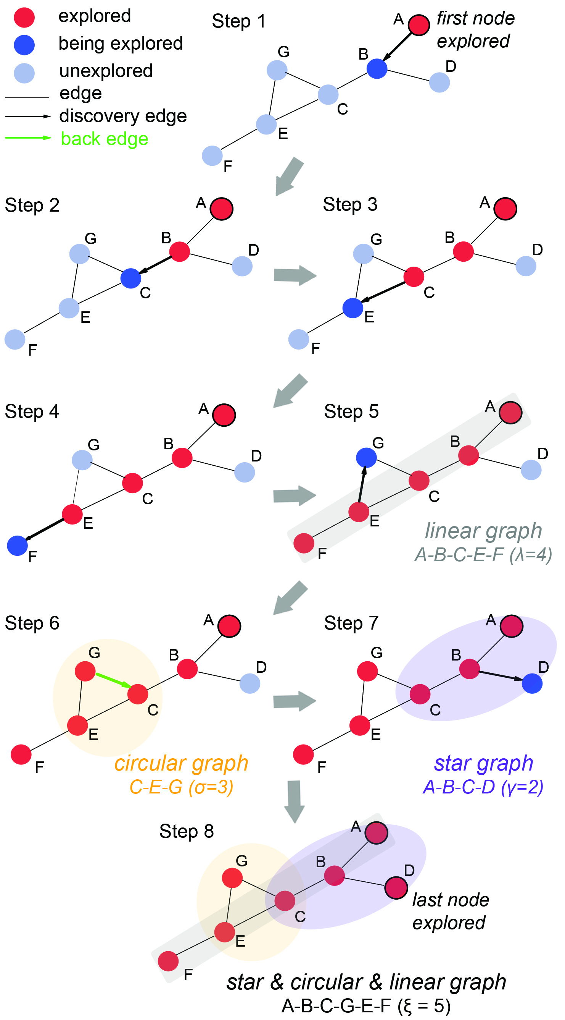
Scheme 1. DFS algorithm used to identify lipid clusters and topologies. Cluster nodes are colored according to the status of the search, with red –nodes already explored, blue, nodes being explored in the current step, and light blue, nodes not yet explored. Edges colored black and with an arrow indicate the direction of the current search; the edge colored green indicates a back edge in step 6. All other edges are colored gray. At step 5 the algorithm identified the linear path A-B-C-E-F of length 4. At step 6 we identify a circular path, where nodes C-E-G are connected in a closed chain. At step 7 we detect a star graph composed of nodes A-B-C-D. At step 8, we show a complex combination of star, circular and linear graph. We record as length the longest linear path found.

Starting from an initial (source) node, the DFS algorithm performs exhaustive searches of all the nodes along the current path. When all nodes are visited, it moves backwards on the same path to find unvisited nodes. When all nodes of the current path were visited, the algorithm selects the next unexplored path. The computation is completed when the entire graph is explored [46]. For the lipid H-bond clusters we study here, we monitor H-bonded pairs and their distances for each simulation step and use this information to construct adjacency or connection matrices. These are binary matrices representing the connections between groups (= 1 if there is a connection between each pair in the system, and 0 otherwise). The usage of the adjacency matrices allows us to project our results in graphs whose nodes are lipid headgroups, and edges are H-bonds between lipid headgroups.
The eight steps of the algorithm (Scheme 1) are as follows. In step 1, the algorithm starts at root node A, which is the first node explored, and it traverses any unvisited adjacent node from A, labeled as node B (Scheme 1). Node B is marked as explored, and adjacent node C is being explored in step 2. When more than one adjacent node exists, the algorithm chooses the next node based on the alphabetical order of node names. For example, at step 3, from node C, node E is explored before G. The procedure is followed until all nodes along the current path are visited (steps 2-4). The algorithm then moves backward on the same path to find unvisited nodes (step 5-7). The computation is completed when the entire graph is explored and all nodes are marked as explored (step 8).

Linear, star, and circular paths, and combinations thereof. Connections of a network are described by the network topology [47]. Graph theory considers several distinct topologies, such as, e.g., regular, path graph or linear, cyclic, acyclic, multi-graph, bipartite, and star [48, 49], distinguished by the degree D of the nodes that constitute the graph, and by the complexity of interactions between these nodes.
Briefly, in a regular graph all nodes have the same degree. In a path graph, or linear graph, n-2 nodes have D = 2, and the remaining 2 nodes have D = 1; in a cyclic path, ≥3 nodes have D = 2 and form a cycle, whereas the acyclic path lacks any cycle; the multi-graph has multiple edges between any node pair, or it has edges from a node to itself – these edges are also denoted as loops. The bipartite graph contains two sets of nodes connected by edges, but it lacks edges between nodes within a set; the star graph has n-1 edges connected to a single central node.
We computed and visualized lipid clusters from various time points of the simulation and different systems. We consider three main types of topologies that we describe, for clarity, as linear, star and circular. These paths, and combinations of these three main types, are illustrated in Scheme 2. We catalogue all paths according to their path length as follows (Schemes 1, 2).
A path is linear when two nodes have D = 1, and all nodes in between have D = 2. That is, a path is linear when all nodes and edges lie on a single line (Scheme 1, step 5). A path is denoted as a star path when there is one internal node connected to all other nodes. In that case, at most one node has D > 1. To detect a star graph, we traverse whole paths and record the degree D of each node, i.e. the number of edges each node has. When N - 1 nodes have D = 1 and 1 node has D = N - 1, where N is the total number of nodes in the graph, a star graph has been detected (Scheme 1, step 7). To detect complex combinations of, e.g., a star and linear graph, we record the number of edges to each node still being explored by the DFS algorithm, and keep the nodes with ≥ 3 edges (Scheme 1, step 8).
A path is circular when all nodes are connected in a closed chain. Thus, the minimum number of nodes for a path to be circular is 3. To detect a circular graph, we check for back edges, which are present when a node connects to its ancestor via an edge in the graph found with DFS. The main difference to edges connected to nodes in a circular vs. a star graph is that, in the case of the circular graph, we detect edges connected to already visited nodes, i.e., everything reachable from these nodes was discovered previously (Scheme 1, step 6).

Length of H-bond paths. For each lipid cluster found in the membrane and for each coordinate snapshot along the trajectory segment used for analyses, we compute the length of each path and we define it as the longest number of edges between a start and an end node (Scheme 2). Thus the length of a path consisting of only one node is zero. To characterize the length of paths according to the topology of lipid clusters, we defined a different length for each topology, as follows.
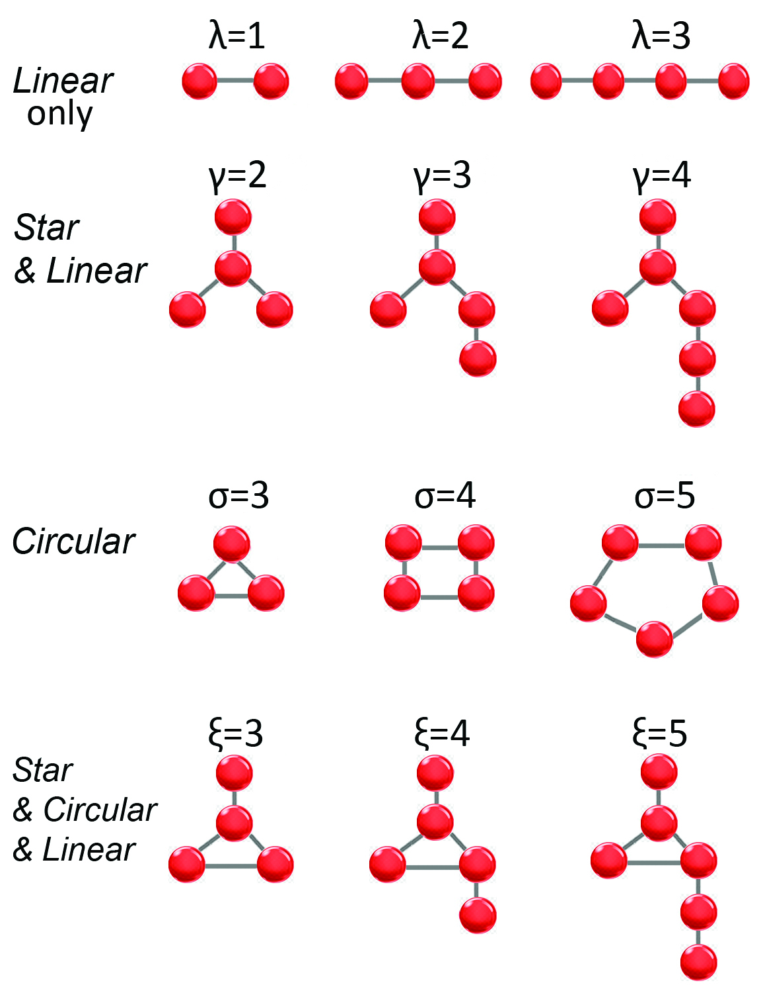
Scheme 2. Schematic illustration of lipids at membrane interfaces. We calculate clusters of lipids mediated by direct H bonds between lipids, mediated by one-water H-bond bridges between lipid phosphates, or by a cation. The size of the cluster is given by the number of nodes (lipid headgroups) of the cluster. We label with λ, γ, σ, and ξ the size of, respectively, clusters in which the lipid arrangement is linear, a combination of star and linear, circular, and, respectively, a combination of star, circular, and linear.

For a linear path, the linear length of the path λ is given by the number of phosphate atoms in the path minus 1, such that the shortest length of a linear path is λ = 1 (Scheme 2). The shortest length of a circular path is σ = 3 (Scheme 2). In pathways that include a combination of linear, star and circular topologies, we exclude short branches from star paths, and keep for the circular paths only the edge that connects the longest path to the end node. Thus, both the simplest star & linear and star & circular paths have 4 nodes each, but shortest lengths γ = 2 and ξ = 3, respectively (Scheme 2). We denote as L the length of linear paths that are either linear paths or linear segments, or branches, of the star & linear and of the star & circular & linear paths.

Implementation of the algorithm used to analyze lipid topologies. The code for the algorithm used to identify topologies of lipid clusters is summarized in Scheme 3. Briefly, the algorithm reads coordinate and simulation files, computes H bonds by applying a geometric criterion to selected candidate atoms for H bonding and returns an ascii file that contains the time series of all H-bond pairs and their corresponding H-bond distances. In the case of water mediated lipid H bonds, the algorithm computes the time series of lipid-water pairs and their H-bond distances. To compute lipids interconnected by the same water molecule, the algorithm checks for water ids that are connected to more than one lipid and creates the corresponding pairs of lipid-lipid water mediated H bonds. For ion-mediated interactions between lipids, the same procedure is followed.
For each time-step, an adjacency matrix is generated with matrix elements a_{ij} = 1 when groups i and j are H-bonded, and a_{ij} = 0 otherwise. The adjacency matrix is then used to generate the graph of the lipid H-bonds with nodes the lipids and edges the H bonds computed to the previous step. The Degree centrality (DC) of each graph node is calculated. Next, the DFS algorithm is applied to the graph. The number of edges to each node still being explored by DFS is recorded; nodes with ≥3 edges are the internal nodes of star graphs (star nodes). To detect a circular graph, algorithm checks for back edges. These are edges connected to a finished node. Lipid H-bond clusters are then identified as illustrated in Schemes 1, 2. For each cluster found, a sub-graph is generated and its path length computed as the longest linear distance between the first and last nodes explored. Topology types are assigned based on the presence of star nodes and back edges. The algorithm reports the number of clusters and the total number of lipids found in clusters as a function of time, the residue identification of lipids that belong to each cluster, the degree centrality for each lipid part of a cluster, the size of each cluster, the path length, and the topology type of each cluster. Results of the computations are reported as .dat and .mat files that are compatible with MatLab. To visualize lipid clusters, the .dat file can be read in VMD together with a coordinate file of the system in standard Protein Data Bank (PDB) [50] format. An additional .tcl script, also released with the code, may be executed in VMD to visualize lipid clusters. Phosphate atoms are represented as spheres colored according to the topology, and H-bonds, as lines.
The code is released on GitLab and as a Mendeley repository together with a directory that contains samples output files obtained from cluster analyses sampled in a pure POPE and in 3:1 POPE: POPG lipid membrane. The names of lipid atoms included in H-bond computations may be edited to allow, e.g., analyses of the topologies of H-bond clusters sampled during simulations performed with a different force field; likewise, the scripts may be edited to choose different H-bond distance criteria, or to consider combined distance and angle H-bond criteria.

Molecular dynamics simulations of lipid membranes. We used CHARMM-GUI [51, 52] to generate starting coordinates for hydrated lipid bilayers composed of POPS, POPE, 3:1 POPE:POPG, 5:1 POPE:POPG, POPS, and for the Top6 E. coli membrane model [45] with updated CHARMM-GUI lipid types: POPE, 3-palmitoleoyl-2-oleoyl-d-glycero-1-phosphatidylethanolamine (YOPE), 1-hexadecanoyl-2-(9Z-hexadecenoyl)-glycero-3-phospho-(1'-sn-glycerol) (PYPG), 1-palmitoyl-2-cis-9,10-methylene-hexadecanoic-acid-sn-glycero-3-phosphoethanolamine (PMPE), 1-palmitoyl-2-cis-9,10-methylene-hexadecanoic-acidglycero-sn-3-phosphoglycerol (PMPG), and 1-pentadecanoyl-2-cis-9,10- methylene-hexadecanoic-acid-snglycero-3-phosphoethanolamine (QMPE) (Figure 1, Table 1). The starting size of all membrane patches was ~103 Å x 105 Å x 87 Å.
We used NAMD [53, 54] to perform the simulations, the CHARMM36 force field [55-57] to describe lipids and ions, and TIP3P [58] for water. Geometry optimization and equilibration were performed according to the CHARMM-GUI protocol. Following geometry optimization and heating, we first equilibrated the system using velocity rescaling and geometry restraints on lipids, then all restraints were switched off for the production run. For early stages of the equilibration we used the NVT ensemble (constant number of particles N, constant volume V and constant temperature T = 303.15 K), whereas for production runs we used NPT (constant pressure P = 1bar). For temperature and pressure control we used a Langevin dynamics scheme with a collision frequency of 5 ${ps}^{-1}$and a Nosé-Hoover Langevin piston [59].
Scheme 3. Schematic diagram of the main steps of the algorithm used to identify topologies of lipid H-bond clusters.

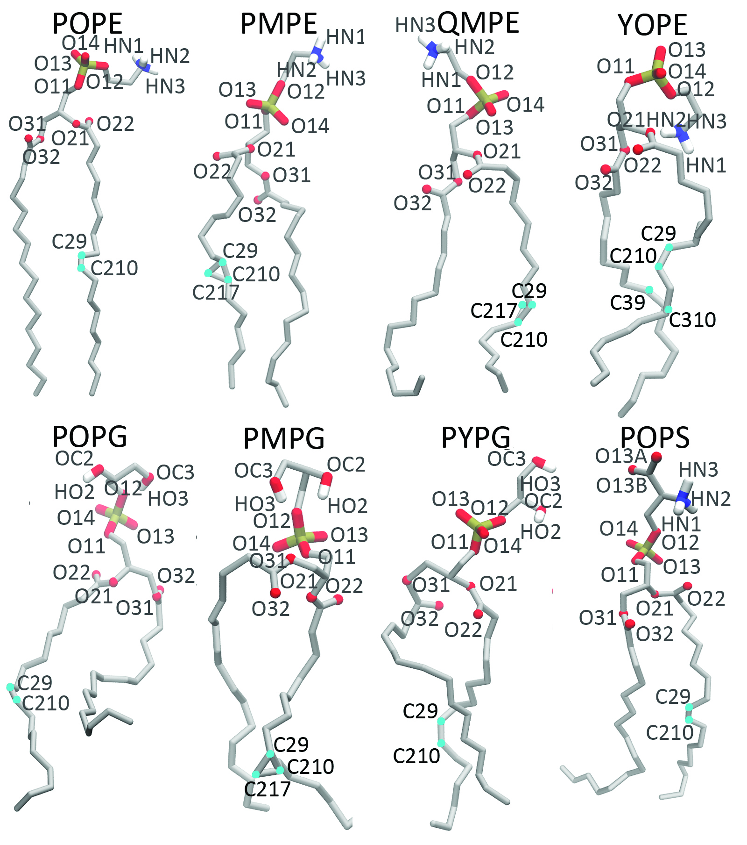
Figure 1. Molecular graphics of lipids of the membranes studied here. Images are based on coordinate snapshots from the simulations. Hydrogen, oxygen, and nitrogen atoms used to compute H-bonds, are labeled according to the CHARMM force field. Visual Molecular Dynamics, VMD [60], was used to prepare all molecular graphics.

Table 1. Summary of simulations performed. Each production run was prolonged to 200ns, for a total of 1.6μs for the complete ensemble of simulations. For each simulation we report the number of lipids per leaflet, the total number of atoms, and the average bilayer thickness, d_{P-P}, computed from the last 100ns.

Membrane | #Lipids/  leaflet | #Atoms | d_{P-P} (Å)
POPE | 138 | 65922 | 42.7 ± 0.4
3:1 POPE:POPG | 102 POPE, 34 POPG | 65545 | 41.6 ± 0.5
5:1 POPE:POPG | 115 POPE, 23 POPG | 66387 | 41.9 ± 0.5
3:1 POPE:POPG(I)^{a)} | 102 POPE, 34 POPG | 65660 | 41.7 ± 0.4
5:1 POPE:POPG(I)^{a)} | 115 POPE, 23 POPG | 66499 | 42.2 ± 0.4
POPS | 135 | 65646 | 41.8 ± 0.5
POPS(I) |  | 65731 | 42.1 ± 0.5
E. coli Top 6 | 74 PMPE, 20 POPE, 12 QMPE,12 YOPE,16 PMPG,  14 PYPG | 81738 | 38.8 ± 0.4
^{a)}0.15M NaCl. ^{b)}Number of lipids in each leaflet.

We used smooth-particle mesh Ewald [61, 62] for Coulomb interactions, and a cut-off between 10Å and 12Å for short-range real-space electrostatics. Van der Waals interactions were treated with a force switching function between 10 and 12Å as set with the standard CHARMM-GUI protocol. We used an integration step of 1fs for heating and the first 1ns of the production run, and for all production runs we used a multiple-time-step integration scheme [63] with 1fs for the bonded forces, 2fs for short-range non-bonded forces, and 4fs for long-range forces.
Coordinate sets from production runs were saved every 10ps. To probe the fast water dynamics at the lipid surface, we generated, starting from the last coordinate set of each simulation, a 1ns trajectory with an integration step of 1fs in the NVE ensemble (constant energy E), with frequent coordinate saving every 10fs.

Computations of lipid bilayer thickness. We used MEMBPLUGIN [64] in VMD [60] to estimate the bilayer thickness, d_{P-P}, as the average distance between the peaks of the phosphorous atoms distribution in the two lipid leaflets.

Average number of clusters, ANC. The ANC is defined as the average number of clusters formed per bilayer leaflet during the simulation time used for analyses. The Occurrence of the ANC, labeled as ANCO, is computed as the percentage of the simulation time during which the number of clusters per leaflet is equal to the ANC.

Average number of lipids in a H-bond cluster, ALC, and the percentage of lipids engaged in H-bond clusters, ALEC. The ALC is defined as the average number of lipids per cluster during the simulation time used for analyses. The ALEC is defined as the percentage of the average number of total lipids engaged in clusters. Unless otherwise specified, all average values were computed from the last 100ns of each NPT simulation. H-bond paths include H-bonds sampled with occupancies ≥5%.

Results and Discussion
We relied on concepts from graph theory to study H-bonding and H-bond clusters sampled during simulations with different lipid membrane composition. Three main types of topologies, and combinations of these topologies, are observed for dynamic clusters sampled by lipids in membranes with different lipid composition.

H-bond dynamics in model lipid membranes. The molecular structure and the dynamics of lipid membranes have been studied extensively with experiment and computation (see, e.g., refs. [34, 65-75]). Thus, we restrict ourselves to a brief discussion of the membrane simulations and summarize lipid H-bonding used for analyses with the DFS algorithm we report here.
The thickness of the POPE bilayer, d_{P-P} = 42.7 ± 0.4Å is close to the 3:1 and 5:1 POPE:POPG bilayers (d_{P-P} between 41.6 ± 0.5Å and 42.2 ± 0.4, Table 1). Values we obtained for d_{P-P} of POPE and POPE:POPG membranes (Table 1) are close to the ~42-43Å reported elsewhere [76-78]. The value of 37.3 ± 0.2Å value reported before for the Top6 E. coli membrane [45] indicates Top6 is ~3Å thinner than POPE, with d_{P-P} = 38.8 ± 0.3Å (Table 1). The thickness of the POPS membranes is ~42Å (Table 1), which is close to the 43.2 ± 0.5 value reported before for POPS [78].
For all lipids we find about 4.3 – 4.7 water H-bonds per lipid phosphate group, which is close to values reported previously for POPC:POPG membranes [25]. Each POPE lipid has ~1.7 POPE H-bonds in the POPE bilayer, vs. 1.3–1.5 POPE H-bonds when it can H-bond to POPG in 3:1 POPE:POPG or 5:1 POPE:POPG; in the E. coli Top6 membrane, a PE lipid has ~1.3 PE-PE H-bonds. In the two POPE:POPG bilayers and in Top6, each PE lipid has on the average ~0.1-0.4 PG H-bonds, and each PG lipid has ~0.8-1.3 PE H-bonds. This is compatible with previous computations reporting ~0.4 POPE-POPG H-bonds for each POPE lipid, and ~1.3 for each POPG lipid [79]. POPS lipids H-bond to each other such that, on the average, there are ~2.7-2.8 POPS-POPS H-bonds for each lipid (Figure 2).
All H-bond values above were obtained using as H-bond criterion the ≤2.5Å distance between the H atom and the acceptor oxygen or nitrogen atom (Figure 1). This distance criterion gives very similar number of H-bonds as a combined criterion of ≤3.5Å distance between the donor and acceptor heavy atoms, and ≤60º H-bond angle: For 10 coordinate sets from the POPE simulation, the single 2.5Å distance criterion gives 105 ± 3 direct lipid H-bonds/leaflet, whereas the combined distance and angle criterion gives 101 ± 2 lipid H-bonds.

Dynamic lipid H-bond clusters. Each leaflet of the POPE, POPE:POPG, and E. coli Top6 membranes has ~24 H-bond clusters of 4-5 lipids (Table 2). POPE:POPG and Top6 membranes can have transient clusters of PG-type lipids (Figure 3); these anionic clusters are small, with an average of about 2-3 lipids per cluster. As anticipated from the ratio of POPE and POPG lipids, POPG-only clusters are less frequent in 5:1 than in 3:1 POPE:POPG membranes, such that in the former there is typically only one POPG cluster at a time (Figure 3).
Consistent with the higher number of to H-bonds per lipid (Figure 2), POPS clusters tend to be slightly larger than those with POPE and/or POPG lipids (about 6 POPS lipids per cluster). Compared to the POPE or POPE:POPG membranes, there is a larger percentage of POPS lipids to contribute to clusters (87-90% for POPS, vs. 67-80% for POPE or POPE:POPG, Table 2). The higher propensity of POPS lipids to H-bond to each other is compatible with previous simulations in which a network of POPS lipid headgroups was observed [80].
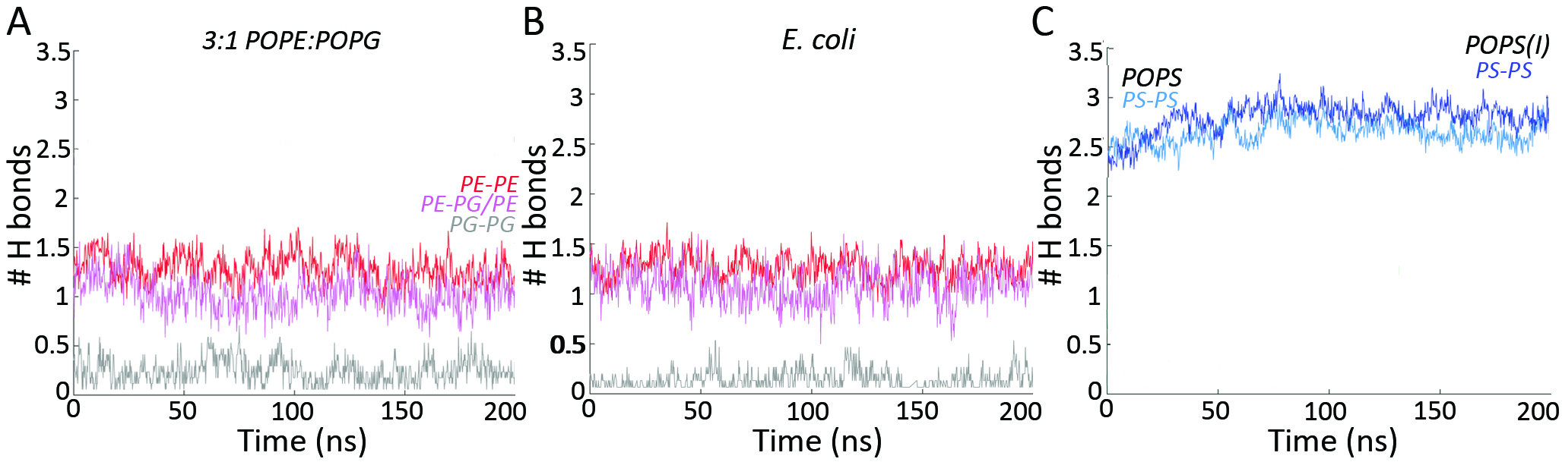
Figure 2. H bonds of POPE, POPG, and POPS membranes. We present time series of the average number of H-bonds per lipid. (A) Average number of lipid H-bonds computed from simulations of the 3:1 POPE:POPG bilayer. Time series for the average number of POPE-POPE H bonds per POPE lipid are shown as a red profile, POPE-POPG H-bonds/POPE lipid, light red, and POPG-POPG H bonds/POPG lipid molecule, gray. (B) Average number of H-bonds computed from simulations of the E. coli Top6 membrane, with POPE-POPE H bonds/POPE shown in red profile, POPE-POPG H-bonds/POPE lipid, light red, and POPG-POPG H bonds/POPG lipid, gray. (C) Time series of the average number of POPS-POPS H bonds/lipid in POPS membranes without and with salt are colored light and dark blue, respectively. Plots were generated with MATLAB R2017b [81].

Table 2. Summary of lipid clusters. We report the average number of clusters, ANC, the occurrence of ANC, ANCO, the average number of lipids in clusters, ALC, and the percentage of average total lipids that participate in lipid clusters, ALEC.
Clusters | Membrane | ANC | ANCO (%) | ALC | ALEC (%)
Direct H bonds | POPE | 24± 3 | 12 | 5± 1.0 | 80
 | 3:1 POPE:POPG | 24± 3 | 13 | 4± 1.0 | 76
 | 5:1 POPE:POPG | 24± 3 | 11 | 5± 1.0 | 79
 | 3:1 POPE:POPG(I) | 24± 3 | 12 | 4± 1.0 | 67
 | 5:1 POPE:POPG(I) | 24± 3 | 12 | 5± 1.0 | 78
 | POPS | 19± 3 | 15 | 6± 1.0 | 88
 | POPS(I) | 20± 3 | 11 | 4± 1.0 | 90
 | E. coli Top6 | 29± 3 | 11 | 4± 0.5 | 78
1-water bridges | POPE | 27± 3 | 13 | 3± 0.2 | 52
 | 3:1 POPE:POPG | 27± 3 | 14 | 3± 0.2 | 53
 | 5:1 POPE:POPG | 27± 3 | 14 | 3± 0.2 | 52
 | 3:1 POPE:POPG(I) | 25± 4 | 10 | 3± 0.2 | 48
 | 5:1 POPE:POPG(I) | 27± 3 | 13 | 3± 0.2 | 53
 | POPS | 26± 3 | 14 | 3± 0.2 | 50
 | POPS(I) | 28± 3 | 14 | 3± 0.3 | 55
 | E. coli Top6 | 29± 3 | 12 | 3± 0.2 | 49
Ion- mediated bridges | POPE | - | - | - | -
 | 3:1 POPE:POPG | 2± 1 | 28 | 2± 0.7 | 3
 | 5:1 POPE:POPG | 1± 1 | 40 | 1± 1 | 1
 | 3:1 POPE:POPG(I) | 1± 1 | 36 | 1±1 | 2
 | 5:1 POPE:POPG(I) | 1± 1 | 34 | 1± 1 | 2
 | POPS | 12± 2 | 16 | 2± 0.2 | 20
 | POPS(I) | 9± 2 | 18 | 2± 0.1 | 14
 | E. coli Top6 | 1± 1 | 32 | 1± 1 | 2

Taken together, the analyses above indicate that, regardless of the lipid bilayer composition, clusters of lipids directly H-bonded to each other tend to be small, of about 4 lipids in POPE, POPE:POPG, and Top6 membranes, and about 6 lipids in POPS membranes. Likewise, clusters in which lipids interact with each other via short, one-water bridges, are small, with about 3 lipids in a cluster. Overall, these clusters are visited only transiently, with occurrences <15% (Table 2). Sodium ions tend to bridge 1-2 pairs of lipids, such that the average cluster size for ion-mediated interactions is ~2. Compared to the clusters with direct or water-mediated lipid H-bonds, the ion-mediated clusters tend to have slightly larger occurences (Table 2), as ions can reside longer in the vicinity of lipids [25].
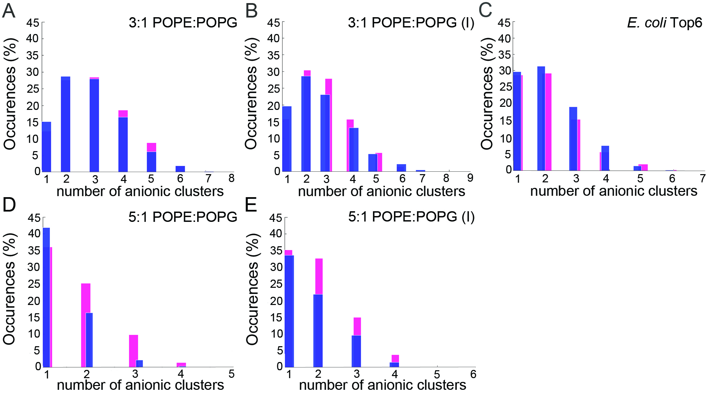
Figure 3. Clusters of anionic lipids. (A-E) Histograms of the number of anionic lipid clusters mediated by direct POPG-POPG interactions in 3:1 POPE:POPG (panel A), 3:1 POPE:POPG(I) (panel B), E. coli Top6 (panel C), 5:1 POPE:POPG (panel D) and 5:1 POPE:POPG(I) (panel E). Purple and magenta bars indicate average values for the two bilayer leaflets.
Computational efficiency of the DFS algorithm for lipid H-bond clusters. We evaluated the computational efficiency of the algorithm using one Intel(R) Xeon (R) CPU E5-2660 core, and 10 coordinate snapshots from the POPE simulation. The tcl script included with the code we release required 3.1 seconds/coordinate snapshot to extract ~119 ± 5 direct H-bonds/coordinate snapshot between POPE lipids. The subsequent topology analysis with the DFS algorithm took 0.06 seconds/coordinate snapshot. Tests for the same set of coordinates using four other Intel cores (Intel(R) Xon(R) CPU E3-1240 V2, Intel(R) Core(TM) i5-2400 CPU, Intel(R) Xon(R) CPU W3550, Intel(R) Xon(R) i7-7700 CPU), and for the 3:1 POPE:POPG membrane, gave similar values of 1.3 - 2.5 seconds/coordinate snapshot to extract all direct lipid H-bonds, and 0.02 - 0.04 seconds/snapshot for the topology analysis using the DFS algorithm. This indicates that the DFS algorithm for analyses of lipid H-bond topologies is efficient and could be used for larger membrane simulations.

Convergence of DFS computations of lipid H-bond topologies. To evaluate the dependence of DFS cluster analyses on the length of the trajectory segment used for analyses, we used the POPE simulation to perform separate cluster calculations for the complete 200ns production run vs. for the first 100ns trajectory segment, and compared to the corresponding values reported in Table 2 for the last 100ns segment of the trajectory. ANC values for clusters mediated by direct H-bonds are 24.3 ± 3 for the last 100ns of the trajectory (Table 2), and 23.3 for the first 100ns and for the complete 200ns trajectory segment. ANCO = 12% regardless of which of the three trajectory segments is used. Likewise, regardless of which of the three trajectory segments we use, direct H-bond clusters have ALC = 5 ± 1.0 and ALEC = 80%. For one-water mediated POPE H-bond clusters, we obtained ANC values of 27 ± 3 – 28 ± 3 when using either of the three trajectory segments, ANCO = 13-14%, ALC = 3 ± 0.2, and ALEC = 52 - 55%; for ion-mediated POPE clusters, regardless of which trajectory segment is used, ANC = 2 ± 1, ANCO = 28 – 29, ALC = 2.0 ± 0.7, and ALEC = 3.
We performed the same tests for the other simulations, and found that all H-bond cluster values have very similar values when computed from the first or the second half of the trajectory, as compared to the complete length of the production run. Based on these tests, we suggest that the H-bond cluster computations have reasonable convergence on the timescale of the simulations we report.

The DFS algorithm identifies similar lipid topologies in all membranes. Lipid clusters are dynamic, and the number of clusters present at any given time in a simulation will necessarily depend on the size of the lipid patch. Our analyses are focused on how the composition of the lipid membrane impacts the size of the cluster –how many lipids are, on the average, in a cluster, and on the topology of the cluster –how the lipids in a cluster interact with each other.
We illustrate with a coordinate snapshot from simulations of a POPS membrane clusters that may be sampled due to transient H-bonds between lipids (Figure 4A), lipids that bridge via one water molecule (Figure 4B), or via cations (Figure 4C). Simple visual inspection suggests that direct H-bonds between POPS lipids may give rise to complex arrangements, whereas the one-water mediated bridges tend to associate with linear arrangements of the lipids (Figures 4A,B). We used the algorithms presented here (Schemes 1, 2) to characterize the topology and size of clusters that may be sampled, and the frequency with which various types of clusters might be visited in each of the membrane simulations performed.
Overall, for all membranes, at any given time there is at least one linear path mediated by direct lipid H-bonding or by one-water bridging (Table 3, Figure 5). For a linear path of lipids that H-bond directly to each other, the length λ reports the number of such direct H-bonds. The most frequent linear path has linear length λ = 1 (Figures 6A, 7A, Table 4), that is, most of the time, only two lipids are likely to H-bond directly to each other, though paths with λ = 2 or λ = 3, i.e., linear clusters with 3-4 lipids, are also visited (Figures 6A, 7A, Tables 3, 4). Longer linear paths are visited only rarely.
Circular paths larger than the minimum length σ = 3 are unlikely (Figure 6C). Star and linear paths are sampled frequently when mediated by direct H-bonding between lipids (Table 3), and most often have length γ = 4 (Figure 6B), i.e., an arrangement in which one of the branches of the basic star graph of three lipids recruits two more lipids connected linearly (Scheme 2).
In all membranes we studied, one-water mediated bridges between lipids lead to linear and star graphs with preferred paths lengths λ = 1 and γ = 3 - 4, respectively (Figures 7A,B); that is, the path lengths for one-water mediated bridges are very similar to those that involve direct interactions between lipids (Figures 6A,B). Likewise, the preferred length of the one-water-mediated circular paths is σ = 3 (Figure 7C), the same as for the direct interactions (Figure 6C); unlike the case of paths via direct H-bonds, circular paths with four water-mediated bridges are not sampled (Figures 6C, 7C).
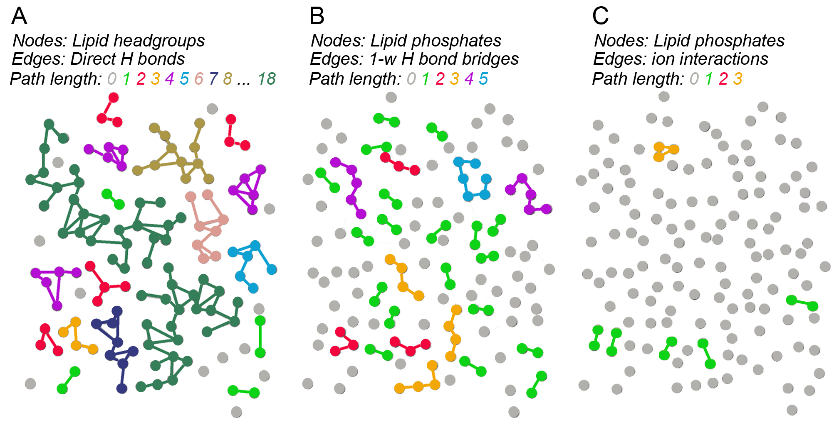
Figure 4. Illustration of POPS lipid clusters. Images were generated based on the last coordinate snapshot from the POPS simulation. Nodes represent head groups or phosphate groups and edges, H-bonds between lipids. We considered direct lipid H-bonds, one-water-mediated interactions between lipid phosphate groups, and ion-mediated interactions between phosphate groups. (A) Direct H-bond paths colored according to path length; there are numerous linear paths between lipids. (B) One-water-mediated paths. Most of the paths are between two phosphate groups, and several paths include 4-6 lipids. One-water bridges can give rise to complex clusters with combinations of linear, star, and circular paths, but the occupancy of these clusters is small when compared with clusters mediated by direct H-bonds between lipids. (C) Ion-mediated paths are short, involving 2-3 lipids.

The most complex type of topology we considered is a combined linear, circular, and star graph, in which one node of the circular graph is also part of a combined star and linear topology (Scheme 1). The preferred length of the combined linear, circular and star graph mediated by direct lipid H-bonds is ξ = 5 - 6 (Figure 6D), which is close to the sum of the circular and star paths. For lipid bridges mediated by one water molecule we find that the combined linear, circular, and star graphs are smaller, with ξ = 3 (Figure 6I), which is the same as for water-mediated circular paths (Figure 6C).
For an overview of the preferred length of each type of path, and the occupancy of each type of path, we extracted from the simulation the median value of the path length for each type of path (Figure 6), and then computed the occupancy of that value of the path length, that is, the percentage of time during which at least one path with the median value of the length is visited (Table 4, Figure 7). For both direct and water-mediated interactions between lipids, there is a high occupancy of short paths with λ = 1 (Figures 7A,F), that is, most likely at least one such path will be sampled at any given moment in any of the membranes. POPS lipids have a relatively high occupancy (~53-71%) of circular paths with σ = 3 (Table 4, Figure 7C), and of the complex star & linear & circular paths with ξ = 6 (Table 4, Figure 7D). For all types of paths, the occupancy of the path length at median value is smaller for water mediated-bridges than for direct lipid H-bonds (Figure 7); this is likely due to the short lifetimes of water-phosphate H-bonding.
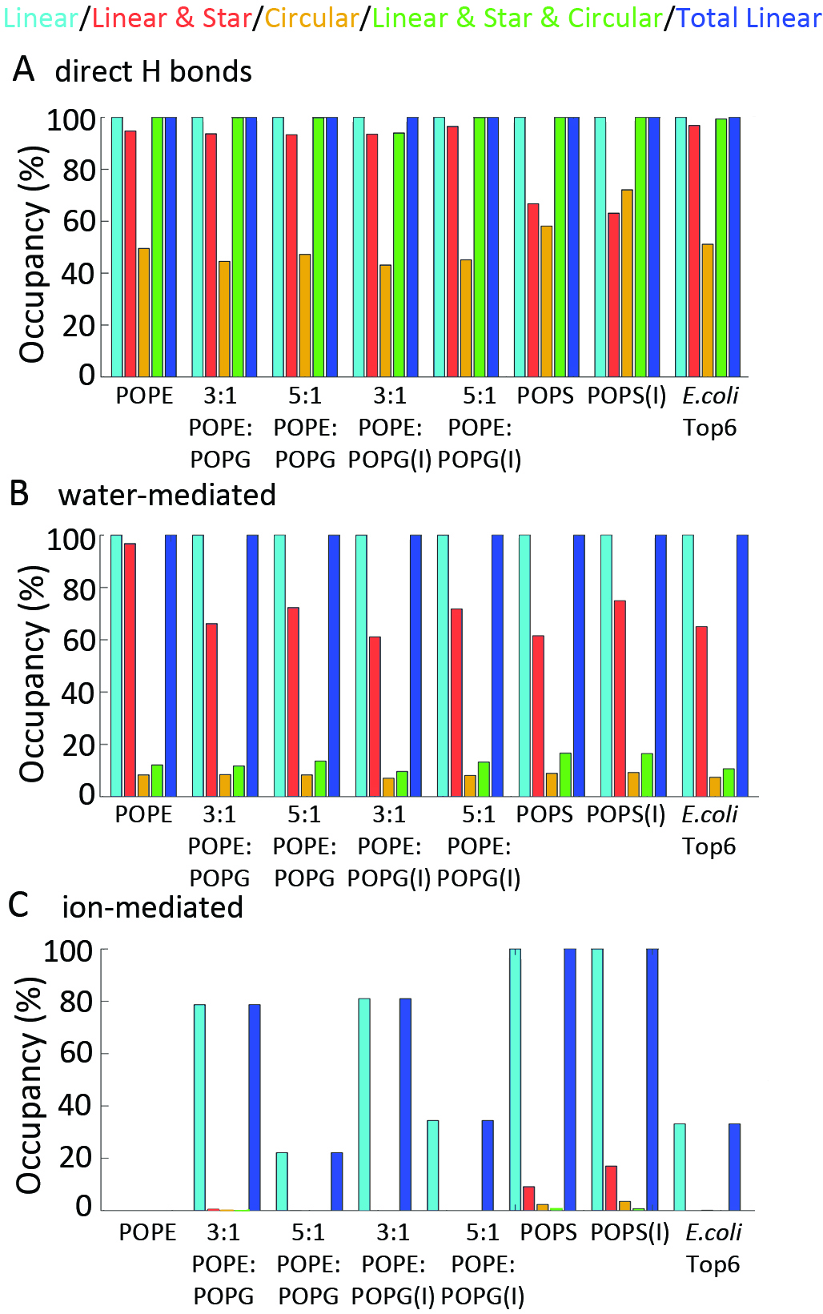
Figure 5. Summary of occupancies paths. We show the total occupancy of each type of path irrespective of the path length. (A) Total occupancies of all paths mediated by direct H bonds between lipids. (B) Total occupancies of all paths mediated by one-water bridges between lipid phosphates. (C) Total occupancies of all paths mediated by ion bridging of lipid phosphate groups. Plots were generated with MATLAB R2017b [81].
Table 3. Summary of types of H-bond paths, or clusters, identified with the DFS algorithm. We report separately occupancies for lipid path that involve direct H-bonds, one-water, and ion mediated bridges between lipids. The occupancy reports the percentage of time during which a path is present irrespectively of its size.
Membrane | Total occurrence of H-bonded paths (%)
 | Linear | Star & Linear | Circular | Star & Circular & Linear | Total linear
Paths with direct lipid H-bonds
POPE | 100 | 94.7 | 49.5 | 100 | 100
3:1 POPE:POPG |  | 93.7 | 44.5 | 99.9
5:1 POPE:POPG |  | 93.3 | 47.2 | 99.9
3:1 POPE:POPG(I) |  | 93.5 | 43.1 | 94.0
5:1 POPE:POPG(I) |  | 96.5 | 45.1 | 99.9
POPS |  | 66.7 | 58.1 | 100
POPS(I) |  | 63.1 | 72.1 | 100
E. coli Top 6 |  | 96.9 | 51.1 | 99.4
Paths mediated by one-water bridges between two lipids
POPE | 100 | 69.8 | 8.3 | 12.1 | 100
3:1 POPE:POPG |  | 66.2 | 8.4 | 11.7
5:1 POPE:POPG |  | 72.3 | 8.3 | 13.6
3:1 POPE:POPG(I) |  | 61.1 | 7.0 | 9.6
5:1 POPE:POPG(I) |  | 71.8 | 8.1 | 13.2
POPS |  | 61.5 | 8.9 | 16.6
POPS(I) |  | 74.9 | 9.2 | 16.4
E. coli Top 6 |  | 65.0 | 7.4 | 10.6
Paths with ion-mediated bridges between lipids
POPE | - | - | - | - | -
3:1 POPE:POPG | 78.7 | <5 | <5 | <5 | 78.7
5:1 POPE:POPG | 22.1 | <5 | - | - | 22.1
3:1 POPE:POPG(I) | 81.0 | - | - | - | 81.0
5:1 POPE:POPG(I) | 34.4 | - | - | - | 34.4
POPS | 100 | 9.1 | <5 | <5 | 100
POPS(I) | 100 | 17.0 | <5 | <5 | 100
E. coli Top 6 | 33.1 | - | <5 | - | 33.1

Table 4. Summary of H-bond paths. We report the occupancy of each lipid topology with length equal to the median value shown in Figure 6; for circular graphs we include the occurence of paths with σ = 4. We define as occupancy the percentage of the analyzed trajectory where a lipid topology type is present, and discard paths with occupancies <5%. The total linear path length reported here is for median values.
Membrane | Median value of path length/  Occurence of medium-value path length (%)
 | Linear,λ | Star & Linear, γ | Circular,  σ | Star & Circular & Linear, ξ | Total linear, L = λ+ γ + ξ
Paths mediated by direct lipid H-bonding
POPE | 1 / 100 | 4 / 40.6 | 3 / 46.0  4 / 6.4 | 5 / 53.0 | 2 / 99.8
3:1 POPE:POPG |  | 4 / 39.0 | 3 / 40.7  4 / 5.1 | 5 / 47.9 | 2 / 99.2
5:1 POPE:POPG |  | 4 / 40.2 | 3 / 44.4 | 6 / 42.6 | 2 / 99.4
3:1 POPE:POPG(I) |  | 4 / 41.1 | 3 / 38.9  4 / 5.8 | 5 / 36.6 | 2 / 99.2
5:1 POPE:POPG(I) |  | 4 / 43.3 | 3 / 40.7  4 / 6.6 | 5 / 55.6 | 2 / 99.1
POPS | 1 / 98.8 | 4 / 20.4 | 3 / 53.9  4 / 12.1 | 6 / 64.4 | 3 / 92.5
POPS(I) | 1 / 99.3 | 4 / 19.4 | 3 / 71.0  4 / 5.9 | 6 / 59.1 | 3 / 94.2
E. coli Top 6 | 1 / 100 | 4 / 44.6 | 3 / 47.3  4 / 6.4 | 5 / 46.5 | 2 / 99.8
Paths mediated by one-water bridges between lipid phosphate groups
POPE | 1 / 100 | 3 / 29.0 | 3 / 6.0 | 3 / 5.0 | 1 / 100
3:1 POPE:POPG |  | 3 / 26.5 | 3 / 6.8 | 3 / 5.0 | 1 / 100
5:1 POPE:POPG |  | 3 / 28.6 | 3 / 6.3 | 3 / 5.0 | 1 / 100
3:1 POPE:POPG(I) |  | 3 / 23.9 | 3 / 5.4 | 3 / <5 | 1 / 100
5:1 POPE:POPG(I) |  | 3 / 29.6 | 3 / 6.1 | 3 / 5.0 | 1 / 100
POPS |  | 3 / 21.1 | 3 / 8.1 | 3 / 9.3 | 1 / 100
POPS(I) |  | 3 / 34.4 | 3 / 8.0 | 3 / 6.4 | 1 / 100
E. coli Top 6 |  | 3 / 27.0 | 3 / 6.0 | 3 / 5.0 | 1 / 100
Paths mediated by ions bridging lipid phosphate groups
POPE | - | - | - | - | -
3:1 POPE:POPG | 1 / 72.4 | - | - | - | 1 / 72.4
5:1 POPE:POPG | 1 / 20.5 | - | - | -
3:1 POPE:POPG(I) | 1 / 48.2 | - | - | -
5:1 POPE:POPG(I) | 1 / 33.9 | - | - | -
POPS | 1 / 100 | 2 / 7.4 | - | - | 1 / 100
POPS(I) | 1 / 100 | 2 / 15 |  |  | 1 / 100
E. coli Top 6 | 1/ 32.1 | - | - | - | 1 / 32.1

Given the high propensity of POPS lipids to H-bond, including in complex, large paths with ξ = 6 (Table 4, Figure 7D), we inspected closely the dynamics of their H-bonded paths in a POPS membrane (Figure 8). At any given time along the simulation there are, on the average, about 15 and as many as 25 linear paths of two lipids bridged by one water molecule (λ = 1 in Figures 8A,B).
The average number of water-bridged linear paths decreases with the path length, from about 5 and up to 10 in the case of paths with λ = 2, to just 1 path in the case of λ = 6 (Figures 8A,B). One circular path with σ= 3 is sampled throughout the entire simulation, but a path with σ = 4 is only observed once (Figure 8C).

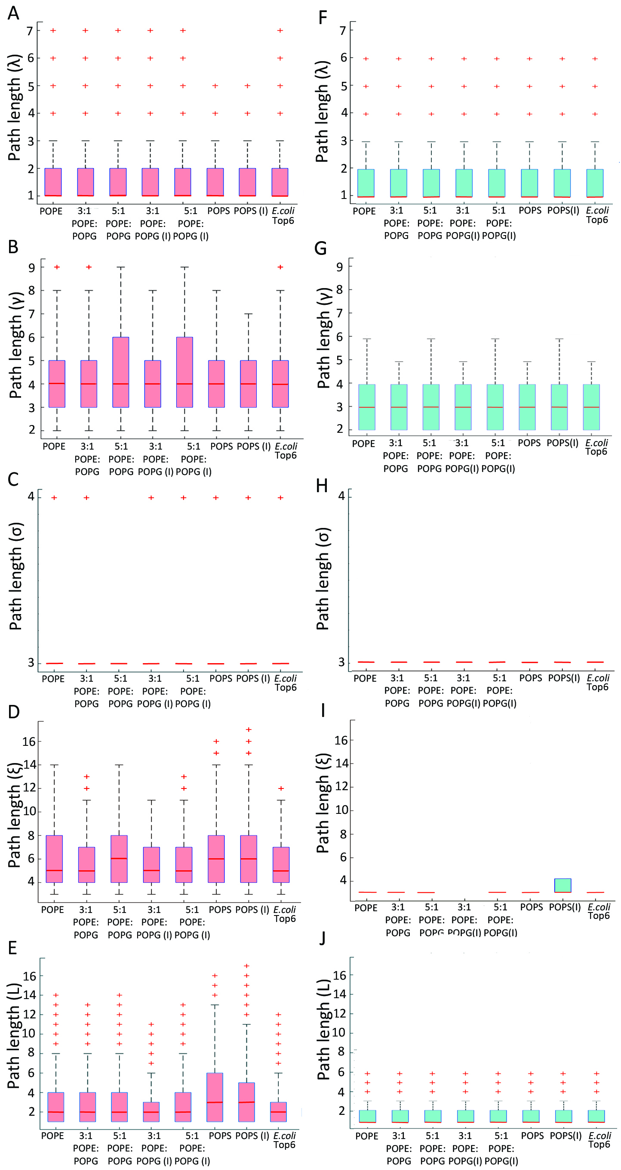
Figure 6. Clusters mediated by direct H-bonds and one-water bridges between lipids. Box plots were generated with MATLAB R2017b [81] using 10.000 equally-spaced coordinate snapshots from the last 100ns of each simulation. On each box, the central mark indicates the median; outliers are plotted using the '+' symbol. (A-E) Distribution of path lengths for directly H-bonded lipids that sample linear paths (panel A), star and linear paths (panel B), circular paths (panel C), star, circular and linear paths (panel D), and total linear paths (panel E). (F-I) Distribution of path lengths for one-water mediated bridges between lipids, for linear paths (panel F), star and linear paths (panel G), circular (panel H), star and linear and circular (panel I), and any linear path, either of a standalone linear path, or a linear path segment of star & linear or star & circular and linear paths (panel J).
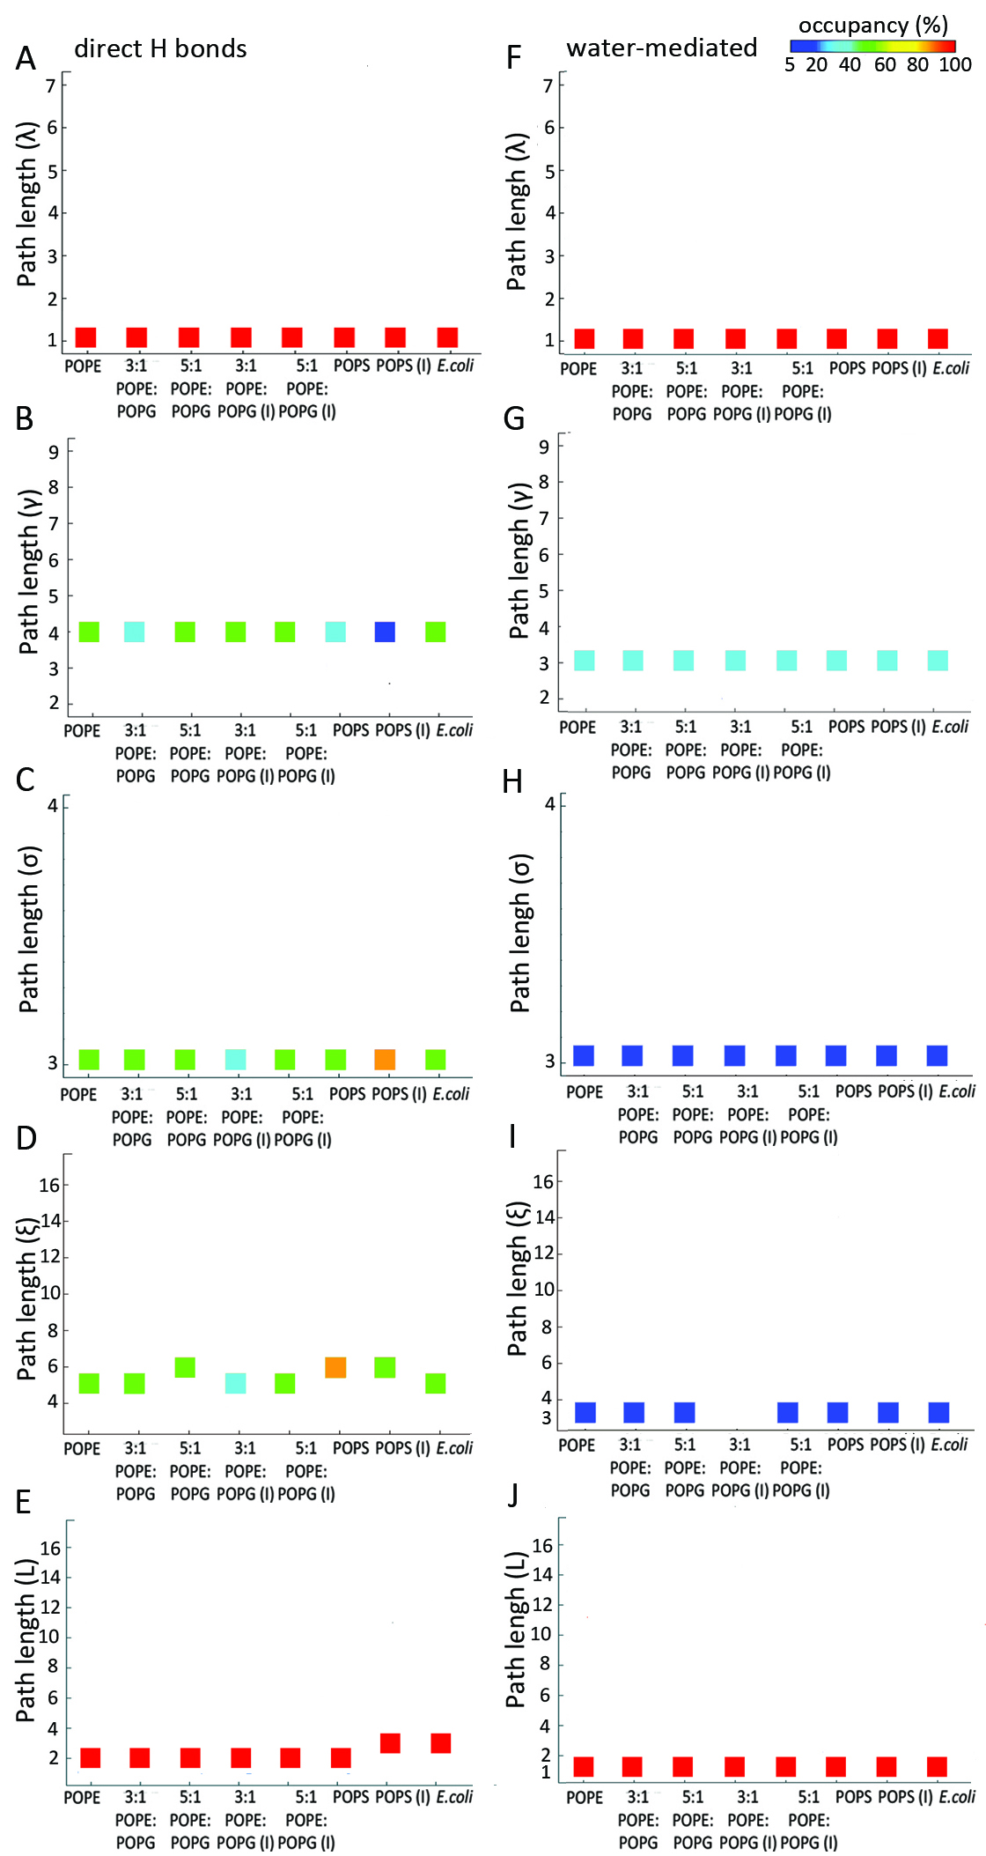
Figure 7. Occupancies of median path lengths for direct and one-water mediated lipid clusters. (A-E) Median value and occupancy of median value for lipid paths with direct lipid H-bonds, for linear paths (path length λ, panel A), star and linear (path length γ, panel B), circular paths (length σ, panel C), star & circular & linear (length ξ, panel D), and all linear path segments of length L (panel D). (F-J) Median value and occupancy of median value for lipid paths that in which two lipids bridge via one water molecule, for linear paths (panel F), star and linear (panel G), circular paths (panel H), star & circular & linear (panel I), and all linear path segments of length L (panel J). We report for the total linear path length L the sum of the median values of any λ, γ and ξ path lengths from direct H-bonds.
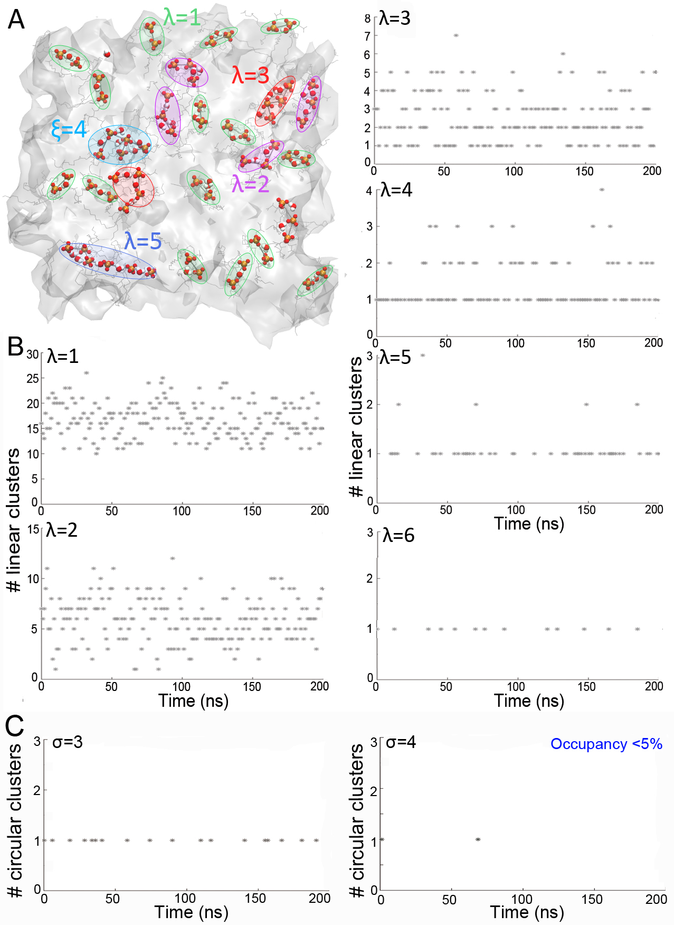
Figure 8. Illustration of one-water mediated bridges inter-connecting phosphate groups in the POPS membrane. (A) Water-mediated paths sampled in one of the membrane leaflets in a coordinate snapshot. Lipid phosphate groups are shown as orange spheres, and water molecules, as van der Waals spheres with oxygen atoms colored red, and hydrogen, white. Paths are marked by contours color-coded according to the path length, with paths of length λ = 1 marked by light green contours, λ = 1, magenta, λ = 2, red, λ = 3, red, cyan, ξ=4, and λ = 5, blue. (B) Time series of the number of paths with lengths 0 < λ ≤ 6 (C) Time series of the number of paths with 3 ≤ σ ≤ 4. For clarity, we read coordinate sets each 1ns.

Conclusions
We developed an algorithm to identify transient H-bond clusters that may be sampled in numerical simulations of lipid membranes. The algorithm relies on computations of graphs of lipid H-bonds, whereby two lipids can H-bond directly or via one water molecule, it computes lipid paths in which all lipids H-bond to each other, and then it uses Depth-First Search to cluster these paths according to the topological arrangement of lipids in the path. Our implementation of the algorithm can identify three main types – the linear, the star, and the circular graph, and the combination thereof.
We applied the algorithm to identify clusters sampled by the lipids of membranes composed of POPE, POPS, and three different models of E. coli membranes – the 3:1 and 5:1 POPE:POPG membranes, and the Top6 E. coli membrane model. We found that, in all membranes, short linear paths whereby two lipids bridge via direct H-bonds, or via one water molecule, will be present at all times. The second most likely arrangement of the lipids directly H-bonded, or bridged via water, is in a star & linear graph of three lipids when mediated by water bridges, and of four lipids when lipids H-bond directly to each other. Circular graphs are visited relatively frequently when 3-4 lipids H-bond directly to each other, however circular water-mediated paths occur only rarely, likely due to the short lifetime of lipid-water H-bonds. More complex path topologies, whereby at least four lipids come together in a combined circular & star & linear graph, are rarely visited.
Models of E. coli lipid membranes are of interest for numerous studies of bacterial membrane proteins. Main models used for the E. coli membrane are 3:1 POPE:POPG and 5:1 POPE:POPG [45, 79], with the more recent, and more accurate model denoted as Top6 containing three types each of PE and PG lipids;[45] for the Bacillus subtilis membrane, an atomistic model was constructed that includes, in addition to PE and PG lipids, cardiolipin, lysyl-PG lipids, and neutral lipids [44]. POPE:POPG membranes are about 3Å thicker than the Top6 membrane (Table 1), suggesting the Top6 membrane is a better model for the E. coli membrane, which is a rather thin membrane: the thickness of the cytoplasmic E. coli membrane, as estimated from experiments, is 37.5 ± 0.5Å, and of liposomes composed of E. coli lipids, 33.5 ± 0.4Å [82]. The H-bond clusters sampled in the E. coli Top6 membrane are, however, very similar to those of POPE:POPG membranes, suggesting that for computations of, e.g., initial events along reaction paths of biomolecule binding to lipid membranes, Top6 and POPE:POPG models would lead to similar results.
PS lipids are a major constituent of eukaryotic cell membranes, and have been the subject of numerous investigations with experiments and computations (see, e.g., refs. [83-87]). The relatively small surface area of PS lipid membranes compared to PC counterparts (in the absence of salt) was interpreted to arise from attractive interactions between PS lipids, such as H-bonding [88]. Indeed, networks of directly H-bonded 1-palmitoyl-2-oleoyl-sn-glycero-3-phospho-L-serine (POPS) lipids could be observed in simulations [80], being suggested that domains of POPS lipids bound via serine interactions could serve as platforms to which an external partner binds. Here, we observed that POPS lipids have a high propensity to H-bond to each other, giving rise to frequent sampling of H-bond paths.
Our analyses of transient H-bond lipid clusters relied on eight independent simulations of hydrated lipid membranes, with a total sampling time of 1.6μs. The limited length of each independent simulation trajectory could, however, influence details of lipid H-bond cluster dynamics. Likewise, details of H-bond cluster dynamics could be sensitive to the size of the membrane patch, and on the force field used to describe lipid and water molecules. The efficiency we reported here for the DFS algorithm, which takes less than one second to extract the H-bond clusters for ~100 H-bonds between lipids, will allow future studies to assess systematically lipid topologies in prolonged simulations of large membrane patches.
The DFS algorithm we implemented here for highly efficient computations of topologies of lipid H-bond clusters could be used to dissect lipid H-bond dynamics in molecular dynamic simulations of hydrated lipid bilayers that model specific lipid membranes. A detailed molecular view of dynamic lipid H-bond clusters, as derived with the DFS algorithm, could be used to guide the interpretation of experimental studies that address questions for which lipid H-bond cluster dynamics is directly relevant, such as lateral proton transfers along membranes [89-91], lipid-mediated protein interactions and protein-membrane interactions [92-94].

Acknowledgements
Research was supported in part by the Freie Universität Berlin and by computing time from The North-German Supercomputing Alliance, HLRN.
References
[1] J. Connor, C.C. Pak, A.J. Schroit, Exposure of phosphatidylserine in the outer leaflet of human red blood cells, J. Biol. Chem., 269 (1994) 2399-2404.
[2] S. Ran, P.E. Thorpe, Phosphatidylserine is a marker of tumor vasculature and a potential target for cancer imaging and therapy, Int. J. Radioation Oncology Biol. Phys., 54 (2002) 1479-1484.
[3] R.F.A. Zwaal, P. Comfurius, E.M. Bevers, Surface exposure of phosphatidylserine in pathological cells, Cell. Mol. Life Sci., 62 (2005) 971-988.
[4] S. Riedl, B. Kinner, M. Asslaber, H. Schaider, S. Walzer, A. Novak, K. Lohner, D. Zweytick, In search of a novel target - phosphatidylserine exposed by non-apoptotic tumor cells and metastases of malignacies with poor treatment efficacy, Biochim. Biophys. Acta, 1808 (2011) 2638-2645.
[5] M. Park, K.W. Kang, Phosphatidylserine receptor-targeting therapies for the treatment of cancer, Arch. Pharm. Res., 42 (2019) 617-628.
[6] A. Ibrahim-Hashim, V. Strella, Acidosis and cancer: from mechanism to neutralization, Cancer and Metastasis Reviews, 38 (2019) 149-155.
[7] F.E. Dìaz, E. Dantas, J. Geffner, Unraveling the interplay between extracellular acidosis and immune cells, Mediators of Inflammation, 2018 (2018) 1218297.
[8] L. Danne, M. Aktas, J. Gleichenhagen, N. Grund, D. Wagner, H. Schwalbe, B. Hoffnecht, M. Metzler-Nolte, F. Narberhaus, Membrane-binding mechanism of a bacterial phospholipid N-methyltransferase, Mol. Microbiol., 95 (2015) 313-331.
[9] A. van Dalen, B. de Kruijiff, The role of lipids in membrane insertion and translocation of bacterial proteins, Biochim. Biophys. Acta, 1694 (2004) 97-109.
[10] J.A. Lemkul, D.R. Bevan, Prot. Sci., 20 (2011) 1530-1545.
[11] R.E. Hubbard, M.K. Haider, Hydrogen bonds in proteins: roles and strength, in: Enciclopedia of Life Sciences, John Wiley & Sons, Ltd: Chichester, 2010.
[12] D. Dong, A.P. Davis, Molecular recognition mediated by hydrogen bonding in aqueous media, Angew. Chem. Int. Ed., 60 (2020) 8035-8048.
[13] E. Espinosa, M. Souhassou, H. Lachekar, C. Lecomte, Topological analysis of the electron density in hydrogen bonds, Acta Cryst., B55 (1999) 563-572.
[14] I.L. Karle, Hydrogen bonds in molecular assemblies of natural, synthetic and 'designer' peptides, J. Mol. Struct., 474 (1999) 103-112.
[15] K. Karathanou, M. Lazaratos, E. Bertalan, M. Siemers, K. Buzar, G.F.X. Schertler, C. del Val, A.-N. Bondar, A graph-based approach identifies dynamic H-bond communication networks in spike protein S of SARS-CoV-2, J. Struct. Biol., 212 (2020) 107617.
[16] F. Guerra, M. Siemers, C. Mielack, A.-N. Bondar, Dynamics of long-distance hydrogen-bond networks in photosystem II, J. Phys. Chem. B, 122 (2018) 4625-4641.
[17] K. Karathanou, A.-N. Bondar, Using graphs of dynamic hydrogen-bond networks to dissect conformational coupling in a protein motor, Journal of Chemical Information and Modeling, 59 (2019) 1882-1896.
[18] M. Siemers, M. Lazaratos, K. Karathanou, F. Guerra, L.S. Brown, A.-N. Bondar, Bridge: A graph-based algorithm to analyze dynamic H-bond networks in membrane proteins, Journal of Chemical Theory and Computation, 15 (2019) 6781-6798.
[19] A. Harris, M. Lazaratos, M. Siemers, E. Watt, A. Hoang, S. Tomida, L. Schubert, M. Saita, J. Heberle, Y. Furutani, H. Kandori, A.-N. Bondar, L.S. Brown, Mechanism of inward proton transport in an Antartic microbial rhodopsin, J. Phys. Chem. B, 124 (2020) 4851-4872.
[20] S. Krishnamurthy, N. Elefteriadis, K. Karathanou, J.H. Smit, A.G. Portaliou, K.E. Chatzi, S. Karamanou, A.-N. Bondar, G. Gouridis, A. Economou, A nexus of intrinsic dynamics underlies translocase priming, Structure, (2021).
[21] A. Shinobu, N. Agmon, Mapping proton wires in proteins: carbonic anhydrase and GFP chromophore biosynthesis, J. Phys. Chem. A, 113 (2009) 7253-7266.
[22] X. Cai, K. Haider, J. Lu, S. Radic, C.Y. Son, Q. Cui, M.R. Gunner, Network analysis of a proposed exit pathway for protons to the P-side of cytochrome c oxidase, Biochim. Biophys. Acta - Bioenergetics, 1859 (2018) 997-1005.
[23] O. Rahat, A. Alon, Y. Levy, G. Schreiber, Understanding hydrogen-bond patterns in proteins using network motifs, Bioinformatics, 25 (2009) 2921-2928.
[24] T. Ghane, R.F. Gorriz, S. Wrzalek, S. Volkenandt, F. Dalatieh, M. Reidelbach, P. Imhof, Hydrogen-bonded network and water dynamics in the D-channel of cytochrome c oxydase, Journal of Membrane Biology, 251 (2018) 299-314.
[25] K. Karathanou, A.-N. Bondar, Dynamic water hydrogen-bond networks at the interface of a lipid membrane containing palmitoyl-oleoyl phosphatidylglycerol, Journal of Membrane Biology, 251 (2018) 461-473.
[26] A. Srivastava, A. Debnath, Hydration dynamics of a lipid membrane: hydrogen bond networks and lipid-lipid associations, J. Chem. Phys., 148 (2018) 094901.
[27] M. In Oh, M. Gupta, C. In Oh, D.F. Weaver, Understanding the effect of nanoconfinement on the structure of water hydrogen bond networks, Phys. Chem. Chem. Phys., 21 (2019) 26237.
[28] T.R. Fischer, G. Zhou, Y. Shi, L. Huang, How does hydrogen-bond network analysis reveal the golden ratio of water-glycerol mixtures?, Phys. Chem. Chem. Phys., 22 (2020) 2887.
[29] M. Pasenkiewicz-Gierula, Y. Takaoka, H. Miyagawa, K. Kitamura, A. Kusumi, Hydrogen bonding of water to phosphatidylcholine in the membrane as studied by a molecular dynamics simulation: location, geometry, and lipid-bridging via hydrogen-bonded water, J. Phys. Chem. A, 101 (1997) 3677-3691.
[30] M. Pasenkiewicz-Gierula, Y. Takaoka, H. Miyagawa, K. Kitamura, A. Kusumi, Charge pairing of headgroups in phosphatidylcholine membranes: a molecular dynamics simulation study, Biophys. J., 76 (1999) 1228-1240.
[31] T. Róg, K. Mutzyn, J. Milhaud, M. Karttunen, M. Pasenkiewicz-Gierula, Water isotope effect on the phosphatidylcholine bilayer properties: A molecular dynamics simulation study, J. Phys. Chem. B, 113 (2009) 2378-2387.
[32] J.P. Slotte, The importance of hydrogen bonding in sphingomyelin's membrane interactions with co-lipids, Biochim. Biophys. Acta, 1858 (2016) 304-310.
[33] B. Dutagaci, J. Becker-Baldus, J.D. Faraldo-Gómez, C. Glaubitz, Ceramide-lipid interactions studied by MD simulations and solid-state NMR, Biochim. Biophys. Acta, 1838 (2014) 2511-2519.
[34] C.F. Lopez, S.O. Nielsen, M.L. Klein, P.B. Moore, Hydrogen bonding structure and dynamics of water at the dimyristoylphosphatidylcholine lipid bilayer surface from a molecular dynamics simulation, J. Phys. Chem. B, 108 (2004) 6603-6610.
[35] W. Zhao, T. Róg, A.A. Gurtovenko, I. Vattulainen, M. Karttunen, Role of phosphatidylglycerols in the stability of bacterial membranes, Biochimie, 90 (2008) 930-938.
[36] M.C. Pitman, F. Suits, K. Gawrisch, S.E. Feller, Molecular dynamics investigation of dynamical properties of phosphatidylethanolamine lipid bilayers, J. Chem. Phys., 122 (2005) 244751.
[37] H. Koldsø, D. Shorthouse, J. Hélie, M.S.P. Sansom, Lipid clustering correlates with membrane curvature as revealed by moleculad simulations of complex lipid bilayers, PLoS Computational Biology, 10 (2014) e1003911.
[38] R. Szczelina, K. Bacy´zynski, M. Markiewicz, M. Pasenkiewicz-Gierula, Network of lipid interconnections at the interface of galactolipid and phospholipid bilayers, J. Mol. Liquids, 298 (2020) 112002.
[39] A.G. Lee, N.J.M. Birdsall, J.C. Metcalfe, P.A. Toon, G.B. Warren, Clusters in ipid bilayers and the interpretation of thermal effects in biological membranes, Biochemistry, 13 (1974) 3699-3705.
[40] Z.T. Graber, J. Thomas, E. Johnson, A. Gericke, E.E. Kooijman, Effect of H-bond donor lipids on phosphatidylinositol-3,4,5 triphosphate ionization and clustering, Biophys. J., 114 (2017) 126-136.
[41] J.A.F. Op den Kamp, I. Redai, L.L.M. van Deenen, Phospholipid composition of Bacillus subtilis, J. Bacteriol., 99 (1969) 298-303.
[42] C.R.H. Raetz, Enzymology, genetics, and regulation of membrane phospholipid synthesis in Escherichia coli, Microbiol. Rev., 42 (1978) 614-659.
[43] C. Sohlenkamp, O. Geiger, Bacterial membrane lipids: diversity in structure and pathways, FEMS Microbiol. Rev., 40 (2016) 133-159.
[44] J.D. Nickels, S. Chatterjee, B. Mostofian, C.B. Stanley, M. Ohl, P. Zolnierczuk, R. Schulz, D.A.A. Myles, R.F. Standaert, J.G. Elkins, X. Cheng, J. Katsaras, Bacillus subtilis lipid extract, a branched-chain fatty acid model membrane, J. Phys. Chem. Lett., 8 (2017) 4214-4217.
[45] K.R. Pandit, J.B. Klauda, Membrane models of E. coli containing cyclic moieties in the aliphatic lipid chain, Biochim. Biophys. Acta, 1818 (2012) 1205-1210.
[46] T.H. Cormen, C.E. Leiserson, R.L. Rivest, C. Sten, Introduction to algorithms, third edition, Massachusetts Institute of Technology, (2009).
[47] A.S. Tanenbaum, D. Wetherall, Computer networks, Prentice-Hall International Editions, 1996.
[48] V.K. Balakrishnan, Schaum's outline of theory and problems of graph theory, McGraw-Hill, 1997.
[49] J.L. Gross, J. Yellen, Graph theory and its applications, CRC Press, 1998.
[50] H.M. Berman, J. Westbrook, G. Feng, G. Gilliland, T.N. Bhat, H. Weissig, I.N. Shindyalov, P.E. Bourne, The Protein Data Bank, Nucleic Acid Research, 28 (2000) 235-242.
[51] S. Jo, T. Kim, V.G. Iyer, W. Im, CHARMM-GUI: a web-based graphical user interface for CHARMM, Journal of Computational Chemistry, 29 (2008) 1859-1865.
[52] E.L. Wu, X. Cheng, S. Jo, H. Rui, K.C. Song, E.M. Dávila-Contreras, Y. Qi, J. Lee, V. Monje-Galvan, R.M. Venable, J.B. Klauda, W. Im, CHARMM-GUI Membrane Builder toward realistic biological membrane simulations, J. Comput. Chem, 35 (2014) 1997-2004.
[53] L. Kalé, R. Skeel, M. Bhandarkar, R. Brunner, A. Gursoy, N. Krawetz, J. Phillips, A. Shinozaki, K. Varadarajan, K. Schulten, NAMD2: greater scalability for parallel molecular dynamics, J. Comput. Phys., 151 (1999) 283-312.
[54] J.C. Phillips, B. Braun, W. Wang, J. Gumbart, E. Takjkhorshid, E. Villa, C. Chipot, R.D. Skeel, L. Kale, K. Schulten, Scalable molecular dynamics with NAMD, J. Comput. Chem, 26 (2005) 1781-1802.
[55] B.R. Brooks, R.E. Bruccoleri, B.D. Olafson, D.J. States, S. Swaminathan, M. Karplus, CHARMM: a program for macromolecular energy, minimization, and dynamics calculations, J. Comput. Chem, 4 (1983) 187-217.
[56] S.E. Feller, A.D. MacKerell Jr., An improved empirical potential energy function for molecular simulations of phospholipids, J. Phys. Chem. B, 104 (2000) 7510-7515.
[57] J.B. Klauda, R.M. Venable, J.A. Freites, J.W. O'Connor, D.J. Tobias, C. Mondragon-Ramirez, I. Votrobyov, A.D. MacKerell Jr., R.W. Pastor, Update of the CHARMM all-atom additive force field for lipids: validation on six lipid types, J. Phys. Chem. B, 114 (2010) 7830-7843.
[58] W.L. Jorgensen, J. Chandrasekhar, J.D. Madura, R.W. Impey, M.L. Klein, Comparison of simple potential functions for simulating liquid water, J. Chem. Phys., 79 (1983) 926-935.
[59] S.E. Feller, Y. Zhang, R.W. Pastor, B. Brooks, Constant pressure molecular dynamics simulation: The Langevin piston method, J. Chem. Phys. , 103 (1995) 4613-4621.
[60] W. Humphrey, W. Dalke, K. Schulten, VMD: visual molecular dynamics, J. Mol. Graph., 14 (1996) 33-38.
[61] T. Darden, D. York, L. Pedersen, Particle mesh Ewald: an N x log(N) method for Ewald sums in large systems, J. Chem. Phys., 98 (1993) 10089-10092.
[62] U. Essmann, L. Perera, M.L. Berkowitz, T. Darden, H. Lee, L.G. Pedersen, A smooth particle mesh Ewald method, J. Chem. Phys., 103 (1995) 8577-8593.
[63] M. Tuckermann, B.J. Berne, G.J. Martyna, Reversible multiple time scale molecular dynamics, J. Chem. Phys., 97 (1992) 1990-2001.
[64] R. Guixà-González, I. Rodriguez-Espigares, J.M. Ramírez-Anguita, P. Carrió-Gaspar, H. Martinez-Seara, T. Giorgino, J. Selent, MEMBPLUGIN: studying membrane complexity in VMD, Bioinformatics, 30 (2014) 1478-1480.
[65] S.Y. Bhide, M.L. Berkowitz, Structure and dynamics of water at the interface with phospholipid bilayers, J. Chem. Phys., 123 (2005) 224702.
[66] A. Dicko, H. Bourque, M. Pézolet, Study by infrared spectroscopy of the conformation of dipalmitoylphospatidylglycerol monolayers at the air-water interface and transferred on solid substrates, Chem. Phys. Lipids, 96 (1998) 125-139.
[67] W. Hübner, A. Blume, Interactions at the lipid-water interface, Chemistry and Physics of Lipids, 96 (1998) 99-123.
[68] S.J. Marrink, M.L. Berkowitz, H.J.C. Berendsen, Molecular dynamics simulation of a membrane/water interface: The ordering of water and its relation to the hydration force, Langmuir, 9 (1993) 3122-3131.
[69] H.W. Ng, C.A. Laugton, S.W. Doughty, Molecular dynamics simulations of the adenosine A2a receptor in POPC and POPE lipid bilayers: effects of membrane on protein behaviour, J. Chem. Inf. Model., 54 (2014) 573-581.
[70] J.F. Nagle, S. Tristram-Nagle, Structure of lipid bilayers, Biochim. Biophys. Acta, 1429 (2000) 159-195.
[71] N. Kučerka, J.F. Nagle, J.N. Sachs, S.E. Feller, J. Pencer, A. Jackson, J. Katsaras, Lipid bilayer structure determined by the simultaneous analysis of neutron and X-ray scattering data, Biophys. J., 95 (2008) 2356-2367.
[72] N. Kučerka, M.-P. Nieh, J. Katsaras, Fluid phase lipid areas and bilayer thickness of commonly used phosphatisylcholines as a function of temperature, Biochim. Biophys. Acta, 1808 (2011) 2671-2771.
[73] N. Kučerka, B. van Oosten, J. Pan, F.A. Heberle, T.A. Harroun, J. Katsaras, Molecular structures of fluid phosphatidylethanolamine bilayers obtained from simulation-to-experiment comparisons and experimental scattering density profiles, J. Phys. Chem. B, 119 (2015) 1947-1956.
[74] M. Wiener, G.I. King, S.H. White, Structure of a fluid dioleoylphosphatodylcholine bilayer determined by joint refinement of X-ray and neutron diffraction data. I. Scalling of neutron data and the distributions of double bonds and water, Biophys. J., 1991 (1991) 568-576.
[75] M.C. Wiener, S.H. White, Structure of a fluid dioleoylphosphatidylcholine bilayer determined by joint refinement of X-ray and neutron diffraction data. III. Complete structure, Biophys. J., 61 (1992) 434-447.
[76] Y. Lyu, N. Xiang, J. Mondal, X. Zhu, G. Narsimhan, Characterization of interactions between curcumin and different types of lipid bilayers by molecular dynamics simulation, J. Phys. Chem. B, 122 (2018) 2341-2354.
[77] A.-N. Bondar, Mechanisms by which lipids influence conformational dynamics of the GlpG intramembrane rhomboid protease, J. Phys. Chem. B, 123 (2019) 4159-4172.
[78] G. Shahane, W. Ding, M. Palaiokostas, M. Orsi, Physical properties of model biological lipid bilayers: insights from all-atom molecular dynamics simulations, J. Mol. Model., 25 (2019) 76.
[79] K. Murzyn, T. Róg, M. Pasenkiewicz-Gierula, Phosphatidylethanolamine-phosphatidylglycerol bilayer as a model of the inner bacterial membrane, Biophys. J., 88 (2005) 1091-1103.
[80] J. Pan, X. Cheng, L. Monticelli, F.A. Heberle, N. Kučerka, D.P. Tieleman, J. Katsaras, The molecular structure of a phosphatidylserine bilayer determined by scattering and molecular dynamics simulations, Soft Matter, 10 (2014) 3716.
[81] I. The MathWorks, MATLAB, Natick, Massachusetts, United States, (2017).
[82] K. Mitra, I. Ubarratxena-Belandia, T. Taguchi, G. Warren, D.M. Engelman, Modulation of the bilayer thickness of exocytic pathway membranes by membrane proteins rather than cholesterol, Proc. Natl. Acad. Sci., 101 (2004) 4083-4088.
[83] S.A. Pandit, D. Bostick, M.L. Berkowitz, Mixed bilayer containing dipalmitoylphosphatidylcholine and dipalmitoylphosphatidylserine: Lipid compensation, ion binding, and electrostatics, Biophys. J., 85 (2003) 3120-3131.
[84] P. Mukhopadhyay, L. Monticelli, D.P. Tieleman, Molecular dynamics simulations of a palmitoyl-oleoyl phosphatidylserine bilayer with Na⁺ counterions and NaCl, Biophys. J., 86 (2004) 1601-1609.
[85] T. Yeung, G.E. Gilbert, J. Shi, J. Silvius, A. Kapus, S. Grinstein, Membrane phosphatidylserine regulates surface charge and protein localization, Science, 319 (2008) 210-213.
[86] P.A. Leventis, S. Grinstein, The distribution and function of phosphatidylserine in cellular membranes, Annu. Rev. Biophys., 39 (2010) 407-427.
[87] R.M. Venable, Y. Luo, K. Gawrisch, B. Roux, R.W. Pastor, Simulations of anionic lipid membranes: development of interaction-specific ion parameters and validation using NMR data, J. Phys. Chem. B, 117 (2013) 10183-10192.
[88] H.I. Petrache, S. Tristam-Nagle, K. Gawrisch, D. Harries, V.A. Parsegian, J.F. Nagle, Structure and fluctuations of charged phosphatidylserine bilayers in the absence of salt, Biophys. J., 86 (2004) 1574-1586.
[89] L.N. Öjemir, H.J. Lee, R.B. Gennis, P. Brzezinski, Functional interactions between membrane-bound transporters and membranes, Proc. Natl. Acad. Sci., 107 (2010) 15763-15767.
[90] T. Nilsson, C. Rydström, G. Nordlund, P. Ädelroth, C. von Ballmoos, P. Brzezinski, Lipid-mediated protein-protein interactions modulate respiration-driven ATP synthesis, Scientific Reports, 6 (2016) 1-11.
[91] M. Prats, J. Teissie, J.F. Tocanne, Lateral proton conduction at lipid-water interfaces and its implications for the chemiosmotic-coupling hypothesis, Nature, 322 (1986) 756-758.
[92] P.C. Jost, O.H. Griffith, The lipid-protein interface in biological membranes, in: Annals of the New York Academy of Sciences, 1980.
[93] K. malhotra, A. Modak, S. Nangia, T.H. Daman, U. Gunsel, V.L. Robinson, D. Moktranjac, E.R. May, N.N. Alder, Cardiolipin mediates membrane and channel interactions of the mitochondrial TIM23 protein import complex receptor Tim50, Sci. Adv., 3 (2017) e1700532.
[94] A.-B. Seinen, D. Spakman, A.M. van Oijen, A.J.M. Driessen, Cellular dynamics of the SecA ATPase at the single moleczúle level, Sci. Rep., 11 (2021) 1433.

TOC image
